Distance between microphones and how to set them appropriately:
(view from above)
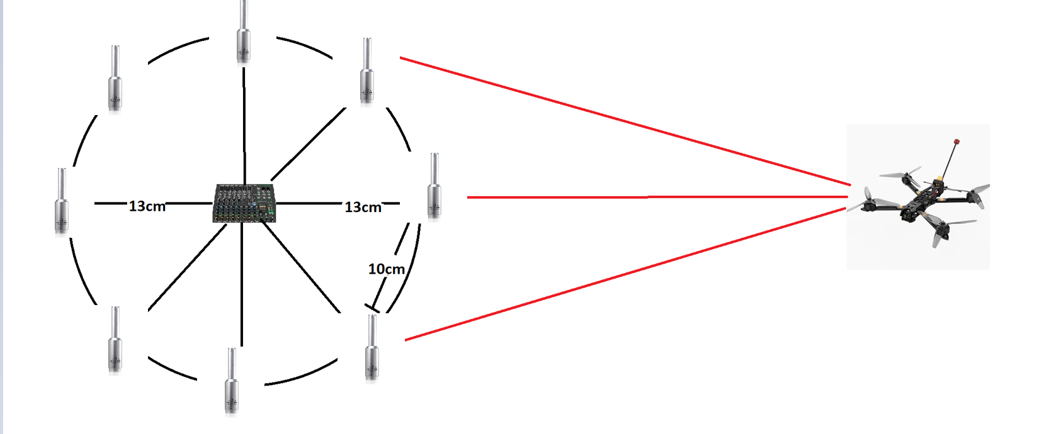
Calculated distance between microphones is 10cm, because:
λ=f/c
the most common frequency (f) we want to hear from drone is 1,5kHz
speed of sound (c) is 343 m/s
so wave (λ) will be about 23cm
to prevent aliasing (error or distortion in a signal or image that makes it appear different from its original form) distance between microfones should be half of wavelength (11,5cm)
Because d=2Rsin(π/8) the radius of this array should be 13 cm.
(of course we can scale this whole setup but when we make radius bigger we need to for radius of 26 cm use 16 microphones and the range of detecting microphones would increase by 41%)
Angle of microphones:
Mount all microphones vertically, with the capsule (the little grille end) pointing straight upward. This way, each mic “sees” the sound field the same way in the horizontal plane (where you estimate azimuth). You avoid one mic’s body casting an “acoustic shadow” on another.
Optionally tilt each mic slightly outward and upward (~10–15°). That helps reduce ground reflections. It also improves sensitivity to drones flying above the array instead of level with it.

Range:
(Radius for 8 microphones in different environments)
Quiet (30dB) | Medium (45dB) | City (55dB)
90 m | 40 m | 12 m

Setup:
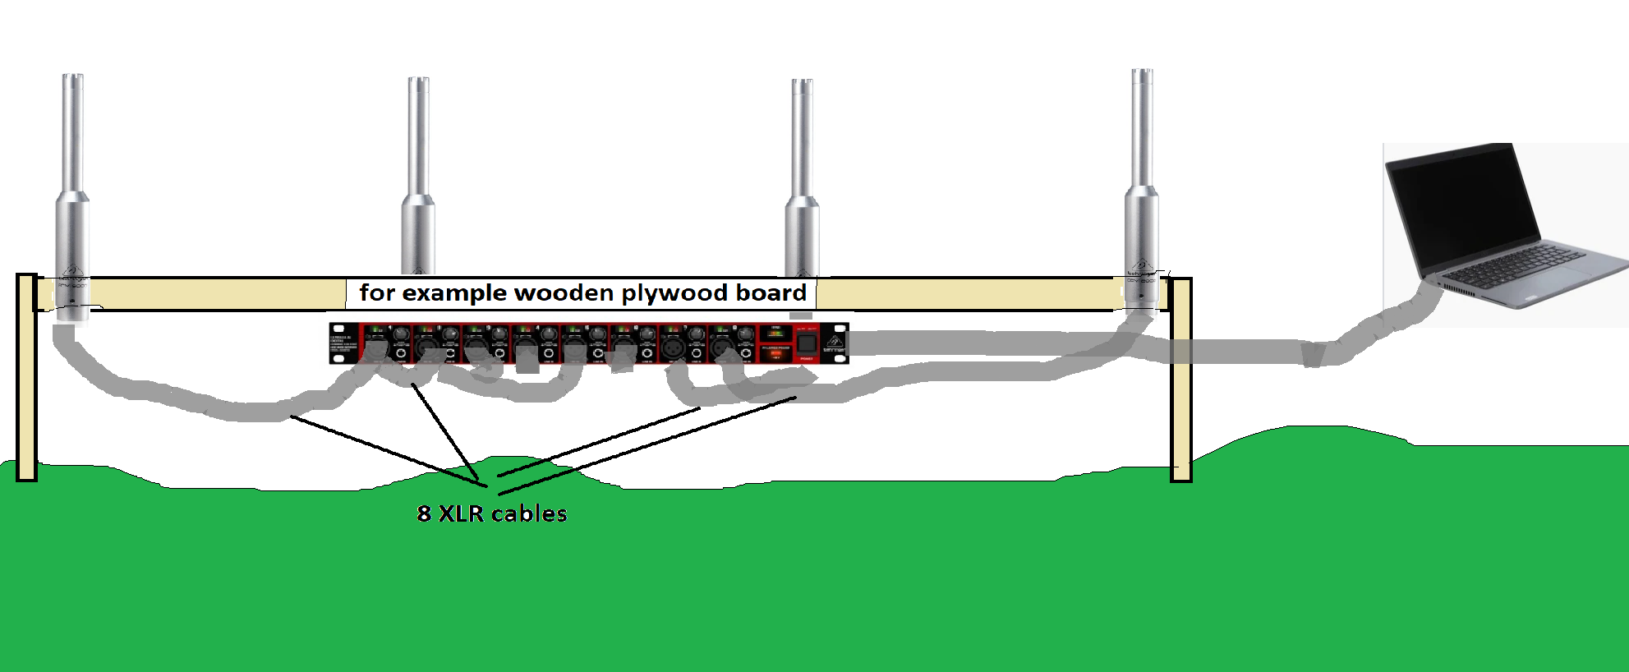
Costs:
For 8 microphones array:
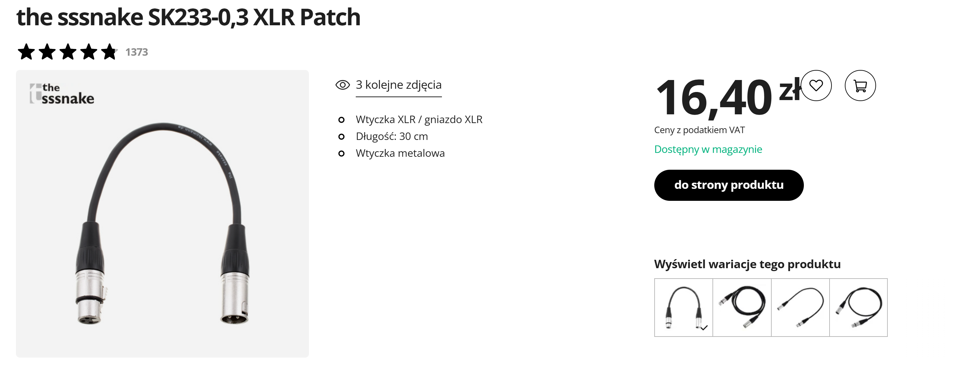
- 8*XLR cable of about 30cm because we need reserve to connect it to the audio interface.
8*17pln = 136 PLN
- 8*Behringer ECM8000 = about 800pln
- 1*Behringer ADA8200 (for example) = about 800 pln
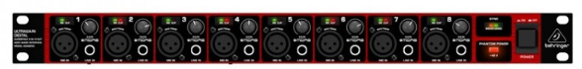

So the estimated cost is about 1800 PLN

