(view from above)
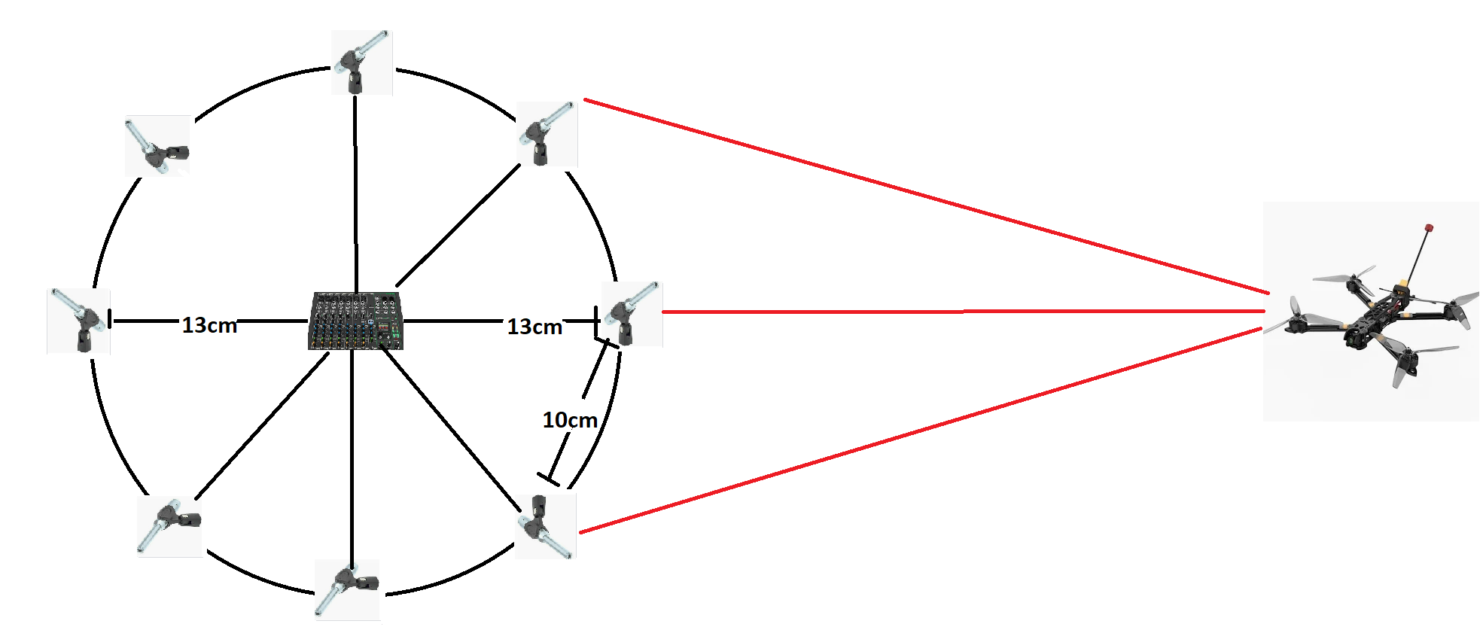
Calculated distance from microfones is 10cm, because:
λ=f/c
the most common frequency (f) we want to hear from drone is 1,5kHz
speed of sound (c) is 343 m/s
so wave (λ) will be about 23cm
to prevent aliasing (error or distortion in a signal or image that makes it appear different from its original form) distance between microfones should be half of wavelength (11,5cm)
Because d=2Rsin(π/8) the radius of this array should be 13 cm.

