Continuous Performance Testing with Jenkins
Content
Introduction & Objectives 2
Prerequisites 2
1. Hardware and Software 2
2. Deploying the Application in Ubuntu 2
Jenkins installation and plugins 3
1. Running Jenkins in Docker 3
2. First Start and Required Plugins 4
3. Setting Up the Tools in the Container 6
Deployment scripts and Jenkinsfiles 7
1. Deployment Scripts 7
2. Structure of the Jenkinsfiles 8
Using the pipelines 9
1. JMeter Pipeline 9
2. Gatling Pipeline 12
3. Lighthouse Pipeline 16
Conclusion 18

Introduction & Objectives
The goal of continuous performance testing with Jenkins is to integrate automated load testing directly into the CI/CD pipeline, enabling performance regressions to be identified early and ensuring that performance tests are executed consistently on demand or on a scheduled basis with results archived alongside build artifacts.
Three tools are driven by Jenkins pipelines: JMeter and Gatling generate server-side load, and Lighthouse measures the client-side metrics of the user interface. Every pipeline checks that the application is reachable, runs the test without a graphical interface, archives the results together with the build and publishes the HTML report as a link on the job page.

Prerequisites

1. Hardware and Software
The environment was built on a Windows machine with WSL2 and an Ubuntu distribution. Docker Engine with the Compose plugin runs inside Ubuntu, and the working user must be able to start containers without sudo, which is checked with docker ps. About 4 CPU cores and 8 GB of RAM are recommended, because the application containers and Jenkins run on the same machine and JMeter is started with a heap of 1–2 GB (-Xms1g -Xmx2g). About 5 GB of free disk space is needed for the images and volumes.
Internet access is required both from Ubuntu and from the Jenkins container, since Docker images, JMeter, the JDK, Maven, Node.js, npm packages and Jenkins plugins are downloaded during the setup. Apart from Docker, only Bash and curl are used, and both are present in Ubuntu and in the Jenkins image. The application and Jenkins are opened from a Windows browser at localhost thanks to WSL2 port forwarding. Port 80 belongs to the application container (wp) and must be free before the start, so any other instance of the application, for example in Rancher Desktop on Windows, has to be stopped first. Port 8080 serves the Jenkins interface, and port 50000 is published for inbound agents but is not used.

2. Deploying the Application in Ubuntu
The application consists of two Docker containers, wp (WordPress) and wp-db (MySQL), started with Docker Compose. The original script setup_PTE.sh was written for Rancher Desktop and does not work in plain Ubuntu, so the script setup_PTE_ubuntu.sh was derived from it: the Rancher-specific commands were removed and replaced with a wait until docker info succeeds.
The script pulls web2wol/wp:1.3 and web2wol/wp-db:latest, and removes the old containers, the volumes wp and db, and the network pte-network. It then writes docker-compose.yaml, with WordPress on port 80, MySQL limited to 50 connections and one CPU, and the named volumes wp and db, and starts the stack with docker compose up -d. The prepared application and database backups are copied out of the wp container, restored into the volumes, and both containers are restarted. At the end the script requests http://localhost/ up to 24 times with a 5 s pause and expects HTTP 200; otherwise it prints diagnostic information and exits with an error.
The script is started from the project folder with bash setup_PTE_ubuntu.sh. When the message "Now you are all set!" appears, the shop must open at http://localhost/.
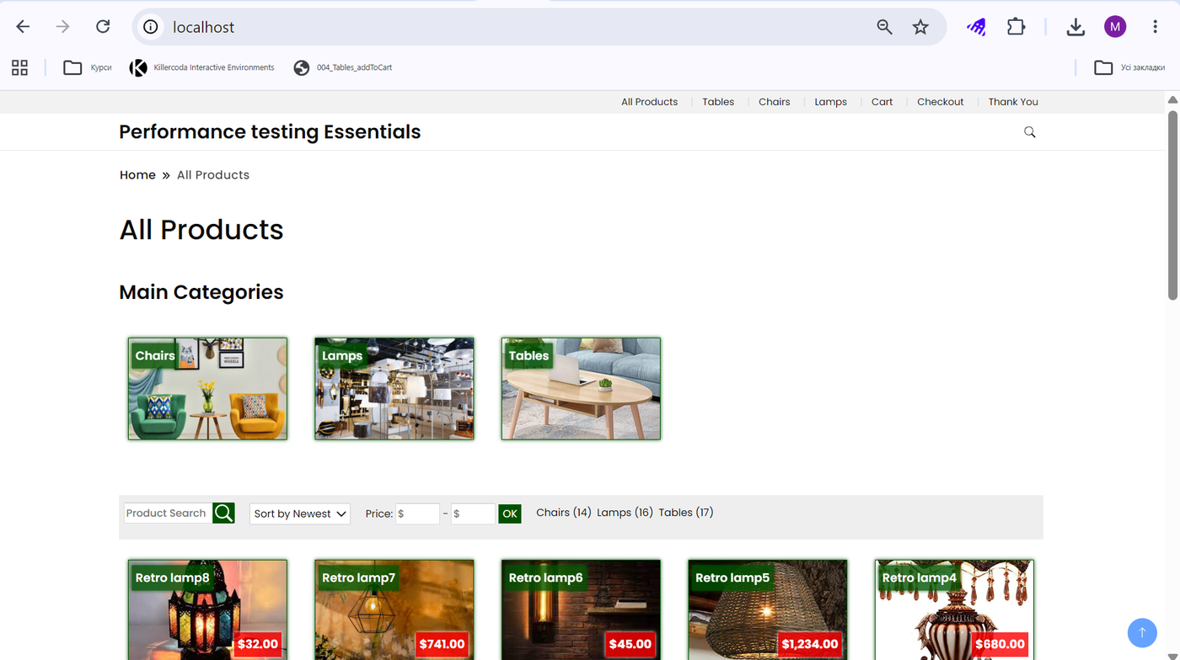
Figure 1 – Performance Testing Essentials opened at http://localhost/ after the setup script

Jenkins installation and plugins

1. Running Jenkins in Docker
Jenkins runs from the official jenkins/jenkins:lts-jdk17 image. A Dockerfile of two lines builds a local image on top of it.
A Docker network is created with
docker network create jenkins,
The image is built with
docker build -t jenkins-no-csrf
The container is started with
docker run -d --name my-jenkins-no-csrf -p 8080:8080 -p 50000:50000 -v jenkins_home:/var/jenkins_home jenkins-no-csrf
The named volume jenkins_home keeps the configuration, jobs, workspaces and artifacts when the container is stopped, so in later sessions it is enough to run docker
start my-jenkins-no-csrf

2. First Start and Required Plugins
On the first start Jenkins has to be unlocked and configured.
- Read the initial administrator password with
docker exec -it my-jenkins-no-csrf cat /var/jenkins_home/secrets/initialAdminPassword
02. Open http://localhost:8080 and paste the password on the Unlock Jenkins page.
03. Choose Install suggested plugins. If an error appears, wait a few minutes and retry, and if necessary restart the container with
docker restart my-jenkins-no-csrf
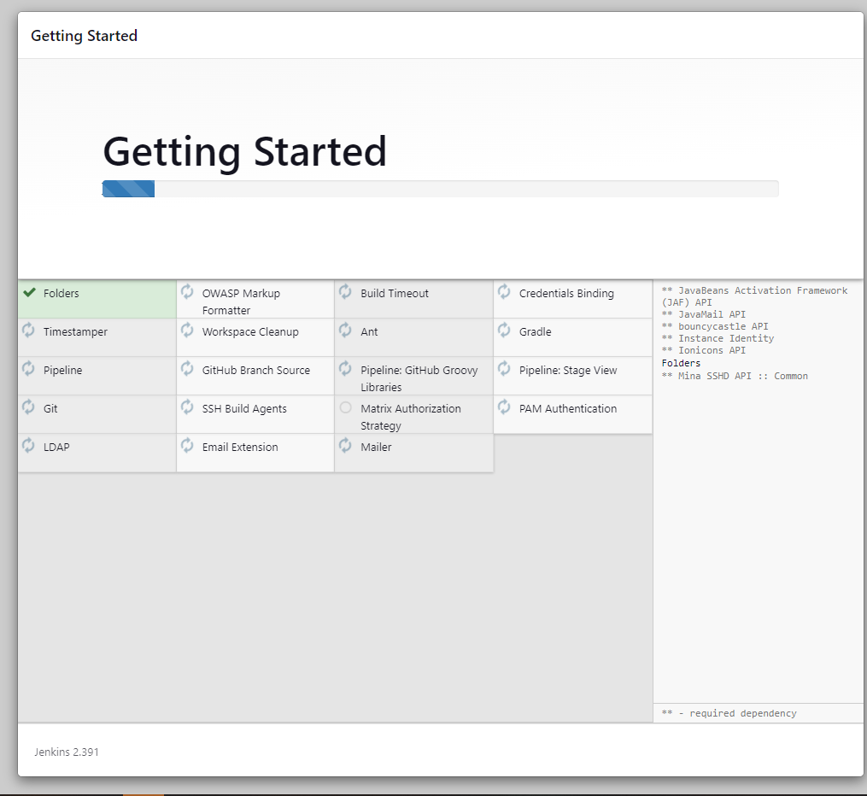
Figure 2 – Jenkins setup wizard: installation of the Suggested Plugins
04. Create the first administrator user. Here the user is admin; if the form reports an error, skip it and continue as admin.

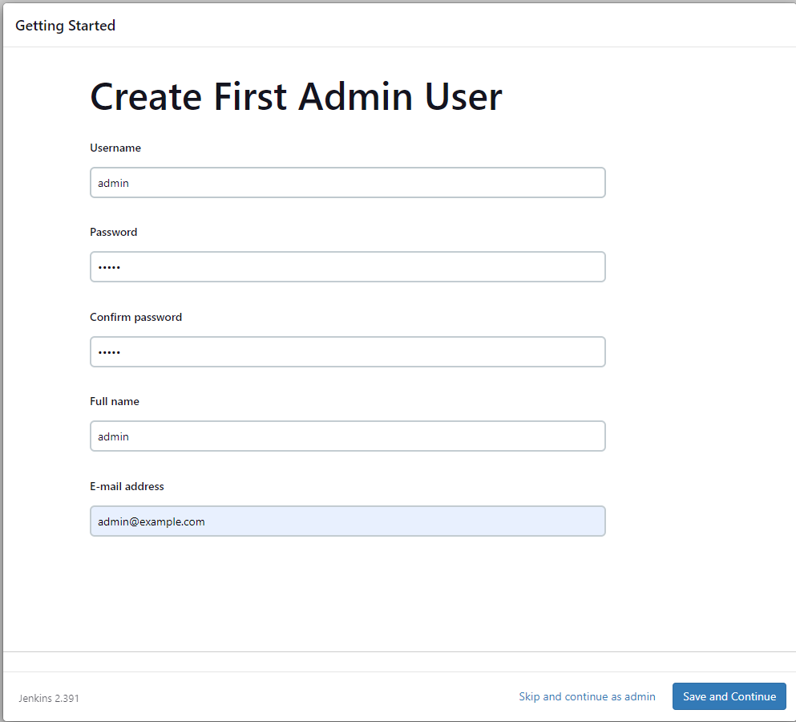
Figure 3 – Jenkins setup wizard: creation of the First Administrator User
05. Click Start using Jenkins on the final page.
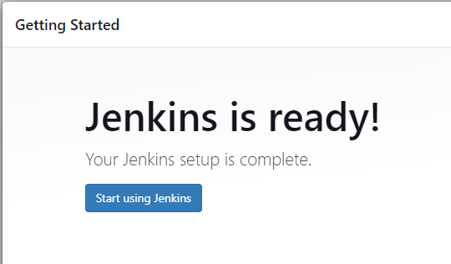
Figure 4 – Jenkins setup wizard: Jenkins is ready
Besides the suggested set, the pipelines need the following plugins.
- Pipeline (workflow-aggregator) and Pipeline: Basic Steps (workflow-basic-steps): part of the suggested set; they parse the declarative pipeline blocks and provide steps such as archiveArtifacts and timeout.
- HTML Publisher (htmlpublisher): the only plugin that has to be installed separately, through Manage Jenkins → Plugins → Available plugins. It provides the publishHTML step that adds the JMeter Report, Gatling Report and Lighthouse Report links to the job and build pages. Without it the report is still available among the build artifacts. The deployment scripts install it automatically when Jenkins credentials are passed to them.
- Pipeline: Stage View or Pipeline Graph View: optional, they show the progress of the stages on the job page.
One more setting concerns the reports. By default Jenkins applies a strict Content-Security-Policy that blocks JavaScript in archived HTML files, so the JMeter and Gatling dashboards open without charts. In this lab the policy is relaxed in Manage Jenkins → Script Console with the command
System.setProperty("hudson.model.DirectoryBrowserSupport.CSP", "")
The setting lasts only until Jenkins is restarted, so the command has to be repeated after a restart, and Jenkins shows a warning that the default policy is overridden.

3. Setting Up the Tools in the Container
The Jenkins image contains Java but none of the test tools, so each tool is installed inside the container. For JMeter this is done by the script deploy_jmeter_ubuntu.sh, which is described in the chapter on deployment scripts. In general terms, the script installs JMeter 5.6.3 under /opt so that it is found at the path the Jenkinsfile expects (JMETER_HOME), adds the JMeter Plugins Manager and installs the Ultimate Thread Group plugin. The test plan PerformanceEssentials.jmx uses this thread group, and without the plugin JMeter cannot create the load scenario. The same script copies the test plan and the csv folder into the Jenkins home and gives them to the jenkins user, so it has to be run again after every change of the .jmx file.
Gatling needs JDK 21 and Maven 3.9.9, because the project is compiled for release 21. The Jenkinsfile downloads Temurin 21 and Maven into /var/jenkins_home/jdk21 and /var/jenkins_home/maven when they are missing, so the first build takes longer than the following ones. Gatling itself is taken by Maven from pom.xml, and the project is stored in /var/jenkins_home/gatling_project.
Lighthouse requires Node.js 18 or newer; version 20.18.1 is installed into /opt/node. The packages lighthouse 9.x and puppeteer 13.x are installed with npm install in /var/jenkins_home/lighthouse_project as the jenkins user, and puppeteer downloads its own Chromium (about 300 MB). Chromium needs system libraries that the Jenkins image does not contain, among them libnss3, libgbm1, libatk-bridge2.0-0 and fonts-liberation, and they are installed with apt-get as root. The installation is verified by starting headless Chromium with the --no-sandbox option.
JMeter, Node.js and the system libraries are stored in the file system of the container and not in the jenkins_home volume. If the container is deleted and created again, these steps must be repeated, which is what the deployment scripts are for.

Deployment scripts and Jenkinsfiles

1. Deployment Scripts
Each project folder (01_jmeter, 02_gatling and 03_lighthouse) contains a script deploy_jmeter_ubuntu.sh, deploy_gatling_ubuntu.sh or deploy_lighthouse_ubuntu.sh. The script creates the Jenkins job. Steps that are already done are skipped, so it can be run again after the container or the project files have changed. The script is started from its own project folder.
All three scripts follow the same order. At first, JMeter and the Ultimate Thread Group plugin are installed for JMeter, Node.js, the Chromium libraries, the npm packages and a Chromium smoke test for Lighthouse, and nothing for Gatling, whose JDK and Maven are fetched by the Jenkinsfile. Then the project is copied into the container and the owner is set to jenkins. After that the script requests the application from inside the container at 172.17.0.1:80 with the header Host: localhost and stops with a diagnostic message if the answer is not HTTP 200. The last step runs only when JENKINS_USER and JENKINS_PASSWORD are set. It installs HTML Publisher through the REST API, relaxes the CSP, creates or updates the job from the Jenkinsfile (jmeter-performance, gatling-perf-test or lighthouse-performance) and, with RUN_BUILD=1, starts the first build.
For JMeter the commands are
cd ~/Draft_Continuous_Performance_Testing_Jenkins_Task/01_jmeter
chmod +x deploy_jmeter_ubuntu.sh
JENKINS_USER=admin JENKINS_PASSWORD='admin' RUN_BUILD=1 ./deploy_jmeter_ubuntu.sh
Gatling and Lighthouse are deployed the same way from the folders 02_gatling and 03_lighthouse. Without credentials the script only installs the tools and copies the files, and the job has to be created by hand. The behavior can be changed with the optional variables JENKINS_CONTAINER, JENKINS_URL, JOB_NAME, APP_HOST, APP_PORT, SET_CSP and RUN_BUILD, and also JMETER_VERSION for JMeter and NODE_VERSION for Lighthouse. The password is passed to curl on the command line and is briefly visible in the process list, so on a shared machine a Jenkins API token should be used instead.
The tests start inside the Jenkins container, where localhost is the container itself, and with a native Docker Engine in WSL2 the name host.docker.internal cannot be resolved. The Docker host gateway 172.17.0.1 is therefore used. JMeter and Gatling send the header Host: localhost, and Lighthouse maps localhost to 172.17.0.1 for Chromium with HOST_RESOLVER_RULES. If the gateway has another address, the variable APP in the Jenkinsfile (APP_CHECK_URL and HOST_RESOLVER_RULES for Lighthouse) has to be changed.

2. Structure of the Jenkinsfiles
The three Jenkinsfiles are declarative. The build timeout is 40 min for JMeter and 60 min for Gatling and Lighthouse. All settings are in the environment block at the top of the file: the paths inside the container, the address of the application, the load model and the results folder results/build-N. No Jenkins job parameters are used, so a build can be started immediately with Build Now.
The first stage, Prepare, checks the environment and the presence of the tool and the project files, verifies the limits of the parameters, deletes the leftovers of the previous build and copies the project into the workspace.
The second stage, Check target, sends one HTTP request to http://172.17.0.1:80/ with the header Host: localhost. If the application does not answer, the build fails at once instead of running for 10 min with 100% errors. Gatling also requires HTTP 200 and the text "Performance testing Essentials" on the home page, while JMeter and Lighthouse only print a warning for another status code.
The third stage runs the test. JMeter is started in non-GUI mode with the options -l results.jtl, -j jmeter.log and -e -o report_full, so the HTML dashboard is generated at the end of the run and covers the whole test, including ramp-up and shutdown. Gatling is started with mvn gatling:test and receives the target address, the Host header, the user counts, the assertion that at least 99% of the requests must succeed. A failed assertion fails the build, but the latest report from target/gatling is copied to report_full in any case. Lighthouse repeats node performance-testing-essentials.js 10 times with a 5 s pause, and then aggregate-lighthouse.js builds one averaged HTML summary from the successful runs. If some runs fail and at least one succeeds, the script exits with code 3 and the build becomes UNSTABLE; if all runs fail, the build fails.
The post section runs in every case. It packs the report folder into report_full.tar.gz (for Lighthouse the large raw artifacts are packed into lighthouse-raw-artifacts.tar.gz), archives everything in results/build-N with archiveArtifacts and calls publishHTML. The report names are JMeter Report, Gatling Report and Lighthouse Report, and the link always points to the last build (alwaysLinkToLastBuild). The call is wrapped in try and catch, so a missing HTML Publisher plugin does not fail the build. The final messages of a failed build point to console.log and to the log of the tool in the artifacts.

Using the pipelines
If the deployment script was started with credentials, the job already exists. Otherwise it is created once on http://localhost:8080 with New Item: a name is entered (jmeter-performance, gatling-perf-test or lighthouse-performance), the type Pipeline is selected, Pipeline script is chosen in the Pipeline section, the complete Jenkinsfile is pasted, and the job is saved. A test is then run in the following order.
01. Start the application and make sure that http://localhost/ opens.
02. Start Jenkins with docker start my-jenkins-no-csrf and open http://localhost:8080.
03. Check that the tool and the project files are in the container, which is done by the deployment script, and that HTML Publisher is installed.
04. Open the job and click Build Now, then follow the progress in Console Output.
05. When the build ends, open the report link in the left menu of the job or Build Artifacts.
The load is changed by editing the environment block in Configure → Pipeline: USERS, TOTAL_DURATION_SEC, RAMP_UP_SEC and SHUTDOWN_SEC for the load, TT_MIN, TT_MAX and the timeouts for think time, APP and APP_PORT for the target, and LOOPS and PAUSE_SECONDS for Lighthouse. The three jobs must not run at the same time, because they load the same application and the same machine.

1. JMeter Pipeline
The JMeter job takes about 10 min. The stages Prepare and Check target finish within seconds, the console prints "Expected duration: 10 min" at the start of the test, and a successful build ends with "Test completed". The report is available in three ways: through the link on the job page (http://localhost:8080/job/jmeter-performance/JMeter_20Report/, where _20 is the space of the report name encoded by Jenkins), through the same link on the page of a particular build, and as an artifact under Build Artifacts → results → build-1 → report_full → index.html.
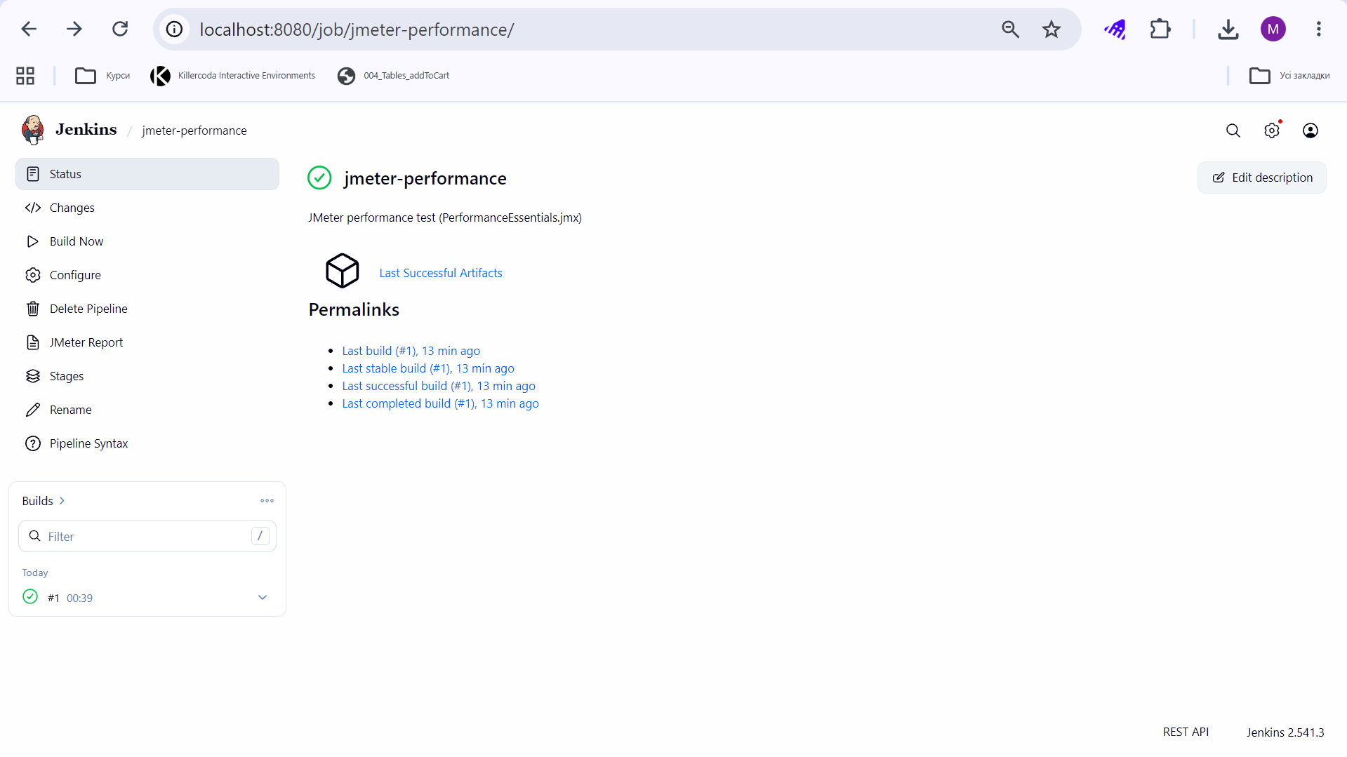
Figure 5 – Jenkins: job jmeter-performance after the first build
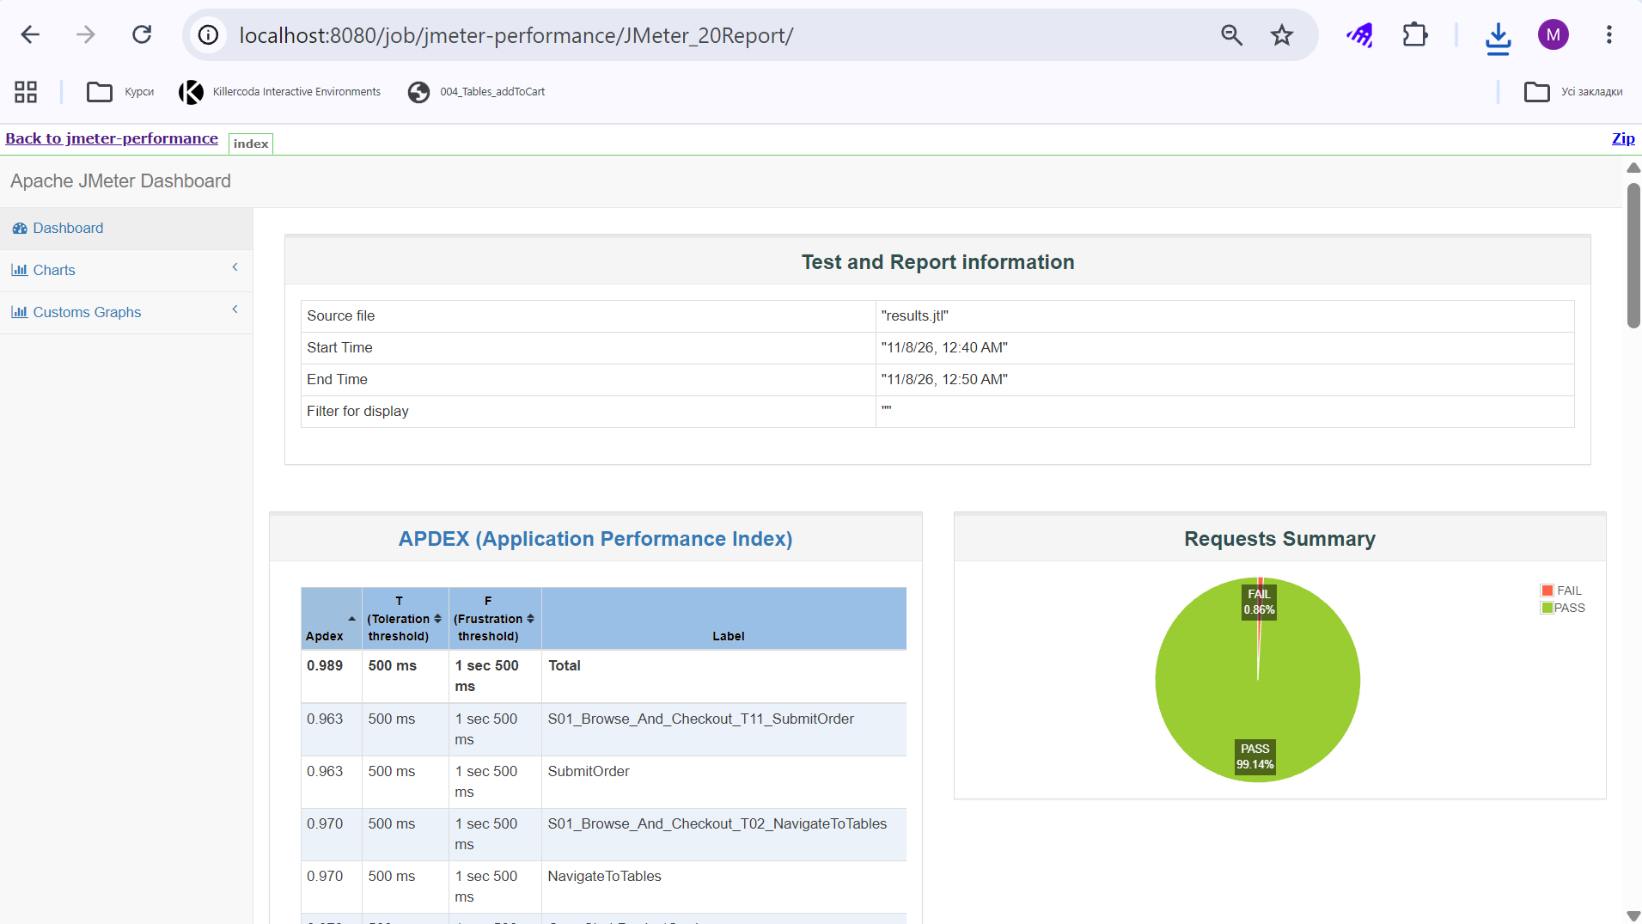
Figure 6 – Jenkins: JMeter dashboard opened through the JMeter report link
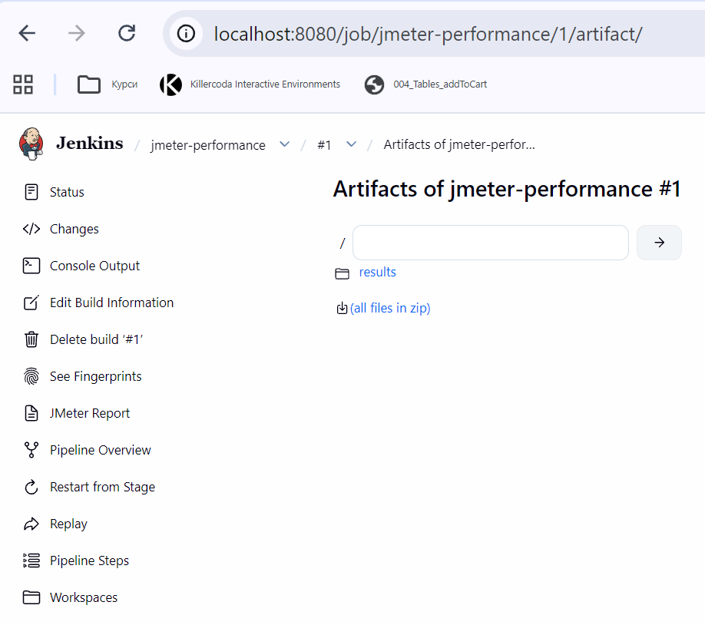
Figure 7 – Jenkins: artifacts of the first build
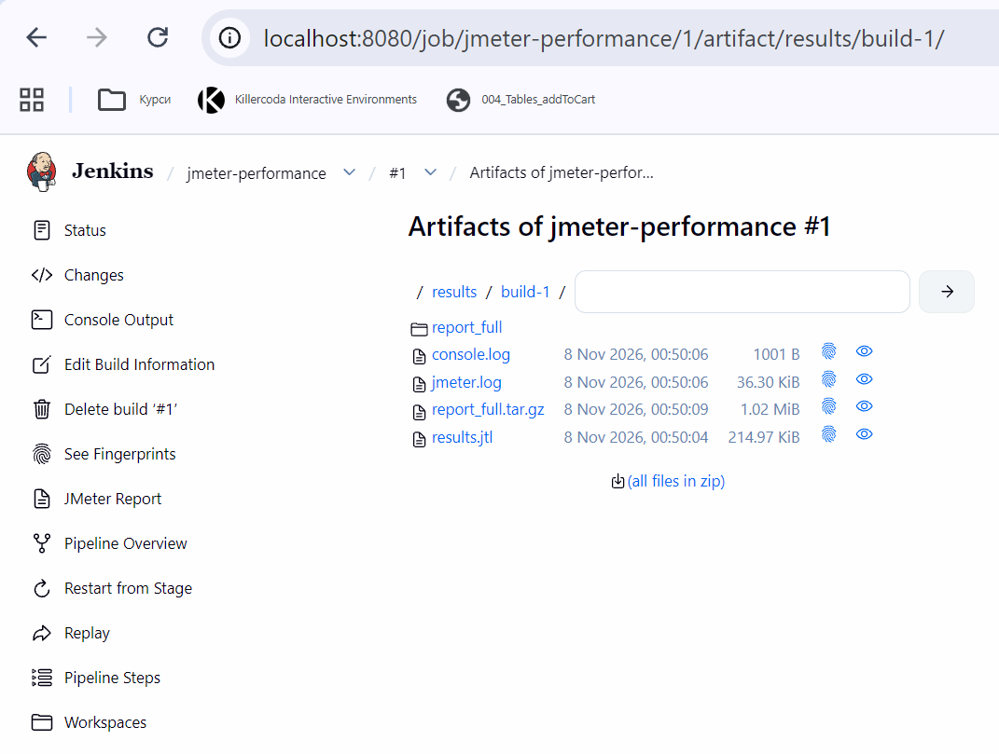
Figure 8 – Jenkins: content of results/build-1
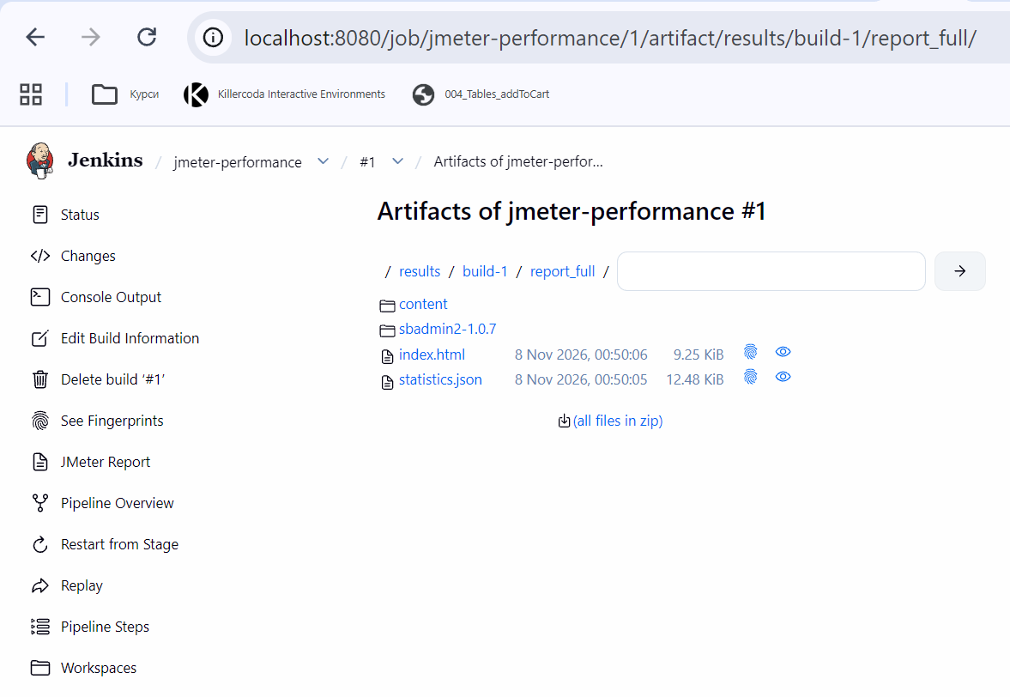
Figure 9 – Jenkins: content of results/build-1/report_full
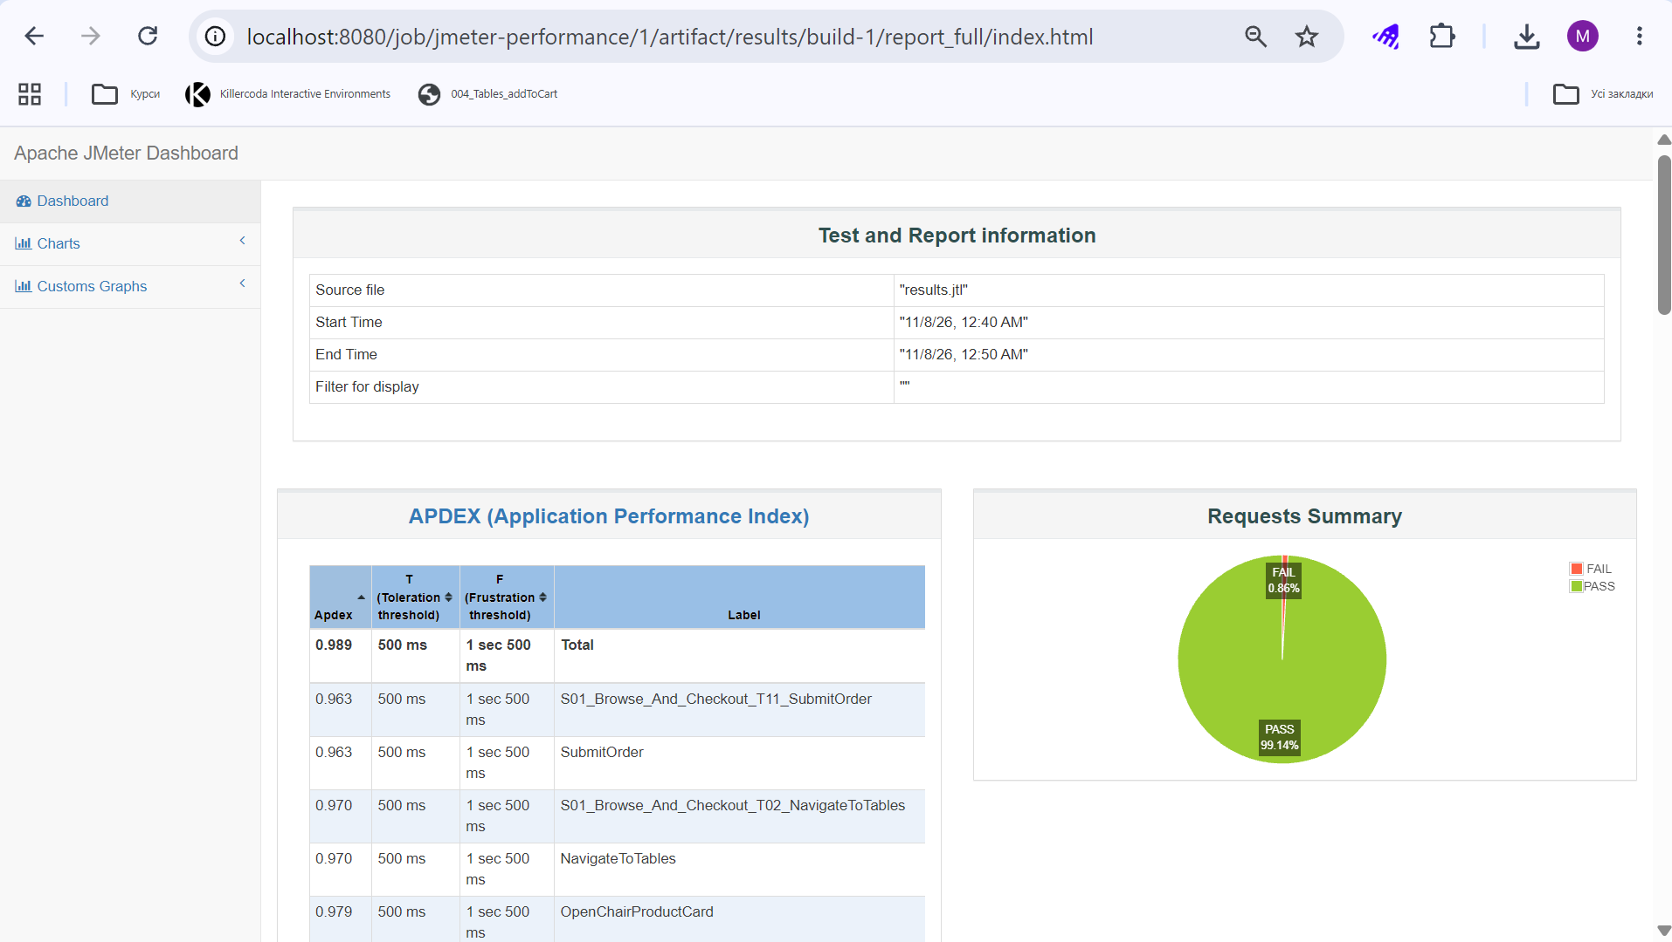
Figure 10 – Jenkins: JMeter dashboard opened from the artifact index.html

2. Gatling Pipeline
The Gatling job (gatling-perf-test) runs the simulation PerfTestSimulation for about 10 min. The first build is longer, because JDK 21, Maven and the project dependencies are downloaded, and the console prints the expected duration at the start of the test. The Gatling Report link appears in the left menu in the same way as for JMeter.
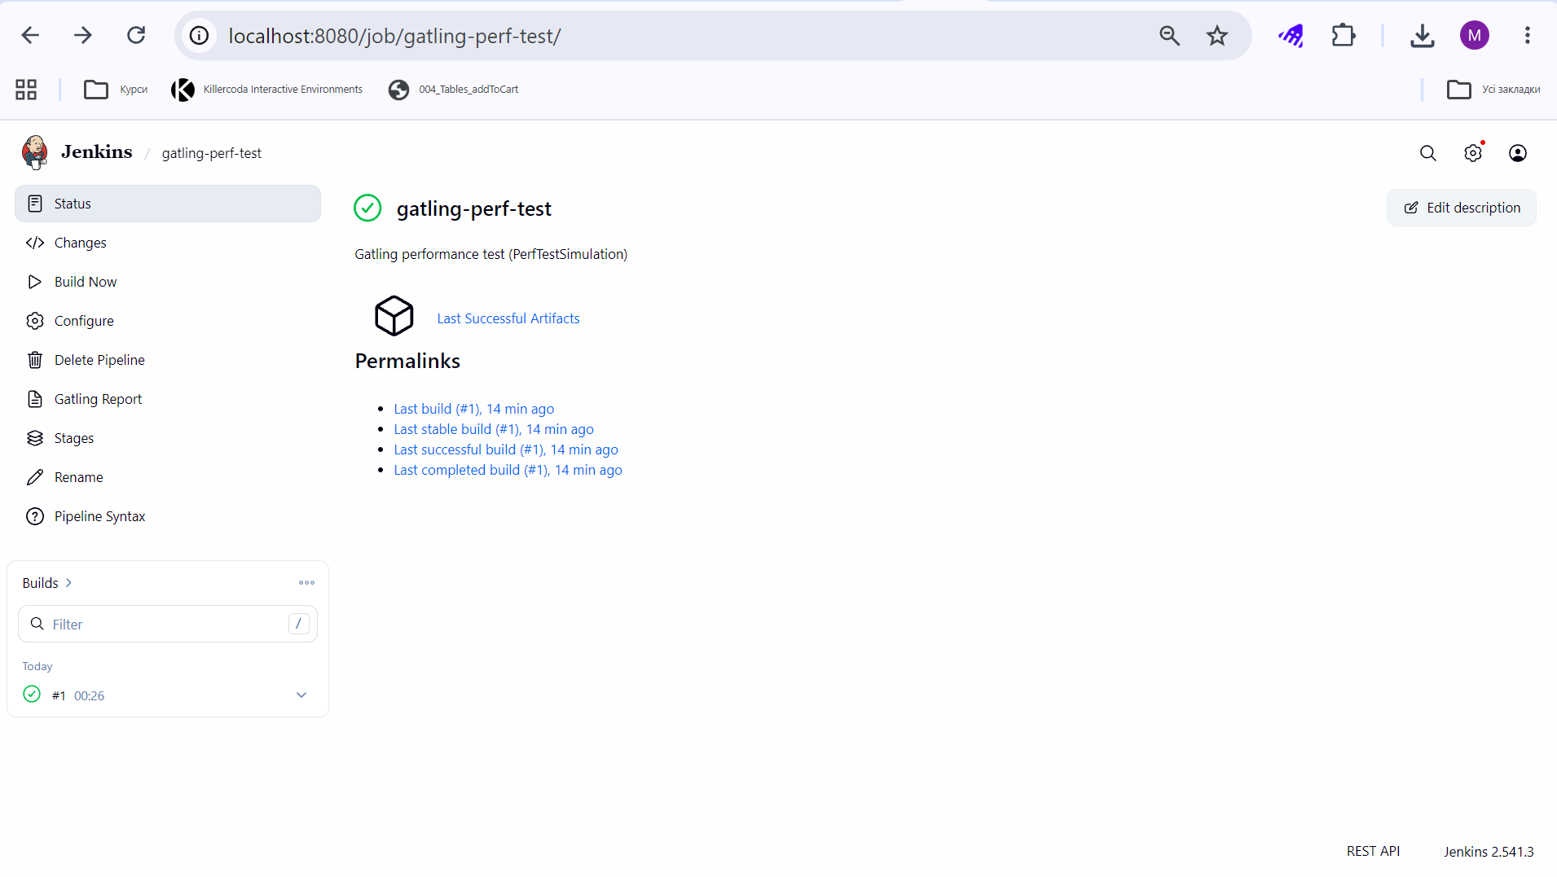
Figure 11 – Jenkins: job gatling-perf-test after the first build
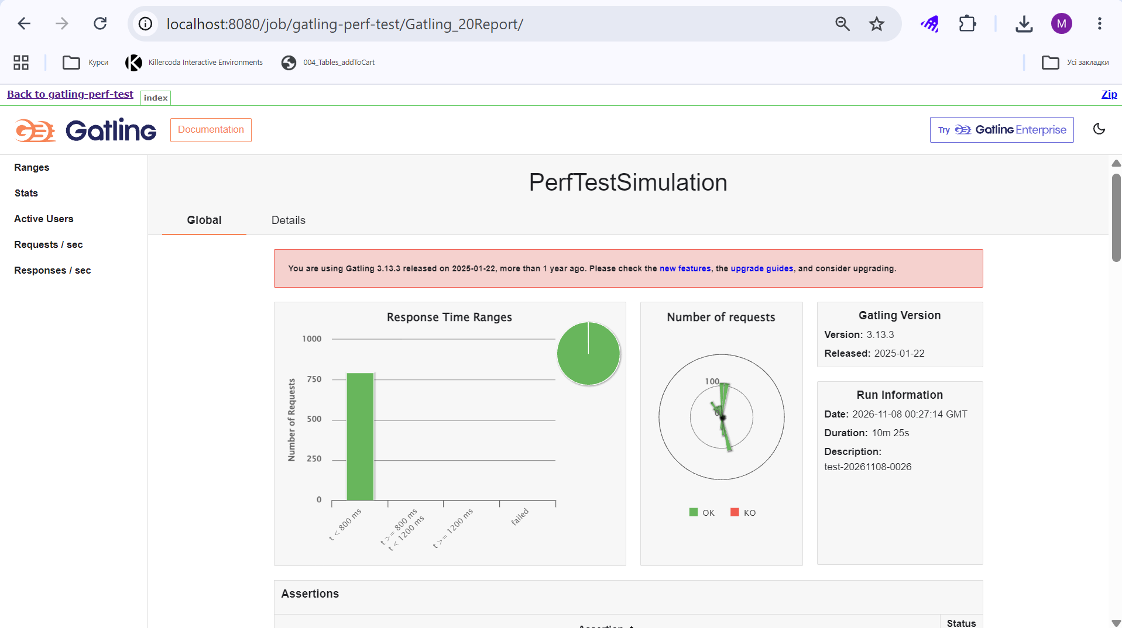
Figure 12 – Gatling: Global report opened through the Gatling report link
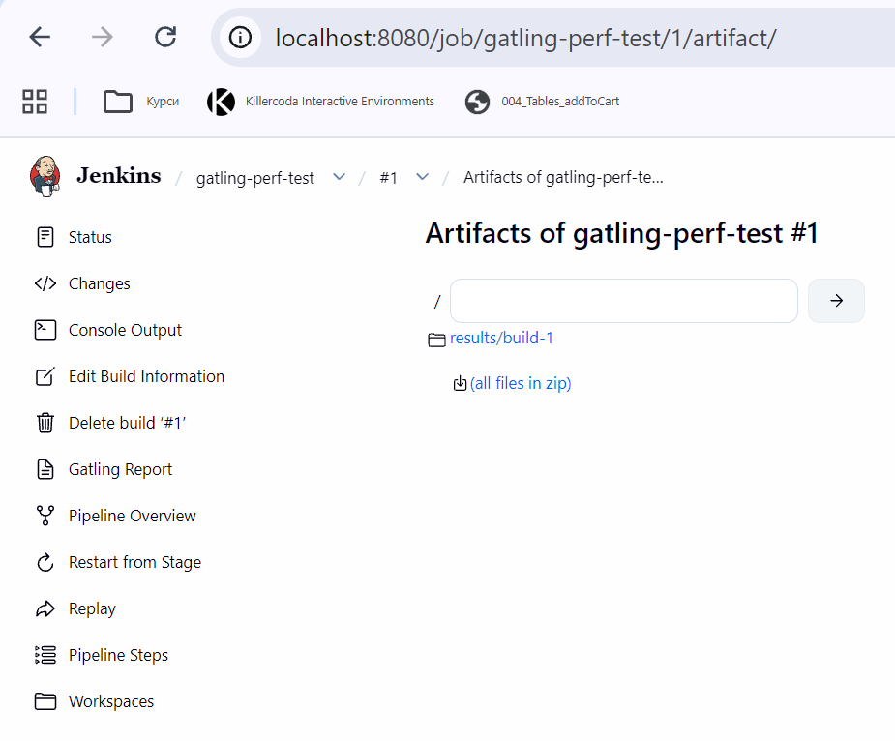
Figure 13 – Jenkins: artifacts of the first Gatling build
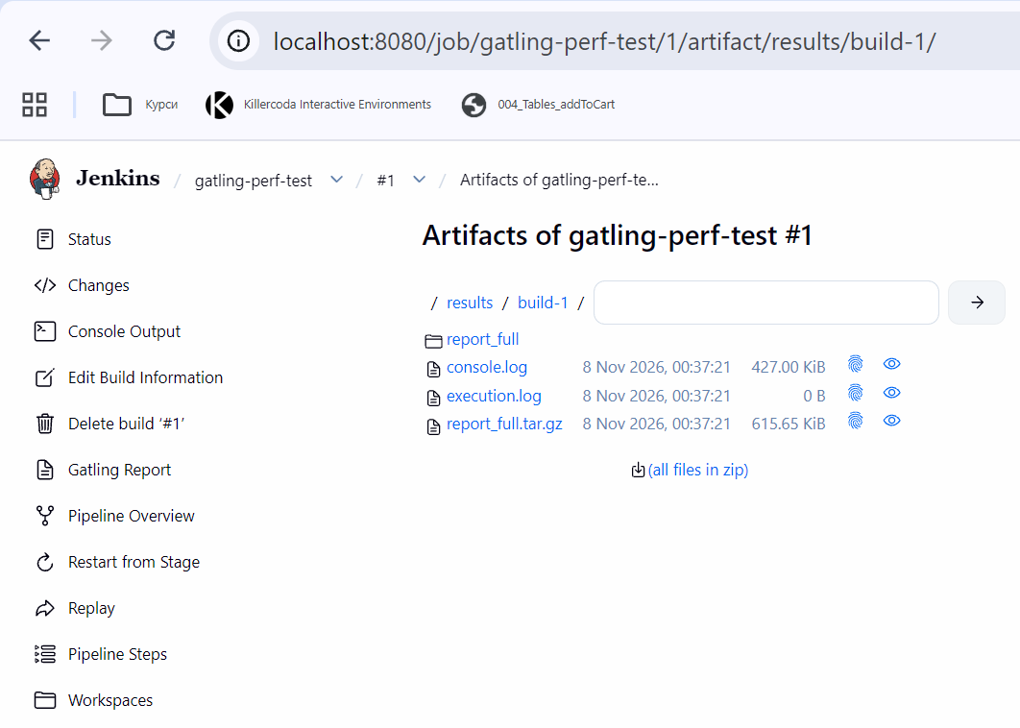
Figure 14 – Jenkins: content of results/build-1
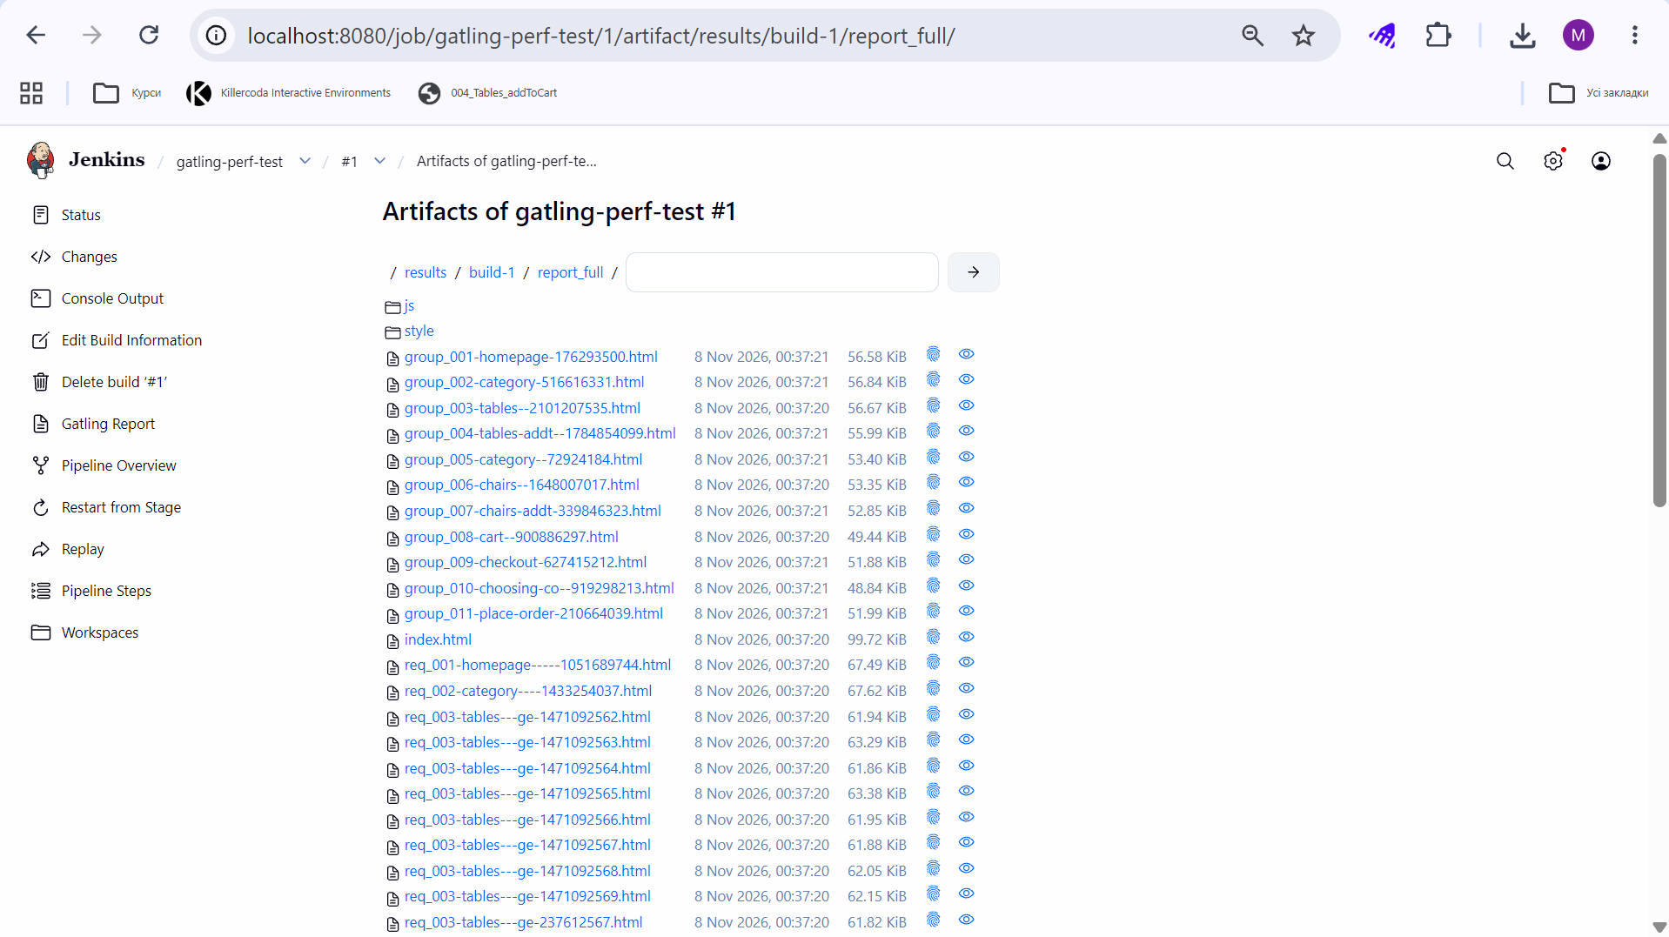
Figure 15 – Jenkins: content of results/build-1/report_full
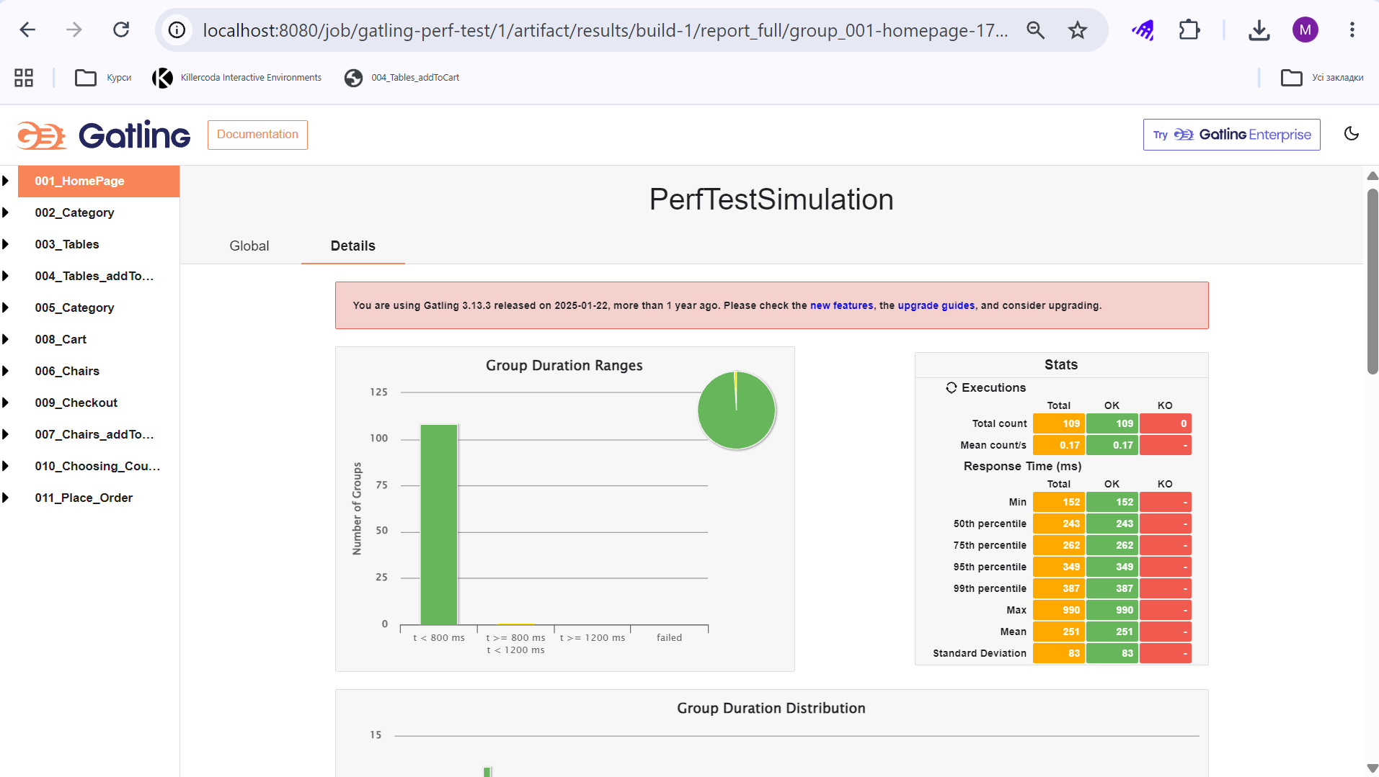
Figure 16 – Gatling: Details page of the group 001_HomePage

3. Lighthouse Pipeline
The Lighthouse job (lighthouse-performance) runs the order flow 10 times with a 5 s pause. The first build took about 15 min: the runs were made between 23:55 and 00:10 UTC. After a successful build the job page offers the Lighthouse Report link, and the link opens the averaged summary.
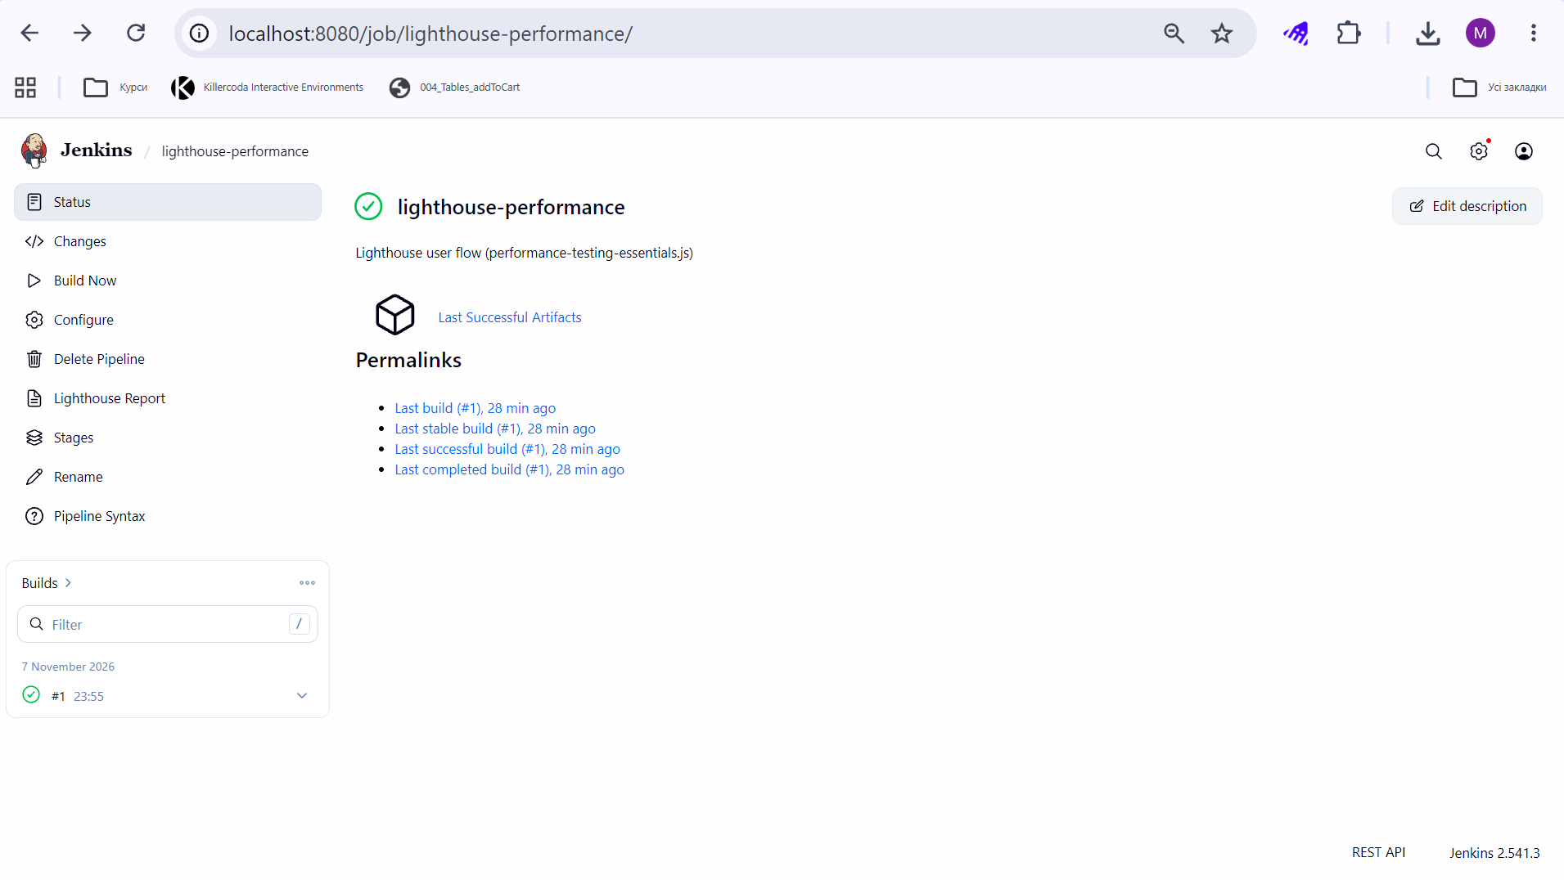
Figure 17 – Jenkins: job lighthouse-performance after the first build
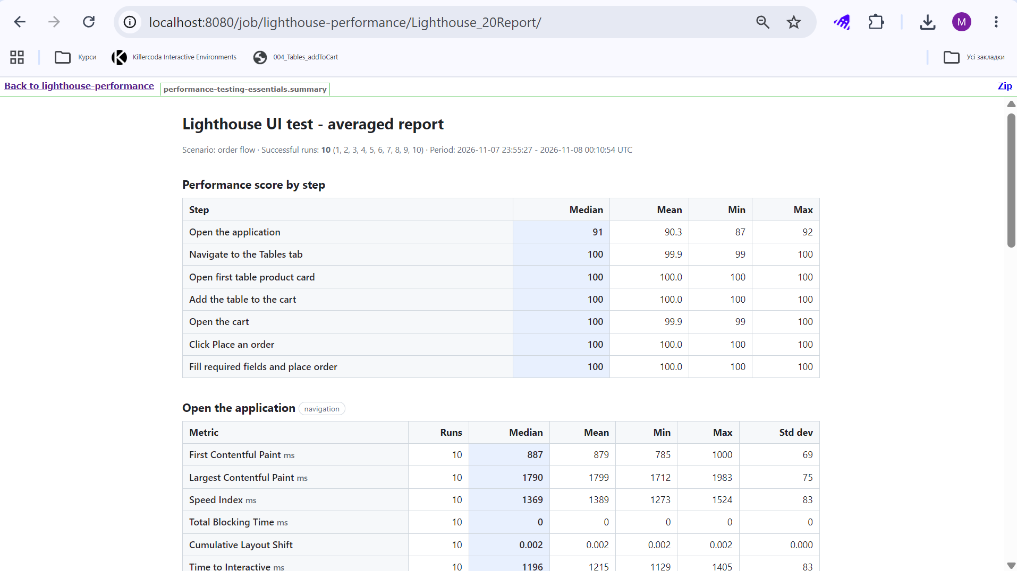
Figure 18 – Lighthouse: Averaged Report opened through the Lighthouse report link
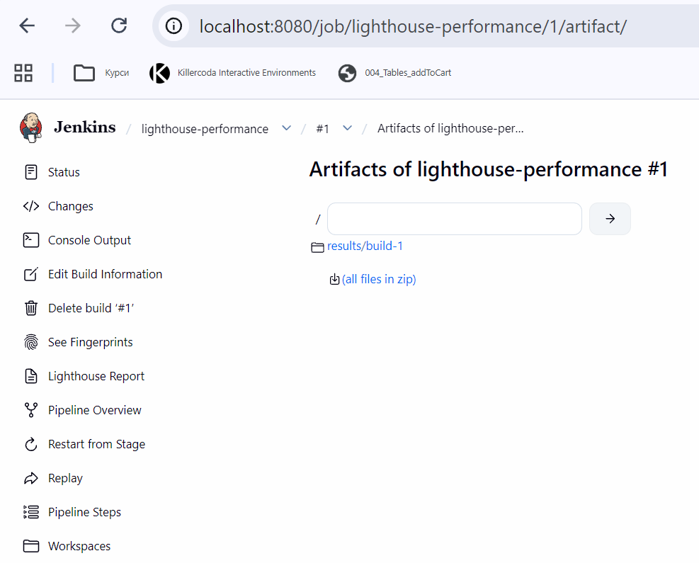
Figure 19 – Jenkins: artifacts of the first Lighthouse build
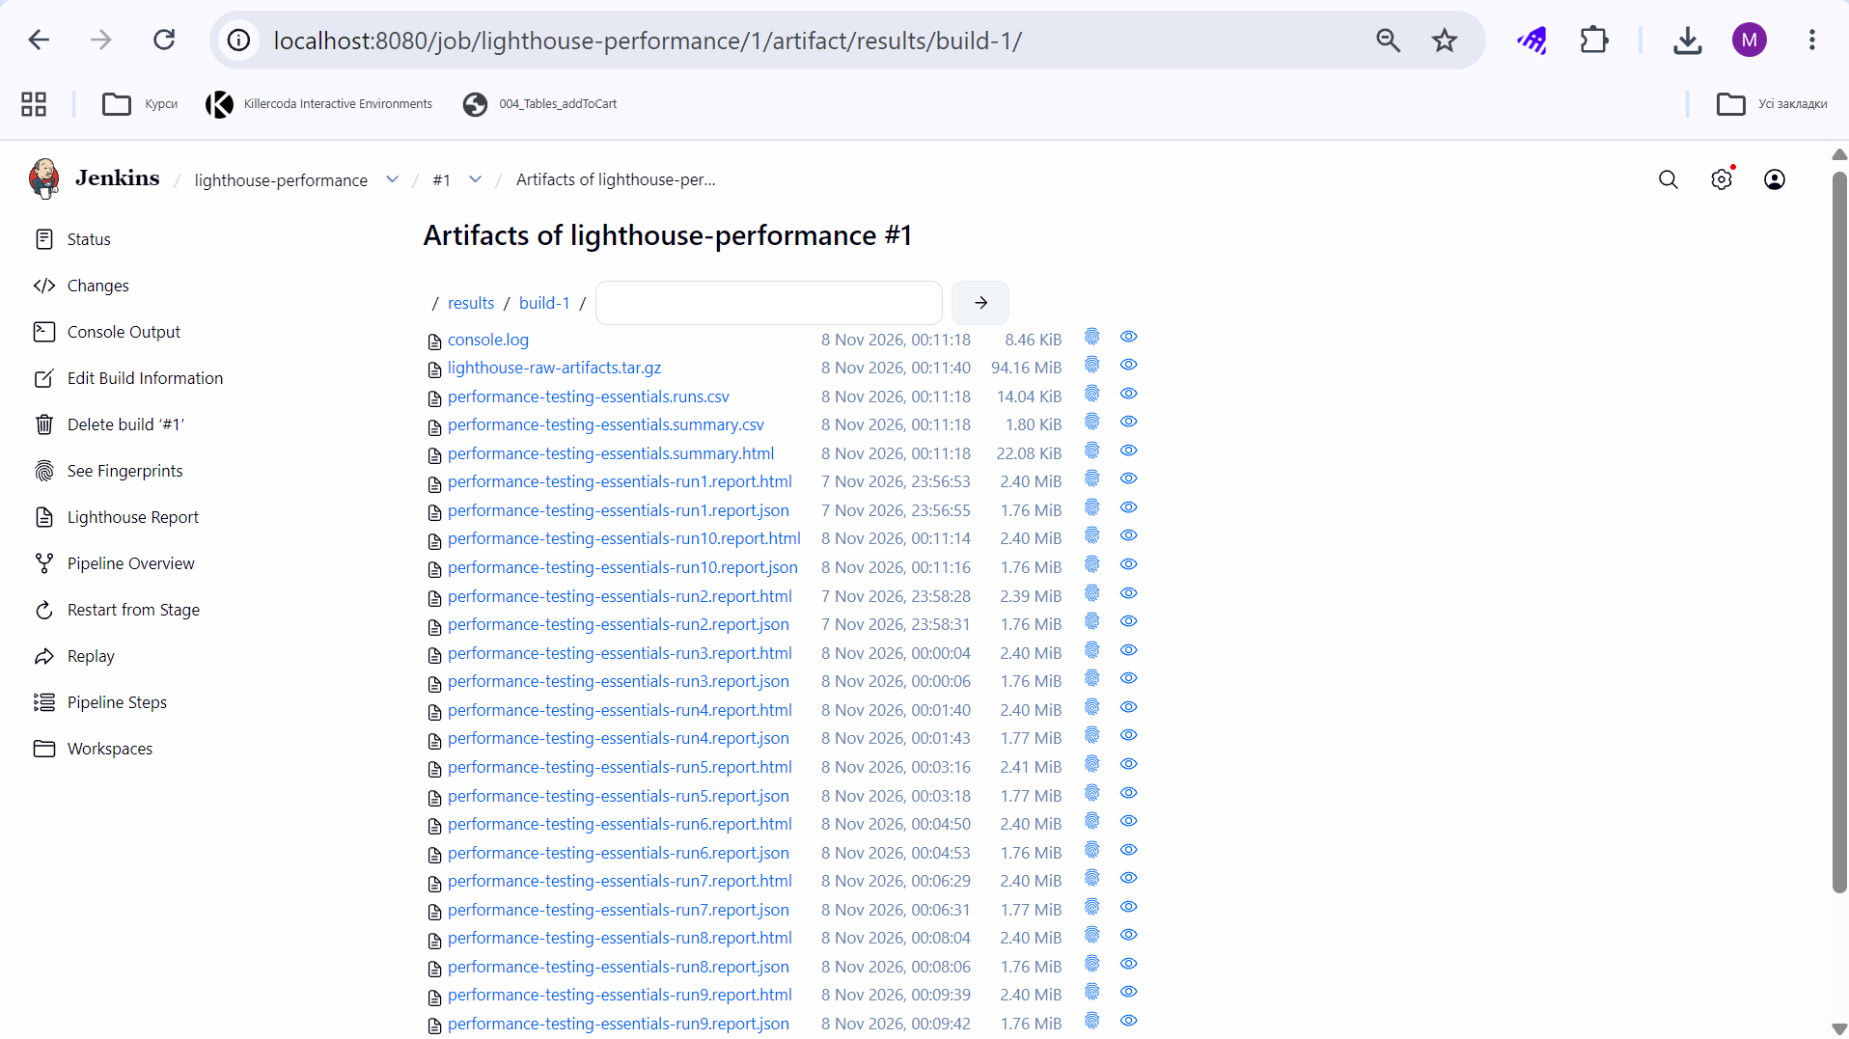
Figure 20 – Jenkins: content of results/build-1
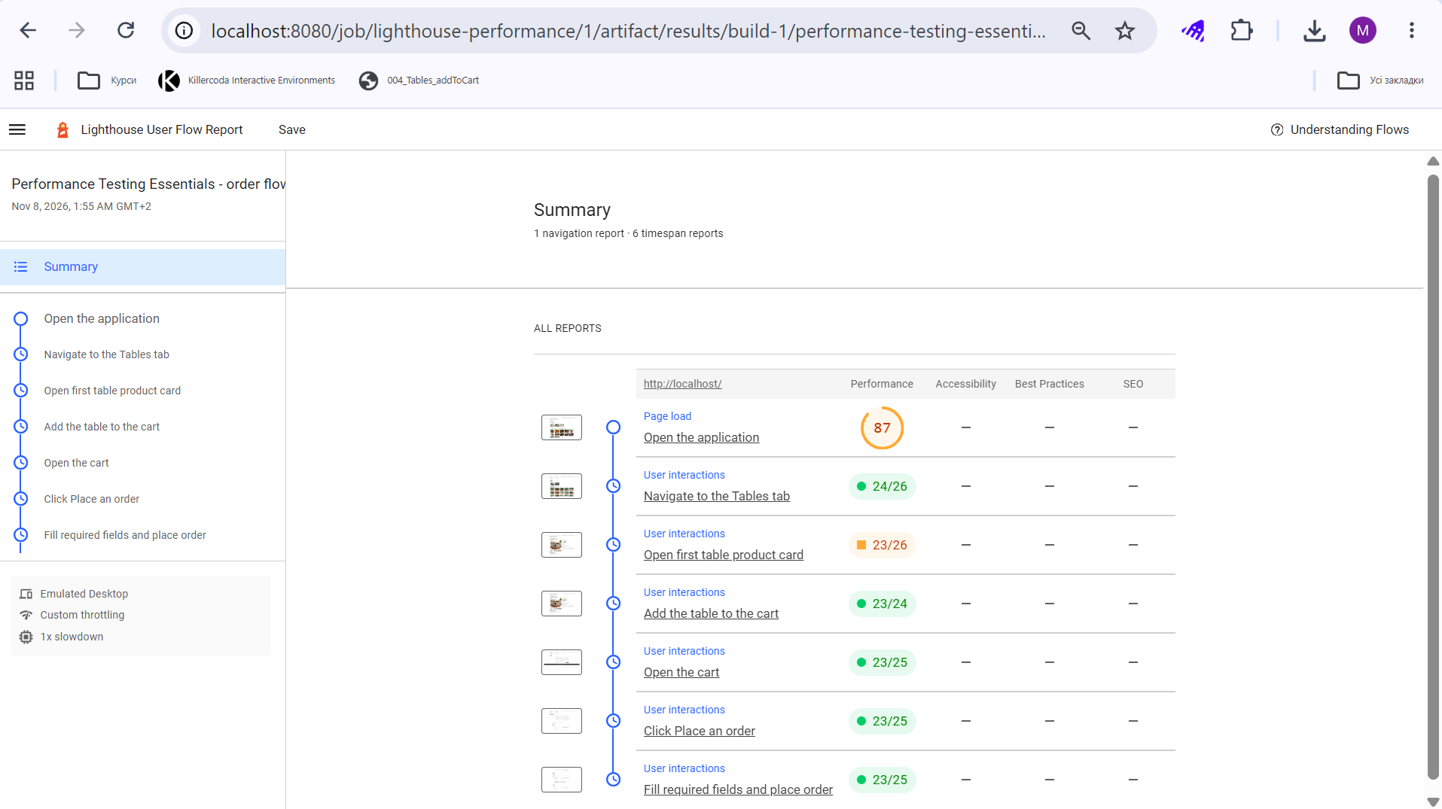
Figure 21 – Lighthouse: Flow Report of a single run

Conclusion
For each of the three tools, JMeter, Gatling and Lighthouse, there is now a declarative Jenkins pipeline for Ubuntu that checks the availability of the application, runs the test without a graphical interface, archives the results with the build and publishes the HTML report as a link on the job page.
Most of the effort in this setup lies in the environment and not in the Jenkinsfiles. The points that need attention are the address of the application as seen from the container, the redirect that WordPress makes for a Host header other than localhost, the Content-Security-Policy that hides the charts of the HTML reports, and the tools stored in the file system of a container that may be recreated.

