Mark Bereza
Wilkins White
Jan Bartels
Divide & Conquer
An analysis of finding the shortest distance between a set of points

How to run?
Navigate into cs325/a1, then run 'python a1.py'

Pseudocode:

Brute Force:

min_distance = MAX
point1 = point2 = NULL
for each point in X
for each other_point in X
if distance(point, other_point) < min_distance
min_distance = distance(point, other point)
point1 = point
point2 = other_point
if distance(point, other_point) == min_distance
point1 += point
point2 += other_point
return point1, point2

Naive:

findShortestDist(points):
if( size(points) <= 3 ):
find_min_distance(point0, point1, point2)
return min_dist, min_point1, min_point2
else
midpoint = size(arr)/2
mid_X = points[midpoint]['X']

min_left, p1left, p2left = findShortestDist(points[:midpoint])
min_right, p1right, p2right = findShortestDist(points[midpoint:])

min_dist = min(min_left, min_right)
find in points all X within min_dist of mid_X
min_middle, p1middle, p2middle = combineAcross(min_dist, points);

if min_left is smallest:
return min_left, p1left, p2left
if min_right is smallest:
return min_right, p1right, p2right
if min_middle is smallest:
return min_middle, p1middle, p2middle
Enhanced:

findShortestDist(points_X, points_Y):
if( size(points_x) <= 3):
find_min_distance(point0, point1, point2)
return min_dist, min_point1, min_point2
else
midpoint = size(points_X)/2
mid_X = data_x[midpoint]['X']

left_x = points_X[:midpoint]
right_x = points_X[midpoint:]

left_y = all points in point_Y with X < mid_X
right_y = all points in point_Y with X > mid_X

min_left, p1left, p2left = findShortestDist(left_x, left_y)
min_right, p1right, p2right = findShortestDist(right_x, right_y)

min_dist = min(min_left, min_right)
find in points_Y all X within min_dist of mid_X
min_middle, p1middle, p2middle = combineAcross(min_dist, points);

if min_left is smallest:
return min_left, p1left, p2left
if min_right is smallest:
return min_right, p1right, p2right
if min_middle is smallest:
return min_middle, p1middle, p2middle

Asymptotic Analysis:

Brute Force:
for each point in X - O(n)
for each other_point in X – O(n)
other stuff - O(c)

Brute Force is O(n^2). There isn't a recurrence relation in here so nothing more to analyze.

Naive:

T( n ) = 2*T(n/2) + O(n) + O(nlog(n)) + O(n)
The calls, in order are: Recursive call, finding all points with delta within smallest_dist of mid_X, mergesorting those points by Y and finding the cross pairs.

T( n/2 ) = 2*T(n/4) + O(n) + O(nlog(n)) + O(n)
One observation to make here is, that since the algorithm keeps dividing until only three points are in each subsection finding all points within delta of mid_X and finding the cross points can both, at most run on 6 points. By using recursion we are able to optimize the mergesort down to O(n) by sorting at the bottom and returning

T( n ) = 2^k*T(n/2^k) + O(n) + O(n)
where k = log2(n) for n/2^k > basecase
Which resolves to:
O(n * log(n) )

Enhanced:

The enhanced call is slightly smarter in that it avoids the expensive call to mergesort by passing in two already sorted arrays. This pushes our recurrence relation down to:
T( n ) = 2*T(n/2) + O(n) + O(n) + O(n)

The calls, in order are: Recursive call, building left_y and right_y based on X coordinate, finding all points with delta within smallest_dist of mid, calculating all cross pairs

In this case, again we're able to skip a lot of the O(n) calls because our algorithm has automatically limited the scope of the problem space to at most 6 points.

Leaving us with the recurrence relation:
T( n ) = 2 * T(n/2^k) + 3*2^k*O(n)
where k = log2(n) for n/2^k > basecase
This gives us complexity: O(n * log(n) ) but this time the internal constants we're ignoring are smaller

Runtime Plots:

Data:

Plot:

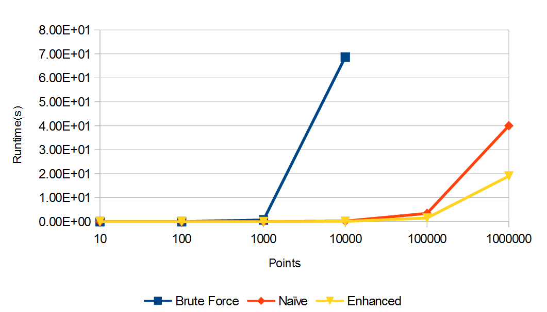
Discussion:

It doesn't pop out as much with our dataset, but the brute force algorithm is on track with exponential growth. Runtime multiplying by about 100 when we multiply the dataset by 10. This is expected. The bruteforce algorithm runs in two for loops checking every possible permutation of points, thus generating exponential growth.
More interesting to us are the recursive approaches to the problem. As expected, our naive and enhanced sort are able to skip a lot of irrelevant points and save a lot of time. This becomes very apparent once we reach >1000 points. At this point the number of possible permutations vastly exceeds the number of interesting connections. The linear aspect of our complexity eventually forces the runtime up as well but vastly outperforms the brute force approach. In the enhanced approach, with the missing O(n*log(n)) from not sorting our points we have roughly doubled the performance. This isn't as apparent in the Asymptotic analysis as we ignore constants but comes to shine in the simulations.

