ST10443512
SELEPE
SAMSON
MAKWELA
GROUP3
Ice Task 1 and 2
INSY6112 1B EXAM
30/07/2025

Question 1
Why use azure blob storage:
Azure Table Storage is a type of NoSQL storage that’s really good for storing large amounts of structured data without needing the complexity of a full database.

Benefits of Table Storage:
- It is quick and expandable, allowing it to manage large volumes of data.

- It’s inexpensive, particularly when compared to SQL databases or Cosmos DB.

- It's schema-free, indicating that each entry can contain different attributes, which is useful if your data is not consistently uniform.

- It utilizes PartitionKey and RowKey to ensure searches are fast and effective.

When to use Table Storage:
- IoT Data: Like temperature and humidity from sensors coming in constantly.

- User Settings: Storing simple settings like theme preferences or notification choices.

- Basic metadata: Such as tracking file uploads or user activity.
- Azure Queue Storage is used when different parts of an app need to talk to each other asynchronously—basically, when they don’t have to respond right away.
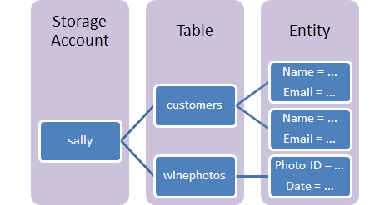

Question 2

Azure Queue Storage is used when different parts of an app need to talk to each other asynchronously—basically, when they don’t have to respond right away.
Good Scenarios for Queue Storage:
- Task Scheduling: For example, if someone uploads a photo, it can be processed later in the background.

- Order Processing: Online orders get queued and processed one at a time.

- Decoupling systems: Front-end and back-end don’t have to work at the same pace.

- Load balancing: When multiple workers are managing tasks, the queue ensures everything remains orderly.

- Blob Storage is likely the most popular Azure storage solution—it’s utilized for storing large amounts of unstructured data such as files, images, and videos.

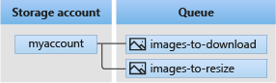

Question 3

Blob Storage is probably the most common Azure storage service—it’s used for storing big chunks of unstructured data like files, images, and videos.
Typical Applications:
- Media files: Storing and transmitting pictures, films, or sound.

- Backups: Keeping copies for databases, applications, or even complete systems.

- Files: Uploading PDFs, Excel documents, and additional formats

- Big Data: Used with Azure Data Lake for analytics.

- Static websites: You can even host a simple HTML website using Blob Storage.



