CLDV 6212
ST10443512
SELEPE SAMSON MAKWELA
GROUP 3
POE PART2
Contents
B’ 1
Github link 2
References: 2
Azure Account Storages 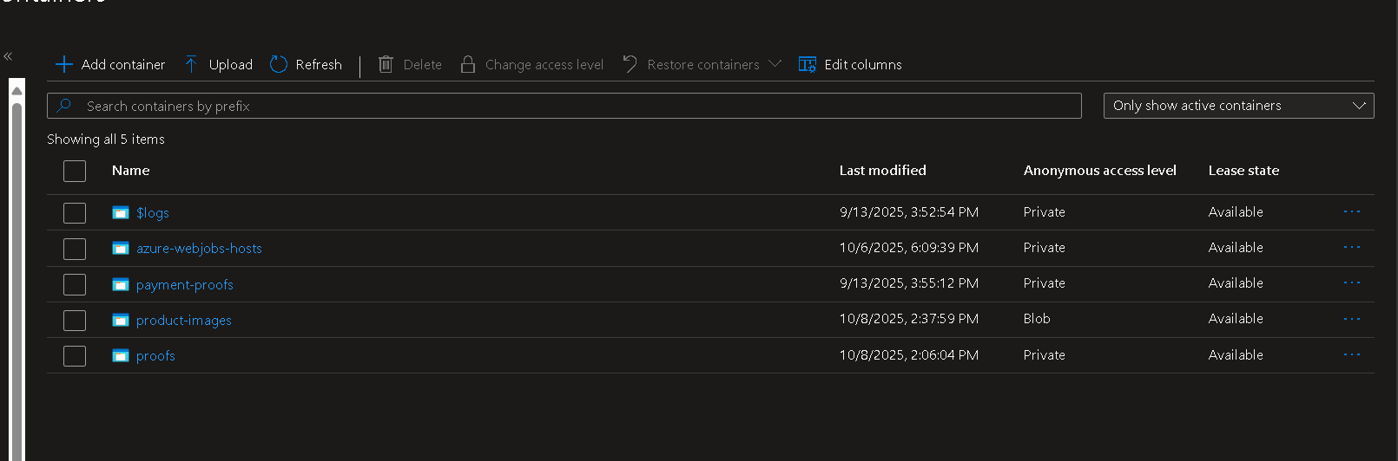 3
Views 4
YouTube Link 4

B’
Event Hubs on Azure
Azure Event Hubs facilitates real-time data collection and processing from various application components. It can, for instance, monitor how users interact with the app, including what they view and purchase. Later on, this data can be utilised to provide quicker notifications or recommendations. It enhances the functionality of the app and provides a more seamless and customised experience for consumers.
Event Hub on Azure
Interaction between various system components is made possible by Azure Event Bus. Even in the event that a portion of the system is unavailable, it ensures that alerts or updates are sent out. Users benefit from reduced wait times or fewer mistakes when using the program, for as when making purchases or getting confirmations. It increases the consistency and dependability of the application.

Github link
https://github.com/Makwela-Selepe/ST10443512-CLDV6212-POEPART-2-3.git

References:
Microsoft Learn. (2024). What is Azure Event Hubs?
Retrieved from: https://learn.microsoft.com/en-us/azure/event-hubs/event-hubs-about
Microsoft Learn. (2024). What is Azure Service Bus?
Retrieved from: https://learn.microsoft.com/en-us/azure/service-bus-messaging/service-bus-messaging-overview
Microsoft Azure Documentation. (2023). Event-driven architecture in Azure.
Retrieved from: https://learn.microsoft.com/en-us/azure/architecture/guide/architecture-styles/event-driven

Azure Account Storages
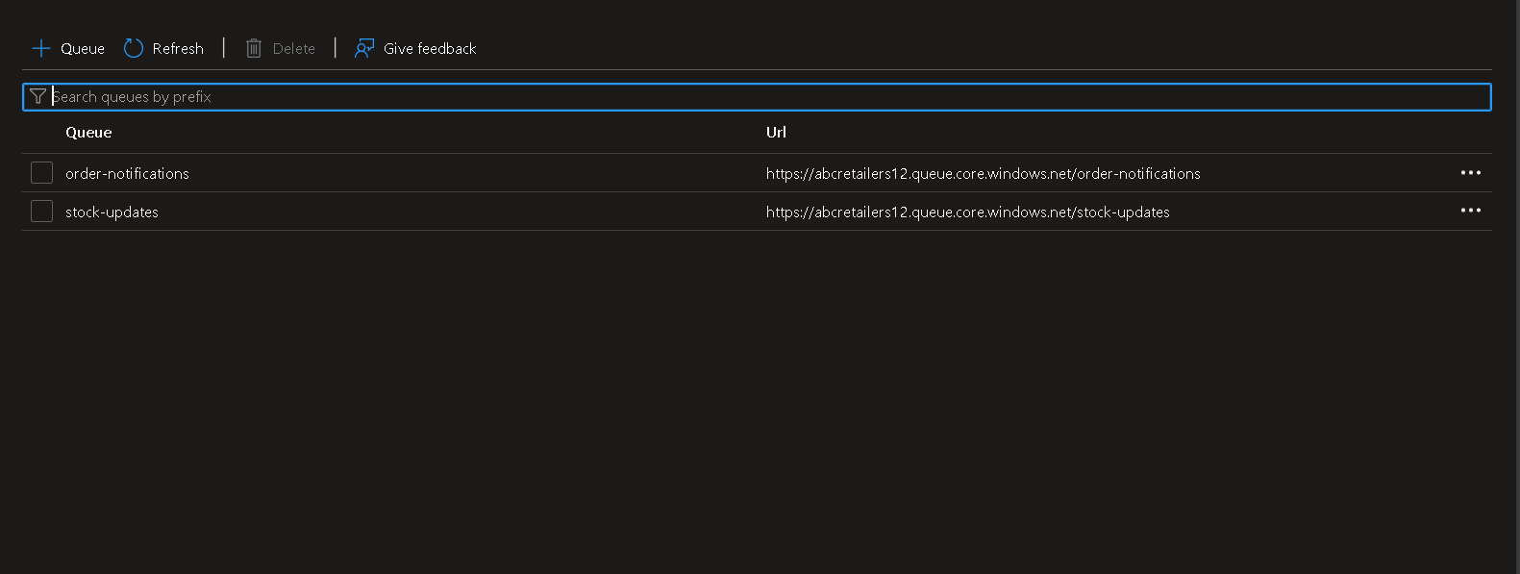
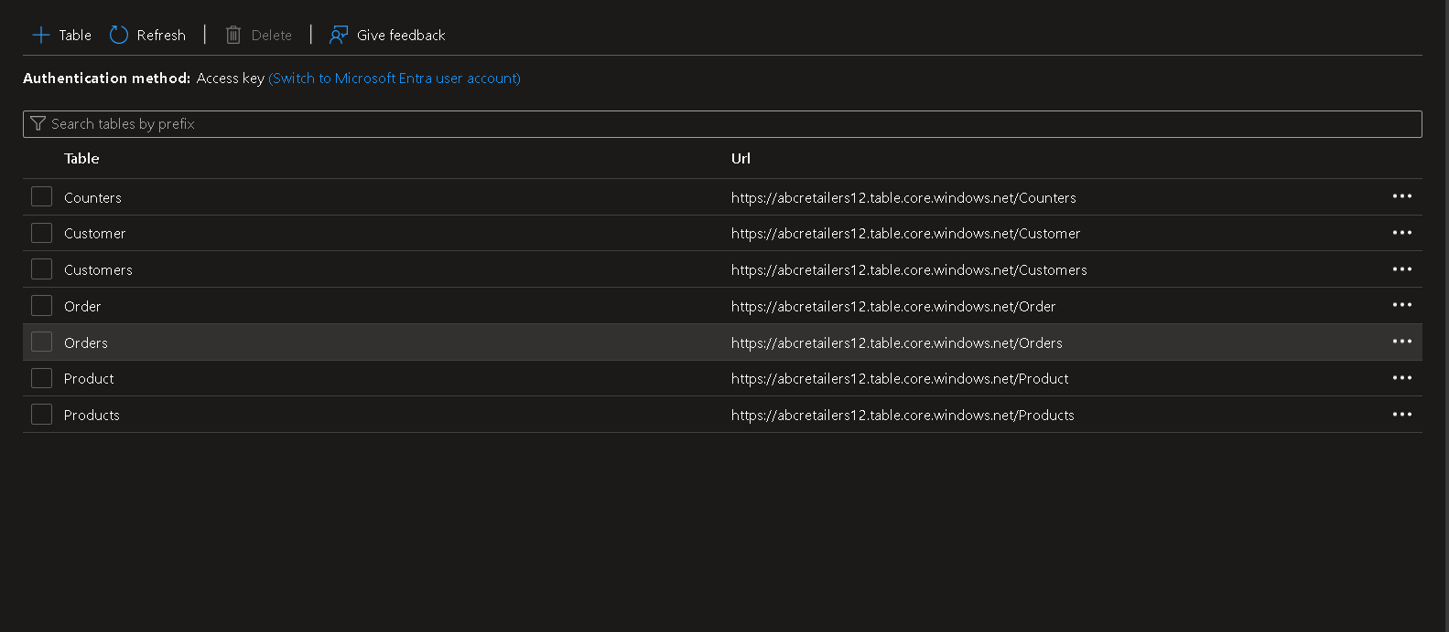

Views
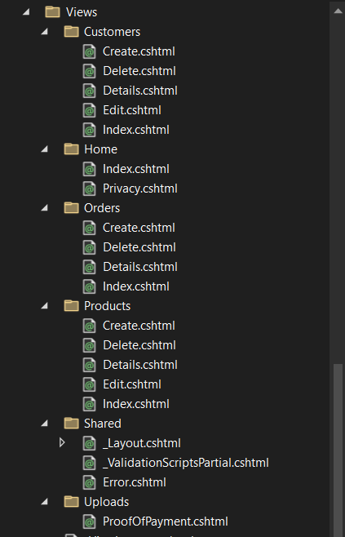

Functions
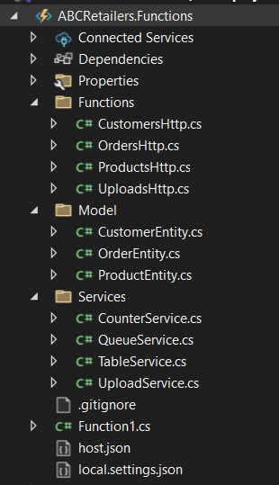

YouTube Link
https://youtu.be/x-cGx7cEjBQ

