samsonselepe9@gmail.com

Name:Selepe Samson Makwela
CVLDV6212 GROUP3 ST10443512

Contents
A. Azure SQL database and replica 2
A.1 Main Azure SQL database 2
A.2 Replica in another region and motivation 7
B. Technology choices table 9
C. Motivation of Azure Services per application requirement 9
Requirement 1 – Store customer, product and order information centrally 10
Requirement 2 – Host the web app on the internet with minimal maintenance 10
Requirement 3 – Store and serve product images and uploaded payment proofs 10
Requirement 4 – Handle customer shopping cart and checkout 10
Requirement 5 – Secure access for admins vs customers 10
Requirement 6 – Monitoring and troubleshooting in production 11
D. Alternative Azure technologies 11
Alternative 1 – Data layer: Azure Cosmos DB instead of Azure SQL 11
Alternative 2 – Hosting: Azure Virtual Machines or Azure Kubernetes Service 11
Alternative 3 – File storage: Azure Files or SharePoint Online 12
Alternative 4 – Authentication: Azure AD B2C instead of custom user table 12
Screenshots 13
Links: 19
Referrences: 19

A. Azure SQL database and replica

A.1 Main Azure SQL database
For the ABCRetailers web application I created an Azure SQL Database as the central data store.
The database lives on an Azure SQL logical server in the same region as my web app to reduce latency.
High–level creation steps:
- In the Azure portal I clicked Create resource → Azure SQL → SQL database. 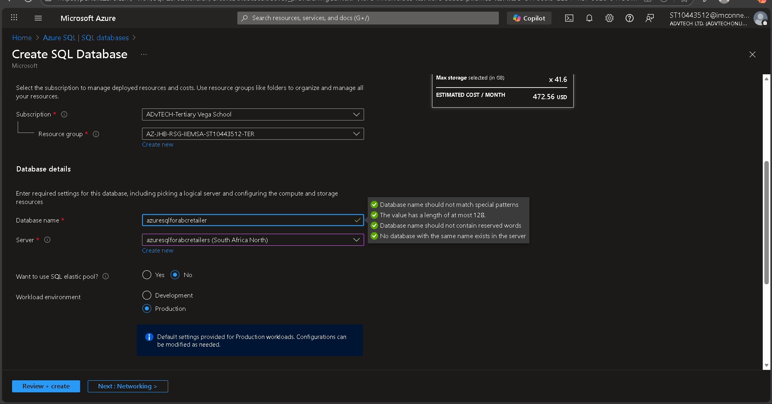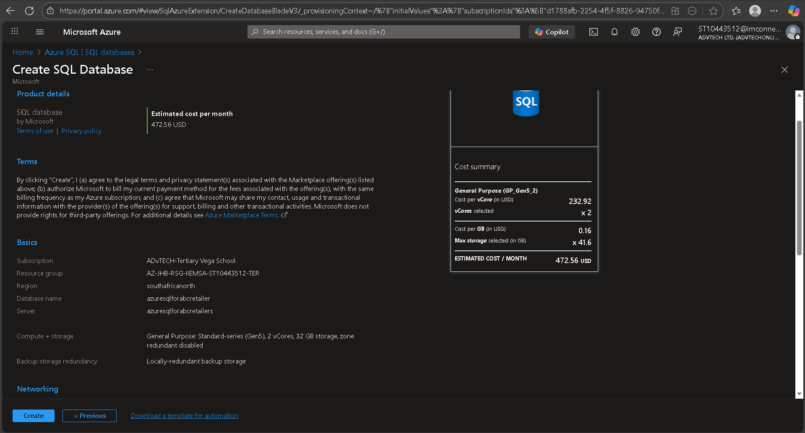
- I created a new logical server, set the admin login and chose the same region as my App Service. 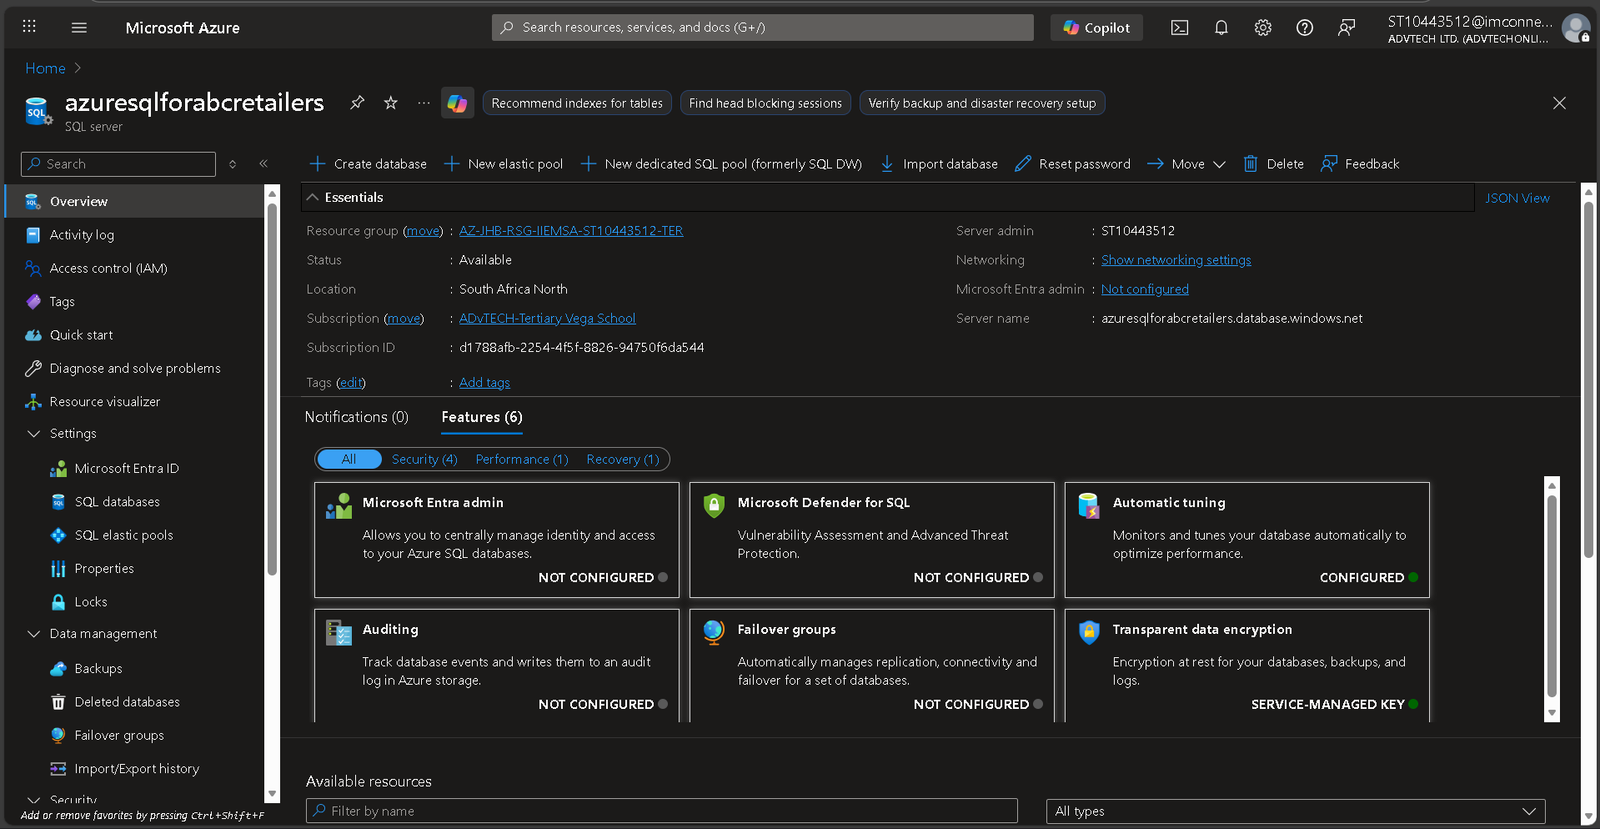
- After deployment finished I used the Query editor (preview) to create my tables. 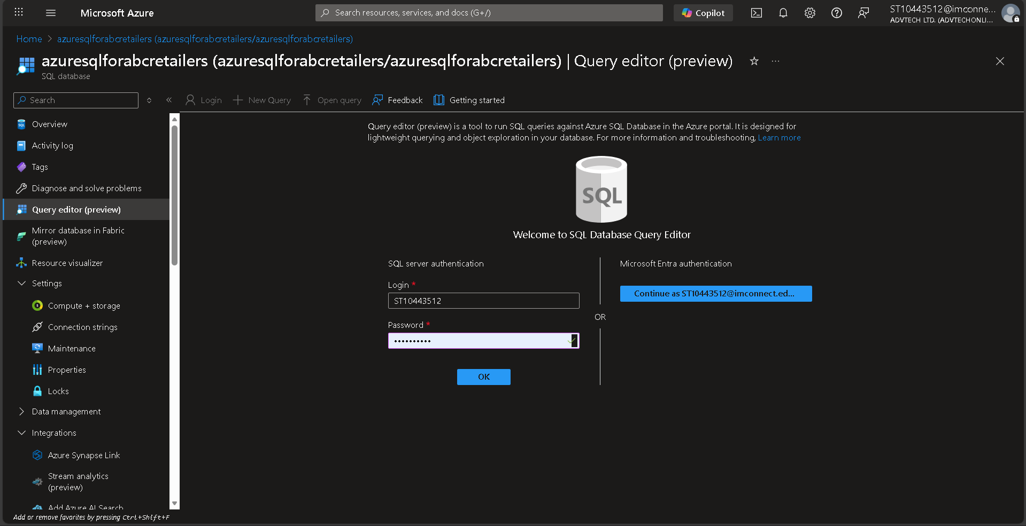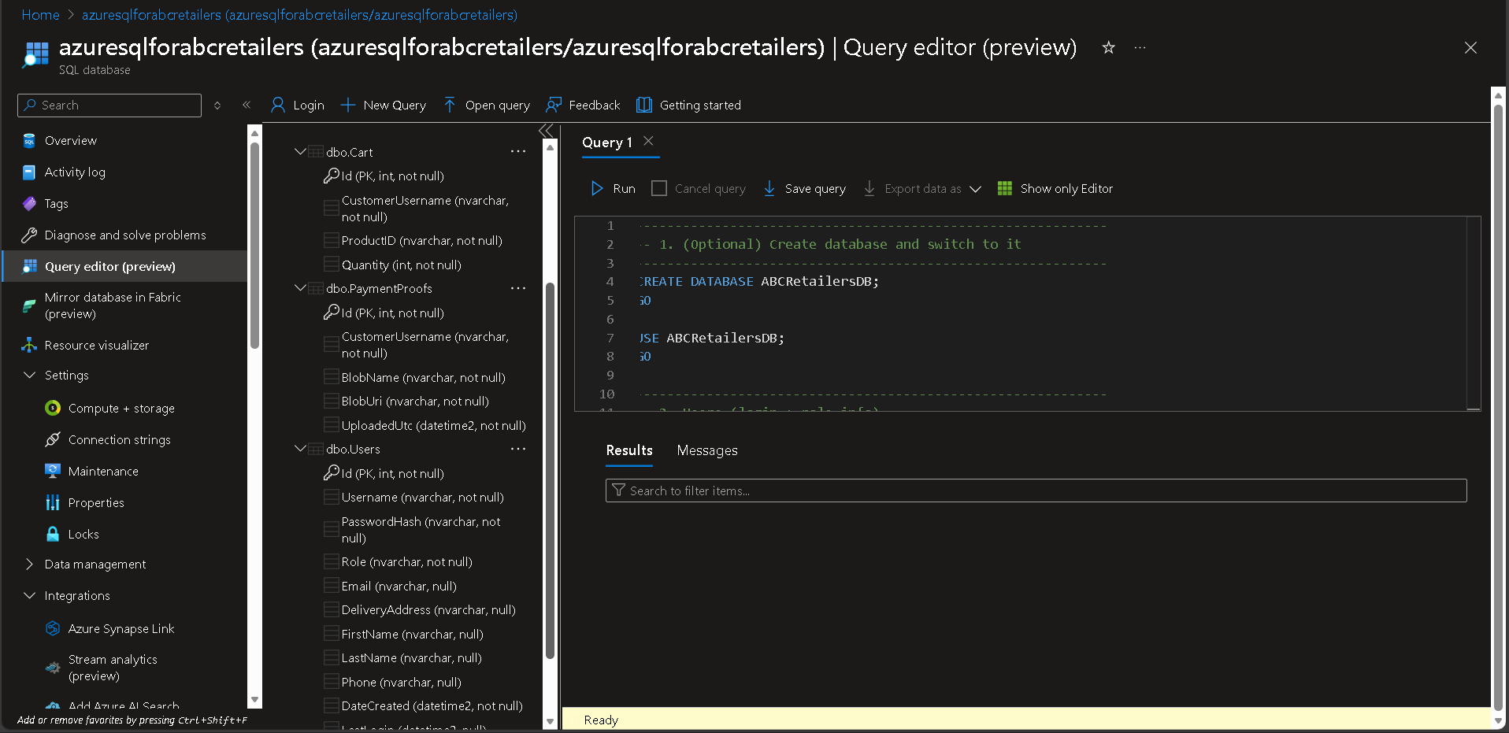
In the database I created three core tables that match the application entities:
- Customers
  - CustomerId (PK, INT IDENTITY)
  - Username (NVARCHAR(100))
  - FirstName, LastName
  - Email, Phone
  - DeliveryAddress
  - DateCreated, LastLogin
- Products
  - ProductId (PK, INT IDENTITY)
  - Name (NVARCHAR(200))
  - Description (NVARCHAR(MAX))
  - Price (DECIMAL(18,2))
  - StockQuantity (INT)
  - ImageUrl (NVARCHAR(500))
- Orders
  - OrderId (PK, INT IDENTITY)
  - CustomerId (FK → Customers)
  - OrderDate (DATETIME2)
  - Status (Pending / Processed / Shipped / Delivered)
  - TotalAmount (DECIMAL(18,2))
- OrderLines (for each item in the cart)
  - OrderLineId (PK, INT IDENTITY)
  - OrderId (FK → Orders)
  - ProductId (FK → Products)
  - Quantity (INT)
  - UnitPrice (DECIMAL(18,2))
This structure lets me run SQL queries to analyse sales per customer, product performance, etc. It’s also much easier for reporting than just using table storage.
Screenshots to include here:
– SQL database creation blade
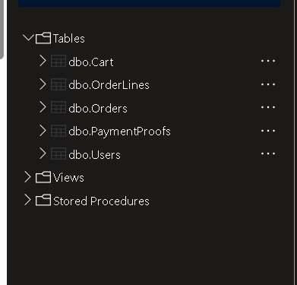
– 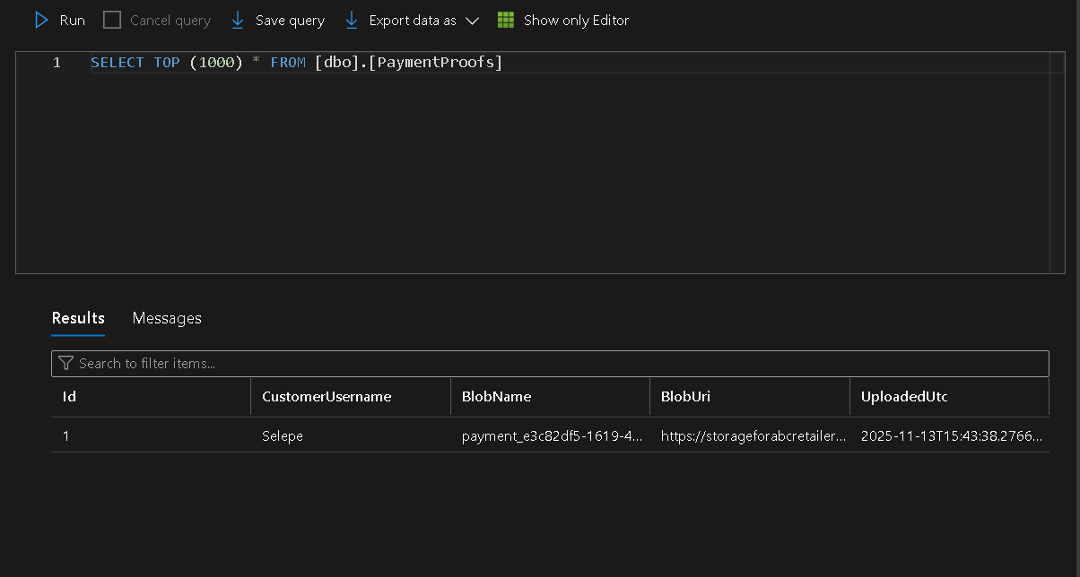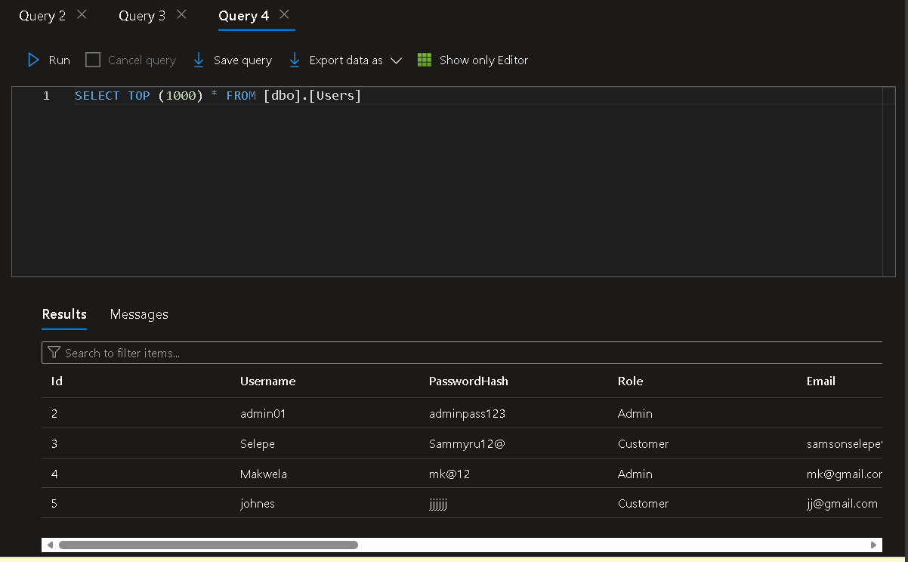

A.2 Replica in another region and motivation
To meet the requirement for a replica in a different region, I enabled active geo-replication for the Azure SQL database: 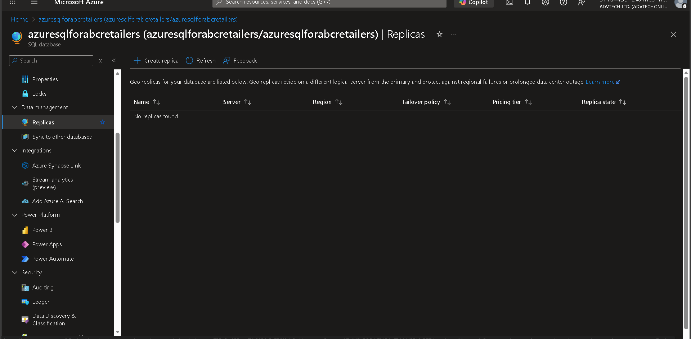
- On the SQL database Geo-replication blade I selected a second region (for example West Europe while the primary is in South Africa North).
- I created a secondary read-only database in that region. Azure automatically keeps it in sync with the primary using asynchronous replication.
Motivation – why a replica is necessary:
• Reliable uptime / emergency recovery
If the main region experiences an outage (such as a significant power failure or network issue), the replica in a different region can be switched over to become the new primary. This implies that the ABCRetailers site can be activated without the need for manual backup restoration.
• Safeguarding against data loss
Since the secondary is constantly synced, the risk of losing recent orders is significantly reduced compared to performing only nightly backups. If something goes seriously wrong in the main database, I can switch over or even utilize the secondary for restoration purposes.
• Adherence and operational continuity
For an online retail site, being entirely offline due to a local problem can result in lost clients and credibility. Possessing a duplicate allows me to adhere to fundamental business continuity practices, despite my system being relatively small.
• Analytics for read-only access (future application)
The secondary might later serve for reporting queries without burdening the primary transactional database. For instance, monthly sales reports could be processed on the replica to avoid hindering actual customers from placing orders.
Screenshots to include here:
– Geo-replication diagram showing Primary + Secondary
– Properties of the secondary database.

B. Technology choices table
Below is a table that documents the main Azure components, what type of service it is, and the hosting model.
Component / feature in app | Azure service used | Technology choice (compute / data / storage etc.) | Hosting model (PaaS / SaaS / other)
Public web front-end for ABCRetailers (MVC app) | Azure App Service – Web App for .NET | Compute platform to host ASP.NET Core MVC web application | PaaS
Admin dashboard and customer portal | Same Azure App Service instance | Same compute, just different controllers / views | PaaS
Relational data (customers, products, orders) | Azure SQL Database | Relational data storage and transactional processing | PaaS (Database-as-a-Service)
Product images & payment proof documents | Azure Blob Storage | Unstructured object storage for images and PDF uploads | PaaS
Background processing (eg. sending order emails*) | Azure Functions (HTTP / queue triggered) | Serverless compute for small background jobs | Serverless / Functions-as-a-Service
Application state / cart session (optional) | Azure Cache for Redis (planned) | In-memory cache for fast lookup of cart data | PaaS
Authentication + roles (Admin / Customer) | Custom user table in Azure SQL for now | Data + simple logic inside the app | PaaS DB + custom code
Monitoring and logs | Application Insights + App Service logs | Telemetry, request tracing, exceptions | PaaS
Static website assets (css, js) | Served from App Service | Files bundled with the web app | PaaS
*If you didn’t actually wire Functions yet you can say “planned / partially implemented” in your final doc.
This table covers the components required by the rubric: database, hosting, and other Azure services used in the solution.

C. Motivation of Azure Services per application requirement
Below I list six concrete application requirements and explain which Azure service I used and why it fits. The explanations are detailed but not overly academic, like how I would actually write it.

Requirement 1 – Store customer, product and order information centrally
- Service used: Azure SQL Database
- Why it fits:
The application needs structured data with relationships (a customer has several orders, an order contains many order lines). Azure SQL is a fully managed relational database, enabling me to define these relationships using foreign keys and run SQL queries to link tables. It also supports transactions, guaranteeing that when a customer places an order, both the Order and the OrderLines are either saved together or rolled back

Requirement 2 – Host the web app on the internet with minimal maintenance
- Service used: Azure App Service – Web App for .NET
- Why it fits:
The college project lacks a specific operations team, so I prefer not to handle Windows or Linux VMs on my own. Using App Service, I simply deploy my built ASP.NET Core application, and Azure manages the operating system, updates, IIS, scaling, and more.
It natively integrates with GitHub / Visual Studio publish, simplifying my deployment pipeline significantly.
Expanding resources (additional CPU/RAM) or adding instances is also a slider, making it simpler to manage increased traffic later than having to set up new servers.

Requirement 3 – Store and serve product images and uploaded payment proofs
- Service used: Azure Blob Storage (container product-images and proof-of-payments)
- Why it fits:
Images and documents are binary files and can become quite large. Putting them inside the SQL database would increase size and costs. Azure Blob Storage is designed for cheap, durable object storage.
Each upload returns a Blob URI which I save inside SQL, so the web app can quickly render <img> tags or links.
Blob storage also handles replication and redundancy, so even if a storage node fails, the files remain available. This would be much harder to implement myself.

Requirement 4 – Handle customer shopping cart and checkout
- Service used: Combination of ASP.NET session (in App Service) + Azure SQL Orders table
- Why it fits:
During browsing, the cart state can live in session and in the CartController. When the user clicks Checkout, the cart is converted into an Order + OrderLines stored in Azure SQL.
Using the same database as other entities means I can easily query all orders per customer and update order status from the Admin side. The transactional support also guarantees that all order lines are saved together.

Requirement 5 – Secure access for admins vs customers
- Service used: Custom authentication + role claims stored in Azure SQL (User table) and enforced in App Service app.
- Why it fits:
For this project I implemented a simple login system with users stored in the Users table. Roles (“Admin” / “Customer”) are stored there as well and mapped to ASP.NET Core Identity style claims.
Because the data is in Azure SQL, user accounts are centralised and consistent across all instances of the web app. App Service itself supports HTTPS and TLS termination, so credentials are encrypted in transit.

Requirement 6 – Monitoring and troubleshooting in production
- Service used: Application Insights + App Service diagnostics
- Why it fits:
When the site is deployed to Azure App Service, I enabled Application Insights. This collects request traces, response times, exceptions and dependency calls (like SQL).
It helps me see if a particular page is slow or if my Azure SQL database starts returning errors. For a production web app this level of visibility is essential, even if my project is relatively small.

D. Alternative Azure technologies
Here I identify four requirements and propose viable alternative Azure services, plus why they could also work. This shows that I understand there are different options, not just one “correct” design.

Alternative 1 – Data layer: Azure Cosmos DB instead of Azure SQL
- Original requirement: Store customer, product and order information.
- Original service: Azure SQL Database.
- Alternative service: Azure Cosmos DB (Core / SQL API)
- Motivation:
Cosmos DB is a globally distributed NoSQL database. For a very high-scale e-commerce solution, Cosmos would offer automatic partitioning and low-latency reads in multiple regions.
Documents could store order and order lines together which simplifies some reads.
However, for this particular project the relational structure and the cost of Cosmos DB might be over-kill, so Azure SQL still makes more sense, but Cosmos is a valid alternative in theory.

Alternative 2 – Hosting: Azure Virtual Machines or Azure Kubernetes Service
- Original requirement: Host the ASP.NET Core web app online.
- Original service: Azure App Service.
- Alternative services: Azure Virtual Machines or Azure Kubernetes Service (AKS)
- Motivation:
A VM gives full control over the OS and environment. I could install any software, set up custom networking and even host other services on the same VM. For large enterprise environments that want more control, or need special network appliances, this can be useful.
AKS would be the choice if ABCRetailers was part of a micro-services architecture with multiple containers that need orchestration.
The trade-off is that both VM and AKS require more operations and configuration. For a student project and simple monolith web app, App Service is easier to manage.

Alternative 3 – File storage: Azure Files or SharePoint Online
- Original requirement: Store product images and payment proofs.
- Original service: Azure Blob Storage.
- Alternative service: Azure Files (file shares) or even SharePoint Online for documents.
- Motivation:
Azure Files exposes SMB file shares, which are useful if legacy applications or Windows services need to access the same files via drive letters. That could be helpful if an accounting desktop application also needed access to payment proof PDFs.
SharePoint Online (as part of Microsoft 365) could be used if the organisation wants end-users (e.g. finance staff) to access documents through a familiar web UI rather than through the custom ABCRetailers admin.
In the current design, Blob Storage is a bit simpler and cheaper, but these other options could work depending on business requirements.

Alternative 4 – Authentication: Azure AD B2C instead of custom user table
- Original requirement: Secure login for customers and admins.
- Original service: Custom user table in Azure SQL with code-based authentication.
- Alternative service: Azure Active Directory B2C (Entra External ID)
- Motivation:
Azure AD B2C is a hosted identity platform that supports sign-up / sign-in, password reset, multi-factor auth, social logins, etc. Using B2C would remove the need for me to store passwords at all and would also be more secure and scalable in the long run.
The downside is that the configuration is more complex and for a small POE project it might be a bit heavy. Also our marking rubric focuses more on the data and hosting parts, so I chose the simpler custom auth for now.

Screenshots
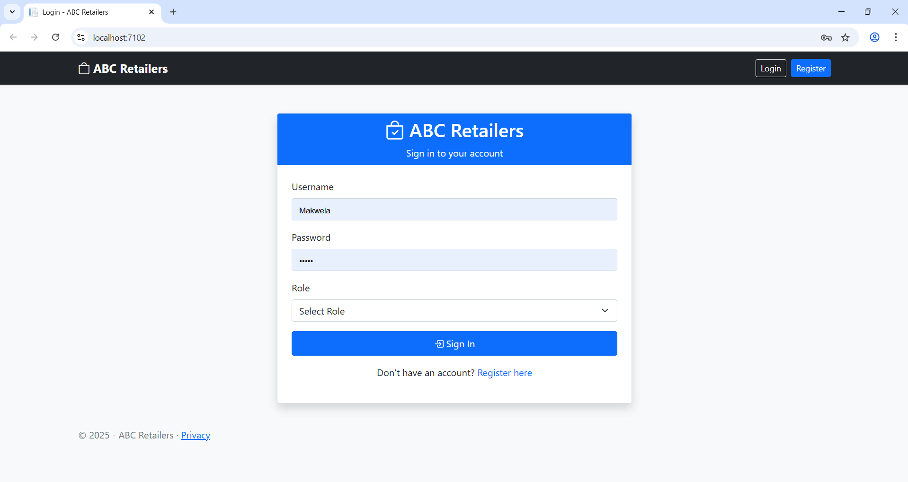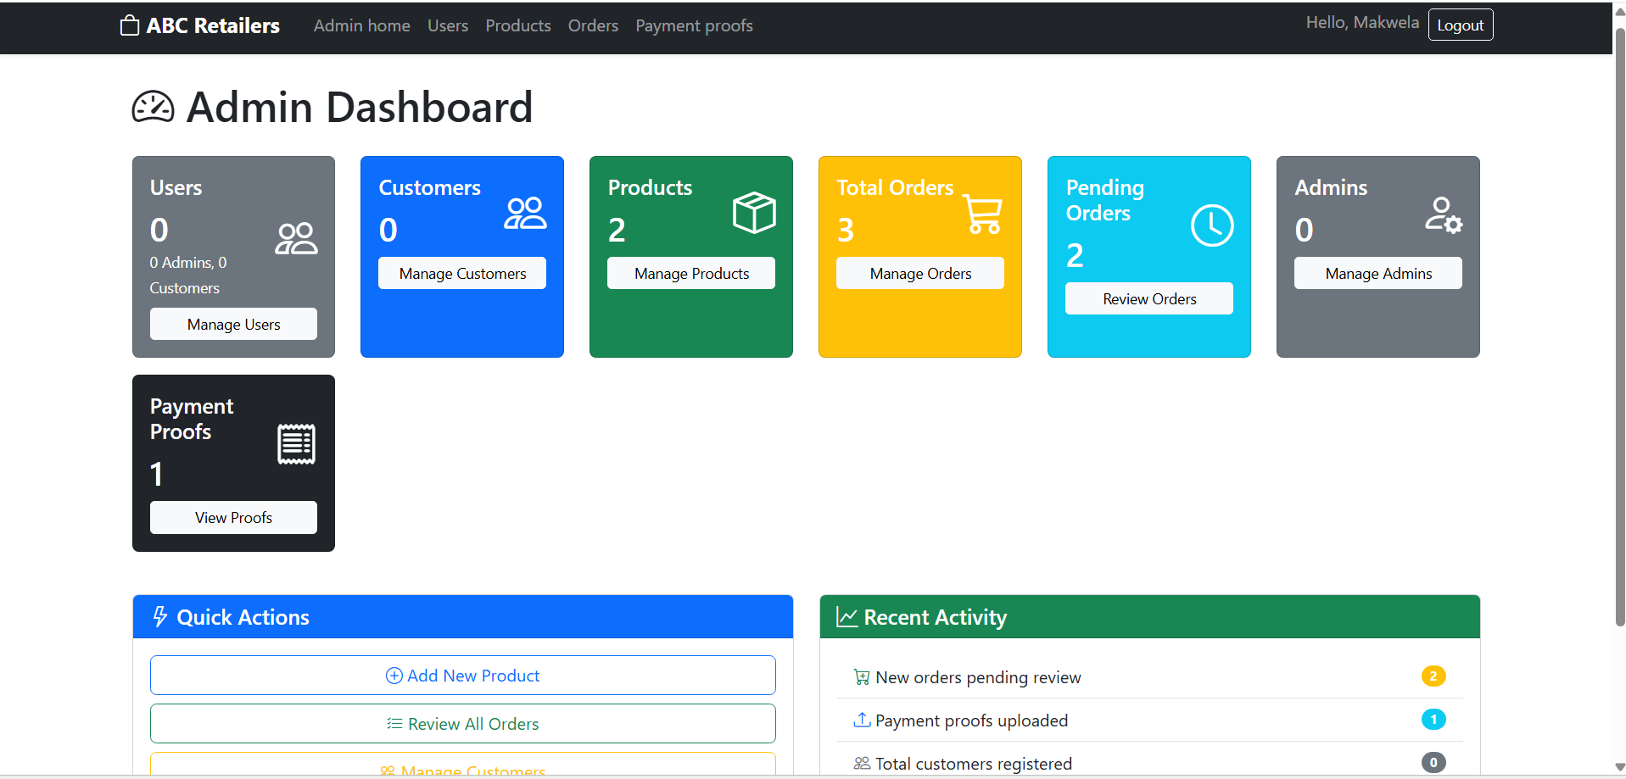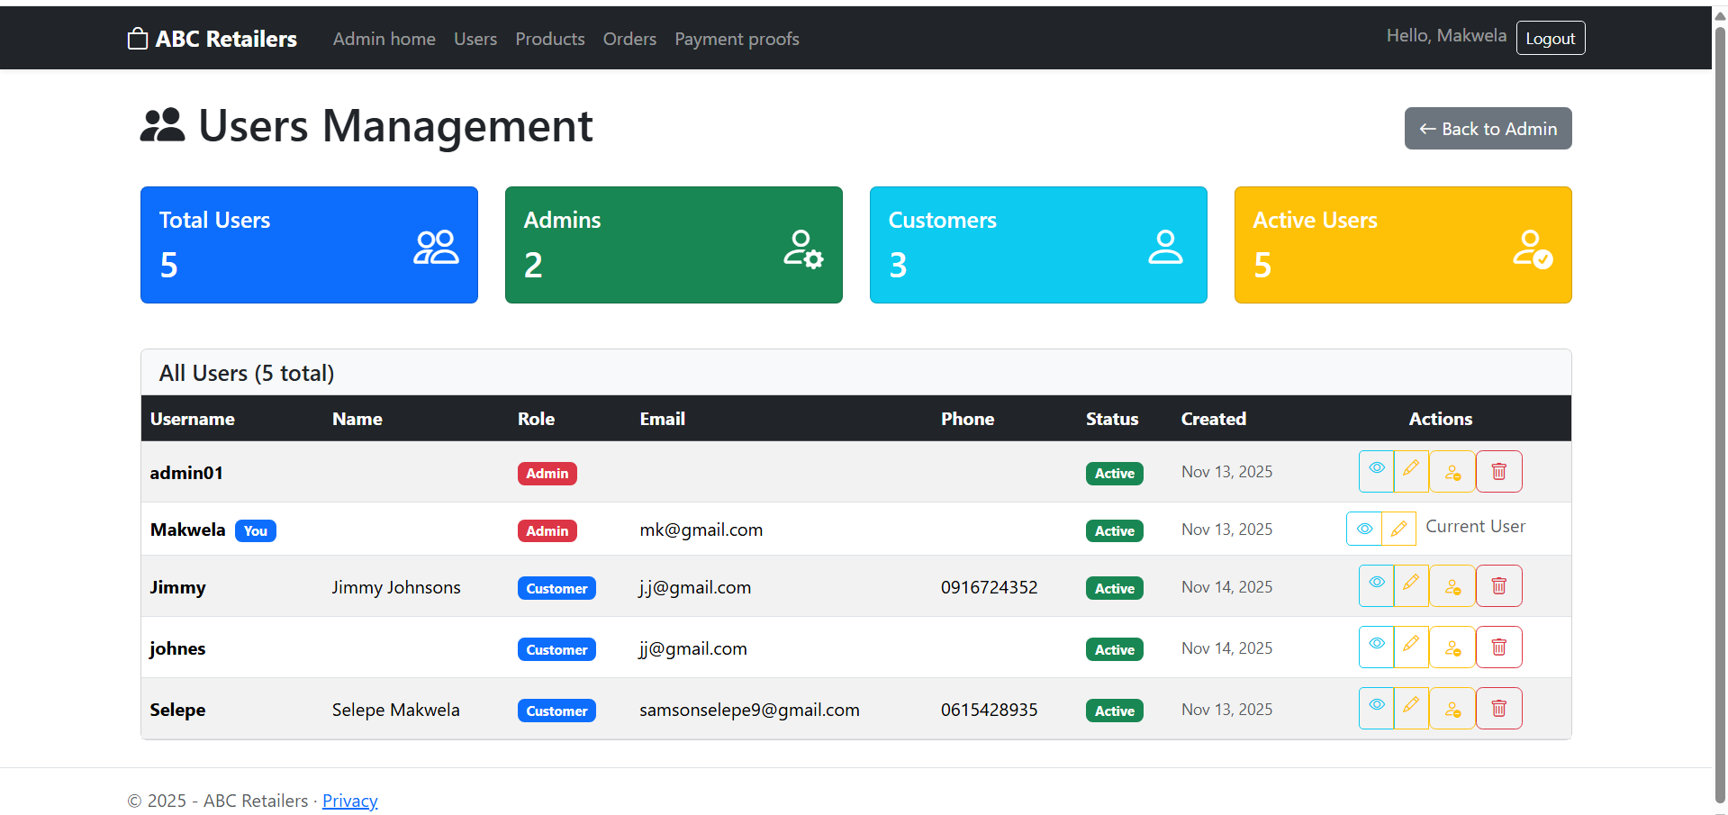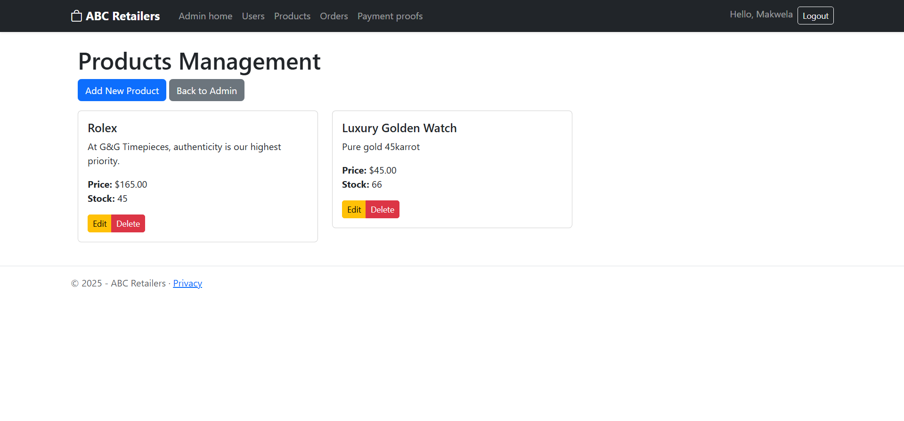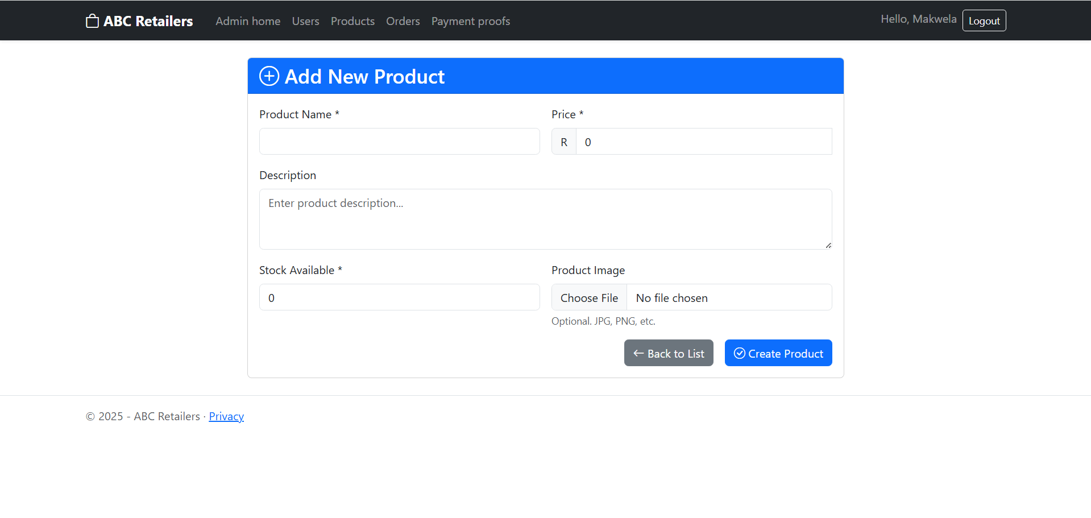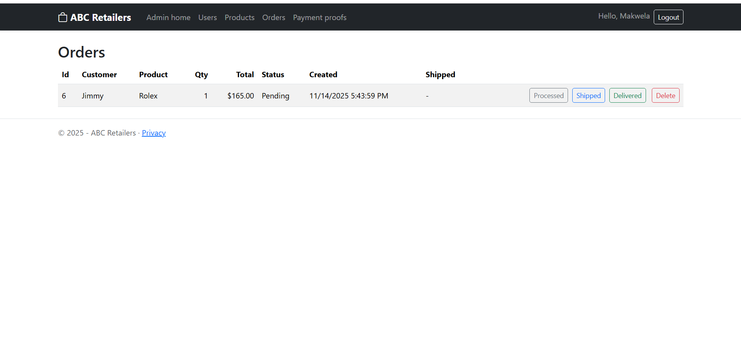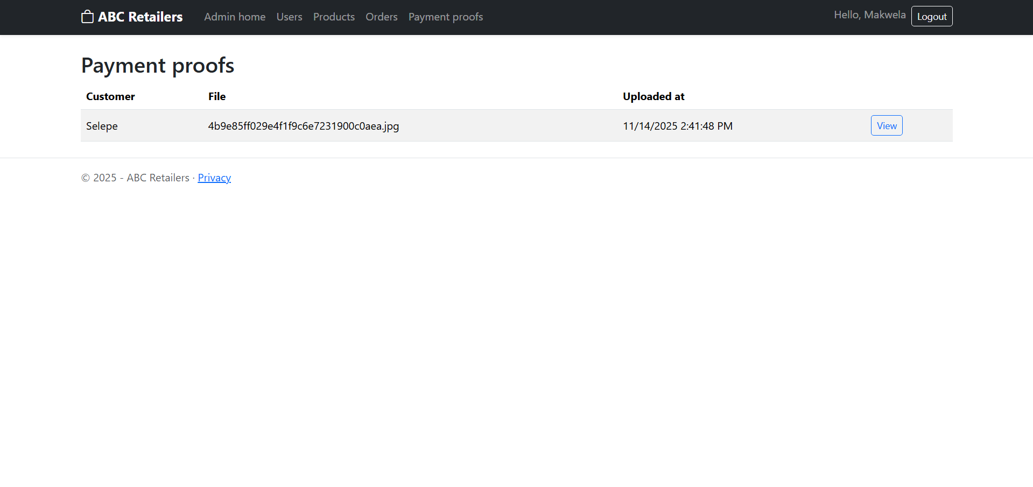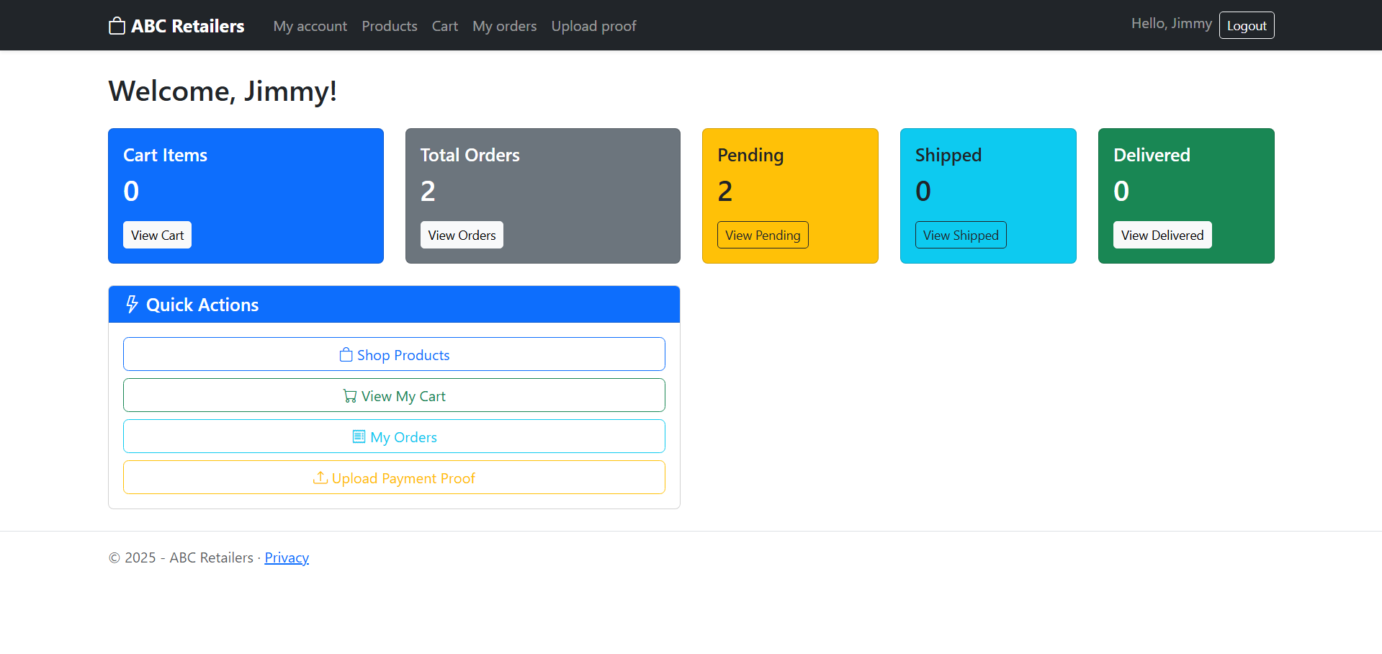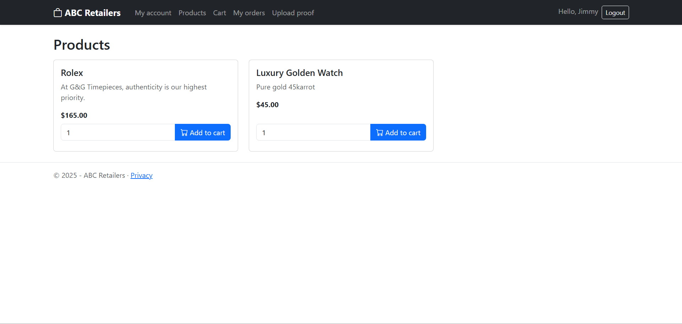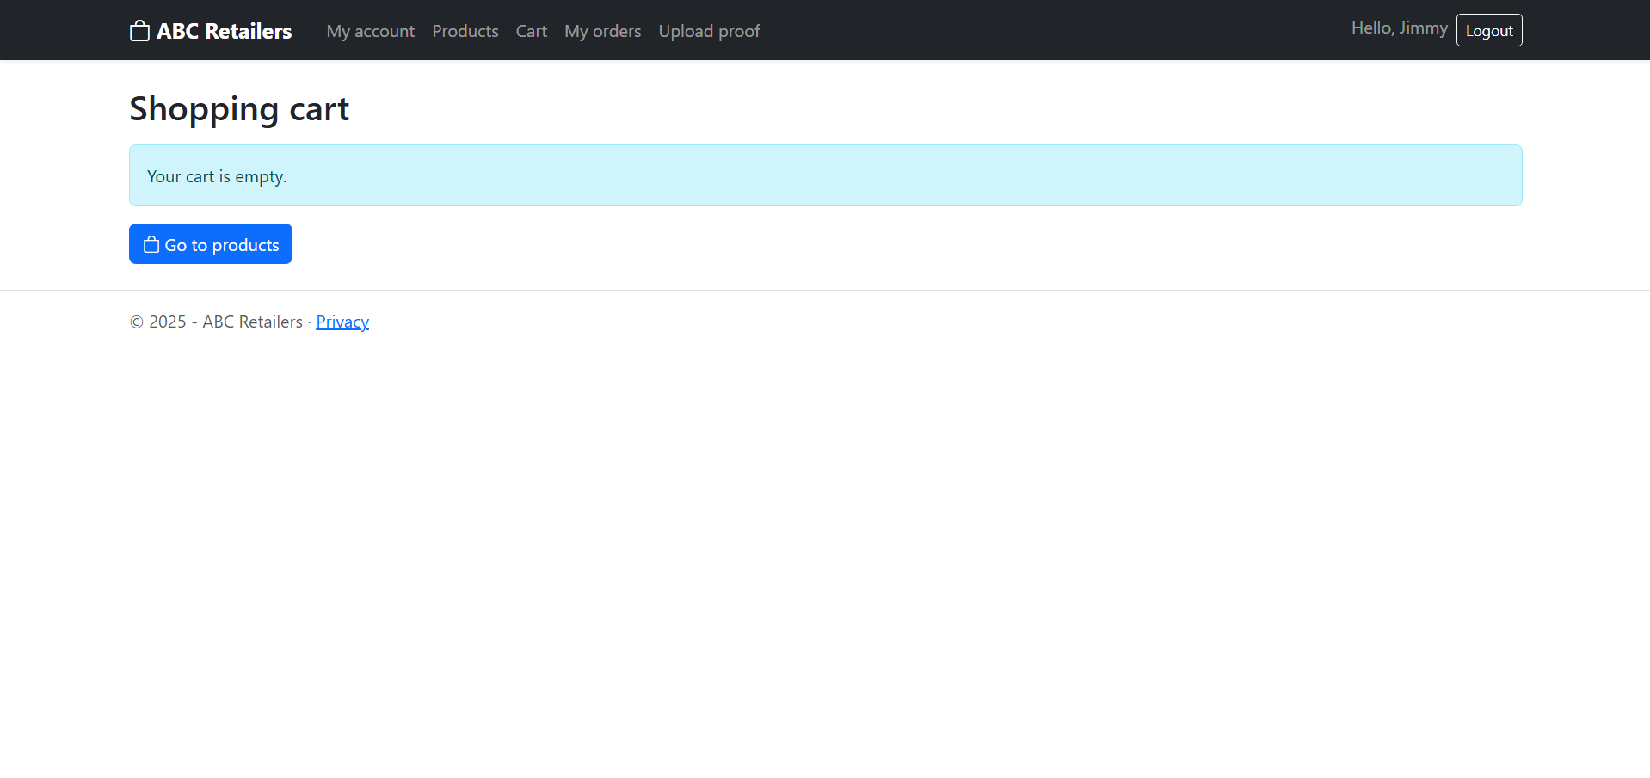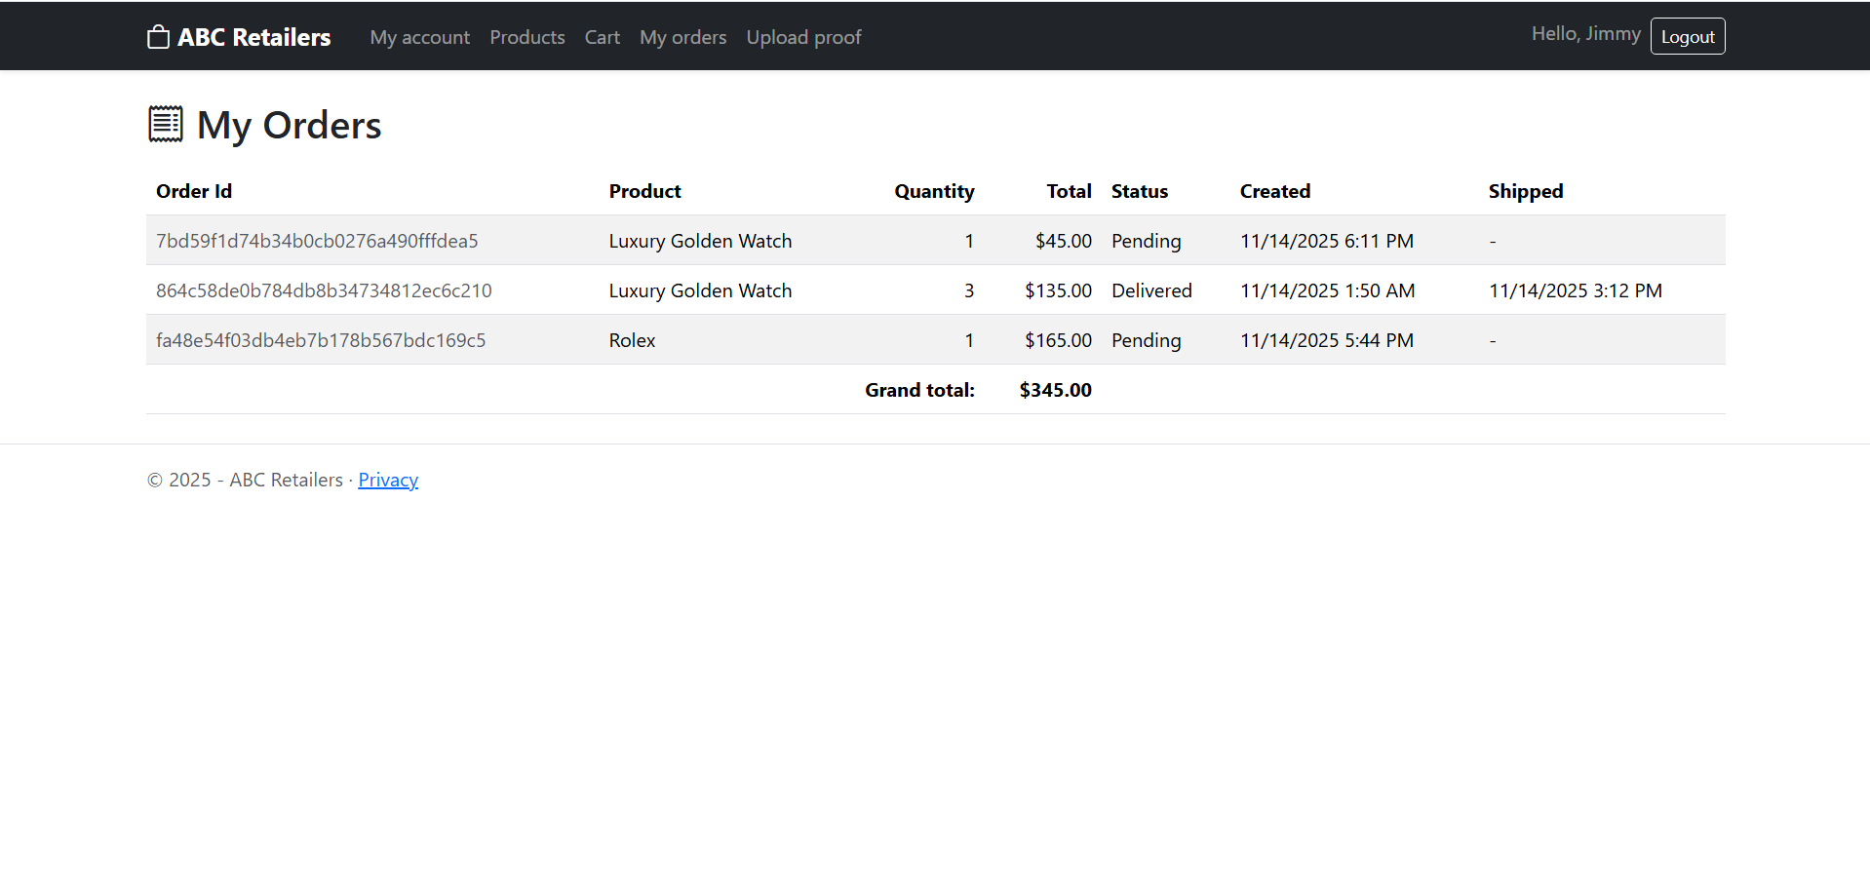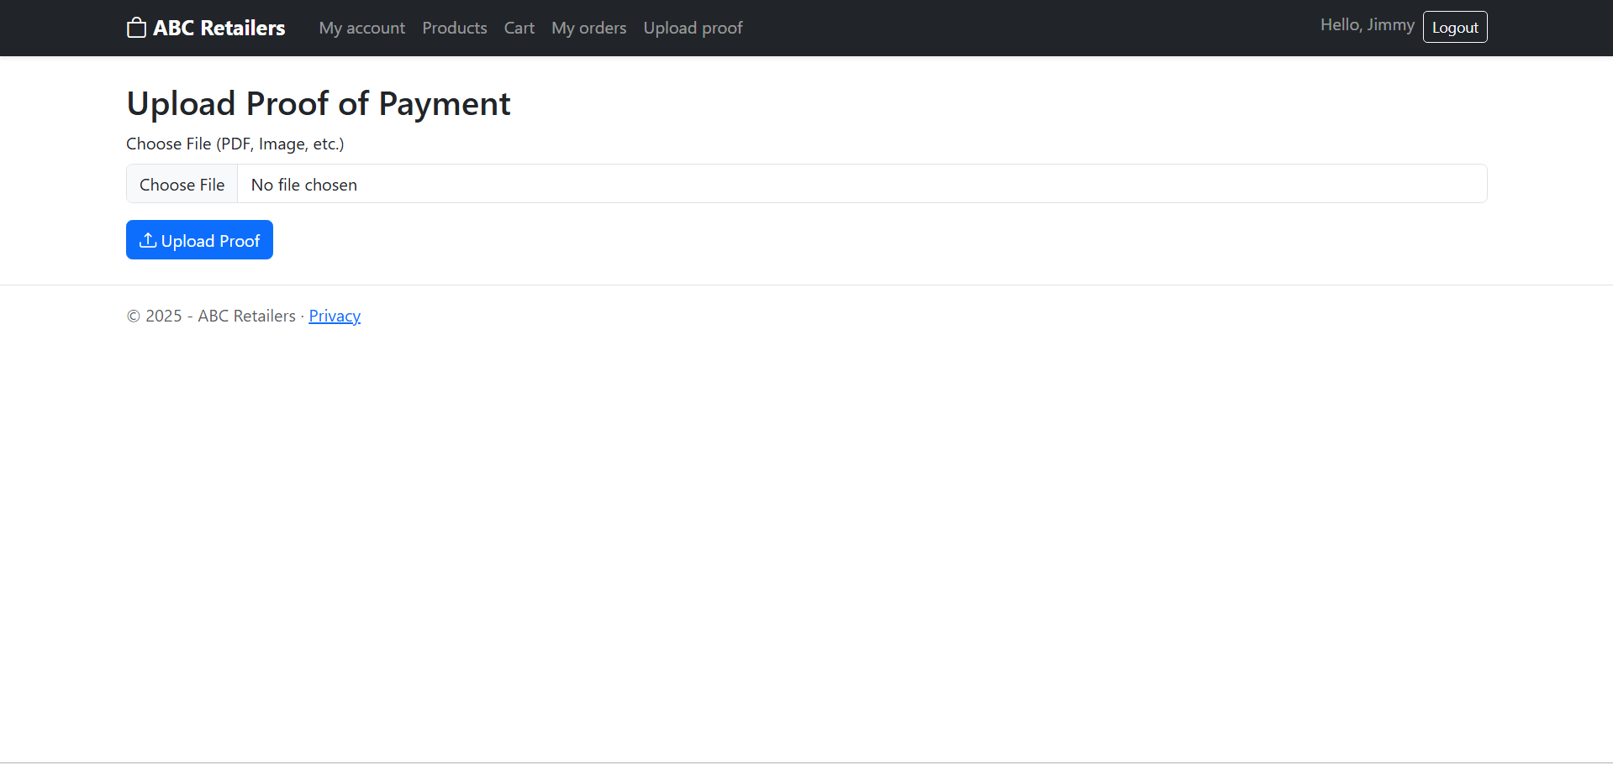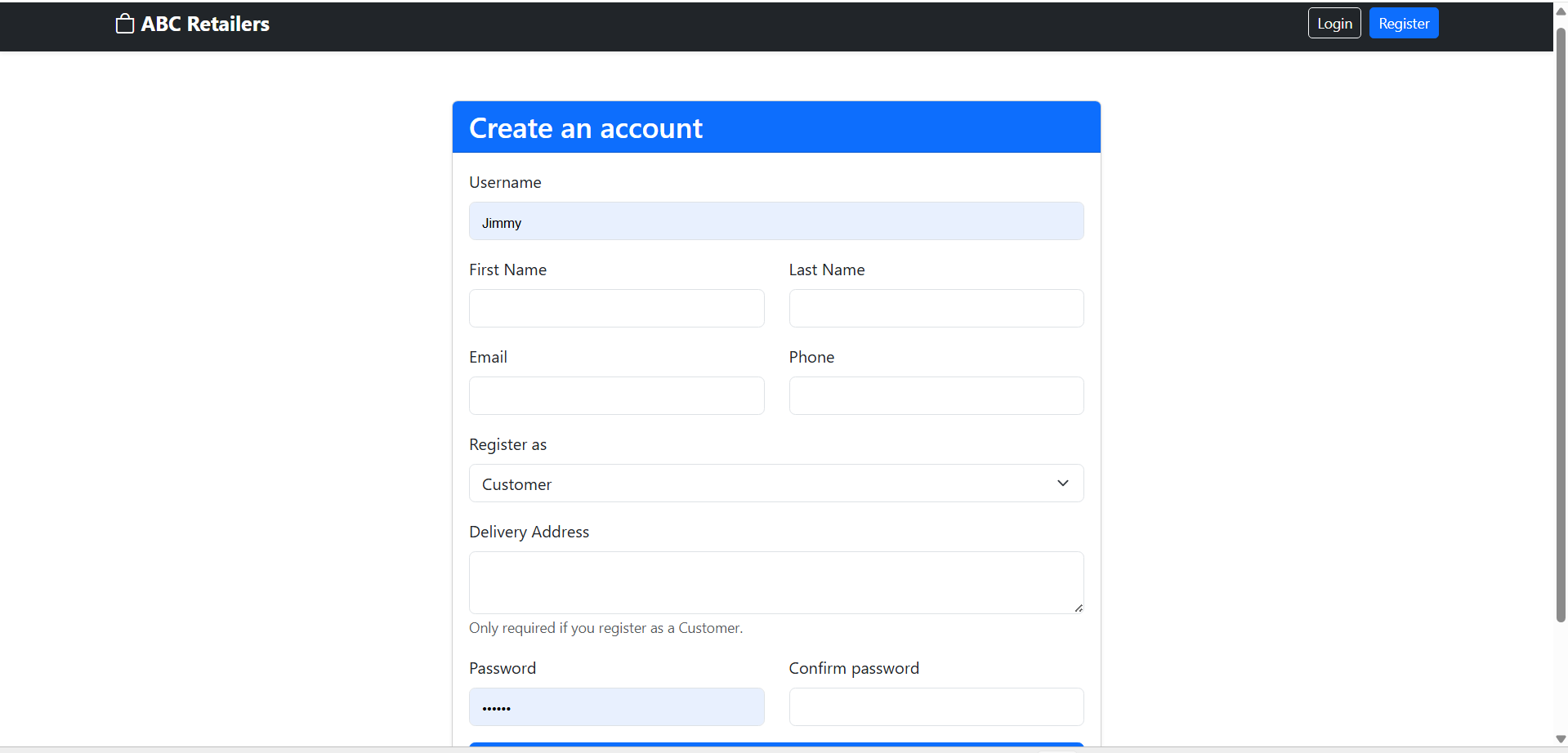

Links:
https://github.com/Makwela-Selepe/ST10443512-CLDV6212-POEPART-3.git
https://youtu.be/spCP-0SOcfM

Referrences:
rajeshsetlem (2025). Cloud Business Continuity - Disaster Recovery - Azure SQL Database. [online] Microsoft.com. Available at: https://learn.microsoft.com/en-us/azure/azure-sql/database/business-continuity-high-availability-disaster-recover-hadr-overview.
akashdubey-ms (2024). Introduction to Azure Storage - Cloud storage on Azure. [online] Microsoft.com. Available at: https://learn.microsoft.com/en-us/azure/storage/common/storage-introduction?utm_source=chatgpt.com.
‌Microsoft 2024, Azure Functions on Azure Container Apps, Microsoft Learn, viewed 14 November 2025,
https://learn.microsoft.com/en-us/azure/container-apps/workloads-dotnet-functions
Microsoft 2024, Use .NET with Azure SQL Database to build apps (developer documentation), Microsoft Learn, viewed 14 November 2025,
https://learn.microsoft.com/en-us/azure/azure-sql/database/samples-dotnet
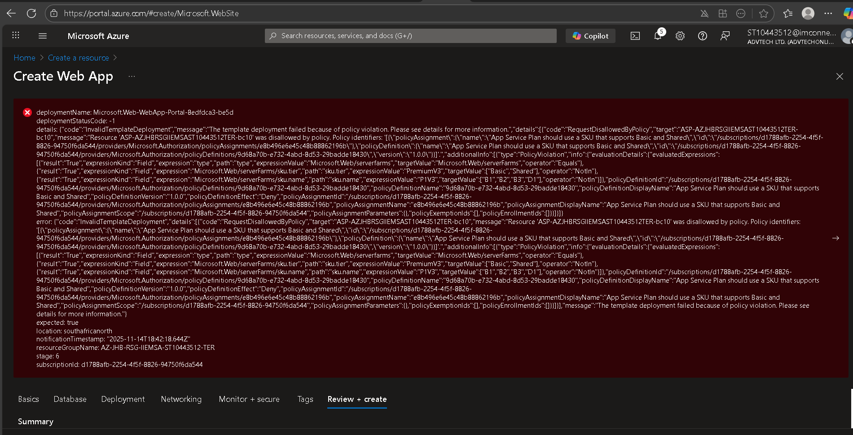
Doesn’t allow me to create a web app or functions api

