Britecore engineering application
documentation

Document type :
◻ draft
◻ to be validated
☑ validated

Purpose of the document

The purpose of this document is to describe the application supplied to the user and its functionalitites.

This document may not be reproduced or communicated without the author's prior agreement.

Contents

Purpose of the document 1
Document history 2
Distribution 2
Validation 2
1. Icons Used in the Manuel 4
2. Presentation of the Solution 4
2.1 Brief description 4
2.2 Descriptives Icons 4
2.3 Project players 4
2.4 Support 5
2.5 Referenced Documentation 5
2.6 History of the Solution 5
3. Connecting to the Application 6
3.1 Address 6
3.2 Authentication 6
4. Structuring of the Application 6
4.1 Layout 6
4.2 Menus 7
4.3 Icons / Shortcuts 7
4.4 Functionalities 7
4.4.1 Functionalities Presented/Described 7
4.4.2 Functionalities not Presented/not Described 7
5. Function XXX / Screen XXX 7
5.1 Screenshot 7
5.2 Descriptions of fields, content 8
5.3 Description of actions 8
5.4 Sequence of screens 8
6. Function XXX / Screen XXX 8
6.1 Screenshot 8
6.2 Descriptions of fields, content 8
6.3 Description of actions 8
6.4 Sequence of screens 9
7. Appendices 9
7.1 Appendix 1 9
7.2 Appendix 2 9

Presentation of the Solution

Brief description

This web application is a solution which allows insurers to define their own custom data for their risks. Application is developed with Django and Vue.js. Django is used for the backend, Vue.js is used for the frontend.

Project players

Players impacted by the solution are:
- Owner of the application
- Users of the application

Referenced Documentation

Documents that may be useful to the user in helping them understand how application-related modules work are:
- https://docs.djangoproject.com/en/2.1/ - Django framework official documentation
- https://vuejs.org/v2/guide/ - Vue.js framework official documentation

History of the Solution

The first part was creation of Entitity Relationship Diagram of the Database.
Then second part was creation of Use Cases which describe how application works.
The third part was Frontend development in Vue.js
The fourth part was Backend development in Django.
The final part was test and debugging.

Connecting to the Application

Running the application

To run the application you must open two Command Line Interfaces for both the Frontend and Backend. There will be two servers running simultaneously one for Backend and one for Frontend.

To run the Backend server you must write the following command in CLI after you find the location of application in your computer:
$ python manage.py runserver
To run the Frontend server you must write the following command in CLI after you find the correct location of Frontend directory in your application:
$ npm run dev

Authentication

Authentication is made with Django build in Authentication System.

Structuring of the Application

Functionalities

Functionalities Presented/Described

Functionalities presented in this document are:
- Creating a new user
- User authentication
- Allowing user to create his/her own risk type policy
- Showing the policies created by user
- Signing out

Functionalities not Presented/not Described

Functionalities which will not be described are as follows:
- Creating a superuser
- Deleting users therefore deleting policies they created
- Updating user data

Those functionalities are not described because they are built in functions.

LOGIN SCREEN

The first page that will open when application is up and running is shown below. For our purpose we assume that a new user should be created before logging in.

Screenshot
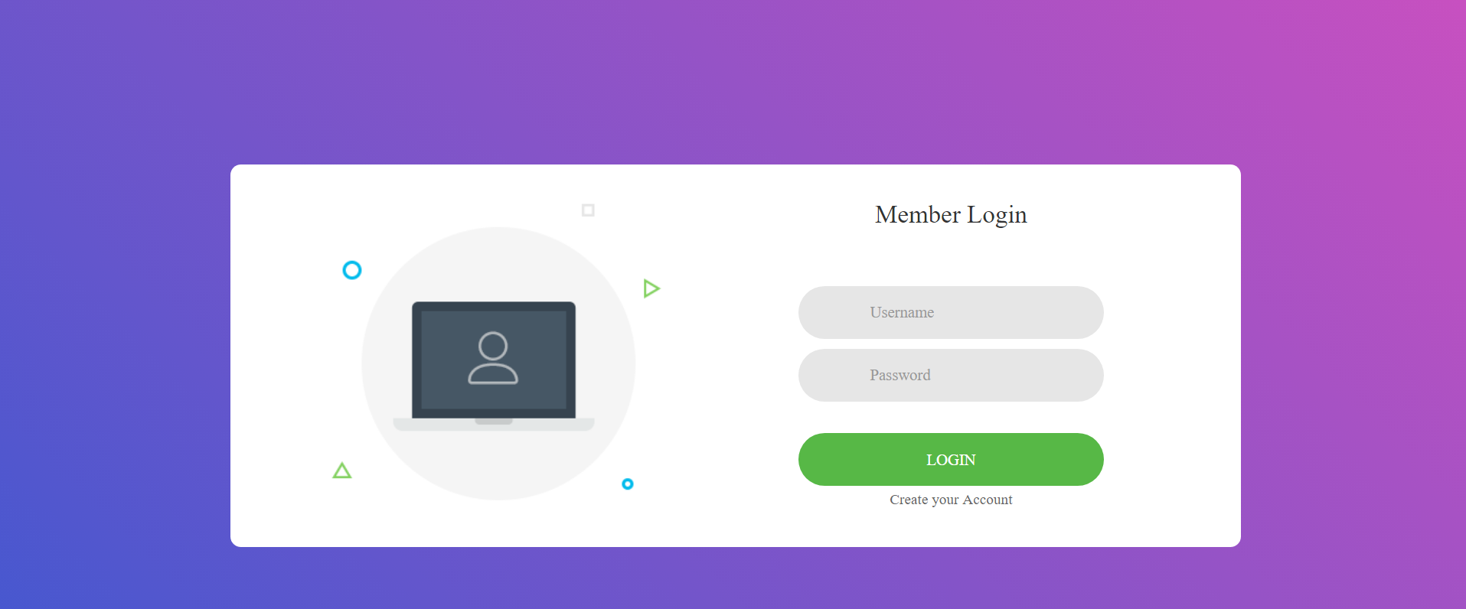

Descriptions of fields, content

Username field requires the username, password field requires users password.

Description of actions

There are two actions in this page:
- Login button which is used to authenticate user and then send them to Home page
- Create your account which sends user to the Registration Form

Sequence of screens

Screenshot for failed user authentication is shown below.

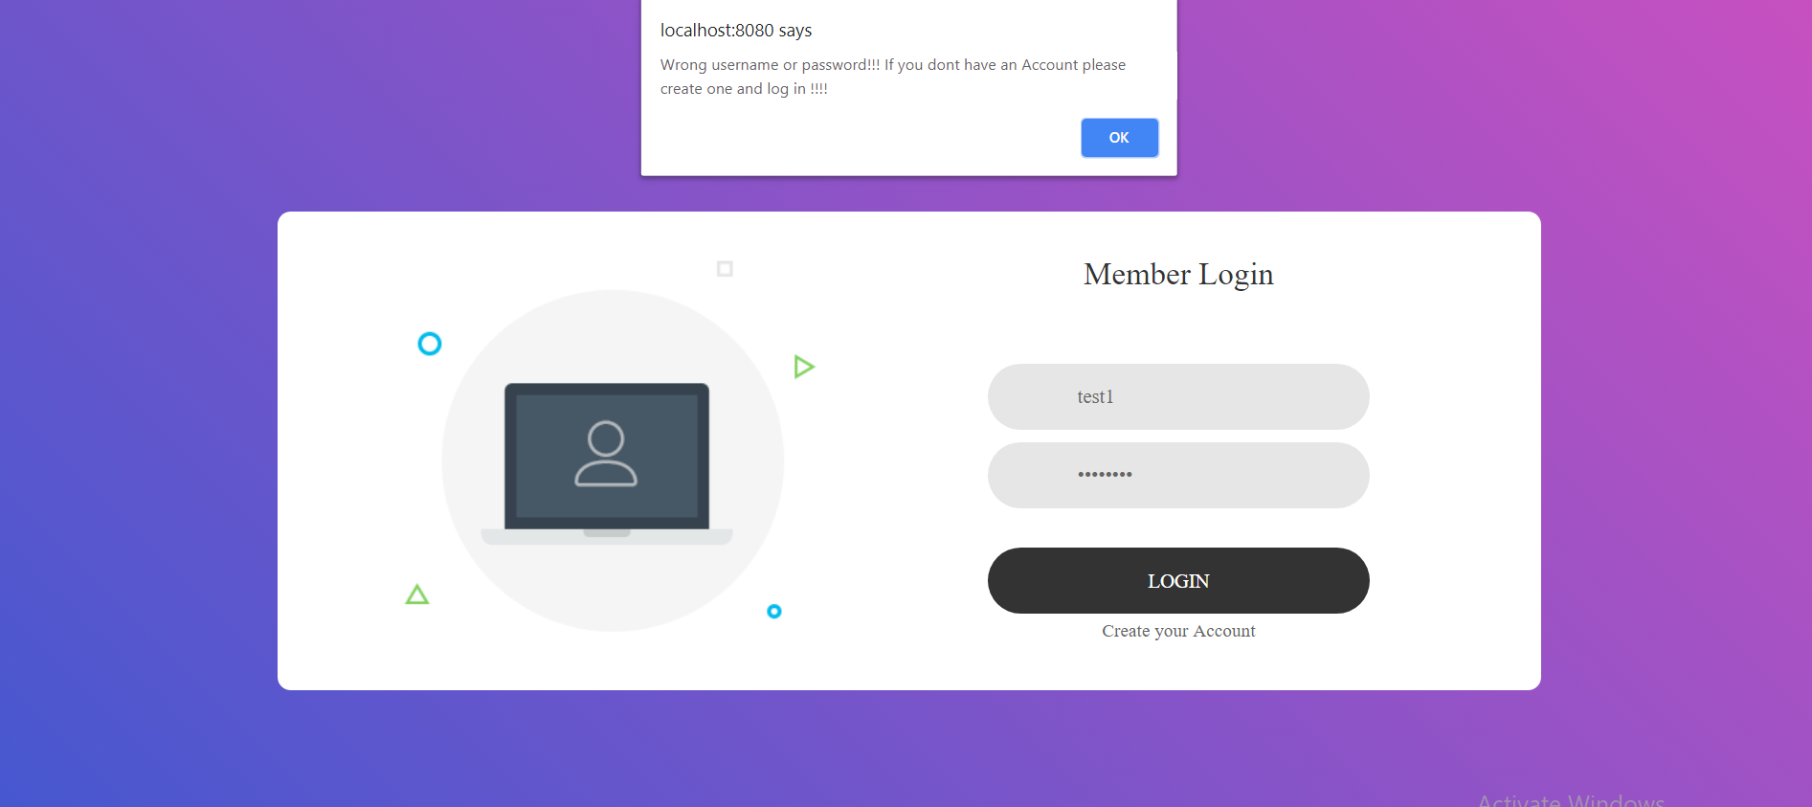

Registration screen

Registration form is opened after Create your Account is clicked. Further details will be explained below.

Screenshot

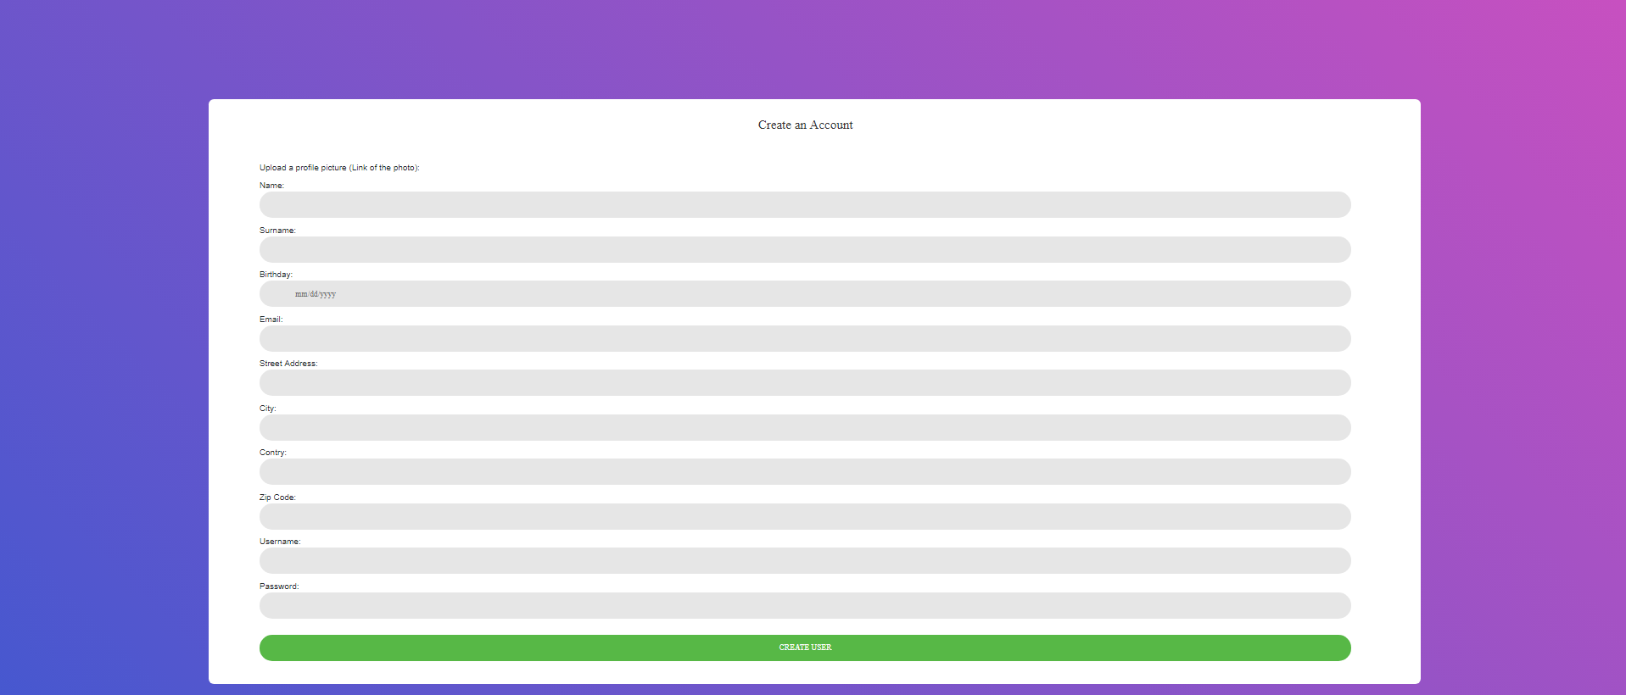

Descriptions of fields, content

Upload a photo: will have an url to a link of an image.
Name : will contain the name of the new user, text field,requied.
Surname : will contain the surname of the new user, text field, required.
Birthday: will contain the birthday of the new user, datetime field, required.
Email: will contain the email of the new user,email field, required.
Street address: will contain the street address of the new user, text field, required
City: will contain the city of the new user, text field, required
Country: will contain country of the new user, text field, required
Zip code: will contain the zip code of the new user, text field, required
Username: will contain the street address of the new user, text field, required
Password: will contain the password of the new user, password field, required

Description of actions
When the form is completely filled, user clicks Create user button. If the creation of user is successful the user will be redirected in Login screen.

Home screen

Home screen is opened after the user is successfully logged in and its layout will be shown below.

Screenshot

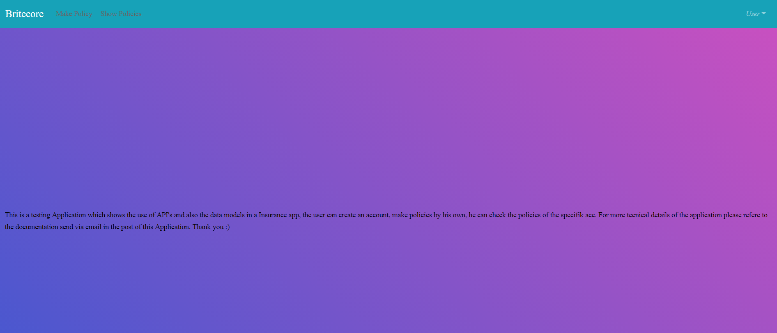

Descriptions of fields, content

It contains an navigation bar and some information useful for user.

Description of actions
If user clicks Make Policy in the navigation bar it will send them to Make policy form in which they can create their own policy, if user clicks Show Policies in the navigation bar it will send them to Show Policies page in which there are listed all policies created by the user. Also a user can click User option in the navigation bar and in the dropdown list click sign out. The actions are shown in the screenshots below.

Sequence of screens
Make policy screenshot

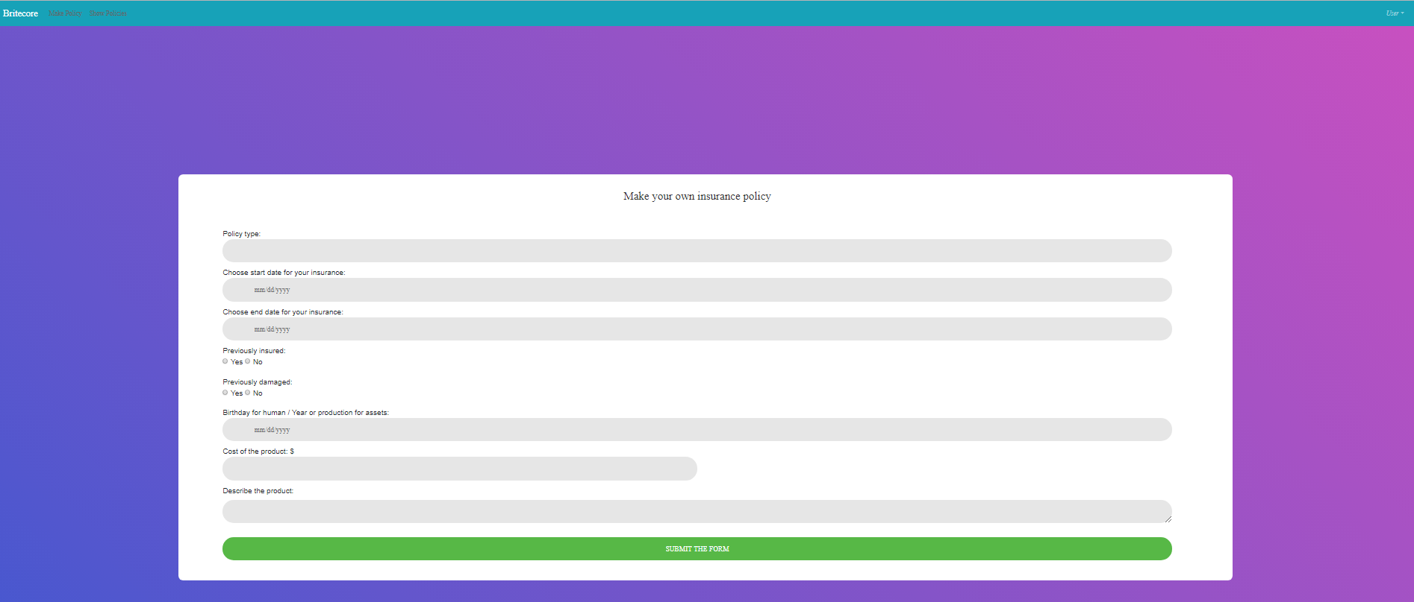

Show policies screenshot

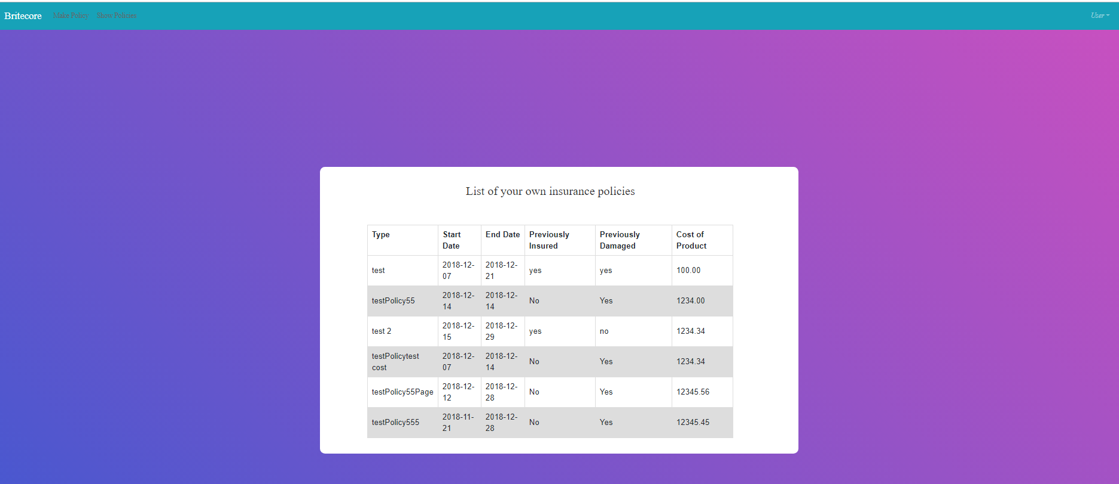

Signout screenshot

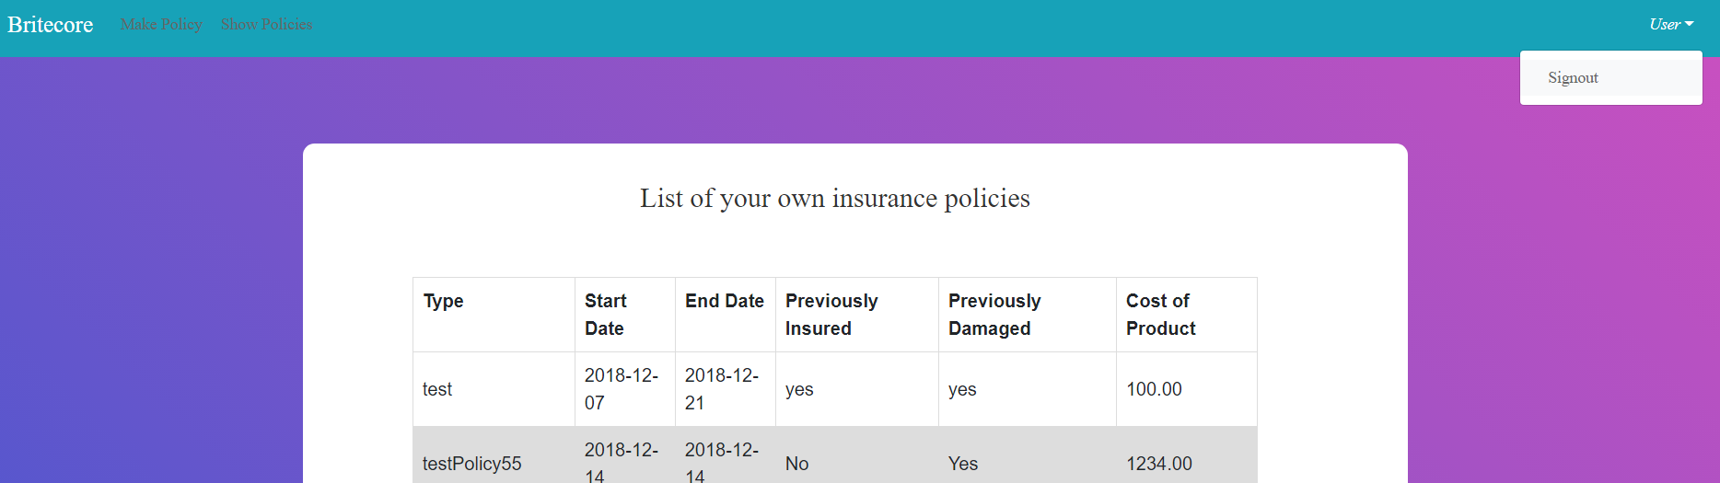

Make policy screen

This sceen will serve to create policy risk types for user. Its details are shown below.

Screenshot

Descriptions of fields, content

Risk type: will contain risk type defined by user,text field, required.
Startdate : will contain the starting day for the risk type, datetime field,requied.
Enddate : will contain the ending day for the risk type, datetime field,requied..
Previously insured: radio button, required.
Previously damaged: radio button, required.
Birthday/year of production: will contain the birthday(human)/year of production(nonhuman), datetime field,requied..
Cost of product: will contain cost of product, number field,required.
Description: will contain the description of product, text field, required.

Description of actions

After form is filled user clicks submit. If the submit is successful a pop up message is shown, also if the submit is unsuccessful a pop up message will also be shown.

Sequence of screens

Screenshot for failed policy creation is shown below.

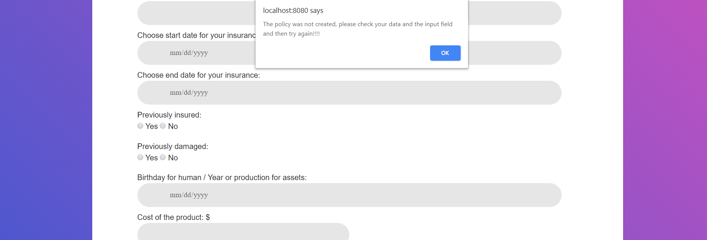

Screenshot for successful

Appendices

Appendix 1

<Give here any additional information that could make the functional specifications easier to understand.>

Appendix 2

End of document

