EIGRP
Table of contents
Header 2
Features 3
How can EIGRP routers become neighbours? 4
Neighbour information 5
DUAL algorithm 6
EIGRP Cisco configuration 7
Basic configuration 7
Named configuration 7
Debug commands 7

Header
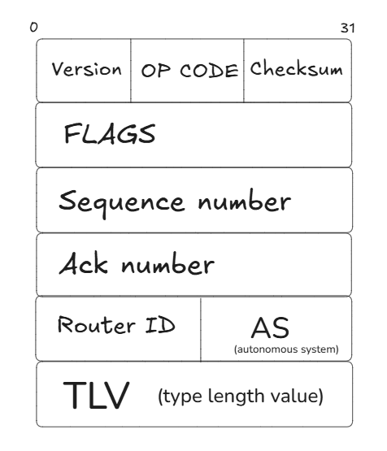
There are 5 OP CODE:
- UPDATE
- ACK
- HELLO
- QUERY
- REPLY
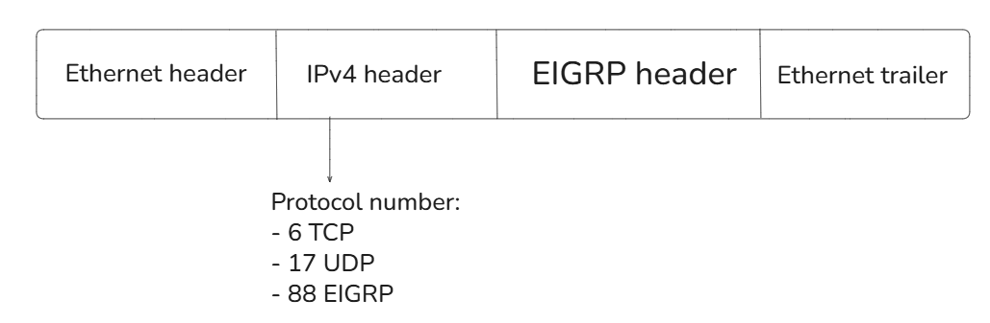

Features
- Triggered update
- Partial update
- Complex metric: bandwidth + delay + reliability + load + MTU size
- IPv4 + IPv6
- Unequal load balancing
- Successor / feasible successor
- Neighbour adjacency: EIGRP needs to discover neighbours Hello packets
EIGRP packets are using multicast addresses:
- IPv4: 224.0.0.10
- IPv6: FF02::A
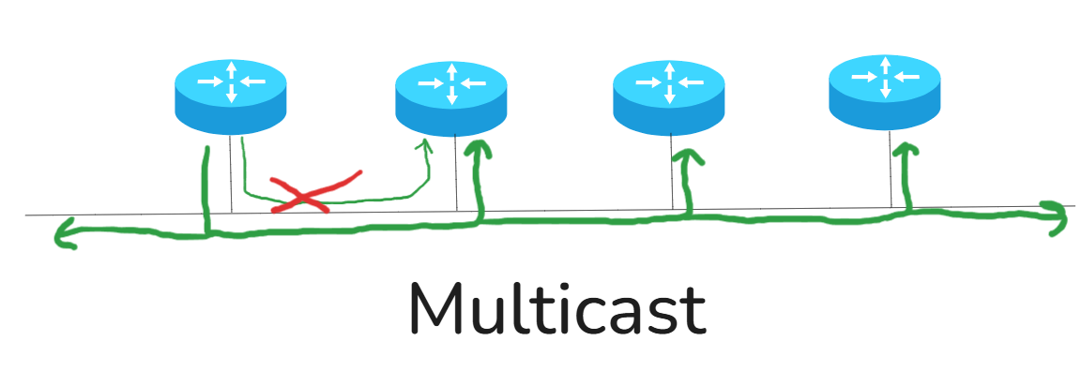
For example, HELLO packets are sent in multicast not only for a specific router.

How can EIGRP routers become neighbours?
- They have the same AS (autonomous system number).
- The authentication must be OK.
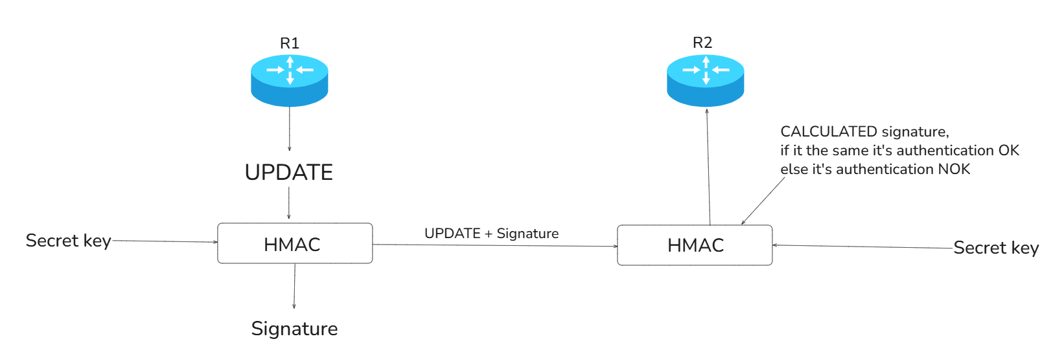
- K values must match.
- Neighbours must be on the same subnet.
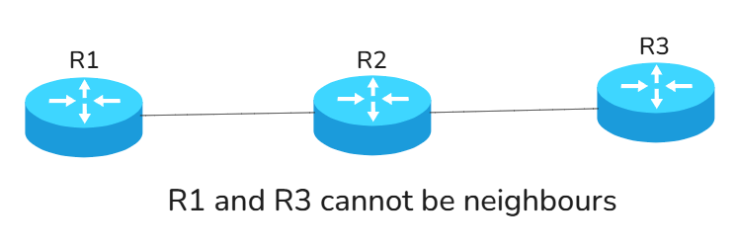

Neighbour information
On a Cisco router, when you do R1 # show ip eigrp neighbors you see:
H | Address | Interface | Hold | Uptime | SRTT | RTO | Q | Seq
 |  |  | (sec) |  | (msec) | (msec) | Count | Num
0 | 192.168.1.2 | Gi0/0 | 12 | 00:10:23 | 20 | 100 | 0 | 15
1 | 10.0.0.2 | Gi0/1 | 58 | 01:05:10 | 30 | 180 | 0 | 42

There are 2 timers:
- Hello timer By default, HELLO packets are sent every 5 seconds on an Ethernet network.
- Hold timer = 3 * hello timer The router accepts to lose one or two HELLO packets, but if it doesn’t hear from its neighbour after 3 * the hello timer, it will remove every information concerning this neighbour.
See the “Hold” column in the R1 #show eigrp command! On an Ethernet network we should see between 10 and 15 if things are going well.
The column “Uptime” = when did the router hear the first packet about this neighbour?
The column “SRTT” (Smooth Round Trip Time) = The time it normally takes between UPDATE and ACK packets.
The column “RTO” (Retransmission Timeout) = bases on the previous SRTT, if after 5 seconds the router hasn’t received an ACK packet, it resends the UPDATE packet.
The column “Qcount” = the number of packets waiting in the queue for this number.
The column “Seq” (number in the packet) = if a router receives a “Seq” with 4 and it already has number 4 in the neighbour table it drops this packet.

DUAL algorithm
The algorithm behind EIGRP is DUAL.
An EIGRP router only knows the network from what is said by his neighbours.
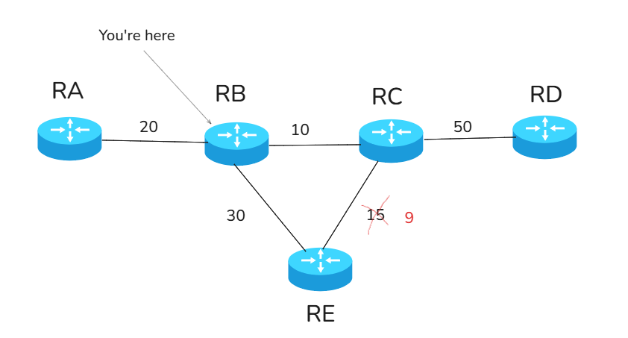
Imagine you are the RB router.
Let us discover how RB is going to reach RD.
The best neighbour to the destination is called SUCCESSOR.
From this simple example, we can directly see that RC is the SUCCESSOR to reach RD (because the metric associated would be in this case the sum of 10 and 50, which is 60).
But we also need to discover a FEASIBLE SUCCESSOR. It’s a router that will directly become SUCCESSOR in case we lose the actual SUCCESSOR.
RB to RD | FEASIBLE DISTANCE | REPORTED DISTANCE = ADVERTISED DISTANCE
RA | 100 | 80
RE | 95 89 | 65 59
RC | 60 | 50
If you want to be a feasible successor, the reported distance must be lower than the feasible distance of the successor.
When there is no feasible successor for a destination the router will send a special EIGRP request packet to its neighbours to say, “I have lost a path to this destination, can you help me?”. The neighbours, if they can help, reply with an EIGRP REPLY packet. If they cannot reply, they will forward the EIGRP request to their neighbours, until there is a reply. If there is no reply, it is called SIA (Stuck in Active).

EIGRP Cisco configuration

Basic configuration
IPv4:
- Configure the autonomous system number
  - R1 (config) #router eigrp 100
- Configure a router ID
  - R1 (config-router) #eigrp router-id 1.1.1.1
- Add network that will run EIGRP (only put directly connected networks)
  - R1 (config-router) #network 1.1.1.0 0.0.0.255
  - R1 (config-router) #network 2.2.2.0 0.0.0.255
IPv6:
- Enable unicast routing
  - R1 (config) #ipv6 unicast routing
- Configure the autonomous system number
  - R1 (config) #router eigrp 100
- Configure a router ID
  - R1 (config-router) #eigrp router-id 2.2.2.2
- On each EIGRP interface, enable EIGRP
  - R1 (config) #interface g0/0
  - R1 (config-if) #ipv6 eigrp 100

Named configuration
R1 (config) #router eigrp MYEIGRP
R1 (config) #address-family ipv4/ipv6 autonomous-system 100
R1 (config) #eigrp router-id 1.1.1.1
R1 (config) #network 10.0.0.0 0.0.0.255
R1 (config) #af-interface g0/0

Debug commands
R1 #show ip/ipv6 eigrp neighbor
R1 #show ip/ipv6 eigrp topology
R1 #show ip/ipv6 route
R1 #show run | section eigrp

