Static route problems
Table of contents
First problem 2
Second problem 2

First problem
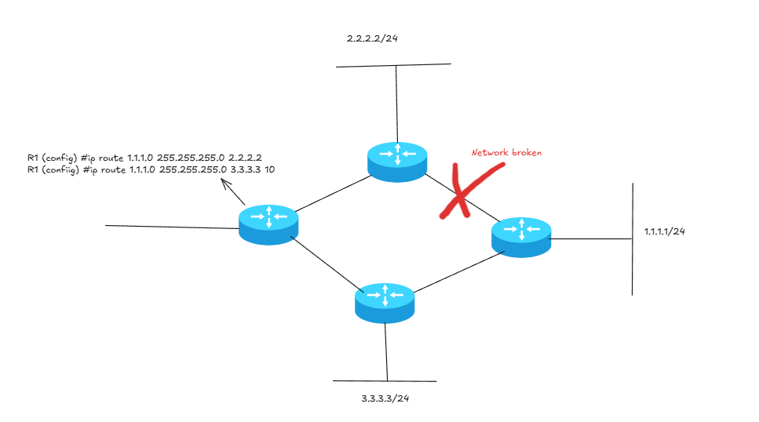
If you have a similar topology to this, if the wire with the red cross is broken, all your network is broken. Because R1 doesn’t know that the wire is down and will continue to send his packet to the 2.2.2.2 router. It will never use the second route.

Second problem
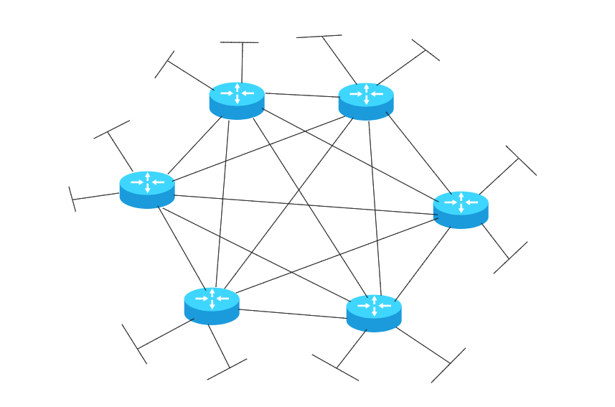
How many static routes do you need for this network? 120 routes
How many networks? We have 12 LANs and 15 WANs (n * (n-1))/2 = (6*5)/2 = 15 WANs
So, we have 15 + 12 = 27 networks. Each router knows 7 networks C = directly connected
- 27 – 7 = 20 routes 6 routers * 20 routes = 120 routes Nightmare !!!

