AAA
Authentication, Authorization & Accounting
Table of contents
On the devices 2
Authentication 2
Authorization 2
Privilege access 2
SSH access 3
Authentication proxy access 4
802.1X Ethernet access 5
On the authenticator device 5
On the Windows device 6
On the ISE server 8
Add network devices 8
Add identities 9
Add policies 11
Create conditions 11

On the devices
Debug:
R1 #debug radius
R1 #show ip auth-proxy cache
Enable AAA on a router:
R1 (config) #aaa new-model
Specify a RADIUS server:
R1 (config) #radius server MYRADIUS
R1 (config-radius-server) #address ipv4 192.168.2.1
R1 (config-radius-server) #key SECRETKEY
Or the old version:
R1 (config) #radius-server host 192.168.2.205 key SECRETKEY

Authentication
R1 (config) #aaa authentication SERVICE LISTNAME METHOD1 METHOD2 …
- login: all the possibilities to connect to the router (SSH, Telnet, console, HTTP, auxiliary…)
- ppp: like the service providers
- dot1x:
- local: use the user in local (username admin privilege 15 password cisco)
- none: no verification
- group radius: use the RADIUS server
- default: use it by default

Authorization
R1 (config) #aaa authorization SERVICE LISTNAME METHOD1 METHOD2 …
- exec: the privilege level of the administrator on the router (0-15)
- auth-proxy: the ACL for the user of the network
- none: no verification
- group radius: use the RADIUS server

Privilege access
Put a privilege level to access a command:
> # (config) (config-if) shutdown (level 5):
R1 (config) #privilege exec level 5 configure
R1 (config) #privilege configure level 5 interface
R1 (config) #privilege interface level 5 shutdown

SSH access
Enable AAA on the router:
R1 (config) #aaa new-model
Specify the RADIUS server:
R1 (config) #radius-server host radius-server-ip key shared-key
Protect the console port:
R1 (config) #username cisco password cisco
R1 (config) #aaa authentication login CONSOLENOAAA local (Warning! Create user before)
R1 (config) #aaa authorization exec IWANTPRIV15 none
R1 (config) #line console 0
R1 (config-line) #login authentication CONSOLENOAAA
R1 (config-line) #authorization exec IWANTPRIV15
Others with the RADIUS server:
R1 (config) #aaa authentication login default group radius
R1 (config) #aaa authorization exec default group radius
Configure SSH:
R1(config) #ip domain-name test.lan
R1 (config) #crypto key generate rsa modulus 2048
R1 (config) #line vty 0 4
R1 (config-line) #transport input ssh
R1 (config-line) #login authentication default
R1 (config-line) #authorization exec default

Authentication proxy access
Enable AAA on the router:
R1 (config) #aaa new-model
Specify the RADIUS server:
R1 (config) #radius-server host radius-server-ip key shared-key
Protect the console port:
R1 (config) #aaa authentication login CONSOLENOAAA local (Warning! Create user before)
R1 (config) #line console 0
R1 (config-line) #login authentication CONSOLENOAAA
Change authorization of the console port:
R1 (config) #aaa authorization exec IWANTPRIV15 none
R1 (config) #line console 0
R1 (config-line) #authorization exec IWANTPRIV15
Refer RADIUS for authentication & authorization:
R1 (config) #aaa authentication login default group radius
R1 (config) #aaa authorization auth-proxy default group radius
Enable the web server on the router:
R1 (config) #ip http server
Enable AAA for the web server:
R1 (config) #ip http authentication aaa
Create ACL to permit the user access the web server:
R1 (config) #access-list 100 permit tcp 192.168.1.0 0.0.0.255 host 192.168.1.254 eq 80
R1 (config) #access-list 100 deny ip 192.168.1.0 0.0.0.255 any
Configure the proxy:
R1 (config) #ip auth-proxy name HTTPPROXY http list 100
Apply the proxy and the ACL on the interface facing the user:
R1 (config) #int g0/0/0
R1 (config-if) #ip auth-proxy HTTPPROXY
R1 (config-if) #ip access-group 100 in

802.1X Ethernet access

On the authenticator device
On the authenticator switch, configure AAA:
SW1 (config) #aaa new-model
SW1 (config) #radius-server host radius-server-ip key shared-key
SW1 (config) #aaa authentication dot1x default group radius
SW1 (config) #aaa authorization network default group radius
Enable the routing on the switch:
SW1 (config) #ip-routing
Enable the 802.1X protocol on the switch:
SW1 (config) #dot1x system-auth-control
Create some VLANs (X times if X VLANs):
SW1 (config) #int vlan 2
SW1 (config-if) #ip address 192.168.2.254 255.255.255.0
Configure DHCP (X pools for X groups):
SW1 (config) #ip dhcp excluded-address 192.168.2.254 192.168.2.254
SW1 (config) #ip dhcp pool GROUP2
SW1 (dhcp-config) #network 192.168.2.0 255.255.255.0
SW1 (dhcp-config) #default-router 192.168.2.254
SW1 (config) #service dhcp
On each interface facing end user:
SW1 (config-if) #spanning-tree portfast
SW1 (config-if) #switchport mode access
On each interface facing end user, enable 802.1X verifications on the interface:
SW1 (config-if) #dot1x port-control auto
Or
SW1 (config-if) #dot1x pae authenticator
SW1 (config-if) #authentication port-control auto
If 2 MAC addresses are on the same interface, on each interface facing end user:
SW1 (config-if) #authentication host-mode multi-host
Or
SW1 (config-if) #dot1x host-mode multi-host

On the Windows device
Start the “Wired autoconfiguration” service. (Configuration automatique du réseau câblé in french):
- Win+R services.msc
- Right-click start
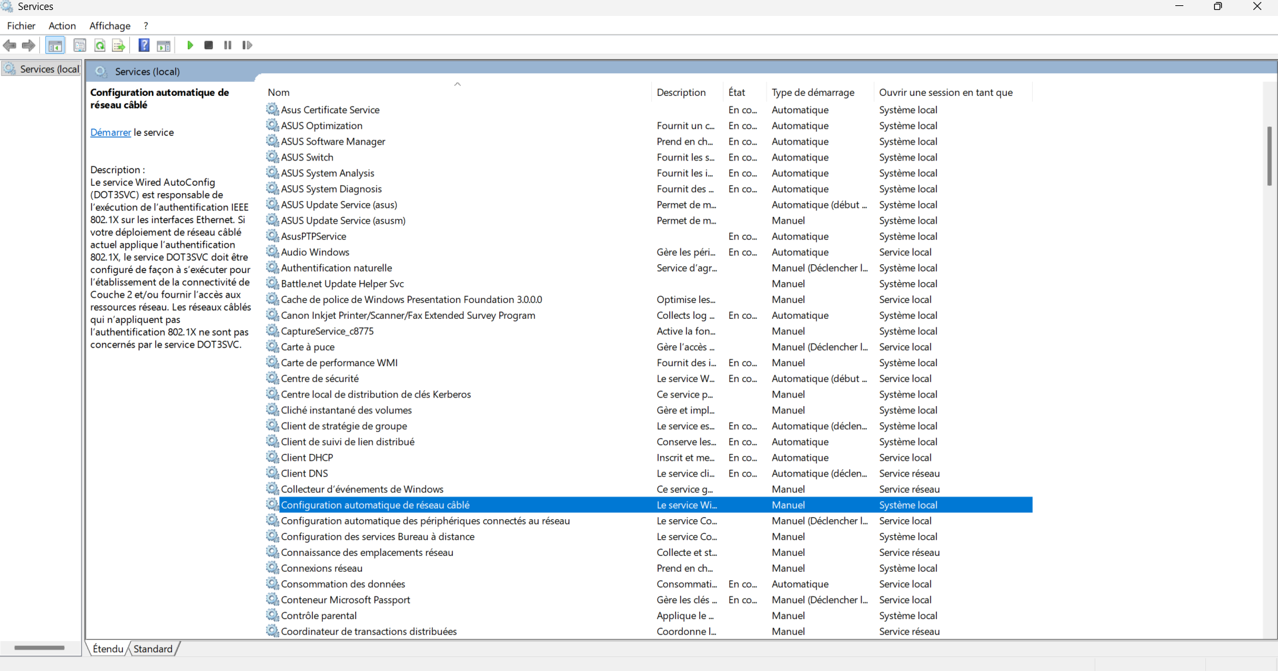
Import the ISE server certificate:
- Download the certificate from your ISE server
- Convert it to a .DER format
- Double-click on the file and choose “install as a trusted root certificate”
Configure the network card:
- There will be a new tab on your network card Win+R ncpa.cpl
- Choose PEAP
- Click on activate IEEE 802.1X authentication
- Click on the “parameters” button
- Check “Verify server identity…”
- Check the ISE server certificate
- Click on the “additional settings” button
- Choose user authentication
- And click on the “register client” button
- Connect with your user
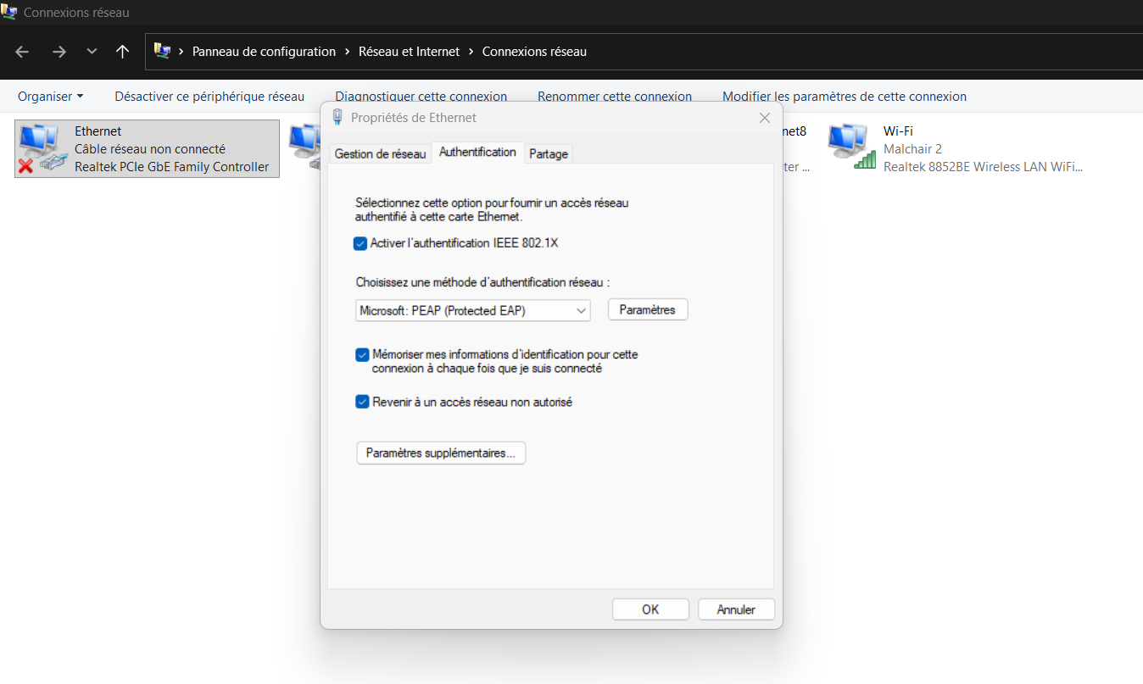
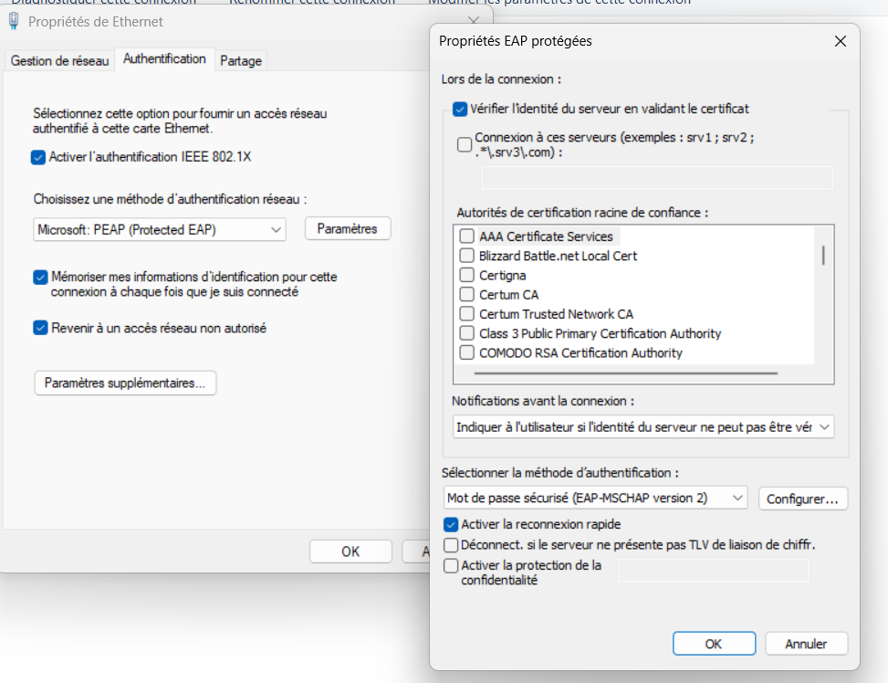
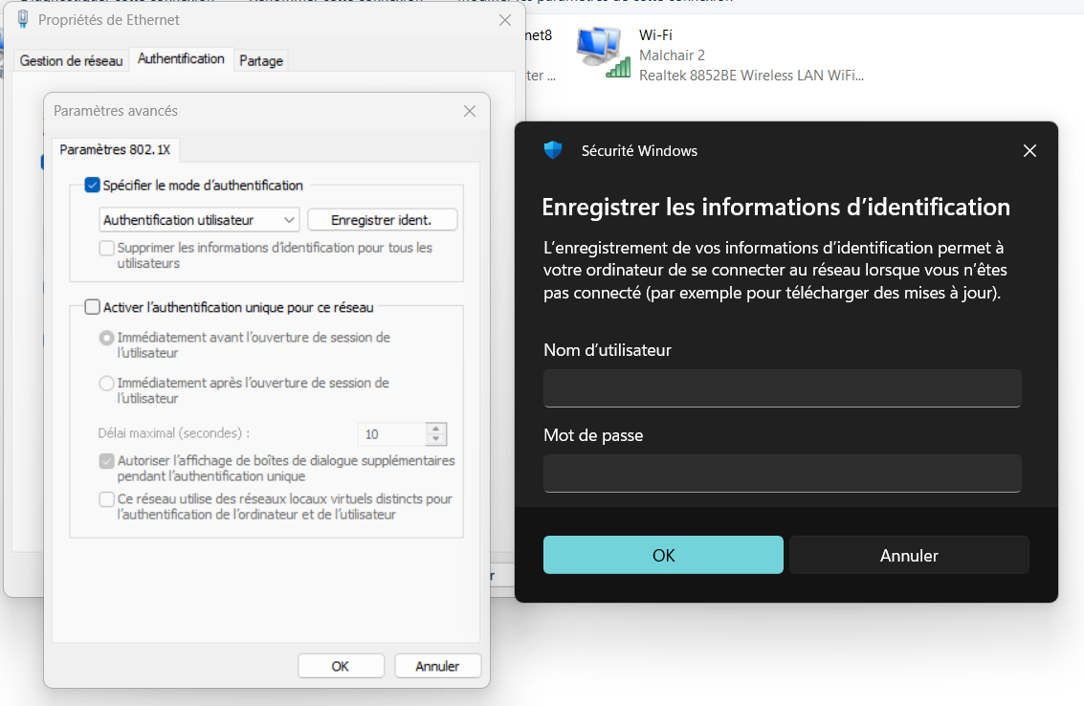

On the ISE server

Add network devices
Configure the network device that serves as an intermediary between the endpoints and ISE.
Give a name, an IP address and the shared secret between the device and the RADIUS server.
Access:
Administration Network Resources Network Devices Add
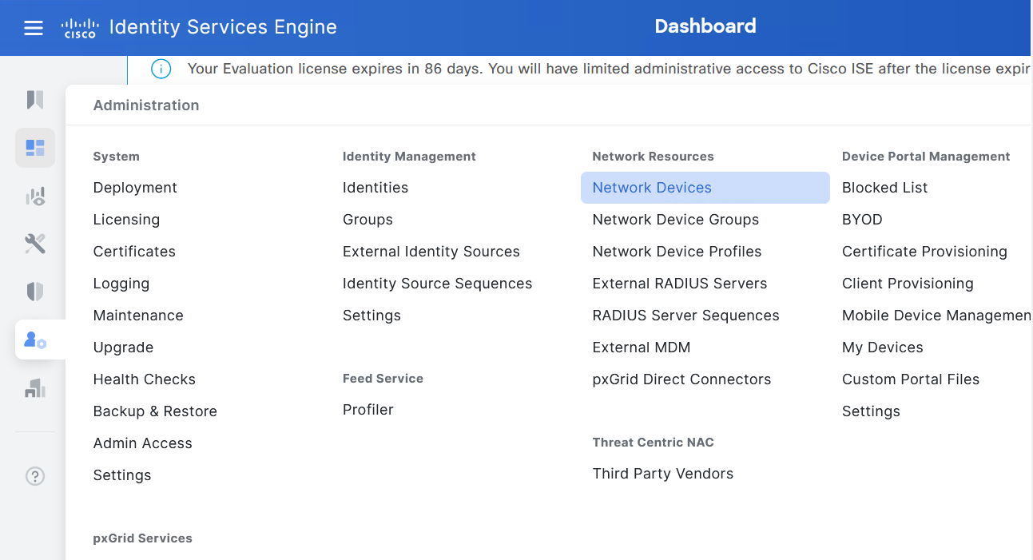
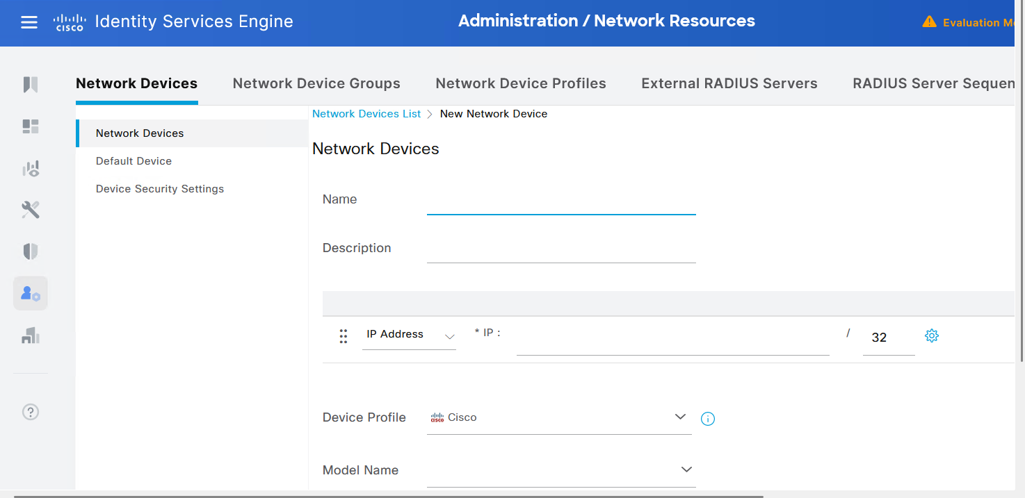
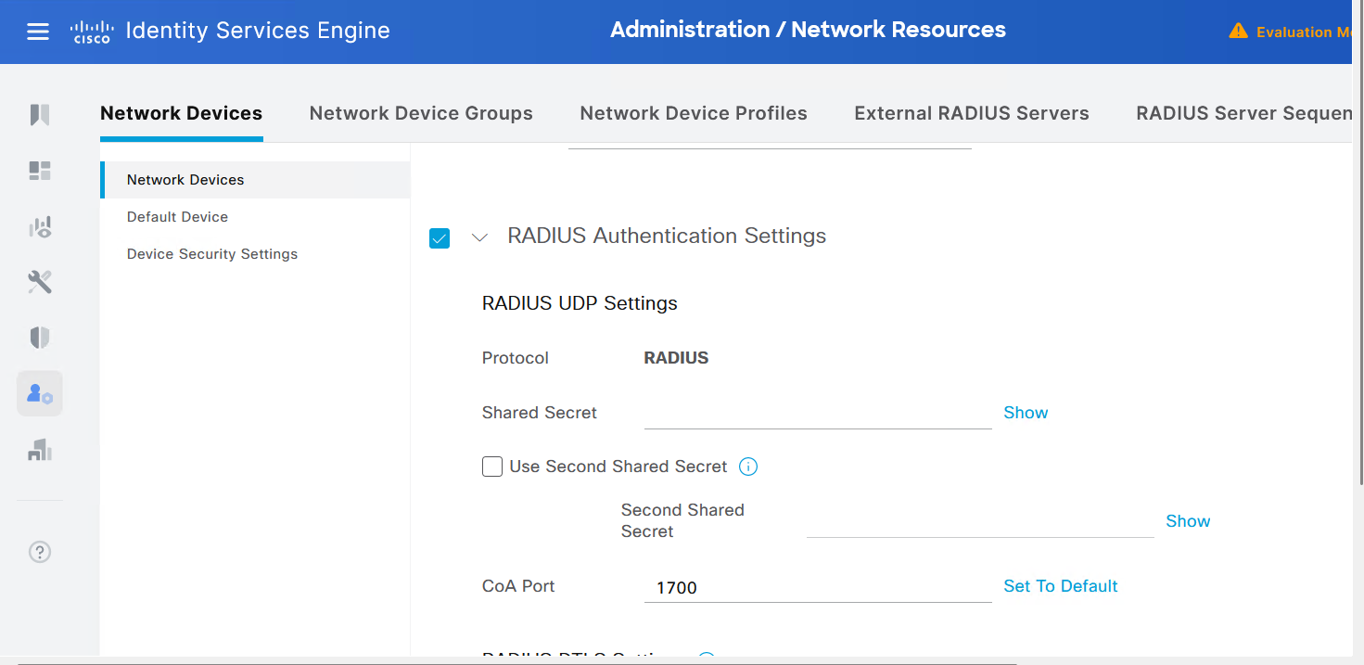

Add identities
Create groups and users. Assign the user in the good group.
Access:
Administration Identity Management Groups
Administration Identity Management Identities
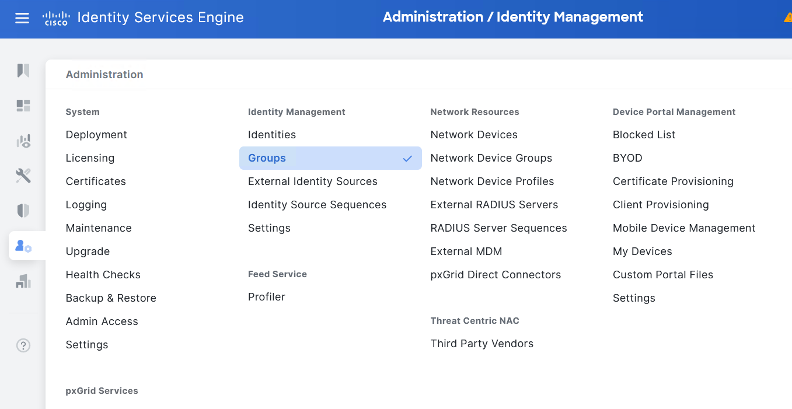
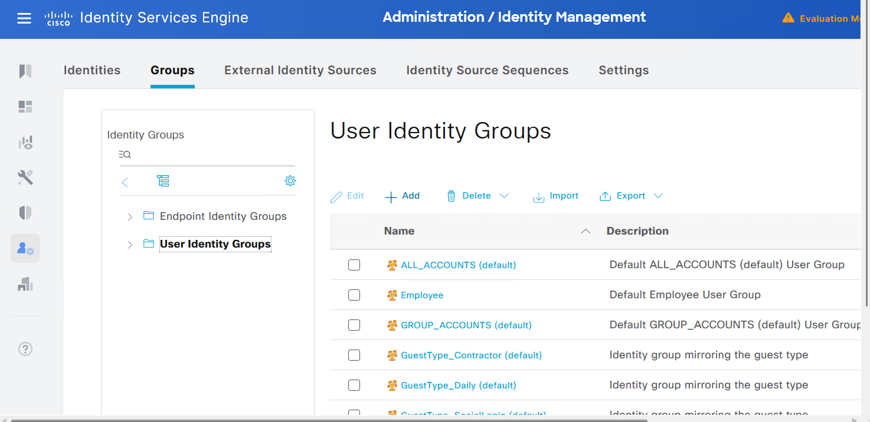
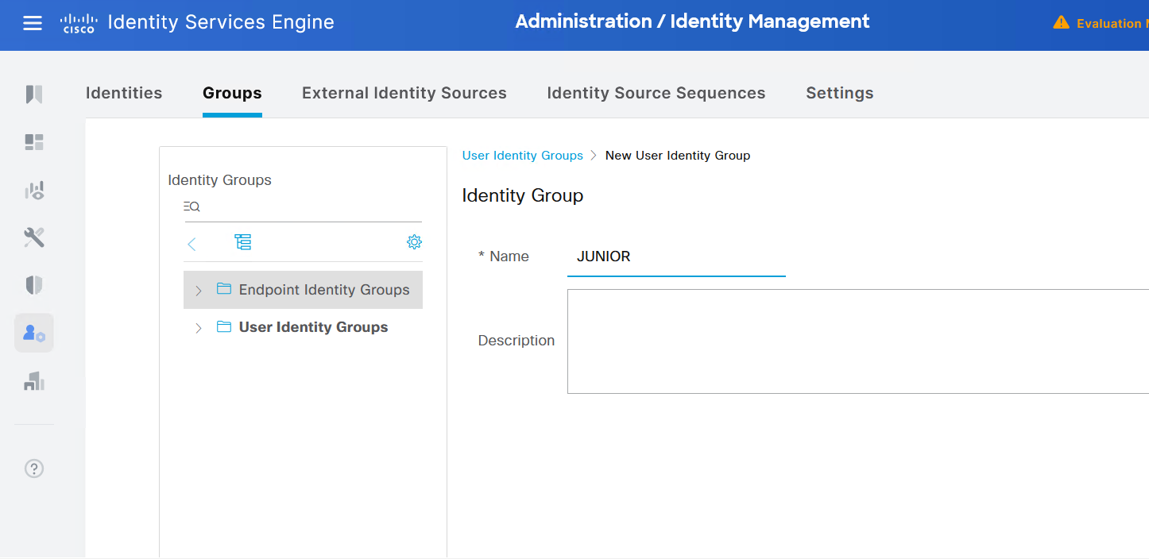
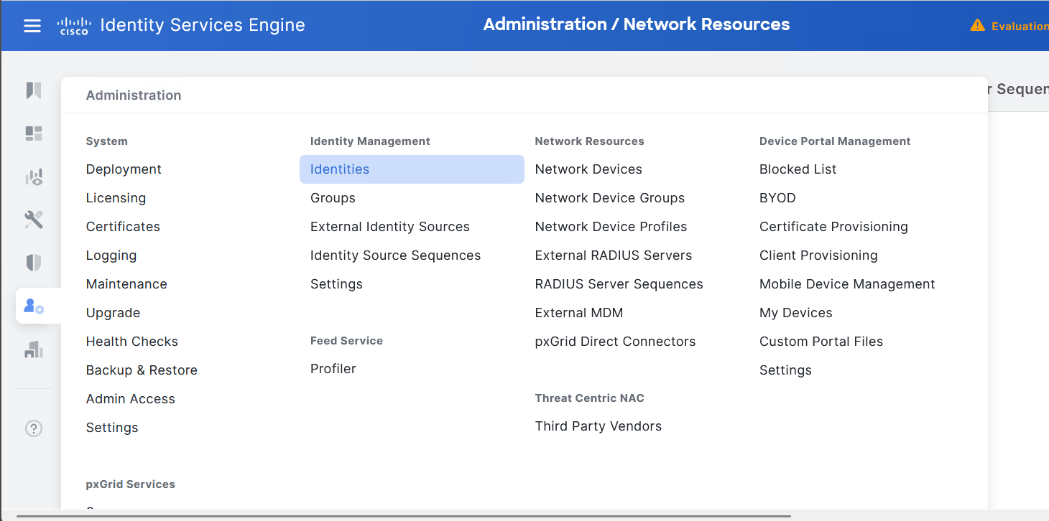
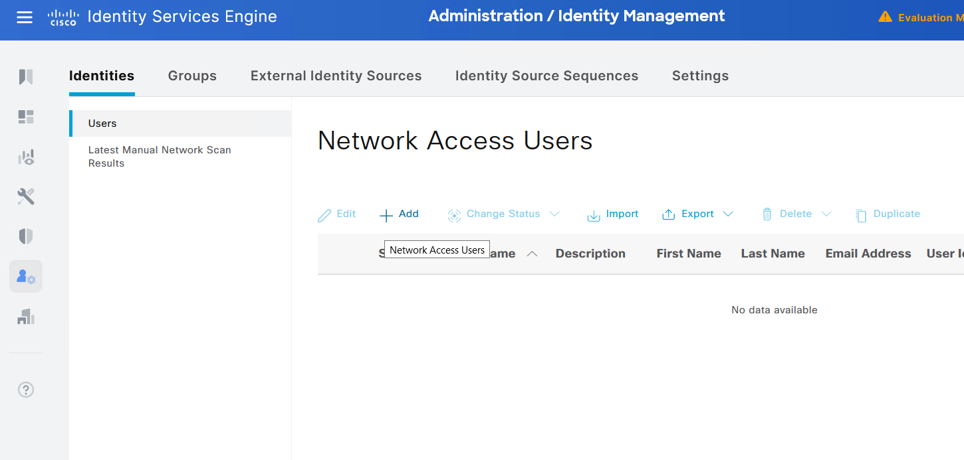
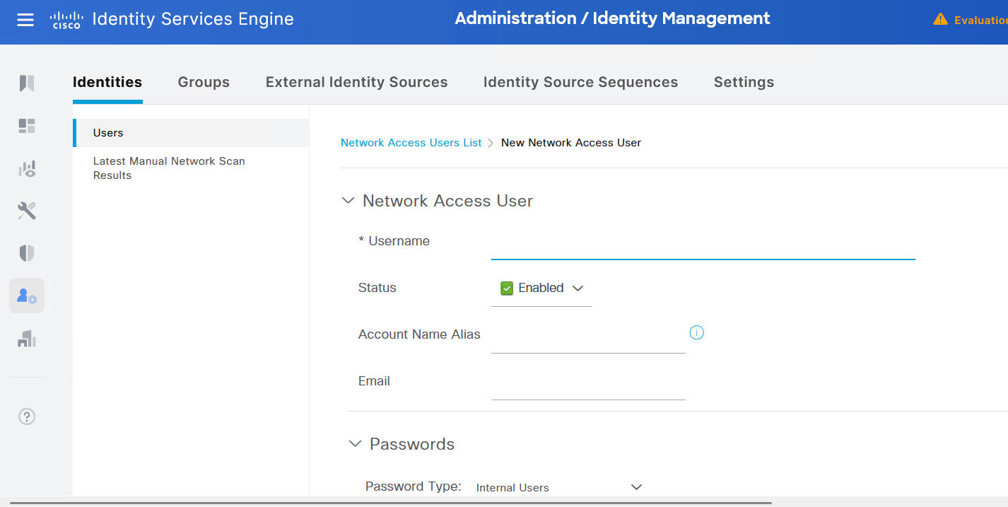

Add policies

Create conditions
Create the conditions, if the conditions are true, the results are applied.
Access:
Policy Policy Sets Create a new policy (click on ”+”) Choose a name, click on “+” in the Conditions column Conditions Studio
Choose a Dictionary Choose a condition (e.g. Nas-Port-Type Wireless) Save the condition
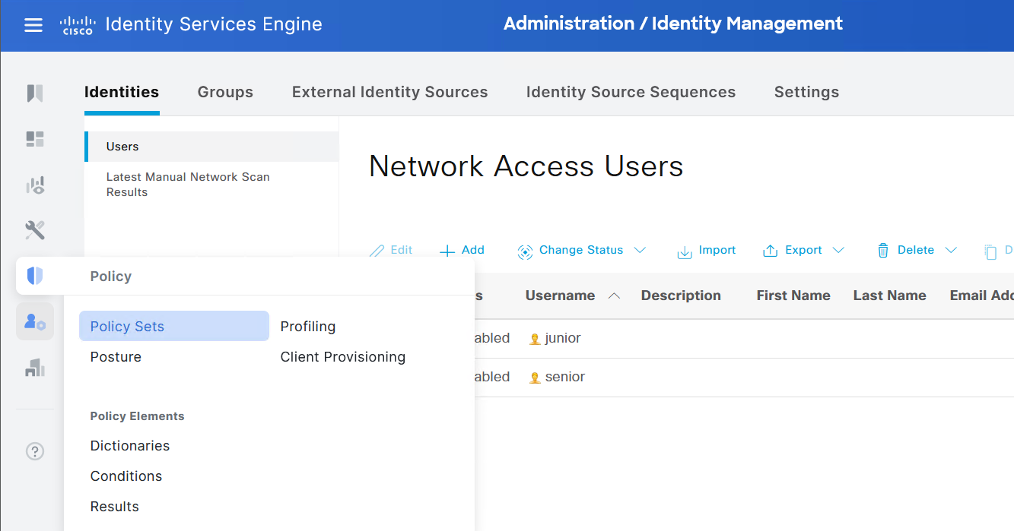
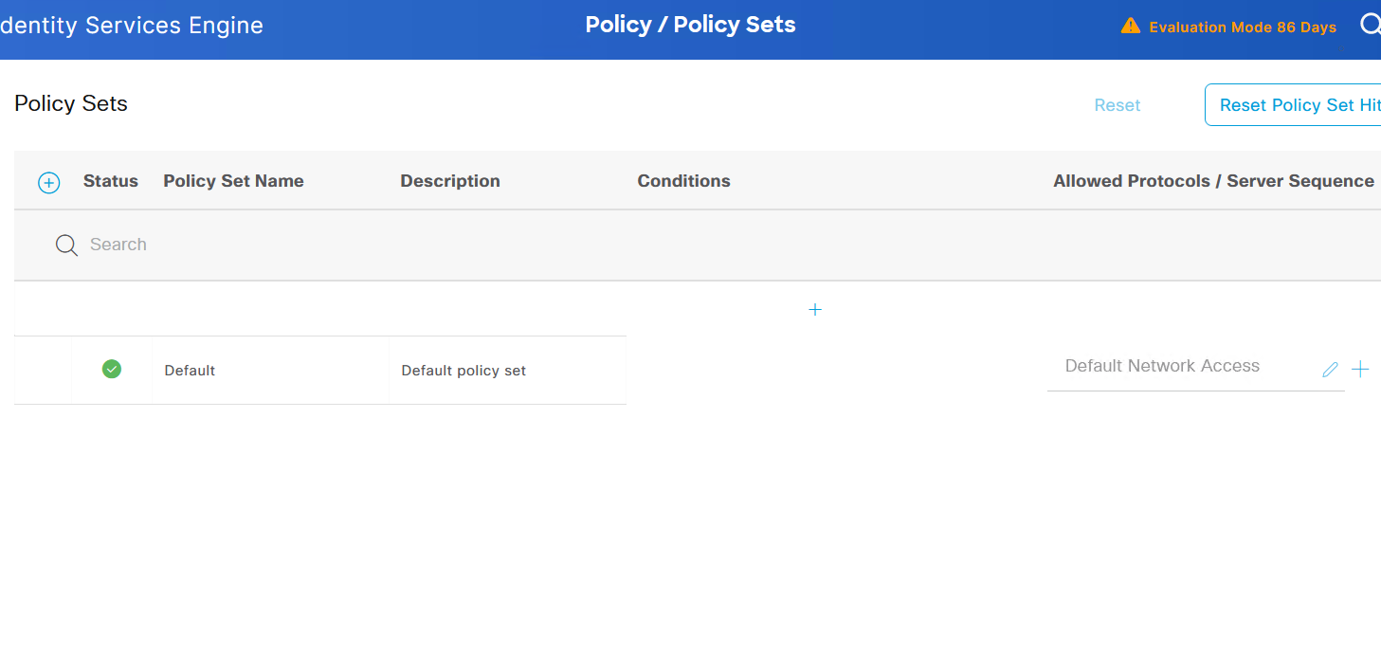
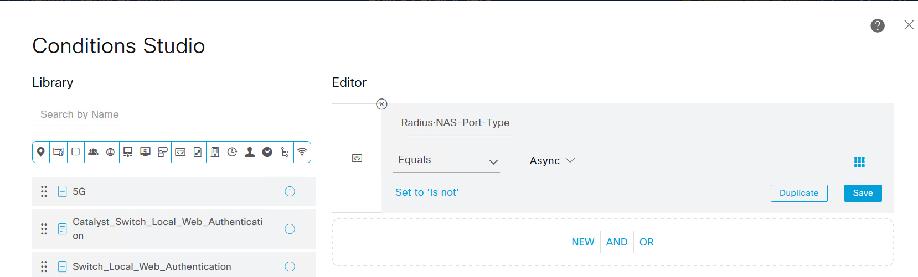
Virtual = SSH/Telnet/VTY
Async = Console/AUX serial
Ethernet = 802.1X
Wireless = Wi-Fi
Choose protocols:
Now choose the protocol(s) that ISE will use to communicate with the network device.
Access:
Allowed Protocols (click on ”+”) define the necessary protocols Choose the Allowed Protocol that you define Save
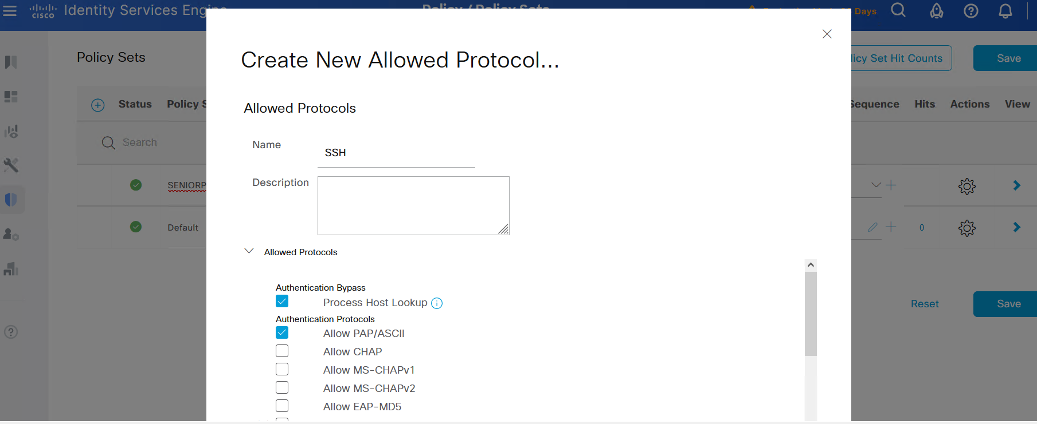
Authentication:
Create the rule for the authentication.
Access:
In the column ”View” click on the right arrow. You will choose the authentication policy and the authorization policy.
Create a Rule for Authentication Policy Condition Studio Drag and drop the previous created condition
In the column ”Use”, choose who this Policy applies to (e.g. Internal Users).
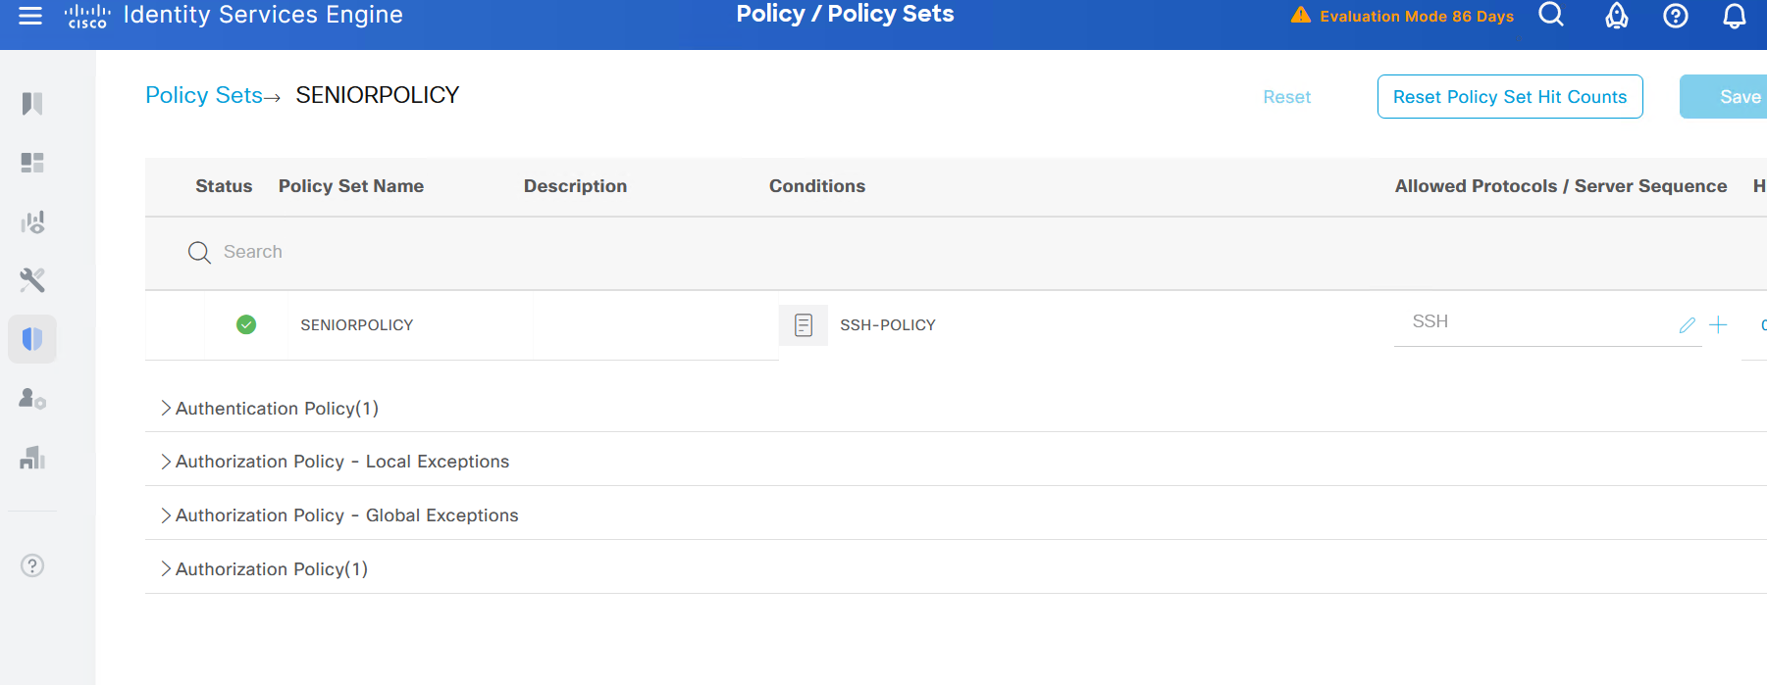
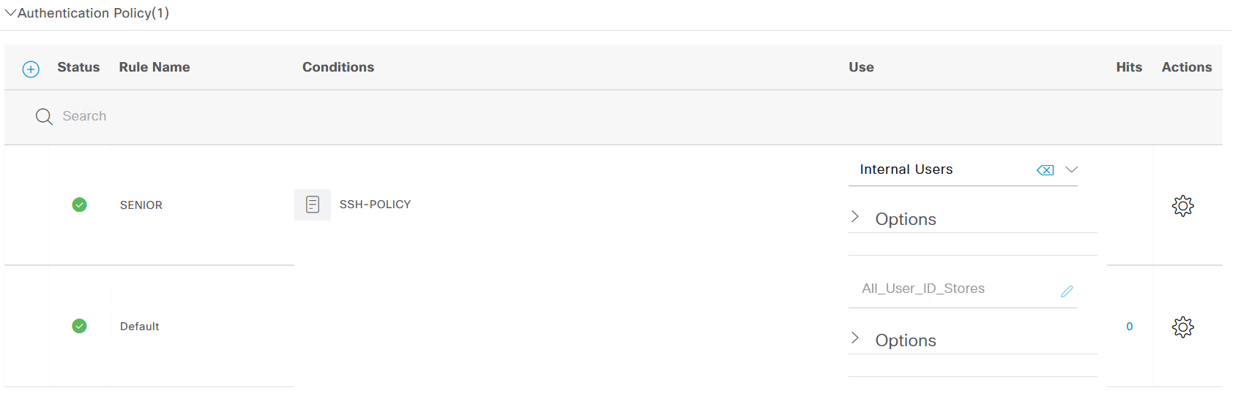
Authorization:
Next, create an Authorization Policy. Choose the same condition that the Authentication Policy. Choose the group affected.
Access:
Conditions Studio choose the icon ”Identity Group-Name” ”equals” choose the name of the desired group
In the column ”Results/Profiles” (click on ”+”) Create a ”New authorization profile” (click on ”+”) Config the authorization policy (e.g. Assign a VLAN or a cisco av-pair)
Do not enter anything in the Security Groups column.
In the column Use choose ”Internal Users” Choose the action to do if the authentication/authorization is KO or if the user can’t be found.
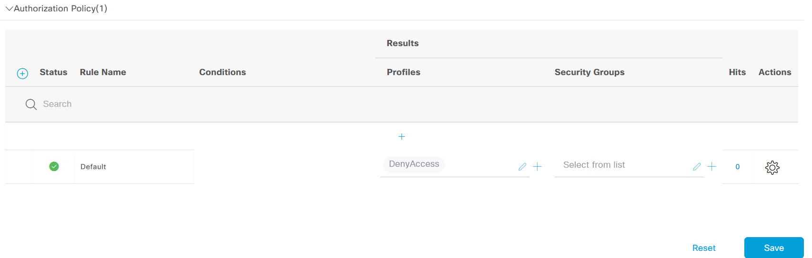
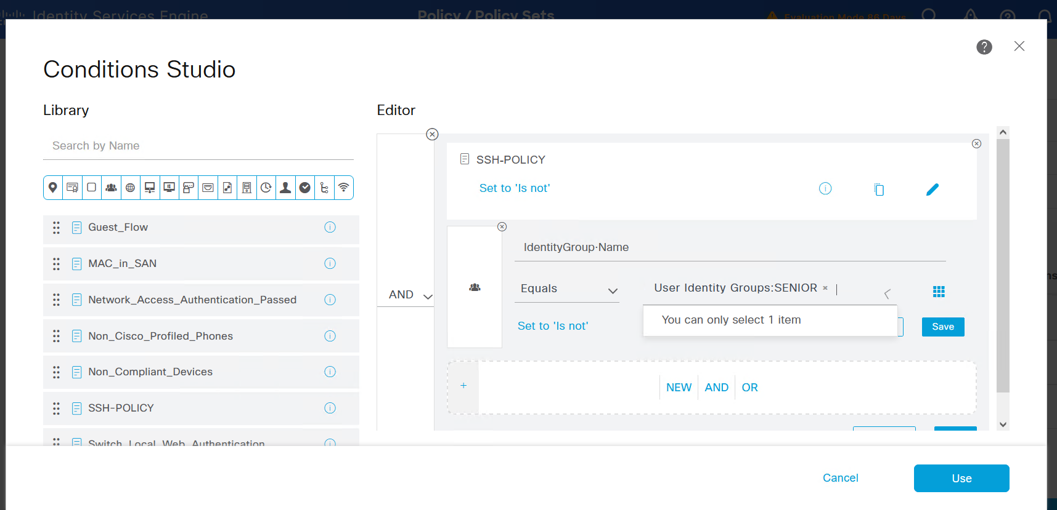
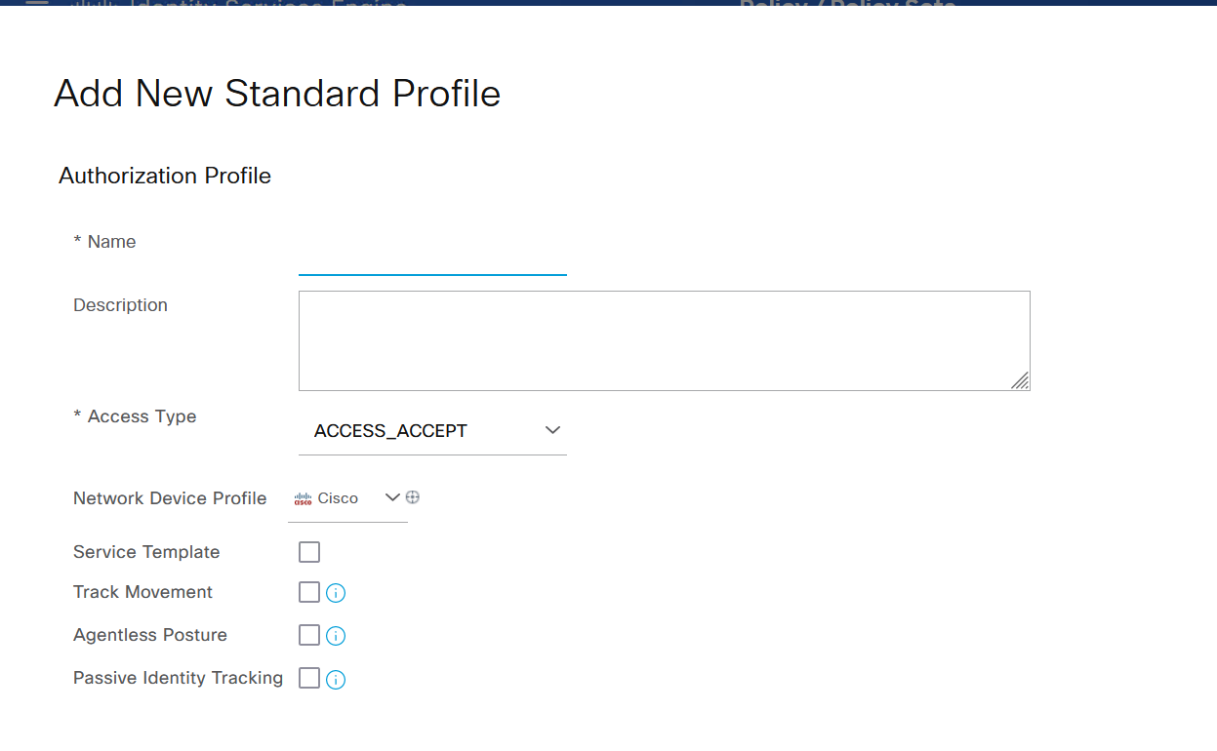
shell:priv-lvl=15
auth-proxy:priv-lvl=15
auth-proxy:proxyacl#1=permit icmp any any
auth-proxy:proxyacl#2=permit tcp any any

