Task
- Snowflake ensures only one instance of a task with schedule
Is executed at a given time.
- If a task is still running when the next scheduled execution time
occurs,then that scheduled time is skipped.
- Task can be combined with table streams for continues ELT workflows
to process recently changed table rows. Streams ensure exactly once
Semantics for new or changed data in table.

Snowflake tree diagram
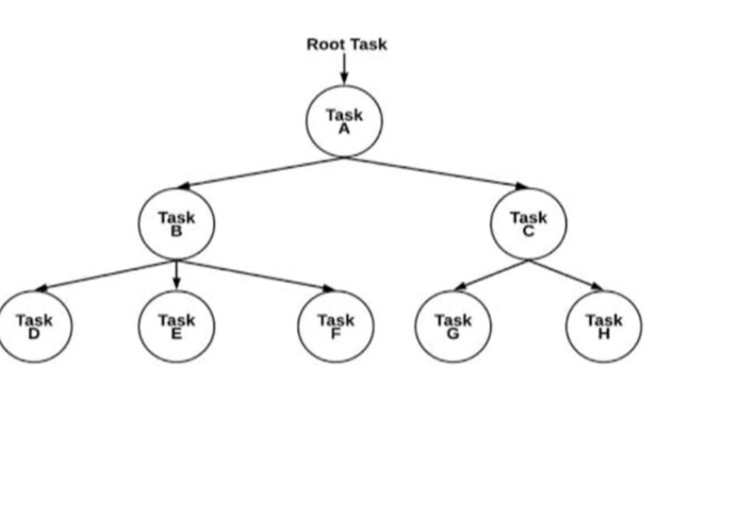 Tree of task in snowflake
- The level 1 has task A this our parent task.
- The task A has two childrens task B task C which is like level 2.
- Then we have level 3 task D,task E,task F goes under task B
and task G and task H goes under task c.
- The task A is a standard task. Whenever task A is executed then the task B and C in parallel.
- Whenever task A is executed then the task B and C in parallel. So the task B and C do not have any scheduling for execution because they use parent task key.
- When we execute level 3 task D,E,F this task depends on child class B for execution.
- When we execute level 3 task G,H this task depends on child class C for execution.So,the snowflakes tree shows the dependency in it.

