# Exercise

## Case study MHC-PMS

## Use cases for the MHC-PMS

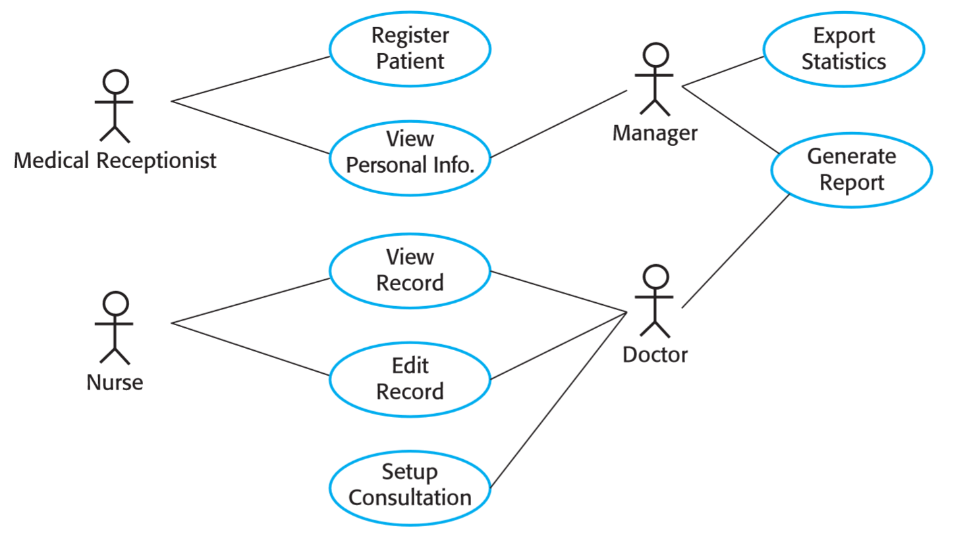

## Classes and associations in the MHC-PMS

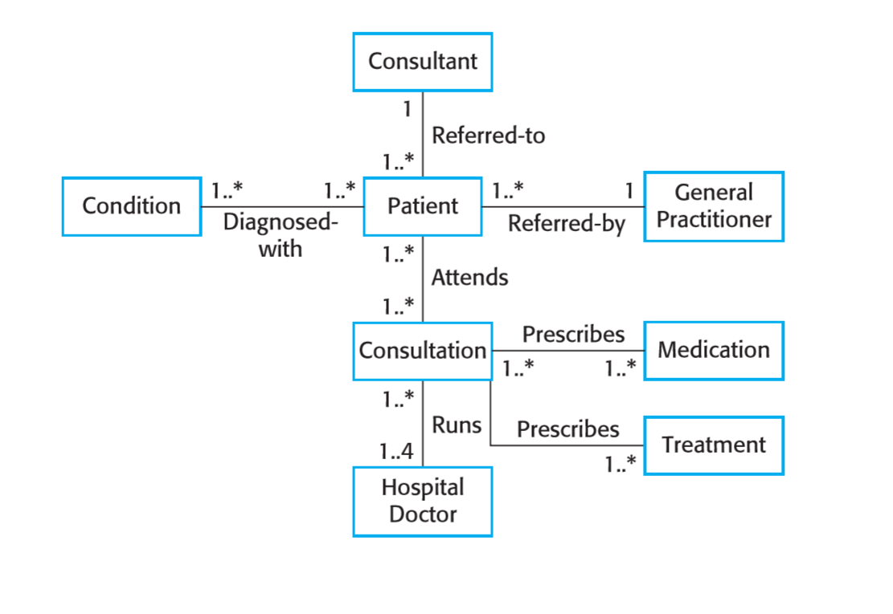

## The consultation class

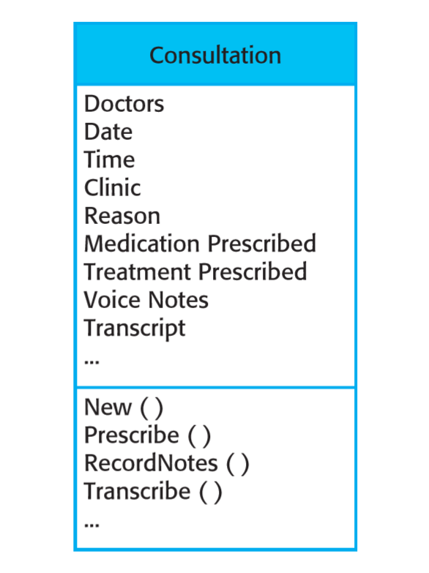

## A generalization hierarchy

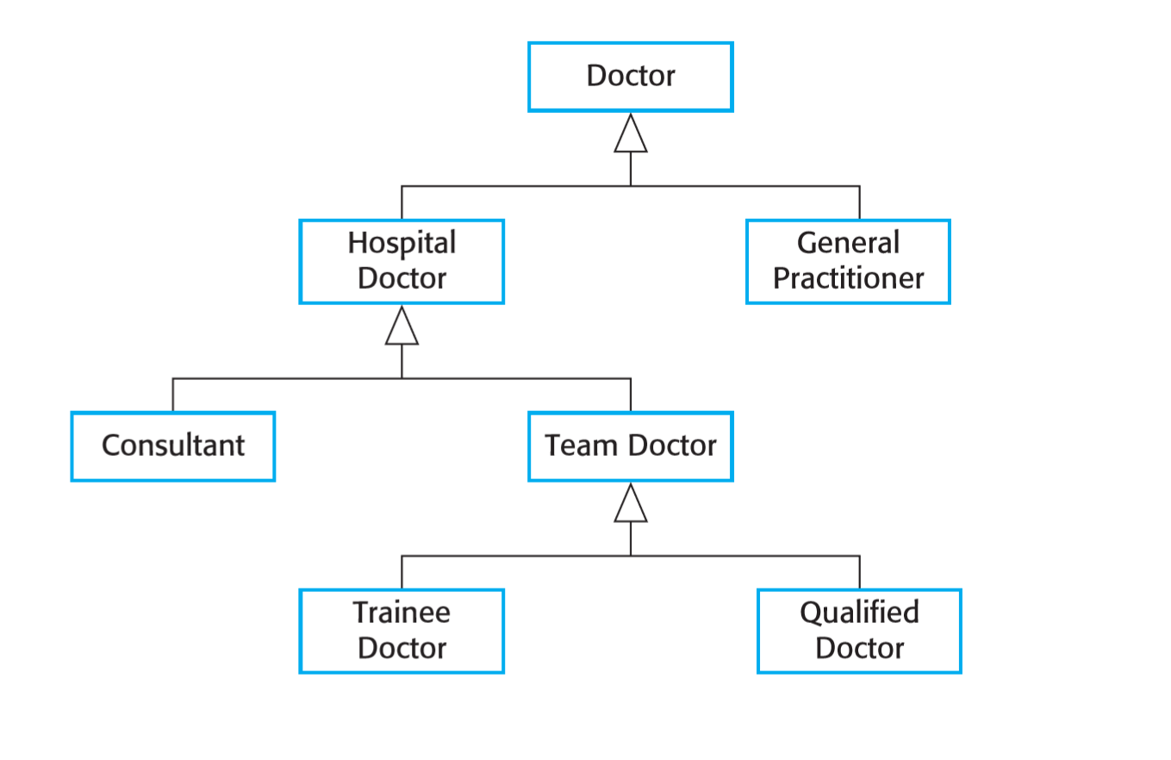

## Scenario for collecting medical history in MHC-PMS

INITIAL ASSUMPTION: The patient has seen a medical receptionist who has created a record in the system and collected the patient’s personal information (name, address, age, etc.). A nurse is logged on to the system and is collecting medical history.

NORMAL: The nurse searches for the patient by family name. If there is more than one patient with the same surname, the given name (first name in English) and date of birth are used to identify the patient.

The nurse chooses the menu option to add medical history.

The nurse then follows a series of prompts from the system to enter information about consultations elsewhere on mental health problems (free text input), existing medical conditions (nurse selects conditions from menu), medication currently taken (selected from menu), allergies (free text), and home life (form).

WHAT CAN GO WRONG: The patient’s record does not exist or cannot be found. The nurse should create a new record and record personal information.

Patient conditions or medication are not entered in the menu. The nurse should choose the ‘other’ option and enter free text describing the condition/medication.

Patient cannot/will not provide information on medical history. The nurse should enter free text recording the patient’s inability/unwillingness to provide information. The system should print the standard exclusion form stating that the lack of information may mean that treatment will be limited or delayed. This should be signed and handed to the patient.

OTHER ACTIVITIES: Record may be consulted but not edited by other staff while information is being entered.

SYSTEM STATE ON COMPLETION: User is logged on. The patient record including medical history is entered in the database, a record is added to the system log showing the start and end time of the session and the nurse involved.

## Steps of validation by inspection:

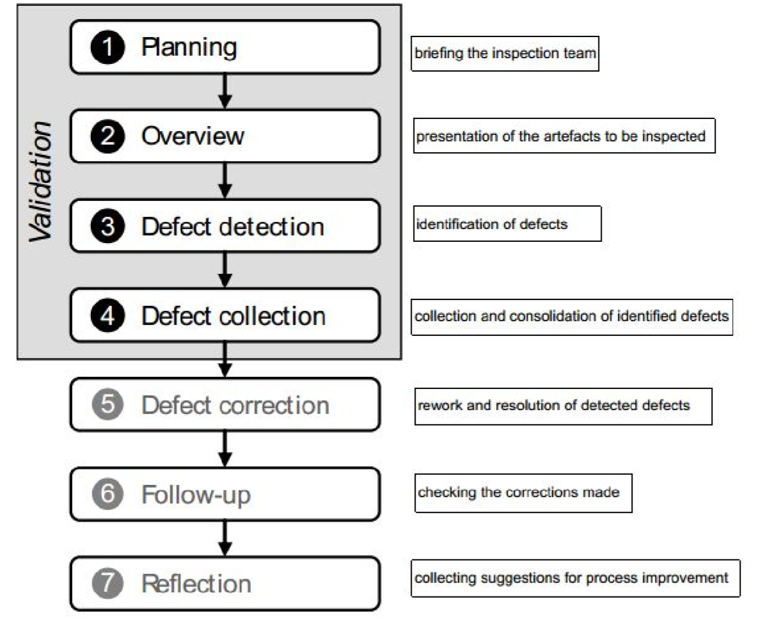

Inspection team:

**Organiser**: Responsible for planning and monitoring the inspection process

**Moderator**: leads the inspection meeting and ensures that the participants adhere to the process scheme. In addition, he should provide for a balance between the (sometimes) contradicting interests of the author and the inspectors. Therefore, he should be as neutral and objective as possible. Consequently, a person who was not involved in the creation of the artefact to be inspected should be appointed as moderator

**Author**: has created the artefact to be inspected. He explains the artefact to the inspectors in the overview phase and is responsible, later on, for correcting the detected defects

**Reader/presenter**: presents the inspection material successively and guides the inspectors through the artefact under inspection. In order to focus the inspection on the requirements artefact itself and not on the interpretation of the author, it is advisable to select a neutral (independent) reader.

**Inspectors**: responsible for detecting defects. They inform the other members of the inspection team about their findings. The inspectors should be selected in such a way that all four context facets are considered accordingly during inspection.

**Minute­taker**: documents the results of the inspection and, in particular, the detected defects

# Exercise

Using the steps and format of an inspection, detect all the defects in the all the requirements artifacts.

Don´t forget the possible defects that you may account:

Tip: There is on error for each one.

When a patient arrives or schedules a consultation, Register a Patient, located in the top bar menu, allows for a medical receptionist to create an entry to the system, fill in with the patient’s personal information and add a record to it for every visit that the patient makes. For each created entry, the Personal Information area, which is presented after selecting a patient profile and is also an accessible option on the side bar menu, describes the given name, middle names, last name, address, birthdate, gender and civil status. This individual entry will also include an area for the medical information, containing all the patient visits’ details and Medical History, which are also an accessible option on the side bar menu. In the patient visit details, the medical receptionist will be able to appoint a Doctor, a Nurse and note the visit’s date and the health-related complaint.   
While triaging the waiting patients, the Nurse can select View Record on the top bar menu so that she can search for a patient. Searching options can be filtered by name and/or birthdate. After selecting a profile, the side bar menu will enable the Personal Information and Medical History options. By accessing the Medical History option on the side bar menu, the Nurse can view/edit all visits’ records. These records display spaces which include information about the illness quality, severity, duration, context, associated signs & symptoms and comments. Quality and severity are dropdown menus while duration, context, associated signs & symptoms and comments are text boxes. Presented on a button by the lower right of the record container, there is an option to print the whole record or just the comment into an institution template document.

When a patient arrives or schedules a consultation, Register a Patient, located in the top bar menu, allows for a medical receptionist to create an entry to the system, fill in with the patient’s personal information and add a record to it for every visit that the patient makes. For each created entry, the Personal Information area, which is presented after selecting a patient profile and is also an accessible option on the side bar menu, describes the given name, middle names, last name, address, birthdate, gender and civil status. This individual entry will also include an area for the medical information, containing all the patient visits’ details and Medical History, which are also an accessible option on the side bar menu. In the patient visit details, the medical receptionist will be able to appoint a Doctor, a Nurse, which is the same as a physician, (Incorrect) and note the visit’s date and the occasion (Ambiguous).   
While triaging the waiting patients, the Nurse can wear crocs (Not relevant) and select View Record on the side bar menu, next to Register a Patient (Inconsistent), so that she can search for a patient. Searching options can be filtered by name and/or birthdate. After selecting a profile, the side bar menu will enable the Personal Information and Medical History options. By accessing the Medical History option on the side bar menu (Redundant), the Nurse can view/edit all visits’ records. These records display spaces which include information about the illness quality, severity, duration, context, associated signs & symptoms and comments. Quality and severity are dropdown menus (Missing or incomplete) while duration, context, associated signals & symptoms (Typo) and comments are text boxes. If the quality of the illness is not present on the dropdown menu option, the Nurse should be able to add the option by saying it out loud (Infeasible). Presented on a button by the lower right of the record container, there is an option to print the whole record or just the comment to an institution template document. The doctor’s prescription print option is located next to this last button, when viewing the record logged on as a doctor. (Misplaced)