# Jogu | Requirements Elicitation Process

# Logs

**Meeting 1**

2016/10/4– Friday

First contact with the product owner.

Ricardo Malafaya, Gustavo.

The first meeting served as a way to introduce the essay of ERMS. The product owner was asked if he has any product ongoing which both sides can benefit from.

The product owner was interested but had to ask colleagues. After, by email, product owner accepts our offer.

**Meeting 2**

2016/10/8 – Thursday

Introduction to the product and interview with the Product Owner.

Ricardo Malafaya, José Esteves, Gustavo.

Interview conducted by Ricardo and José to Gustavo, the product owner.

The product owner explained the goals of the product.

In group, it was made a list of use cases. In order to correctly understand the process, a use case diagram was drafted and possible scenarios were discussed.  
By the end of the meeting, the use cases were reviewed one last time and validated with product owner.

**Meeting 3**

2016/12/04 – Sunday

Document review and app experience simulation.

Ricardo Malafaya, José Esteves, Gustavo.

The meeting started with the presentation of the developments on the document.  
The use cases were reviewed and roamed within possible scenarios between each other. This so we could explore the product’s complexity and nuances and also attribute priorities.  
After reviewing and validate all use cases, it mentioned and agreed that the document lacked the notion of users’ aggregation.  
The product owner was asked to imagine a walkthrough in the app.

**Meeting 4**

2016/12/14– Sunday

Document and questionnaire review.

Ricardo Malafaya, José Esteves, Gustavo.

The document was reviewed and validated, following a checklist, and the questionnaire directed to the product owner was answered.  
The results gathered from the user’s questionnaire were shared and discussed with Gustavo.

# Validation

Validation was made in periodical reviews with the Product Owner to ensure compliance and or to determine if a change was required.  
  
While going through the document’s components, the review iterated a guideline, determined by a checklist:

* What is the goal of this action?
* What do you intend to obtain in this case?
* Who uses this functionality?
* How do think this functionality will be used?
* How can this scenario go wrong?
* What is the best case scenario for this?
* Is there any other way the user can reach the same goal?
* Does anything happen automatically at a present time?
* Is this what you intend to achieve?
* Is this what it’s supposed to do?

Also, a simulation was made in a form of an abstract walkthrough in the app so that expectations were compared with the requirements already documented.

# Elicitation

The elicitation process was made in periodical interviews with the Product Owner.

Asking open-ended questions, follow-up on the more complicated and vague answers as well as explore the implications of them served as base lines for the conversations.

Questionnaires directed to the users and another to the PO, who is also a developer, were sent.

**User Questionnaire Questions:**

* <https://goo.gl/forms/cJUZ1I3zwTDzj93u2>

1. How many times per month do you play football with your friends/colleagues? (1;2;more)
2. How do you schedule the games? (text message, facebook, email, other)
3. How do you normally organize your teams? (on site, before, randomly, turn-based picking, other)
4. Do you keep score of goals and winning sides? (yes/ no/sometimes)
5. Is that something you would like to check and share with your friends? (yes/no/not relevant)
6. Is there anything else you would like to keep track of?
7. Is there anything else you would like to share with your friends?
8. Would you use a mobile app to manage your games’ schedule and teams? (yes/no/maybe)
9. Do you have any suggestions?

**User Questionnaire Answers:**

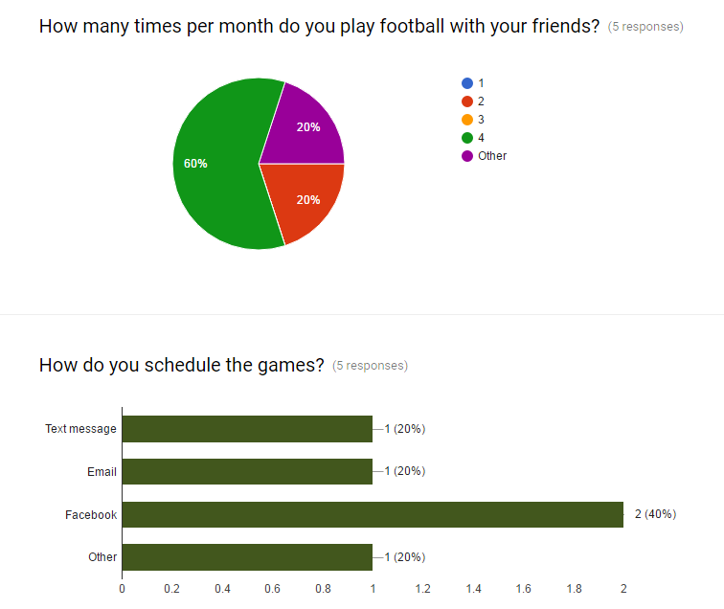

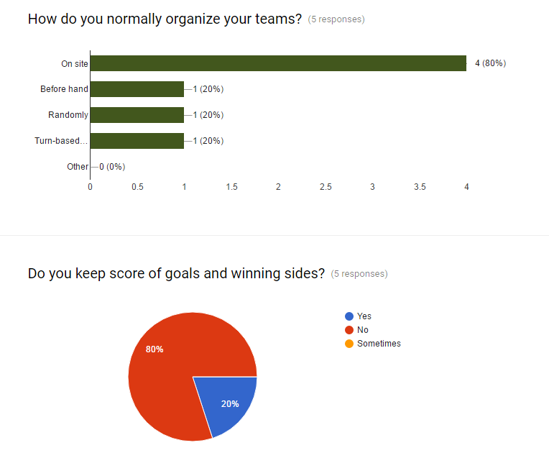

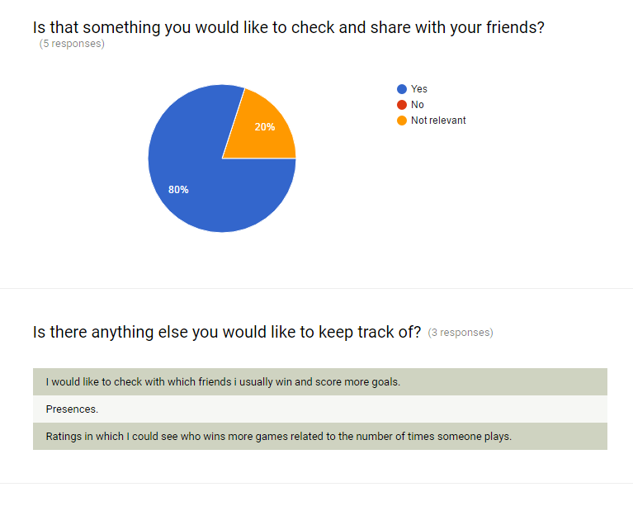

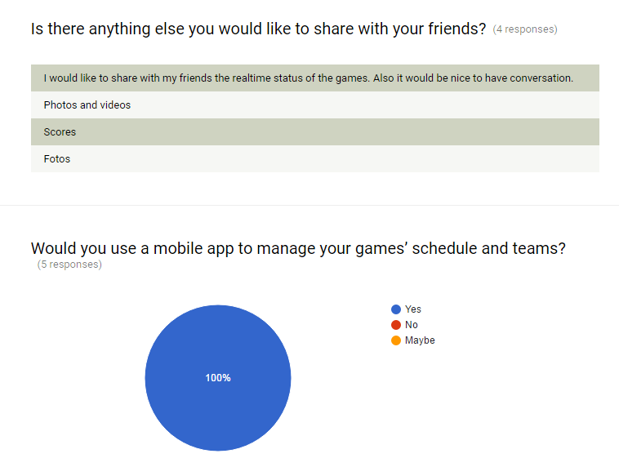

Although the results have very little range, there are still some interesting conclusions that can be issued from these answers. There is clearly margin for improvement on the functionalities the app will have to offer, since media is something several users would also like to be able to share. Being the other desired improvement, a more complex display of stats. But overall, the answers seem to indicate that there is openness to an app that manages your football activities but also a craving for more depth.

**PO + Dev Questionnaire:**

* https://goo.gl/forms/yNqyY0LoqxSna7Xe2

A – Same as before defining the project’s requirements.

B – Partially improved.

C – Largely wider notion.

After reading this document, do you think you have a better understanding of:

|  |  |
| --- | --- |
|  | Answer |
| 1. Identify the project’s components. | C |
| 1. Division of the project’s tasks and responsibilities. | B |
| 1. Determine the technical approach. | C |
| 1. Identify the knowledge and skills needed to perform the project. | B |
| 1. Estimate cost and effort of tasks. | C |
| 1. Establish budget and schedule. | B |
| 1. Identify major milestones. | C |
| 1. Identify constraints and risks. | C |
| 1. Determine staffing requirements. | B |
| 1. Develop overall project plan. | C |

The questionnaire was presented and explained during the 4th meeting. The PO answers indicate an overall increase of awareness of the project’s components and structure.