

JOGU

Software Requirements Specification

Version 1.2

December 14, 2016

José Esteves
Ricardo Malafaya

Prepared for ERMS - Requirements Engineering and Software Modeling, FEUP, 2016


Revision History
Date | Description |  | Author | Comments
2016-11-10 |  | Iteration 0 - First draft | J&R | Version 1.1
2016-11-11 |  | Iteration 1 - PO Modifications | J&R | Version 1.2
2016-12-07 |  | Iteration 2 | J&R | Version 1.3
2016-12-14 |  | Final – Structure Reformulated | J&R | Version 2.0

Document Approval
The following Software Requirements Specification has been accepted and approved by the following:
Signature | Printed Name | Title | Date
Gustavo | Gustavo | PO | 2016-11-09
Gustavo | Gustavo | PO | 2016-11-11
Gustavo | Gustavo | PO | 2016-12-14

Table of Contents

Revision History ii
Document Approval ii
1. Introduction 1
1.1 Purpose 1
1.2 Scope 1
1.2.1 Goals 1
1.2.2 Stakeholders 1
1.3 Definitions, Acronyms, and Abbreviations 2
1.4 References 2
1.5 Overview 2
2. General Description 3
2.1 Product Perspective 3
2.2 Product Functions 3
2.2.1 User Login Use Case 4
2.2.2 User Manages Groups Use Case 5
2.2.3 User Manages Events Use Case 7
2.2.4 User Manages Stats Use Case 9
2.3 User Characteristics 11
2.4 General Constraints 11
2.5 Assumptions and Dependencies 11
4. Specific Requirements 11
3.1 External Interface Requirements 11
3.1.1 User Interfaces 11
3.1.2 Hardware Interfaces 14
3.1.3 Software Interfaces 14
3.1.4 Communications Interfaces 14
3.2 Functional Requirements 14
3.4 Classes / Objects 19
3.4.1 User Entity 19
3.4.2 Group Entity 20
3.4.3 UserType Entity 20
3.4.4 Event Entity 20
3.4.5 Team Entity 20
3.4.6 Stat Entity 20
3.5 Non-Functional Requirements 21
3.5.1 Performance 21
3.5.2 Reliability 21
3.5.3 Availability 21
3.5.4 Security 21
3.5.5 Maintainability 21
3.5.6 Portability 22
3.6 Inverse Requirements 22
3.7 Design Constraints 22
3.8 Logical Database Requirements 22
A. Appendices 1
A.1 Activity Diagram 1
A.2 Class Diagram 2
A.3 State Diagram 3
A.4 Dependency Matrix 3
A.5 Requirements and their attributes 4

1. Introduction

1.1 Purpose
The purpose of this document is to present a detailed description of the Web Social Football amateur system. It will explain the purpose and features of the system, the interfaces of the system, what the system will do, the constraints under which it must operate and how the system will react to external stimuli. This document is intended for both the stakeholders and the developers of the system.
The software JOGU is a mobile platform where football amateur players can share experiences. The users of this application can create football games, called events, and invite other users to join and create a game. This app permit to share live goals, attendance and results of each event. Each player can also check past games, goals and statistics.

1.2 Scope
This software system will be a mobile platform where football amateur players can share experiences called JOGU. The system will be designed to the facilitate the management of large groups of friends that have scheduled game events.
The users of this application can create football games, called events, and invite other users to join and create a game. More specifically, this system is designed to allow the user to create and share events with a group of friends and share live goals, attendance and results of each event. Each user will be able to check the score of past events and consult statistics about them self’s.

1.2.1 Goals
This software is a platform of share experience of the amateur football players. The user can create events. To each event, other users can be invited and attend. After the users confirm that they will attend the event, the teams are made. All the participants of the event can share stats of the event. The creator of the event is set as an administrator of that event and can overwrite any stat publish by the attendees. The administrator can attribute administrator’s permissions to other users on the event.
Each user can connect to application through login and access their own stats.
This application is targeting mobile devices (Android and IOS). To publish stats the application needs access to internet but also will permit to consult the stats offline.
In summary, the goals are:
- User Invites Friends to Events
- User Creates Game Events
- User Publishes Game Stats
- Run on IOS and Android mobile phones

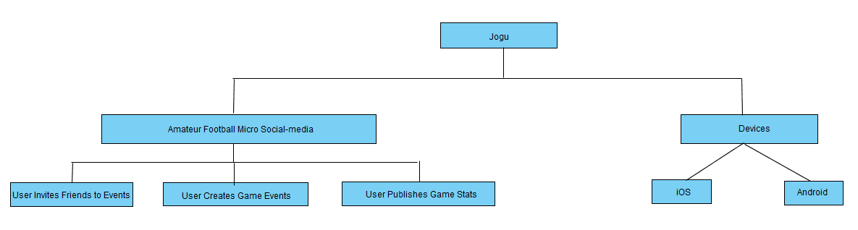

1.2.2 Stakeholders
The relevant stakeholder of this application are the product owner, the group of developers and the people that will use the app, both those who interact with its features and users as well as the users who are just viewing and exploring the displayed information.

1.3 Definitions, Acronyms, and Abbreviations
Term | Definition
User | Any amateur football player that use the application to create events, attend to events or check stats.
Event | Is a meeting created by the users which users can attend with the information about the time and the place where the amateur football game will be taking place.
Administrator | In case of incorrect stats, the administrator is the user with the permission to alter the stats published by the users.
Super Administrator | Person of developing team charged to intervene in case of failure.
Group | A list of users. A group can be associated to several events.
Stats | Published information that can be goals, attendance or final score of the event
Team | At event, the participants are divided in to groups.
Invitation | An invitation sent by the creator of the event. The users can accept this invitation.
Statistics | Information that the user can access about the events, goals, results and attendance of past events.

1.4 References
IEEE. IEEE Std 830-1998 IEEE Recommended Practice for Software Requirements Specifications. IEEE Computer Society, 1998.

1.5 Overview
The next chapters, the Overall Description section, of this document gives an overview of the functionality of the product. It describes the informal requirements and is used to establish a context for the technical requirements specification in the next chapter.
The third chapter, Requirements Specification section, of this document is written primarily for the developers and describes in technical terms the details of the functionality of the product.
Both sections of the document describe the same software product in its entirety, but are intended for different audiences and thus use different language.
This table represent the relations between goals (section 1.3), user cases (section 2.2) and requirements (section 3.2):
ID | Goals | ID | Use Cases |  | Requirements
 |  | UC0 | User Login | R0.1 | User Login
 |  | UC0 | User Login | R0.2 | User Register
G1 | User Invites Friends to Events | UC1.1 | User Manages Group | R1.1 | User Creates Groups
 |  |  |  | R1.2 | User Checks Group
 |  |  |  | R1.3 | Admin Edits Group
G1 | User Invites Friends to Events | UC1.2 | User Accepts Invitation | R1.4 | User Accepts Invitation
G1 | User Invites Friends to Events | UC1.3 | Admin Adds Event to Group | R1.5 | Admin Adds Event to Group
G2 | User Creates Game Events | UC2.1 | User Manages Event | R2.1 | User Creates Event
 |  |  |  | R2.2 | User Checks Event
 |  |  |  | R2.3 | Admin Edit Event
G3 | User Publishes Game Stats | UC3.1 | User Adds Stat to Event | R3.1 | User Adds Stat to Event
G3 | User Publishes Game Stats | UC3.2 | User Manages Stat | R3.2 | User Check Stat
 |  |  |  | R3.3 | Admin Edits Stat

2. General Description
This section will give an overview of the whole system. The system will be explained in its context to show how the system interacts with other systems and introduce the basic functionality of it. It will also describe what type of users that will use the system and what functionality is available for each type. At last, the constraints and assumptions for the system will be presented.

2.1 Product Perspective
This system will consist of two parts. The mobile application through which the users can access and a central repository containing all the data. The mobile application will be used to create the game events, manage friend’s groups and share stats with others users.
The mobile application will need to communicate by internet to the repository in order to get and store information. This communication by internet will be embedded into the application in order for the user to be able to use the functions in the application in a seamlessly manner.

2.2 Product Functions
With the mobile application, the users will be able to create, edit and consult group of friends. The user will be able to invite a friend by entering his email or any friend from past events. In the order end, users will receive and email invitation. By clicking on the provide link, the users will gain access to the group.
Only the creator of the groups will have the permission of an administrator, however, he can set other members of the group as administrators as well.
For each group, the user can create a game event. All the users members of that group will have access to the event’s time, locations, teams and score. Only the administrator can change change the teams dispositions, location, or time.
The users will be able to change the score by adding stats to an event. Each stat is associated with the team and the user who score the goal. In case of insertion of some kind of incorrect stat, the administrator could change that stat.
Any user will be able to access the all the statistics of pass scores.
In order to manage and users identify and locate friends a login system will be used and required to use the application.
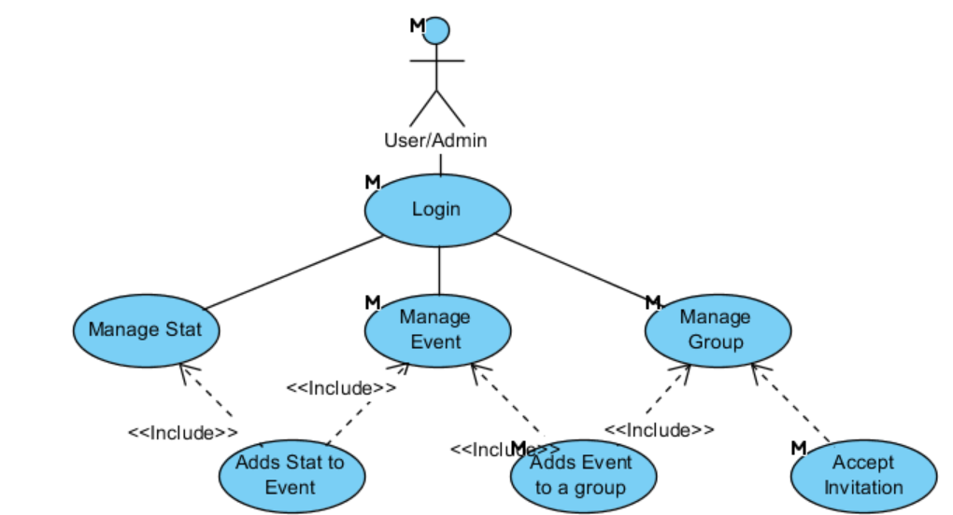
Figure 1 - System Environment

2.2.1 User Login Use Case

Use Case: UC0 - User Login
Diagram:
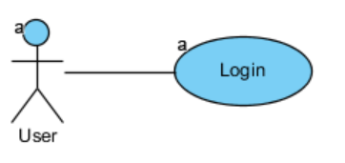
Brief Description
The user can login into the system with email and password. If the user is not registered in system, he can register a new account.

Initial Step-By-Step Description
The first interaction between the user and the application. The login will appear on the launch of the App.

- The user selects login method: email and password or Google account or Facebook account.
- The user inserts credentials.
- After confirmation, the system will show the main app window.

Xref:
Goals: G1 + G2
Requirements: R0.1 + R0.2
Mock: M0

2.2.2 User Manages Groups Use Case

Use case: UC1.1 - User Manages Group
Diagram:
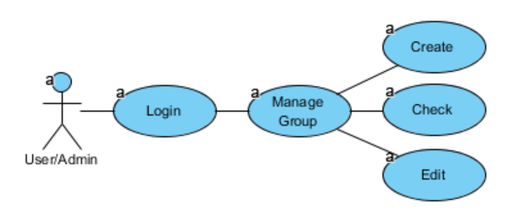
Brief Description
The user creates a group by adding users by inputting an email or a username. Every user in the group can consult, but only the user with administrator permissions can edit it.

Initial Step-By-Step Description
Before user create a group, has to be login on system.

- The user on “Main Page” can select a group on the group’s list or select the add sign to create a new one.
- The system redirects to the “Group page”.
- If the user is admin, he can select the group name to alters it, can add admin permissions to users or select the add sign to send invites to other users.
- All the users that already accept an invite will show on the list.

Xref:
Goals: G1
Requirements: R1.1 + R1.2 + R1.3
Mock: M1 + M2

Use case: UC1.2 - User Accepts Invitation
Diagram:
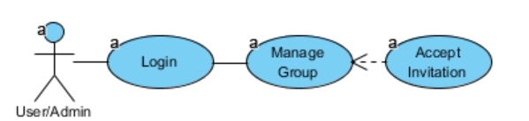
Brief Description
The user can receive invitations to enter in other group

Initial Step-By-Step Description
As soon as the author of the user add a friend user to a group. This user will receive an invitation by email.

- The user selects the link send by email.
- The system automatically adds the user to the group of the invitation.

Xref:
Goals: G1
Requirements: R1.4

Use case: UC1.3 - Admin Adds Event to Group
Diagram:
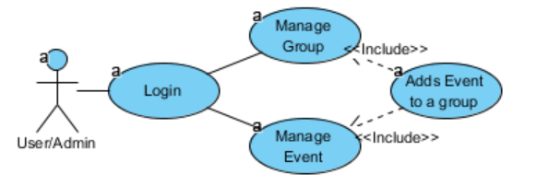
Brief Description
After the group is made, the administrator can add new events.

Initial Step-By-Step Description

- From the “Main Page” the user selects the group that wants to add an Event.
- The System will show the “Group Page”
- The user selects option “Add Event”
- The system lists all the events within the group and an option to create a new one.

Xref:
Goals: G1 + G2
Requirements: R1.5
Mock: M1

Scenario: S1 - User Invites Friends to Events

Description
After logging in, the user continues to create a group so that he can gather a specific group of friends. He achieves this by inviting them to join in that group and when his invitation is accepted by the receiving end. After his friends accept the invitation, they are now able to view all the existing events and join the available ones created in that group. Here, he’ll grant permission powers to some of them, so that one can perform administrator tasks whenever more available or in case of another being less so. The admins share responsibilities such as inviting other members in order to grow their community or naming the group. The user creates an event so he and his friends can gather in scheduling and forming the teams for an upcoming game. When the event is created and the group members are able to subscribe to its teams, then the user has successfully invited his friends to join the event.
Xref:
Use Cases: UC1.1+ UC1.2+ UC1.3
Requirements: R1.1 + R1.2 + R1.3 + R1.4 + R1.5

2.2.3 User Manages Events Use Case

Use case: UC2.1 - User Manages Event
Diagram:
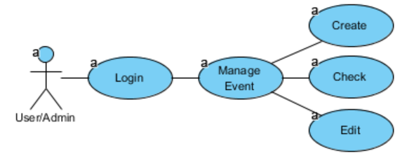
Brief Description
The user creates an event. Every event has an associated group. Each user of the associated group, can check the event. Only the users with administrator permissions can edit the event.

Initial Step-By-Step Description
Before user create an event, has to be login on system.

- From the “Main Page”, the user can select an event on the event’s list and system redirects to the “Event page” that will show the date, location, teams and final score of the event.
- If the user is admin, he can:
  - Select modify the date, location and team dispositions of the event.
  - Create a new event from the Group page.

Xref:
Goals: G2
Requirements: R2.1 + R2.2 + R2.3
Mock: M3

Scenario: S2 - User Creates Game Events

Description
After selecting a group, the user creates an event by introducing a new event entry and scheduling its date/location, so that he can organize an upcoming match with his friends. Meanwhile the event date approaches, he checks the event and its’ teams in order to verify if the event will have sufficient players to complete the teams or simply to consult them. If need be, an admin can edit the location and the date, so that he can manage individual circumstances and possibilities, thus providing a flexible and better alignment with the members commitment. The admin can also change a team member’s allocation so that he can readjust the team’s line-up.

Xref:
Use Cases: UC2.1
Requirements: R2.1 + R2.2 + R2.3

2.2.4 User Manages Stats Use Case

Use case: UC3.1 - User Adds Stat to Event
Diagram:
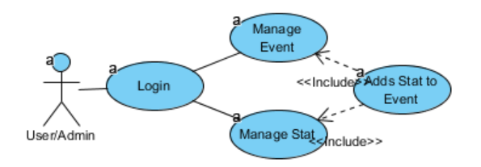
Brief Description
After the event is made, the users can add stats to it. The users can access the event and add stats to it.

Initial Step-By-Step Description

- From the “Main Page” the user selects the event that wants to add an Stat.
- The System will show the “Event Page”
- The user selects option “Add Stat”
- The system will redirect to the “Stat Page”.
- The user enters the author of the stats and the stat info.

Xref:
Goals: G1 + G2
Requirements: R3.1
Mock: M3

Use case: UC3.2 - User Manages Stat
Diagram:
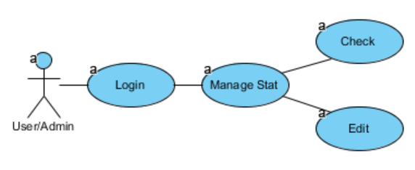
Brief Description
The user can check the stats associated to him or the stats associated with an event. If the user has administrator permissions on the group associated with the event that contain the stat, then he can edit it.

Initial Step-By-Step Description
Before user manage a stat, has to be login on system.

- The user selects the Stats from the “Main Page”
- The system will show the list of all the stats which the user is involved.
- If the user has admin permission over the stats, he can change it by clicking on it.

Alternative

- The user selects the Event from the “Main Page”
- The system will show the “Event Page”, and the list of all the stats related to that Event.
- If the user has admin permission over the stats, he can change it by clicking on it.

Xref:
Goals: G1 + G2
Requirements: R3.2 + R3.3
Mock: M4 + M3

Scenario: S3 - Publishes Game Stats

Description

After a game, the user accesses the related event so that he can publish the final score and the match’s goal scorers. Other users will be able to check that information when consulting the event’s stats and add new ones when verifying that there is missing information. Nevertheless, the admin will be able to edit and overwrite whichever stat so that he can correct mistakes or have the final word about defining a record.

Xref:
Use Cases: UC3.1+ UC3.2
Requirements: R3.1 + R3.2 + R3.3

2.3 User Characteristics
There are two types of users, the regular user and the administrator. Every administrator have the same capabilities of a user and the capabilties to edit groups, events or stats.
The functionalities that the administrator has that users don’t are:
- Editing a group - change permissions, add, remove any member.
- Editing an event - change location, time and team disposition.
- Editing a stat - change goal author.
The administrators are only relative to the group. A user can be a regular user in a group and an administrator in another. The regular user gain administrator permissions by one of two ways:
- By being the original creator of a group
- By be set as administrator of a group by the original creator of a group
Every other functionality can be done by the users or administrators.

2.4 General Constraints
The mobile application is constrained by operation system of the mobile phone. Since there are multiple, the interface will most likely not be the same for every one of them. Also, there may be a difference between what navigation features each of them provide.
The Internet connection is also a constraint for the application. Since the application fetches data from the database over the Internet, it is crucial that there is an Internet connection for the application to function.

2.5 Assumptions and Dependencies
One assumption about the product is that it will always be used on mobile phones that have enough performance. If the phone does not have enough hardware resources available for the application, for example the users might have allocated them with other applications, there may be scenarios where the application does not work as intended or even at all.

Specific Requirements
This section contains all of the functional and quality requirements of the system. It gives a detailed description of the system and all its features.

External Interface Requirements
This section provides a detailed description of all inputs into and outputs from the system. It also gives a description of the hardware, software and communication interfaces and provides basic prototypes of the user interface.

User Interfaces
A first-time user of the mobile application should see the log-in page when he/she opens the application. If the user has not registered, he/she should be able to do that on the log-in page.
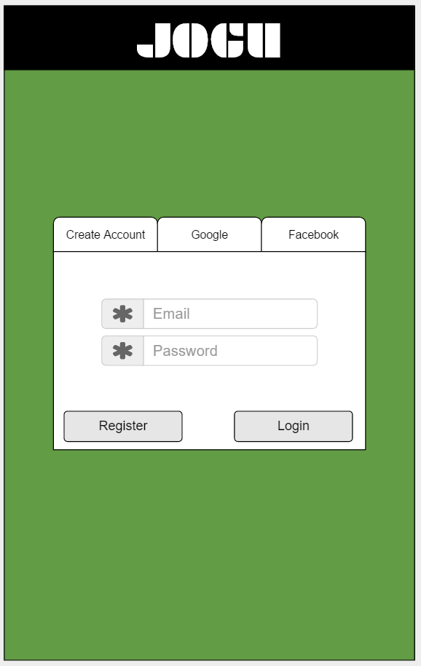
Figure 2 M0 - Login Page
If the user is not a first-time user, he/she should be able to see the search page directly when the application is opened.
Here, in the Main page, the user can see the groups, future events and last stats.
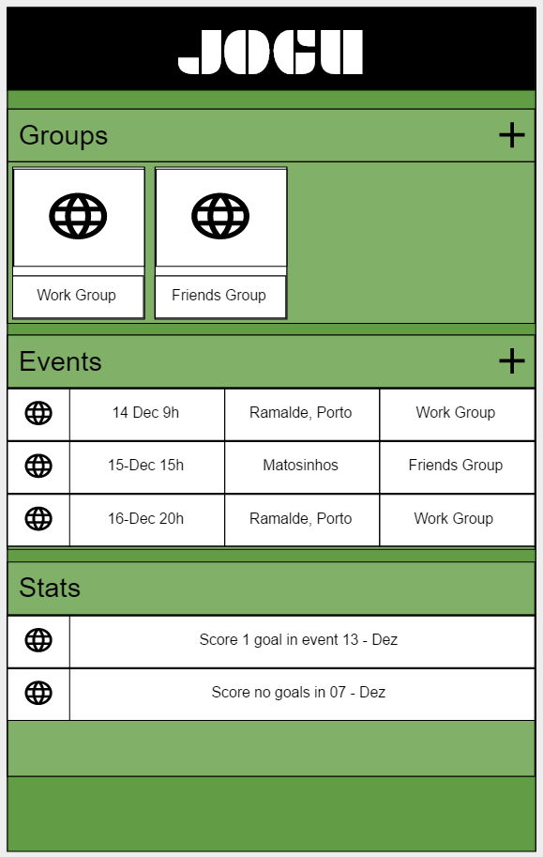
Figure 3 M1 - Main Page
In the group view is the list of the group members with a button option to each one to provide admin access. There is also the button to invite new members and associate events to the group.
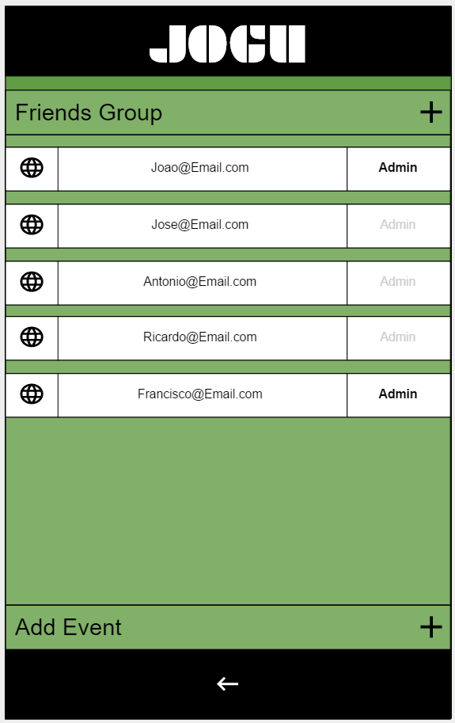
Figure 4 M2 - Group Page
In the event view the users can see the time and location, score and the team dispositions. There is also a button to add a stat to the event.
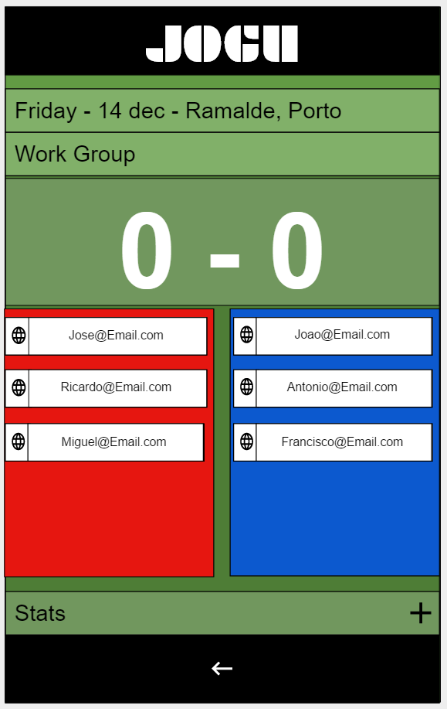
Figure 5 M3 - Event Page
Each user can view the list of stats associated with a user or an event.
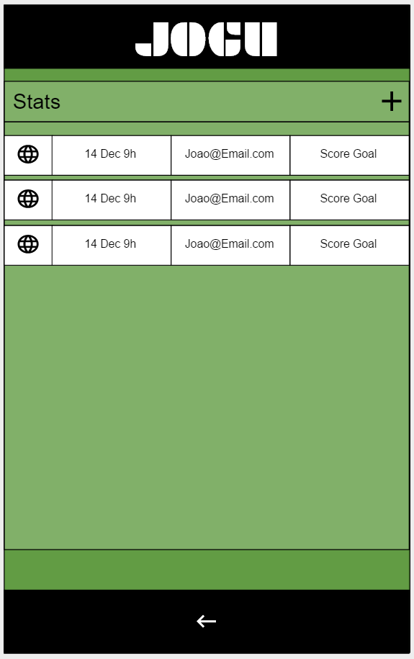
Figure 6 M4 - Stats Page

3.1.2 Hardware Interfaces
Since the mobile application have any designated hardware, it does not have any direct hardware interfaces. The hardware connection to the database server is managed by the underlying operating system on the mobile phone and the web server.

3.1.3 Software Interfaces
The communication between the database and the web portal consists of operation concerning both reading and modifying the data, while the communication between the database and the mobile application consists of only reading operations.

3.1.4 Communications Interfaces
The communication between the different parts of the system is important since they depend on each other. However, in what way the communication is achieved is not important for the system and is therefore handled by the underlying operating systems.

3.2 Functional Requirements
This section includes the requirements that specify all the fundamental actions of the software system.

3.2.1 R0.1 - User Login
Use Case Name | UC0 - User Login
XRef | Section 2.2.1, UC0 - User Login  Mock M0
Trigger | The user opens application
Precondition | The user has not yet logon on application
Basic Path | - The user opens the application  - The system displays login by email, Google or Facebook.  - The user has to choose the login type and enter the credentials.  - The system will check if the credentials are correct  - The main window of the app is shown
Alternative Paths | In step 2., if user already logon on app go to 5.
Postcondition | User enters main page
Exception Paths | If credentials are not correct, shows an error message.
Other | None

3.2.2 R0.2 - User Registers
Use Case Name | UC0 - User Login
XRef | Section 2.2.1, UC0 - User Login  Mock M0
Trigger | The user opens application
Precondition | The user has not yet logon on application
Basic Path | - The user opens the application  - The system displays login by email, Google or Facebook.  - The user enters the credentials and selects Register.  - The system will send a verification email to user.  - The system shows a message to the user verify the email.  - System hangs until confirmation of email and proceeds.  - System verify invitations (See 3.2.6 R1.4 - User Accepts Invitation)
Alternative Paths | None.
Postcondition | The database has been updated.
Exception Paths | In case of no internet, the system message user that he cannot proceed without internet
Other | None

3.2.3 R1.1 - User Creates Group
Use Case Name | UC1.1 - User Manages Group
XRef | Section 2.2.2, UC1.1 - User Manages Group  Mock M1, M2
Trigger | The user selects the option “Create a Group” from Main page
Precondition | The user has already logon on system
Basic Path | - The user selects the users to add (from past events) or inputs the other users email.  - The system verifies information and shows the group window
Alternative Paths | None.
Postcondition | The database has been updated.
Exception Paths | In case of no internet, the system message user that he cannot
Other | None

3.2.4 R1.2 - User Checks Group
Use Case Name | UC1.1 - User Manages Group
XRef | Section 2.2.2, UC1.1 - User Manages Group  Mock M1, M2
Trigger | The user selects the group from Main page or select the associated group from the event page.
Precondition | The user has already logon on system
Basic Path | - The system shows all the users and permission of that group.
Alternative Paths | None.
Postcondition | The users that were invited but not accepted the invitation yet will appear in grey.
Exception Paths | None.
Other | None.

3.2.5 R1.3 - Admin Edits Group
Use Case Name | UC1.1 - User Manages Group
XRef | Section 2.2.2, UC1.1 - User Manages Group  Mock M1, M2
Trigger | The user selects the group from Main page
Precondition | The user has to have administrator permissions in the group.
Basic Path | - The user select a user from the group and can:  - Add Admin permissions  - Remove user
Alternative Paths | The user can still add new users (see R1.1)
Postcondition | The database has been updated.
Exception Paths | In case of no internet, the system message user that he cannot
Other | None

3.2.6 R1.4 - User Accepts Invitation
Use Case Name | UC1.2 - User Accepts Invitation
XRef | Section 2.2.2, UC1.2 - User Accepts Invitation  Mock M2
Trigger | “Other” user add “this” user to a group
Precondition | The user has to be invited to enter a group and user must have an email.
Basic Path | - User receives an email with an invitation link  - When user access the link, the system adds the user to the group automatically without user open the app.
Alternative Paths | If there the user had not created an account:  - User receives an email with an invitation link  - When user access the link, the system adds the email user to group.  When the user Register the email, the system checks if the email is already associated with any Group.
Postcondition | The database has been updated.
Exception Paths | In case of no internet, the system message user that he cannot
Other | None.

3.2.7 R1.5 - Admin Adds Event to Group
Use Case Name | UC1.3 - Admin Adds Event to Group
XRef | Section 2.2.2, UC1.3 - Admin Adds Event to Group  Mock M1, M2, M3
Trigger | The user selects option “Add Event” from group page.
Precondition | The user has already logon on system
Basic Path | - The user selects option “Add Event” from group page  - The system show list of events associated with group and an option to create a new one.  - The user can:  - Select an already created event to repeat  - Create a new event (see R2.1 - User Creates Event)  - The system returns back from the Group page with the new event listed.
Alternative Paths | In step 3, user can go back.
Postcondition | The database has been updated.
Exception Paths | In case of no internet, the system message user that he cannot
Other | None.

3.2.8 R2.1 - User Creates Event
Use Case Name | UC2.1 - User Manages Event
XRef | Section 2.2.3, UC2.1 - User Manages Event  Mock M2, M3
Trigger | The user selects the option “Add an Event” from Group page (see R1.5 - Admin Adds Event to Group)
Precondition | The group has to already be created.
Basic Path | - The system shows the event page.  - The users enter the Event info (location, date, etc.).  - The system returns back from the Group page with the new event listed.
Alternative Paths | In step 1. and 2., user can go back.
Postcondition | The database has been updated.
Exception Paths | In case of no internet, the system message user that he cannot
Other | None.

3.2.9 R2.2 - User Checks Event
Use Case Name | UC2.1 - User Manages Event
XRef | Section 2.2.3, UC2.1 - User Manages Event  Mock M1, M2, M3
Trigger | The user selects Event from group page or from the main page.
Precondition
Basic Path | - The system shows:  - The Event info (location, date, etc.).  - The associated group  - The Score  - The teams
Alternative Paths | None.
Postcondition | None.
Exception Paths | None.
Other | None.

3.2.10 R2.3 - Admin Edit Event
Use Case Name | UC2.1 - User Manages Event
XRef | Section 2.2.3, UC2.1 - User Manages Event  Mock M3
Trigger | The user selects Event from group page or from the main page
Precondition | The user must have admin permissions
Basic Path | - The user can:  - Edit any Event info (location, date, etc.).  - Drag users from one team to another
Alternative Paths | None.
Postcondition | The database has been updated.
Exception Paths | In case of no internet, the system message user that he cannot
Other | None.

3.2.11 R3.1 – User Adds Stat to Event
Use Case Name | UC3.1 - User Adds Stat to Event
XRef | Section 2.2.4, UC3.1 - User Adds Stat to Event  Mock M4, M3
Trigger | The user selects add stat on event page
Precondition
Basic Path | - The system opens the stat page  - The user sets stat info (owner, type, etc.) and proceed.  - The system will back to event page with the added Stat  - The event score will be updated
Alternative Paths | None.
Postcondition | The database has been updated.
Exception Paths | In case of no internet, the system message user that he cannot
Other | None.

3.2.12 R3.2 – User Checks Stats
Use Case Name | UC3.2 - User Manages Stat
XRef | Section 2.2.4, UC3.2 - User Manages Stat  Mock M4, M3
Trigger | User selects stats from the Main page or from the event page.
Precondition
Basic Path | - The system provides the owner, the event, the type of the stat.
Alternative Paths | None.
Postcondition | None.
Exception Paths | In case of no internet, the system message user that he cannot
Other | None.

3.2.13 R3.3 – Admin Edits Stats
Use Case Name | Remove Article
XRef | Section 2.2.4, UC3.2 - User Manages Stat  Mock M4, M3
Trigger | The user checks Stat (see R3.2 – User Checks Stats)
Precondition | The user must have admin permissions of the group that contains the event that contains the stat to be modified.
Basic Path | - The system shows the stat page.  - The user alters the field that want to edit.
Alternative Paths | None.
Postcondition | The database has been updated.
Exception Paths | In case of no internet, the system message user that cannot
Other | None.

3.4 Classes / Objects
The logical structure of the data to be stored in the internal JOGU database that is given below.
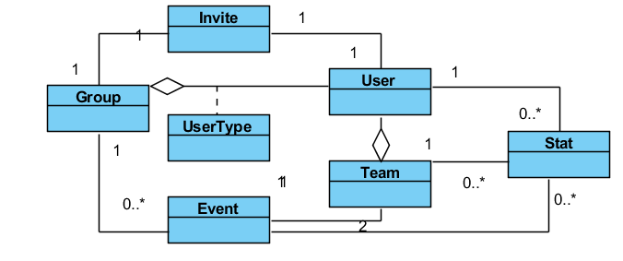
Figure 7 - Logical Structure simplified

3.4.1 User Entity
Data Item | Type | Comment
Name | Text
Email Address | Text
UserName | Text
IsActive | Boolean
Group | Pointer | List
ProfilePicture | Pointer

3.4.2 Group Entity
Data Item | Type | Comment
ID | Integer
Name | Text
User | Pointer | List
Event | Pointer | List

3.4.3 UserType Entity
Data Item | Type | Comment
Group | Pointer
User | Pointer
Accepted | Boolean

3.4.4 Event Entity
Data Item | Type | Comment
ID | Integer
Name | Text
Date | Date
Location | Pointer
Group | Pointer
Team | Pointer | There are 2
Stat | Pointer | List

3.4.5 Team Entity
Data Item | Type | Comment
ID | Integer
Group | Pointer | May be several
Event | Pointer | Used for keyword search
Stat | Pointer | List

3.4.6 Stat Entity
Data Item | Type | Comment
ID | Integer
Type | Text
Value | Text
Group | Pointer | May be several
Event | Pointer | Used for keyword search
User | Pointer | List

3.5 Non-Functional Requirements

3.5.1 Performance

Performance Requirement: PR1 - Usage of application
Description: The application flow should be evident, simple and easy to understand.
Reason: In order to for a user to use the application easily.
Meter: Number of clicks needed to access a feature.
Must: No more than 15
Wish: No more than 10

Performance Requirement: PR2 – Response Time
Description: All the data required by the application should be required fast.
Reason: In order to for a user to use the application quickly.
Meter: Response time of any fetch data.
Must: No more than 2 seconds 100% of the time.
Wish: No more than 1 second 100% of the time.

3.5.2 Reliability

Reliability Requirement: RR1 – System Reliability
Description: The reliability of the system when is used.
Reason: The system has to be reliable.
Meter: Number of system unavailability moments in 100 hours of usage.
Must: less than 1.

3.5.3 Availability

Availability Requirement: AR1 – Internet Connection
Description: In case of no internet, the user should be aware with a message.
Reason: In order to for a user to be aware if the unavailability of the system.
Meter: A message informing the user.
Must: 100% of the time

3.5.4 Security

Security Requirement: SR1 – Communication Security
Description: Security of the communication between the system and server.
Reason: Prevent wrong using of the system.
Meter: The messages should be encrypted for log-in communications, so others cannot get user-name and password from those messages.
Must: Attempts to get user-name and password fail 100%

3.5.5 Maintainability
There are no requirements related to this feature.

3.5.6 Portability

Portability Requirement: PTR1 – Application portability
Description: The application should be portable with iOS and Android.
Reason: The adaptable platform for the application to run on.
Meter: Run on both systems.

3.6 Inverse Requirements
There are no requirements related to this feature.

3.7 Design Constraints
There are no requirements related to this feature.

3.8 Logical Database Requirements
There are no requirements related to this feature. All the current database requirements are listed in section 3.4 Classes / Objects.

A. Appendices

A.1 Activity Diagram
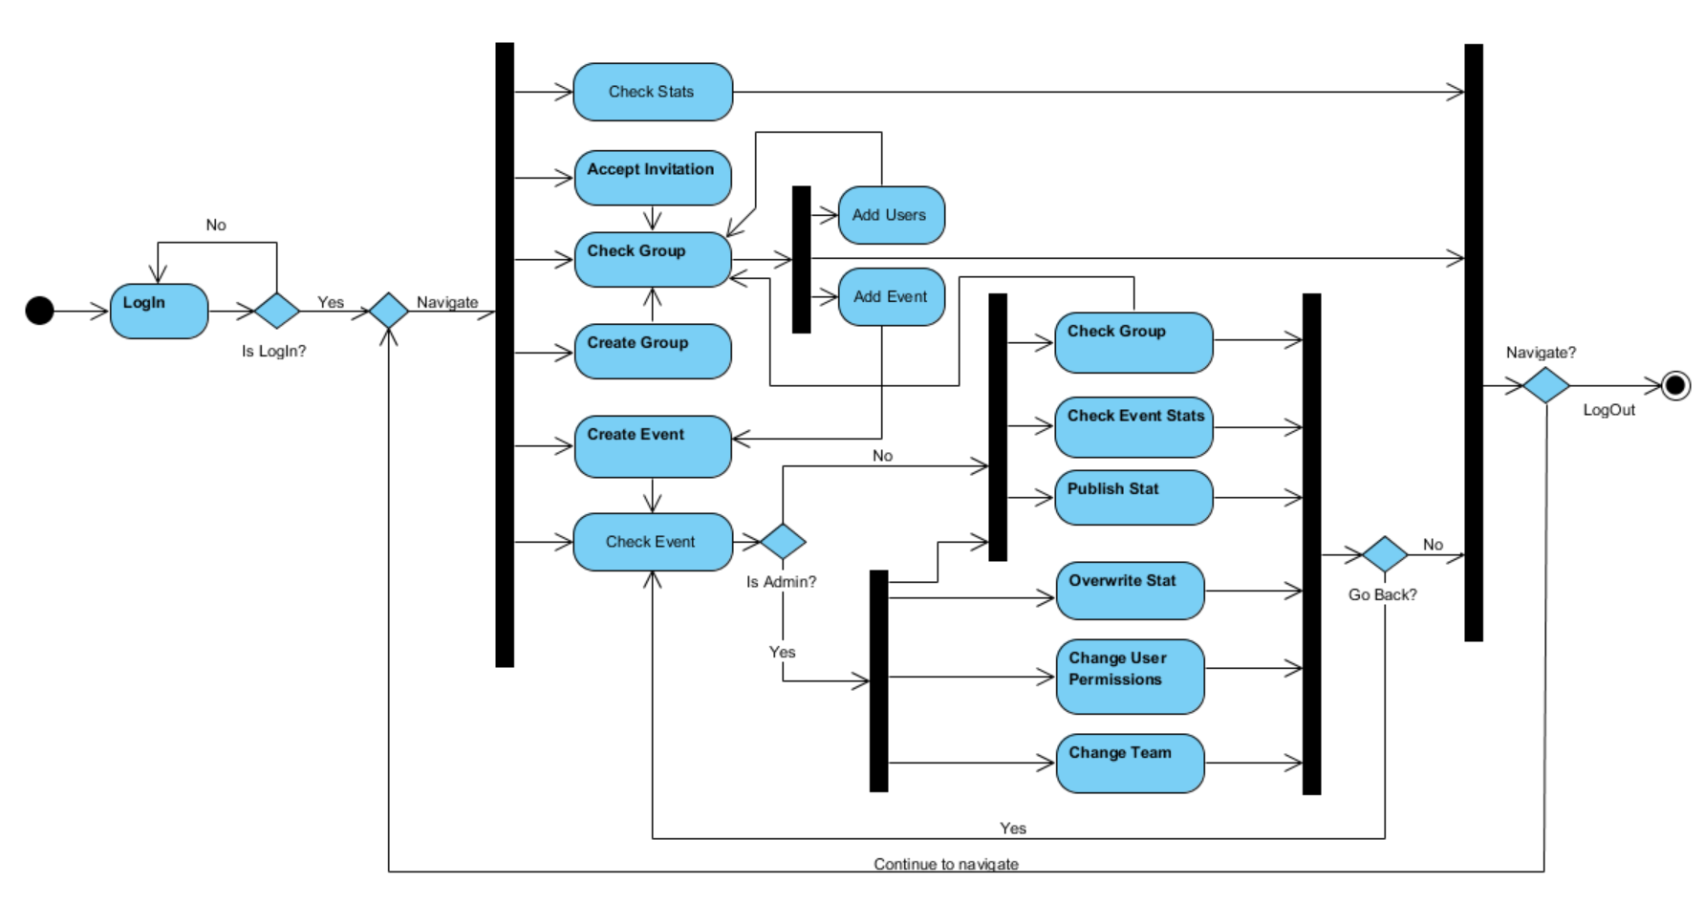

A.2 Class Diagram
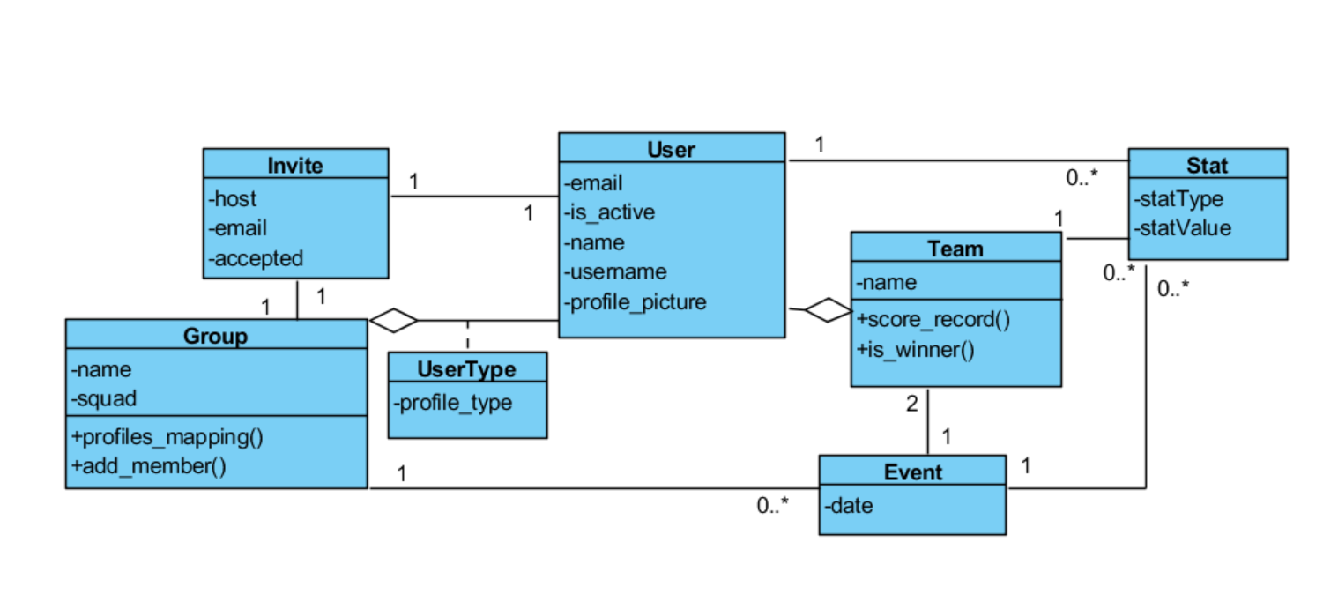

A.3 State Diagram
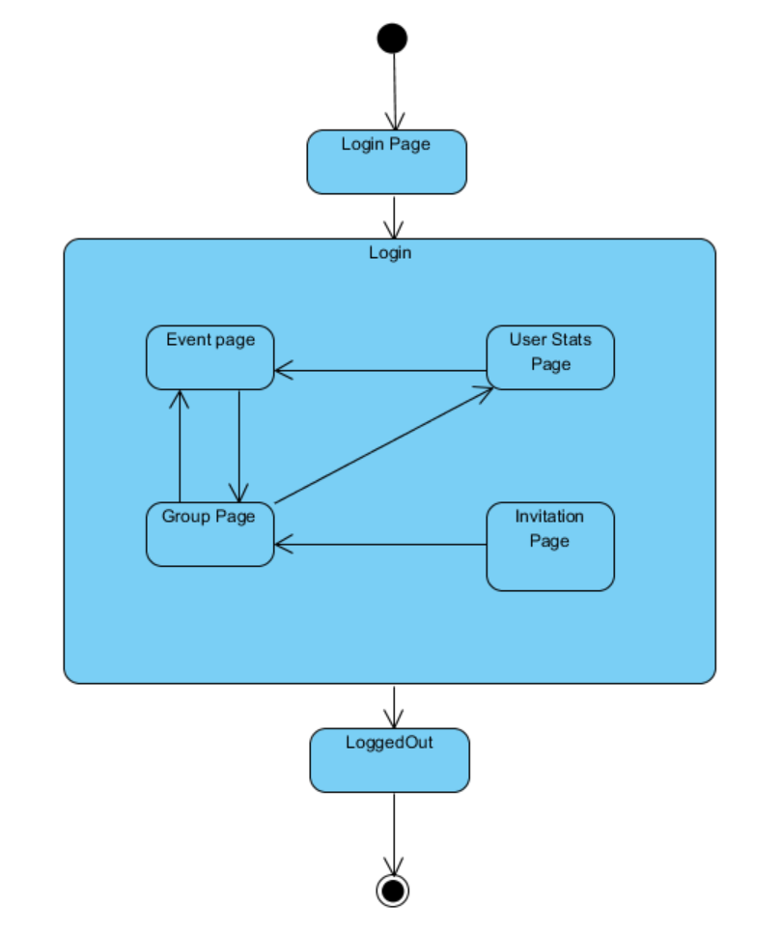

A.4 Requirements and their attributes
Name of Requirement | Identifier | Date Created | Current Version | Author | Stability | Status | Origin/Source | Effort | Priority | Stakeholders
User Login | R0.1 | 10/11/2016 | 1.1 | José & Ricardo | stable | approved | P.O. | 13 | 1 | P.O./Users/Devs
User Register | R0.2 | 11/11/2016 | 1.2 | José & Ricardo | changing | proposed | P.O. | 21 | 2 | P.O./Users/Devs
User Creates Groups | R1.1 | 11/11/2016 | 1.2 | José & Ricardo | changing | proposed | P.O. | 8 | 3 | P.O./Users/Devs
User Checks Group | R1.2 | 10/11/2016 | 1.1 | José & Ricardo | stable | approved | P.O. | 8 | 4 | P.O./Users/Devs
Admin Edits Group | R1.3 | 10/11/2016 | 1.1 | José & Ricardo | stable | approved | P.O. | 13 | 6 | P.O./Users/Devs
User Accepts Invitation | R1.4 | 10/11/2016 | 1.1 | José & Ricardo | stable | approved | P.O. | 13 | 5 | P.O./Users/Devs
Admin Adds Event to Group | R1.5 | 10/11/2016 | 1.1 | José & Ricardo | stable | approved | P.O. | 8 | 9 | P.O./Users/Devs
User Creates Event | R2.1 | 10/11/2016 | 1.1 | José & Ricardo | stable | approved | P.O. | 8 | 7 | P.O./Users/Devs
User Checks Event | R2.2 | 10/11/2016 | 1.1 | José & Ricardo | stable | approved | P.O. | 8 | 8 | P.O./Users/Devs
Admin Edit Event | R2.3 | 10/11/2016 | 1.1 | José & Ricardo | stable | approved | P.O. | 8 | 10 | P.O./Users/Devs
User Adds Stat to Event | R3.1 | 10/11/2016 | 1.1 | José & Ricardo | stable | approved | P.O. | 8 | 11 | P.O./Users/Devs
User Check Stat | R3.2 | 10/11/2016 | 1.1 | José & Ricardo | stable | approved | P.O. | 8 | 12 | P.O./Users/Devs
Admin Edits Stat | R3.3 | 10/11/2016 | 1.1 | José & Ricardo | stable | approved | P.O. | 8 | 13 | P.O./Users/Devs

A.5 Dependency Matrix
Name of Requirement | Identifier | R0.1 | R0.2 | R1.1 | R1.2 | R1.3 | R1.4 | R1.5 | R2.1 | R2.2 | R2.3 | R3.1 | R3.2 | R3.3
User Login | R0.1 | -
User Register | R0.2 | X | -
User Creates Groups | R1.1 | X |  | -
User Checks Group | R1.2 | X |  | X | -
Admin Edits Group | R1.3 | X |  | X | X | -
User Accepts Invitation | R1.4 | X |  | X |  |  | -
Admin Adds Event to Group | R1.5 | X |  | X | X |  |  | - | X | X
User Creates Event | R2.1 | X |  |  |  |  |  |  | -
User Checks Event | R2.2 | X |  |  |  |  |  |  | X | -
Admin Edit Event | R2.3 | X |  | X | X |  |  |  | X | X | -
User Adds Stat to Event | R3.1 | X |  |  |  |  |  |  | X | X |  | -
User Check Stat | R3.2 | X |  |  |  |  |  |  | X | X |  | X | -
Admin Edits Stat | R3.3 | X |  | X | X |  |  |  | X | X |  | X | X | -

