

Faculty of Computing

CS344: Web Engineering
Class: Fall 2026

Lab 2: Personal Portfolio

Name: Malaika Ansar
CMS ID: 510089
Class: BESE 15 A

Date: September 17, 2026

Instructor: Ms. Naema Asif

Lab Engineer: Engr. Ayesha Asif

Lab 2: Personal Portfolio

Introduction
In this lab, you will create a personal portfolio website from scratch using HTML and CSS. The portfolio should include multiple pages, personal details, images, and styling to present yourself in a professional and creative way.

Objectives
The main objective of this lab is to:
- Build a complete multi-page HTML portfolio from scratch.
- Apply inline and internal CSS styling to improve presentation.
- Practice linking multiple web pages together using hyperlinks.
- Organize personal information (skills, hobbies, contact, images, etc.) into structured web pages.

Tools / Software Requirements
- Any text editor (e.g., Notepad, VS Code, Sublime Text)
- A modern web browser (e.g., Chrome, Edge, Firefox)
- Internet access for reference (Google, Bing, DuckDuckGo, etc.)

Description
You are required to design a multi-page personal portfolio website from scratch. Your portfolio should:
- Contain at least 5 different pages (Home, Hobbies, Contact Me, Image Gallery, Personal Skills).
- Include personal information such as your name, hobbies, skills, and contact details.
- Use hyperlinks to connect all pages (at least from home.html).
- Insert at least 5 images and display them in an image gallery.
- Apply inline or internal CSS styling (no external CSS files allowed).
- Ensure proper structure and navigation between all pages.
Once completed, test your website in a browser, compress all files into a .zip folder, and upload it to LMS.

Pitfalls to Avoid
- Forgetting to upload the solution to LMS.
- Missing links between pages (broken navigation).
- Not following the requirement to use inline/internal CSS only.

Lab Tasks
- Create a portfolio website from scratch.
- Add at least the following pages:
  - Home
Screenshot:
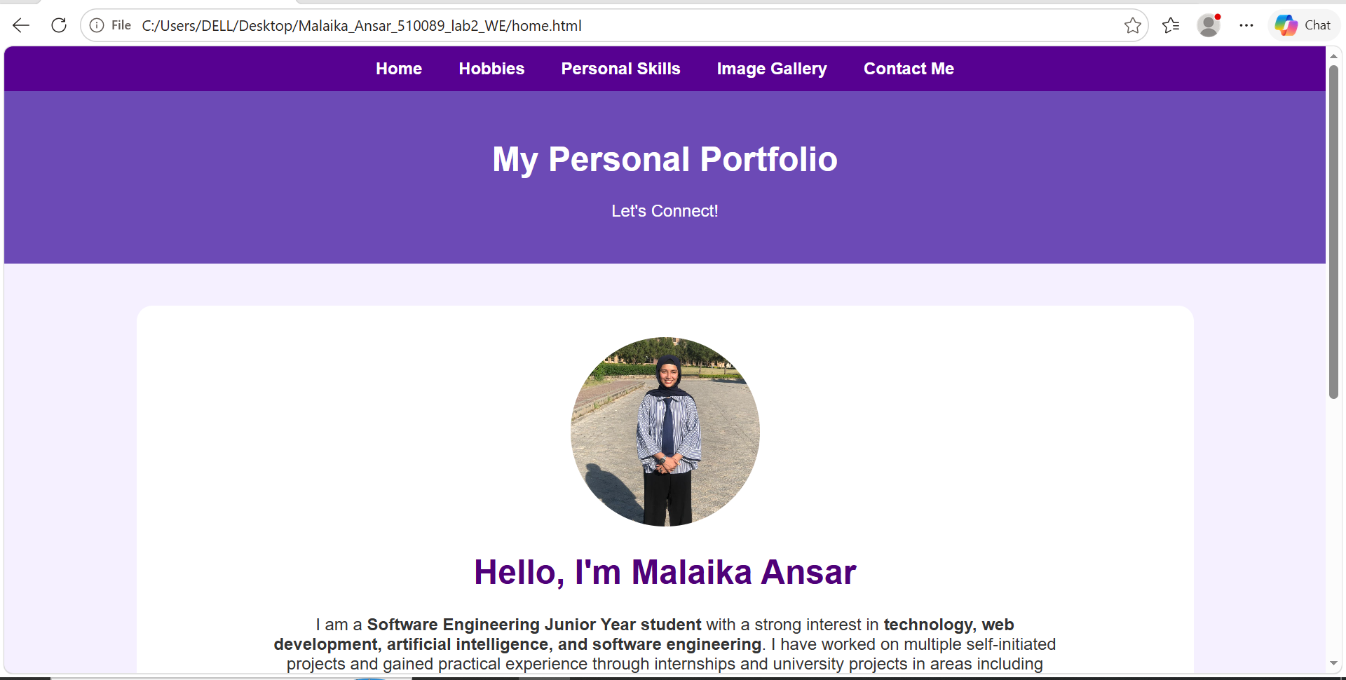
  - Hobbies
Screenshot:
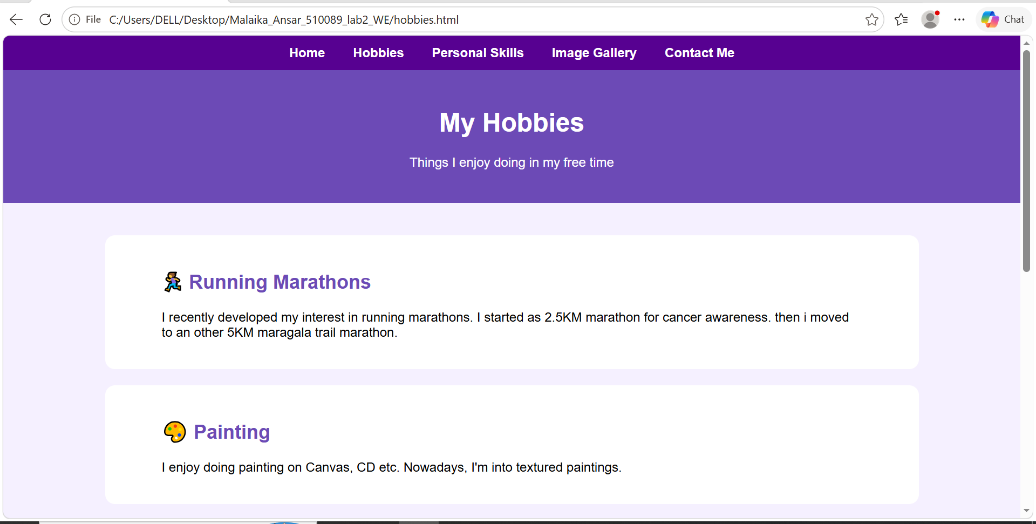
  - Contact Me
Screenshot:
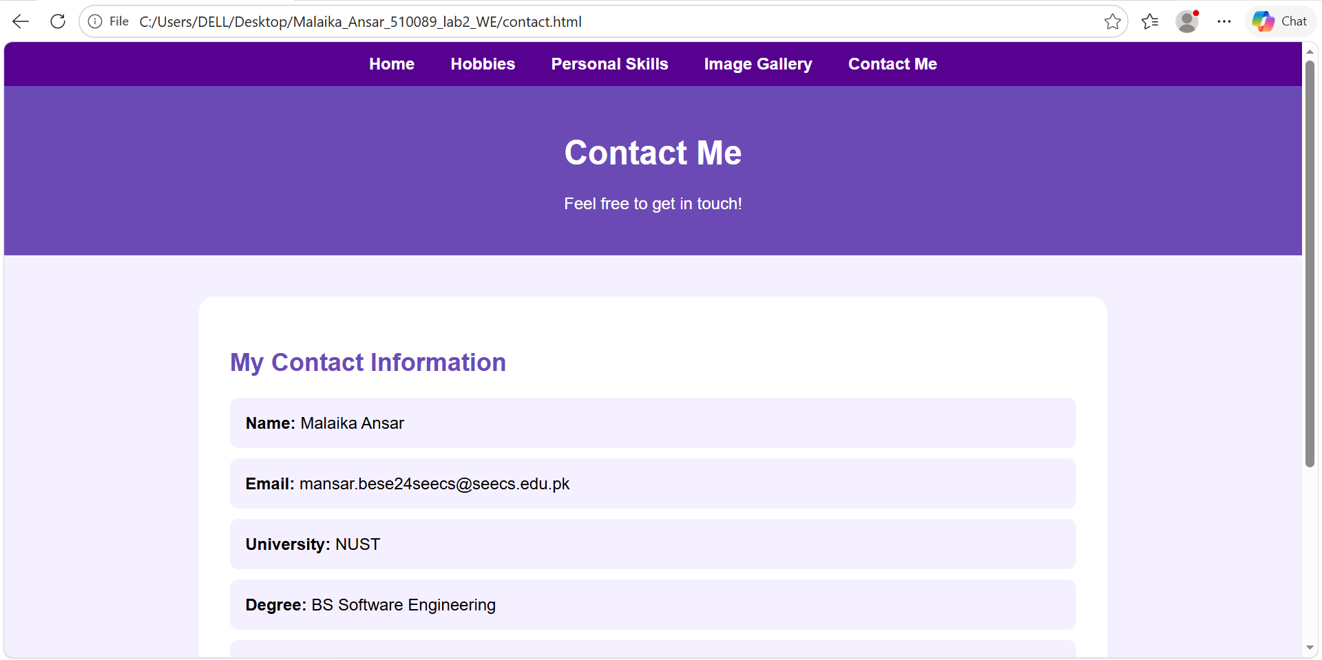
  - Image Gallery (with at least 5 images)
Screenshot:
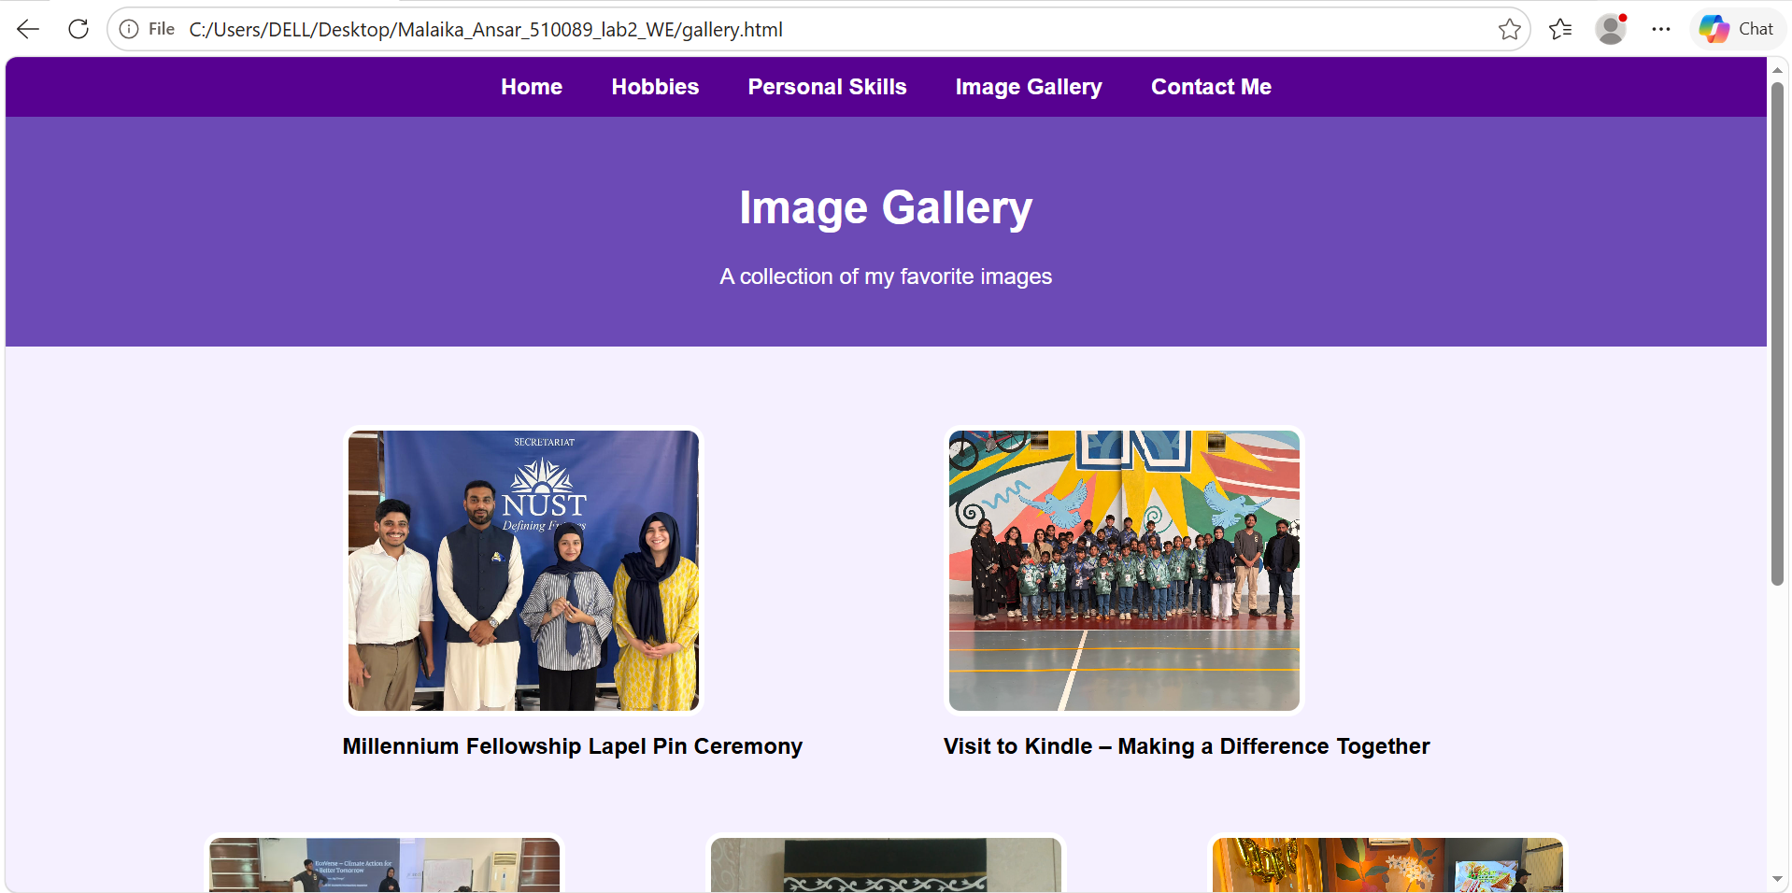
  - Personal Skills (e.g., programming languages, spoken languages, or other skills)
Screenshot:
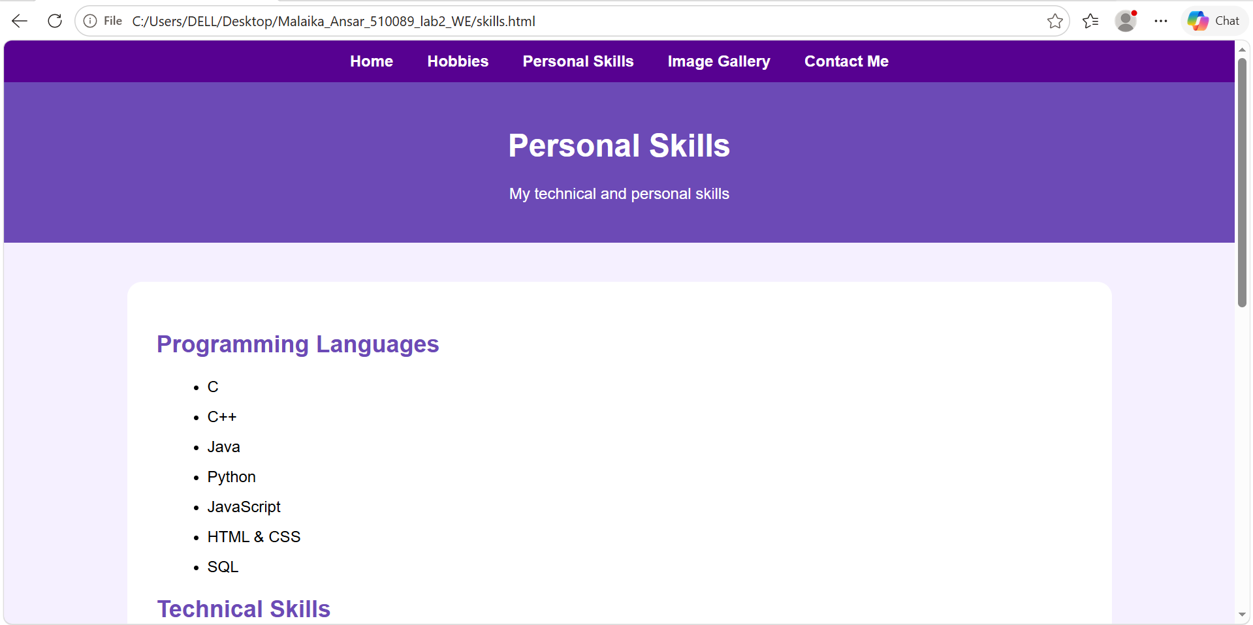
- Use inline or internal CSS for styling.
- Ensure smooth navigation between all pages using hyperlinks.

Deliverables
Each student must submit an individual solution containing:
- Source code of all web pages.
- Files compressed into a single .zip folder.
- Naming convention for the folder:
  - Name – RegistrationNo – Section
- Upload the .zip file to LMS before the deadline.

