**DOCUMENTATION**

**Project Title: “Sales Data Analysis”**

**Domain: “Data Science”**

**Batch 2**

**Problem Statement:**

Competitive business environment of today's world, firms greatly depend on data-driven decision-making in order to improve, maximize sales strategies and increase profitability. Without the analysis of structured data set, businesses can face challenges to visualize key performance indicators (KPIs), identify customer behavior, timeframes, detect sales trends between products and demographics.

**Objective:**

This project will work on analyzing retail sales data to calculate key KPIs like total revenue, profit, average order value, units sold, and profit margin. By transforming datasets into meaningful ,useful features help organizations in optimizing profitability.

**Tools Used:**

* Vs code
* Jupyter notebook
* Python

**Libraries Used:**

* Pandas: Used for data handling
* Matplotlib
* Seaborn : Both used for data visualization

**DataSet Used:**

The sales_data.csv data set consists of sales transactions and customer, order, and product details. Purpose of applying is to identify and visualize KPIs and plot their trends.

**Key Features:**

• Exploratory Data Analysis (EDA):

Missing values, correlations, summary statistics

• KPI Computation:

Total Revenue, Total Profit, Average Order Value, Profit Margin, Units Sold, Orders per Customer

• Data Visualization:

* Correlation heatmap
* Monthly Revenue Trends
* Profit Margin by Product _Category
* Revenue by Order Quantity
* Pairplot of Revenue

**Code and Output**:

**Step 1**:

**Importing Libraries**

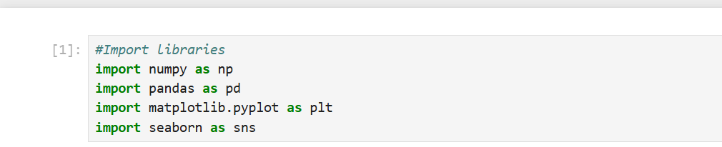

**Step 2:**

**Dataset Loading**

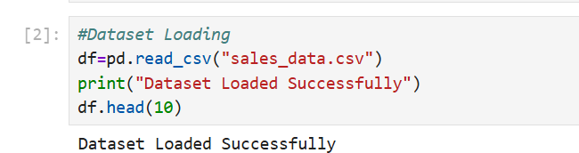

**Output:**

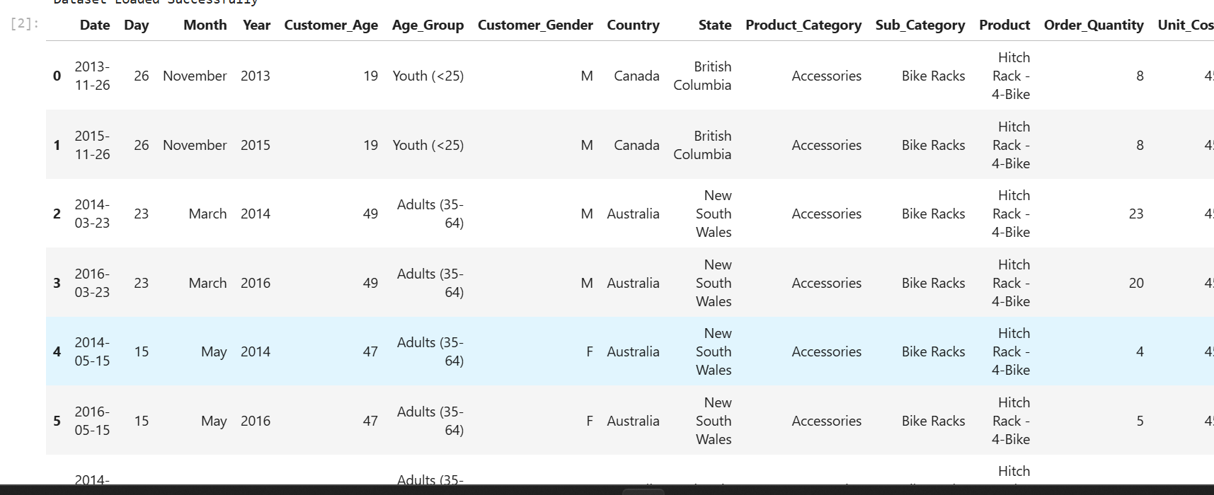

**Step 3:**

**Expolatory Data Analysis:**

* **Information of dataset**

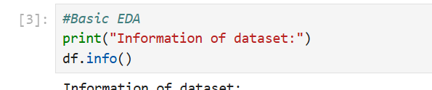

**Output:**

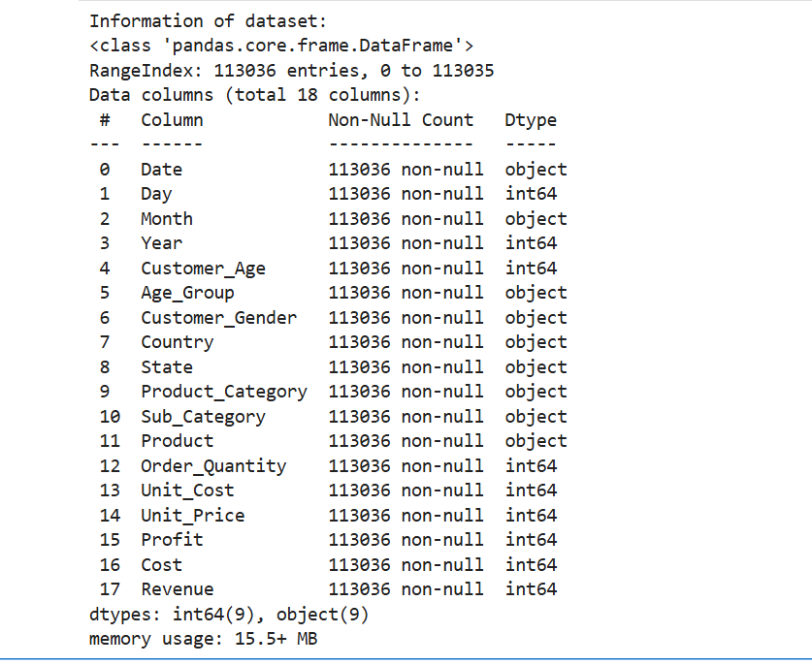

* **Statistic of Dataset:**

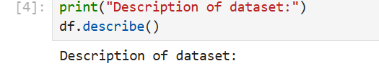

**Output:**

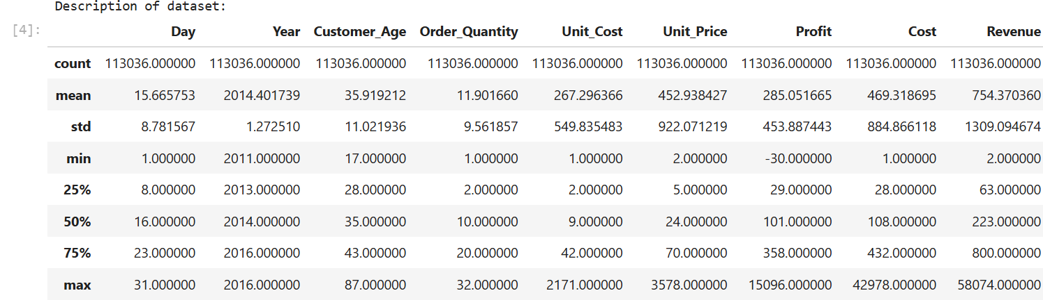

* **Check missing values:**

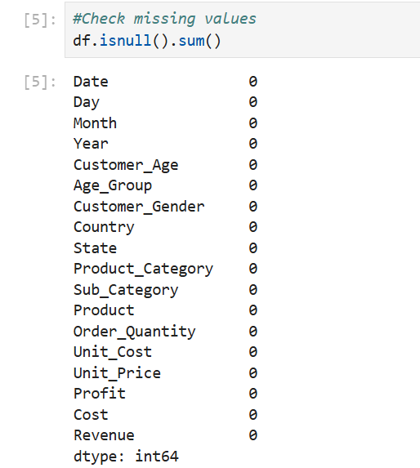

* **Correlation Heatmap:**

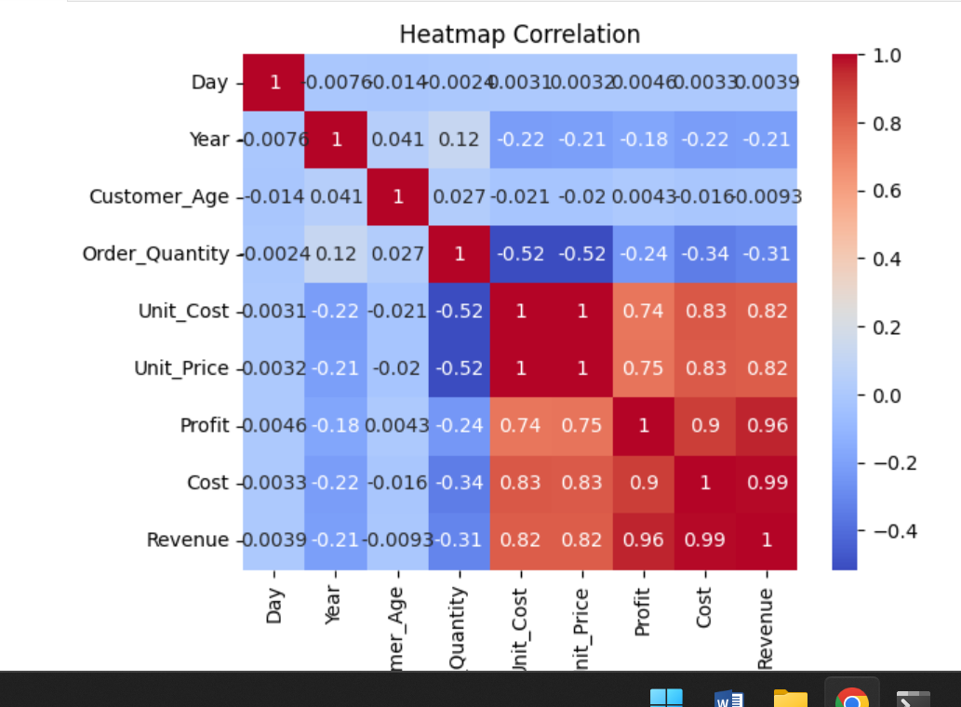

**Step 4:**

**KPI’s Computation:**

* **Total Revenue**

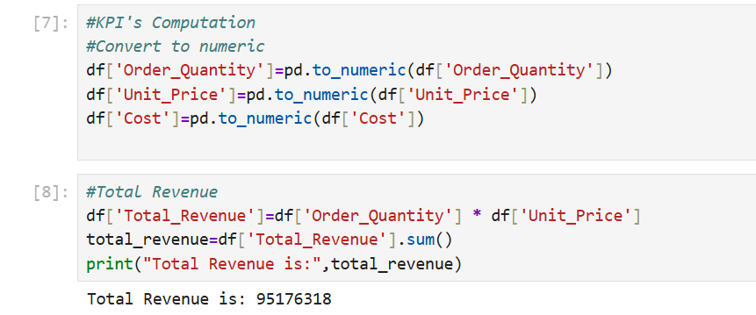

* **Total Profit:**

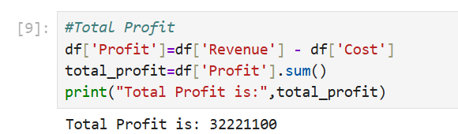

* **Average Order Value:**

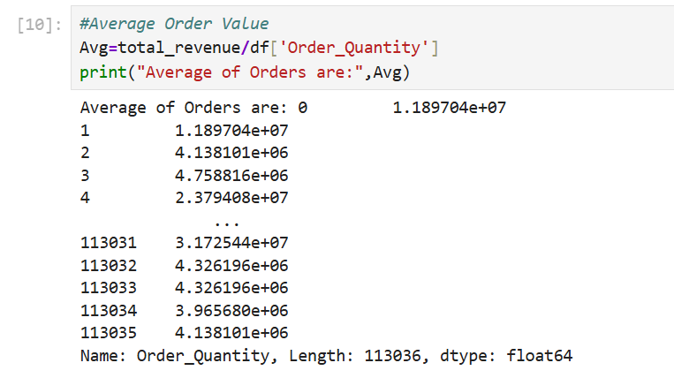

* **Profit Margin:**

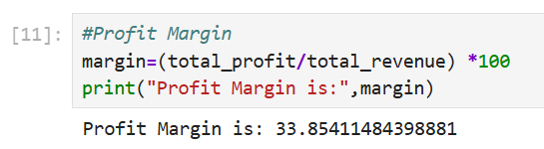

* **Sales per unit:**

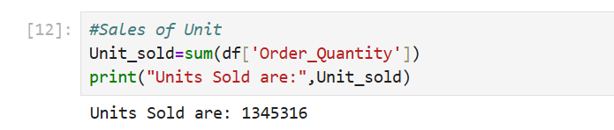

* **Orders Per customer:**

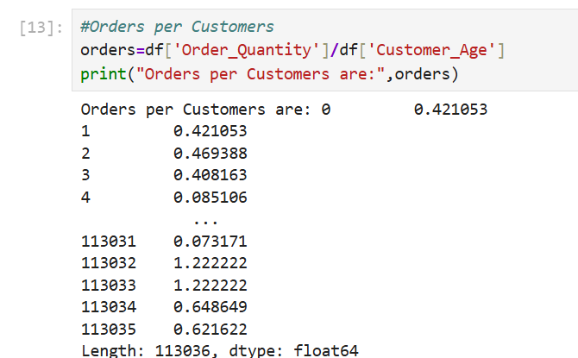

**Step 5:**

**KPI’s Visualization**

* **Revenue by OrderQuantity**

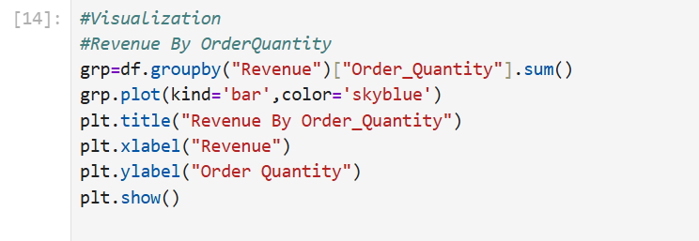

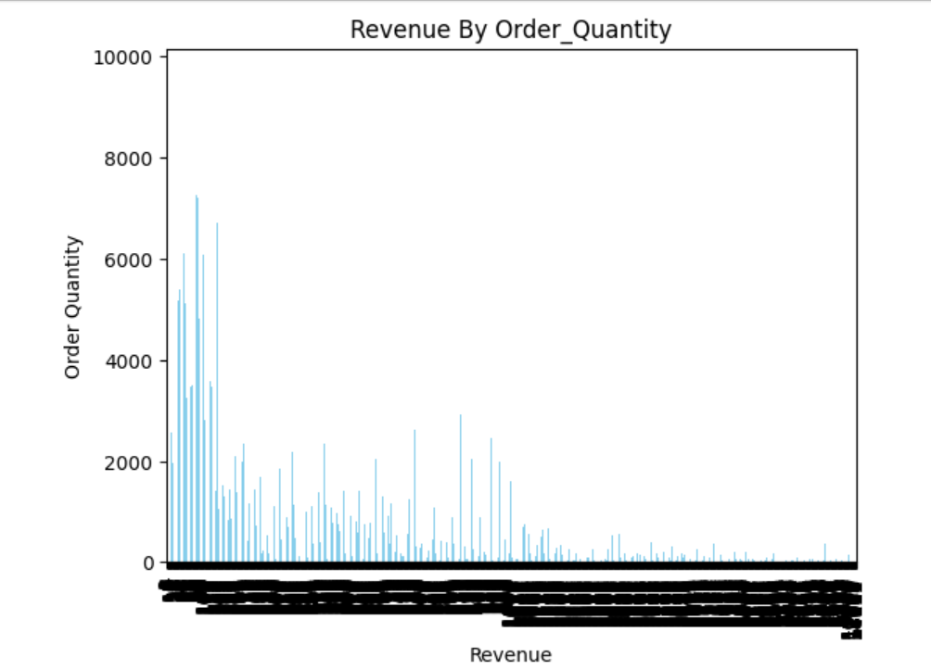

* **Monthly Revenue:**

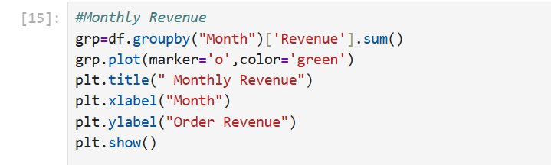

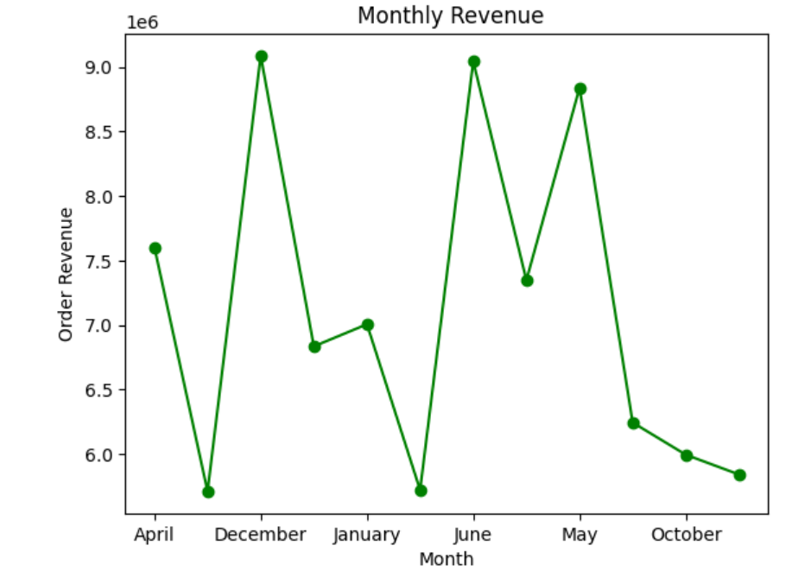

* **Profit margin by category**

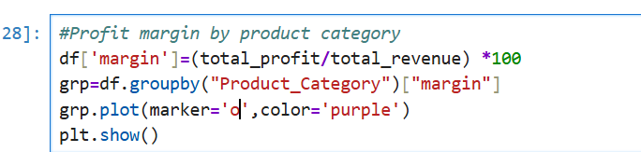

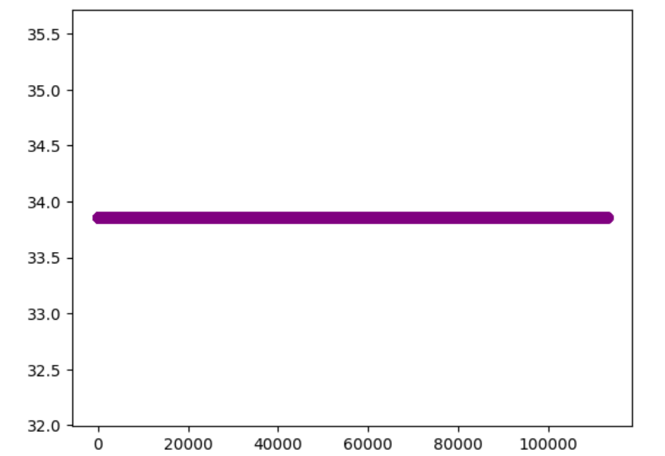

* **Revenue by Customer age or month**



