Question-1 ESP32 Webserver (webserver.cpp)

Part A: Short Questions

1. What is the purpose of WebServer server(80); and what does port 80 represent?
WebServer server(80); creates a web server object on the ESP32 that allows it to serve web pages to users through a browser.
Port 80 represents the default HTTP port.
When you type the ESP32 IP address in a browser (for example http://192.168.1.5), the browser automatically connects using port 80. This is why no port number is written in the URL.

2. Explain the role of server.on("/", handleRoot); in this program.
This line tells the web server what to do when a client accesses the root URL (/).
- / means the home page of the server
- handleRoot is the function that runs when someone opens the ESP32 IP in a browser
So when a user types the ESP32 IP address:
- The server calls handleRoot()
- The HTML page with temperature and humidity is generated
- That page is sent to the browser
👉 It works like URL → function mapping

3. Why is server.handleClient(); placed inside the loop() function? What will happen if it is removed?
server.handleClient(); continuously checks for incoming web requests from browsers.
It is placed inside loop() because:
- The ESP32 must always listen for new clients
- Web requests can come at any time
If this line is removed:
- The web server will stop responding
- Opening the ESP32 IP in a browser will show no page / connection error
- Only the button and OLED will still work
👉 Without this line, the ESP32 cannot serve web pages

4. In handleRoot(), explain the statement:
This statement sends the web page response to the browser.
Explanation of each part:
- 200 → HTTP status code meaning “OK / Success”
- "text/html" → Tells the browser the content is an HTML webpage
- html → The actual HTML content stored in the String html
.

5. What is the difference between displaying last measured sensor values and taking a fresh DHT reading inside handleRoot()?
Displaying last measured values means the ESP32 shows already stored sensor data, which is fast and safe.
Taking a fresh reading inside handleRoot() means the DHT sensor is read every time the page refreshes, which can cause delay and sensor errors because DHT sensors cannot be read too frequently.
That is why using last measured values is a better approach.

Part B: Long Question

Working of ESP32 Webserver-Based Temperature and Humidity Monitoring System

1. ESP32 Wi-Fi Connection and IP Address
First, the ESP32 connects to Wi-Fi using the given SSID and password.
It keeps checking until the connection is successful.
Once connected:
- The router assigns an IP address
- The IP is shown on the Serial Monitor
- The same IP is also displayed on the OLED screen
This IP is later used to open the ESP32 webpage in a browser.

2. Web Server Initialization and Request Handling
The web server is created on port 80.
The root webpage / is linked with the handleRoot() function.
When a user opens the ESP32 IP in a browser:
- The ESP32 receives the request
- handleRoot() runs
- An HTML webpage is sent back to the browser
The server.handleClient() function ensures that all incoming requests are handled properly.

3. Button-Based Sensor Reading and OLED Update
A push button is connected to the ESP32 using INPUT_PULLUP mode.
When the button is pressed:
- The ESP32 reads temperature and humidity from the DHT22 sensor
- The values are stored in variables
- The OLED screen is updated with the new readings
A small delay is added to avoid false triggering due to button bounce.

4. Dynamic HTML Webpage Generation
The webpage is created dynamically using a String.
- If no sensor data is available, a message is shown
- If valid data exists, temperature and humidity values are displayed
This makes the webpage change automatically based on sensor readings.

5. Purpose of Meta Refresh in the Webpage
The meta refresh tag refreshes the webpage every 5 seconds.
This allows the user to see updated temperature and humidity values without manually reloading the page.

6. Common Issues and Their Solutions
Some common problems include:
- Webpage not opening if server.handleClient() is missing
- DHT sensor giving wrong values due to frequent readings
- Wi-Fi disconnection due to weak signal
- OLED not working because of wrong I2C address
- Button bounce causing multiple readings
These issues can be solved by proper delays, correct wiring, and correct function placement.

Question-2: Blynk Cloud Interfacing (blynk.cpp)
Part-A: Short Questions

1. What is the role of Blynk Template ID in an ESP32 IoT project? Why must it match the cloud template?
The Blynk Template ID connects the ESP32 device to a specific project (template) created on the Blynk Cloud.
It must match the cloud template because:
- The template defines what widgets, datastreams, and virtual pins are used
- If the Template ID is wrong, the ESP32 will not know which project it belongs to
- Data will not appear on the Blynk dashboard
In simple words, the Template ID acts like an identity card for the project.

2. Differentiate between Blynk Template ID and Blynk Auth Token.
Feature | Template ID | Auth Token
Purpose | Identifies the project | Identifies the device
Scope | Same for all devices in a template | Unique for each device
Generated when | Template is created | Device is added
Used for | Project structure | Secure device connection
So, Template ID links the project, while Auth Token links the ESP32 device.

3. Why does using DHT22 code with a DHT11 sensor produce incorrect readings? Mention one key difference.
DHT11 and DHT22 are different sensors with different data formats.
One key difference:
- DHT11: Lower accuracy and integer values
- DHT22: Higher accuracy and decimal values
If DHT22 code is used with a DHT11 sensor, the ESP32 misinterprets the data, which results in wrong temperature and humidity readings.

4. What are Virtual Pins in Blynk? Why are they preferred over physical GPIO pins for cloud communication?
Virtual Pins are software-based pins used to send and receive data between ESP32 and Blynk Cloud.
They are preferred because:
- They are not limited by hardware pins
- One sensor value can be sent to multiple widgets
- They allow easy cloud communication without changing wiring
- They make the code cleaner and more flexible
Virtual Pins act as a bridge between hardware and the cloud.

5. What is the purpose of using BlynkTimer instead of delay() in ESP32 IoT applications?
delay() blocks the program and stops other tasks from running.
BlynkTimer is used because:
- It allows tasks to run at fixed intervals
- It does not block Wi-Fi or Blynk communication
- It keeps the ESP32 responsive
Using BlynkTimer ensures smooth multitasking in IoT applications.

Part-B: Long Question
Complete Workflow of Interfacing ESP32 with Blynk Cloud for Temperature and Humidity Monitoring

1. Creation of Blynk Template and Datastreams
First, a template is created on the Blynk Cloud.
Inside the template:
- Datastreams are created for temperature and humidity
- Virtual pins (for example V0 and V1) are assigned
- Widgets like gauge or value display are added in the mobile app
This template acts as the blueprint of the IoT project.

2. Role of Template ID, Template Name, and Auth Token
- Template Name helps identify the project in the Blynk dashboard
- Template ID connects the ESP32 code to the correct cloud template
- Auth Token securely links a specific ESP32 device to the cloud
All three must be correct, otherwise the device will fail to connect.

3. Sensor Configuration Issues (DHT11 vs DHT22)
The ESP32 reads temperature and humidity using the DHT sensor.
It is important to:
- Select the correct sensor type in the code
- Match the wiring and GPIO pin correctly
Using the wrong sensor definition causes:
- Incorrect values
- NaN (Not a Number) readings
- Communication failure with Blynk

4. Sending Data Using Blynk.virtualWrite()
After reading the sensor:
- Temperature is sent to Virtual Pin V0
- Humidity is sent to Virtual Pin V1
Blynk.virtualWrite(V0, temperature);
Blynk.virtualWrite(V1, humidity);
This sends the sensor data to the Blynk Cloud, where it appears instantly on the app widgets.

5. Button-Based and Timer-Based Data Updates
- A physical button allows manual sensor updates
- BlynkTimer sends data automatically at regular intervals
This gives both manual control and automatic cloud updates, making the system reliable and user-friendly.

6. Common Problems and Their Solutions
Problem | Cause | Solution
Device offline | Wrong Auth Token | Use correct token
No data on app | Wrong virtual pin | Match datastream pins
Wrong readings | Sensor mismatch | Correct DHT type
Frequent disconnects | Using delay() | Use BlynkTimer
OLED not updating | I2C issue | Check SDA/SCL pins

Screenshots:
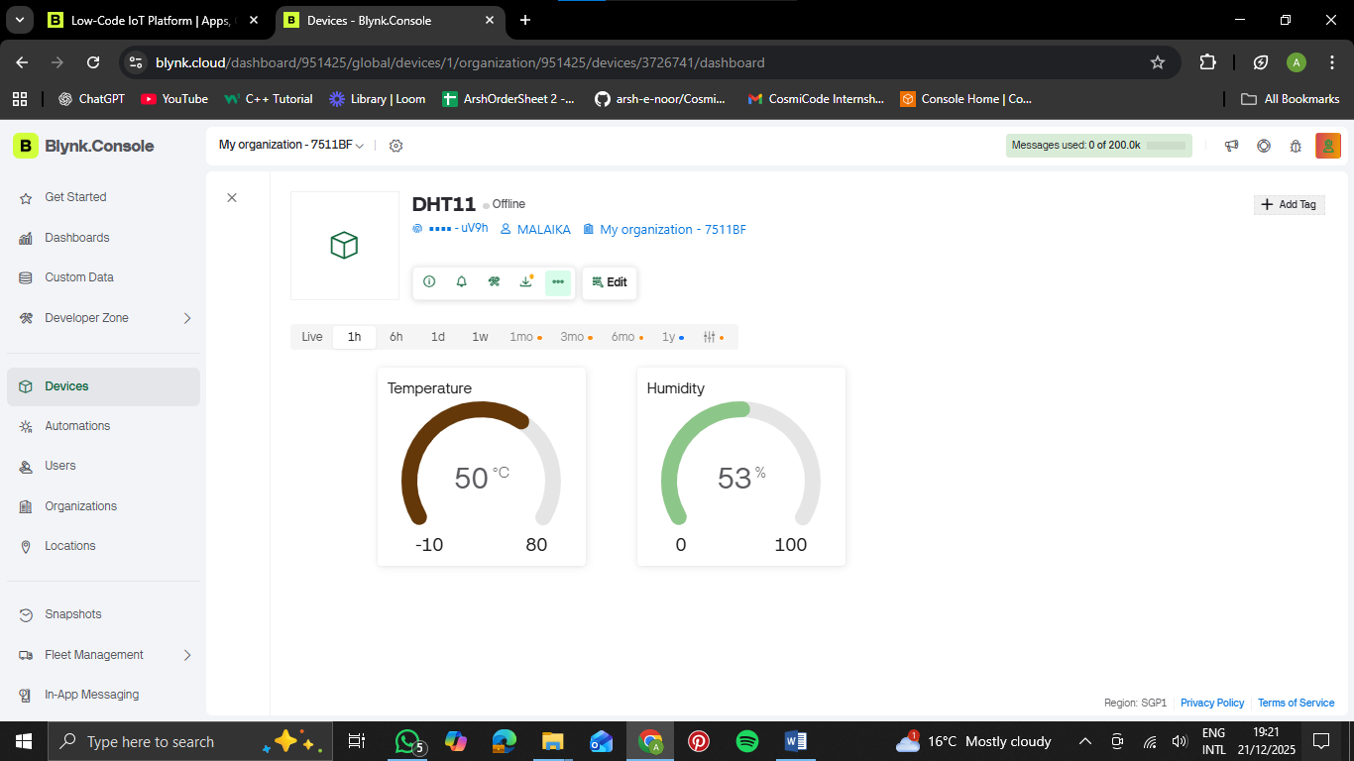
webpage
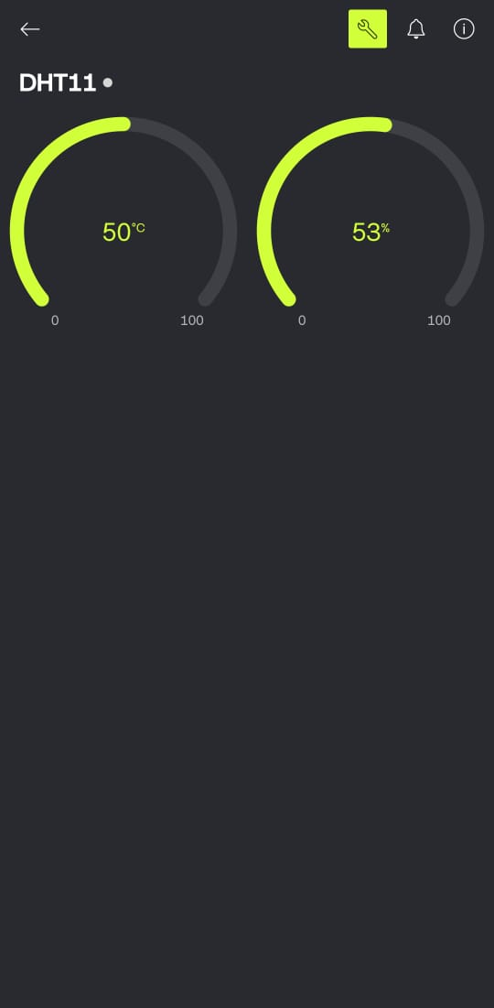”
Mobile app

