**Software Development & Architecture**

**BSEF21-M**

**Campus Management System(CMS)**

***Presented to:* Fatima Sabri**

***Presented by:***

**BSEF21M017 Malaika Urooj**

**BSEF21M028 Amna Shahzadi**

**BSEF21M513 Aqsa Tariq**

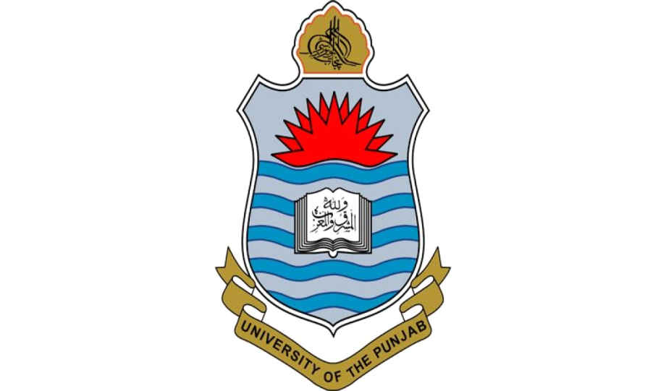

**University of Punjab**

Faculty of Computing and Information Technology, Allama Iqbal Campus