Assignment 01: Git, Gitea, GitHub,
Git LFS, and GitHub Pages
Name: Malaika Irfan
Registration Number: FA24B1-SE-004
Course Code: SE-665
Section: B
GitHub Username: MalaikaIrfan004
Submission Date: 10 October 2026

Task 1: Install Gitea and Push a Repository from the Ubuntu Server
- task1_gitea_running.png

Figure: Ubuntu terminal showing both Gitea-related containers running and a successful HTTP response from the Gitea service.
- task1_gitea_push.png
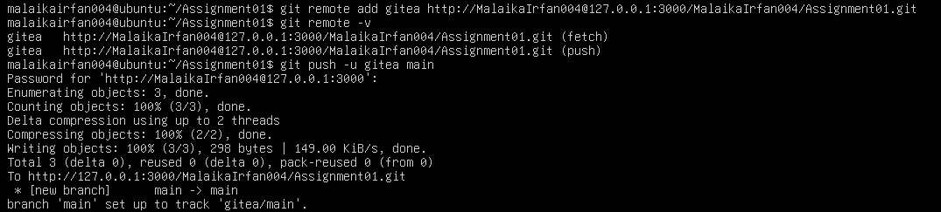

Figure: Ubuntu terminal showing the repository remote and a successful push of the main branch to Gitea.
- task1_gitea_repository.png
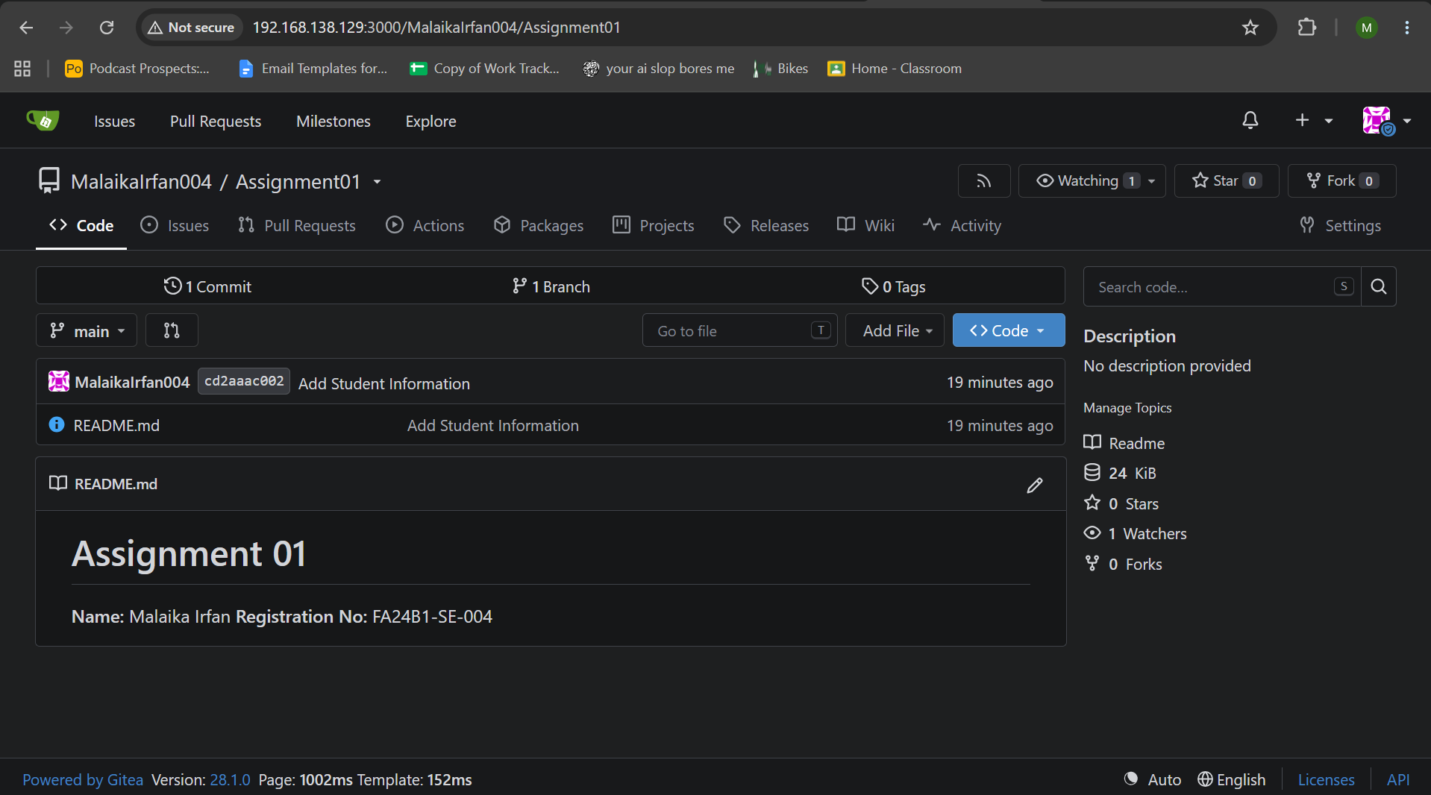

Figure: Browser showing the public Gitea Assignment01 repository with the README and repository URL visible.

Task 2: Push the Same Repository to GitHub
- task2_remotes.png
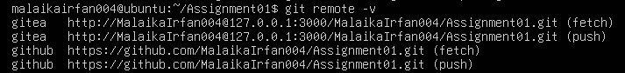

Figure: Ubuntu terminal showing the configured Gitea and GitHub remotes for the same local repository.
- task2_github_push.png
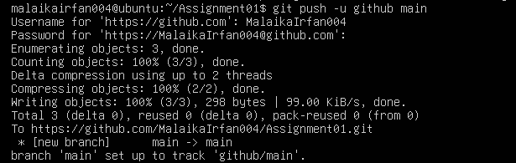

Figure: Ubuntu terminal showing a successful push of the main branch to GitHub.
6. task2_github_repository.png
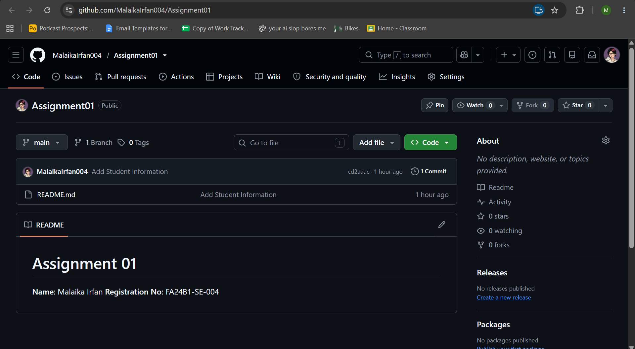

Figure: Browser showing the public GitHub Assignment01 repository with the README and repository URL visible.

Task 3: Track Three Large Files with Git LFS
- task3_lfs_setup.png
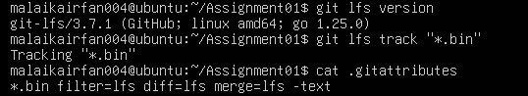

Figure: Ubuntu terminal showing Git LFS initialized, the *.bin tracking rule, and the .gitattributes entry.
- task3_lfs_files.png
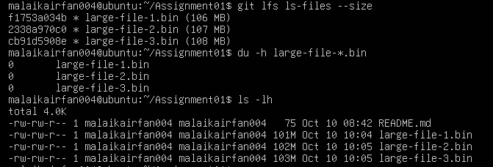

Figure: Ubuntu terminal showing the three large .bin files and Git LFS listing them as tracked files.
- task3_lfs_push.png

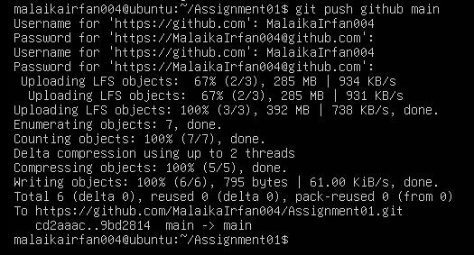

Figure: Ubuntu terminal showing the commit and successful GitHub push, including the Git LFS object upload completion.

Task 4: Create a Portfolio/CV with GitHub Pages
- task4_pages_repository.png
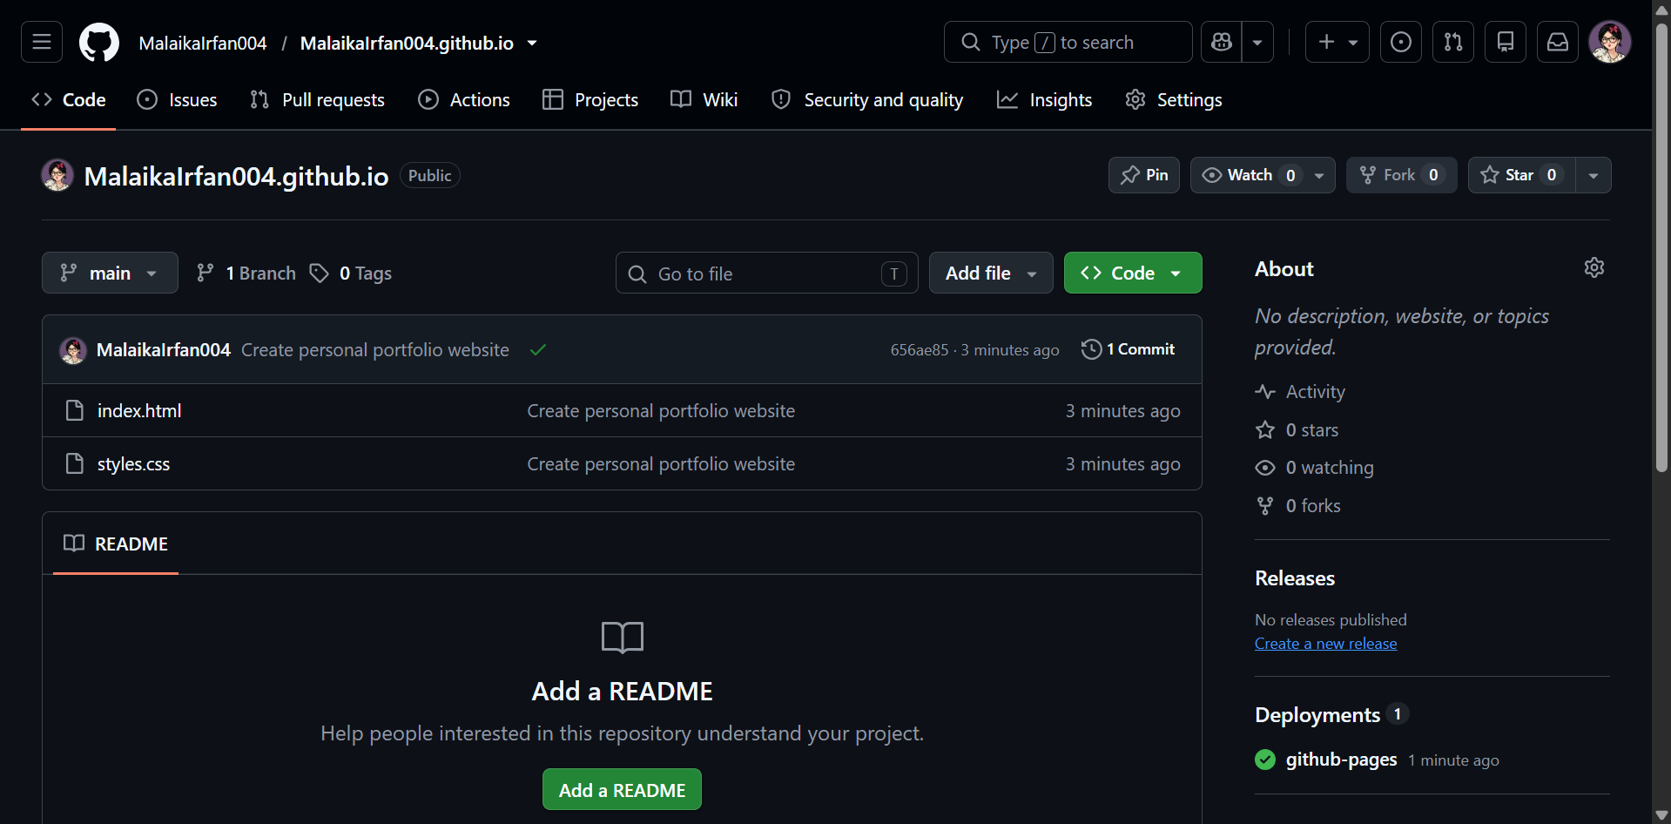

Figure: Browser showing the public username.github.io repository and the index.html and styles.css files.
- task4_pages_deployment.png

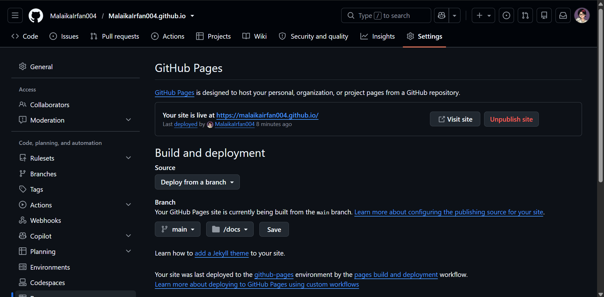

Figure: GitHub Pages settings showing deployment from the main branch and root folder, with the published status or site URL.

- task4_portfolio_live.png
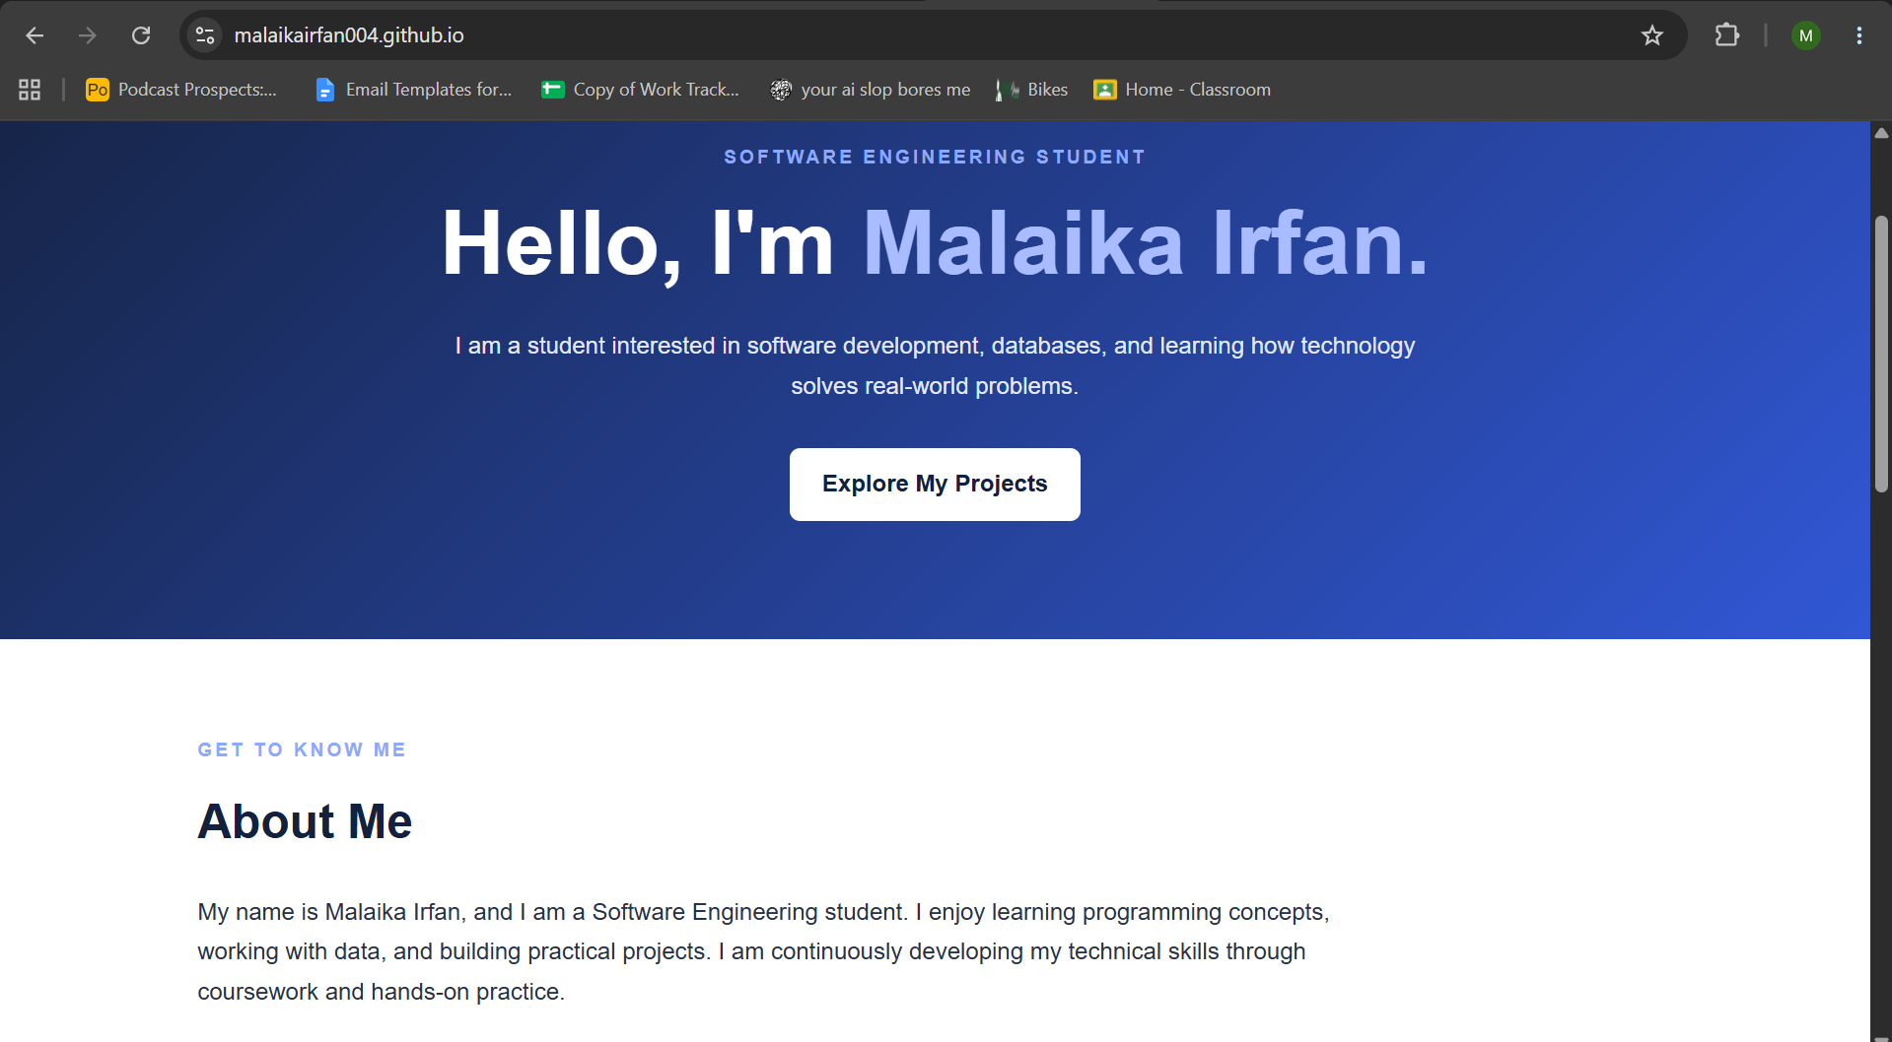

Figure: Browser showing the live portfolio at https://username.github.io/ with the address bar and portfolio sections visible.

Required Submission Links
CC Repository Link:
https://github.com/MalaikaIrfan004/CC
GitHub Assignment01 Repository Link:
https://github.com/MalaikaIrfan004/Assignment01
Live GitHub Pages Portfolio Link:
https://MalaikaIrfan004.github.io/

