LAB # 02

Introduction to GitHub

OBJECTIVE
Intoduction to GitHub by creating Git repository and cloning its configuration to eclipse project.

Lab Task:
Create account on GitHub, add a clone git repository in eclipse and push the java project on GitHub.
Step 01: Create GitHub Account and SignIn
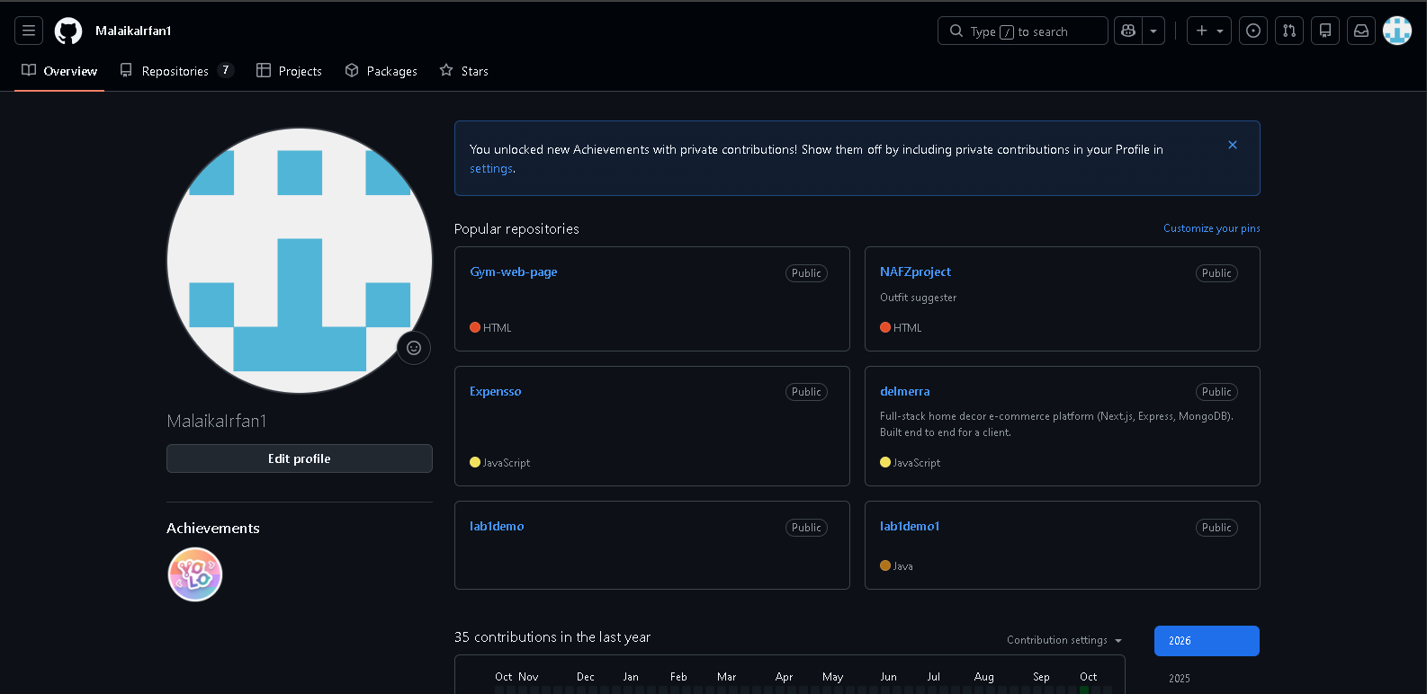
Step 02: Create a Repository.
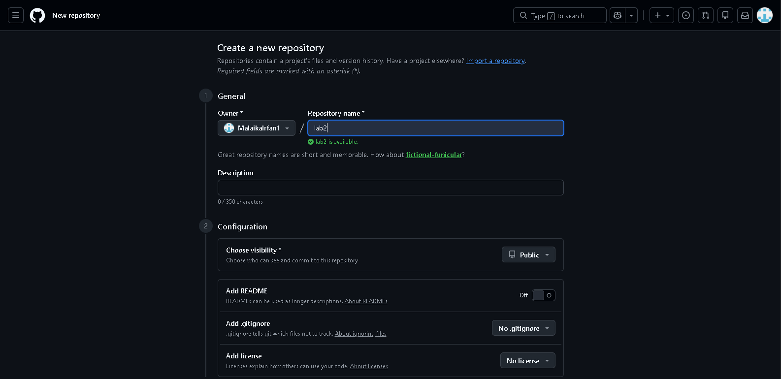
After creating repository, copy the URL
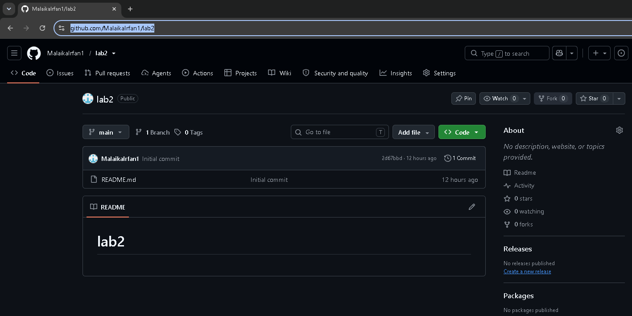
Step 03: Start Eclipse.
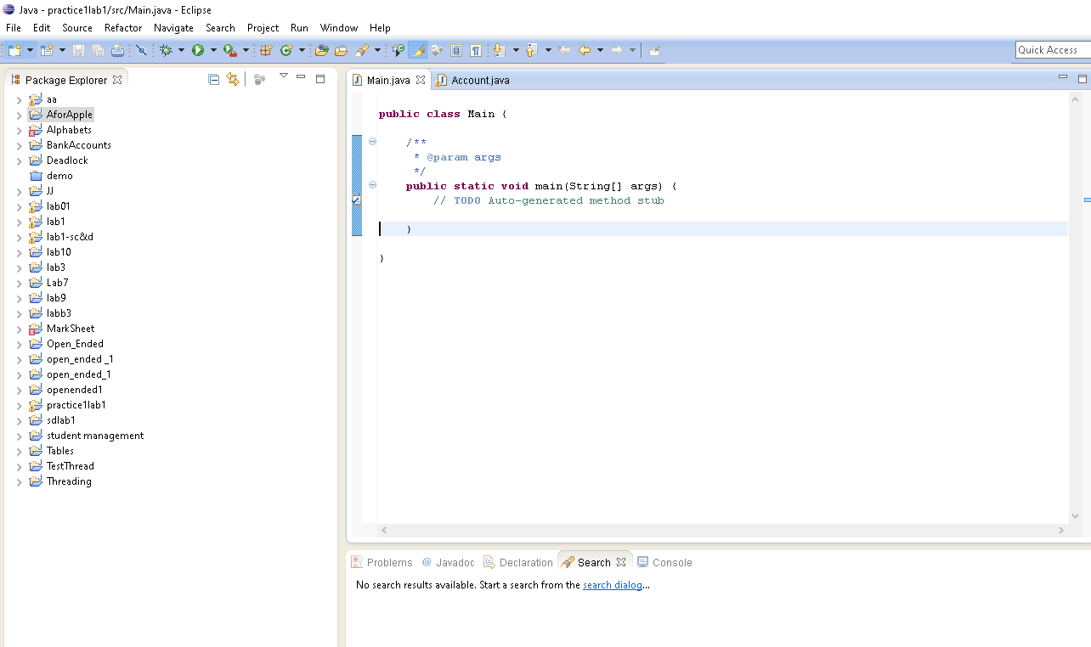

Step 04: Go to Perspective → Git Repositories → Add Git Repositories
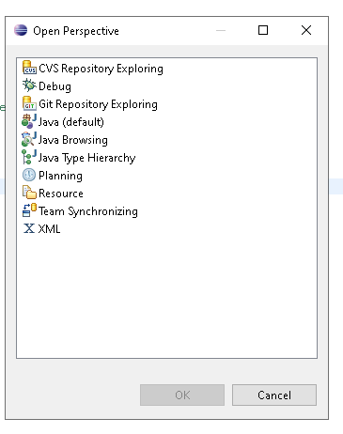
As we have already created repository in GitHub, we will now clone that repository in Eclipse.
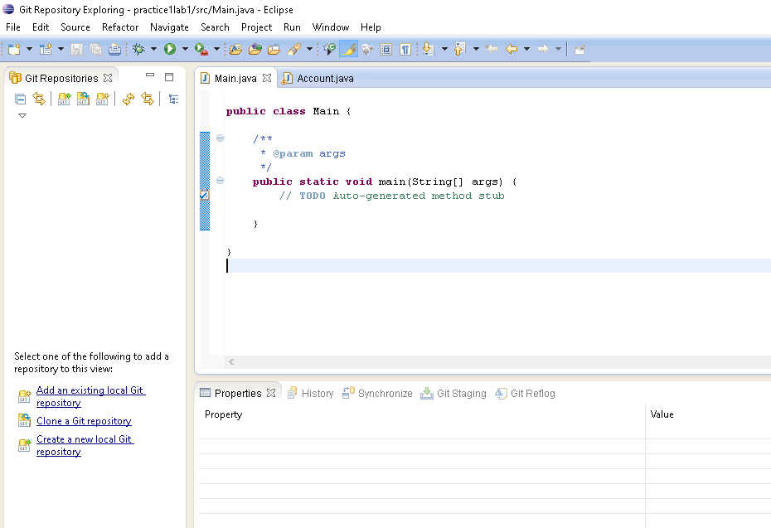

Enter the URL copied from GitHub and then Provide login credentials and enter next.
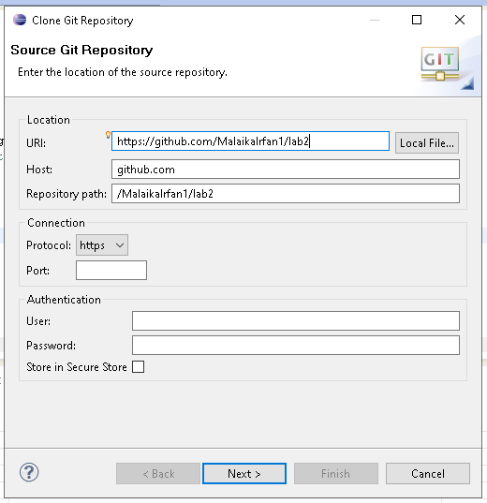
Enter Finish
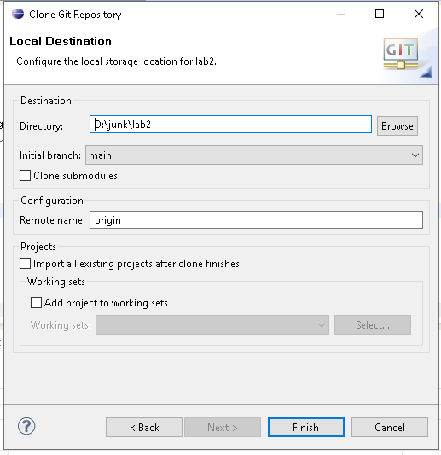
Step 05: Create a Project in Eclipse.

