LIMKOKWING UNIVERSITY OF CREATIVE TECHNOLOGY
SIERRA LEONE CAMPUS
FACULTY OF INFORMATION & COMMUNICATION TECHNOLOGY
DEPARTMENT OF SOFTWARE ENGINEERING & MULTIMEDIA
COURSE ASSIGNMENT 1 (WEEKS 1 TO 4)
Design and Development of Web Platform & Authentication System for Django Girls Sierra Leone
Student Name: | Alimatu Maliaka Jalloh
Student ID: | 905004463
Academic Program: | BSC(Hons) Software Engineering with Multimedia
Current Semester: | Semester 5
Module / Course: | Web Programming (DTECH 206 / ICT204)
Lecturer in Charge: | Kenneth G. Campbell
Submission Academic Year: 2026
Freetown, Sierra Leone

1. Executive Summary & Selected Organisation Profile
For Assignment 1, the chosen organisation is Django Girls Sierra Leone (Freetown Chapter). Django Girls is an inspiring, non-profit volunteer movement dedicated to bridging the digital gender divide by introducing women and young girls to computer programming and modern software craftsmanship through completely free, high-impact workshops. In Sierra Leone, female representation in computing, software engineering, and technical leadership remains historically low. Django Girls Freetown solves this challenge by dismantling intimidating barriers to entry and providing an inclusive, safe, and supportive environment where beginners can transition from tech consumers to software creators in a single day.
The digital platform developed for this assignment provides the core web infrastructure for Django Girls Sierra Leone. It incorporates modern HTML5 structure, bespoke CSS aesthetics, server-side PHP data handling, MySQL database persistence, and secure user session management, directly reflecting the learning outcomes covered in Weeks 1 to 4 of the Web Programming syllabus.
2. Architecture & Web Platform Page Structure
The application is structured into modular components adhering to web development industry standards:
• Prominent Logo Display (Header): The official Django Girls logo is positioned prominently at the top header of every page alongside the Sierra Leone national tech badge, establishing instantaneous brand recognition and organizational legitimacy.
• Home Page (index.php): Serves as the public-facing gateway showcasing the organisation's mission, impact statistics (500+ girls trained in SL, 100% free), interactive code terminals, live upcoming workshop cohorts dynamically queried from MySQL, and calls-to-action.
• User Registration Page (register.php): Provides a complete onboarding registration form capturing full name, username, email, phone number, experience level, and preferred learning track, backed by comprehensive server-side validation and password encryption.
• Secure Authentication Page (login.php): Implements a secure login form utilizing PDO prepared statements to query user credentials, verifying input passwords against encrypted database hashes and establishing a protected PHP session.
• Personalized User Dashboard (dashboard.php): A protected portal accessible only after successful authentication. Displays tailored profile information, account status, enrolled training progress, assigned mentors, and quick administrative shortcuts.
• Secure Session Termination (logout.php): Securely unsets session memory, destroys session records on the server, removes browser session cookies, and safely redirects the user back to the login interface with flash feedback.
• Standardized Copyright Footer (footer.php): Incorporates the mandatory assignment footer displaying: '© Alimatu Maliaka Jalloh, BSC(Hons) Software Engineering with Multimedia, Semester 5, 905004463, 2026' on every page.

3. Detailed Explanation of Design Choices, Plugins & Themes
A deliberate, user-centered design system was engineered specifically for the Django Girls Sierra Leone platform. The interface prioritizes simplicity, professionalism, and a distinctive feminine aesthetic tailored to women in technology:
• Feminine & Professional Color Palette: The visual identity is styled around a chic, modern feminine palette featuring rose-pink (#e11d48) and coral-pink (#fb7185) gradients as primary accents. This is paired with delicate rose-blush surfaces (#fff1f2, #faf8f9) and deep midnight-plum slate (#181124) for headers and cards, producing an empowering, sophisticated look that celebrates women in STEM.
• Professional Vector SVG Icons (No Emojis): To maintain a high standard of professional visual hierarchy, all decorative OS emojis were replaced with crisp, lightweight inline SVG vector icons (calendar, map pin, sparkle, code, users, globe, shield, lock). This guarantees uniform rendering across all mobile, desktop, and operating system platforms.
• Clean, Minimalist Layout Structure: Cards and containers feature balanced padding, smooth rounded borders (14px radius), soft shadows (box-shadow: 0 4px 10px rgba(225, 29, 72, 0.05)), and subtle borders (#fce7f3), avoiding visual clutter and keeping user attention focused on key actions.
• Typography Strategy: The platform employs Plus Jakarta Sans and Tahoma as primary font families, ensuring crisp legibility and strict assignment compliance. Accent script (Caveat) is selectively used on the logo mark to preserve community friendliness.
• Interactive Feedback & HCI Principles: Buttons feature smooth micro-interactions on hover, form fields provide active rose focus rings, and registration fields feature real-time password visibility toggles and matching status indicators.
4. PHP Technical Implementation & Security Considerations
The server-side backend demonstrates proficiency in foundational PHP concepts covered in Weeks 1 to 4:
• Password Hashing (password_hash & password_verify): Plaintext passwords are never stored. During user registration, the system applies PHP's native password_hash($password, PASSWORD_DEFAULT), producing an irreversible 60-character bcrypt hash with automated cryptographic salting. Authentication uses password_verify() to evaluate login attempts securely in constant time.
• SQL Injection Prevention via PDO Prepared Statements: Database operations utilize PHP Data Objects (PDO). All dynamic user inputs are executed through prepared statements with parameter binding (e.g., $stmt->execute([$username])), eliminating SQL injection vulnerabilities.
• Session Protection & Fixation Defense: Upon successful credential verification, session_regenerate_id(true) is invoked to replace the active session identifier with a new cryptographically secure token, preventing session fixation and hijacking attacks. Session destruction in logout.php completely wipes $_SESSION arrays and deletes client session cookies.
• Cross-Site Scripting (XSS) Sanitization: All user-generated data displayed across the public pages and personalized dashboard is filtered through htmlspecialchars() with UTF-8 encoding, safeguarding against script injection attacks.

5. Home Page Interface Presentation (Printed Screenshot)
In strict compliance with the Assignment 1 submission guidelines ('Include printed screenshots of the following pages: Home Page only'), the figure below presents the fully rendered Home Page interface of Django Girls Sierra Leone as served locally via XAMPP Apache.
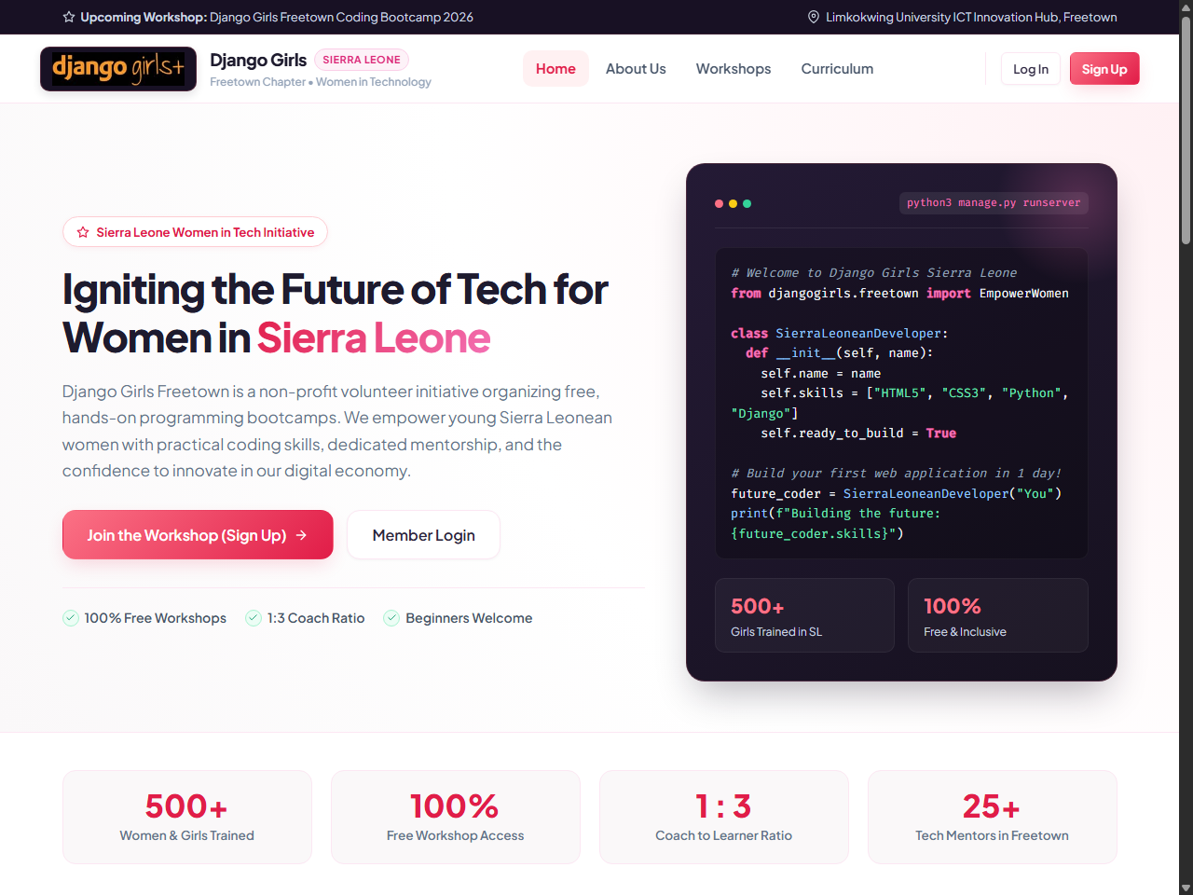
Figure 1.0: Printed Screenshot of the Django Girls Sierra Leone Home Page (index.php) displaying prominent logo, feminine rose palette, vector icons, and statistics.
Key Home Page Interface Observations:
1. Prominent Logo Display: The Django Girls logo is positioned in the sticky header bar with custom coral highlights and the Sierra Leone badge.
2. Feminine & Professional Aesthetic: Warm rose accents, crisp SVG icons, and elegant card styling give the site a distinctive feminine yet professional atmosphere.
3. Live Cohort Database Integration: Below the hero section, active workshop sessions are queried directly from the MySQL database and presented in responsive cards.

6. Individual Assessment Form & Student Declaration
As required by the assignment guidelines, this individual assessment form outlines the evaluation criteria, deliverables achieved, and personal declaration of original work.
Assessment Criteria / Deliverable | Requirement Description | Status & Evidence
Logo Prominence | Prominently display the Django Girls logo at the top header. | Achieved (Visible in sticky header)
Sign-Up Page | User registration form with input validation and database insert. | Achieved (register.php with validation)
Login Page | Authentication form verifying user credentials against DB. | Achieved (login.php with prepared statements)
Dashboard | Personalized user dashboard displaying member details and track. | Achieved (dashboard.php with profile card)
Logout Function | Secure logout destroying session and clearing cookies. | Achieved (logout.php session destruction)
Security Hashing | Use password hashing for storing user passwords securely. | Achieved (password_hash bcrypt standard)
Copyright Footer | Include required format: © First Last, Program, Sem, ID, Year. | Achieved (footer.php exact compliance)
Student Declaration of Original Work:
I hereby declare that this assignment titled 'Design and Development of Web Platform for Django Girls Sierra Leone' is my own original individual work produced for the Web Programming module. All code, design structures, and documentation have been prepared in accordance with academic integrity guidelines of Limkokwing University of Creative Technology Sierra Leone.
Student Signature: ______________________  Name: Alimatu Maliaka Jalloh | Date: 12 October 2026  Student ID: 905004463

