Lab 3 - Containerizing the Model with Docker
Student: Malak Srour
Repository: https://github.com/Malak-Srour/mlops-lab-1
Date: October 4, 2026

Overview
The best model of Lab 2 (adventurous-bat-170, run ID 8685c506f2d5489cbd68652780816347) is registered in the mlflow Model Registry as food11, served by a FastAPI API (src/food11/serve.py), and packaged in a multi-stage Docker image.

Checking Docker
After installing Docker Desktop, I checked that it works with docker run hello-world:
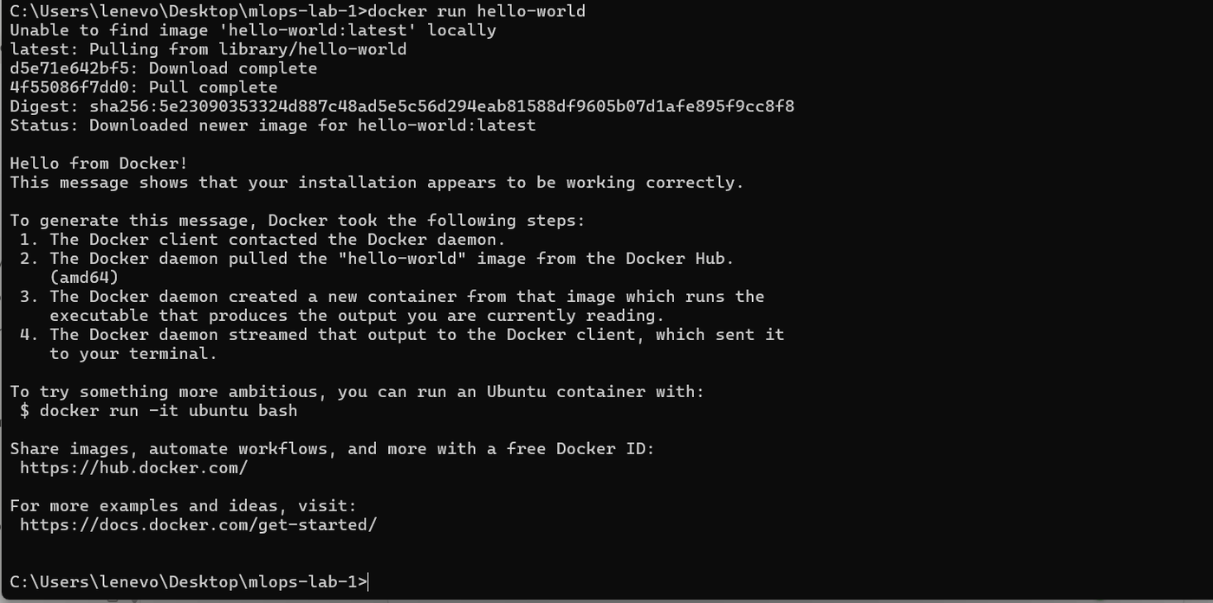
Docker pulled the hello-world image and ran a container from it

The container created from the hello-world image

Part 1 - Registering the Model
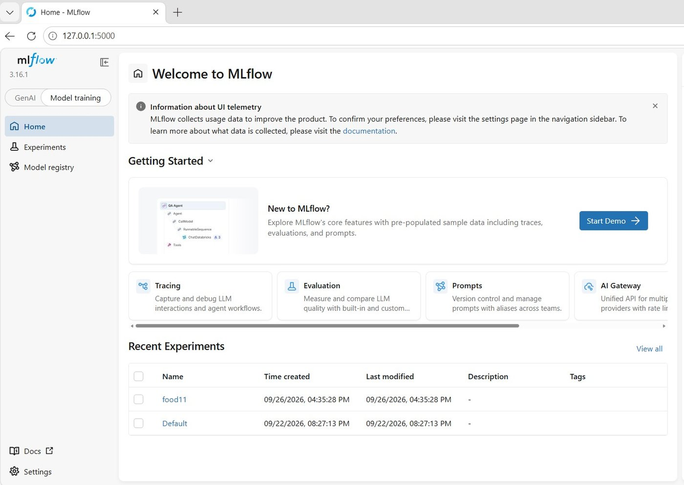
mlflow tracking server with the food11 experiment from Lab 2
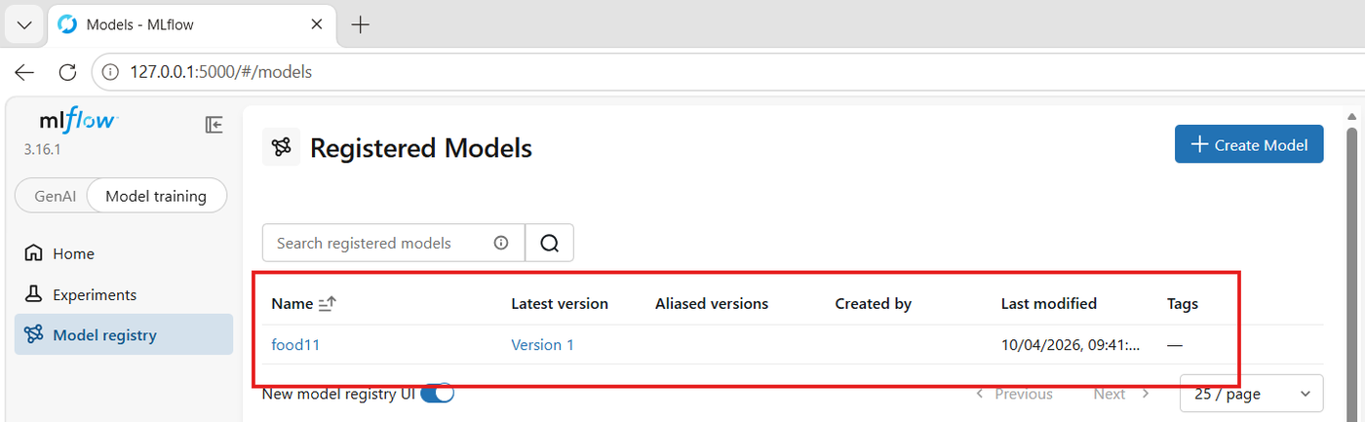
Best run registered as food11, Version 1

Question 1
Open the "Models" tab in the mlflow UI. What version number was your model given? What's the difference between a run's logged model artifact and a registered model?
My model was given version 1 (the first version registered under the name food11).
- Logged model: saved automatically by each training run, identified only by an automatic ID and its run. Every run has one.
- Registered model: a named entry in the registry (food11) with version numbers, pointing to the logged model I choose. Code loads it by name and version instead of by run ID.
Example: logged models are all the photos on a phone; the registered model is an album of the chosen ones, numbered 1, 2, 3...
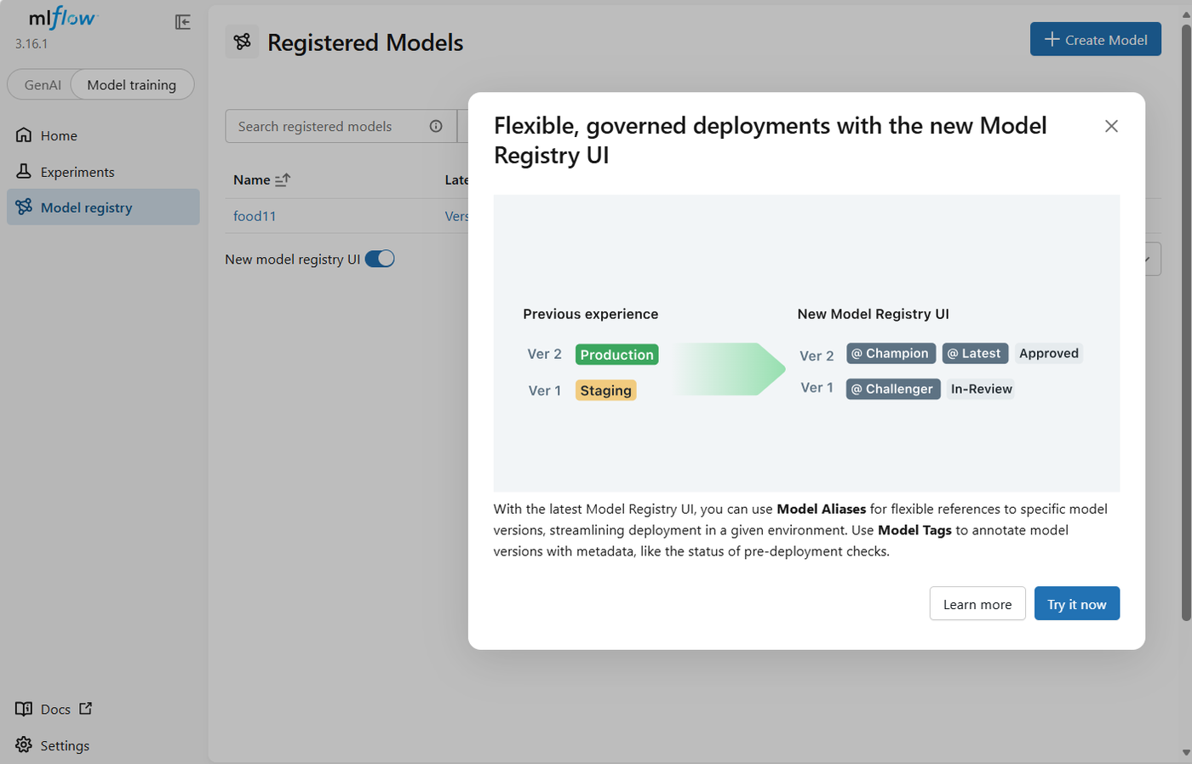
mlflow UI: aliases and tags replace the old stages
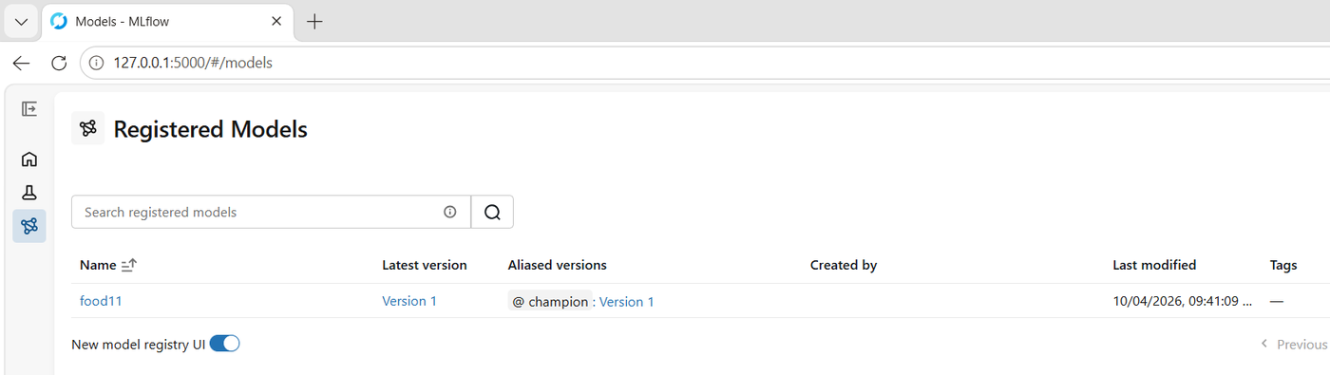
Alias champion added to Version 1 from the UI

Question 2
What aliases replaced the old built-in stages in mlflow? Why version a model separately from the run that produced it, and why is an alias more flexible than a fixed stage name?
The stages (Staging, Production, Archived) were replaced by aliases (named pointers to a version, such as champion or challenger) and free-form tags.
- Versioning separately: a run is one training attempt among many. The registry gives the chosen model a stable name and a version history, independent of the runs, so going back to an old version is easy.
- Alias vs stage: any name, several aliases at the same time, and an alias moves to another version in one step without changing the code. Example: in Question 7 I moved champion from version 1 to version 2.

Part 2 - Serving Script
serve.py exposes GET /health and POST /predict, loads models:/food11@champion once at startup, and reads the mlflow address from MLFLOW_TRACKING_URI.
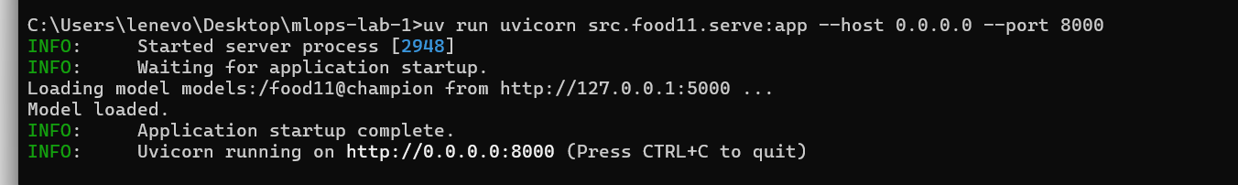
API started locally with uvicorn, model loaded
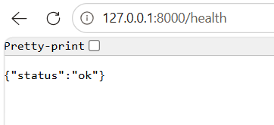
GET /health
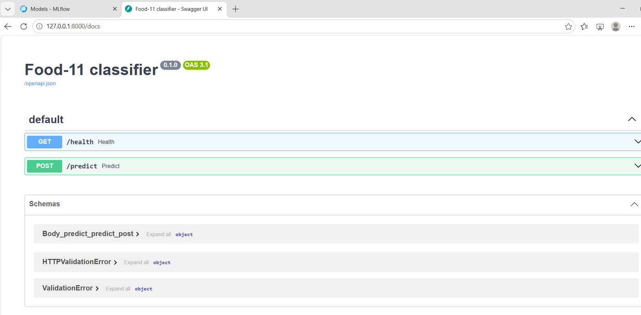
FastAPI test page (/docs)
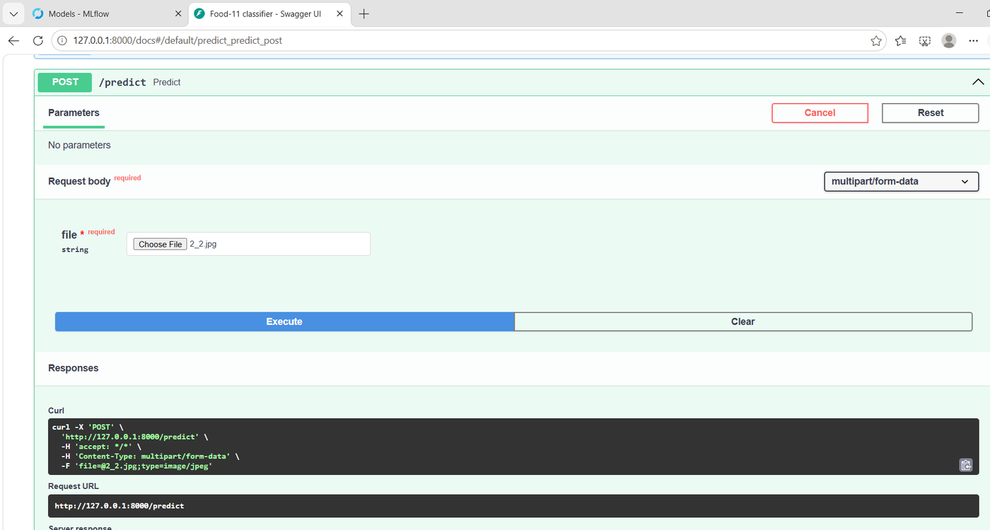
POST /predict with an image
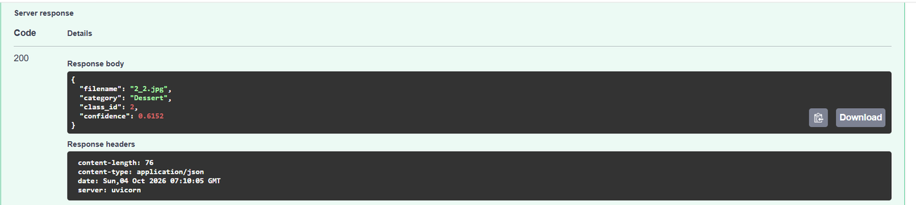
Response: Dessert, confidence 0.6152
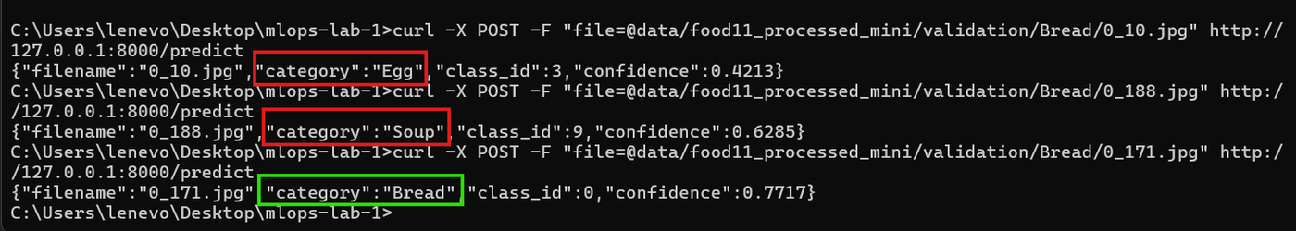
curl tests on Bread images (about 71% validation accuracy, so some mistakes are expected)

Question 3
Why load the model through an mlflow model URI (models:/food11@champion) instead of pointing directly at the .pth file on disk? What would you have to change to serve a newer model version?
- Problem with the .pth path: it only exists on my laptop, it is tied to one run, and changing the model means editing the code.
- With the model URI: mlflow finds the version that has the champion alias and loads it with its saved format and requirements. The code never changes.
- To serve a newer version: register it as a new version of food11, move champion to it, and restart the API. No code change.

Part 3 - Docker Image
Multi-stage Dockerfile (builder stage runs uv sync, runtime stage copies only .venv and src/ into a slim image) and a .dockerignore, built with docker build -t food11-api:latest .
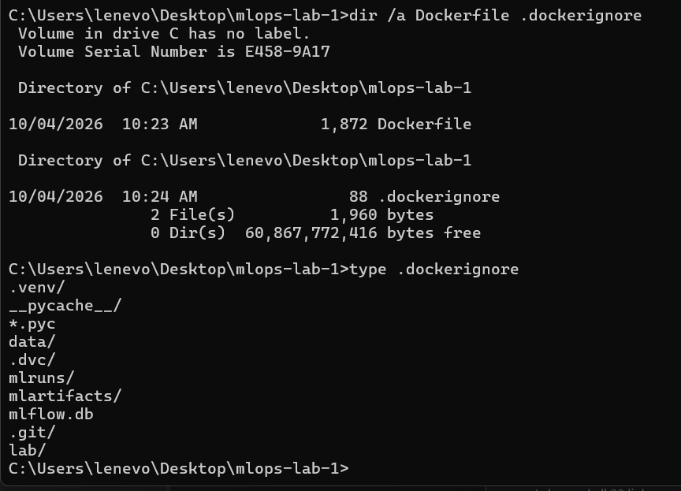
Dockerfile and .dockerignore at the root of the repo
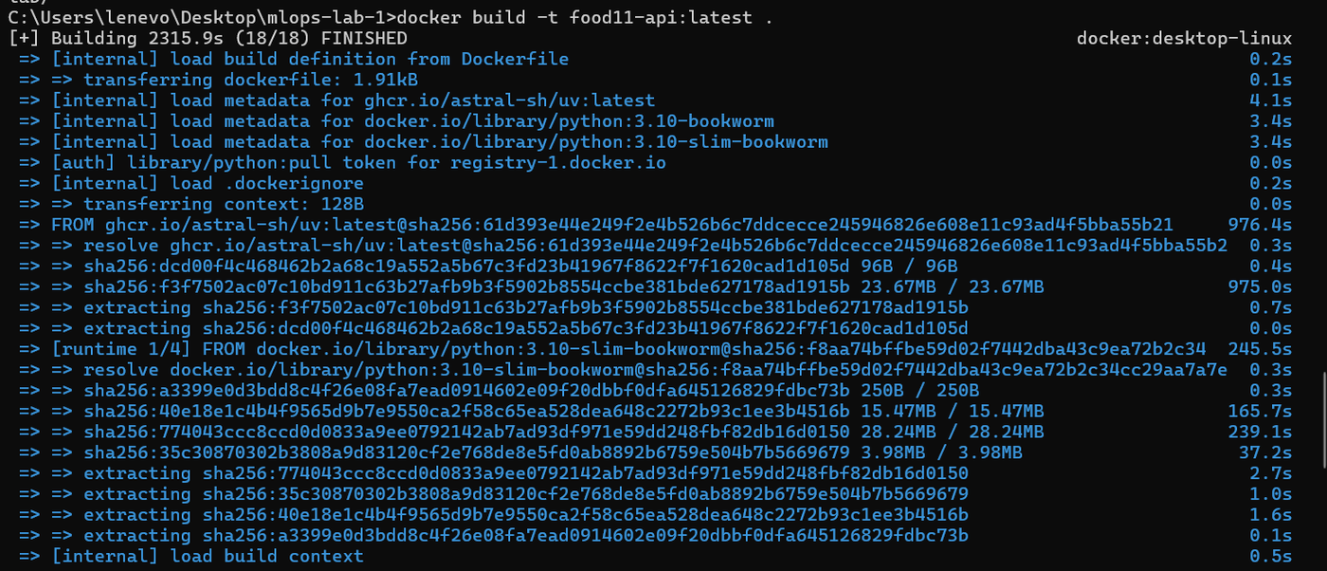
First build: 2,315.9 s (mostly downloads)

Question 4
Why copy pyproject.toml/uv.lock and run uv sync before copying the rest of the source code, instead of copying everything at once? What happens to the build cache when you only change a line in serve.py?
Each instruction is a cached layer; when one changes, it and all the layers after it are rebuilt. uv sync, the slowest step, only depends on pyproject.toml and uv.lock, so copying them first keeps it cached when only the code changes. With COPY . ., any edit would reinstall all the libraries.
What happened: after changing one line in serve.py, COPY pyproject.toml uv.lock and RUN uv sync were CACHED and only COPY src/ ran: 3.4 s instead of 2,315.9 s.
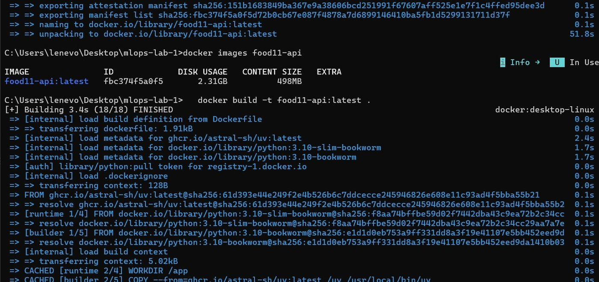
Rebuild after changing serve.py: dependency layers CACHED

Question 5
What's the size difference between a naive single-stage image and your multi-stage one? Use docker history <image> to see which layers are the biggest.
I compared it with a naive single-stage image (Dockerfile.single: full Python image, COPY . ., everything in one stage):
Image | Disk usage | Compressed
food11-api:latest (multi-stage) | 2.31 GB | 498 MB
food11-api:single (single-stage) | 5.52 GB | 1.24 GB

- Biggest layer in both: the Python libraries, mainly torch (1.67 GB in the multi-stage image, 3.15 GB in the single-stage one).
- Why 3.21 GB more: the single-stage image keeps build-only things: the full base image (≈ 1.08 GB vs ≈ 150 MB for slim), uv's download cache (≈ 1.5 GB) and the uv tool (54 MB).
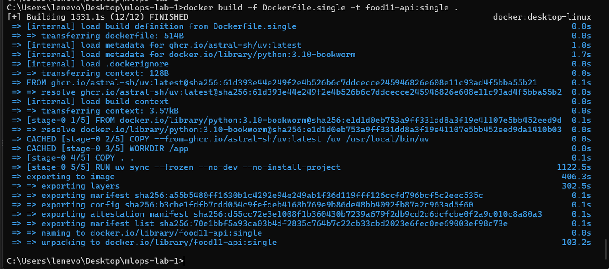
Building the single-stage image
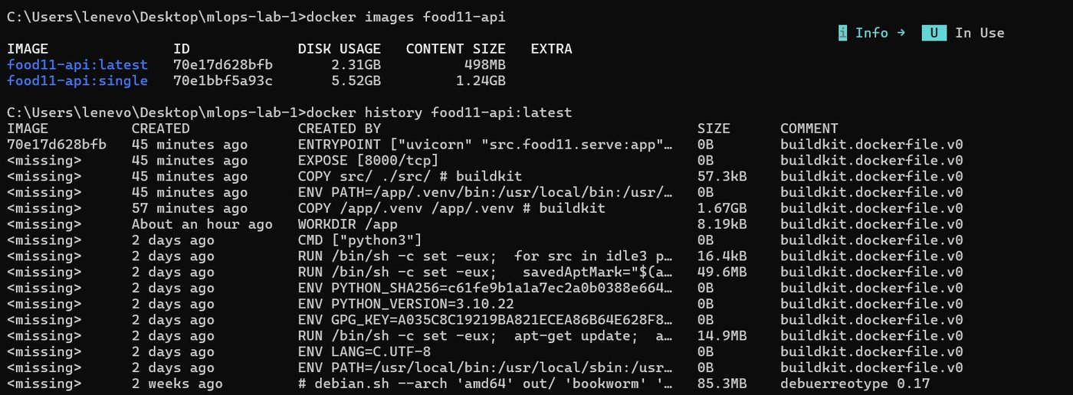
docker images and docker history of the multi-stage image
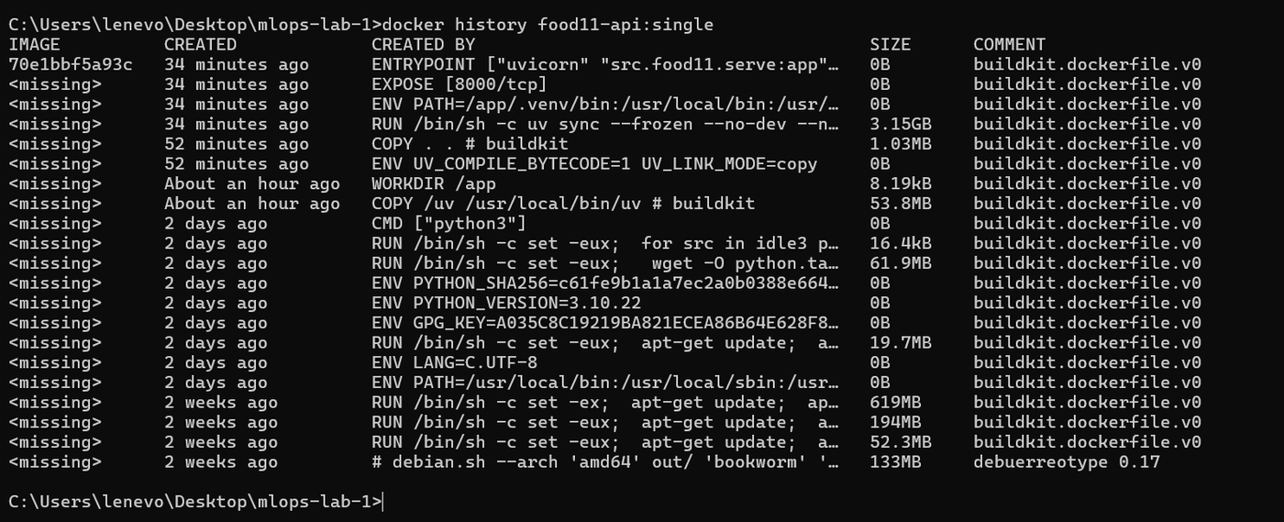
docker history of the single-stage image

Question 6
What happens to build speed and image size if you forget the .dockerignore? Which of the excluded folders would actually break the build if they were sent to the Docker daemon?
- Build speed: the build context would be ≈ 3.6 GB (data 1.19 GB, .dvc 1.14 GB, .venv 1.00 GB, mlruns 0.23 GB...) instead of 962 kB, sent at every build.
- Image size: same with my Dockerfile (it copies only pyproject.toml, uv.lock and src/), but several GB bigger with COPY . ..
- Breaks the build: .venv/, a Windows environment that would overwrite /app/.venv in the Linux container.

Part 4 - Running the Container
docker run -p 8000:8000 -e MLFLOW_TRACKING_URI=http://host.docker.internal:5000 food11-api:latest

Question 7
Why can't the container simply use 127.0.0.1:5000 to reach the mlflow server on your host? What does host.docker.internal resolve to?
A container has its own network: inside it, 127.0.0.1 is the container itself, not my laptop, so mlflow is not there. host.docker.internal is a Docker Desktop name that points to the host. In my container:
127.0.0.1 inside the container is: d27f7c5806ce
host.docker.internal -> 192.168.65.254
Extra steps needed on my setup:
- Problem: mlflow refused the container's requests (403 Invalid Host header). Fix: start the mlflow server with --allowed-hosts including host.docker.internal.
- Problem: the model files were saved as a Windows path (C:/Users/.../mlruns) that the container cannot see (No such artifact). Fix: start the server with --artifacts-destination ./mlartifacts so it sends the files over HTTP, register the same model again as version 2 (publish_for_serving.py) and move champion to it.
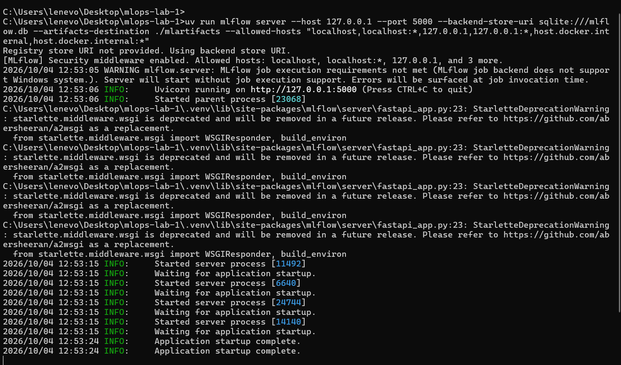
mlflow server with --artifacts-destination and --allowed-hosts
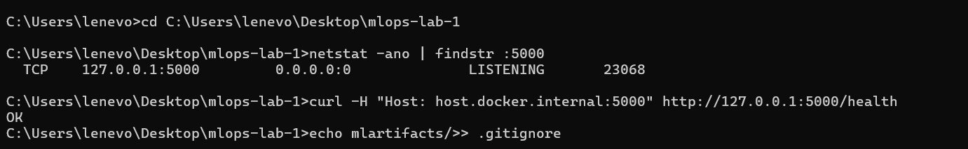
The server accepts the host name host.docker.internal (OK)
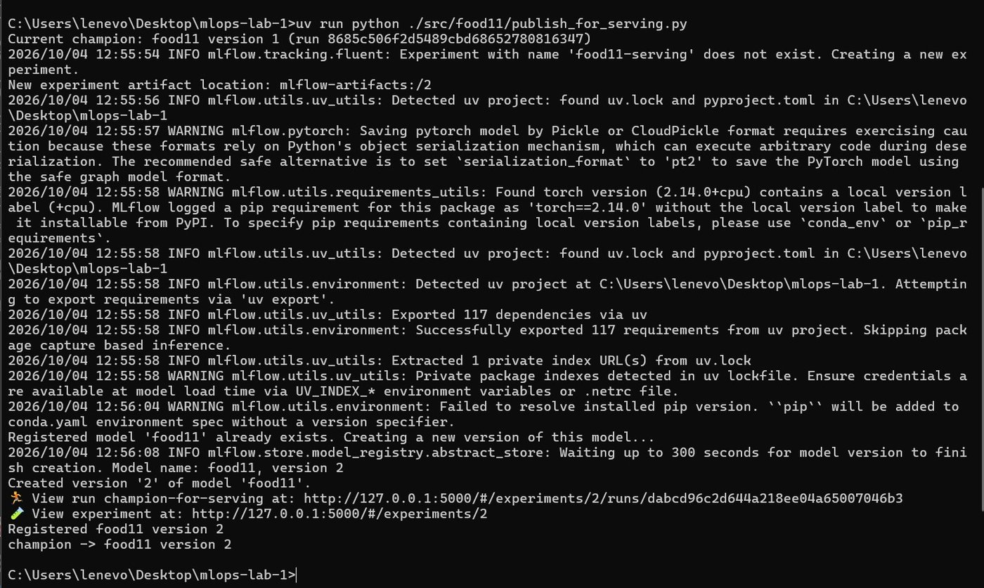
Model registered as version 2 and champion moved to it
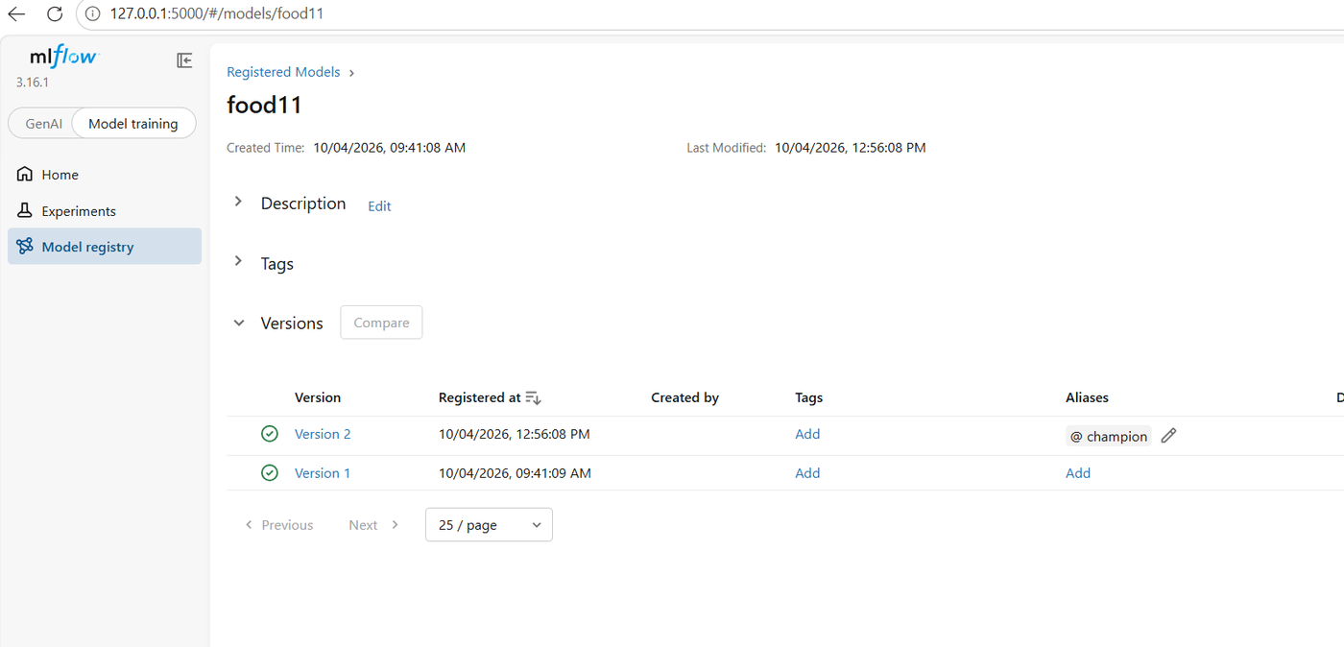
food11: @champion on Version 2
Result: the container loads the model and predicts like the local API (Bread, 0.7717).
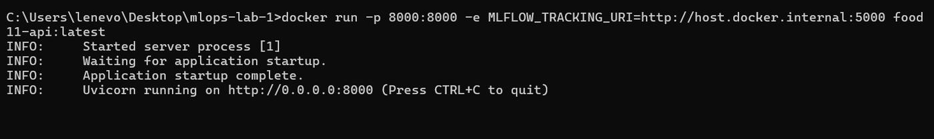
Container running
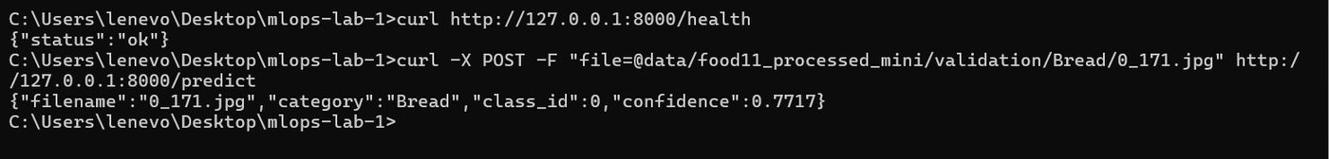
Prediction from the container

Question 8
Stop the container and start a new one from the same image. Does the model still load correctly without you rebuilding? What does that tell you about what's baked into the image versus fetched at runtime?
Yes: a new container from the same image loaded the model again without rebuilding (9_10.jpg → Soup, 0.8539).
- Baked into the image: Python, the libraries and serve.py.
- Fetched at runtime: the model (food11@champion) from mlflow, at each start.
- So moving the alias and restarting serves a new model, but the container needs the mlflow server to be reachable.
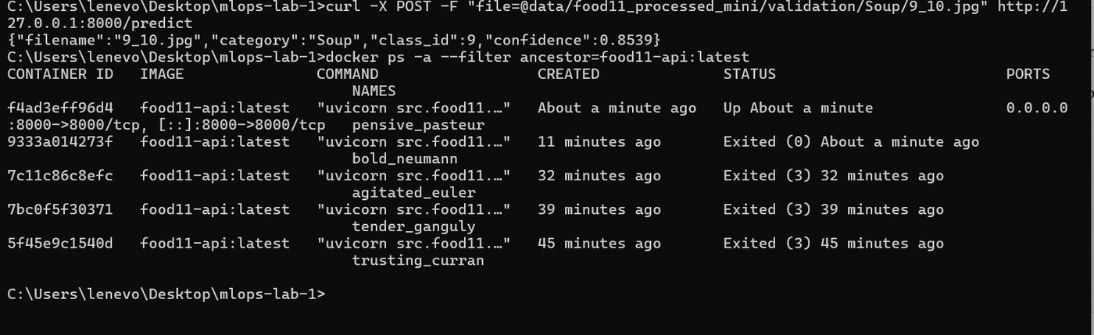
Each docker run creates a new container from the same image

Question 9
The Dockerfile and image are versioned differently: one lives in git, the other doesn't (yet). What's still missing before another machine (like a CI runner or a Kubernetes cluster) could reliably pull and run the exact image you just built?
The Dockerfile is in git, but the image only exists on my laptop. Still missing:
- A registry (Docker Hub, ghcr.io) to push the image and pull it elsewhere.
- A unique tag (git commit or version number) instead of latest.
- Pull credentials for the CI runner or the cluster.
- Pinned base images (uv:latest can change over time).
- A CI pipeline that builds, tags and pushes the image on every commit.
- A reachable mlflow server and model storage (host.docker.internal and mlartifacts/ only work on my laptop).

