Lab 2 - Model Training and Experiment Tracking with MLflow
Student: Malak Srour
Repository: https://github.com/Malak-Srour/mlops-lab-1
Date: September 27, 2026

Overview
This lab continues the project started in Lab 1, where I prepared the Food-11 dataset with git and dvc. In this lab I wrote a training script that fine-tunes a pretrained ResNet18 on the Food-11 images, started a local MLflow tracking server, logged the parameters, metrics and trained model of every run, and compared several runs in the MLflow UI to find the best settings.
The main idea of the lab is that each tool keeps what it is good at keeping:
- git versions the code (train.py, pyproject.toml, uv.lock),
- dvc versions the data (the raw and processed Food-11 datasets),
- mlflow stores the experiments: the settings of each run, its results, and the trained model.

My setup
- Windows laptop without an NVIDIA GPU, so I installed the CPU-only version of PyTorch.
- dvc uses a local folder as its remote (no DagsHub), as chosen in Lab 1.
- Versions used: mlflow 3.16.1, torch 2.14.0+cpu, torchvision 0.29.0+cpu, scikit-learn 1.7.2.
- All training runs use the food11_processed_mini dataset (1,100 training images, 1,096 validation images, 1,096 test images).

Part 1 - Environment Setup

Installing mlflow and the training libraries
Since my laptop has no NVIDIA GPU, I first added the PyTorch CPU-only package server to pyproject.toml, then ran:
uv add mlflow torch torchvision scikit-learn
I checked that all the libraries load correctly and that torch is the CPU version (+cpu):
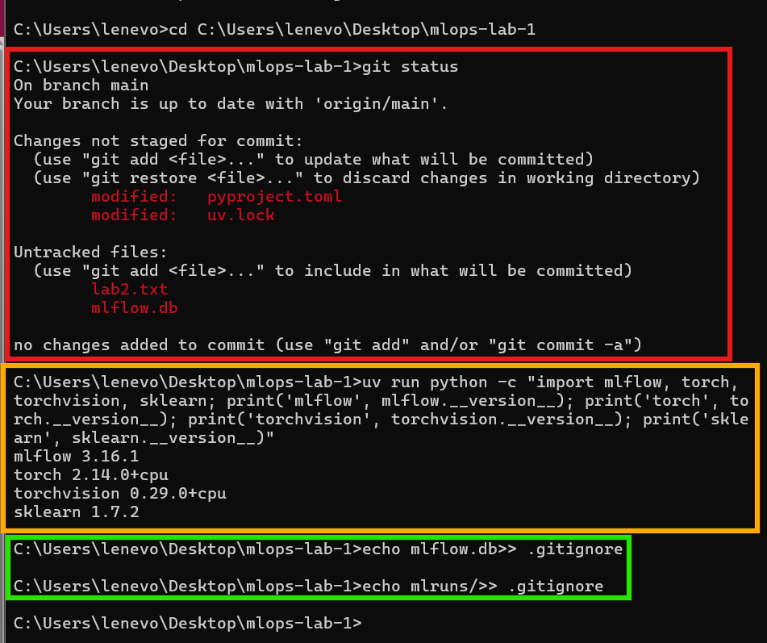
git status after installing, library versions check, and adding mlflow files to .gitignore

Question 1
Look at pyproject.toml and uv.lock. What changed?
In pyproject.toml, the dependencies list now includes mlflow, torch, torchvision and scikit-learn next to pillow, each with a minimum version (for example mlflow>=3.16.1). uv added them automatically when I ran uv add. I also added two sections before installing: [[tool.uv.index]], which points to PyTorch's CPU-only package server, and [tool.uv.sources], which tells uv to install torch and torchvision from there, since my laptop has no NVIDIA GPU.
The resulting pyproject.toml:
[project]
name = "mlops-lab-1"
version = "0.1.0"
requires-python = ">=3.10"
dependencies = [
"mlflow>=3.16.1",
"pillow>=12.3.0",
"scikit-learn>=1.7.2",
"torch>=2.14.0",
"torchvision>=0.29.0",
]

[[tool.uv.index]]
name = "pytorch-cpu"
url = "https://download.pytorch.org/whl/cpu"
explicit = true

[tool.uv.sources]
torch = { index = "pytorch-cpu" }
torchvision = { index = "pytorch-cpu" }

Running the local mlflow tracking server
In a separate terminal, from the root of the repo:
uv run mlflow server --host 127.0.0.1 --port 5000 --backend-store-uri sqlite:///mlflow.db --default-artifact-root ./mlruns
The MLflow UI then opens at http://127.0.0.1:5000 with an empty "Default" experiment:
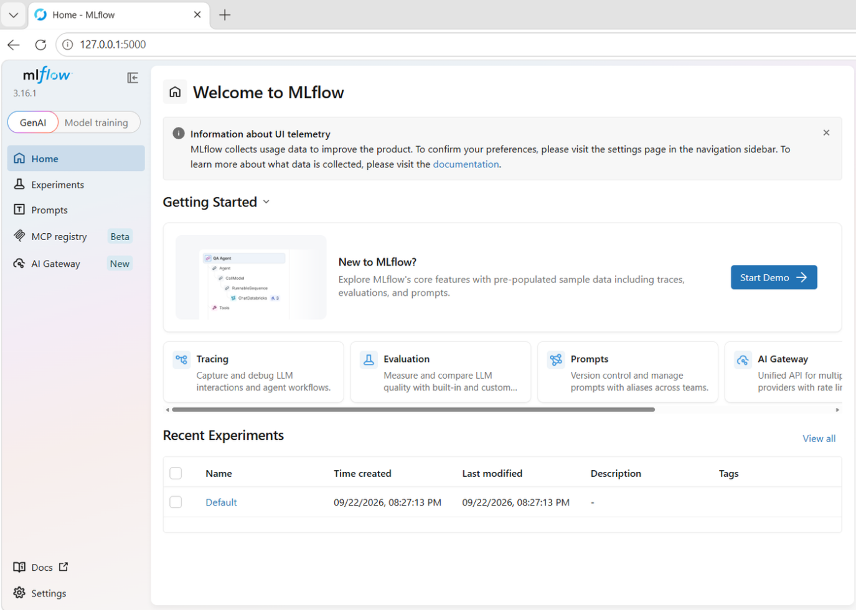
MLflow UI with the empty Default experiment

Question 2
What is --backend-store-uri used for? What is --default-artifact-root used for? What is the difference between the metadata mlflow stores and the artifacts it stores?
--backend-store-uri tells mlflow where to store the metadata of experiments and runs. Here it is sqlite:///mlflow.db, meaning a SQLite database saved in a single file, mlflow.db, in the project folder.
The metadata is small, structured information about each run: experiment name, run ID, start time, parameters (for example learning rate and batch size) and metrics (for example loss and accuracy per epoch). Because it is small and structured, it is stored in a database where mlflow can quickly search, sort and compare runs.
--default-artifact-root tells mlflow where to store the artifacts, meaning the files produced by a run. Here it is ./mlruns, a normal folder in the project.
The artifacts are the actual output files of a run, mainly the trained model, but also possibly plots or other files. They can be large and of any type, so they are stored as files in a folder instead of in the database. The metadata of each run keeps a link to where its artifacts are stored.

Keeping mlflow files out of git
On Windows, echo writes the quotes into the file, so I used the commands without quotes:
echo mlflow.db>> .gitignore
echo mlruns/>> .gitignore
git add .gitignore
git commit -m "Ignore local mlflow tracking files"
git push
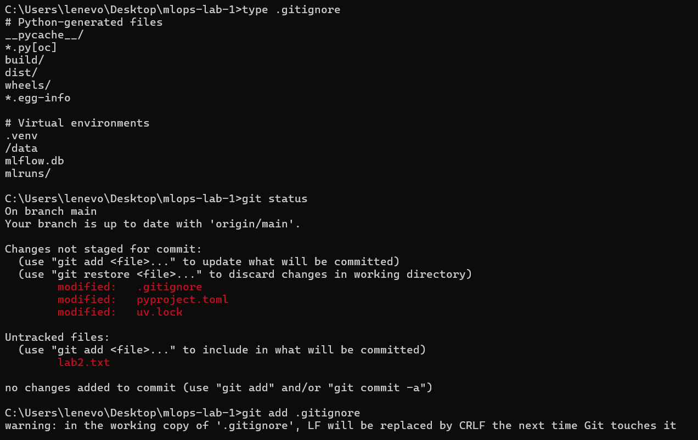
.gitignore now ends with mlflow.db and mlruns/, and mlflow.db no longer appears as untracked
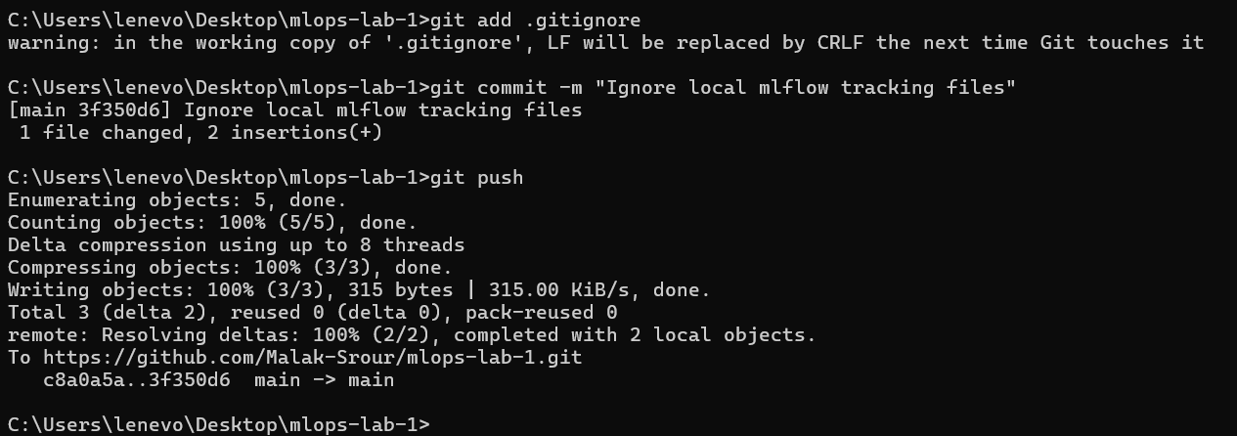
Commit 3f350d6 pushed to GitHub

Question 3
Why shouldn't mlflow.db and mlruns/ be tracked by git, and why shouldn't they be tracked by dvc either?
They shouldn't be tracked by git because git is made for source code: small text files that we write and change on purpose. mlflow.db and mlruns/ are outputs created automatically by mlflow, and they change every time we train a model. mlflow.db is a binary database file, so git cannot show meaningful differences in it, and mlruns/ contains large files such as trained models. Tracking them would make the repository heavy and fill its history with automatic changes.
They shouldn't be tracked by dvc either because dvc is made for versioning datasets, by taking snapshots of data at specific moments. mlflow.db is a live database that the mlflow server keeps updating while it runs, so a snapshot would quickly be out of date. Also, mlflow already versions its own content: each run has a unique ID and its own artifacts. Tracking these files with dvc would mean two tools managing the same information.
So each tool keeps its own responsibility: git versions the code, dvc versions the data, and mlflow stores the runs, metrics and models.

Pointing the code to the tracking server
uv run python -c "import mlflow; mlflow.set_tracking_uri('http://127.0.0.1:5000'); exp = mlflow.set_experiment('food11'); print('Experiment ID:', exp.experiment_id)"
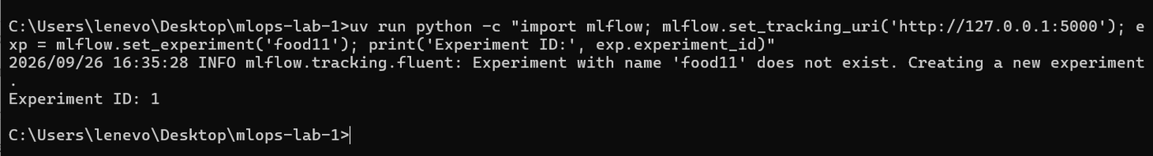
mlflow creates the food11 experiment because it does not exist yet
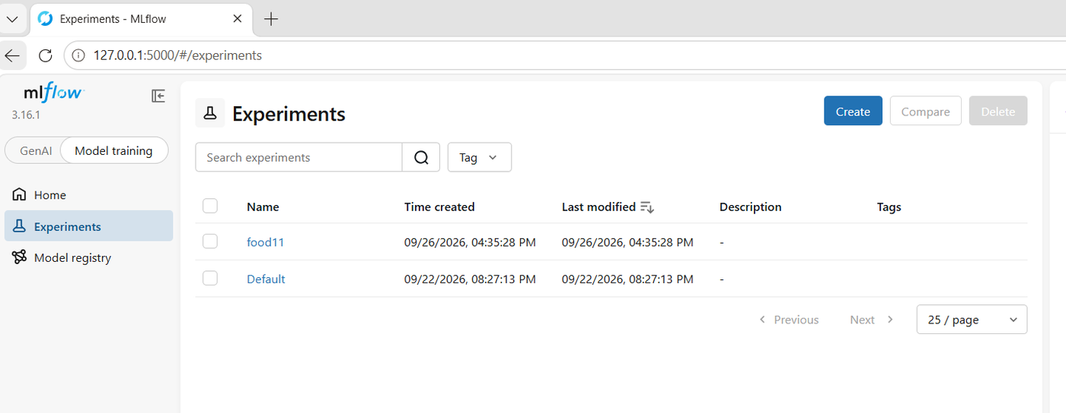
The food11 experiment now appears in the UI next to Default

Question 4
What happens the first time you call set_experiment with a name that doesn't exist yet? Check the mlflow UI.
If no experiment with that name exists, mlflow creates it automatically instead of giving an error. The terminal showed the message: "Experiment with name 'food11' does not exist. Creating a new experiment." The new experiment received the ID 1 (the "Default" experiment has ID 0), and it is then set as the active experiment, so all following runs are logged inside it.
After refreshing the mlflow UI, the food11 experiment appears in the experiments list next to Default, with no runs yet.
When I ran the same command a second time, the message did not appear and the same ID 1 was returned. This shows that set_experiment only creates the experiment the first time; after that, it simply selects the existing one.

Part 2 - Training the Model

The training script
I wrote src/food11/train.py step by step, testing each part before adding the next one:
Part | What it does
1. Settings and data | Reads --dataset, --epochs, --lr and --batch-size with argparse, and loads the training, validation and evaluation images with ImageFolder and DataLoader.
2. Model | Loads ResNet18 pretrained on ImageNet and replaces its last layer (fc) so it outputs 11 classes instead of 1,000 (transfer learning).
3. Training | For each epoch: trains on the training set with CrossEntropyLoss and the Adam optimizer, then measures loss and accuracy on the validation set. At the end, measures the test accuracy.
4. MLflow logging | Wraps everything in mlflow.start_run(), logs the params once, logs train_loss, val_loss and val_accuracy every epoch with step=epoch, then logs test_accuracy and the trained model.

Part 1 test - the data loads correctly: 11 classes, 1,100 training images (11 x 100), and 1,096 validation and test images (some categories have fewer than 100 images).
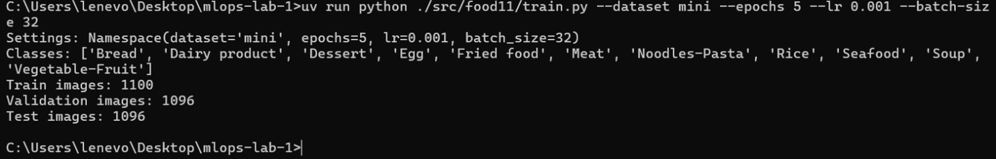
Part 1: settings and datasets loaded
Part 2 test - the pretrained weights are downloaded, the new last layer has 11 outputs, and one batch of shape [32, 3, 128, 128] gives an output of shape [32, 11].
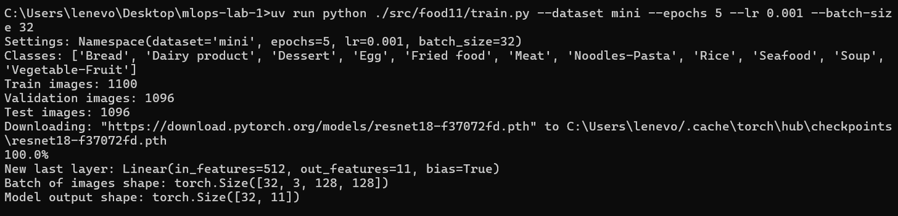
Part 2: ResNet18 with a new 11-class last layer
Part 3 test - the model learns: train_loss goes down every epoch and val_accuracy goes from 0.33 to 0.54. The validation loss stays much higher than the training loss, which shows some overfitting on this small dataset.
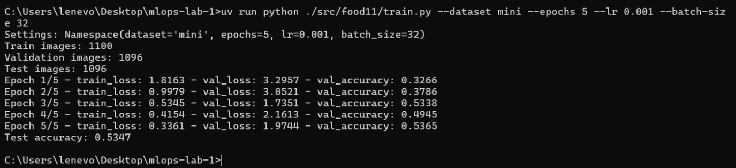
Part 3: first training without mlflow

Main MLflow part of the code
with mlflow.start_run() as run:
# settings: logged once, they never change during the run
mlflow.log_params({
"dataset": args.dataset, "epochs": args.epochs,
"lr": args.lr, "batch_size": args.batch_size, "model": "resnet18",
})

for epoch in range(1, args.epochs + 1):
train_loss = train_one_epoch(model, train_loader, loss_fn, optimizer)
val_loss, val_accuracy = evaluate(model, val_loader, loss_fn)
# results: logged every epoch, step = epoch number
mlflow.log_metric("train_loss", train_loss, step=epoch)
mlflow.log_metric("val_loss", val_loss, step=epoch)
mlflow.log_metric("val_accuracy", val_accuracy, step=epoch)

test_loss, test_accuracy = evaluate(model, test_loader, loss_fn)
mlflow.log_metric("test_accuracy", test_accuracy)

# save the trained model inside the run
mlflow.pytorch.log_model(model, name="model",
input_example=input_example,
serialization_format="pickle")

Problem faced: saving the model
With mlflow 3.16, mlflow.pytorch.log_model(model, "model") failed at the end of training. The newer default format, pt2, first asked for an input_example:
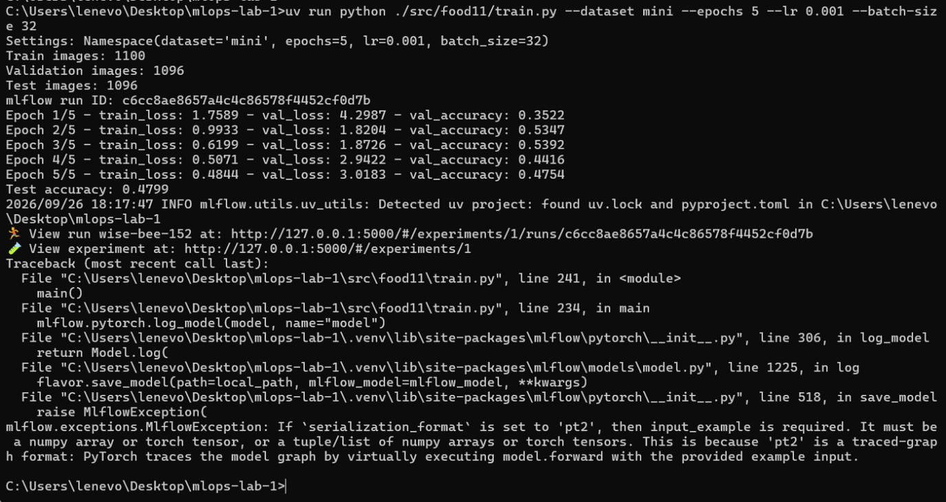
First error: pt2 format requires an input_example
After adding an example input, it failed again because the pt2 format needs a very precise input description (a TensorSpec signature):
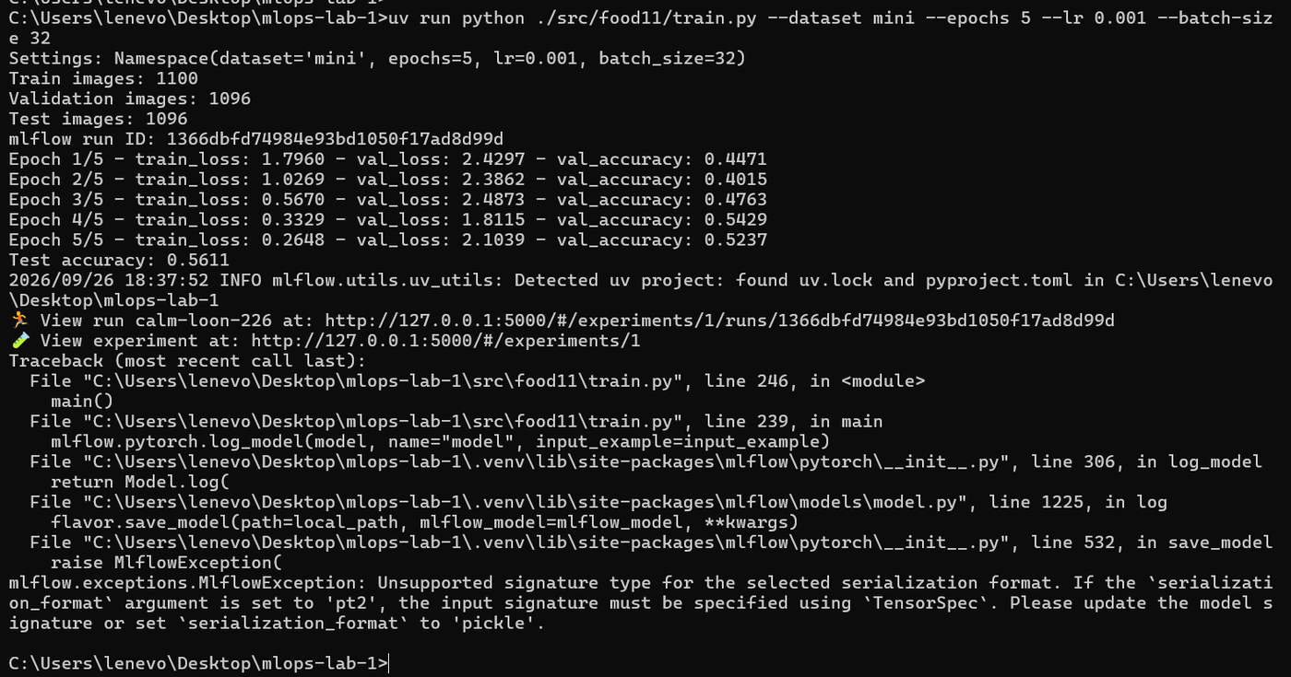
Second error: pt2 format requires a TensorSpec signature
Fix: as suggested by the error message, I saved the model with the classic serialization_format="pickle" and passed two real test images (as a numpy array) as the input_example. I tested the fix quickly with 1 epoch, and the model was saved. mlflow also exported the 116 dependencies from uv.lock next to the model, so the environment can be recreated later.
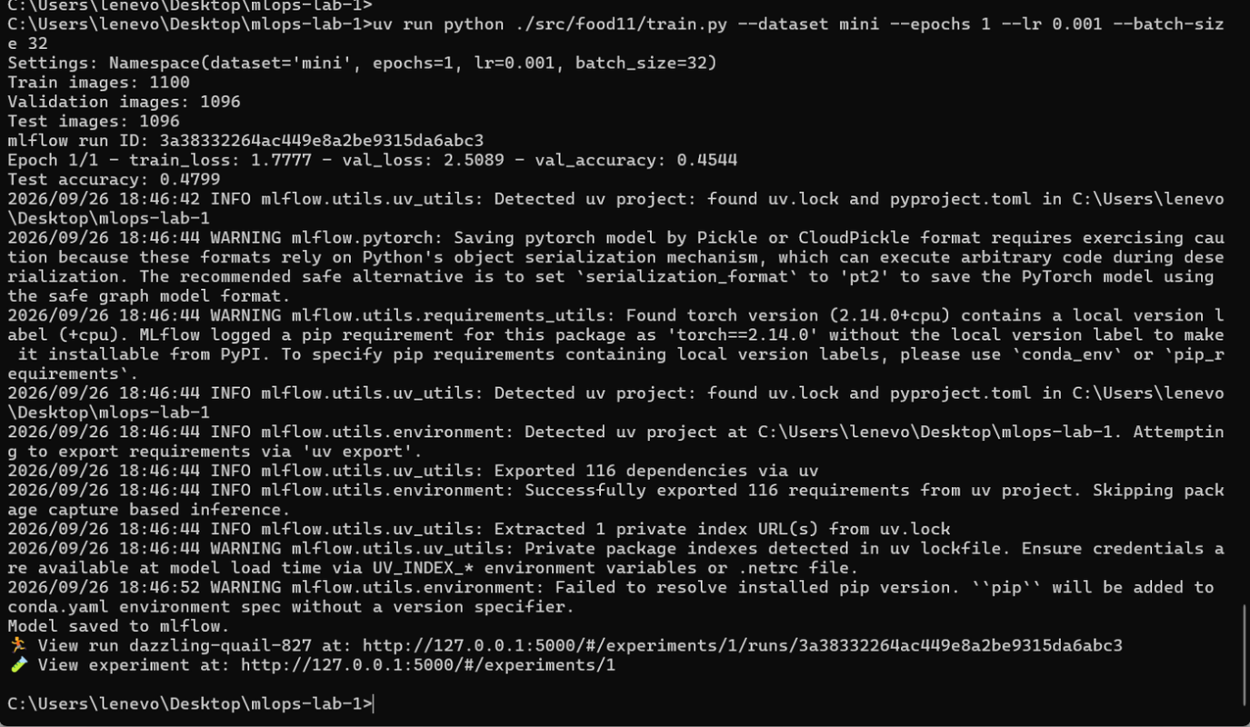
1-epoch test run: "Model saved to mlflow."
Because the errors happened inside the runs, mlflow marked them as Failed. I deleted the two failed runs and the 1-epoch test run so that only complete, real runs are compared:
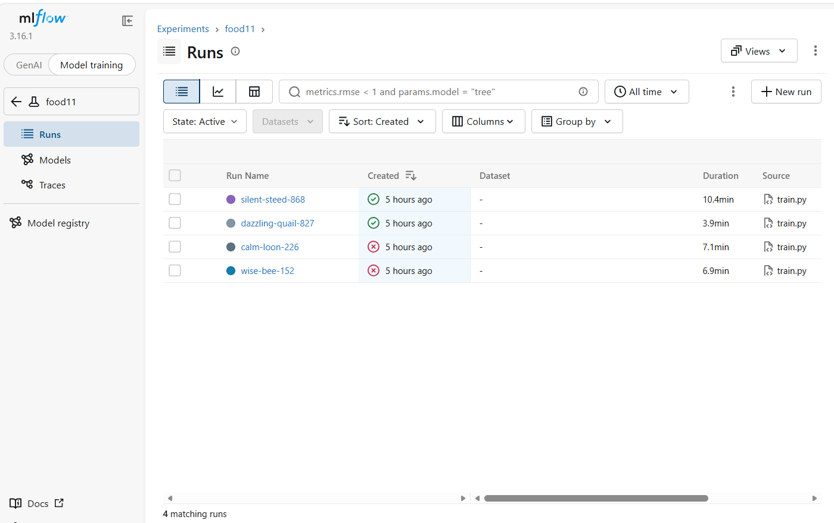
Before cleanup: two failed runs and one test run
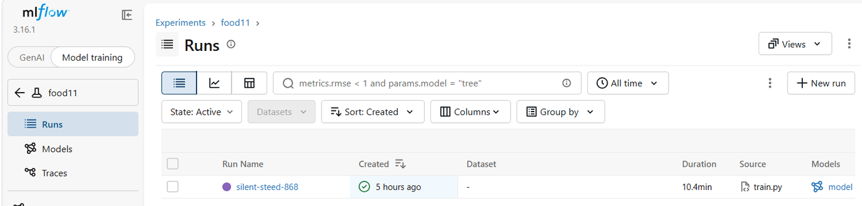
After cleanup: only the real run remains, with its model

First complete run
uv run python ./src/food11/train.py --dataset mini --epochs 5 --lr 0.001 --batch-size 32
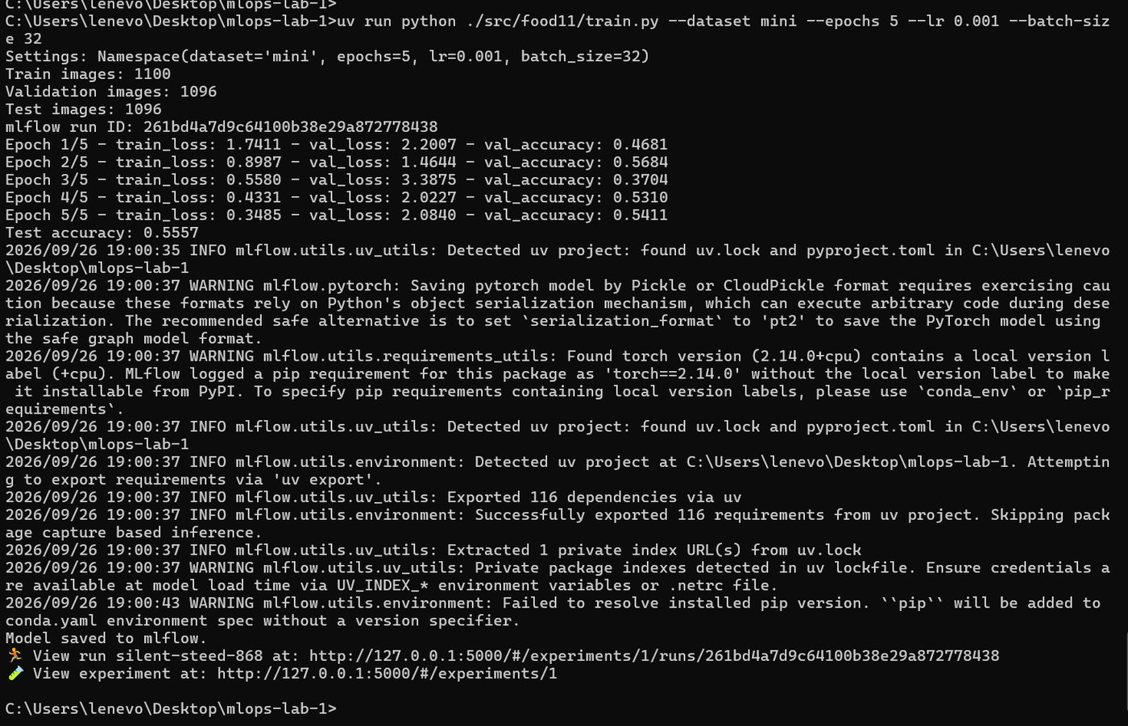
Run silent-steed-868: training, test accuracy 0.5557, model saved

Question 5
What is the difference between mlflow.log_param and mlflow.log_metric? Why does log_metric take a step argument and log_param doesn't?
mlflow.log_param records a setting chosen before training that stays fixed during the whole run, such as the learning rate, the batch size, the number of epochs or the dataset. Each param has a single value per run, so in my script I log them once at the start of the run. mlflow does not allow changing a param's value later in the same run.
mlflow.log_metric records a numeric result produced by the training, such as train_loss, val_loss or val_accuracy. These values change as the model learns, so a metric can be logged many times in the same run. In my script I log them at the end of every epoch, and test_accuracy once at the end. For example, in my run val_accuracy was logged 5 times: 0.4681, 0.5684, 0.3704, 0.5310 and 0.5411.
log_metric takes a step argument because a metric has a history: step tells mlflow which point in training each value belongs to (here, the epoch number). This lets mlflow keep the values in order and draw charts of how the loss and accuracy evolve. A param has only one fixed value, so there is no history and no need for a step.

Question 6
Open the run in the mlflow UI. Find the params, the metric charts, and the logged model artifact. Where does the model artifact actually live on disk?
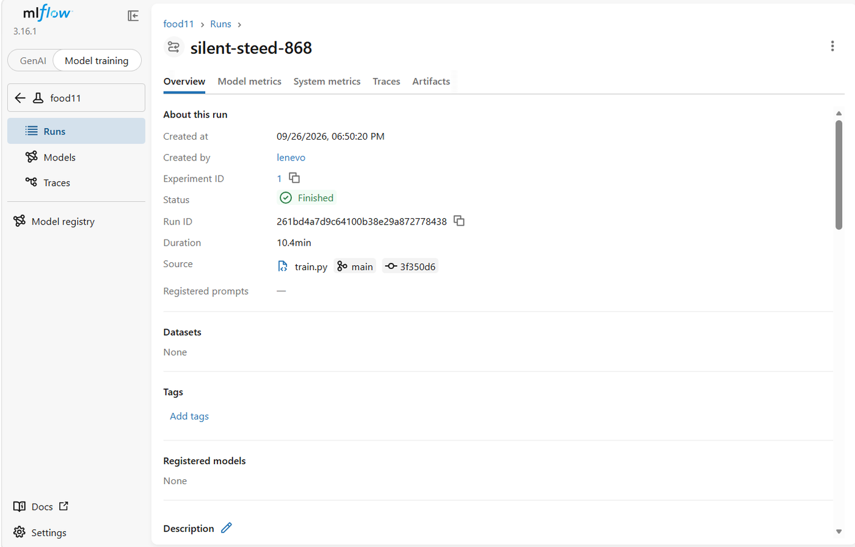
Run overview: run ID, status, duration and source (train.py, branch main, commit)
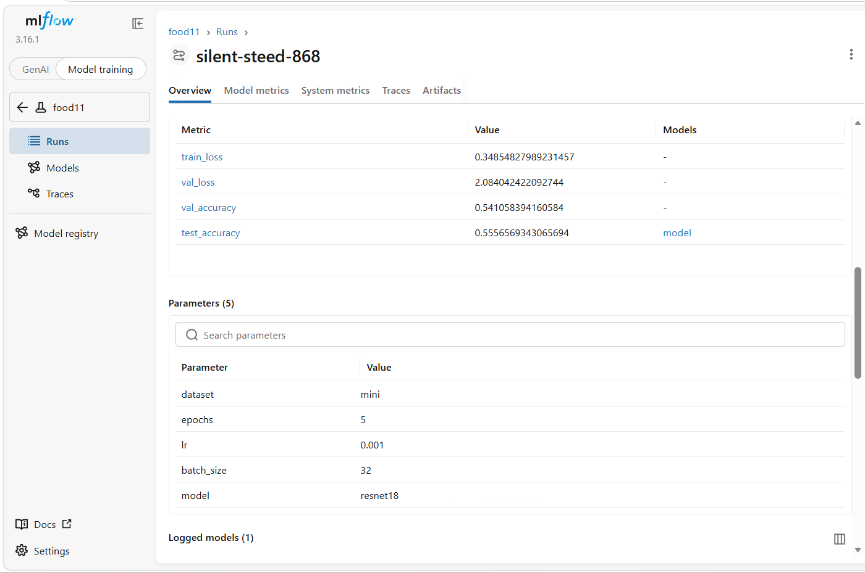
Metrics (last value of each) and the 5 logged parameters
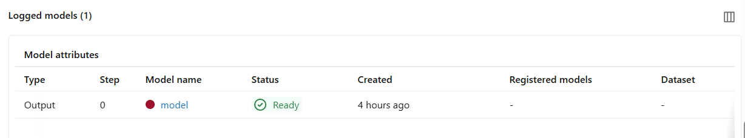
Logged models section: the model is Ready
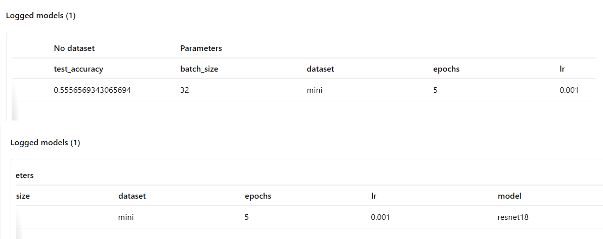
The logged model is linked to its test_accuracy and to the params it was trained with
In the mlflow UI, I opened the food11 experiment and the run silent-steed-868. On the Overview tab, the Parameters table shows the 5 params I logged: dataset=mini, epochs=5, lr=0.001, batch_size=32 and model=resnet18. The Metrics table shows the last value of each metric, for example val_accuracy = 0.541 and test_accuracy = 0.556. On the Model metrics tab, there is a chart for train_loss, val_loss and val_accuracy, with the epoch number (the step) on the horizontal axis. The trained model appears in the Logged models section, where it is linked to the params it was trained with and to its test_accuracy, so the model can always be traced back to how it was produced.
The UI also shows the source of the run: the script train.py, the git branch main and the git commit, which links the run to the code version that produced it.
On disk, the model is stored in the artifact folder chosen with --default-artifact-root:
mlruns\1\models\m-4208b911966d4b4a880fcab642d9857a\artifacts\data\model.pth
where 1 is the experiment ID of food11, m-4208b911966d4b4a880fcab642d9857a is the unique ID of the logged model, and model.pth is the saved PyTorch model. The metadata of the run (params, metrics, and the link to this model) is stored separately in mlflow.db. This shows the split from Question 2: the database keeps the information about the run, and the mlruns folder keeps the actual files.

Part 3 - Running Several Experiments and Comparing Them
I trained the model with different settings, changing one hyperparameter at a time. The run with lr = 0.001 and batch_size = 32 was already done (silent-steed-868), so I ran the 3 other configurations:
uv run python ./src/food11/train.py --dataset mini --epochs 5 --lr 0.01 --batch-size 32
uv run python ./src/food11/train.py --dataset mini --epochs 5 --lr 0.0001 --batch-size 32
uv run python ./src/food11/train.py --dataset mini --epochs 5 --lr 0.001 --batch-size 64
Validation accuracy per epoch for the 4 runs (from the terminal output):
Epoch | lr 0.01, bs 32 | lr 0.001, bs 32 | lr 0.0001, bs 32 | lr 0.001, bs 64
1 | 0.0839 | 0.4681 | 0.6469 | 0.4325
2 | 0.1113 | 0.5684 | 0.6998 | 0.4717
3 | 0.1004 | 0.3704 | 0.7135 | 0.6040
4 | 0.1141 | 0.5310 | 0.7135 | 0.5602
5 | 0.1524 | 0.5411 | 0.7117 | 0.5684

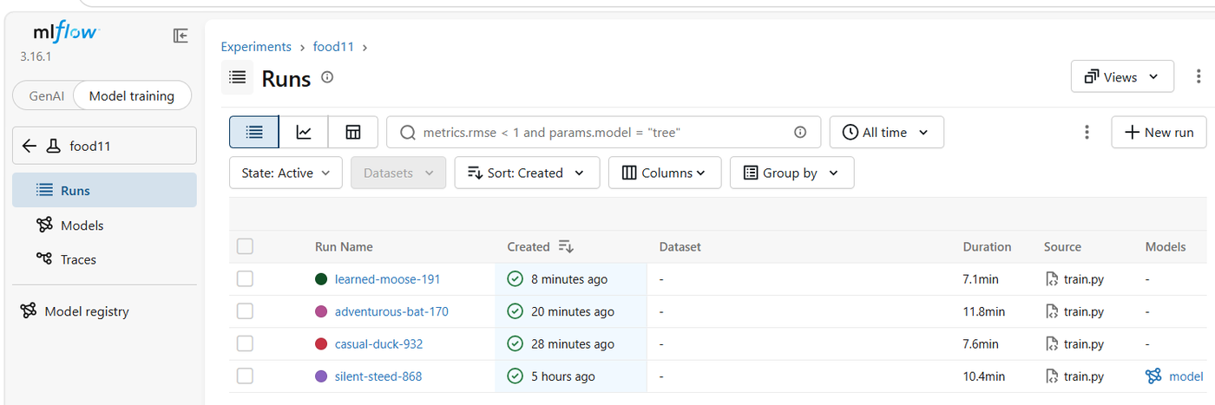
The 4 runs in the food11 experiment

Question 7
In the mlflow UI, open the food11 experiment. Select these runs and click "Compare". Which learning rate gave the best val_accuracy? Is higher always better?
I selected the 4 runs in the food11 experiment and clicked "Compare":
Run | lr | batch_size | val_accuracy | test_accuracy
casual-duck-932 | 0.01 | 32 | 0.152 | 0.149
silent-steed-868 | 0.001 | 32 | 0.541 | 0.556
adventurous-bat-170 | 0.0001 | 32 | 0.712 | 0.757
learned-moose-191 | 0.001 | 64 | 0.568 | 0.586

The best val_accuracy was obtained with the smallest learning rate, lr = 0.0001 (0.712).
No, a higher learning rate is not always better. With lr = 0.01, the model barely learned anything: its accuracy stayed around 15%, close to random guessing between 11 classes (about 9%). Because we start from a pretrained ResNet18, the weights already contain useful knowledge. A large learning rate makes such big changes that it destroys this knowledge, while a small learning rate adjusts it gently to the new task. The run with lr = 0.0001 was also more stable: its validation loss decreased smoothly, while the runs with lr = 0.001 jumped up and down between epochs.
The learning rate has to be chosen carefully: too high and training becomes unstable, too low and training can become very slow. In this case, 0.0001 gave the best balance.

Question 8
Use the parallel coordinates plot on the compare page to look at lr, batch_size and val_accuracy together. What pattern do you see?
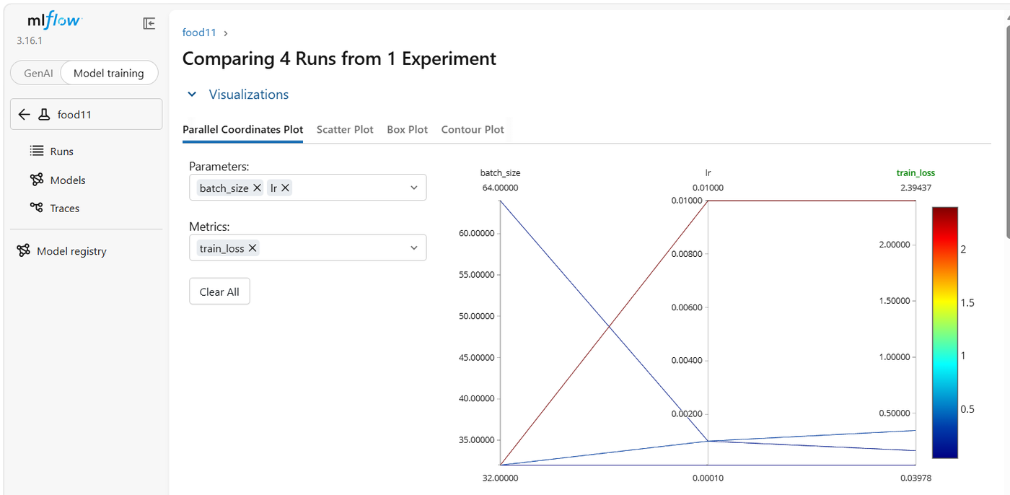
Parallel coordinates plot with train_loss (the lr = 0.01 run has the highest loss)
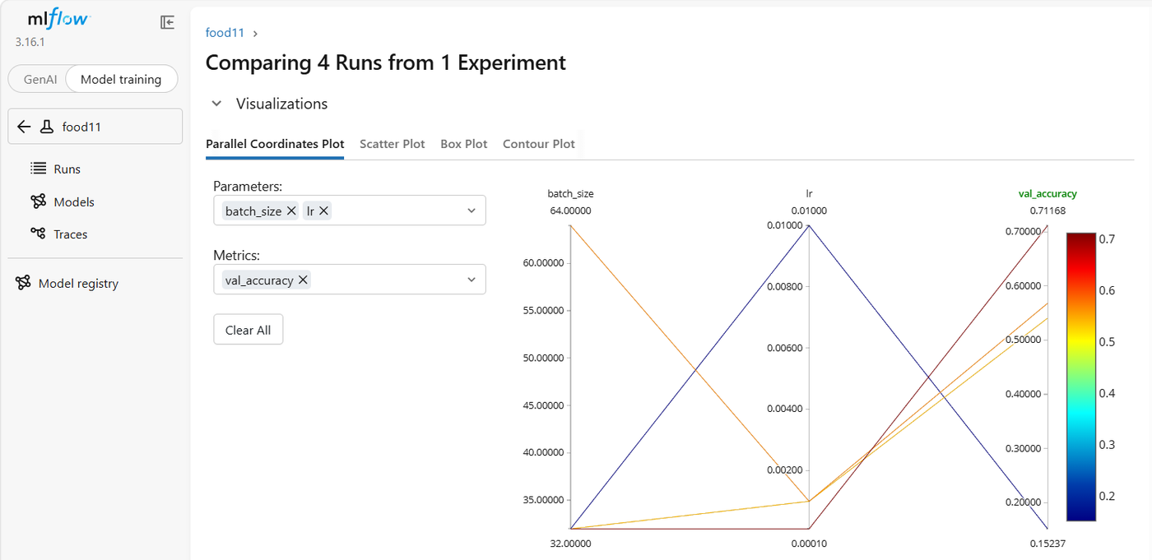
Parallel coordinates plot with val_accuracy (red = high accuracy, blue = low accuracy)
Visually, the lines cross each other between the lr axis and the val_accuracy axis, forming an X shape: the highest learning rate connects to the lowest accuracy, and the lowest learning rate connects to the highest accuracy. This crossing shows an inverse relationship between the learning rate and the validation accuracy in these runs.

Question 9
Sort the runs table by val_accuracy descending. Which run is the best one? Note its run ID, you'll need it in the next lab.
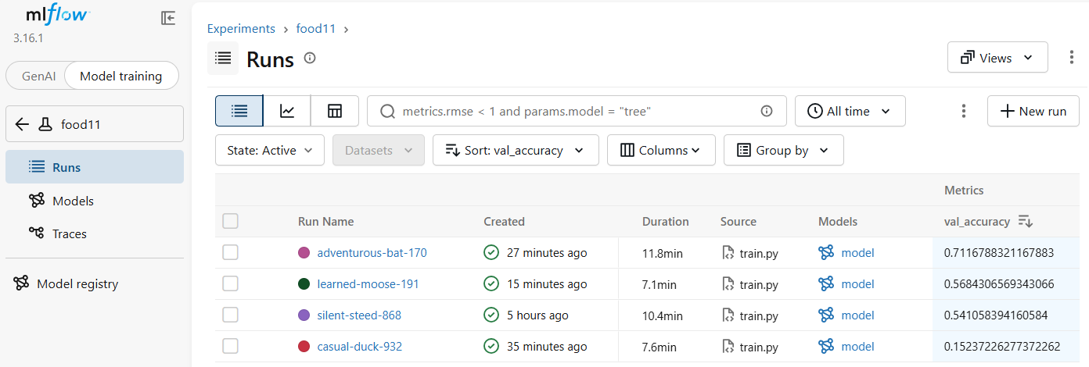
Runs sorted by val_accuracy, highest first
After sorting the runs table by val_accuracy in descending order, the runs are ranked as follows:
Rank | Run | lr | batch_size | val_accuracy
1 | adventurous-bat-170 | 0.0001 | 32 | 0.712
2 | learned-moose-191 | 0.001 | 64 | 0.568
3 | silent-steed-868 | 0.001 | 32 | 0.541
4 | casual-duck-932 | 0.01 | 32 | 0.152

The best run is adventurous-bat-170, trained with lr = 0.0001 and batch_size = 32. It reached a validation accuracy of 0.712 and a test accuracy of 0.757.
Run ID of the best run: 8685c506f2d5489cbd68652780816347
Note: the val_accuracy shown in the runs table is the last logged value (epoch 5), not the best value reached during training.

Committing the Training Code
The code is versioned with git, while the run metadata, metrics and models stay in mlflow (not in git or dvc):
git add src/food11/train.py pyproject.toml uv.lock
git commit -m "Add training script with mlflow tracking"
git push

