Lab 4 - Orchestrating the App with Docker Compose
Student: Malak Srour
Repository: https://github.com/Malak-Srour/mlops-lab-1

Question 1
What happens to everything written to /mlflow-data if you never mount a volume there and just docker run this image standalone? Try it: run the container, register nothing, stop it, remove it, start a new one from the same image — what do you see in the UI?
It is written in the container's own writable layer, so it is deleted together with the container.
- Test: I ran the image without a volume (docker run -d --name mlflow-test -p 5000:5000 food11-mlflow), created an experiment test-q1, then ran docker stop + docker rm and started a new container from the same image.
- Result: test-q1 was gone and Default was created again. The new container started with a new empty database:
2026/10/09 18:31:12 INFO ... Creating initial MLflow database tables...
-rw-r--r-- 1 root root 954368 Oct 9 18:31 mlflow.db
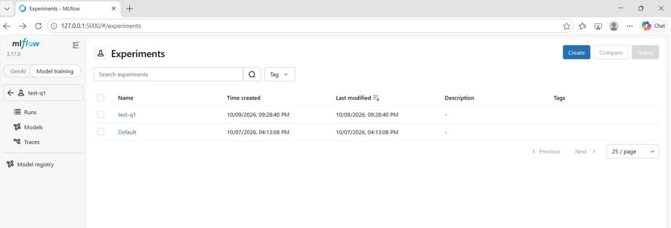
Standalone mlflow container with the experiment test-q1
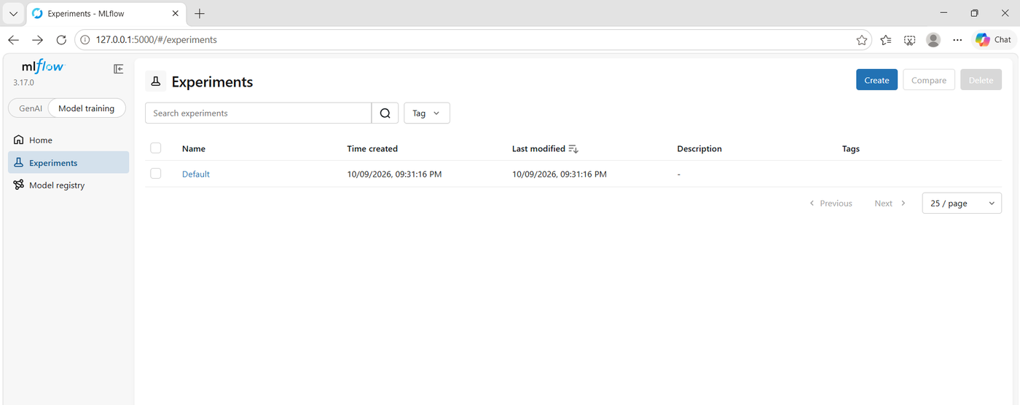
New container from the same image: test-q1 is gone, Default is re-created

Question 2
Why a named volume here instead of a bind mount to a folder in your repo (the way you might for local dev)? Would a bind mount work just as well?
A bind mount would also keep the data, but a named volume is better here:
- Managed by Docker: no path that only exists on my laptop (C:\Users\...), so the same docker-compose.yml works on any machine.
- Not in the repo: mlflow.db and the model files are not mixed with the code or committed by mistake.
- No Windows problems: a bind mount goes through file sharing between Windows and Docker's Linux VM, which is slower and can cause permission issues for SQLite.
- Deleted only on purpose: with docker compose down -v (Question 10).
A bind mount is still useful in local development, when I want to see or edit the files directly.

Part 2 - Inference and Frontend Services
serve.py is unchanged. frontend/app.py, frontend/Dockerfile and docker-compose.yml are the lab's files. I checked that serve.py returns the keys that app.py reads:
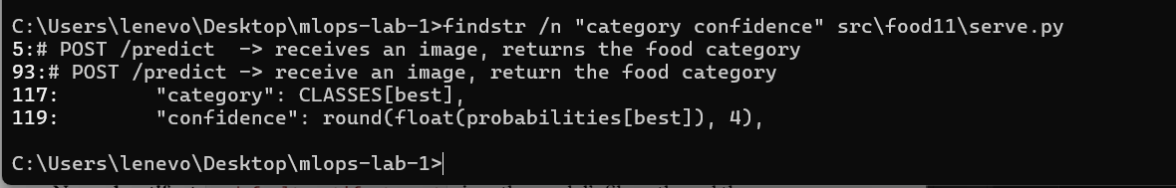
serve.py returns category and confidence

Question 3
In Lab 3 you had to use host.docker.internal or --network host to reach mlflow from inside the container. In this lab, MLFLOW_TRACKING_URI will simply be http://mlflow:5000. Why does that hostname resolve now when it didn't before?
Compose puts the three services on one private network (mlops-lab-1_default), and its DNS resolves each service name to the IP of that container. In Lab 3, mlflow ran on my laptop, outside any Docker network, so only host.docker.internal could reach it.
Proof: inside the inference container, socket.gethostbyname('mlflow') returns 172.18.0.2, the IP of the mlflow container (docker compose exec inference python -c "import socket; print(socket.gethostbyname('mlflow'))"). The mlflow logs also show the requests coming from 172.18.0.3, the inference container.

Question 4
Why does the frontend read INFERENCE_URL from an environment variable instead of hardcoding http://inference:8000? Think about what happens if you ever docker run this frontend image on its own, outside Compose.
The name inference only exists inside the Compose network. Outside Compose, a hardcoded http://inference:8000 would always fail. With the variable, the same image works anywhere without a rebuild, for example with -e INFERENCE_URL=http://host.docker.internal:8000. It is the same idea as MLFLOW_TRACKING_URI in serve.py.

Part 3 - Wiring It Together with Docker Compose

Question 5
Only mlflow and frontend publish a port to the host. inference doesn't. Why not, and how does the frontend still reach it?
Only what a person opens in the browser needs a published port: the mlflow UI (5000) and the upload page (8501). Nobody calls the API directly. The frontend reaches it inside the Compose network at http://inference:8000 (the container's own port). Not publishing it also keeps the API hidden from outside.

Question 6
depends_on here only waits for the mlflow container process to start, not for the tracking server inside it to be ready to accept connections. If your serve.py tries to load the Staging model at startup and mlflow isn't ready yet, what happens to the inference container? Look at docker compose logs inference if it fails.
The container stops. serve.py loads the model once at startup. If that fails, the API cannot start and the container stays Exited, because nothing restarts it. docker compose logs inference showed this twice:
mlflow-1 | ... Rejected request with invalid Host header: mlflow:5000
inference-1 | ... 403 ... 'Invalid Host header - possible DNS rebinding attack detected'
inference-1 | ERROR: Application startup failed. Exiting.
inference-1 exited with code 3

inference-1 | ... RESOURCE_DOES_NOT_EXIST: Registered Model with name=food11 not found
inference-1 | ERROR: Application startup failed. Exiting.
- 1st failure: mlflow refused the name mlflow (403). Fixed with --allowed-hosts (Part 4).
- 2nd failure: the new mlflow was still empty. Fixed by adding the model, then docker compose restart inference.
Start order is not readiness: in the logs, inference starts before mlflow prints Uvicorn running. A more robust setup would use restart: on-failure, a retry loop in serve.py, or a healthcheck on mlflow with depends_on: condition: service_healthy.

Part 4 - Bringing the Stack Up
Extra steps needed on my setup:
- Problem: mlflow refused inference (403). The lab's image installs the latest mlflow (3.17.0), which only accepts localhost. Fix: I changed only the CMD of mlflow/Dockerfile: --allowed-hosts with mlflow, and --artifacts-destination /mlflow-data/mlartifacts instead of --default-artifact-root, so the model files go to the server over HTTP and into the volume (same problems as Lab 3, Question 7).
- Problem: slow network. pip install streamlit timed out (ReadTimeoutError) while Compose built the three images at the same time. Fix: docker compose build frontend alone (the pip step took 703 s).
- Problem: the inference build lost Lab 3's cache (the base images were downloaded again, and uv:latest even changed between my two attempts), then uv sync failed on a network timeout after about 50 minutes. Fix: same Dockerfile and code as Lab 3, so I reused its image (docker tag food11-api:latest mlops-lab-1-inference:latest) and ran docker compose up without --build.
- Problem: the new mlflow starts empty, so food11@champion did not exist. Fix (no retraining): src/food11/copy_model_to_compose.py copies two Lab 2 models from their files (mlruns/1/models/m-.../artifacts) into the mlflow container as runs. In the UI, I registered copy-of-m-4208b911 (silent-steed-868, the weaker model) as food11 version 1 with the alias champion (the lab's "Staging") and restarted inference.
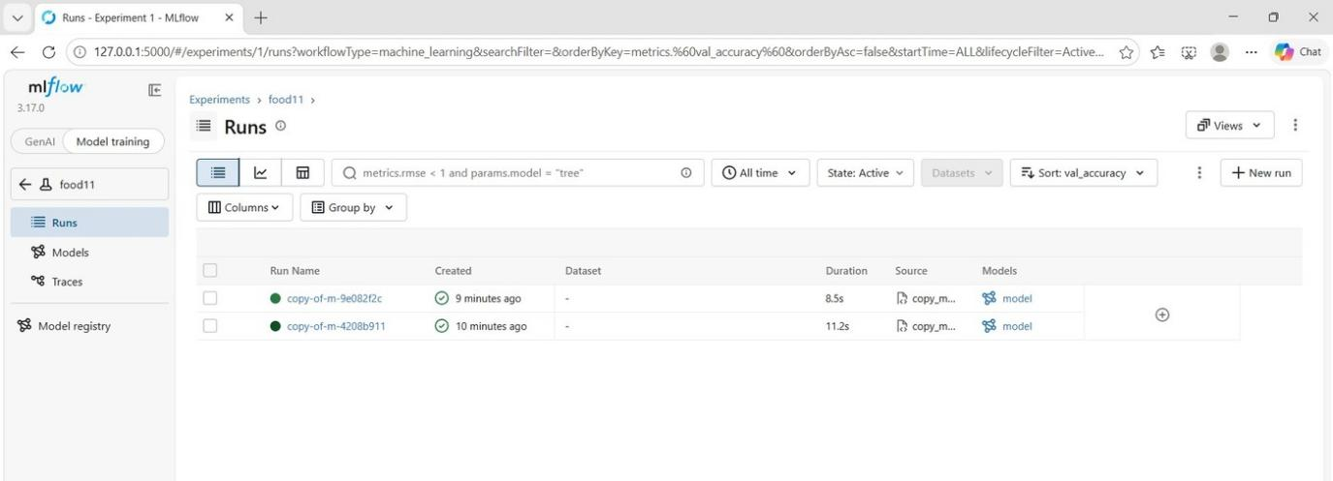
The two Lab 2 models copied into the mlflow container
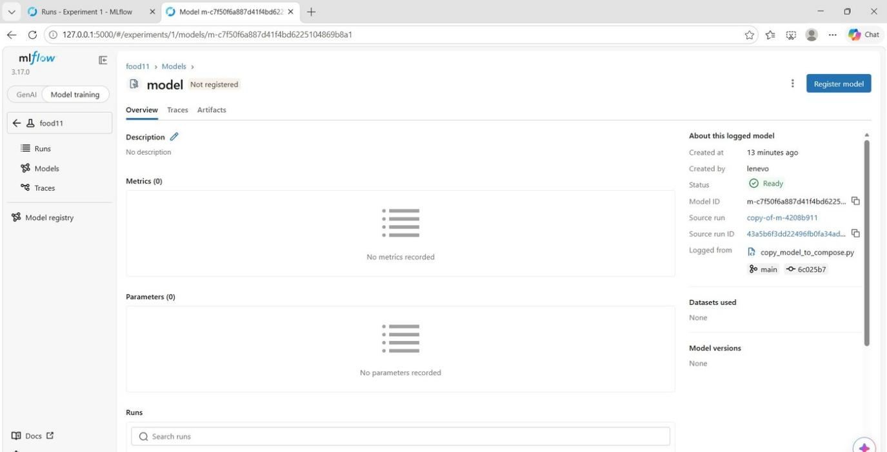
Logged model from copy-of-m-4208b911, registered from the UI
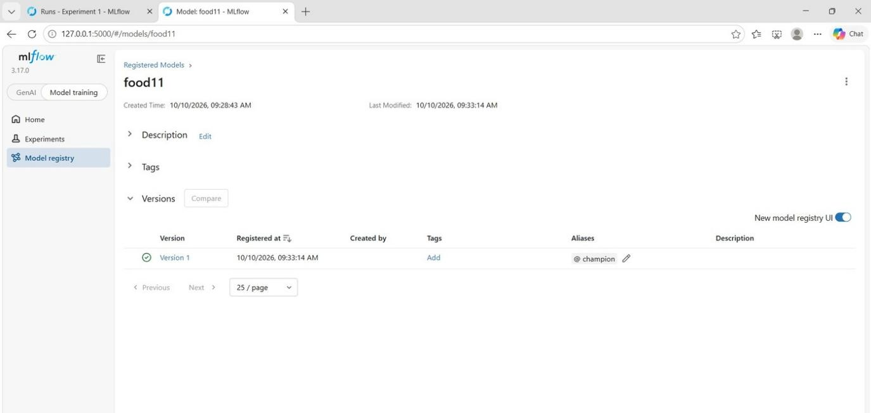
food11 version 1 with the alias champion
Result: the upload page returns a prediction through the three services.
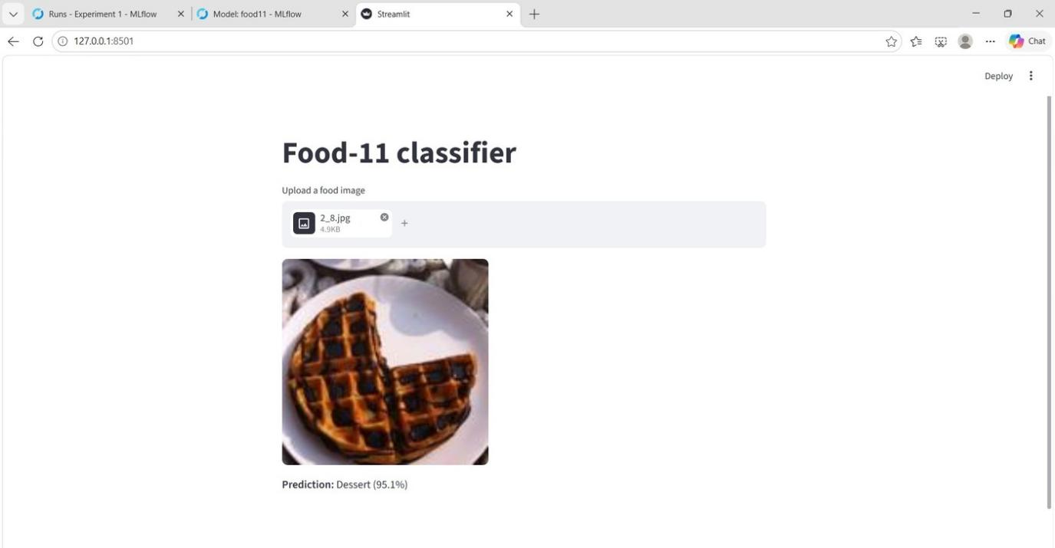
Frontend: 2_8.jpg (waffles) predicted as Dessert (95.1%) with version 1

Question 7
Run docker compose ps. Which services have a published port listed, and which don't? Does that match what you'd expect from the docker-compose.yml?
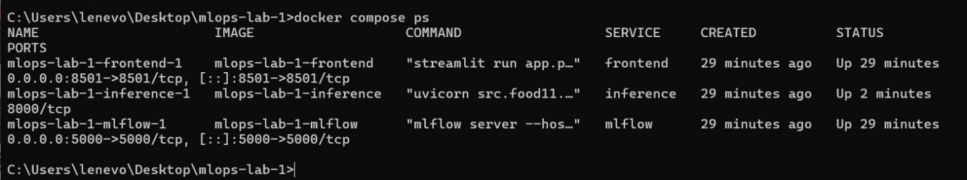
docker compose ps
- Published: frontend (0.0.0.0:8501->8501/tcp) and mlflow (0.0.0.0:5000->5000/tcp). The arrow maps a port of my laptop to the container.
- Not published: inference shows only 8000/tcp, with no arrow. That port is reachable only inside the Compose network.
Yes, it matches: only mlflow and frontend have ports: in docker-compose.yml. (inference shows Up 2 minutes because I restarted it after registering the model.)

Part 5 - Promoting a New Model Version
In the UI, I registered copy-of-m-9e082f2c (adventurous-bat-170, my best Lab 2 model) as version 2 and moved champion to it. Version 1 lost the alias automatically.
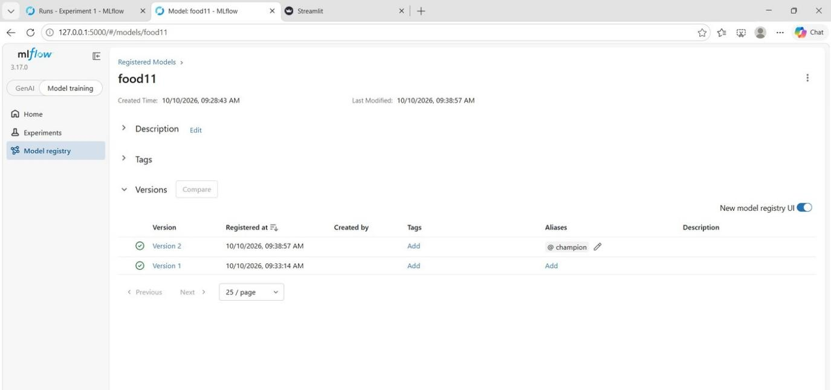
champion moved to version 2

Question 8
Refresh the frontend and upload an image again. Does the prediction come from the new model version, or the old one? Your serve.py loads the model once, at startup — what single command lets you pick up the new Staging version without rebuilding any image?
From the old version: inference keeps version 1 in memory and does not see the alias change. The command is docker compose restart inference (1.4 s, no rebuild).
Moment | Model in memory | 2_8.jpg (waffles)
Before the change | version 1 | Dessert (95.1%)
champion moved, no restart | version 1 | Dessert (95.1%)
After docker compose restart inference | version 2 | Dessert (37.5%)

Lower confidence does not mean worse: both answers are correct, and version 2 has the better validation accuracy.
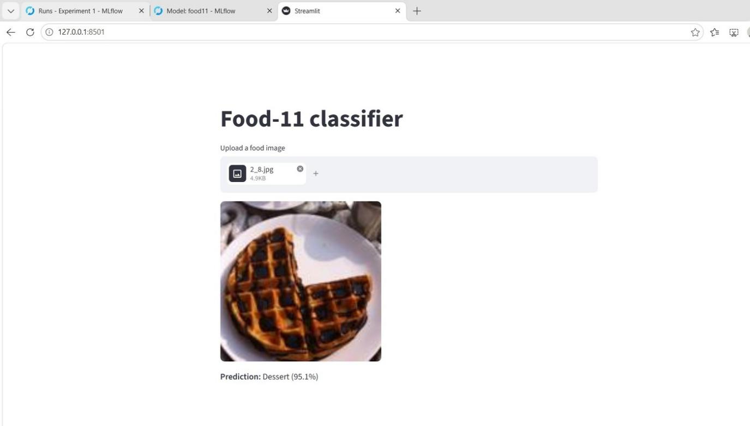
After moving champion, without restart: same result as version 1
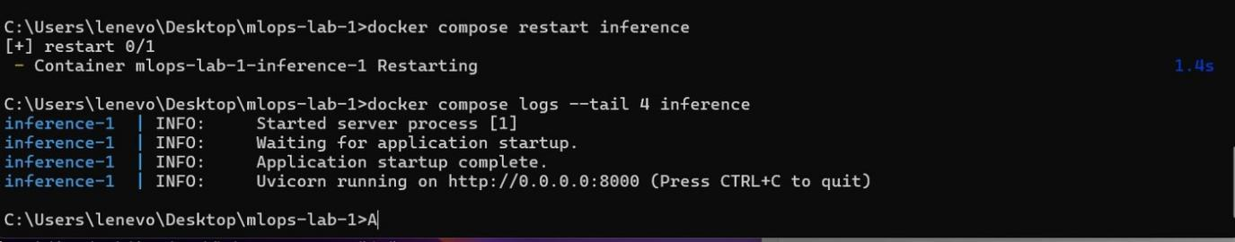
docker compose restart inference: the model is loaded again
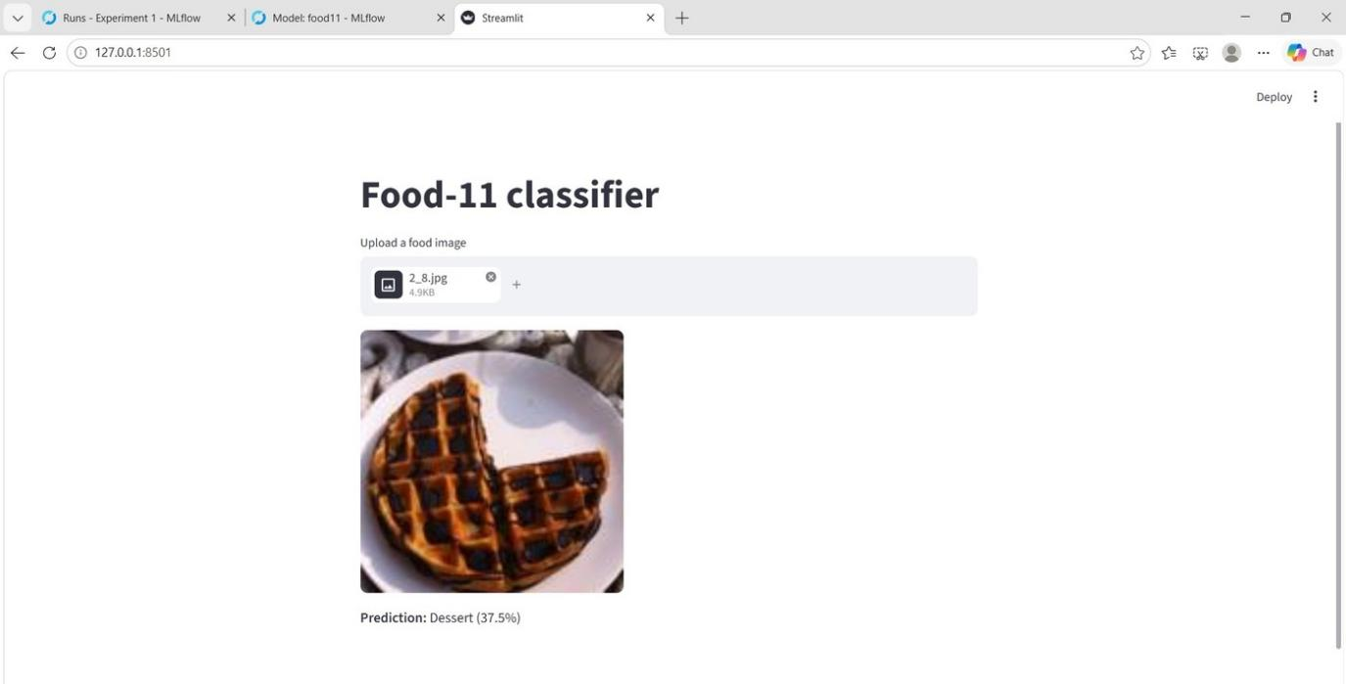
After the restart: Dessert (37.5%) from version 2

Question 9
Why does restart alone work here — no rebuild needed? What does that tell you about what's baked into the inference image versus fetched at container startup?
Because the model is not inside the image:
- Baked into the image: Python, the libraries and serve.py.
- Fetched at startup: the model (models:/food11@champion from http://mlflow:5000) and the settings from environment variables.
So a new model only needs a moved alias and a restart. The same image served two model versions. The downside: inference needs mlflow at startup (Question 6).

Part 6 - Persistence Check

Question 10
Is your registered model and its Staging assignment still there after this down/up cycle? Now try docker compose down -v followed by docker compose up — what's different this time, and why?
down then up: everything is still there. down removes the containers and the network, not the volume. up printed no Volume ... Created line and no Creating initial MLflow database tables..., and inference started by itself, loading version 2 from the volume:
mlflow-1 | ... "GET .../registered-models/alias?name=food11&alias=champion" 200 OK
mlflow-1 | ... "GET .../model-versions/get-download-uri?name=food11&version=2" 200 OK
mlflow-1 | ... "GET .../models/m-7637dd0f.../artifacts/data/model.pth" 200 OK
inference-1 | INFO: Application startup complete.
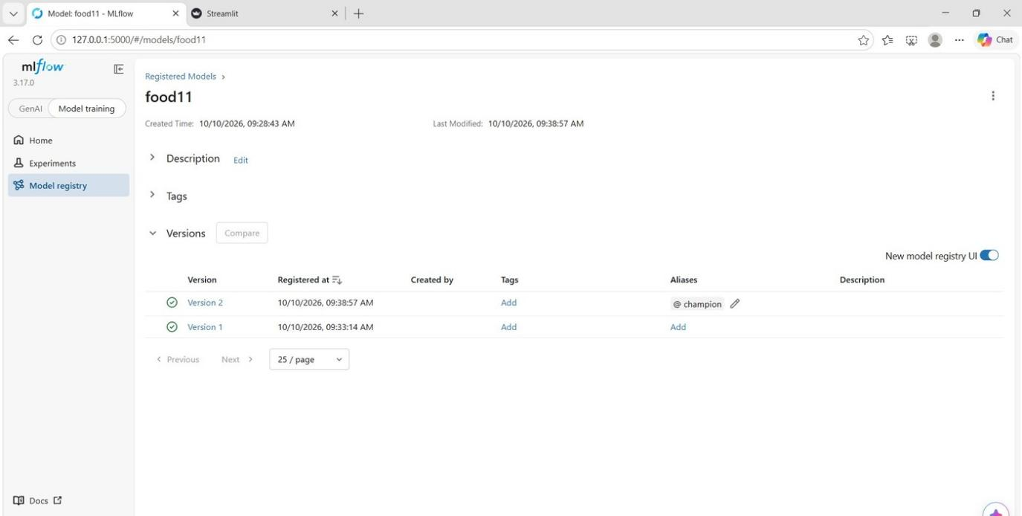
After down and up: version 1, version 2 and champion are still there
down -v then up: everything is gone. -v also deletes the volume, so Compose creates a new empty one and mlflow creates a new database. The registry is empty and inference fails again with Registered Model with name=food11 not found.
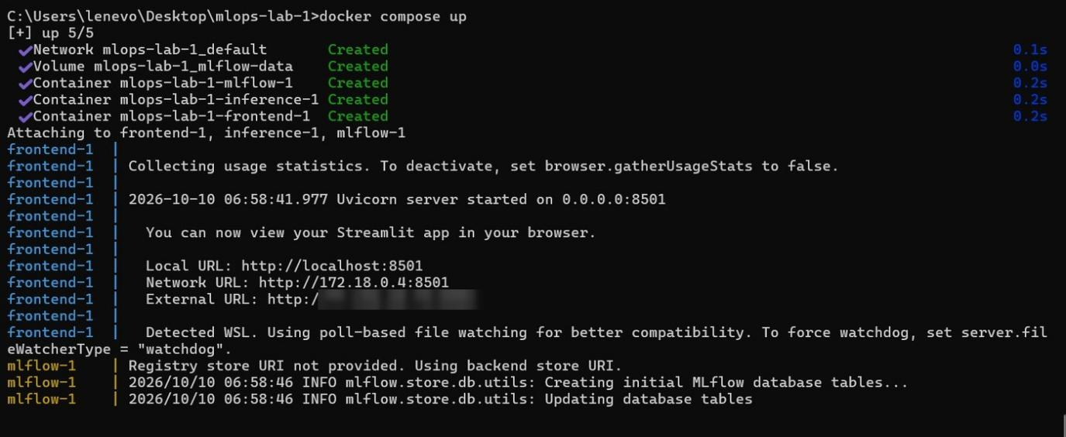
After down -v and up: new volume and new empty database
Why: the data lives in the volume, not in the containers. down is a safe restart, while down -v is a full reset.

Part 7 - Commit and Scaling
Committed: mlflow/Dockerfile, frontend/Dockerfile, frontend/app.py, docker-compose.yml and src/food11/copy_model_to_compose.py.

Question 11
This compose file is still meant to run on one machine. What would have to change for the inference service to run as three replicas behind a load balancer, or for the mlflow service to survive a machine failure? (You don't need to implement this — just name what Docker Compose can't give you here.)
Compose runs everything on one machine: if it stops, all the services stop.
- 3 inference replicas: docker compose up --scale inference=3 only works on one machine. Missing: a load balancer in front of the replicas, health checks (for example /health), rolling updates, and spreading the replicas over several machines.
- mlflow surviving a machine failure: SQLite and the model files are in a volume on my laptop's disk. Missing: a real database server (PostgreSQL), shared storage for the model files (S3, MinIO), several mlflow servers, and restarting a failed service on another machine.
This is what an orchestrator like Kubernetes provides (replicas, load balancing, health checks, persistent storage).

