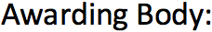
Arden University
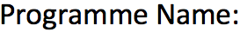
BSc in Computing
Data Mining- COM6013
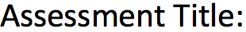
Data Mining Mini Project: Lobster Population Health
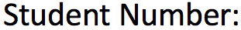
STU14322
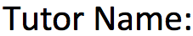
Mohammad Nour Albaarini
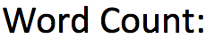
3,685 words

Table of Contents
Data Mining Mini Project 3
Lobster Population Health 3
Task 1: Comprehensive Data Analysis 3
1. Introduction 3
2. Data Acquisition & Initial Overview 3
2.1. Loading the Dataset 3
2.2. Exploratory Data Analysis (EDA) 3
3. Data Cleaning & Preprocessing 5
3.1 Handling Data Entry Errors and Missing Values 5
3.2 Identifying and Handling Outliers 6
3.3 Final Dataset Size After Cleaning: 7
3.4 Normalising and Scaling Data 8
3.5 Principal Component Analysis (PCA) 8
4. Feature Engineering Lobster Health Metrics 11
4.1 Biological Rationale & Allometric Growth 11
4.2 Derivation of Sex-Specific Parameters ('a' and 'b') 12
4.3 Calculation of Health_Score 12
5. Statistical Modelling Techniques 13
5.1 Assumption Checks 14
5.2 Comparative Statistical Tests 17
6. Overall Analysis and Meaningful Solutions 21
6.1 Synthesis of Statistical Findings 21
6.2 Preliminary Insights & Solutions: 21
Task 2- Comperhensive Report 22
1. Executive Summary 22
2. Introduction 22
3. Our Data-Driven Approach 22
Phase 1: Business Understanding 22
Phase 2: Data Collection & Understanding 22
Phase 3: Data Cleaning and Preparation 22
Phase 4: Feature Engineering 22
Phase 5: Modeling and Comparative Analysis 23
4. Key Findings 23
Overall Health Score Distribution: 23
No Significant Change Year-on-Year: 23
No Significant Differences Across Sexes: 23
5. Analysis & Discussion 24
6. Conclusions & Recommendations 24
Conclusion 24
Recommendations: 24
6.3 Future Research: 24
Bibliography 25
Appendix- Full Code 26

Data Mining Mini Project

Lobster Population Health

Task 1: Comprehensive Data Analysis

Introduction
The main goal for this report is to showcase the detailed analysis of Lobster health in the Isle of Skye. To obtain this, methodical steps were taken to preprocess data, statistically explore, evaluate and develop a numeric Health Score as an engineered representation for lobster physical condition

This analysis aims to identify and understand Lobster health based on Sex throughout the two years of recorded data.

Data Acquisition & Initial Overview
Focusing on collecting data and understanding it, this first step follows the Data Understanding phase of the CRISP-DM methodology (Schröer, Kruse and Gómez, 2021).

2.1. Loading the Dataset
The necessary libraries were first imported. From pandas for data manipulation and analysis (pandas, 2025) to seaborn for statistical data visualisation(Waskom, 2021). 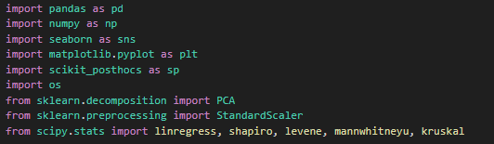
The data for this project was provided as 2 separate tables with identical attributes: "Lobster Data 2018" and "Lobster Data 2019." The two datasets were loaded and concatenated with the distinguishing column ‘year’.
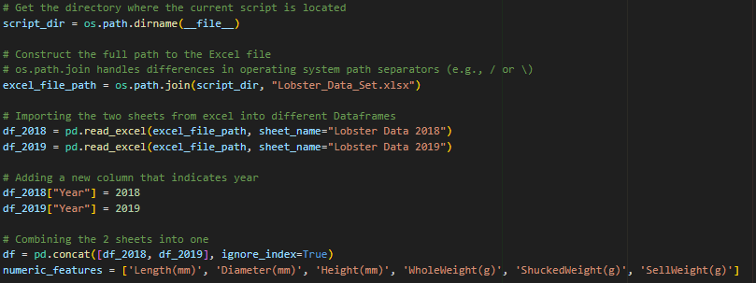

2.2. Exploratory Data Analysis (EDA)
Exploratory Data Analysis (EDA) was performed to create statistical summaries, uncover trends and patterns, and extracted meaning from the data (Nyamawe et al., 2025).
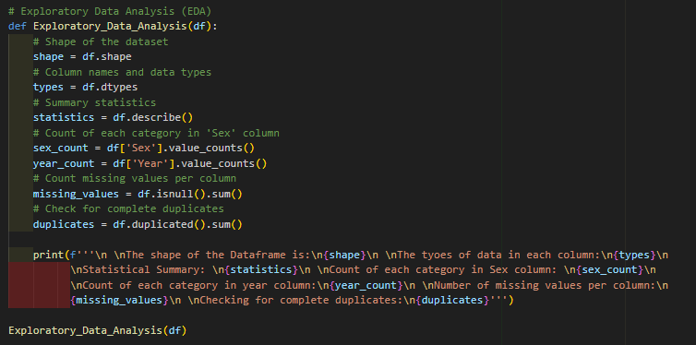

The initial EDA provided crucial insights into the dataset's structure and quality:

Shape and Data Types
From the function’s output, we could see that the combined unprocessed dataframe included 4177 rows and 9 columns, along with their data types.
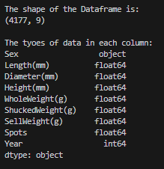

General Statistics:
‘df.describe()`:
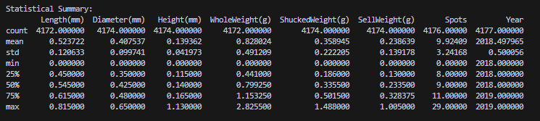
Important information about the distribution and scale of each numerical variable was gleaned from the descriptive statistical summary. A notable mention is the biologically impossible minimum value of zero that some of our traits possess. This suggests the presence of biologically impossible measurements, indicating data entry errors that require correction before further analysis.

Categorical and Missing Value Analysis:
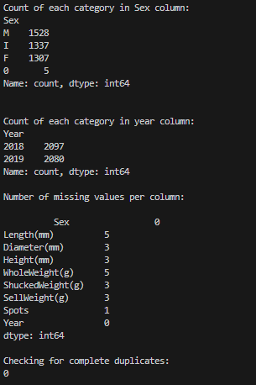
Lastly, through inspecting the missing and erroneous values, it is revealed that the ‘sex’ column includes the incorrect value of ‘0’ in five different instances. Additionally, a very small proportion of missing values (less than 0.2%) were identified across several numerical columns. No complete duplicate rows were found.

Data Cleaning & Preprocessing
The Data Preparation phase of the CRISP-DM methodology is described in this section, with an emphasis on turning raw data into a high-quality, clean dataset that is ready for analysis.

For an analysis to be accurate, data quality is crucial (Larose, 2015, chap. 2.2). To methodically fix the found data flaws, a multifaceted strategy was used:

Handling Data Entry Errors and Missing Values
Missing Values: Because there were so few missing values (less than 0.2%), rows with these NaN values were eliminated to preserve data integrity with the least amount of effect on the total size of the dataset.
Invalid Numerical Entries: For the `Length`, `Diameter`, `Height`, and all `Weight` metrics, entries with zero values were eliminated as well. These measurements would distort statistical analyses and render the `Health_Score` computation invalid because they are biologically impossible.
Values in ‘Sex’ Category: Lastly, to guarantee correct biological classification and consistency for sex-specific analyses, the five incorrect `0` entries in the `Sex` column were removed too.
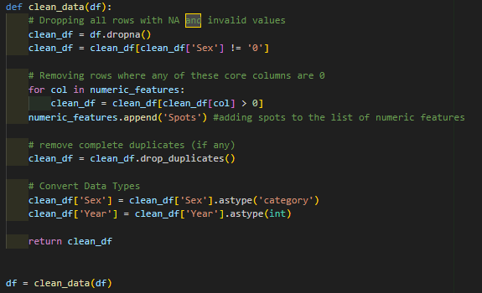

Identifying and Handling Outliers
The Interquartile Range (IQR) method was used to methodologically find and delete outliers. A common method for outlier detection, IQR focuses on removing the extreme data, leaving only the middle 50% of the data (Wu, 2024, chap. 5.2).

Visualisation Before Outlier Removal:
To view the presence of extreme values, we visualised our data using box plots before outlier removal:
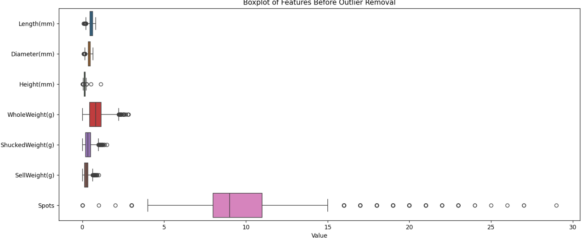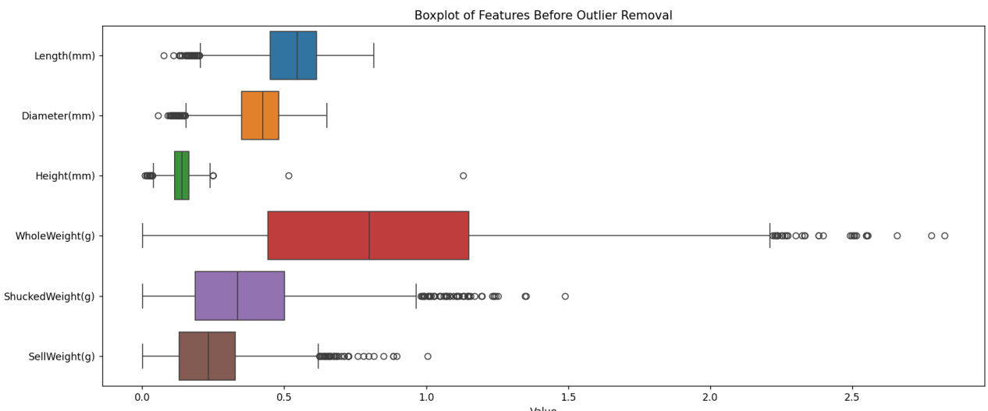

Outlier Removal Implementation:
After determining that our data suffers from a large number of outliers, the Interquartile Range (IQR) method was applied across the numerical columns:
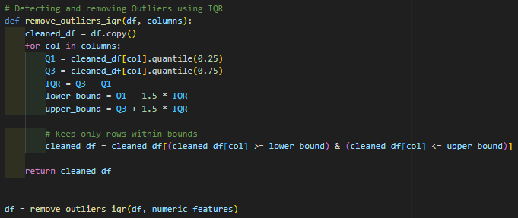

Visualization After Outlier Removal:
The plots below showcase how successful our function was for removing extreme outliers:
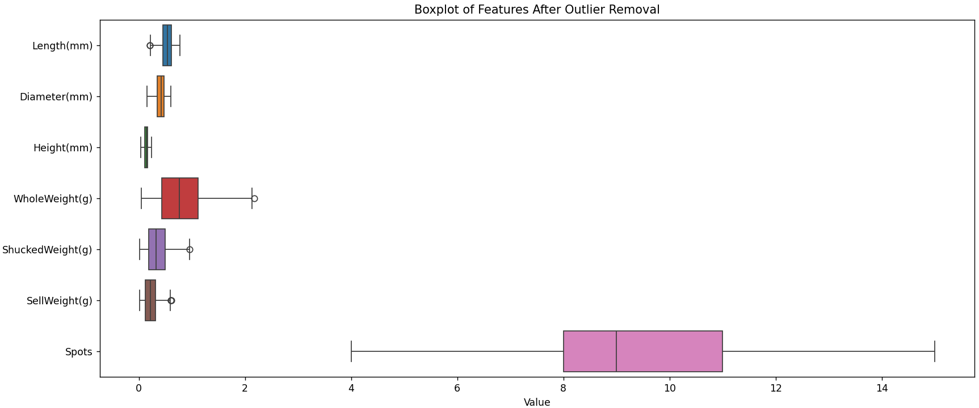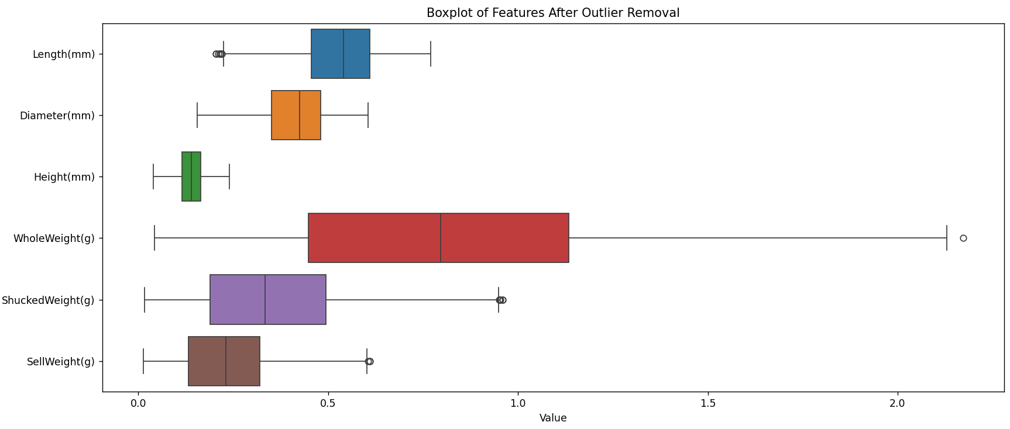

Final Dataset Size After Cleaning:
The new clean data set now contains 4,129 rows after removing the “unclean” data.

Normalising and Scaling Data
By subtracting the mean from our data, essentially moving our graph to the centre, and then scaling it to unit variance, the data is normalised, with a mean of 0 and a standard deviation of 1 (Nyamawe et al., 2025, chap. 3.5.2.3)
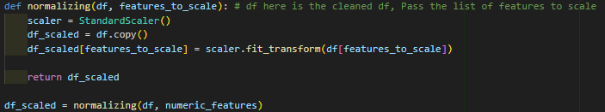

Visualisation of Scaled Data:
All features now have comparable scales and are centered around zero, ensuring that no single feature disproportionately influences magnitude-sensitive algorithms, such as PCA, in the next step:
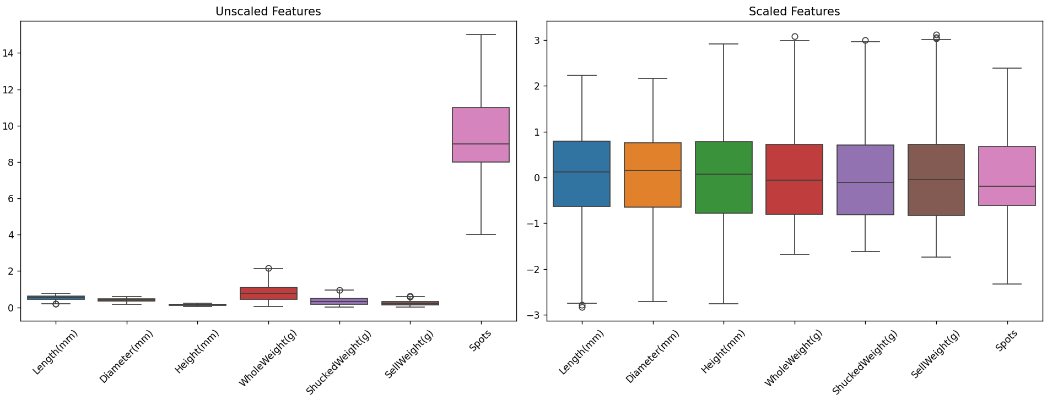

Principal Component Analysis (PCA)
A PCA was performed after the data was standardised to lower dimensionality, aid in data visualisation, and find underlying patterns (Mueller and Massaron, 2019, chap. 4.2).

Running PCA Analysis:
To enable efficient two-dimensional visualisation, two principal components were calculated. The "loadings," which show how each original feature contributed to the newly created principal components, were also computed by the PCA transformation.
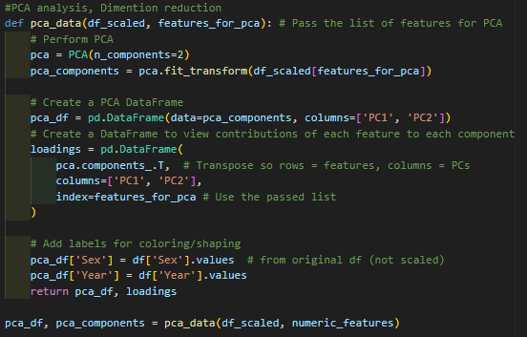

Interpretation of PCA Loadings:
Understanding how each original variable contributes to the principal components is crucial before looking at the scatter plot. The loadings show how the principal components and the original variables are correlated.
According to the PCA loadings, PC1 mainly denotes the lobster's total mass and size, whereas PC2 denotes the quantity of spots.
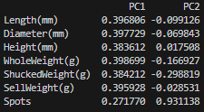

Interpreting the Initial PCA Scatterplot:
The first scatter plot of the principal components, which is shaped by year and colored by sex, shows how various lobster groups group together based on.
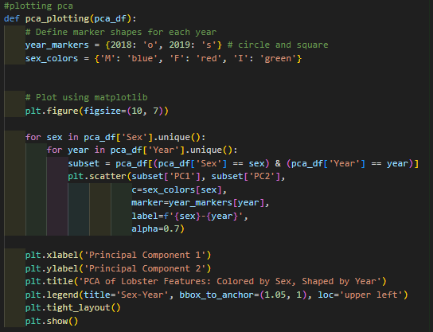
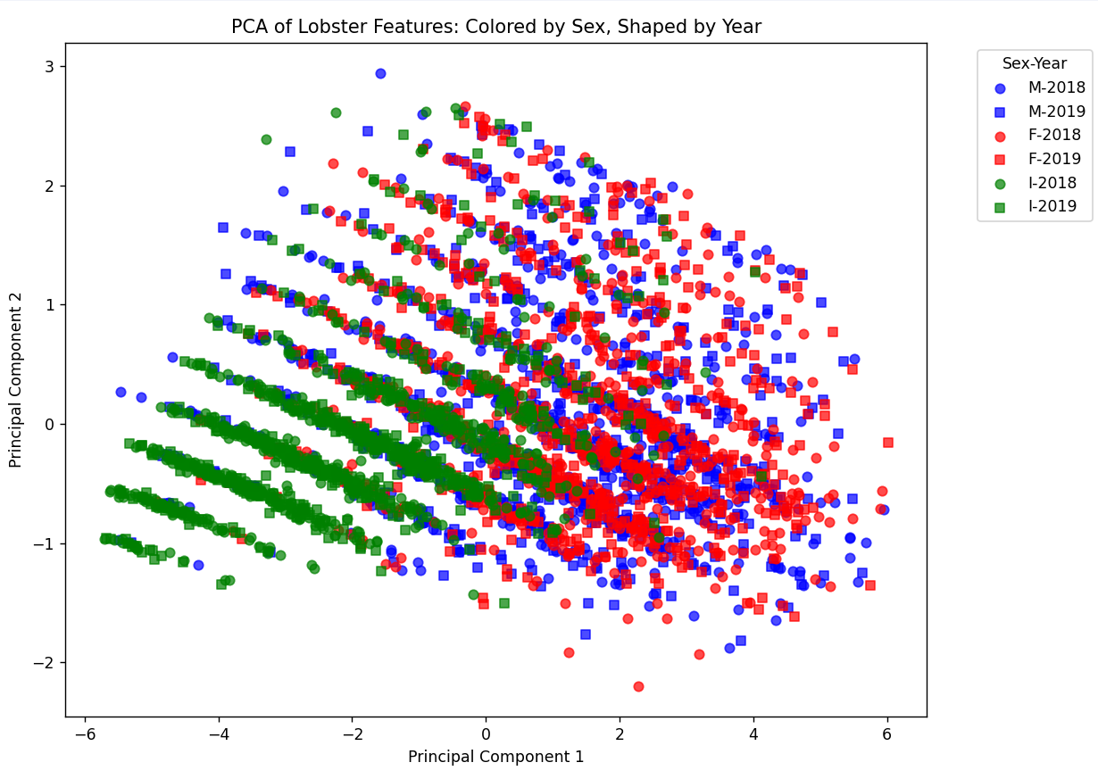
It is possible to draw some initial conclusions from this combined visualisation: Smaller size/weight and fewer spots are characteristics of infant lobsters. Compared to some males, female (F) lobsters seem to have comparatively fewer spots (lower PC2) but larger sizes/weights (higher PC1). A greater range in size/weight and spot count is suggested by the fact that male (M) lobsters seem to be more varied across both components. However, accurate interpretation is difficult due to the overlap and density of points, especially when attempting to differentiate between year-over-year trends.

Faceted PCA Plot by Sex for Enhanced Readability:
The PCA scatter plot was re-generated using a faceting technique, which separated the plots by `Sex` and coloured the points by `Year` in order to enhance readability and facilitate more understandable group comparisons. This makes it possible to compare the two years more directly within each sex category.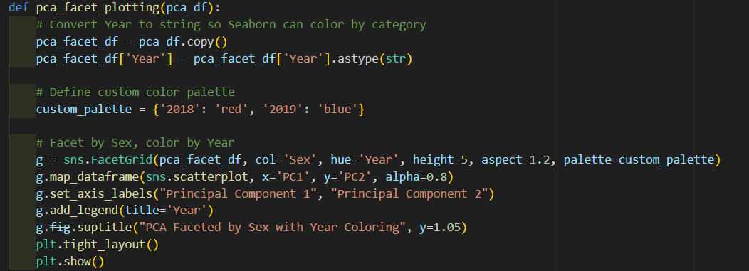
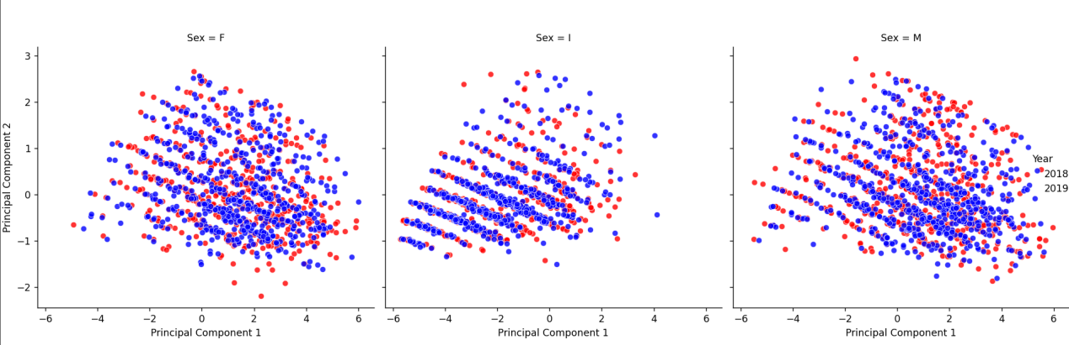
This facetted visualisation adds more clarity and validates our earlier findings. The 2018 and 2019 data points for infants are located in comparable, lower plot regions. In both years, female lobsters seem to exhibit a largely consistent pattern. Once more, male lobsters exhibit the greatest dispersion across both principal components, emphasising their higher degree of variation in size/mass and spots.

Feature Engineering Lobster Health Metrics

Biological Rationale & Allometric Growth
Allometric growth, as defined by Tresnati, Omar, and Situmorang, is the disproportionate growth of an organism's body parts, particularly its weight (W) and length (L) (2021). For lobsters, this basic biological relationship is expressed as:
$$W=aL^{b}$$
In this case, 'a' is a scaling factor that represents the overall "fullness" or shape of the body at a specific length, and 'b' is the growth coefficient that indicates the rate at which weight increases in relation to length.
A Condition Factor is computed using this formula. We can determine a lobster's condition by comparing its actual weight to its predicted weight. According to its anticipated growth pattern, a lobster with a score above 1.0 is considered "stout," while one with a score below 1.0 is considered "lean" (Martínez-Calderón, Lozano-Álvarez and Briones-Fourzán, 2018). A standardised evaluation of each person's health is made possible by this metric.

Derivation of Sex-Specific Parameters ('a' and 'b')
The next step in our feature engineering is finding the components of ‘a’ and ‘b’ for each sex, which involves log-transforming the curve $W=aL^{b}$ into a straight line: $\log{(W)} = \log{(a)+b\log{(L)}}$ , in terms of width ‘W’ and length ‘L’ (Almahy and Ali, 2022). The slope ('b') and y-intercept (log(a)) are then determined for each sex using linear regression. Lastly, log(a) is converted back to "a" (Wu, 2024, chap. 7.1)
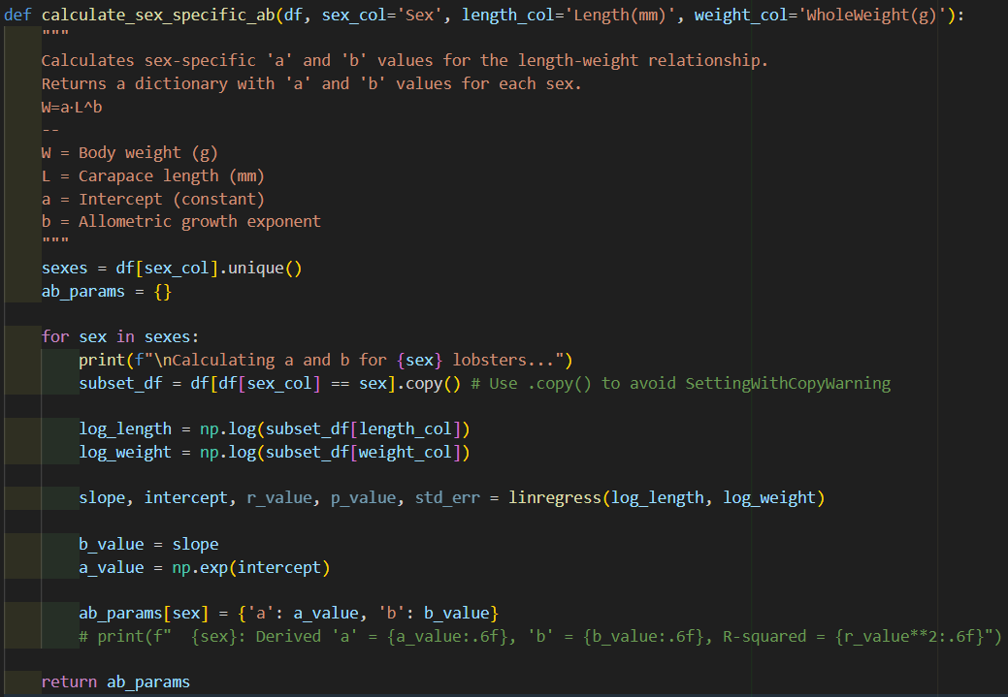

Calculation of Health_Score
The following formula is used to calculate the Health Score: $Health Score = \frac{Predicted Weight}{Observed Weight}$
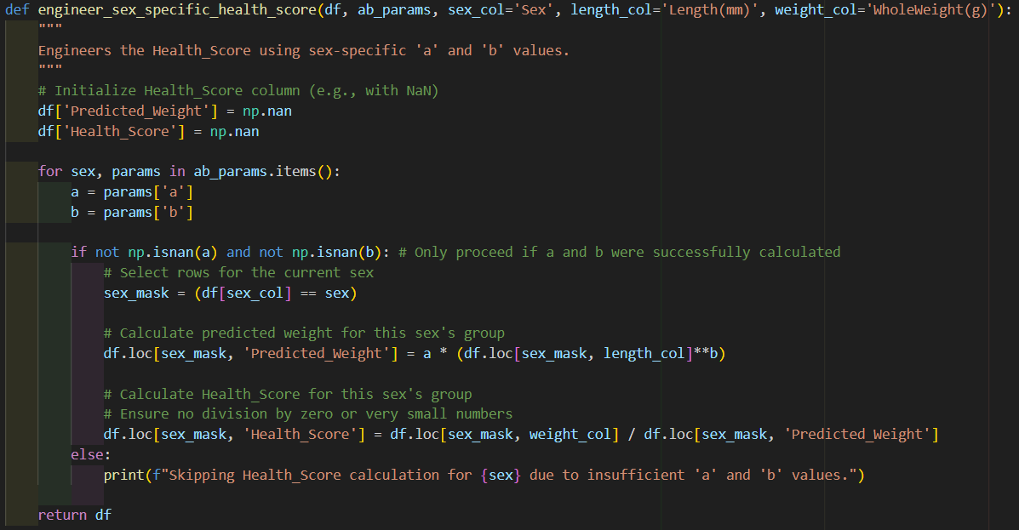
A lobster's condition in relation to its anticipated growth is indicated by this score:
A lobster that has a Health_Score higher than 1.0 is heavier than one might anticipate given its length, indicating that it is in better condition or is "stouter."
A lobster with a Health_Score below 1.0 is considered to be in poorer condition or to be "leaner" because it weighs less than one would anticipate for its length.
The lobster is in average condition in relation to its anticipated growth pattern if its Health Score is roughly equal to 1.0.

Observation from Sample Data
For ease of comparison, the Health Scores were modeled as histograms.
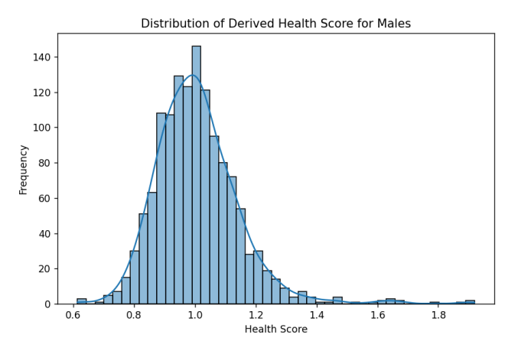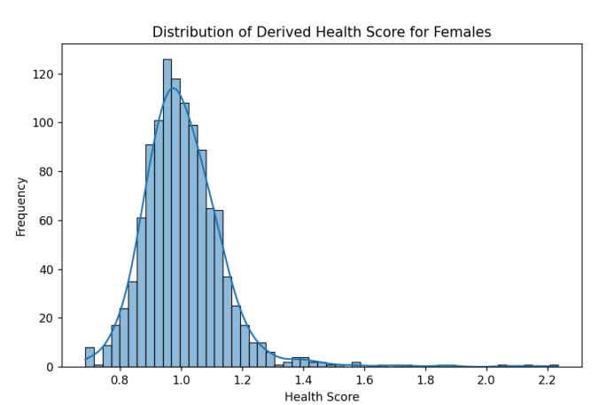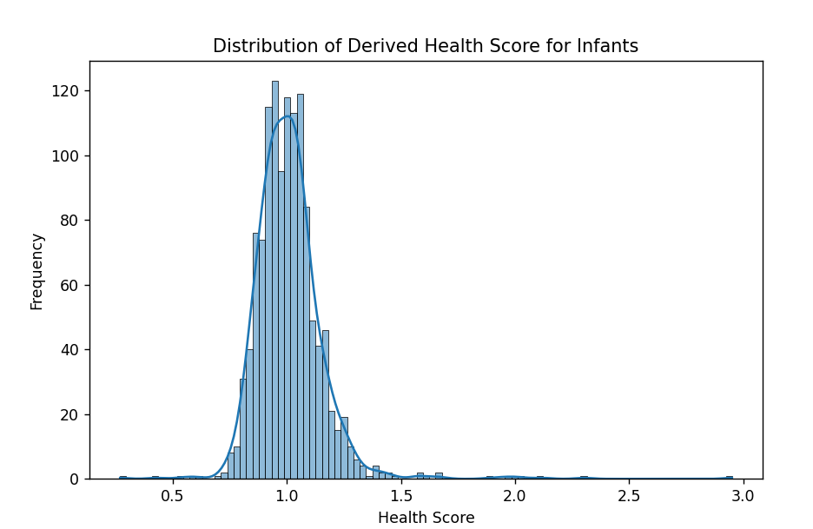

Statistical Modelling Techniques
The modelling phase of the CRISP-DM framework is represented by this section, which uses statistical techniques to find important trends in lobster health.

When comparing different groups, such as 2018 vs. 2019 or Male vs. Female vs. Infant, statistical tests are essential to determine whether there are statistically significant differences or trends in lobster `Health_Score` (Lynch, 2023, chap. 15).

Assumption Checks
Important assumption checks were carried out prior to comparative analysis in order to ascertain the data's underlying statistical characteristics and make sure the best and most accurate statistical tests were chosen for sound conclusions.

Check for Normality (Visual & Statistical)
For every particular group, the `Health_Score` distribution's normality is examined.
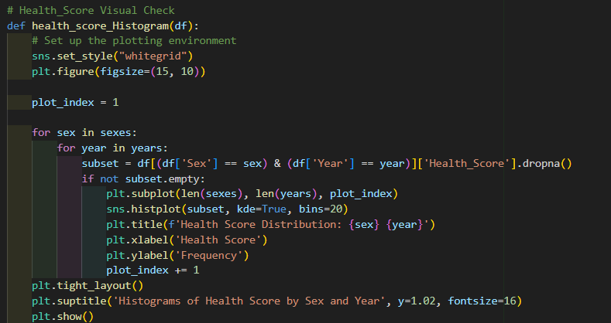
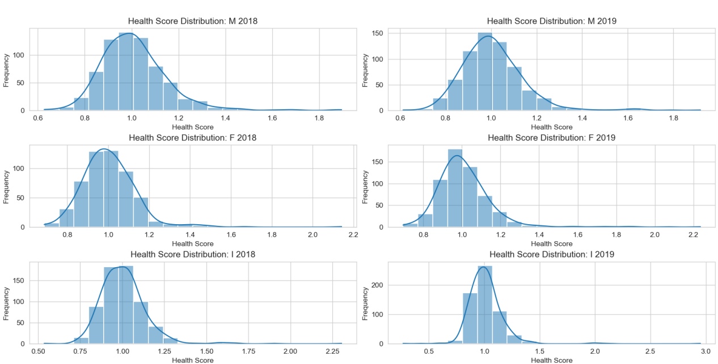

Interpretation of Histogram
A somewhat normal distribution of health scores around an average is suggested by the unimodal distribution that all six histograms show overall, which roughly resembles a bell curve (Saltz and Stanton, 2024, chap. 5). Nonetheless, each group has minor yet significant distinctions that should be noted.

Central Tendency: For all groups, the `Health_Score` peak frequency (mode) seems to be around 1.0, which is ideal for a health metric where 1.0 is the "average" or "expected" condition for a given length and sex.
Variability/Spread: Health scores for all groups show a discernible range, with "leaner" (scores < 1.0) and "stouter" (scores > 1.0) lobsters within each population segment.
Outliers/Extremes: The distributions' tails extend in both directions, indicating that some people are noticeably stouter or leaner than the norm.

The noticeable right-skew in I 2019 emphasises the variability within the infant population for that year, even though the majority of groups visually resemble a normal distribution.

Shapiro-Wilk Test
A formal statistical test for normalcy is the Shapiro-Wilk test (Lemke, 2021, p. 83). It will assist in determining whether the data is statistically normal.

Null Hypothesis (H0): The data follows a normal distribution.
Alternative Hypothesis (H1): The data does not follow a normal distribution.
Interpretation of p-value:
H0 will not be rejected if p > 0.05. This indicates that there is insufficient data to conclude that the sample is abnormal.
H0 will be rejected if p <= 0.05. This indicates that there is enough data to draw the conclusion that the sample is not normally distributed.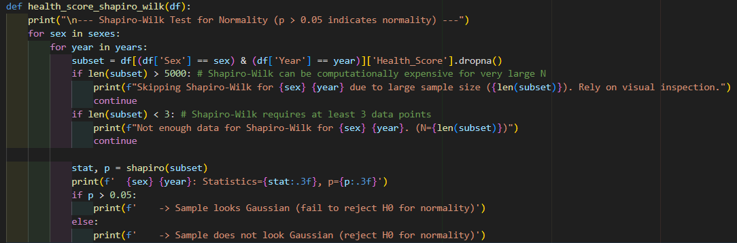
The results of this function:
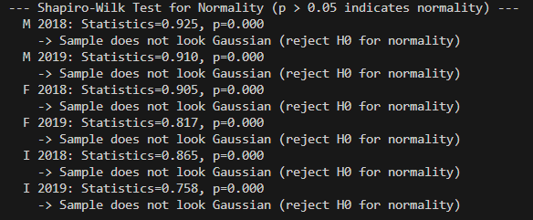

Interpretation of Shapiro-Wilk Test Results
The p-value for each of the six groups (M 2018, M 2019, F 2018, F 2019, I 2018, I 2019) was 0.000, which is significantly less than 0.05. The ‘Health_Score` distributions for all lobster segments do not follow a normal distribution, as a result of which the null hypothesis of normality was rejected for each group.

Levene's Test
Levene's test verifies that variances in various groups are equal (Meyers, Gamst and Guarino, 2013, chap. 53.4).
Null Hypothesis (H0): All population variances are equal.
Alternative Hypothesis (H1): All population variances are not equal.
Interpretation of p-value:
- If p > 0.05: H0 is not rejected. The variances are presumed to be homogeneous because there is insufficient evidence to support the idea that they differ.
- If p <= 0.05: H0 is rejected. This indicates that there is enough evidence to draw the conclusion that the variances are heterogeneous.

The first function created compares the variances between years.
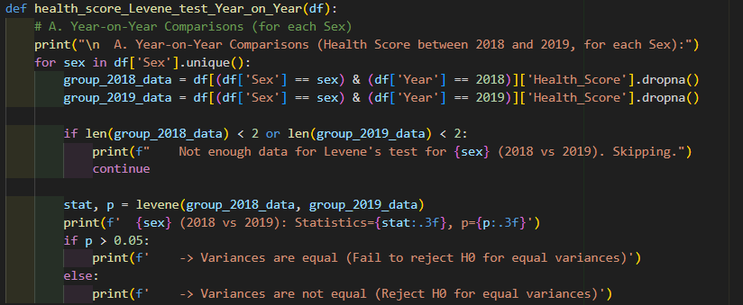
The second function compares between sexes.
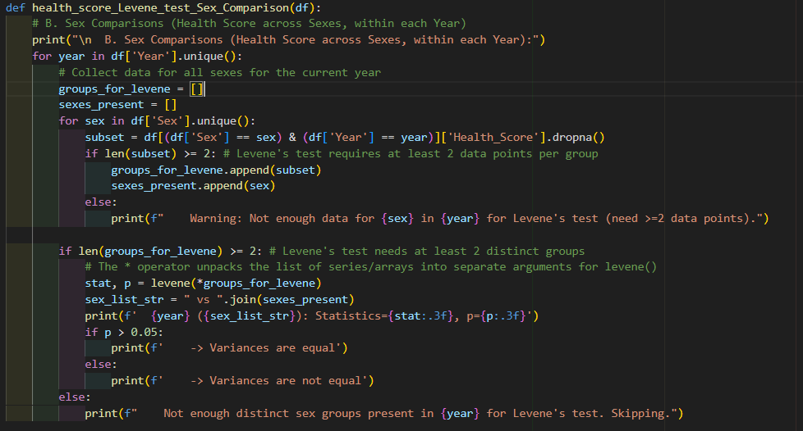

Interpretation of Levene's Test Results
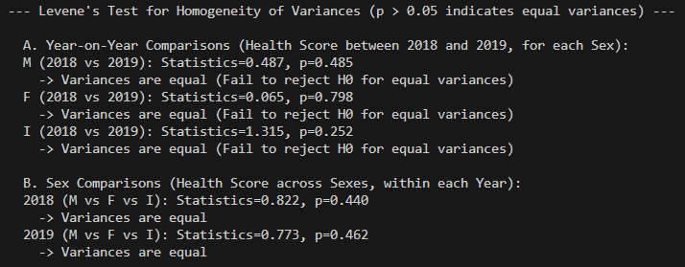
The p-values were significantly higher than 0.05 for all comparisons (year-on-year within sexes and sex-on-sex within years). These findings led to the conclusion that the variances of the `Health_Score` distributions for all groups under comparison are statistically equal.

Decision on Statistical Tests
Non-parametric tests were deemed suitable for the comparative analysis since the `Health_Score` data was discovered to be non-normal but showed homogeneous variances (Field, 2018, chap. 7.2).

Comparative Statistical Tests

5.2.1 Mann-Whitney U Tests (Year-on-Year Comparisons)
The Health_Score distributions of two independent groups were compared using the Mann-Whitney U test, a non-parametric test that does not assume a normal data distribution (Corder and Foreman, 2014, chap. 4.3). If distribution shapes are similar, this test determines whether the two groups' distributions differ, which is frequently interpreted as a difference in medians

Null Hypothesis (H0): The two groups' `Health_Score` distributions are the same.
Alternative Hypothesis (H1): The two groups' `Health_Score` distributions are not the same.

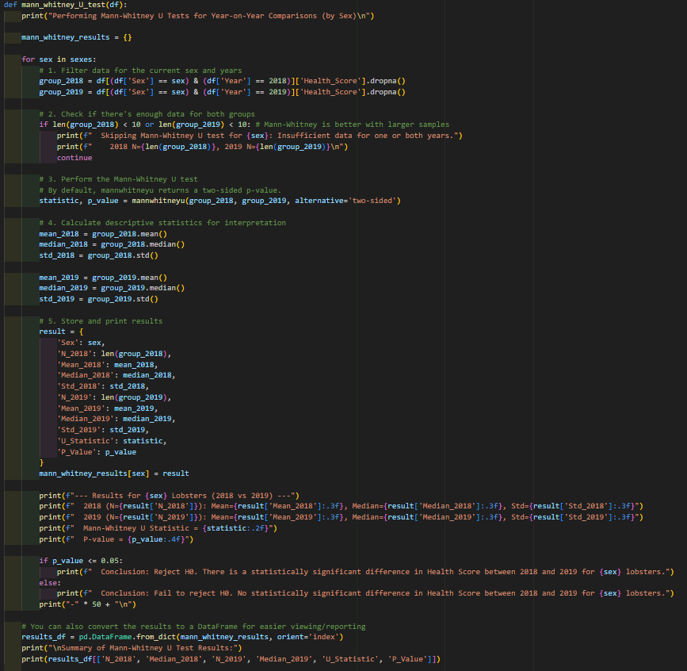
The median `Health_Score` for each group, the Mann-Whitney U statistic, and the associated p-value were computed for each comparison (Male 2018 vs. 2019, Female 2018 vs. 2019, Infant 2018 vs. 2019). 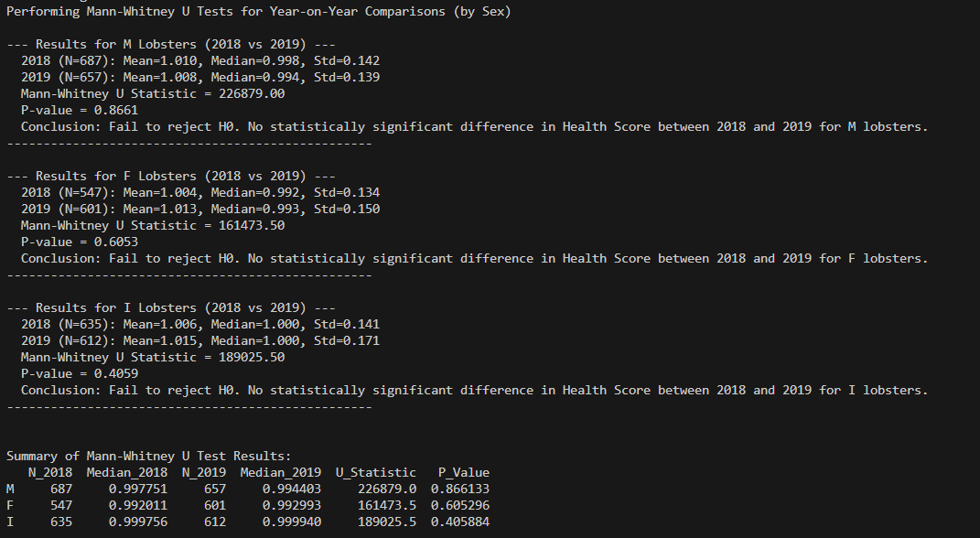

Interpretation of Mann-Whitney U Test Results
The p-values were significantly higher than the 0.05 significance level for each of the three year-over-year comparisons (Male: 0.8661, Female: 0.6053, Infant: 0.4059). This means that we failed to reject the null hypothesis, indicating that the `Health_Score` for male, female, and infant lobsters did not change statistically significantly between 2018 and 2019. The general state of health for each sex group stayed consistent, despite slight variations in means and medians.

5.2.2 Kruskal-Wallis H Tests (Sex Comparisons within Years)
The Health_Score distributions were compared across three or more independent groups (Male, Female, Infant) within each year using the Kruskal-Wallis H test, another non-parametric test that is used further elaborate the Mann-Whitney U test (Willard, 2020, p. 277).
Null Hypothesis (H0): All groups have equal medians, or the samples are drawn from the same population distribution.
Alternative Hypothesis (H1): At least one group's median differs from the others.
- If p > 0.05: Fail to reject H0, meaning that amongst the groups’ medians, there is no statistically significant difference.
- If p <= 0.05: Reject H0, meaning that amongst the groups’ medians, there is a statistically significant difference.
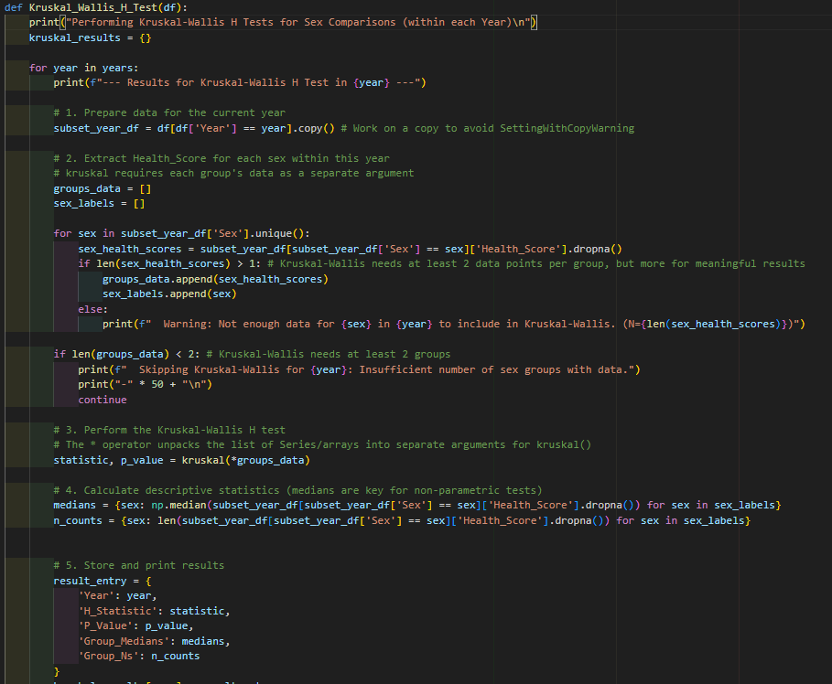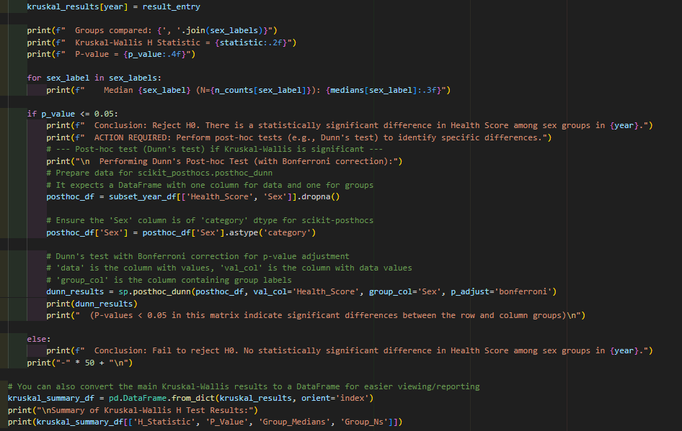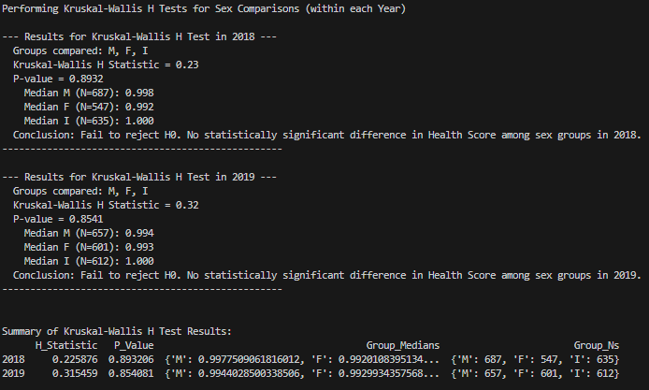

Interpretation of Kruskal-Wallis H Test Results
The p-values were significantly higher than 0.05 in both instances (p = 0.893 in 2018 and p = 0.854 in 2019). Because of this, the null hypothesis cannot be rejected, suggesting that there were no statistically significant variations in health status between the sex groups in either year. All groups' median `Health_Score` values were extremely similar and near 1.0, indicating that the relative health status of the sexes within each year was comparable.

Overall Analysis and Meaningful Solutions

Synthesis of Statistical Findings
There were no statistically significant differences in Health_Score between 2018 and 2019 or between sexes, according to the Kruskal-Wallis H and Mann-Whitney U tests. This suggests that lobster health, as determined by the standardised Health_Score, was constant across years and between groups of males, females, and infants. The general pattern points to a lobster population that was physiologically stable throughout the study period.

Preliminary Insights & Solutions:
Health stability across time and sex groups is highlighted by the lack of significant differences, indicating that there is no immediate physiological stress in the population. This is a good sign of ecological resilience.
The forthcoming business report for Task 2 will delve deeper into these findings and turn them into useful suggestions.

Task 2- Comperhensive Report

Executive Summary
Using data gathered in 2018 and 2019, this report presents a thorough data mining study into the health situation of lobster populations on the Isle of Skye. Developing a strong metric for lobster condition and doing comparative studies to find any notable changes across biological sexes or over time was the main goal

Introduction
For our business and the larger Isle of Skye community, the sustainability of marine ecosystems—especially commercially important species like lobsters—becomes a major issue. Effective resource management, conservation planning, and guarantees of long-term ecological balance depend on an awareness of the health of these populations (Wang et al., 2024). Based on morphological data from 2018 and 2019, this paper offers the results of a data-driven project aiming at objective assessment of the health situation of lobster populations (Plagányi et al., 2024). Our objective was to find whether there were any notable changes in health over these two years or differences between various biological sexes, so laying a scientific basis for next strategic choices.

Our Data-Driven Approach
Our research used the methodical data mining approach, CRISP-DM, to provide consistent, useful insights. This guaranteed careful preparation of the data and application of suitable, strong statistical methods in analysis (Plotnikova, Dumas and Milani, 2020).

Phase 1: Business Understanding
The first step of the project was clearly defining the business objectives, which involved determining the questions to be answered, understanding the need for analyzing lobster health for conservation and management.

Phase 2: Data Collection & Understanding
We combined information from lobster surveys that were carried out on the Isle of Skye in 2018 and 2019.
Although preliminary evaluations affirmed the datasets' general quality, they also made clear the need for careful data preparation to resolve small discrepancies.

Phase 3: Data Cleaning and Preparation
The data needed intensive cleaning, where deleting a small number of missing records, biologically impossible measurements, and erroneous entries was involved. This step also involved removing statistically improbable outliers, which ensured the reliability and accuracy of all the following analysis (Sedkaoui, 2018, chap. 5.3.1).

Phase 4: Feature Engineering
A complex 'Health Score' metric was created in order to measure lobster condition objectively. The established biological principle of allometric growth—which acknowledges that an organism's weight and length grow disproportionately—is the basis for this score (Almahy and Ali, 2022). A lobster's actual weight is compared to its statistically expected weight for its particular length and biological sex in order to calculate its Health Score. We can identify whether a single lobster is "stout" or "lean" thanks to this standardisation. Average, expected health is indicated by a score close to 1.0.

Phase 5: Modeling and Comparative Analysis
After the last step, the appropriate statistical techniques were used to compare lobster health across important groups. The data's statistical properties were verified through thorough assumption checks prior to comparison. This important step made sure that the best and most trustworthy statistical tests were selected in order to produce accurate results.
Then, in order to ascertain whether the average Health Scores varied significantly, we performed comparative analyses:
In between years: contrasting each sex category in 2018 and 2019.
Between the sexes: Comparing lobsters by year: male, female, and infant.

Key Findings
Our comprehensive data analysis reveals a consistent picture of lobster health in the Isle of Skye across the study period.

Overall Health Score Distribution:
A natural range of conditions from leaner to stouter individuals is indicated by variations in the Health Score distribution, which generally clusters around 1.0 for all lobster groups. For each sex, these distributions visually seem to be fairly constant from year to year.
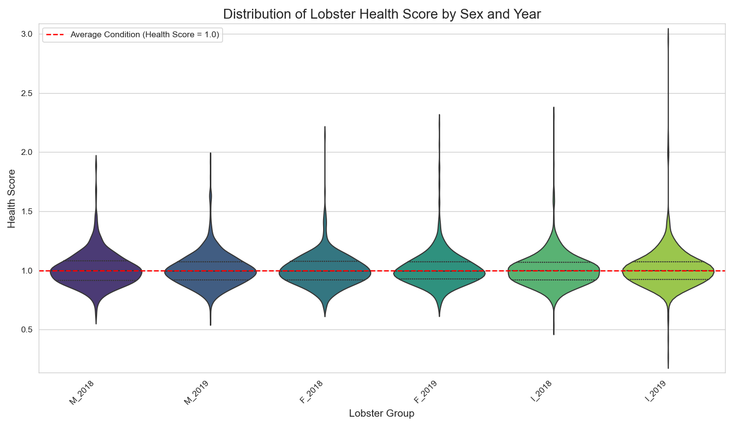

No Significant Change Year-on-Year:
When comparing the Health Scores of male, female, and baby lobsters in 2018 and 2019, thorough statistical comparisons revealed no statistically significant differences. This suggests that during these two years, the physiological state of lobsters for each sex group stayed consistent on average. Any slight variations that were noticed fell within the range of normal fluctuation.

No Significant Differences Across Sexes:
The Health Scores of male, female, and baby lobsters did not differ statistically significantly in either 2018 or 2019, according to our analysis. Although there appeared to be more variation in the Health Scores of baby lobsters in 2019, this difference was not statistically significant enough to indicate a general shift in the distribution of these lobsters. This implies that although these groups reflect different biological stages, they have similar relative health conditions as determined by our standardised Health Score.

Analysis & Discussion
Positive Health Stability: A robust and physiologically stable lobster population is strongly suggested by the steady health status seen across years and sexes. This stability, which indicates sound conditions or efficient current management, is comforting for both ecological health and commercial viability.

Strategic Resource Allocation: The lack of concerning health trends indicates that there isn't a pressing need for interventions that target widespread physiological stress. This makes it possible for the Board to carefully distribute funds to other important conservation, research, or operational enhancements.

Limitations: Morphological data collected over a two-year period served as the basis for this analysis. Although strong within these bounds, it's crucial to remember that outside variables affecting lobster health were not evaluated directly.

Conclusions & Recommendations

Conclusion
To sum up, the data mining analysis of the Isle of Skye's lobster populations shows a steady and reliable health profile from 2018 to 2019. There were no statistically significant variations in Health Scores between the sexes within a given year or between male, female, or baby lobsters from year to year. This strong result points to a resilient lobster population over the course of the study, suggesting either favourable conditions or efficient management at the moment.

Recommendations:
Sustained Monitoring: Keep up the current procedures for gathering data, using the Health Score as a standardised indicator for evaluating population health.
Environmental Integration: To better understand health drivers and improve management, give priority to research that combines environmental data with Health Scores.
Long-Term Trend Analysis: Increase data collection to find patterns and subtle long-term trends.
Targeted Infant Research: Examine the observed variability in infant lobster health.

Future Research:
Time Series Analysis: Use time series models to forecast health trends and find long-term patterns using expanded multi-year data.
Classification Models: Create models to forecast a lobster's health status such as "at-risk," "optimal," etc. in order to take preventative action.
Clustering Analysis: Using common health traits, find hidden, natural subgroups within the lobster population.
Enhanced Anomaly Detection: Use advanced algorithms to identify individual lobsters that exhibit exceptionally high health scores, which could be a sign of new problems or special resilience.

Bibliography
- Almahy, M.I.M. and Ali, S.M. (2022) ‘The weight-length relationship and condition factor of the spiny lobster Panulirus penicillatus (Olivier, 1791) in the red sea coast’, International Journal of Fisheries and Aquatic Studies, 10(6), pp. 22–27. Available at: https://doi.org/10.22271/fish.2022.v10.i6a.2745.
- Corder, G.W. and Foreman, D.I. (2014) Nonparametric Statistics. 2nd edn. Wiley (A Step-by-Step Approach).
- Field, A. (2018) Discovering Statistics Using IBM SPSS Statistics. SAGE Publications.
- Larose, D.T. (2015) Data Mining and Predictive Analytics. 2nd edn. Wiley.
- Lemke, C. (2021) Accounting and Statistical Analyses for Sustainable Development. Wiesbaden: Springer Nature (Multiple Perspectives and Information-Theoretic Complexity Reduction).
- Lynch, S. (2023) Python for Scientific Computing and Artificial Intelligence. 1st edn. Taylor and Francis.
- Martínez-Calderón, R., Lozano-Álvarez, E. and Briones-Fourzán, P. (2018) ‘Morphometric relationships and seasonal variation in size, weight, and a condition index of post-settlement stages of the Caribbean spiny lobster’, PeerJ, 6, p. e5297. Available at: https://doi.org/10.7717/peerj.5297.
- Meyers, L.S., Gamst, G.C. and Guarino, A.J. (2013) Performing Data Analysis Using IBM SPSS. 1st edn. Wiley.
- Mueller, J.P. and Massaron, L. (2019) Python for Data Science For Dummies. 2nd edn. Wiley.
- Nyamawe, A.S. et al. (2025) Practical Machine Learning. 1st edn. Taylor and Francis (A Beginner’s Guide with Ethical Insights).
- pandas (2025) General functions — pandas 2.3.0 documentation. Available at: https://pandas.pydata.org/docs/reference/general_functions.html#data-manipulations (Accessed: 24 June 2025).
- Plagányi, É. et al. (2024) ‘Lessons from long-term monitoring of tropical rock lobsters to support fisheries management’, Fisheries Research, 275, p. 107030. Available at: https://doi.org/10.1016/j.fishres.2024.107030.
- Plotnikova, V., Dumas, M. and Milani, F. (2020) ‘Adaptations of data mining methodologies: a systematic literature review’, PeerJ Computer Science, 6, p. e267. Available at: https://doi.org/10.7717/peerj-cs.267.
- Saltz, J.S. and Stanton, J.M. (2024) An Introduction to Data Science With Python. 1st edn. Thousand Oaks: Sage Publications US.
- Schröer, C., Kruse, F. and Gómez, J.M. (2021) ‘A Systematic Literature Review on Applying CRISP-DM Process Model’, CENTERIS 2020 - International Conference on ENTERprise Information Systems / ProjMAN 2020 - International Conference on Project MANagement / HCist 2020 - International Conference on Health and Social Care Information Systems and Technologies 2020, CENTERIS/ProjMAN/HCist 2020, 181, pp. 526–534. Available at: https://doi.org/10.1016/j.procs.2021.01.199.
- Sedkaoui, S. (2018) Data Analytics and Big Data. 1st edn. Wiley.
- Situmorang, Y.M.L., Omar, S.B.A. and Tresnati, J. (2021) ‘Carapace length-body weight relationship and condition factor of painted rock lobster Panulirus versicolor in Sorong waters, West Papua, Indonesia’, 14(1).
- Wang, X. et al. (2024) ‘Marine Health Assessment: An Application Case of the Ocean Health Index in Dalian, China’. Available at: https://doi.org/10.2139/ssrn.4994749.
- Waskom, M. (2021) ‘seaborn: statistical data visualization’, Journal of Open Source Software, 6(60), p. 3021. Available at: https://doi.org/10.21105/joss.03021.
- Willard, C.A. (2020) Statistical Methods. 2nd edn. Oxford: Taylor and Francis (An Introduction to Basic Statistical Concepts and Analysis).
- Wu, D. (2024) Data Mining with Python. 1st edn. Taylor and Francis (Theory, Application, and Case Studies).

Appendix- Full Code
import pandas as pd
import numpy as np
import seaborn as sns
import matplotlib.pyplot as plt
import scikit_posthocs as sp
import os
from sklearn.decomposition import PCA
from sklearn.preprocessing import StandardScaler
from scipy.stats import linregress, shapiro, levene, mannwhitneyu, kruskal

# Get the directory where the current script is located
script_dir = os.path.dirname(__file__)

# Construct the full path to the Excel file
# os.path.join handles differences in operating system path separators (e.g., / or \)
excel_file_path = os.path.join(script_dir, "Lobster_Data_Set.xlsx")

# Importing the two sheets from excel into different Dataframes
df_2018 = pd.read_excel(excel_file_path, sheet_name="Lobster Data 2018")
df_2019 = pd.read_excel(excel_file_path, sheet_name="Lobster Data 2019")

# Adding a new column that indicates year
df_2018["Year"] = 2018
df_2019["Year"] = 2019

# Combining the 2 sheets into one
df = pd.concat([df_2018, df_2019], ignore_index=True)
numeric_features = ['Length(mm)', 'Diameter(mm)', 'Height(mm)', 'WholeWeight(g)', 'ShuckedWeight(g)', 'SellWeight(g)']

# Exploratory Data Analysis (EDA)
def Exploratory_Data_Analysis(df):
# Shape of the dataset
shape = df.shape
# Column names and data types
types = df.dtypes
# Summary statistics
statistics = df.describe()
# Count of each category in 'Sex' column
sex_count = df['Sex'].value_counts()
year_count = df['Year'].value_counts()
# Count missing values per column
missing_values = df.isnull().sum()
# Check for complete duplicates
duplicates = df.duplicated().sum()

print(f'''\n \nThe shape of the Dataframe is:\n{shape}\n \nThe tyoes of data in each column:\n{types}\n
\nStatistical Summary: \n{statistics}\n \nCount of each category in Sex column: \n{sex_count}\n
\nCount of each category in year column:\n{year_count}\n \nNumber of missing values per column:\n
{missing_values}\n \nChecking for complete duplicates:\n{duplicates}''')

# General Data clean
def clean_data(df):
# Dropping all rows with NA and invalid values
clean_df = df.dropna()
clean_df = clean_df[clean_df['Sex'] != '0']

# Removing rows where any of these core columns are 0
for col in numeric_features:
clean_df = clean_df[clean_df[col] > 0]
numeric_features.append('Spots') #adding spots to the list of numeric features

# remove complete duplicates (if any)
clean_df = clean_df.drop_duplicates()

# Convert Data Types
clean_df['Sex'] = clean_df['Sex'].astype('category')
clean_df['Year'] = clean_df['Year'].astype(int)

return clean_df

# Detecting and removing Outliers using IQR
def remove_outliers_iqr(df, columns):
cleaned_df = df.copy()
for col in columns:
Q1 = cleaned_df[col].quantile(0.25)
Q3 = cleaned_df[col].quantile(0.75)
IQR = Q3 - Q1
lower_bound = Q1 - 1.5 * IQR
upper_bound = Q3 + 1.5 * IQR

# Keep only rows within bounds
cleaned_df = cleaned_df[(cleaned_df[col] >= lower_bound) & (cleaned_df[col] <= upper_bound)]

return cleaned_df

def normalizing(df, features_to_scale): # df here is the cleaned df, Pass the list of features to scale
scaler = StandardScaler()
df_scaled = df.copy()
df_scaled[features_to_scale] = scaler.fit_transform(df[features_to_scale])

return df_scaled

#PCA analysis, Dimention reduction
def pca_data(df_scaled, features_for_pca): # Pass the list of features for PCA
# Perform PCA
pca = PCA(n_components=2)
pca_components = pca.fit_transform(df_scaled[features_for_pca])

# Create a PCA DataFrame
pca_df = pd.DataFrame(data=pca_components, columns=['PC1', 'PC2'])
# Create a DataFrame to view contributions of each feature to each component
loadings = pd.DataFrame(
pca.components_.T, # Transpose so rows = features, columns = PCs
columns=['PC1', 'PC2'],
index=features_for_pca # Use the passed list
)

# Add labels for coloring/shaping
pca_df['Sex'] = df['Sex'].values # from original df (not scaled)
pca_df['Year'] = df['Year'].values
return pca_df, loadings

#plotting pca
def pca_plotting(pca_df):
# Define marker shapes for each year
year_markers = {2018: 'o', 2019: 's'} # circle and square
sex_colors = {'M': 'blue', 'F': 'red', 'I': 'green'}

# Plot using matplotlib
plt.figure(figsize=(10, 7))

for sex in pca_df['Sex'].unique():
for year in pca_df['Year'].unique():
subset = pca_df[(pca_df['Sex'] == sex) & (pca_df['Year'] == year)]
plt.scatter(subset['PC1'], subset['PC2'],
c=sex_colors[sex],
marker=year_markers[year],
label=f'{sex}-{year}',
alpha=0.7)

plt.xlabel('Principal Component 1')
plt.ylabel('Principal Component 2')
plt.title('PCA of Lobster Features: Colored by Sex, Shaped by Year')
plt.legend(title='Sex-Year', bbox_to_anchor=(1.05, 1), loc='upper left')
plt.tight_layout()
plt.show()

def pca_facet_plotting(pca_df):
# Convert Year to string so Seaborn can color by category
pca_facet_df = pca_df.copy()
pca_facet_df['Year'] = pca_facet_df['Year'].astype(str)

# Define custom color palette
custom_palette = {'2018': 'red', '2019': 'blue'}

# Facet by Sex, color by Year
g = sns.FacetGrid(pca_facet_df, col='Sex', hue='Year', height=5, aspect=1.2, palette=custom_palette)
g.map_dataframe(sns.scatterplot, x='PC1', y='PC2', alpha=0.8)
g.set_axis_labels("Principal Component 1", "Principal Component 2")
g.add_legend(title='Year')
g.fig.suptitle("PCA Faceted by Sex with Year Coloring", y=1.05)
plt.tight_layout()
plt.show()

# visualisations
# Boxplots and histograms for each numerical feature
def graphs_numerical_distribution(df):
for col in numeric_features:
plt.figure(figsize=(12, 4))

plt.subplot(1, 2, 1)
sns.histplot(df[col], kde=True)
plt.title(f'Histogram of {col}')

plt.subplot(1, 2, 2)
sns.boxplot(x=df[col])
plt.title(f'Boxplot of {col}')

plt.tight_layout()
plt.show()

# catagorical distribution graph
def graphs_catagorical_distribution(df):
sns.countplot(data=df, x='Sex')
plt.title('Sex Distribution')
plt.show()

# For engineering Condition Factor

def calculate_sex_specific_ab(df, sex_col='Sex', length_col='Length(mm)', weight_col='WholeWeight(g)'):
"""
Calculates sex-specific 'a' and 'b' values for the length-weight relationship.
Returns a dictionary with 'a' and 'b' values for each sex.
W=a⋅L^b
--
W = Body weight (g)
L = Carapace length (mm)
a = Intercept (constant)
b = Allometric growth exponent
"""
sexes = df[sex_col].unique()
ab_params = {}

for sex in sexes:
print(f"\nCalculating a and b for {sex} lobsters...")
subset_df = df[df[sex_col] == sex].copy() # Use .copy() to avoid SettingWithCopyWarning

log_length = np.log(subset_df[length_col])
log_weight = np.log(subset_df[weight_col])

slope, intercept, r_value, p_value, std_err = linregress(log_length, log_weight)

b_value = slope
a_value = np.exp(intercept)

ab_params[sex] = {'a': a_value, 'b': b_value}
# print(f" {sex}: Derived 'a' = {a_value:.6f}, 'b' = {b_value:.6f}, R-squared = {r_value**2:.6f}")

return ab_params
def engineer_sex_specific_health_score(df, ab_params, sex_col='Sex', length_col='Length(mm)', weight_col='WholeWeight(g)'):
"""
Engineers the Health_Score using sex-specific 'a' and 'b' values.
"""
# Initialize Health_Score column (e.g., with NaN)
df['Predicted_Weight'] = np.nan
df['Health_Score'] = np.nan

for sex, params in ab_params.items():
a = params['a']
b = params['b']

if not np.isnan(a) and not np.isnan(b): # Only proceed if a and b were successfully calculated
# Select rows for the current sex
sex_mask = (df[sex_col] == sex)

# Calculate predicted weight for this sex's group
df.loc[sex_mask, 'Predicted_Weight'] = a * (df.loc[sex_mask, length_col]**b)

# Calculate Health_Score for this sex's group
# Ensure no division by zero or very small numbers
df.loc[sex_mask, 'Health_Score'] = df.loc[sex_mask, weight_col] / df.loc[sex_mask, 'Predicted_Weight']
else:
print(f"Skipping Health_Score calculation for {sex} due to insufficient 'a' and 'b' values.")

return df

def print_df_with_heath_score(df_with_sex_specific_health_score):
print("\nDataFrame with Sex-Specific Health Scores:")
print(df_with_sex_specific_health_score[['Sex', 'Length(mm)', 'WholeWeight(g)', 'Predicted_Weight', 'Health_Score']].head(10))

# Step 3: Verify for different sexes
print("\nMale Lobsters Health Scores:")
print(df_with_sex_specific_health_score[df_with_sex_specific_health_score['Sex'] == 'M'][['Length(mm)', 'WholeWeight(g)', 'Health_Score']])

print("\nFemale Lobsters Health Scores:")
print(df_with_sex_specific_health_score[df_with_sex_specific_health_score['Sex'] == 'F'][['Length(mm)', 'WholeWeight(g)', 'Health_Score']])

print("\nInfant Lobsters Health Scores:")
print(df_with_sex_specific_health_score[df_with_sex_specific_health_score['Sex'] == 'I'][['Length(mm)', 'WholeWeight(g)', 'Health_Score']])

# Health_Score Visual Check
def health_score_Histogram(df):
# Set up the plotting environment
sns.set_style("whitegrid")
plt.figure(figsize=(15, 10))

plot_index = 1

for sex in sexes:
for year in years:
subset = df[(df['Sex'] == sex) & (df['Year'] == year)]['Health_Score'].dropna()
if not subset.empty:
plt.subplot(len(sexes), len(years), plot_index)
sns.histplot(subset, kde=True, bins=20)
plt.title(f'Health Score Distribution: {sex} {year}')
plt.xlabel('Health Score')
plt.ylabel('Frequency')
plot_index += 1
plt.tight_layout()
plt.suptitle('Histograms of Health Score by Sex and Year', y=1.02, fontsize=16)
plt.show()
def health_score_shapiro_wilk(df):
print("\n--- Shapiro-Wilk Test for Normality (p > 0.05 indicates normality) ---")
for sex in sexes:
for year in years:
subset = df[(df['Sex'] == sex) & (df['Year'] == year)]['Health_Score'].dropna()
if len(subset) > 5000: # Shapiro-Wilk can be computationally expensive for very large N
print(f"Skipping Shapiro-Wilk for {sex} {year} due to large sample size ({len(subset)}). Rely on visual inspection.")
continue
if len(subset) < 3: # Shapiro-Wilk requires at least 3 data points
print(f"Not enough data for Shapiro-Wilk for {sex} {year}. (N={len(subset)})")
continue

stat, p = shapiro(subset)
print(f' {sex} {year}: Statistics={stat:.3f}, p={p:.3f}')
if p > 0.05:
print(f' -> Sample looks Gaussian (fail to reject H0 for normality)')
else:
print(f' -> Sample does not look Gaussian (reject H0 for normality)')
def health_score_Levene_test_Year_on_Year(df):
# A. Year-on-Year Comparisons (for each Sex)
print("\n A. Year-on-Year Comparisons (Health Score between 2018 and 2019, for each Sex):")
for sex in df['Sex'].unique():
group_2018_data = df[(df['Sex'] == sex) & (df['Year'] == 2018)]['Health_Score'].dropna()
group_2019_data = df[(df['Sex'] == sex) & (df['Year'] == 2019)]['Health_Score'].dropna()

if len(group_2018_data) < 2 or len(group_2019_data) < 2:
print(f" Not enough data for Levene's test for {sex} (2018 vs 2019). Skipping.")
continue

stat, p = levene(group_2018_data, group_2019_data)
print(f' {sex} (2018 vs 2019): Statistics={stat:.3f}, p={p:.3f}')
if p > 0.05:
print(f' -> Variances are equal (Fail to reject H0 for equal variances)')
else:
print(f' -> Variances are not equal (Reject H0 for equal variances)')
def health_score_Levene_test_Sex_Comparison(df):
# B. Sex Comparisons (Health Score across Sexes, within each Year)
print("\n B. Sex Comparisons (Health Score across Sexes, within each Year):")
for year in df['Year'].unique():
# Collect data for all sexes for the current year
groups_for_levene = []
sexes_present = []
for sex in df['Sex'].unique():
subset = df[(df['Sex'] == sex) & (df['Year'] == year)]['Health_Score'].dropna()
if len(subset) >= 2: # Levene's test requires at least 2 data points per group
groups_for_levene.append(subset)
sexes_present.append(sex)
else:
print(f" Warning: Not enough data for {sex} in {year} for Levene's test (need >=2 data points).")

if len(groups_for_levene) >= 2: # Levene's test needs at least 2 distinct groups
# The * operator unpacks the list of series/arrays into separate arguments for levene()
stat, p = levene(*groups_for_levene)
sex_list_str = " vs ".join(sexes_present)
print(f' {year} ({sex_list_str}): Statistics={stat:.3f}, p={p:.3f}')
if p > 0.05:
print(f' -> Variances are equal')
else:
print(f' -> Variances are not equal')
else:
print(f" Not enough distinct sex groups present in {year} for Levene's test. Skipping.")

# Comparative Statistical Tests
def mann_whitney_U_test(df):
print("Performing Mann-Whitney U Tests for Year-on-Year Comparisons (by Sex)\n")

mann_whitney_results = {}

for sex in sexes:
# 1. Filter data for the current sex and years
group_2018 = df[(df['Sex'] == sex) & (df['Year'] == 2018)]['Health_Score'].dropna()
group_2019 = df[(df['Sex'] == sex) & (df['Year'] == 2019)]['Health_Score'].dropna()

# 2. Check if there's enough data for both groups
if len(group_2018) < 10 or len(group_2019) < 10: # Mann-Whitney is better with larger samples
print(f" Skipping Mann-Whitney U test for {sex}: Insufficient data for one or both years.")
print(f" 2018 N={len(group_2018)}, 2019 N={len(group_2019)}\n")
continue

# 3. Perform the Mann-Whitney U test
# By default, mannwhitneyu returns a two-sided p-value.
statistic, p_value = mannwhitneyu(group_2018, group_2019, alternative='two-sided')

# 4. Calculate descriptive statistics for interpretation
mean_2018 = group_2018.mean()
median_2018 = group_2018.median()
std_2018 = group_2018.std()

mean_2019 = group_2019.mean()
median_2019 = group_2019.median()
std_2019 = group_2019.std()

# 5. Store and print results
result = {
'Sex': sex,
'N_2018': len(group_2018),
'Mean_2018': mean_2018,
'Median_2018': median_2018,
'Std_2018': std_2018,
'N_2019': len(group_2019),
'Mean_2019': mean_2019,
'Median_2019': median_2019,
'Std_2019': std_2019,
'U_Statistic': statistic,
'P_Value': p_value
}
mann_whitney_results[sex] = result

print(f"--- Results for {sex} Lobsters (2018 vs 2019) ---")
print(f" 2018 (N={result['N_2018']}): Mean={result['Mean_2018']:.3f}, Median={result['Median_2018']:.3f}, Std={result['Std_2018']:.3f}")
print(f" 2019 (N={result['N_2019']}): Mean={result['Mean_2019']:.3f}, Median={result['Median_2019']:.3f}, Std={result['Std_2019']:.3f}")
print(f" Mann-Whitney U Statistic = {statistic:.2f}")
print(f" P-value = {p_value:.4f}")

if p_value <= 0.05:
print(f" Conclusion: Reject H0. There is a statistically significant difference in Health Score between 2018 and 2019 for {sex} lobsters.")
else:
print(f" Conclusion: Fail to reject H0. No statistically significant difference in Health Score between 2018 and 2019 for {sex} lobsters.")
print("-" * 50 + "\n")

# You can also convert the results to a DataFrame for easier viewing/reporting
results_df = pd.DataFrame.from_dict(mann_whitney_results, orient='index')
print("\nSummary of Mann-Whitney U Test Results:")
print(results_df[['N_2018', 'Median_2018', 'N_2019', 'Median_2019', 'U_Statistic', 'P_Value']])

def Kruskal_Wallis_H_Test(df):
print("Performing Kruskal-Wallis H Tests for Sex Comparisons (within each Year)\n")
kruskal_results = {}

for year in years:
print(f"--- Results for Kruskal-Wallis H Test in {year} ---")

# 1. Prepare data for the current year
subset_year_df = df[df['Year'] == year].copy() # Work on a copy to avoid SettingWithCopyWarning

# 2. Extract Health_Score for each sex within this year
# kruskal requires each group's data as a separate argument
groups_data = []
sex_labels = []

for sex in subset_year_df['Sex'].unique():
sex_health_scores = subset_year_df[subset_year_df['Sex'] == sex]['Health_Score'].dropna()
if len(sex_health_scores) > 1: # Kruskal-Wallis needs at least 2 data points per group, but more for meaningful results
groups_data.append(sex_health_scores)
sex_labels.append(sex)
else:
print(f" Warning: Not enough data for {sex} in {year} to include in Kruskal-Wallis. (N={len(sex_health_scores)})")

if len(groups_data) < 2: # Kruskal-Wallis needs at least 2 groups
print(f" Skipping Kruskal-Wallis for {year}: Insufficient number of sex groups with data.")
print("-" * 50 + "\n")
continue

# 3. Perform the Kruskal-Wallis H test
# The * operator unpacks the list of Series/arrays into separate arguments for kruskal()
statistic, p_value = kruskal(*groups_data)

# 4. Calculate descriptive statistics (medians are key for non-parametric tests)
medians = {sex: np.median(subset_year_df[subset_year_df['Sex'] == sex]['Health_Score'].dropna()) for sex in sex_labels}
n_counts = {sex: len(subset_year_df[subset_year_df['Sex'] == sex]['Health_Score'].dropna()) for sex in sex_labels}

# 5. Store and print results
result_entry = {
'Year': year,
'H_Statistic': statistic,
'P_Value': p_value,
'Group_Medians': medians,
'Group_Ns': n_counts
}
kruskal_results[year] = result_entry

print(f" Groups compared: {', '.join(sex_labels)}")
print(f" Kruskal-Wallis H Statistic = {statistic:.2f}")
print(f" P-value = {p_value:.4f}")

for sex_label in sex_labels:
print(f" Median {sex_label} (N={n_counts[sex_label]}): {medians[sex_label]:.3f}")

if p_value <= 0.05:
print(f" Conclusion: Reject H0. There is a statistically significant difference in Health Score among sex groups in {year}.")
print(f" ACTION REQUIRED: Perform post-hoc tests (e.g., Dunn's test) to identify specific differences.")
# --- Post-hoc test (Dunn's test) if Kruskal-Wallis is significant ---
print("\n Performing Dunn's Post-hoc Test (with Bonferroni correction):")
# Prepare data for scikit_posthocs.posthoc_dunn
# It expects a DataFrame with one column for data and one for groups
posthoc_df = subset_year_df[['Health_Score', 'Sex']].dropna()

# Ensure the 'Sex' column is of 'category' dtype for scikit-posthocs
posthoc_df['Sex'] = posthoc_df['Sex'].astype('category')

# Dunn's test with Bonferroni correction for p-value adjustment
# 'data' is the column with values, 'val_col' is the column with data values
# 'group_col' is the column containing group labels
dunn_results = sp.posthoc_dunn(posthoc_df, val_col='Health_Score', group_col='Sex', p_adjust='bonferroni')
print(dunn_results)
print(" (P-values < 0.05 in this matrix indicate significant differences between the row and column groups)\n")

else:
print(f" Conclusion: Fail to reject H0. No statistically significant difference in Health Score among sex groups in {year}.")
print("-" * 50 + "\n")

# You can also convert the main Kruskal-Wallis results to a DataFrame for easier viewing/reporting
kruskal_summary_df = pd.DataFrame.from_dict(kruskal_results, orient='index')
print("\nSummary of Kruskal-Wallis H Test Results:")
print(kruskal_summary_df[['H_Statistic', 'P_Value', 'Group_Medians', 'Group_Ns']])

### All the code applications are below, comment and uncomment parts as needed, running everything together takes a longer run time

# Exploratory_Data_Analysis(df)
df = clean_data(df)
# Function to remove outliers
df = remove_outliers_iqr(df, numeric_features)
# Normalising and scaling the dataframe
df_scaled = normalizing(df, numeric_features)

# Applying PCA
pca_df, pca_components = pca_data(df_scaled, numeric_features)
# Printing out the PCA components
print(pca_components)
# Plotting the PCA facet graph
pca_facet_plotting(pca_df)

# For further analysis
sexes = df['Sex'].unique()
years = df['Year'].unique()

## Feature Engineering
# Calculate sex-specific 'a' and 'b' values
sex_ab_parameters = calculate_sex_specific_ab(df.copy())
# Engineer the Health_Score using these sex-specific parameters
df_with_sex_specific_health_score = engineer_sex_specific_health_score(df.copy(), sex_ab_parameters)

## Assumption Checks
# Checking Normality visually with histograms
health_score_Histogram(df_with_sex_specific_health_score)
# Conduction the Shapiro-Wilk Statistical check
health_score_shapiro_wilk(df_with_sex_specific_health_score)
# Conduction the Levene Statistical check
health_score_Levene_test_Year_on_Year(df_with_sex_specific_health_score)
health_score_Levene_test_Sex_Comparison(df_with_sex_specific_health_score)

## Statistical Modeling
mann_whitney_U_test(df_with_sex_specific_health_score)
Kruskal_Wallis_H_Test(df_with_sex_specific_health_score)

