Comprehensive Sequence Analysis of the Human TNF Gene

# Introduction:

TNF gene (Tumor Necrosis Factor) encodes a cytokine primarily involved in systemic inflammation. This cytokine is part of the body's immune response and plays a crucial role in the regulation of immune cells, as well as the inflammation process. TNF is involved in several cellular processes, including cell proliferation, differentiation, apoptosis, and survival. The gene is located on chromosome 6 in humans and is associated with various inflammatory and autoimmune conditions, such as rheumatoid arthritis, Crohn's disease, and psoriasis. Overexpression of TNF can lead to chronic inflammatory diseases, making it a key target for therapeutic interventions.

# Task 1: Download a Biological Sequence from NCBI and View/Edit It

**Output:**

The output for this task is a screenshot of the TNF gene sequence displayed in the BioEdit software. This screenshot demonstrates that the sequence was successfully downloaded from NCBI and opened in the BioEdit software for further analysis.

Task 2: Generate a Translation of a DNA or RNA Sequence into Amino Acids**Output:**

In this task, I translated the DNA sequence of the TNF gene into its corresponding amino acid sequence using BioEdit. The screenshot captures the output generated by the ‘Translate’ feature in BioEdit, showcasing the amino acid sequence derived from the TNF gene. This sequence is crucial for understanding the protein structure and function of TNF, which plays a significant role in inflammation and immune responses.

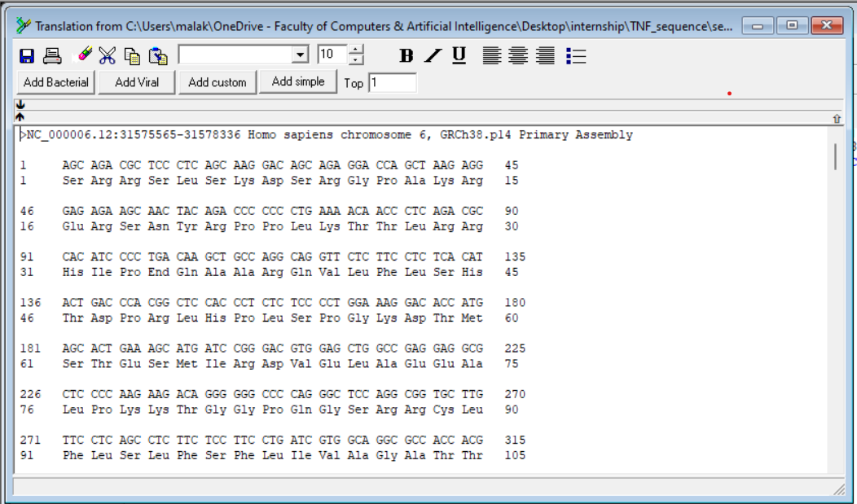

Task 3: Find ORFs (Open Reading Frames) in a DNA or RNA Sequence

**Output:** In analysis of the TNF gene sequence, I identified several potential Open Reading Frames (ORFs), each characterized by specific start and stop positions. These ORFs represent candidate protein-coding regions within the gene.

Task 4: Analyze Sequence Composition (Nucleotide or Amino Acid Frequencies)

**Output:**

* High GC content often indicates stability and functional importance.
* Low GC content might suggest a different function or evolutionary history.
* Compare these results to known patterns in other genes or species.
* Consider any potential implications for gene expression, regulation, or protein structure.

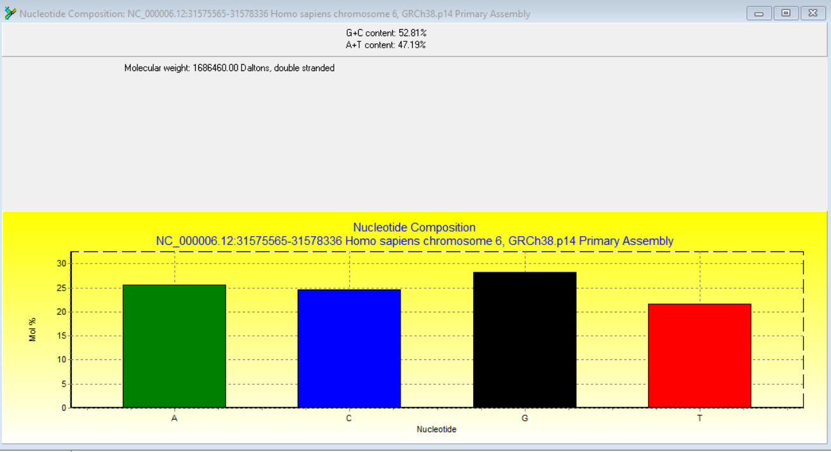

Task 5: Identify Transcription Factor Binding Sites Using the PROMO Tool

**Output:**

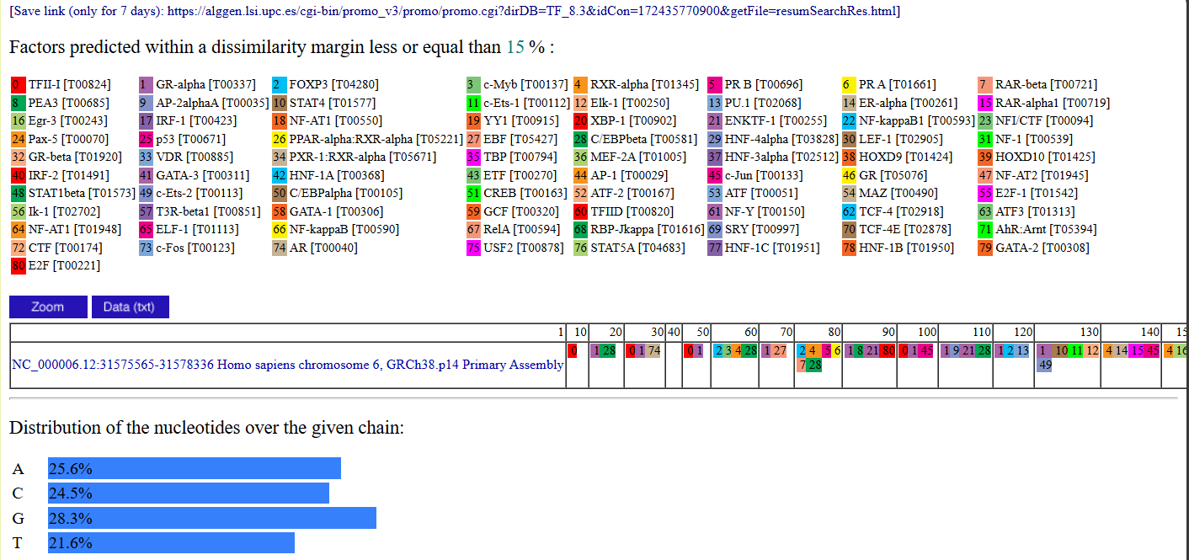The analysis of the TNF gene sequence, i identified several potential Open Reading Frames (ORFs), each characterized by specific start and stop positions. These ORFs represent candidate protein-coding regions within the gene.

Task 6: Search for Functional Motifs in a Genome or Transcriptome Using MEME Suite

**Output:**

In the exploration of the TNF gene sequence using the MEME Suite, uncovered intriguing motifs—those elusive snippets of genetic choreography. These motifs, akin to musical motifs in a symphony, might hold the key to TNF’s regulatory dance.

1. **Motif Discovery**:
   * MEME Suite diligently scanned the sequence, spotlighting recurring patterns.
   * Each motif—like a soloist on stage—could signify a transcription factor binding site or a functional element.
   * We eagerly awaited their unveiling.
2. **Functional Significance**:
   * Consider the context:
     + Are these motifs conserved across species?
     + Do they align with known regulatory elements?
   * Perhaps they’re the secret cues that orchestrate TNF’s expression.
3. **Potential Roles**:
   * Some motifs might be backstage passcodes—allowing specific factors to access TNF’s promoter.
   * Others could be enhancer invitations—beckoning regulatory proteins to join the performance.
   * We speculate on their roles: Are they conductors, soloists, or harmonizers?
4. **Saving the Encore**:
   * Document these motifs—their positions, sequences, and significance.
   * Perhaps they’ll inspire future studies, unraveling TNF’s genetic symphony further.

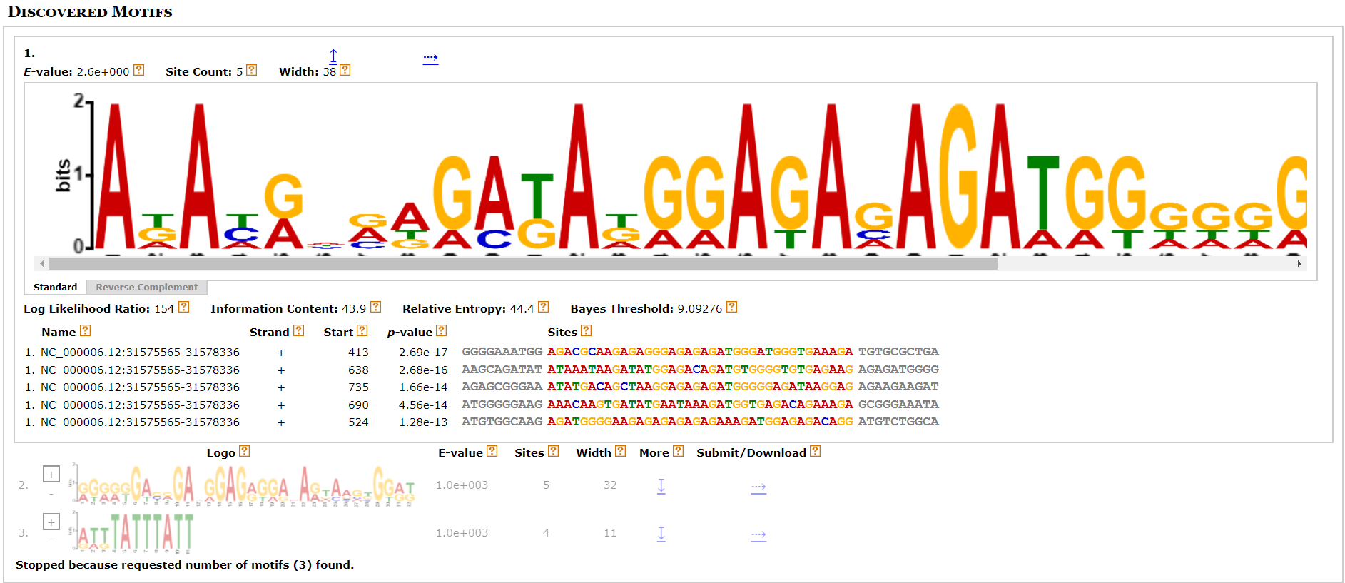

Task 7: Predict Coding/Non-Coding Regions in a Genome Using GENSCAN

**Output:**

GENSCAN analysis of the TNF gene sequence, we identified coding exons—segments encoding proteins—and non-coding introns. These regions together compose the genetic symphony of TNF.

Task 8: Convert Between Sequence File Formats Using BioEdit (FASTA to PHYLIP):

* 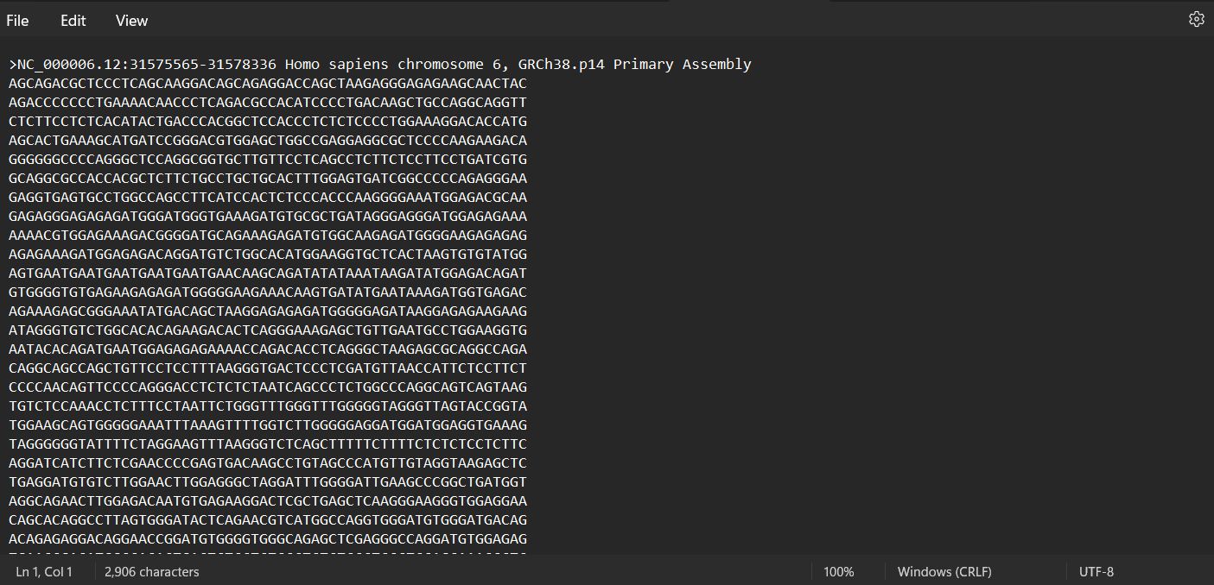fasta format
* 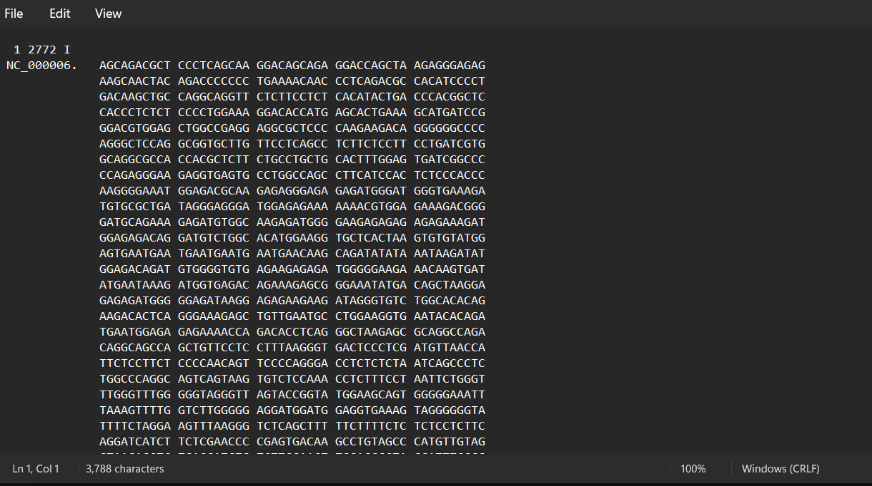phylip format :