

Faculty of Engineering and Technology
Department of Electrical and Computer Engineering Artificial Intelligence – ENCS3340

Prepared by:
Maysam Habbash 1220075
Malak Milhem 1220031
Instructor name: Dr. Samah Alaydi
Section: 3
Date: 02/05/2025

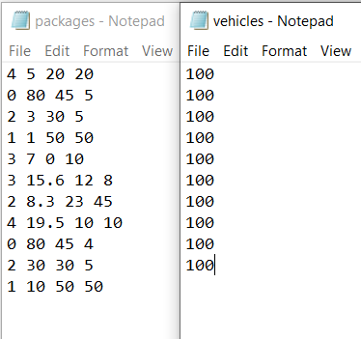
Figure 1: input file data
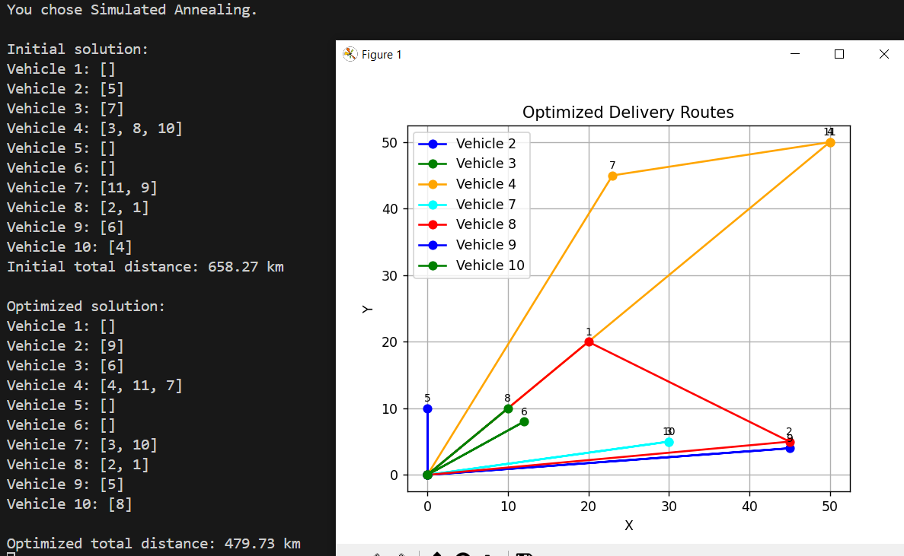
Figure 2:simulated Annealing result
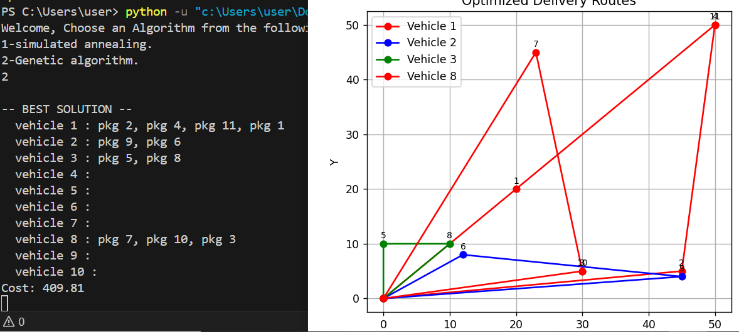
Figure 3:Genetic Algorithm result.

