Chat System Project
When exporting the project as a .rar file, it will produce a root folder named:
OS_Project/
│
├── SocketClient/ # Socket-based Chat Client project
│ ├── client.cbp # Code::Blocks project file
│ └── bin/
│ └── debug/
│ └── gui.exe # Runs as admin
│
├── SocketServer/ # Socket-based Chat Server project
│ ├── server.cbp # Code::Blocks project file
│ └── bin/
│ └── debug/
│ └── gui2.exe # Runs as admin
│
├── SharedMemoryClient/ # Shared-Memory Chat Client project
│ ├── client2.cbp # Code::Blocks project file
│ └── bin/
│ └── debug/
│ └── gui3.exe # Runs as admin
│
├── SharedMemoryServer/ # Shared-Memory Chat Server project
│ ├── server2.cbp # Code::Blocks project file
│ └── bin/
│ └── debug/
│ └── gui4.exe # Runs as admin
│
└── README.md # Project documentation,screenshots,demo

2. Project Details
- Programming Language: C++
- Project Requirements:
Implement two chat systems with a simple graphical user interface (GUI), both completed with the following properties:
  - Sockets and Multithreading (Completed)
    - Users can communicate over the network on different machines.
    - Uses TCP sockets and multithreading to support multiple clients.
  - Shared Memory and Synchronization (Completed)
    - Users communicate on the same machine.
    - Uses shared memory with synchronization primitives (mutexes/events).
Team Members:
- Malak Magdy Mohammed Abdalwahab | ID: 2300512
- Mohamed Ahmed Abdel Fatah Hussein Ismail | ID: 2300535
- Mohamed Ibrahim Abdelfattah Youssef Shalaby | ID: 2300528
- Sama Omar Saad Mohamed Meliha | ID: 2300522
- Ahmed Mohamed Morsy Abdallah | ID: 2302383

Notes: Contributions by Team Members
- Malak Magdy Mohammed Abdalwahab
  - Implemented Socket-based chat client GUI.
- Mohamed Ahmed Abdel Fatah Hussein Ismail
  - Implemented Socket-based chat server GUI.
- Mohamed Ibrahim Abdelfattah Youssef Shalaby
  - Implemented Shared-Memory chat server.
- Sama Omar Saad Mohamed Meliha
  - Implemented Shared-Memory chat client GUI.
- Ahmed Mohamed Morsy Abdallah
  - Implemented Shared-Memory chat client GUI.
  - Created project documentation and README.

3. How to Open and Use the Project
- Run the server first (either TCP Socket or Shared Memory)
- Run any number of clients of the same type
- Make sure to run as administrator on Windows
- Both server and clients will have a GUI to enter IP/Port (TCP) or use default shared memory (Shared Memory)
- Messages sent from clients will appear in all connected clients’ log boxes

4. GitHub Link and Required Installations
- GitHub Repository: https://github.com/MalakMAmer/osproject
- Video Link: https://drive.google.com/file/d/1HWNac60BD_7BuKH7KRZUfgpH-a-xDXde/view?usp=sharing
- Required Installations:
  - Windows OS (server and clients tested on Windows)
  - Code::Blocks or any C/C++ compiler supporting Win32 API and Winsock2
  - Run all .exe files as administrator
  - No additional libraries required (uses standard Windows API)

5. Screenshots & Demo

Socket Chat System
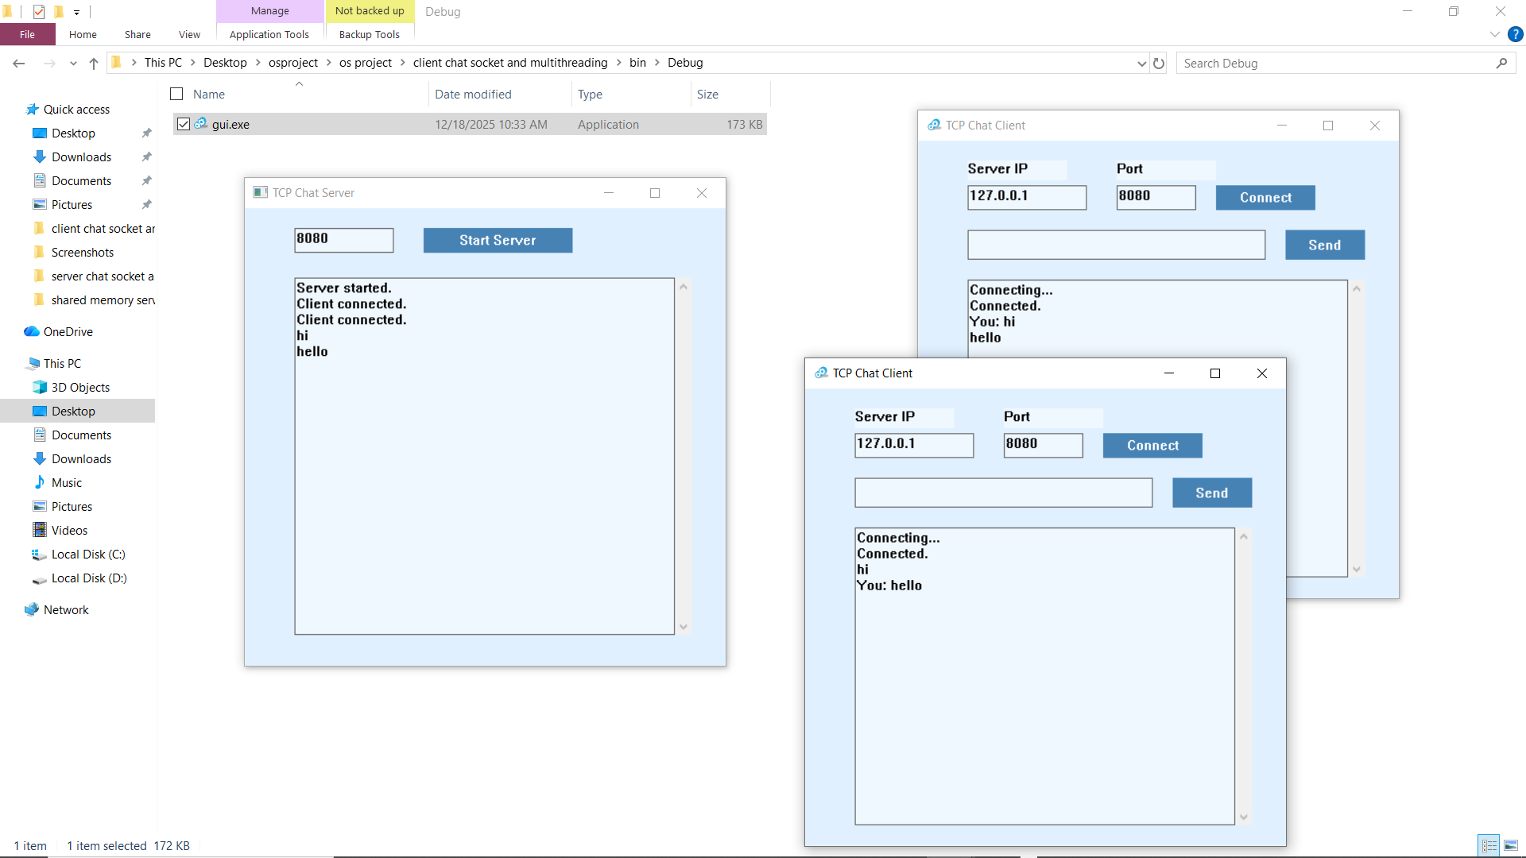

Shared Memory Chat System
