Project Documentation – Real Estate Data Analysis

1. Introduction
Overview of the project and its objective in analyzing the USA Real Estate dataset to extract insights and support business decision-making.
2. Dataset Description
Explanation of the dataset source, its purpose, and detailed description of all columns used in the analysis.
3. Data Warehouse Overview
Brief introduction about the Data Warehouse concept and how it supports analytical processing (OLAP) for decision making.
4. Tools Used
Overview of the tools used in the project:
Alteryx
SSIS (SQL Server Integration Services)
5. Data Splitting Process
Explanation of how the dataset was divided into two halves using Alteryx for parallel processing between Alteryx and SSIS.
6. Data Processing in Alteryx
Detailed explanation of:
Data cleaning
Data transformation
Feature engineering
Filtering and outlier handling
Aggregations and summarization
Output to SQL Server
7. Data Processing in SSIS
Explanation of SSIS workflow including:
Data input
Derived column transformations
Data conversion
Conditional splitting
Loading data into SQL Server
8. Data Transformation Techniques
Description of applied transformations such as:
Handling missing values
Formatting text fields
Splitting date attributes
Filtering invalid data
9. Data Analysis & Insights
Business insights extracted from the dataset such as:
Pricing patterns
Property characteristics impact
Location-based trends
Market behavior analysis
10. Decision Making
Key business decisions derived from charts and analysis results.
11. Conclusion
Summary of the project outcome and value of using data warehouse tools for real estate analytics.

1. Dataset Description
The dataset used in this project is the USA Real Estate Dataset obtained from Kaggle(https://www.kaggle.com/datasets/ahmedshahriarsakib/usa-real-estate-dataset). It contains approximately 2.5 million records describing real estate property transactions across different states in the United States.
This dataset is used to analyze housing market trends, identify pricing patterns, and support business decision-making in the real estate domain.
Columns Description:
- brokered_by: ID of the broker responsible for the transaction.
- status: Status of the property (e.g., for sale, sold).
- price: Selling price of the property.
- bed: Number of bedrooms.
- bath: Number of bathrooms.
- acre_lot: Size of land in acres.
- street: Street information of the property.
- city: City where the property is located.
- state: State where the property is located.
- zip_code: Postal code of the property.
- house_size: Size of the house in square feet.
- prev_sold_date: Date when the property was previously sold.

2. Tools Used and Components
Alteryx Components
We used Alteryx for data preprocessing, cleaning, and transformation:
- Input Data Tool
  - Used to load the dataset into Alteryx.
- Record ID Tool
  - Added a unique identifier for each record to support dataset splitting.
- Sample Tool (50%)
  - Used to split the dataset into two equal halves.
- Sort Tool (Descending)
  - Used to reverse dataset order before splitting.
- Select Tool
  - Used for renaming columns and selecting required fields only.
- Data Cleansing Tool
  - Removed null values and cleaned missing or invalid data.
- Summarize Tool
  - Calculated:
    - Mean of price, lot size, and house size
    - Mode of bedrooms and bathrooms
- Formula Tool
  - Replaced null values using calculated values
  - Converted text formatting (e.g., uppercase city, state, status)
  - Split prev_sold_date into year, month, day
- Filter Tool
  - Removed:
    - Null/empty street values
    - Invalid sales dates
    - Properties with price > 10,000,000 (outlier filtering)
- Output Data Tool
  - Exported processed data into SQL Server tables.

SSIS Components
We used SSIS for the second half of the dataset and loading into the database:
- Flat File / Input Source
  - Imported dataset into SSIS data flow.
- Derived Column
  - Used to:
    - Handle missing values
    - Transform data types
    - Create new calculated fields
- Data Conversion
  - Ensured compatibility between Unicode and non-Unicode columns (e.g., Zip Code).
- Conditional Split
  - Used for filtering invalid records and separating data logic.
- Lookup (if applied in workflow)
  - Used to validate or match reference data.
- OLE DB Destination
  - Loaded transformed data into SQL Server tables.

3. Dataset Splitting Process (Alteryx Logic)
To handle large dataset efficiently, we split it into two parts:
- Input Tool → Load dataset
- Select Tool → Select first 2000000 from dataset
- Record ID Tool → Assign unique ID
- Sample Tool (50%) → Take first half
- Sort Tool (Descending) → Reverse order
- Sample Tool (50%) again → Extract second half
- Result:
  - Part 1 → Processed in Alteryx
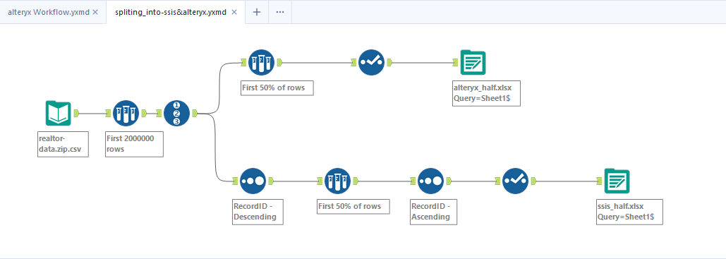
  - Part 2 → Processed in SSIS

4. Data Transformations & Business Logic (Alteryx Workflow)
Data Input & Preparation
- Input Data Tool
  - Used to import the main USA Real Estate dataset into Alteryx.
- Select Tool
  - Used to select only the required columns for analysis.
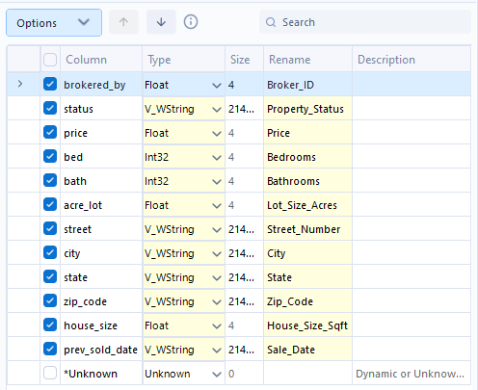
  - Also used to rename columns for better readability and consistency.

Data Cleaning
- Data Cleansing Tool
  - Removed null values and missing data from the dataset.
  - Ensured data consistency by eliminating incomplete or invalid records.
- Filter Tool
  - Removed records containing:
    - Null or empty values in the street field
    - Invalid or missing values in the sales date

Feature Engineering & Data Transformation
- Formula Tool
  - Converted text fields to uppercase for standardization:
    - City
    - State
    - Property Status
  - Split prev_sold_date into:
    - Year
    - Month
    - Day
  - Replaced null values with appropriate default or calculated values.

Data Aggregation (Summarization)
- Summarize Tool
  - Calculated the mean (average) for:
    - Price
    - Lot Acre
    - House Size
  - Calculated the mode (most frequent value) for:
    - Number of Bedrooms
    - Number of Bathrooms

Outlier Handling(filtering)
- Filter Tool
  - Removed properties with price greater than 1000,000
  - This step was applied to eliminate extreme outliers and improve data reliability.

Data Splitting & Processing Logic
- Record ID Tool
  - Assigned a unique ID to each record.
  - Used as a reference for dataset splitting.
- Sample Tool (50%) + Sort Tool
  - The dataset was split into two equal parts:
    - One processed in Alteryx
    - The other processed in SSIS
  - Sorting (descending) was applied before sampling to ensure proper distribution.

Data Output
- Output Data Tool
  - Final cleaned and transformed data was exported to a SQL Server database.
  - Data was stored in separate tables based on the splitting logic.

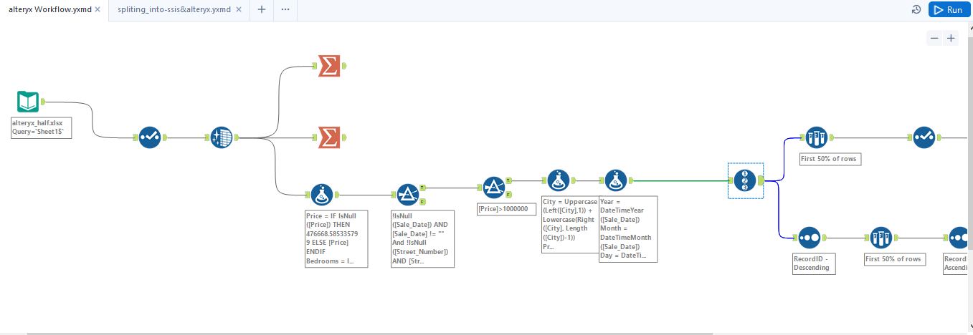
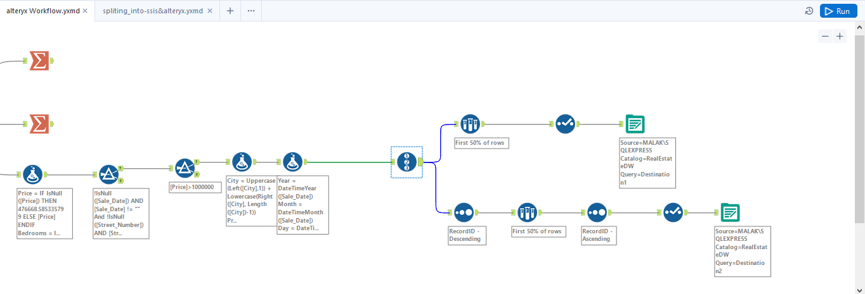
Alteryx part 1 is 19100 record
SSIS Data Flow Pipeline Design
The SSIS package was designed to extract, transform, and load real estate data from an Excel source into a SQL Server database table. The data flow consists of several transformation steps to ensure data quality, consistency, and compatibility with the destination schema.

1. Excel Source
The process starts with an Excel Source, which is used as the input data provider.
This source contains raw real estate data including property details such as price, bedrooms, bathrooms, lot size, house size, location, and sale date.

2. Conditional Split (Initial Filtering)
A Conditional Split Transformation is used to separate and validate specific fields such as:
- Street Number
- Sale Date
This step ensures that records containing invalid or missing critical values are handled appropriately before further processing.

3. Derived Column Transformation (Handling Null Values)
A Derived Column Transformation is applied to clean missing data by replacing NULL values in the following fields:
- Price
- Bedrooms
- Bathrooms
- Lot Size (Acres)
- House Size (Sqft)
Default values are assigned to ensure data completeness and avoid loading errors in the database.

4. Conditional Split (Outlier Filtering)
Another Conditional Split is used to filter out high-value properties:
- Only records where Price > 1,000,000 are accepted for further processing.
- This helps in removing extreme outliers and improving data quality for analysis.

5. Derived Column Transformation (Feature Engineering)
This transformation is used to enhance and structure the dataset by:
- Splitting Sale Date into:
  - Year
  - Month
  - Day
- Converting text fields such as Property Status and Status to Upper Case for standardization.

6. Derived Column Transformation (Data Formatting)
The City column is cleaned by replacing spaces with underscores (“_”) to ensure consistency and avoid issues during storage or querying.

7. Percentage Sampling (Data Splitting)
A Percentage Sampling Transformation is used to divide the dataset into two subsets:
- Training / Analysis Dataset (50%)
- Testing / Validation Dataset (50%)
This allows for data analysis and model evaluation purposes.

8. Data Conversion Transformation
A Data Conversion Transformation is applied to ensure that all data types match the destination SQL Server table schema.
This step includes converting:
- Strings to numeric types
- Strings to date formats
- Floating values to appropriate precision types

9. OLE DB Destination
Finally, the cleaned and transformed data is loaded into the SQL Server database using an OLE DB Destination.
This represents the final output layer where structured and validated data is stored for further analysis and reporting.

Summary
The SSIS package ensures a complete ETL process starting from raw Excel data, performing multiple cleaning and transformation steps, and finally loading structured data into a relational database with high data quality and consistency.
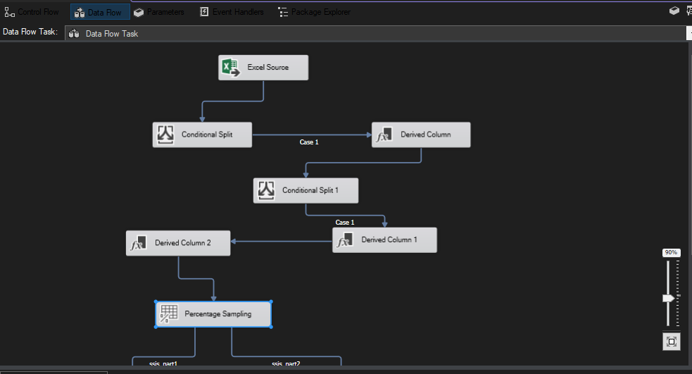
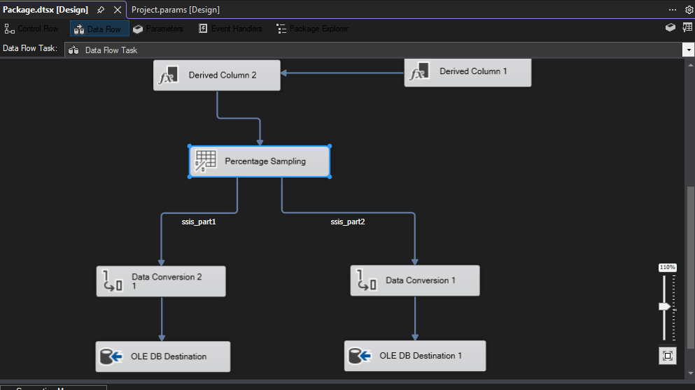
*powerBi part*
5. Insights & Decision Making (Business Intelligence)
Based on analysis results, the following decisions can be derived:
Pricing Insights
- High variance in property prices indicates market segmentation.
- Outliers (very high prices) represent luxury properties and should be analyzed separately.
Property Features Impact
- Houses with higher number of bedrooms and bathrooms tend to have higher prices.
- House size and lot size are strong predictors of price.
Location-Based Decisions
- Certain cities and states show higher average prices → indicates high-demand areas.
- Helps investors decide where to focus investments.
Sales Trends
- Previous sale dates help identify market activity trends over time.
- Seasonal patterns may influence buying behavior.
Business Decision Summary
- Focus investment on high-demand cities.
- Segment properties into luxury vs normal markets.
- Use bedroom/bathroom count as key pricing factor.
- Remove extreme outliers for accurate forecasting models.

6. Conclusion
This project demonstrates a complete Data Warehouse pipeline using Alteryx and SSIS to clean, transform, and load real estate data.
The analysis supports:
- Market trend identification
- Investment decision-making
- Property pricing strategy
- Data-driven real estate insights

