**Results**

The methodology applied in this research is targeted at making use of state-of-the-art Deep Learning and Machine Learning techniques to enable accurate prediction of the Range of Motion angle. Concretely, Gated Recurrent Units (GRUs) and Long Short-Term Memory (LSTM) networks have been implemented as the core deep learning models. These architectures are chosen for their proven ability to capture temporal dependencies and handle sequential data effectively, making them particularly suitable for time-series prediction tasks like ROM angle estimation. Besides deep learning approaches, several machine learning algorithms have been utilized in complementing the predictive analysis.

It includes models such as K-Nearest Neighbors Regressor, Support Vector Regression, and Random Forest Regressor. Each model offers specific benefits: KNN offers better capabilities in the explanation of local patterns of data; SVR makes robust predictions owing to its ability to deal with non-linear relationships, and Random Forest comes with strong performance via ensemble learning to prevent overfitting. Since the goal of this study is to predict a continuous variable, the ROM angle, regression-based artificial intelligence models are applied. Both deep learning and traditional machine learning algorithms are combined in this study to ensure comprehensiveness in the approach to prediction by combining strengths of sequential modeling with feature-focused regressors for overall improved accuracy and reliability. We have graded these algorithms according to the R2 Score, MSE and MAE results of the machine learning algorithms.

1. **Support Vector Regression (SVR):**

The results summarize the performance of the Support Vector Regression model in the prediction of the target variable, using metrics such as R², MSE, MAE, and RMSE. These metrics have been evaluated using a 10-fold cross-validation approach, where the dataset was split into ten subsets, and the model was trained and tested on different combinations of these subsets. Here's a detailed breakdown:

|  |  |  |  |  |
| --- | --- | --- | --- | --- |
| Cross-Validation Split | R2 Score | MSE | MAE | RMSE |
| 1 | 0.656371 | 66.381072 | 6.840942 | 8.147458 |
| 2 | 0.313708 | 32.001188 | 5.052802 | 5.656959 |
| 3 | 0.685755 | 14.807428 | 3.424892 | 3.848042 |
| 4 | 0.942447 | 7.558939 | 1.945472 | 2.749352 |
| 5 | 0.899167 | 11.497509 | 2.797446 | 3.390798 |
| 6 | 0.913922 | 9.490316 | 2.573259 | 3.080636 |
| 7 | 0.905561 | 7.999321 | 2.096159 | 2.828307 |
| 8 | 0.903377 | 8.672771 | 2.515685 | 2.944957 |
| 9 | 0.914370 | 13.314672 | 3.272796 | 3.648928 |
| 10 | 0.902287 | 13.368730 | 3.374741 | 3.656327 |
| Averages | **0.803696** | **18.509195** | **3.389419** | **3.995176** |

The cross-validation table summarizes the performance of the Support Vector Regression model in ten different data splits. It provides, for each fold, key metrics such as R² (coefficient of determination), MSE (Mean Squared Error), MAE (Mean Absolute Error), and RMSE (Root Mean Squared Error), showing the accuracy and reliability of the model. The average R² value of the SVR model is 0.8037, which means that, on average, it explains about 80% of the variance in the target variable, with an average MSE of 18.51 and an MAE of 3.39. However, the results over folds are very different, with some R² scores as low as 0.31 and as high as 0.94, while the MSE values range from 7.56 to 66.38. It follows that the variability in the performance also suggests sensitivity to the distribution of the data in each fold. Thus, while the model in general performs well, further optimisation could help bring these performances closer together. Indeed, the best performance happens to be in fold 4, which is outstanding by its lowest error metrics value; hence, it can present a benchmark for improvement.

**Overall Metrics:**

* **Average R²: 0.803696**

This shows that the average SVR model explains around 80.37% of the variance in the target variable and is a strong overall fit.

* **Average MSE: 18.509195**

The average MSE simply provides a measure of the average of the squared differences between predicted and actual values. This shows the magnitude of the overall error, where lower values are better. While an MSE of 18.51 is acceptable, some scope for further improvement remains.

* **Average MAE: 3.389419**

This means that, on average, the difference between the predicted and actual values is around 3.39 units. It is a simple measure of accuracy in prediction.

* **Average RMSE: 3.995176**

The RMSE is the standard deviation of the prediction errors and gives a better interpretation of the reliability of the prediction. An RMSE of 3.99 means the predictions are usually about 4 units off from the actual values.

1. **Random Forest Regressor (RFR):**

The table shows the cross-validation performance of the RFR model for ten different data splits. The main evaluation metrics include R², representing the coefficient of determination; MSE, which is the Mean Squared Error; MAE, the Mean Absolute Error; and RMSE, the Root Mean Squared Error, all of which give a full view of the model's predictability

|  |  |  |  |  |
| --- | --- | --- | --- | --- |
| Cross-Validation Split | R2 Score | MSE | MAE | RMSE |
| 1 | 0.823812 | 34.035417 | 4.658643 | 5.833988 |
| 2 | 0.697794 | 14.091627 | 2.840062 | 3.753882 |
| 3 | 0.971930 | 1.742091 | 0.913886 | 1.319883 |
| 4 | 0.943781 | 4.190285 | 1.382041 | 2.047018 |
| 5 | 0.948241 | 3.883101 | 1.321665 | 1.970558 |
| 6 | 0.893160 | 4.867509 | 1.611156 | 2.206243 |
| 7 | 0.991379 | 1.426605 | 0.818089 | 1.194406 |
| 8 | 0.767034 | 16.429321 | 3.215079 | 4.053310 |
| 9 | 0.986421 | 1.053367 | 0.700370 | 1.026337 |
| 10 | 0.987504 | 2.166532 | 1.014344 | 1.471915 |
| Average | 0.901105 | 8.388585 | 1.847534 | 2.487754 |

It turns out that the RFR model has a very strong overall performance, with an R² score of 0.9011, thereby explaining more than 90% of the variance in the target variable. The average error metrics with an MSE at 8.39, MAE at 1.85, and RMSE at 2.49 provide further underlining of its accuracy and reliability. It is also seen that performances across individual folds are remarkably consistent, with R² values varying between 0.698 to 0.991, and showing a robust ability to generalize across data splits.

The best performance is observed in folds 7 and 9, where the R² scores are above 0.986 and the error metrics are the lowest, particularly an MSE as low as 1.05 in fold 9. This suggests the model's exceptional accuracy in these cases. In contrast, fold 1 has a relatively higher MSE of 34.03 and MAE of 4.66, indicating that the model generally performs well but may be sensitive to the distribution of data in certain splits.

**Overall Metrics:**

* **Average R²: 0.901105**

This suggests that the model RFR explains about 90.11% of the variance in the target variable, hence a very strong fit and reliable predictive capability.

* **Average MSE: 8.388585**

The Mean Squared Error of 8.39 is representative of the average squared differences between predicted and actual values. This relatively low value suggests that the model retains most of the accuracy, hence not large deviations.

* **Average MAE: 1.847534**

The Mean Absolute Error means that, on average, predictions are off by just 1.85 units. This low MAE showcases the model's capability for delivering highly accurate predictions.

* **Average RMSE: 2.487754**

The Root Mean Squared Error of 2.49 measures the standard deviation of prediction errors, indicating that normally, the predictions will vary by about 2.49 units from the true values. This supports that the model has performed sound and is reliable.

1. **K-Nearest Neighbours (KNN):**

The table depicts the cross-validation performance of the KNN model against ten data splits. The evaluation metrics that have been used in the current analysis are the R², which is the coefficient of determination; MSE, the Mean Squared Error; MAE, Mean Absolute Error; and RMSE, Root Mean Squared Error, showing a comprehensive view of the model's predictive capabilities. The table depicts the cross-validation performance of the K-Nearest Neighbours model against ten data splits.

|  |  |  |  |  |
| --- | --- | --- | --- | --- |
| Cross-Validation Split | R2 Score | MSE | MAE | RMSE |
| 1 | 0.693911 | 59.129093 | 4.430968 | 7.689544 |
| 2 | 0.923459 | 3.569030 | 1.501328 | 1.889188 |
| 3 | 0.979217 | 0.979315 | 0.801429 | 0.989604 |
| 4 | 0.980338 | 2.582316 | 1.138268 | 1.606959 |
| 5 | 0.994687 | 0.605803 | 0.558870 | 0.778334 |
| 6 | 0.969648 | 3.346397 | 1.352539 | 1.829316 |
| 7 | 0.987076 | 1.094700 | 0.728928 | 1.046279 |
| 8 | 0.988542 | 1.028425 | 0.743954 | 1.014113 |
| 9 | 0.987118 | 2.003031 | 1.216768 | 1.415285 |
| 10 | 0.976144 | 3.263933 | 1.344803 | 1.806636 |
| Averages | 0.948014 | 7.760204 | 1.381786 | 2.006526 |

The table displays the performance of the K-Nearest Neighbours (KNN) algorithm evaluated through cross-validation across 10 splits. The performance, in terms of the R² score, ranges between 0.6939 and 0.9947 with an average of 0.9480, which means that on average, the KNN model explains about 94.8% of the variance within the target variable, implying strong predictive power. The MSE values vary between a minimum of 0.6058 to a maximum of 59.1291, with an average of 7.7602. Although in most of the splits the MSE is very low, the first split has a large error; that may indicate how well the model generalizes with respect to variations in training data. The MAE ranges from 0.5589 to 4.4309, with an average of 1.3818, which means that on average, the model's predictions deviate by about 1.38 units from the actual values. The RMSE ranges from 0.7783 to 7.6895, with an average of 2.0065, which means that on average, the KNN model's predictions deviate by about 2 units. Overall, the KNN algorithm shows quite good predictive performance with an average R² indicating reasonable model fit, though there is some fluctuation within the error metrics of splits.

* **Average R²: 0.948014**

The average R² value of 0.948 indicates that about 94.8% of the variance in the target variable is explained by the KNN model. This is an excellent fit; the model captures most of the underlying patterns in the data.

* **Average MSE: 7.760204**

The MSE value of 7.76 implies that, on average, the difference between the forecasted and actual values is relatively small in a squared sense. Although this value is acceptable, it leaves much room for further improvement in order to reduce especially larger error values.

* **Average MAE: 1.381786**

A Mean Absolute Error of 1.38 illustrates that the KNN model is generally off by approximately 1.38 units. It is a good way of getting at the accuracy of this predictor since it gives a great general interpretation - these values in forecasts for this model are close.

* **Average RMSE: 2.006526**

A root mean squared error of 2.01 would translate to the fact that this is the typical deviation by a unit or two away from actual values, hence very strong and usually reliable in this way, with a pretty reasonable degree of error.

The LSTM and GRU are deep learning models selected in doing the best performance in the time sequence prediction.

1. **Gated Recurrent Units (GRU):**

The data was divided into 90% training and 10% test datasets. Based on this, out of the available data, 114 samples were used for training, and the remaining 13 were used for testing and validation.

|  |  |
| --- | --- |
| 90%  Training | 10%  Testing |

This split ensures that the model is trained on a substantial portion of the data while still being evaluated on an independent set to gauge its generalization performance.

This results in an excellent R² of 0.9796, where 97.96% of the variation in the target variable has been correctly explained by this model. On top of this, its MAE reached 1.10, which suggests that, on average, the difference between the real and the estimated value is no more than 1.10 units. The Mean Squared Error of 1.94 shows the minimal magnitude of the squared differences, while the RMSE of 1.39 points to the strong predictive accuracy of the model, since lower RMSE values indicate better performance. These metrics demonstrate the model's robust learning ability and its potential to make highly reliable predictions, even when tested on unseen data. The low error values and high R² score are indicative of a well-tuned and effective model, suitable for tackling real-world regression tasks.

**R2 Score: 0.97961025**

**MAE : 1.104778**

**MSE : 1.937539**

**RMSE : 1.391955**

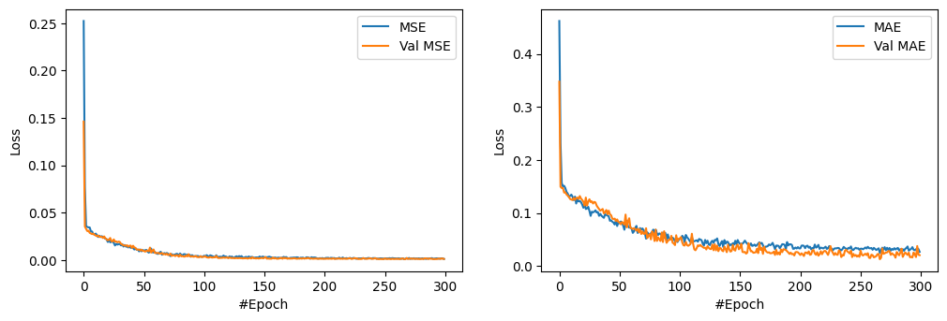

**Explanation of the MSE and MAE Graphs:**

**MSE Graph (Left Panel):** The MSE graph shows the loss of both training and validation across 300 epochs. The training and validation loss starts off high but then rapidly decreases as the model learns from the data. By around 50 epochs, the MSE values stabilize at very low levels, indicating effective learning and minimal overfitting. The closeness of the training and validation MSE curves means that the model generalizes well to unseen data.

**MAE Graph (Right Panel):** Similarly, the MAE graph shows the reduction of error in training and validation. Both curves show a sharp decline in error during the initial epochs, eventually stabilizing at values close to zero. The smooth convergence of the training and validation MAE curves further confirms the model's robustness and its ability to handle temporal dependencies in the dataset effectively.

These graphs highlight the GRU model’s strong learning capacity and the consistency between training and validation performance, reflecting the model’s reliability in making accurate predictions.

1. **Long Short-Term Memory (LSTM):**

|  |  |
| --- | --- |
| 90%  Training | 10%  Testing |

Like the previous, the data split into a 90%-10% partition, considering 114 samples for training and 13 for testing and validation.

The LSTM algorithm performed extremely well, with an R² score of 0.9892, which indicates that 98.92% of the variance in the target variable was explained by the model. The MAE was 0.5823, and the MSE was 0.7019, reflecting the high accuracy of the model. The RMSE was 0.8378, which again speaks to the LSTM model's ability to make precise and reliable predictions.

**R2 score: 0.98923024**

**MAE : 0.582275**

**MSE : 0.701869**

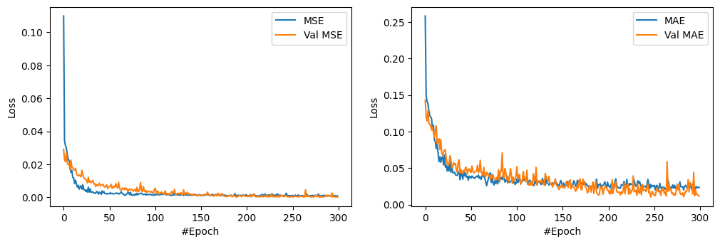**RMSE : 0.837776**

**Explanation of the MSE and MAE Graphs:**

**MSE Graph (Left Panel):** The MSE graph illustrates how the model's loss evolved over 300 epochs on both training and validation datasets. At the start, the MSE values are very high because the weights have been initialized randomly; these start to decrease rapidly as the model starts learning patterns in the data. By about 50 epochs, the loss for both training and validation stabilizes at very low values. The validation curve lies well with the training curve, indicating no severe overfitting, which demonstrates excellent generalization performance for unseen data.

**MAE Graph (Right Panel):** The MAE graph also shows the decrease in error for training and validation. Similar to the MSE graph, the MAE values start high and decrease significantly during the initial epochs. Both training and validation MAE values converge smoothly, stabilizing at low levels by the 50th epoch. This reflects the model's capability of making highly accurate predictions with minimal error.

The graphs really act as evidence for excellent learning capability by the LSTM model. The convergence of training and validation losses without much divergence is proof of the robustness of the model, while low final values of MSE and MAE show its high prediction accuracy.

**Final Results Analysis**

The performances of the various AI algorithms are gauged based on their R², MAE, MSE, and RMSE scores.

|  |  |  |  |  |
| --- | --- | --- | --- | --- |
| AI Algorithm | R2 score | MAE | MSE | RMSE |
| SVR | 0.803696 | 3.389419 | 18.509195 | 3.995176 |
| RFR | 0.901105 | 1.847534 | 8.388585 | 2.487754 |
| KNN | 0.948014 | 1.381786 | 7.760204 | 2.006526 |
| GRU | 0.979610 | 1.104778 | 1.937539 | 1.391955 |
| LSTM | 0.989230 | 0.582275 | 0.701869 | 0.837776 |

The SVR comes with an R² score of 0.803696, explaining about 80.37% of the variance in the target variable, with a mean MAE of 3.39 units and mean MSE of 18.51. While the model performance is pretty good, its predictions could be further improved. While the performance of the SVR model is fair, the RFR does better with an R² score of 0.901105, showing that it explains 90.11% of the variance in data. It also achieves a lower MAE of 1.85 and a much-reduced MSE of 8.39, reflecting better prediction accuracy. The K-Nearest Neighbors model further enhances the performance of the models with a very good R² of 0.948014, depicting 94.8% of the variance explained, and MAE and MSE of 1.38 and 7.76, respectively, showing an excellent predictive ability of the model. The performance of both GRU and LSTM is the best of all models, where the LSTM shows the highest value of R² as 0.989230, which explains 98.92% of the variance. The MAE of 0.58, MSE of 0.70, and the RMSE of 0.84 for it indicates a highly accurate prediction with relatively small errors. Overall, LSTM gave the best performance, closely followed by GRU, then KNN, RFR, and lastly SVR.