DS4102 — Practical Assignment
Descriptive Data Analysis of the Palmer Penguins Dataset
Dataset: Palmer Penguins (344 observations, 7 variables)
Tool used: Python (pandas, seaborn, matplotlib, scipy)

1. Introduction
This report presents a descriptive analysis of the Palmer Penguins dataset, which records physical measurements for 344 penguins across three species (Adelie, Chinstrap, and Gentoo) sampled from three islands in the Palmer Archipelago, Antarctica. The dataset contains four numeric variables — bill length, bill depth, flipper length, and body mass — and three categorical variables: species, island, and sex.
The goals of this analysis are to: (1) compute descriptive statistics for each variable, (2) visualize the distribution and behavior of each variable, (3) examine how the numeric variables differ across categories such as species and island, and (4) draw conclusions from the observed patterns.

2. Dataset Overview
Variables:
- species (categorical) — Adelie, Chinstrap, Gentoo
- island (categorical) — Biscoe, Dream, Torgersen
- sex (categorical) — Male, Female (11 missing values)
- bill_length_mm (numeric)
- bill_depth_mm (numeric)
- flipper_length_mm (numeric)
- body_mass_g (numeric)
Two rows were missing all four numeric measurements and were excluded from the numeric analysis, leaving 342 usable records. All categorical variables retain their full counts where relevant.

3. Descriptive Statistics — Numeric Variables
Variable | N | Mean | Median | Std Dev | Min | Max | Skew
Bill length (mm) | 342 | 43.92 | 44.45 | 5.46 | 32.1 | 59.6 | 0.05
Bill depth (mm) | 342 | 17.15 | 17.30 | 1.97 | 13.1 | 21.5 | -0.14
Flipper length (mm) | 342 | 200.92 | 197.00 | 14.06 | 172.0 | 231.0 | 0.35
Body mass (g) | 342 | 4201.75 | 4050.00 | 801.95 | 2700 | 6300 | 0.47

All four numeric variables have skewness close to zero (between -0.14 and 0.47), indicating roughly symmetric distributions with a slight right-skew for body mass. Negative kurtosis values (around -0.7 to -1.0) indicate flatter-than-normal distributions — consistent with three distinct species creating multiple humps rather than one sharp peak, as seen in the histograms below.

4. Descriptive Statistics — Categorical Variables
Species | Count | Percent
Adelie | 152 | 44.2%
Gentoo | 124 | 36.0%
Chinstrap | 68 | 19.8%

Island | Count | Percent
Biscoe | 168 | 48.8%
Dream | 124 | 36.0%
Torgersen | 52 | 15.1%

Sex | Count | Percent
Male | 168 | 50.5%
Female | 165 | 49.5%

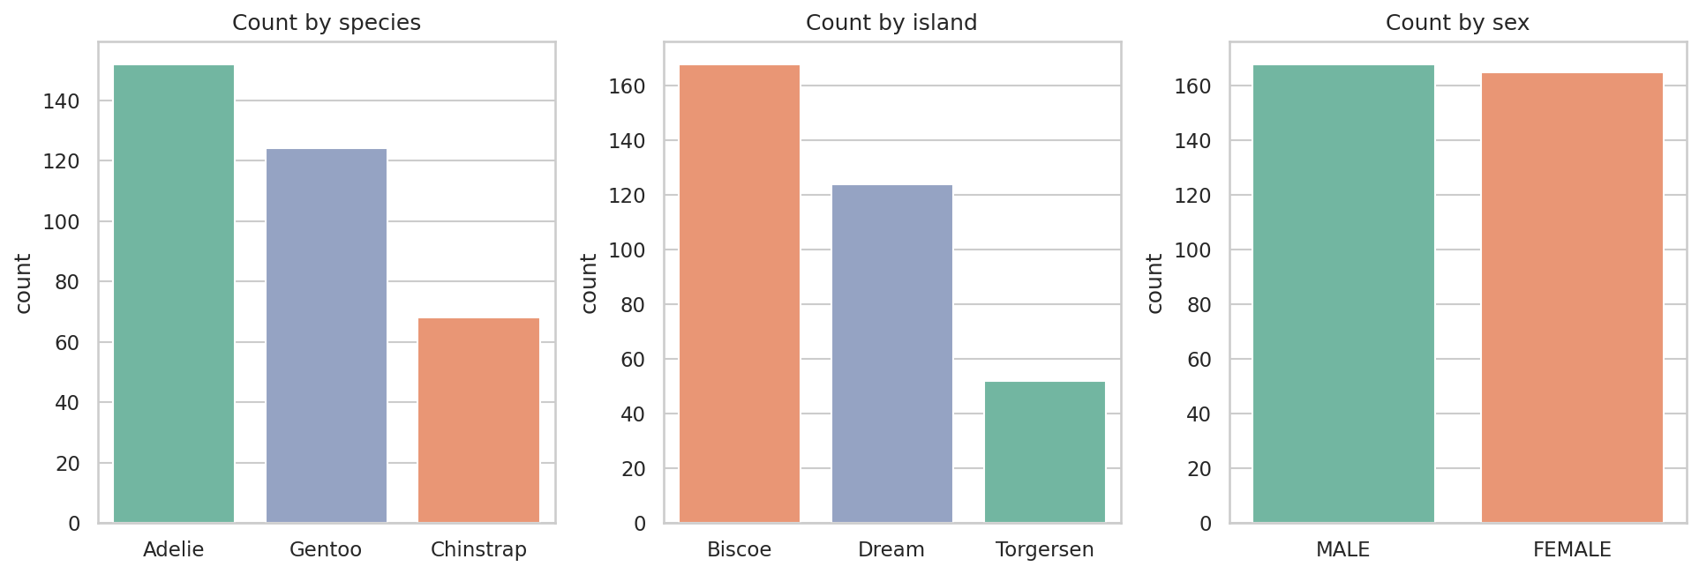
Figure 1. Counts of observations by species, island, and sex.
Adelie is the most common species (44.2%), and Biscoe is the most-sampled island (48.8%). Sex is almost perfectly balanced (50.5% male vs. 49.5% female).

5. Distribution of Numeric Variables
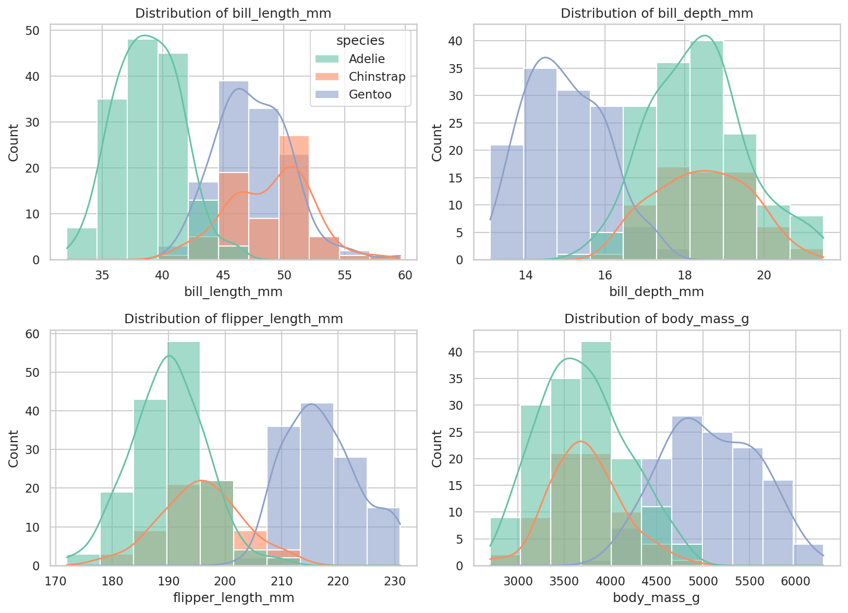
Figure 2. Histograms of the four numeric variables, colored by species.
Each histogram reveals that the apparent single distribution is really a mixture of three species-specific sub-distributions. Bill depth and body mass show the clearest separation, with Gentoo penguins standing apart from Adelie and Chinstrap.
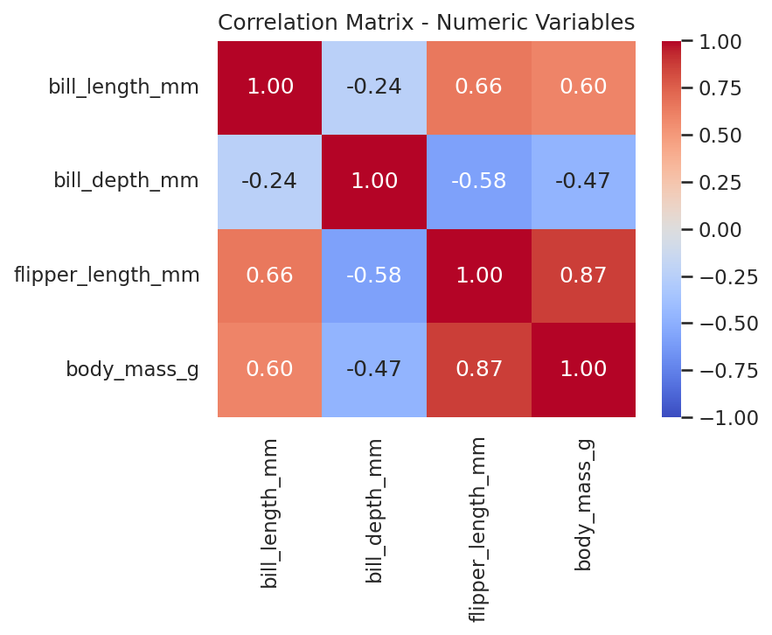
Figure 3. Correlation matrix of the numeric variables.
Flipper length and body mass are strongly positively correlated (r ≈ 0.87), as expected for overall body size. Bill depth is negatively correlated with both flipper length (r ≈ -0.58) and body mass (r ≈ -0.47) — this is a between-species effect: Gentoo penguins have long flippers, high body mass, and shallow bills, while Adelie/Chinstrap show the opposite pattern.

6. Behavior of Variables by Category

6.1 By Species
Species | Mean bill length | Mean bill depth | Mean flipper length | Mean body mass (g)
Adelie | 38.79 | 18.35 | 189.95 | 3700.66
Chinstrap | 48.83 | 18.42 | 195.82 | 3733.09
Gentoo | 47.50 | 14.98 | 217.19 | 5076.02

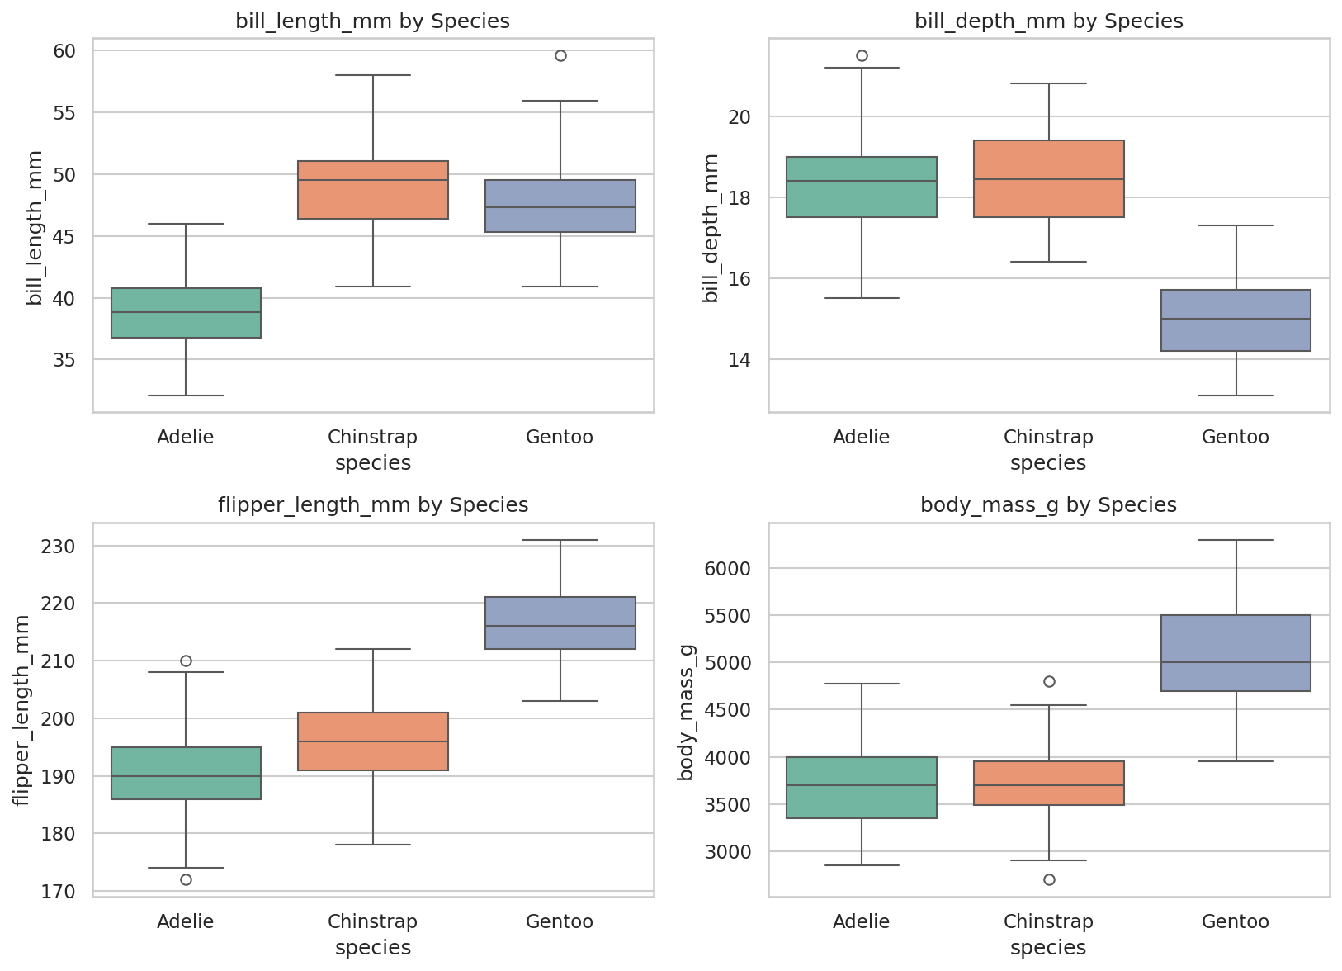
Figure 4. Boxplots of each numeric variable by species.
Species is the dominant source of variation in this dataset. Gentoo penguins are markedly larger (body mass, flipper length) but have notably shallower bills than the other two species. Adelie has the shortest bill length; Chinstrap and Gentoo have similar bill lengths but very different bill depths and body sizes. A one-way ANOVA confirms these differences are statistically significant for body mass (F = 343.6, p < 0.001) and bill length (F = 410.6, p < 0.001).

6.2 By Island
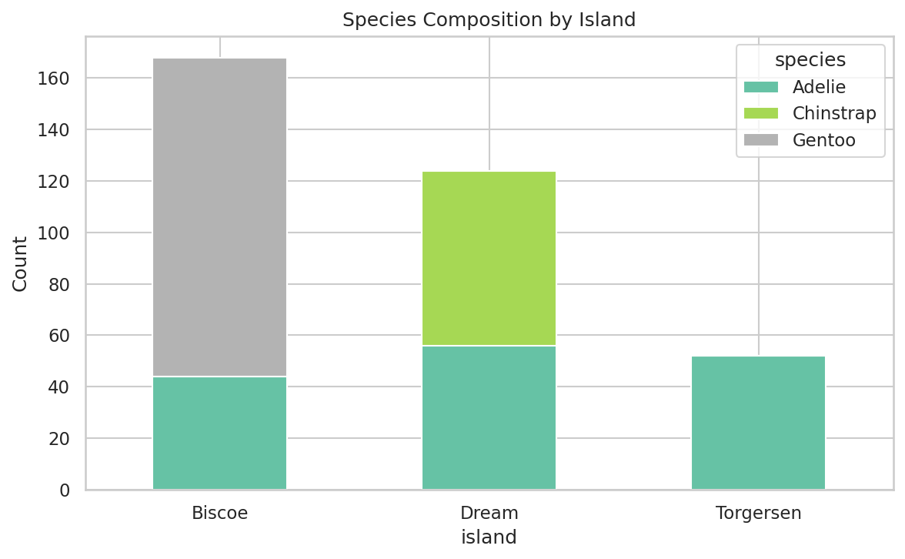
Figure 5. Species composition by island.
Island is not an independent grouping factor — it is almost a proxy for species. Torgersen contains only Adelie penguins, Dream contains Adelie and Chinstrap, and Biscoe contains Adelie and Gentoo. As a result, apparent differences in measurements 'by island' (e.g., higher average body mass on Biscoe) are largely driven by which species happen to live there, rather than an island effect in itself.

6.3 By Sex
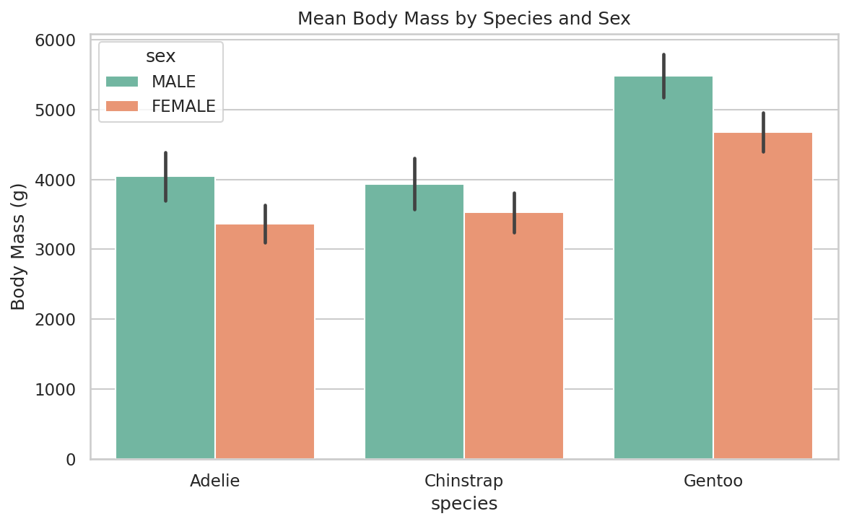
Figure 6. Mean body mass by species and sex, with standard deviation error bars.
Within every species, males are consistently heavier than females — a pattern known as sexual size dimorphism. The gap is present across all three species, meaning sex and species act as independent, additive sources of variation in body mass rather than one masking the other.

6.4 Pairwise Relationships

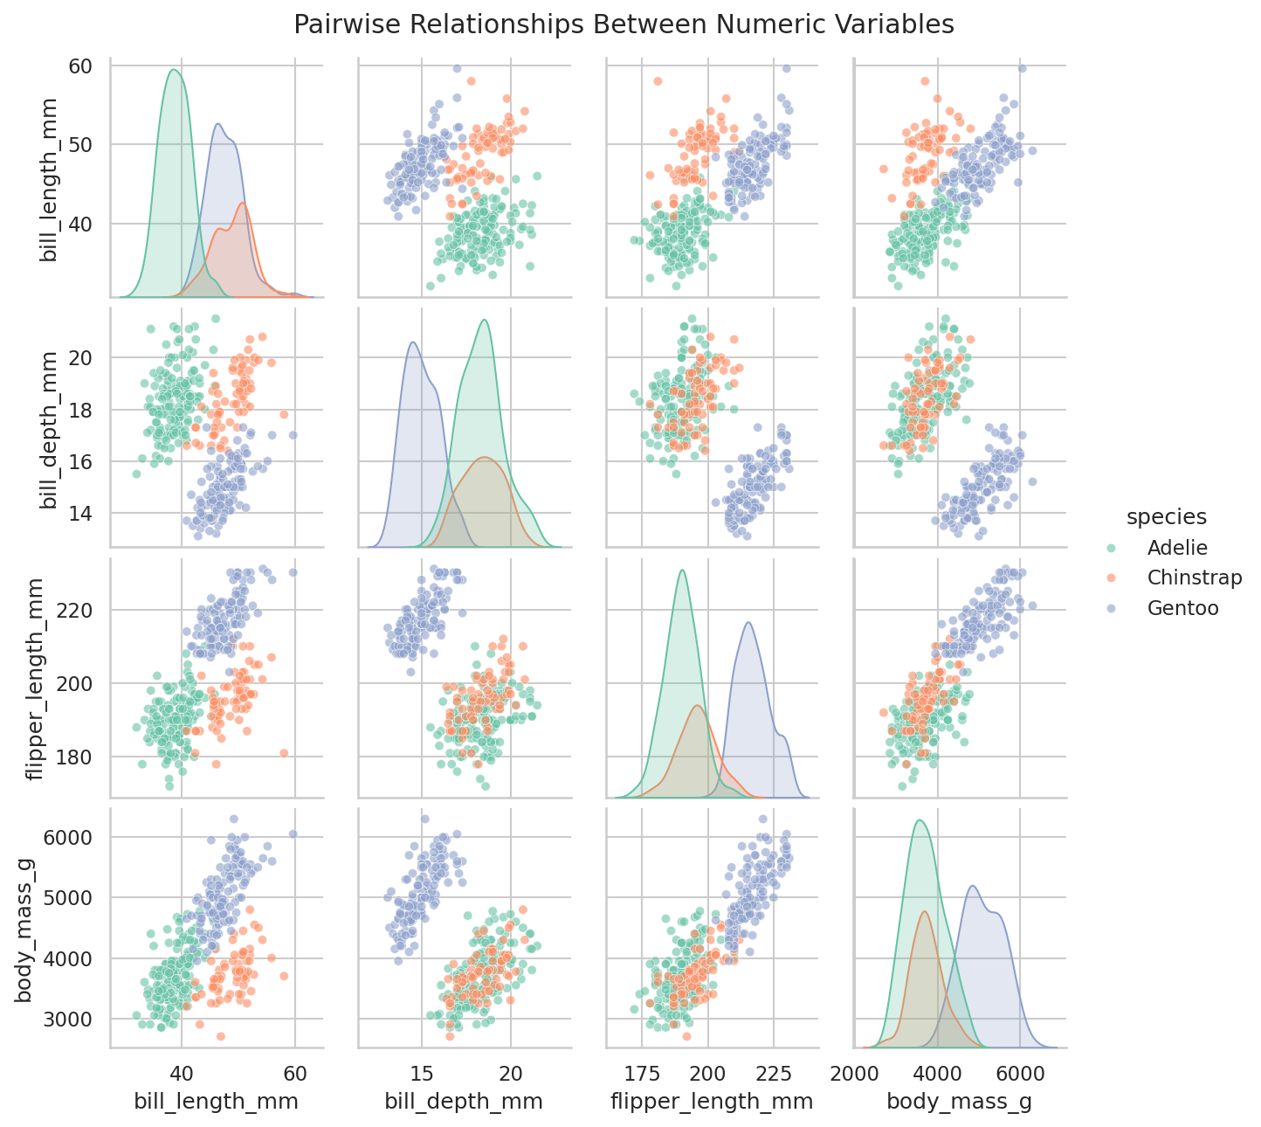
Figure 7. Pairwise scatterplots and marginal distributions for all numeric variables, coloured by species.
The pairplot shows that combinations of just two variables (e.g., bill length and bill depth, or flipper length and bill depth) are enough to separate the three species almost perfectly into distinct clusters. This suggests the four numeric measurements together carry strong discriminative information about species identity.

7. Conclusions
- Species is the primary driver of variation in all four numeric variables. Gentoo penguins are distinctly larger with shallower bills; Adelie has the shortest bills; Chinstrap sits between Adelie and Gentoo on most measures but overlaps closely with Gentoo on bill length.
- Island differences are confounded with species — each island hosts a different subset of species, so island-level averages mainly reflect species composition rather than a geographic effect.
- Sex creates a consistent, additive effect: males are heavier than females within every species, indicating sexual dimorphism independent of species differences.
- Flipper length and body mass are strongly correlated (larger-bodied birds have longer flippers), while bill depth behaves almost inversely to overall body size across species — driven by Gentoo's unusually shallow bill relative to its large body.
- All four numeric variables are reasonably symmetric (low skew) but flatter than a normal distribution (negative kurtosis), which is explained by the underlying three-species mixture rather than any single well-behaved population distribution.
- Practical implication: species can be predicted with high accuracy from just two of the four numeric measurements (e.g., bill length and bill depth), as shown in the pairplot clustering — a useful basis for a simple classification exercise as a follow-up to this descriptive analysis.

