Software Test Plan

for

<Travel website>

Version 1.0 approved

Prepared by <Malak Mahameed>

<Samana>

<09/03/2023>

**Document History**

|  |  |  |  |
| --- | --- | --- | --- |
| Version | Date | Author | Description of Change |
| 1 | 2/2/2023 | Malak Mahameed | Draft |
| 2 | 7/3/2023 | Malak Mahameed | Draft-Reviewed |
|  |  |  |  |

1. **INTRODUCTION**

Our application allows users to search for many countries and find solution about his questions about the country who want to visit, like: capital name of country, what the official language, the official Currency, the best 10 places and website for booking in this country. The user can add review with rating and can send E-mails.  
The test contain all functional.

1. **Objectives**

This test plan describes the testing approach, the objectives, scope, schedule, risks, approach, Enter Exit criteria, Test Tree and Testing methodology. And overall framework that will drive the testing.

1. **Support documents**

SRS documents.

1. **Tree Testing**
2. Add country
   1. Add without image
   2. Add without video
   3. Add same image
3. Delete country
   1. Delete image exist twice.
4. Alter country
5. Add review
   1. Add review without name
   2. Add review without text
   3. Add review without rating
6. Send E-mail
7. Search
   1. Search by country name
   2. Search by one letter

**5. Entry and Exit Criteria**

1. Entry Criteria

- Android mobile devices: J7 and A8;

- Android 7 and over;

- Product version V 4.3.6

2. Exit Criteria

- 0 critical bugs;

- 0 Regression bugs;

- MAXIMUM 3 Medium bugs;

- MAXIMUM 7 LOW bugs;

**6. TEST STRATEGY**

**6.1. Test Approach**

The tests mainly target the GUI testing and validating data Requirements Specifications provided by Client. The project is using an agile approach, with weekly iterations. At the end of each week the requirements identified for that iteration will be delivered to the team and will be tested.

**6.2. Test Automation**

Automated unit tests are part of the development process, but no automated functional tests are planned at this time.

**6.3. In Scope**

**6.3.1. Exploratory**

***PURPOSE***: the purpose of this test is to make sure critical defects are removed before the next levels of testing can start.

***SCOPE***:  Signup, Send message and mobile version.

***TESTERS***: Testing team.

***METHOD***: This exploratory testing is carried out in the application without any test scripts and documentation.

**6.3.2. User Acceptance Test**

***PURPOSE***: This test focuses on validating the business logic.

***TESTERS***: Client-side testers.

***METHOD***: UAT test cases based on the inputs from End user and Business Analyst’s.

***TIMING***: After all other levels of testing (Exploratory and Functional) are done.

**6.3.3. Functional Test**

***PURPOSE***: The functional testing is carried out by feeding the input and validates the output from the application.

**TESTERS**: Testing Team.

**METHOD**: The test will be performed according to Functional scripts, which are stored in test rail.

***TIMING***: After Exploratory test is completed.

**6.4. Out of scope**

**PURPOSE**: Clarity on what we are not going to cover.

**Not in Scope**: Testing of Business SOPs, disaster recovery

**7.Testing methodology**

**7.1 Validation and Defect Management**

Defects found during the Testing will be categorized according to the bug-reporting tool “Jira” and the categories are:

|  |  |
| --- | --- |
| **Severity** | **Impact** |
| Critical | This bug is critical enough to crash the system |
| High | It causes lack of program functionaly |
| Medium | This bug prevents other areas of the product from being tested However other areas can be independently tested |
| Low | Error message which has minimum impact on product use |

**7.2. Defect tracking & Reporting**

Flowchart depicts Defect Tracking Process

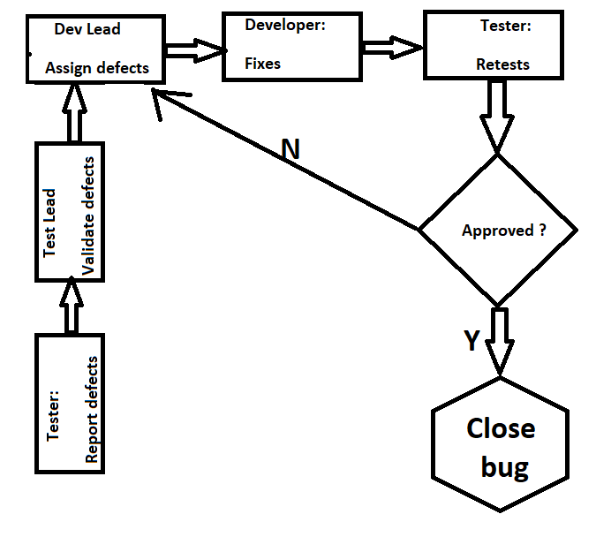

**7.3. Status of the Bug/Fault**

- New: Just created bug;

- Open: Opened bug and still not solved;

- Rejected: Dev Lead rejected it (it's not bug);

- Fixed: SOLVED bug;

- Closed: After bug is fixed, need close this bug;

- Re-Open: Bug was been fixed and closed but appear again with time

**7.4 TEST MANAGEMENT PROCESS**

**7.4.1 TOOLS**

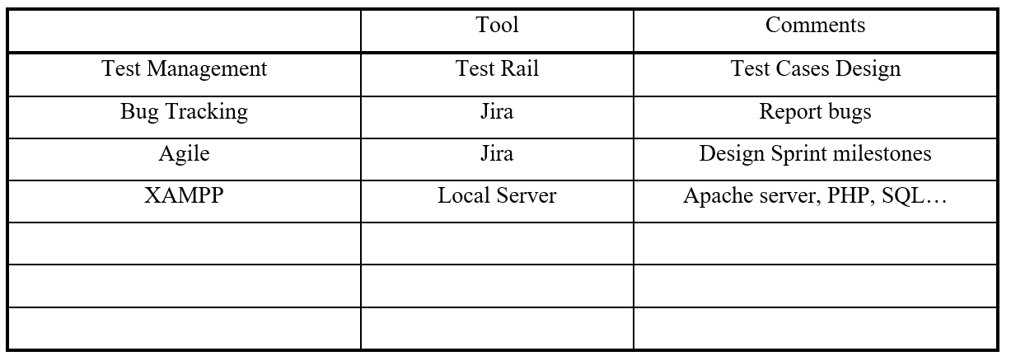

**7.5. Assumptions / Risks**

**7.5.1. Assumptions for Test Execution**

All the conditions that need to hold true for us to be able to proceed successfully.

EXAMPLE: For User Acceptance testing, the Developer team has completed unit, system and integration testing and met all the Requirement’s based on Requirement Traceability Matrix. User Acceptance testing will be conducted by End-users.

**7.5.2. Risks 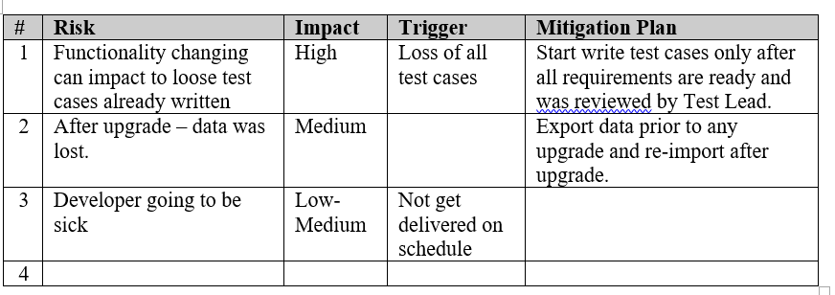 7.5.3. Suspension Criteria:**

If the number or type of defects reaches a point where the follow-on testing has no value! So, testing will be stopped if: >=5 high priority bugs >=20 med/low priority bugs Testing environment not works as planned.

**7.5.4. Resumption Requirements:** Remains <=2 high priority bugs Remains <=10 med/low priority bugs Testing environment fixed and works as planned.

**8. TEST ENVIRONMENT**

**1. HARDWARE REQUIREMENTS**

- Computer with 8 GB RAM, Windows 10 and Chrome;

- Android (7 or over) mobile phone J7 and A8;

- iPhone..**.**

**9. ROLES & RESPONSIBILITIES**

**QA testers:**

* Develop test cases and combine them in test suites – STD

* Report BUGS

* Regression testing

**Test manager:**

* Manage the Testing and provide technical support to the Testing team.

* Make Review of Software Test Plan and test cases for the STD document.

**Test Lead:**

* Prepare the Software Test Plan

* Analyze requirements during the requirements analysis phase.

* Evaluating exit criteria

* Preparing Test Summary Report