MPRE-TRAINING ASSIGNMENT
CNC Motion & Control Research
Connect industrial automation principles to CNC machinery through the design of a simple two-axis pen plotter.
ESTIMATED EFFORT  60-90 minutes | OUTPUT  Concise notes and completed tables | BRING  Research findings and source links

Trainee name
Type here: Malak Alsharqawi

1. Purpose and Objective
The purpose of this assignment is to connect industrial automation principles to real CNC systems. By researching motion mechanisms, motors, feedback devices, drives, and spindle control, you will understand how automation components interact within a CNC machine. You will then apply these principles by proposing a safe, practical two-axis pen plotter.
Your objective: Explain each concept clearly in your own words and support every design decision with sound technical reasoning. The strength of your justification matters more than the price or complexity of the components you select.

Expected Learning Outcomes
- Describe how industrial automation components and signal flow apply to CNC machines.
- Compare common CNC axis-motion mechanisms.
- Identify major motor types and distinguish between stepper and servo systems.
- Explain feedback, encoders, motor drivers, STEP/DIR commands, and VFDs.
- Propose a complete, practical architecture for a two-axis pen plotter.

How to Complete the Task
- Use reliable sources, including manufacturer documentation, textbooks, and technical training materials.
- List at least three source links at the end of this document.
- Keep your answers concise. Use keywords, short explanations, and small sketches where appropriate.
- Be prepared to justify one design decision during the training discussion.

2. Research Task A - CNC Axis Motion
Electric motors produce rotary motion, whereas CNC axes generally require linear motion. Research how each method transmits or converts motor rotation into linear axis movement.

A1. Method Overview
Method | How it works | Main advantages | Main limitations | Typical applications
Timing belt | A toothed belt meshes with toothed pulleys to transfer rotation without slipping | Accurate synchronization, high efficiency, quiet operation, no lubrication, low maintenance. | Limited load capacity, sensitive to tension/alignment, can wear, and may skip teeth under overload. | Automotive engines, robotics, CNC machines, 3D printers, conveyors, and industrial automation.
Lead screw | Converts rotary motion into linear motion by rotating a threaded screw against a matching nut. The lead determines the linear distance moved per revolution. | Converts rotary motion into linear motion using a threaded screw and nut. | Lower efficiency, slower, friction, wear, and possible backlash. | CNC machines, 3D printers, actuators, lifts, and clamps.
Ball screw | Converts rotary motion into linear motion using recirculating balls between the screw and nut. | High efficiency, high precision, high speed, and low friction. | Expensive, requires lubrication, and noisy, especially at high speeds | CNC machines, robotics, 3D printers, and precision positioning systems.
Rack and pinion | A rotating pinion gear meshes with a toothed rack to convert rotary motion into linear motion. | High speed, long travel, efficient, simple, and good force transmission. | Backlash, tooth wear, noise, requires lubrication, and not self-locking. | Vehicle steering, CNC machines, automatic gates, robotics, and industrial automation.

A2. Comparison Matrix
Use relative ratings such as Low, Medium, or High, and add a brief note when clarification is needed.
Method | Speed | Accuracy | Backlash | Cost | Load capacity
Timing belt | High | Moderate-High | Low | Low | Moderate
Lead screw | Low | High | Common | Low | Low-Moderate
Ball screw | High | Very High | Eliminated via preload | High | High
Rack and pinion | High | Moderate-High | Common | Moderate | High

A3. Engineering Choice
- Which method would you select for a small pen plotter, and why?
Response: I would choose a timing belt because a small pen plotter needs fast, lightweight, and repeatable X/Y movement rather than high load capacity. Timing belts are also relatively inexpensive and have low backlash compared with rack-and-pinion systems.
- What changes if the same frame is later used for cutting instead of drawing?
Response: If the same frame is used for cutting, I would switch from a timing belt to a ball screw because cutting introduces much higher loads. The ball screw provides higher load capacity, stiffness, and precision, making it more suitable for resisting cutting forces.

3. Research Task B - Motors for CNC

B1. Five-Minute Motor Scan
Identify the following motor types and write one sentence explaining how each operates or where it is typically used: brushed DC, brushless DC (BLDC), AC induction, stepper, and servo systems.
Motor family | Basic operating idea | One common application
Brushed DC | DC current flows through the armature, while brushes and a mechanical commutator continuously switch the current direction to keep the motor rotating. | Fans, pumps, small actuators
BLDC | Permanent magnets on the rotor interact with a rotating magnetic field created by electronically switched stator windings. | Drones, electric vehicles, cooling fans
AC induction | AC creates a rotating magnetic field in the stator, which induces current in the rotor. The interaction between the two magnetic fields produces torque. | Industrial pumps, conveyors, compressors
Stepper | The controller energizes the stator windings in a specific sequence, causing the rotor to move in discrete steps. | 3D printers, CNC positioning
Servo system | A motor is combined with feedback and a controller. The controller compares the desired position/speed/torque with the actual value and continuously corrects the motor. | Industrial robots, CNC machines

B2. Detailed Comparison - Stepper vs Servo
Complete the comparison by considering the full system: motor, driver, feedback device, controller, and tuning requirements.
Criterion | Stepper system | Servo system
Control / feedback | Open-loop | Closed-loop
Torque at low speed | Excellent | Excellent
Torque at high speed | Decreases significantly | Generally better
Holding at standstill | Excellent | Excellent
Accuracy and repeatability | Good and predictable under proper loading, but can lose position if overloaded | Excellent; feedback allows the system to correct position errors
Missed-step / position-error behavior | Can miss steps under excessive load or acceleration; basic system may not detect the error | Encoder / potentiometer + comparator detects position error and the controller can correct it; excessive load can still cause a fault or loss of tracking
  position-error behavior
Efficiency, heat, and noise | Can consume significant current while holding; more heat and can produce stepping noise/vibration | Generally more efficient because current is adjusted to the required load; smoother and usually quieter when properly tuned
Setup and tuning | Simpler; mainly configure driver current, steps/microstepping, acceleration, etc. | More complex; requires encoder/drive setup and often tuning of control parameters
Cost and complexity | Lower cost and simpler system | Higher cost and more complex system
Typical CNC use | Good for smaller, lower-cost CNC machines where loads and speeds are predictable | Better for high-performance CNC machines requiring high speed, acceleration, and reliable position control

B3. Selection Question
Which motor system would be the most suitable starting point for a lightweight pen plotter? Give two reasons and identify one limitation.
Response: I would choose a stepper motor system for a lightweight pen plotter because it is low-cost and simple to set up and control, requiring only a basic driver and step/direction signals. It is also well suited for the plotter because its discrete steps allow precise and repeatable small movements, which are important for accurate pen positioning. One limitation is that a basic stepper system is open-loop, so if the motor is overloaded or accelerated too quickly, it may skip steps and lose its actual position; however, with a lightweight pen and properly sized motor, this is unlikely to be a major issue.

4. Research Task C - Control, Feedback, and Drives

C1. Open-Loop vs Closed-Loop Control
- Define open-loop control and give one CNC example.
- Define closed-loop control and identify the information returned to the controller or drive.
- Describe what may happen if an open-loop stepper motor is overloaded.
- Explain how feedback enables a system to detect or correct a position error.
Your answer / notes:
Open-Loop Control
Open-loop control is a system where the controller sends commands to the motor without receiving feedback about the actual result. The controller assumes that the motor follows the command correctly. For example, in a CNC machine using stepper motors, the controller sends a specific number of step pulses to move an axis a certain distance and assumes that the axis reached the commanded position.

Closed-Loop Control
Closed-loop control is a system where the controller receives feedback about what the motor is actually doing. An encoder or another feedback sensor can return information such as the motor's actual position, speed, or torque to the controller or drive. The controller compares this information with the desired value and adjusts the motor command when necessary to reduce the error.

What Happens if an Open-Loop Stepper Is Overloaded?
If an open-loop stepper motor is overloaded, it may not produce enough torque to follow the commanded movement, causing it to miss or skip steps. Since there is no feedback, the controller does not know that the motor has lost steps and continues assuming that the motor is at the commanded position. As a result, the actual position of the CNC axis can become different from the position the controller thinks it is at.

How Does Feedback Detect or Correct Position Error?
Feedback allows the system to compare the desired position with the actual position measured by the encoder. If the controller commands the motor to move to 100 mm but the encoder reports that it is only at 95 mm, the controller detects a 5 mm position error and can adjust the motor's movement to reduce that error. This continuous measurement and correction allows a closed-loop system to detect and correct position errors that an open-loop system would not know about.

C2. Encoder Role and Types
Explain how an encoder converts mechanical motion into electrical feedback. Then compare the two encoder types below.
Encoder type | What it reports | What happens after power is removed | Advantages | Limitations / uses
Incremental | Reports changes in position using pulses. The controller counts the pulses to determine movement and can use A/B signals to determine direction. | The position count is normally lost, so the system usually needs to re-establish a reference position (homing) after power is restored. | Simple, relatively low-cost, good for measuring position changes, speed, and direction. | Does not inherently provide absolute position; often used in motors, CNC machines, and motion systems where homing is acceptable.
Absolute | Reports the actual shaft position directly, usually as a digital position value. | The encoder can determine the shaft's position after power is restored, so homing may not be required, depending on the encoder and system design. | Provides immediate position information and is useful when position must be known after power loss. | More expensive and generally more complex; commonly used in industrial servo systems, robotics, and high-precision machines.
Encoder role summary: feedback sensor that measures the motor shaft's movement and provides information such as position, direction, and speed to the controller or drive.

C3. Motor Driver and STEP/DIR
- State the purpose of a motor driver and explain why a controller should not supply power directly to a motor.
- Explain the STEP signal: what motion does each pulse normally command?
- Explain the DIR signal: what does its logic level determine?
- Describe how microstepping and pulse-per-unit settings affect commanded travel.
- Review the documentation for the RD controller and selected driver to confirm signal type, voltage levels, grounding requirements, and compatible wiring.
Your answer / notes:
Motor driver: A motor driver acts as the interface between the controller and motor. The controller only provides low-power control signals, while the driver supplies and controls the higher current required by the motor. Therefore, the controller should not power the motor directly because its outputs cannot safely provide the required motor current.
STEP signal: Each valid STEP/PUL pulse normally commands the motor driver to move the motor by one configured step or microstep. More pulses produce more movement.
DIR signal: The logic level of the DIR signal determines the direction of rotation. Which level means forward or reverse depends on the driver's configuration.
Microstepping and pulse-per-unit: Microstepping divides each full motor step into smaller increments, increasing the number of pulses required per revolution. The pulse-per-unit setting converts physical travel into pulses; for example, if the system is configured for 200 pulses/mm, moving 10 mm requires 2,000 pulses.
RDC6445G/S + 3DM580S: The RDC6445G/S provides PUL (STEP) and DIR open-collector outputs with a +5 V motor-driver interface. The 3DM580S supports PUL/DIR control and 5 V/24 V logic inputs. The connection should follow the manufacturer's common-anode wiring and specified signal requirements to ensure correct grounding and compatibility.
Signal path to understand: RD controller -> STEP/DIR command signals -> motor driver -> controlled phase current -> motor rotation. If feedback is used, it returns through the drive or controller according to the selected architecture.

C4. VFD / Inverter for a Spindle
- What is a variable-frequency drive (VFD), often called an inverter in CNC workshops?
- Why is a VFD used with many AC spindle motors? Address speed control, acceleration and deceleration, direction, and protection.
- Why is a VFD generally unnecessary for a pen-only plotter?
Your answer / notes:
1. What is a VFD?
A Variable-Frequency Drive (VFD) is an electronic drive used mainly to control AC motors. It changes the frequency and voltage supplied to the motor, allowing the motor's speed and operation to be controlled. In CNC workshops, it is often called an inverter, especially when controlling a spindle.
2. Why is a VFD used with AC spindle motors?
A VFD allows the spindle's speed to be controlled by changing the motor frequency. It can also provide controlled acceleration and deceleration instead of starting or stopping suddenly, control the rotation direction, and provide protections such as overcurrent, overload, and over/undervoltage protection, depending on the VFD.
3. Why is a VFD unnecessary for a pen-only plotter?
A VFD is generally unnecessary for a pen-only plotter because the plotter's motors are used for precise X/Y positioning, not for driving a high-speed cutting spindle. Stepper motors with STEP/DIR drivers are simpler and more suitable for this application, so adding a VFD would only add unnecessary complexity.

5. Final Challenge - Propose a Two-Axis Pen Plotter
Design a simple, safe, two-axis (XY) CNC pen plotter using the two components already available:
- One RD controller.
- Two stepper motors: one for the X axis and one for the Y axis.
Design scope: The machine will draw with a pen and will not cut material. A powered spindle and VFD are therefore outside the scope of the base design. If you include a pen-lift mechanism, explain how it will be actuated and controlled.

D1. Required Remaining Components
List all additional components required to complete the machine. For each item, state the quantity, a basic specification or assumption, and the reason it is needed.
Category | Component | Qty. | Key specification / assumption | Why it is required
Control / electrical | Stepper motor driver (3DM580S) | 2 | STEP/DIR compatible; one driver per stepper motor | Receives STEP/DIR commands from the RD controller and supplies the required current to each stepper motor
Control / electrical | Controller power supply | 1 | Controller power supply | Powers the RD controller safely
Control / electrical | Motor-driver power supply | 1 | DC supply within the 3DM580S operating range and sized for both drivers/motors | Supplies power to the two stepper drivers and motors
Sensors / Electrical | Limit switches | 2 | One home switch for X and one for Y | Used for homing and establishing a known reference position
Safety/protection | Fuse / circuit protection | 1 set | Correctly rated for the power supplies and loads | Protects wiring and electronics against excessive current or short circuits
Mechanical / Motion Transmission | Timing belt | 2 | One belt for X and one for Y; toothed belt with low stretch | Transfers motion from the stepper motor to the moving carriage
Mechanical / Motion Transmission | Timing pulley | 2 | Mounted on each stepper motor shaft and matched to the belt pitch | Converts motor rotation into belt movement
Mechanical / Motion Transmission | Idler pulley | 2 | One for each axis, used at the opposite end of the belt | Guides the belt and helps maintain proper belt tension
Mechanical frame | Wooden base + aluminum extrusion frame | 1 set | Flat rigid wooden base with aluminum extrusions around the edges for mounting and alignment | The wood provides a low-cost flat drawing surface, while the aluminum edges provide greater rigidity and accurate mounting for the rails, motors, and belt system
Linear guidance | Linear rail + carriage block | 2 sets | One set for X and one for Y; low-friction, suitable for a lightweight plotter | Keeps each axis moving in a straight line and supports the carriage while the timing belt provides the pulling force
Pen tool/lift | Solenoid Pen Lift | 1 | - 5v DC solenoid  - Spring return (pen up when OFF)  - Stroke: ~5 -15 mm | Left the pen up and down, allowing drawing and non-drawing moves.

D2. System Architecture
Create a system architecture sketch that shows the complete signal and power flow. Include:
- AC power input, isolation, and protection, where applicable.
- DC power supply or supplies, including assumed voltage and current ratings.
- Connections from the RD controller to two compatible stepper drivers using STEP/DIR signals.
- Motor-phase wiring from each driver to the X- and Y-axis motors.
- Home and limit switches, an emergency-stop circuit, grounding, and cable management.
- The selected linear guides and motion-transmission mechanisms for both axes.
- The pen holder and optional pen-lift mechanism.
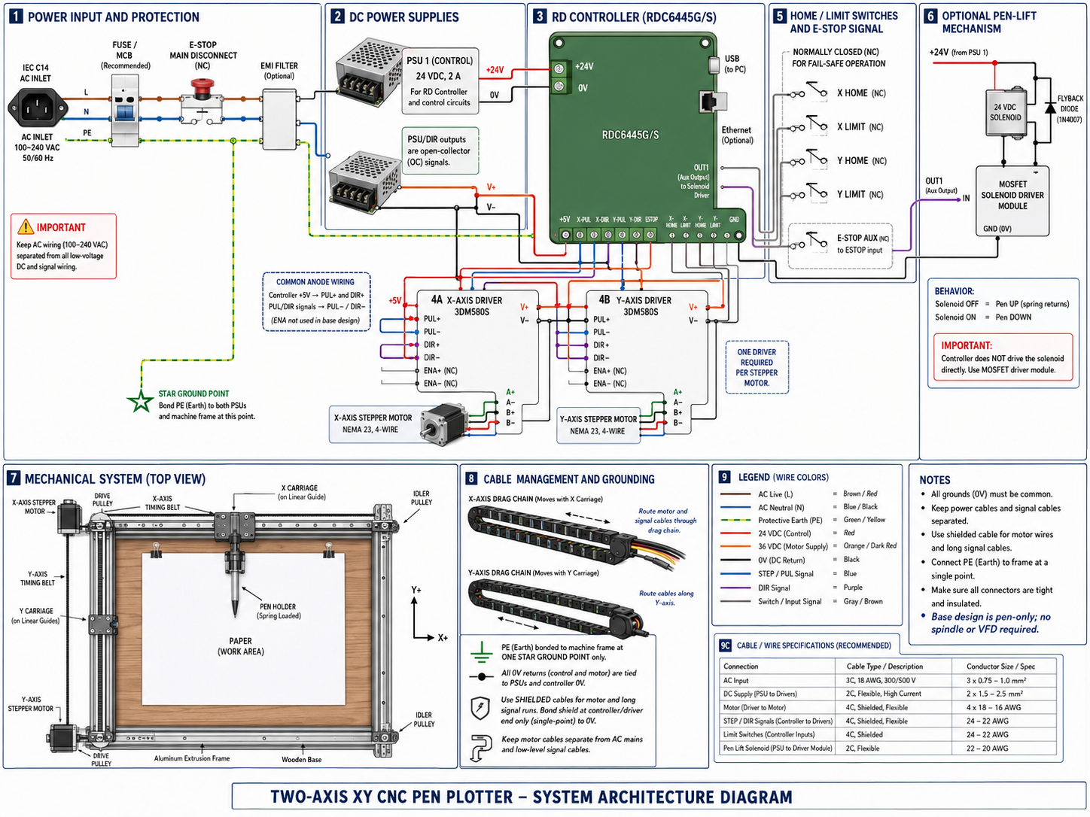

D2. System Architecture Sketch
Use the entire A4 page for your sketch. Show the power path, control-signal path, X and Y axes, motion-transmission mechanisms, safety devices, and optional pen-lift mechanism. Clearly label all major components and connections.

6. Design Rationale and Submission Check

D3. Explain Your Choices
Question A: Why is your selected motion-transmission method appropriate for a pen plotter?
Response: I selected a timing-belt and pulley system because a pen plotter has a lightweight load and does not require the high force needed for cutting. Timing belts provide fast, smooth motion with low backlash when correctly tensioned, while also being inexpensive and simple to assemble. This makes them suitable for accurate X-Y positioning of a lightweight pen.

Question B: How did you match the drivers and power supply to the stepper motors?
Response: Each stepper motor uses its own 3DM580S driver. The driver current setting should be adjusted to match the rated phase current of the selected motor so the motor is not overloaded. The motor-driver power supply must also be within the driver's permitted voltage range and provide enough current for both motors operating together. A separate 24 V supply is used for the RDC6445G/S controller. The final motor-supply rating should therefore be confirmed from the actual motor specifications.

Question C: How will the machine establish its home position and prevent unsafe overtravel?
Response: The machine will use home/limit switches on the X and Y axes. During startup, each axis moves slowly toward its home switch until the switch is activated, giving the controller a known reference or zero position. Limit settings and switches can also stop motion before the carriage exceeds the safe mechanical travel. An emergency-stop button provides an additional way to stop the machine immediately if a fault occurs.
Question D: What resolution do you expect? Show how motor steps, microstepping, and transmission produce steps per millimeter
Response: Assuming a 1.8° stepper motor, the motor has 200 full steps per revolution. With the 3DM580S configured for 1/8 microstepping, this becomes 1600 pulses per revolution. If a GT2 belt with a 20-tooth pulley is used, one pulley revolution moves the belt by (20 \times 2 = 40) mm. Therefore, the system requires (1600 \div 40 = 40) pulses/mm, giving a theoretical commanded resolution of 0.025 mm per pulse. The actual positioning accuracy will be slightly lower because of belt stretch, mechanical tolerances, alignment, and microstepping accuracy.

Question E: What is the main technical risk in your design, and how would you test it?
Response: The main technical risk is position error caused by missed stepper steps or incorrect belt tension, because the basic design is open-loop and has no encoder feedback. I would test this by repeatedly drawing a known shape, such as a square, measuring its dimensions, and checking whether the carriage returns to the same home position after several cycles. If errors appear, I would check belt tension, motor current, acceleration, speed, and mechanical alignment before increasing performance

Submission Checklist
[ x] All four axis-motion methods researched and compared.
[ x] Motor-family scan completed.
[ x] Stepper vs servo comparison completed.
[ x] Open-loop, closed-loop, and encoder roles explained.
[ x] Incremental vs absolute encoders compared.
[ x] Driver purpose and STEP/DIR concept explained.
[ x] VFD purpose for spindle control explained.
[ x] Pen-plotter component list, system architecture, and design rationale completed.

Sources Consulted
https://www.brecoflex.com/blog/what-is-a-timing-belt
https://www.iqsdirectory.com/articles/conveyor-belts/timing-belt.html
https://www.autozone.com/diy/belts/what-is-a-timing-belt
https://fractory.com/lead-screws/
https://www.youtube.com/watch?v=WpG11dtAgJA
https://www.youtube.com/watch?v=tkOhH9OUMto
https://www.iqsdirectory.com/articles/ball-screws.html
https://www.jotamachinery.com/what-is-a-ball-screw/
https://jcmstech.com/steering-rack-vs-rack-and-pinion/
https://www.youtube.com/watch?v=SwUqCod40jI
https://assunmotor.com/blog/brushed-dc-motor/
https://www.youtube.com/watch?v=CWulQ1ZSE3c
https://www.renesas.com/en/support/engineer-school/brushless-dc-motor-01-overview?srsltid=AfmBOoq9SA40KU-Pt0RLgIdaNHgSFKr0zfu5zA5WIMGkw0WOHkqLzC5z
https://anaheimautomation.com/blog/post/brushless-dc-motor-guide?srsltid=AfmBOoq2D-C1cMm8HVJJLYTqJyMWUsNjiwaspgUzi-9qn_FIoWVg8vO-
https://www.youtube.com/watch?v=bCEiOnuODac
https://www.parvalux.com/us/what-is-the-difference-between-brushed-and-brushless-dc-motors/?gad_source=1&gad_campaignid=22670080961&gbraid=0AAAAADgfNB23foEvbw38MZRk773RARunn&gclid=Cj0KCQjw4orUBhCjARIsAIbF3qxb7NH4_s7q5lb-VSmD_qtaA9F6Ed-OOkHMwHUeidwD8hfZdxs4tewaAg9gEALw_wcB
https://www.youtube.com/watch?v=wAtN3SEYSco
https://scienceready.com.au/pages/ac-induction-motor?srsltid=AfmBOoqUXKQGg8-SX1OcNiEMyJkHiisuPU-7u8zOjTJnrDenTdv4ji7b
Come prepared for the training session: Bring your completed research, source links, and any questions you would like to discuss. The CNC pen plotter’s mechanical structure will already be assembled. Starting with this ready motion system, you will connect and wire the electrical control and power circuits, develop a practical solution for controlling the pen mechanism, and learn how to create and run drawings using the RD controller. You will then test the machine, evaluate its motion, and improve its performance by calculating and adjusting the pulse equivalent and other motion-control parameters.

