IoT / EMBEDDED SYSTEMS
Daily Technical Report

Project Title | IoT Training Program
Report / Day No. | Day 1
Date | 19/7/2026
Prepared By | Malak Alsharqawi
Organization | Cyber Robot

Confidential — Internal Training Documentation

Table of Contents
Table of Contents 2
1. Daily Overview 3
1.1 Summary 3
1.2 Tasks Completed Today 3
Task 1: 3
1. Objective 3
2. Procedure 3
Step 1 — Install the CP210x USB-to-UART driver 3
Step 2 — Install Windows Subsystem for Linux (WSL) 3
Step 3 — Install and configure PlatformIO 3
Step 4 — Configure USB/serial passthrough (usbipd) 3
3. Code / Configuration 4
4. Schematic 4
5. Photos 5
6. Issues & Troubleshooting 5
7. Results & Outcome 5
Task 2: GitHub 5
1. Objective 5
2. Procedure 5
Phase 1 — SSH key setup 5
Phase 2 — Initialize and link the repository 5
Phase 3 — Push to GitHub 6
3. Code / Configuration 6
4. Issues & Troubleshooting 6
5. Results & Outcome 6
3. Project Documentation & Notes 6

1. Daily Overview

1.1 Summary
This session successfully set up a complete ESP32 development environment by linking Windows hardware to a Linux-based WSL backend for building and flashing firmware. The environment was fully verified by running an external LED blink sketch and establishing a secure, password-free connection to GitHub using SSH.

1.2 Tasks Completed Today
- VS Code & PlatformIO Setup + ESP32 Blink
- Git & Github

Task 1: VS Code & PlatformIO Setup + ESP32 Blink

1. Objective
Set up a complete embedded development environment capable of recognizing, building for, and flashing firmware to an ESP32 microcontroller from a Linux-based toolchain running on Windows.

2. Procedure

Step 1 — Install the CP210x USB-to-UART driver
- Downloaded and installed the CP210x VCP driver so Windows recognizes the ESP32 over USB.

Step 2 — Install Windows Subsystem for Linux (WSL)
- Ran the one-command installation and restarted the machine to apply virtualization layers.
- Initialized the Linux user account (username and password) on first boot.
- Verified the installed distribution and WSL version using the status list command.
- Updated the internal package database before installing any compilers or extensions.

Step 3 — Install and configure PlatformIO
- Installed the PlatformIO IDE extension inside VS Code (connected to the WSL: Ubuntu backend).
- Resolved a Python interpreter error by installing python3 and python3-venv inside WSL, then retried the extension setup.

Step 4 — Configure USB/serial passthrough (usbipd)
- Granted the Linux user permission to access serial devices (dialout group).
- Force-bound the ESP32's USB Bus ID on the Windows host using usbipd.
- Attached the device to the WSL distribution with auto-attach enabled for persistent reconnection.

3. Code / Configuration
Key commands used during setup:
# Install WSL
wsl --install

# Verify installation
wsl --list -v

# Update Linux packages
sudo apt update && sudo apt upgrade -y

# Fix PlatformIO Python interpreter error
sudo apt update && sudo apt install python3 python3-venv -y

# Grant serial device permissions
sudo usermod -a -G dialout $USER

# Bind and attach ESP32 (run in Windows PowerShell as Administrator)
usbipd list
usbipd bind --busid <YOUR_BUS_ID> --force
usbipd attach --wsl --busid <YOUR_BUS_ID> --auto-attach

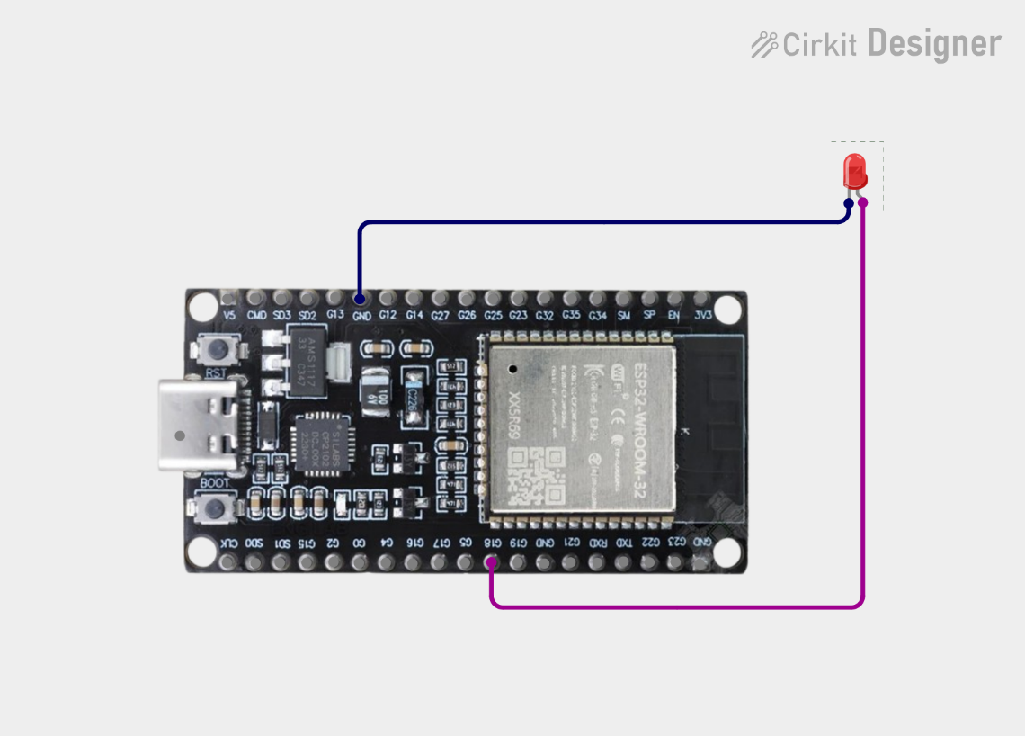
4. Schematic

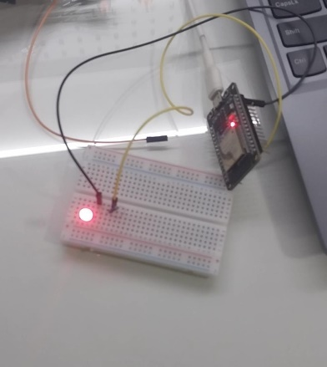
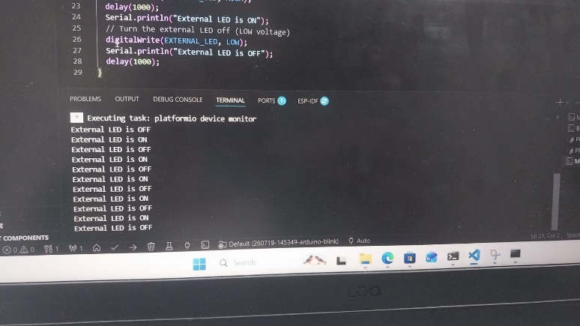
5. Photos

6. Issues & Troubleshooting
PlatformIO initially failed with “Can not find working Python 3.6+ Interpreter” because it was searching for Python inside the WSL Linux environment rather than Windows. Resolved by installing python3 and python3-venv inside WSL and retrying.

7. Results & Outcome
The ESP32 was successfully recognized by WSL over a shared USB/serial connection, PlatformIO built and uploaded a basic Blink LED sketch (GPIO 18, 115200 baud), and serial monitor output was confirmed to display “External LED is ON/OFF” at 1-second intervals.

Task 2: GitHub

1. Objective
Turn an existing local project folder into a version-controlled Git repository and link it to a remote GitHub repository using a secure SSH connection.

2. Procedure

Phase 1 — SSH key setup
- Generated a new ed25519 SSH key pair and added the public key to GitHub (Settings → SSH and GPG keys).

Phase 2 — Initialize and link the repository
- Navigated to the project directory and ran git init to start version tracking.
- Staged and committed all existing files as the initial commit.
- Renamed the default branch to main and added the GitHub remote using the SSH URL.

Phase 3 — Push to GitHub
- Pushed the local commit history to GitHub and set the upstream tracking branch.
- Accepted GitHub's host fingerprint on first connection.

3. Code / Configuration
Commands executed:
# Generate SSH key
ssh-keygen -t ed25519 -C "your_email@example.com"
cat ~/.ssh/id_ed25519.pub # copy this into GitHub

# Initialize and commit
cd ~/test/IoT_training
git init
git add .
git commit -m "Initial commit of existing project files"
git branch -M main
git remote add origin git@github.com:<user>/<repo>.git

# Push
git push -u origin main

4. Issues & Troubleshooting
None — first-time SSH host verification prompt was accepted as expected.

5. Results & Outcome
The local project was successfully version-controlled and pushed to the remote GitHub repository over SSH; subsequent commits can now be pushed directly with git push.

3. Project Documentation & Notes
- Development Notes & Key Learnings All daily progression logs, troubleshooting steps, and core takeaways for this initial project milestone are actively documented here: 👉 View My First-Day Notion Notebook

- Hardware Schematic & Circuit Layout The system architecture design, GPIO pinout mapping, and electrical connections were mapped out using the cloud platform: 👉 Open Circuit Designer Workspace
- GPIO Pinout
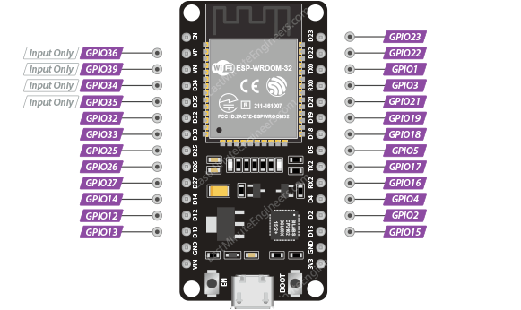

End of Report

