T E C H N I C A L R E P O R T
IoT / EMBEDDED SYSTEMS
Task 3.1: Node-RED Dashboard for Visual Control and Live Telemetry
Daily Technical Report, Day 18 + Day 19
Platform | ESP32-S3-WROOM · Arduino Framework · PubSubClient
Subsystem | Node-RED dashboard: live BME280 telemetry, L298N motor control and true-state feedback
Broker | Self-hosted Mosquitto 2.0.22 inside WSL 2 (Ubuntu), reused from Task 11. No second broker was installed.
Runtime | Node.js v24.19.0 and Node-RED installed on Windows through npm, run from PowerShell on port 1880
Dashboard | node-red-dashboard palette (ui_gauge, ui_chart, ui_text, ui_switch, ui_slider, ui_button)
Clients | Node-RED dashboard (laptop and phone browser), MQTT Explorer, mosquitto_pub / mosquitto_sub, ESP32-S3 firmware
Prepared By | Malak Alshrqawi
Prepared For | IOT Training Program

Confidential, Internal Training Documentation

Contents
1. Daily Overview 3
1.1 Summary 3
1.2 Goal & Submission Format 3
1.3 Tasks Completed 3
2. Part 1: Installing the Node-RED Environment on Windows 4
2.1 Why Node-RED Runs on Windows While the Broker Stays in WSL 4
2.2 Node.js as a Prerequisite 5
2.3 Installing and Verifying Node.js 5
2.4 The PowerShell Execution Policy Problem 5
2.5 Installing Node-RED Globally 6
2.6 Running Node-RED from the Terminal 6
2.7 The Node-RED Editor: Palette, Workspace, Sidebar, Deploy 7
2.8 First Flow: Inject to Debug 7
2.9 Installing the Dashboard Palette 7
3. Connecting Node-RED to the Existing Mosquitto Broker 9
3.1 One Broker, Not Two 9
3.2 Why localhost Works Instead of the WSL IP 9
3.3 Verifying That Mosquitto Is Listening 9
3.4 The First MQTT Flow: MQTT IN to Debug 10
3.5 Adding the Remaining Sensor Topics 11
4. System Schematic: Hardware Wiring and Node-RED Flow 12
4.1 Hardware Wiring and Signal Path 12
4.2 The Node-RED Flow, Node by Node 13
4.3 What the Flow Confirms and What It Reveals 15
5. Topic Model: Command Topics vs Telemetry Topics 16
5.1 Why the Separation Is Necessary 16
5.2 Telemetry Topics (ESP32 to Node-RED) 16
5.3 Command Topics (Node-RED to ESP32) 16
5.4 Complete Topic Tree 17
5.5 Firmware Alignment Note 17
6. Part 2: Dashboard Layout and Live Telemetry 18
6.1 Layout and Grouping 18
6.2 Environmental Telemetry: Gauges and Historical Charts 18
6.3 Value Format: Correct Data, Wrong Presentation 19
6.4 Motor State Telemetry 19
6.5 Motor Direction Telemetry 19
6.6 Motor Speed Telemetry 20
6.7 Why Actual Telemetry Matters: Command State vs Actual State 20
7. Connection Status Detection: MQTT Last Will and Testament 20
7.1 The Stale Dashboard Problem 20
7.2 LWT Topic and Payloads 20
7.3 Configuring the Last Will on the ESP32 21
7.4 Publishing the Retained Online State 21
7.5 LWT Flow and the Node-RED Connection Indicator 22
7.6 Detection Timing and Keep-Alive 22
8. Part 2: Control Panel, Node-RED to ESP32 22
8.1 Motor Power Control 22
8.2 Motor Direction Control 23
8.3 Motor Speed Control 23
8.4 Speed Validation and Clamping Inside Node-RED 23
8.5 Slider Publishing Behaviour 24
8.6 Emergency Stop 24
9. Part 3: Requirements Compliance 25
10. End-to-End Verification & Screenshots 25
11. Definition of Done 27
12. Remaining Work and Next Steps 27
13. References 27

1. Daily Overview

1.1 Summary
Day 18 and Day 19 close the last gap in the control loop built over the earlier MQTT task. Up to this point the only way to talk to the ESP32 was MQTT Explorer, which is a debugging tool rather than an interface: it shows raw topics and raw payloads and assumes whoever is using it already knows the namespace by heart. These two days replaced it with a Node-RED dashboard running locally on the Windows host against the same Mosquitto broker, so the whole system can now be watched and driven from a browser on a laptop or a phone.
The work was deliberately layered rather than rushed. Node.js was installed and verified first, then a PowerShell execution policy problem that blocked npm was diagnosed and fixed, then Node-RED was installed globally and run from the terminal, then a trivial inject to debug flow proved the editor worked at all, then a single MQTT IN node proved that real ESP32 data could reach Node-RED, and only after that were any gauges created. Each layer was tested on its own, so when something failed there was only ever one new variable to blame.
The dashboard that came out of it is two-directional. In one direction the ESP32 publishes BME280 readings and its own true motor state, and Node-RED renders those as gauges, historical charts and colour-coded indicators. In the other direction the dashboard publishes command payloads on a separate cmd branch of the topic tree, which the ESP32 subscribes to, validates and applies to the L298N driver. The two directions never share a topic, which is what allows the dashboard to display what the hardware is actually doing instead of echoing back what the user just asked for. The third piece is presence detection: an MQTT Last Will and Testament on esp32/status, so that if the ESP32 loses power or drops off the Wi-Fi network, the broker announces it on the device's behalf and the dashboard flips to OFFLINE instead of freezing on stale values.

1.2 Goal & Submission Format
Goal: build on the MQTT system from Task 11 by creating a live Node-RED dashboard that visualises sensor data and controls the motor, so that MQTT Explorer is no longer needed to talk to the ESP32.
Submission Format
GitHub repository link + exported Node-RED flow (flows.json) + dashboard screenshots or screen recording.

1.3 Tasks Completed
- Installed Node.js on Windows and verified it from PowerShell with node --version, which returned v24.19.0.
- Diagnosed an npm failure that was not an npm failure: the npm.ps1 wrapper was blocked by the PowerShell execution policy, and it was fixed for the current user only with Set-ExecutionPolicy RemoteSigned.
- Installed Node-RED globally through npm rather than using a hosted service, and confirmed the install with node-red --version.
- Ran Node-RED from the terminal so its log stays visible, mirroring the way Mosquitto is run in Task 11, and opened the editor at http://localhost:1880.
- Learned the editor layout, palette, workspace, sidebar and Deploy, and ran an inject to debug flow to confirm messages move between nodes.
- Installed the dashboard palette from Manage palette so the ui_ widget nodes became available.
- Confirmed from WSL that Mosquitto was listening on 0.0.0.0:1883 before pointing anything at it.
- Connected Node-RED to the existing broker over localhost:1883, reusing the Windows to WSL port forwarding rather than the WSL virtual IP, and without starting a second broker.
- Proved the path end to end with a single MQTT IN node on esp32/sensor/temperature wired to a debug node, then added humidity and pressure.
- Built the environmental section: a live gauge and a historical chart for each of temperature, humidity and pressure.
- Fixed a gauge that showed no value by configuring the Value Format field, a presentation problem rather than a data problem.
- Added motor state, motor direction and motor speed indicators driven by the ESP32 telemetry topics, not by the last command sent from the UI.
- Implemented MQTT Last Will and Testament on the ESP32 with a retained online payload, and added an ONLINE / OFFLINE indicator on the dashboard.
- Built the control panel: motor power switch, direction control and a 0 to 100 percent speed slider, all publishing to the cmd branch.
- Laid out an Emergency group that is visually separate from the normal Control group.

2. Part 1: Installing the Node-RED Environment on Windows

2.1 Why Node-RED Runs on Windows While the Broker Stays in WSL
The task specifies that Node-RED is installed locally on the Windows machine through npm. Mosquitto, from Task 11, lives inside WSL 2. That split is deliberate and it is worth stating plainly, because it is the source of every networking question that follows.
Environment | What runs there | Why
WSL 2 (Ubuntu) | Mosquitto broker on port 1883, Linux development tools, the ESP32 project environment | The broker was set up here in Task 11 and is already reachable by the ESP32 through the Windows firewall rule and the netsh portproxy bridge.
Windows | Node.js, Node-RED, the browser, the dashboard | Required by the task, and it puts the dashboard on the machine the operator actually uses.
The resulting architecture
WINDOWS
Node.js -> Node-RED -> Dashboard (browser)
|
| MQTT over the local network stack
v
WSL 2
Mosquitto broker :1883
^
| MQTT over Wi-Fi
ESP32
Running Node-RED from a terminal rather than as a background service follows the same philosophy applied to Mosquitto in Task 11: when the runtime prints its own log to a visible window, every MQTT connection, disconnection, deploy and node error is observable at the moment it happens. Running it locally rather than in the cloud also keeps the entire loop on the LAN, so a command leaving the dashboard reaches the motor with local network latency and the system keeps working with the internet disconnected.

2.2 Node.js as a Prerequisite
Node-RED is a Node.js application, so Node.js has to exist before Node-RED can be installed. Node.js also ships npm, the package manager, which is the tool used to install Node-RED itself and any additional node packages such as the dashboard palette.
The dependency chain
Node.js
| provides the runtime and npm
v
Node-RED
|-- MQTT processing
|-- dashboard logic
+-- web dashboard served at /ui

2.3 Installing and Verifying Node.js
Node.js was installed on Windows from the official installer, then verified from PowerShell rather than assumed to be working:
PowerShell, verify Node.js
node --version
v24.19.0
That output confirms two separate things at once: Node.js is installed, and it is on the PATH so it can be called from any terminal directory. The next check, npm, is where the first real problem appeared.

2.4 The PowerShell Execution Policy Problem
Running the npm version check produced an error that reads like a missing installation but is not one:
PowerShell, the error
npm --version

npm : File C:\Program Files\nodejs\npm.ps1 cannot be loaded because
running scripts is disabled on this system.
npm was installed correctly, as part of Node.js. On Windows, npm is invoked through a PowerShell wrapper script, npm.ps1, and PowerShell refuses to run any script file while the execution policy forbids it. The command never reaches npm at all.
What actually happens
npm command
v
npm.ps1 (a PowerShell script)
v
PowerShell execution policy
+-- script blocked
The fix changes the policy for the current Windows user only, rather than for the whole machine:
PowerShell, fix the execution policy
Set-ExecutionPolicy -Scope CurrentUser -ExecutionPolicy RemoteSigned

Execution Policy Change
[Y] Yes [A] Yes to All [N] No
Y
Part of the command | What it does | Why it was chosen
Set-ExecutionPolicy | Changes the rules PowerShell applies when it is asked to run a script file. | This is the actual blocker, not npm or Node.js.
-Scope CurrentUser | Applies the change only to the current Windows user. | Narrower than a machine-wide change, and it does not need an administrator shell.
-ExecutionPolicy RemoteSigned | Locally created scripts run. Scripts downloaded from the internet must be signed or explicitly unblocked. | Keeps the protection that matters, which is against untrusted downloaded scripts. Unrestricted would have removed that protection for no benefit.
PowerShell reads the policy when the session starts, so the current window has to be closed and a new one opened before the change takes effect. Running the check again then returns a version number in the 10.x range, and at that point Node.js, npm and PowerShell are all in a working state.

2.5 Installing Node-RED Globally
PowerShell, install Node-RED
npm install -g --unsafe-perm node-red
The -g flag installs Node-RED globally rather than into a single project folder, which is what puts the node-red command on the system path so it can be started from any directory. Without it, the install would be tied to whichever directory it was run in. The install is then confirmed the same way Node.js was:
PowerShell, verify Node-RED
node-red --version

2.6 Running Node-RED from the Terminal
Terminal, start Node-RED
node-red

Welcome to Node-RED
===================
...
Server now running at http://127.0.0.1:1880/
The terminal stays open for as long as Node-RED is running, which means the project now has two long-lived terminals side by side, in the same style as Task 11:
Terminal | Environment | Process | Why it stays open
Terminal 1 | WSL 2 (Ubuntu) | mosquitto -c mosquitto.conf -v | Verbose broker log: every client connect, subscribe and disconnect is visible as it happens.
Terminal 2 | Windows PowerShell | node-red | Runtime log: flow deploys, MQTT connection state and node errors are visible as they happen.
Two URLs matter from here on. The flow editor is at http://localhost:1880 and the dashboard itself at http://localhost:1880/ui, which is the address visible in the browser bar of Figure 6. To reach the dashboard from a phone on the same Wi-Fi network, the same paths are used with the Windows LAN IP in place of localhost.

2.7 The Node-RED Editor: Palette, Workspace, Sidebar, Deploy
Before connecting anything to MQTT, the editor itself has to make sense. It has three areas and one button that matters.
Area | Position | Purpose
Palette | Left | The available node types, grouped into categories such as common, function, network, sequence, parser, storage and dashboard. Nodes are dragged from here onto the canvas.
Workspace | Middle | Where nodes are placed and joined. The line joining two nodes is a wire, and messages travel along it from left to right.
Sidebar | Right | Information, help and the Debug panel, which prints the messages passing through any debug node.
Deploy | Top right | Node-RED does not apply edits as they are made. Changes only take effect when Deploy is pressed.
The working cycle
Create nodes -> Connect nodes -> Configure nodes -> Deploy -> Test

2.8 First Flow: Inject to Debug
The first flow built was deliberately trivial: an inject node wired to a debug node. Pressing the inject button produces a message, and the message appears in the Debug sidebar.
The first flow
[ Inject ] -----> [ Debug ]

Inject creates a message
Debug displays the message
It looks unrelated to MQTT, and that is the point. It establishes the one concept everything else in Node-RED rests on, which is that nodes generate, modify, process and consume messages, and it proves the editor and the deploy cycle work before any external system is involved. If the inject test had failed, no amount of MQTT configuration would have helped.

2.9 Installing the Dashboard Palette
Node-RED ships the flow editor but not the UI widgets. Gauges, charts, switches, sliders and buttons come from a dashboard package, installed from inside the editor through Menu, Manage palette, Install, then searching for the package by name.
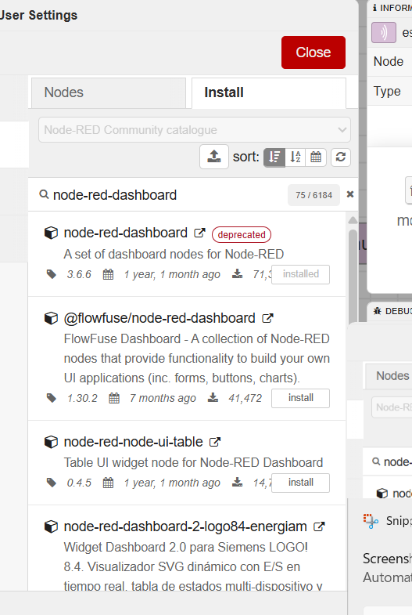
Figure 1. The Manage palette install dialog. node-red-dashboard 3.6.6 is marked installed and flagged deprecated, while @flowfuse/node-red-dashboard 1.30.2 is offered as a separate install.
This screenshot settles a question worth being precise about in the README. Two packages exist. The original node-red-dashboard is the one that is installed in this environment, and it is the one that provides the ui_gauge, ui_chart, ui_text, ui_switch, ui_slider and ui_button node types used throughout the rest of this report, along with the dashboard served at /ui that appears in Figures 6 and 7. Its maintainers declared it deprecated on 27 June 2024: it still installs and runs, but it is based on AngularJS v1 and will not receive further development. The successor is FlowFuse Dashboard, published as @flowfuse/node-red-dashboard and commonly called Dashboard 2.0, which the same dialog shows as available but not installed.
Note for the README
The working notes for these two days mention installing the FlowFuse package, while the palette dialog and the widget types actually in the flow both point to the original node-red-dashboard. The README should name the package that is really in use, since a reviewer reproducing the flow from flows.json will install whichever one is stated. The topic design, the clamping logic and the LWT mechanism described in this report all sit outside the widget layer, so a later migration to Dashboard 2.0 would only touch the UI nodes.

3. Connecting Node-RED to the Existing Mosquitto Broker

3.1 One Broker, Not Two
The single most important rule at this stage is that Node-RED connects to the broker that already exists. Node-RED is not an MQTT broker and does not contain one. Mosquitto routes messages between clients, and Node-RED is simply another client alongside the ESP32 and MQTT Explorer. Installing a second broker would have produced two isolated message spaces, and the dashboard would have sat there subscribed to topics that nothing was ever going to publish to.
Who does what
MOSQUITTO (message router)
|
+---------------+---------------+
| |
ESP32 Node-RED (logic and interface)
|
Dashboard

3.2 Why localhost Works Instead of the WSL IP
The broker runs inside WSL 2, which sits on its own NAT-isolated virtual subnet, so the obvious assumption is that Node-RED must be pointed at the WSL virtual IP. It was checked:
Inside WSL, find the virtual IP
hostname -I
172.29.163.242
That address turned out to be unnecessary. Task 11 already configured Windows to forward port 1883 into WSL through a netsh portproxy rule, which is what lets the ESP32 reach the broker at the Windows LAN IP. Node-RED runs on that same Windows host, so it can use the near end of the same forwarding path and connect to localhost.
The path a Node-RED packet takes
Node-RED
| localhost:1883
v
Windows port 1883
| netsh portproxy (NAT)
v
WSL port 1883
v
Mosquitto
Using localhost is also the more robust choice, not just the more convenient one. The WSL virtual IP is assigned by the Hyper-V NAT switch and changes when WSL restarts, so a hardcoded 172.29.x.x address in the broker configuration node would silently break the dashboard on the next reboot. Note the asymmetry that follows: the ESP32 connects to the broker at the Windows LAN IP because it is a separate device on the Wi-Fi network, while Node-RED connects at localhost because it is on the host itself. Both reach the same broker.

3.3 Verifying That Mosquitto Is Listening
Before pointing Node-RED at anything, the broker was confirmed to be up and bound correctly from inside WSL:
WSL, check the listening socket
sudo ss -lntp | grep 1883

LISTEN 0 100 0.0.0.0:1883 0.0.0.0:* users:(("mosquitto",pid=5729,fd=4))
LISTEN 0 100 [::]:1883 [::]:* users:(("mosquitto",pid=5729,fd=5))
The part that matters is 0.0.0.0:1883. It means Mosquitto is bound to every IPv4 interface rather than only to the loopback address, which is the configuration set in mosquitto.conf during Task 11 and the reason external traffic can reach it at all. Checking this first costs one command and removes an entire class of false leads later: if this line is missing, no amount of Node-RED configuration will help.

3.4 The First MQTT Flow: MQTT IN to Debug
With the broker confirmed, one MQTT IN node was added and pointed at a topic the ESP32 was already publishing, wired to nothing more ambitious than a debug node.
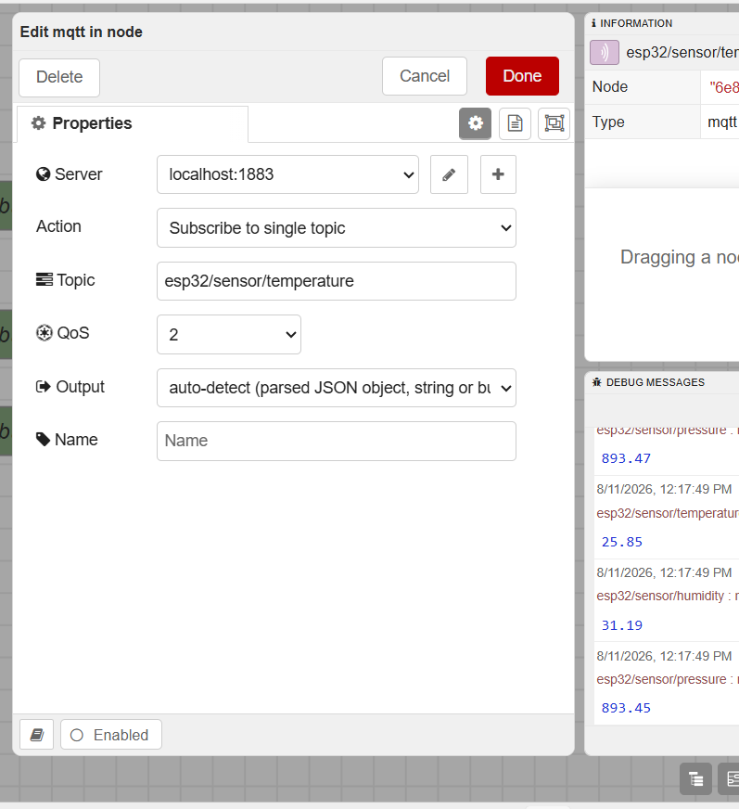
Figure 2. The MQTT IN node configuration: the broker entry reads localhost:1883, the action is a single-topic subscription, and the topic is one the ESP32 already publishes.
Field | Value | Comment
Server | localhost:1883 | The existing Mosquitto broker, reached through the Windows to WSL port forwarding. One shared broker configuration node is reused by every MQTT node in the flow.
Action | Subscribe to single topic | One topic per node at this stage. A wildcard subscription would have made the first test harder to read.
Topic | esp32/sensor/temperature | An existing topic. No new topics were invented for Node-RED.
QoS | 2 | Requested by the subscriber. Effective delivery is still QoS 0 here, because PubSubClient on the ESP32 only publishes at QoS 0 and the delivered quality of service is the lower of the two.
Output | auto-detect | Parses a JSON object where possible and otherwise passes a string or buffer. The debug output shows msg.payload arriving as a number, which is what the gauge and chart widgets need.
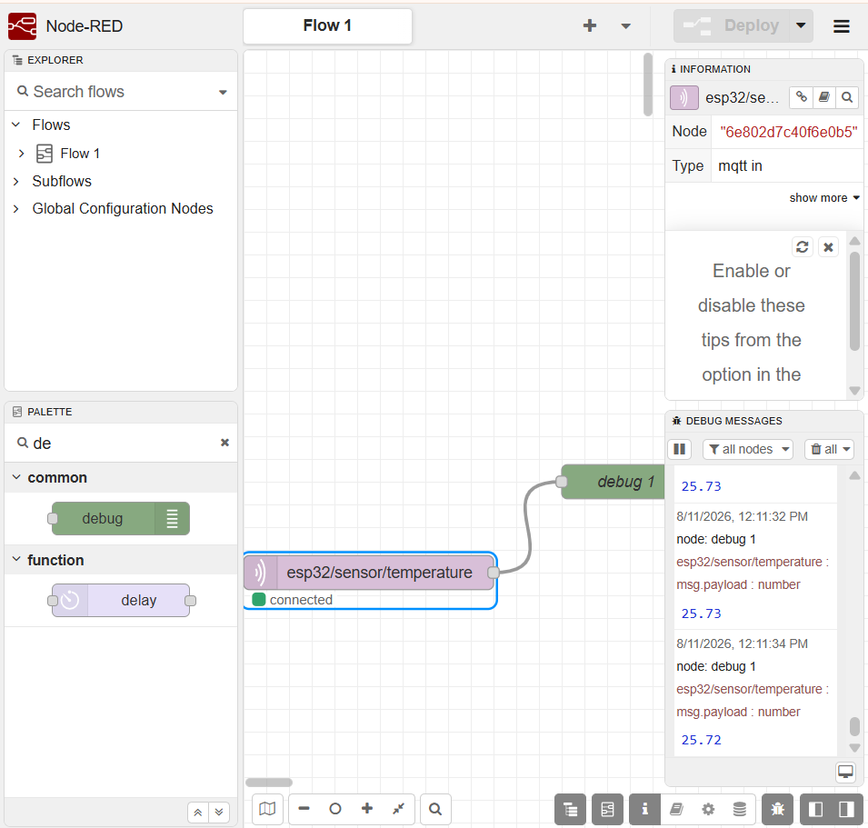
Figure 3. The first successful MQTT test. The MQTT IN node shows connected, and the Debug sidebar prints timestamped temperature payloads arriving from the ESP32 as numbers.
Seeing values in the Debug panel confirmed something a gauge could never have confirmed on its own: that real MQTT data from the ESP32 was reaching Node-RED, rather than a message Node-RED had generated internally. The full path was now proven.
The proven path
ESP32 -> Mosquitto (WSL) -> Windows localhost:1883 -> MQTT IN -> Debug

3.5 Adding the Remaining Sensor Topics
Once temperature worked, humidity and pressure were added the same way. No new topics were created on the device side, since the ESP32 had been publishing all three since Task 11.
Sensor | MQTT topic | Purpose
Temperature | esp32/sensor/temperature | Current temperature from the BME280
Humidity | esp32/sensor/humidity | Current relative humidity
Pressure | esp32/sensor/pressure | Current atmospheric pressure
With all three arriving in the Debug panel, the layered approach had done its job: the ESP32 was known good from Task 11, the broker was known good, and now the Node-RED link was known good too. Only the dashboard layer remained untested, so any problem from this point on could only be a dashboard problem.

4. System Schematic: Hardware Wiring and Node-RED Flow
Two schematics describe this system, and they meet at the broker. One is the physical wiring that turns an MQTT payload into a spinning shaft, the other is the Node-RED flow that turns a topic into a widget. Neither is complete on its own, so both are reproduced here.

4.1 Hardware Wiring and Signal Path
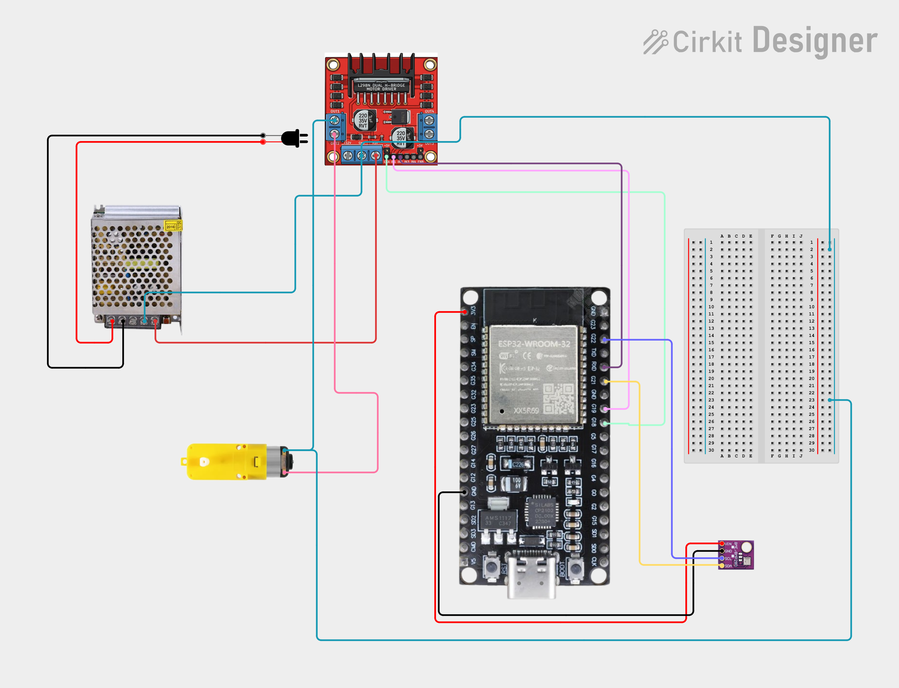
Figure 4. Hardware wiring carried over from the MQTT task: ESP32-WROOM development board, L298N dual H-Bridge driving a DC gear motor, a BME280 module on the I2C bus, and a bench power supply feeding the motor rail, with a breadboard used for distribution and test points.
The wiring separates two power domains and one signal domain. The bench supply feeds the motor rail on the L298N, the ESP32 runs from its own USB-C supply, and the only thing crossing between them at logic level is three control lines and a shared ground. That shared ground is not optional detail, it is the reference the H-Bridge uses to read the direction pins, and without it the driver sees floating inputs and behaves unpredictably even though the wiring looks complete.
Connection | From | To | Purpose
Motor supply | Bench power supply output | L298N motor voltage and ground terminals | Supplies the motor rail. Motor current never passes through the ESP32.
Motor output | L298N OUT1 and OUT2 | DC gear motor terminals | The switched H-Bridge output. Swapping these two wires reverses what forward means.
Direction lines | Two ESP32 GPIO pins | L298N IN1 and IN2 | Set rotation direction. Both LOW isolates the motor, which is what stop() does.
Speed line | One ESP32 PWM-capable GPIO | L298N ENA | Carries the analogWrite PWM duty, 0 to 255, that sets speed. The onboard ENA jumper must be removed for this to have any effect.
Sensor bus | ESP32 SDA and SCL pins | BME280 module | I2C telemetry bus. The module answers on address 0x76 or 0x77, and the firmware probes both.
Sensor power | ESP32 3V3 and GND | BME280 VCC and GND | The sensor draws microamps, so it runs directly off the board regulator.
Common ground | Bench supply ground | L298N ground and ESP32 GND | Ties both supplies to one reference so the logic levels on IN1, IN2 and ENA are meaningful.
One note on scope. The architecture sketches in the working notes list an IR sensor alongside the BME280 and the motor on the ESP32 block. Nothing in Task 3.1 subscribes to or displays an IR value, so it is out of scope for this dashboard and no topic was reserved for it.

4.2 The Node-RED Flow, Node by Node
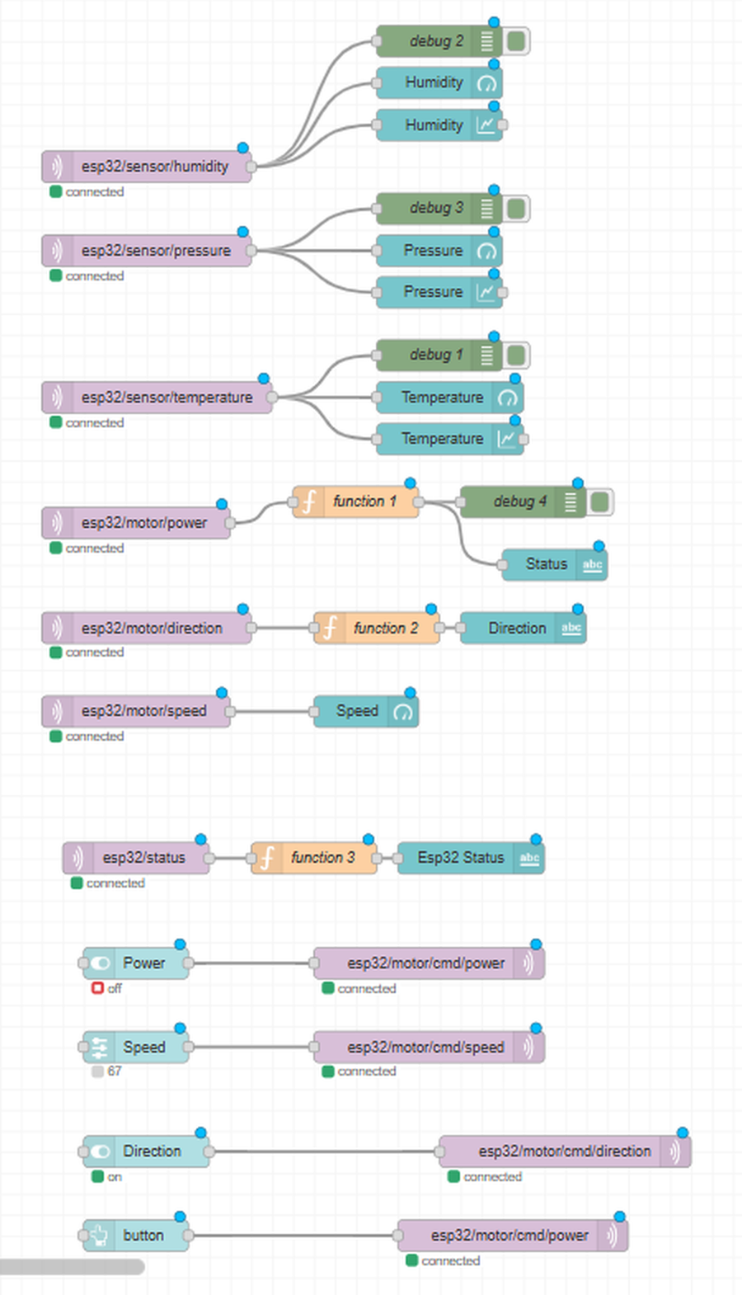
Figure 5. The complete Flow 1 canvas: sensor telemetry chains at the top, motor telemetry and device presence in the middle, and the control widgets publishing to the cmd branch at the bottom. Every MQTT node reads connected, confirming one live session against the shared broker configuration.
The canvas is organised in horizontal bands that mirror the direction of data. Everything above the midpoint is an MQTT IN node feeding widgets, everything below it is a widget feeding an MQTT OUT node. Reading it top to bottom is the fastest way to check the rule that governs this whole task: no indicator is ever wired to a control, and no control is ever wired to a telemetry topic.
Chain | Nodes in order | What it does
Humidity | MQTT IN esp32/sensor/humidity, then debug 2, Humidity gauge, Humidity chart | One subscription fanned out to a debug node and two widgets in parallel.
Pressure | MQTT IN esp32/sensor/pressure, then debug 3, Pressure gauge, Pressure chart | Same pattern, live value plus trend.
Temperature | MQTT IN esp32/sensor/temperature, then debug 1, Temperature gauge, Temperature chart | Same pattern, live value plus trend.
Motor state | MQTT IN esp32/motor/power, then function 1, then debug 4 and the Status text widget | The function node maps running and stopped to a label and a colour, giving the green or red indicator.
Motor direction | MQTT IN esp32/motor/direction, then function 2, then the Direction text widget | The function node translates backward into REVERSE for display while the payload stays untouched.
Motor speed | MQTT IN esp32/motor/speed, then the Speed gauge | Straight to the gauge, since the ESP32 already publishes a 0 to 100 percentage.
Device presence | MQTT IN esp32/status, then function 3, then the Esp32 Status text widget | Maps online and offline to the green or red presence indicator, fed by the retained payload and the Last Will.
Power control | Power switch, then MQTT OUT esp32/motor/cmd/power | Publishes the ON and OFF setpoint.
Speed control | Speed slider, then MQTT OUT esp32/motor/cmd/speed | Publishes the percentage setpoint. The slider reads 67 in the screenshot.
Direction control | Direction switch, then MQTT OUT esp32/motor/cmd/direction | Publishes forward or backward.
Emergency button | button widget, then MQTT OUT esp32/motor/cmd/power | Publishes on the same command topic as the power switch.

4.3 What the Flow Confirms and What It Reveals
Three things are confirmed by the canvas. Every MQTT node carries a green connected marker, so all eleven of them share one working session against the broker configuration described in Section 3.4. Every indicator is fed from a telemetry topic and none of them is fed from a control widget, which is the requirement in Section 6.7 satisfied structurally rather than by convention. And the presence chain on esp32/status is present and connected, so the Last Will path described in Section 7 is wired end to end.
The canvas also reveals two gaps between the design described in this report and the flow as deployed, both worth fixing before flows.json is exported:
- The speed slider wires directly into the MQTT OUT node with no function node between them. The clamping logic set out in Section 8.4 is therefore not present in the deployed flow, and the only protection against an out of range speed is the constrain() call in the firmware. The task asks explicitly for Node-RED itself to be incapable of publishing an invalid value, so the function node has to be inserted into that wire.
- The emergency button publishes to esp32/motor/cmd/power, the same topic the power switch uses, and still carries the default button label. It therefore behaves as a second OFF rather than an independent stop: it does not zero the speed setpoint, and it does not reset the switch and slider positions, so the requested state and the actual state can drift apart after it is pressed.
Two smaller observations, neither of which is a requirement. The motor speed chain has a gauge but no historical chart, which is consistent with the task, since only the three environmental values need a graph. And the four debug nodes are development aids: they cost nothing functionally and they made the layered testing described in Section 3 possible, but disabling them before the final export keeps the runtime log readable and makes the submitted flow easier for a reviewer to follow.

5. Topic Model: Command Topics vs Telemetry Topics

5.1 Why the Separation Is Necessary
A command says what the user wants. Telemetry says what the device is doing. Publishing both on the same topic collapses that distinction and produces two concrete failures. First, the dashboard would show the requested state even when the ESP32 is offline and physically cannot act on it, which is exactly the behaviour the task forbids. Second, because the ESP32 subscribes with the wildcard esp32/motor/#, any status it publishes under that same branch would be delivered straight back to its own callback, so the device would end up parsing its own telemetry as if it were an incoming command.
The namespace therefore keeps device-to-broker traffic on the plain motor branch and broker-to-device traffic on a dedicated cmd sub-branch.

5.2 Telemetry Topics (ESP32 to Node-RED)
Topic | Payload | Meaning | Dashboard widget
esp32/sensor/temperature | float, °C | BME280 temperature reading | Gauge 0 to 50 plus line chart
esp32/sensor/humidity | float, %RH | BME280 relative humidity | Gauge 0 to 100 plus line chart
esp32/sensor/pressure | float, hPa | BME280 barometric pressure | Gauge 0 to 1000 plus line chart
esp32/motor/power | running | stopped | Actual motor state derived from the live driver output | Colour-coded state text, green or red
esp32/motor/direction | forward | backward | stopped | Actual direction currently applied to the H-Bridge | Direction text, presented as FORWARD / REVERSE / STOPPED
esp32/motor/speed | integer 0 to 100 | Actual speed converted back from raw PWM | Speed gauge 0 to 100 percent
esp32/status | online | offline | Connection presence, retained, offline published by the broker as the Last Will | ONLINE / OFFLINE indicator

5.3 Command Topics (Node-RED to ESP32)
Topic | Payload | Meaning | Dashboard widget
esp32/motor/cmd/power | 1 or 0 (also on / off accepted) | Motor ON / OFF setpoint | ui_switch, payload type number
esp32/motor/cmd/direction | forward | backward | Direction setpoint | Direction toggle, presented as Forward / Reverse
esp32/motor/cmd/speed | integer, clamped 0 to 100 | Speed setpoint as a percentage | ui_slider plus clamping function node

5.4 Complete Topic Tree
MQTT namespace after Task 3.1
esp32/
|
|-- sensor/
| |-- temperature (telemetry, float)
| |-- humidity (telemetry, float)
| +-- pressure (telemetry, float)
|
|-- motor/
| |-- power (telemetry, running | stopped)
| |-- direction (telemetry, forward | backward | stopped)
| |-- speed (telemetry, 0 to 100)
| |
| +-- cmd/
| |-- power (command, 1 | 0)
| |-- direction (command, forward | backward)
| +-- speed (command, 0 to 100)
|
+-- status (presence, online | offline, retained + LWT)
The structure is hierarchical rather than flat, which is what makes the wildcard subscription esp32/motor/# workable on the device side: any new command sub-topic added later is picked up automatically without a firmware change, while each telemetry topic stays individually addressable so MQTT Explorer, Node-RED and any other subscriber can watch a single value change on its own.

5.5 Firmware Alignment Note
Moving the commands into the cmd branch is a change on both sides, not only in Node-RED. Three points need to hold true in the firmware for the split to work end to end, and they are worth checking against the current sketch before the flow is demonstrated:
- The topic comparisons inside mqttCallback must match the new command topics, that is esp32/motor/cmd/power, esp32/motor/cmd/direction and esp32/motor/cmd/speed. If they still compare against esp32/motor/power, commands published by the dashboard will arrive but never match, and the motor will not respond.
- The wildcard subscription esp32/motor/# already covers the cmd sub-branch, so no additional subscribe call is needed.
- The status publisher writes the running or stopped string to esp32/motor/power, which is the topic the dashboard state indicator reads. In the earlier firmware that string was published to esp32/motor/state, so whichever topic is kept, the Node-RED MQTT IN node and the publish call have to agree.

6. Part 2: Dashboard Layout and Live Telemetry

6.1 Layout and Grouping
Widgets are grouped by function rather than dropped onto one page in the order they were created. The dashboard tab, Environmental Monitor, contains an environmental group per measurement, a motor status group, a device presence group and, on the bottom row, the control groups. Grouping this way is what keeps the layout readable when the browser is narrow: the dashboard reflows groups into a single column on a phone, so a group that mixes unrelated widgets becomes hard to read on a small screen, while a group that holds one measurement stays coherent.
Group | Contents | Direction
Pressure / Temperature / Humidity | Live gauge and historical line chart for each measurement | ESP32 to dashboard
Motor status | Direction text, colour-coded state text, speed gauge | ESP32 to dashboard
Esp32 | ONLINE / OFFLINE presence indicator driven by esp32/status | Broker and ESP32 to dashboard
Control | Speed slider, direction toggle, power toggle | Dashboard to ESP32
Emergency | Emergency stop button, kept visually separate from the normal power toggle | Dashboard to ESP32

6.2 Environmental Telemetry: Gauges and Historical Charts
Each of the three BME280 values is subscribed once and then wired to two widgets in parallel, a gauge for the instantaneous value and a chart for the trend. This is one of the advantages of a flow-based runtime: one message can be sent down several paths, so there is no need for the gauge, the chart and the debug node to each hold their own MQTT subscription.
Telemetry flow, one per measurement
[ MQTT IN: esp32/sensor/temperature ]
|
+-----+-----+-----------+
v v v
[ ui_gauge ] [ ui_chart ] [ debug ]
Widget | Configuration | Reasoning
Temperature gauge | Range 0 to 50, unit °C | Covers indoor and lab ambient range with usable needle resolution.
Humidity gauge | Range 0 to 100, unit % | Relative humidity is a percentage by definition.
Pressure gauge | Range 0 to 1000, unit hPa | Wide range. At roughly 894 hPa in Amman the needle sits near full scale, so a narrower range such as 850 to 950 would give far better visual resolution.
Line charts | X-axis window of about 35 minutes, one series per chart | Satisfies the requirement for at least a few minutes of history.
The gauge answers what the value is right now. The chart answers whether it is rising, falling or steady, which the gauge cannot show at all. Together they are worth more than either alone, and the task asks for both.
Chart persistence deserves its own note. The requirement is that history is not lost on a browser refresh. The chart node keeps its series in the Node-RED runtime, not in the browser, so a refresh reloads the stored buffer as long as the chart's time window or point limit has not expired and the flow has not been redeployed. A full deploy clears chart state, which is expected behaviour rather than a fault. Seeing a line on the graph does not by itself prove the requirement is met, so this is tested deliberately as described in Section 12.

6.3 Value Format: Correct Data, Wrong Presentation
The first gauge appeared on the dashboard without showing its value, even though the MQTT connection was working and the debug node was printing numbers. The cause was the gauge's Value Format field, which had not been configured. Setting it to interpolate the incoming value and append the unit fixed the display:
Gauge value format
{{value}} °C

payload received: 25.4
gauge displays: 25.4 °C
The same pattern was applied to humidity with a percent unit and pressure with hPa. The lesson is worth recording because it will come up again: MQTT data can be entirely correct while the dashboard presentation is misconfigured. When a widget looks wrong, the debug node answers the question of which layer to fix, and in this case it pointed away from the network and towards the widget.

6.4 Motor State Telemetry
The state indicator subscribes to esp32/motor/power, where the ESP32 publishes the string running or stopped. A small function node maps the payload to a colour and a label so the widget renders a green marker with RUNNING or a red marker with STOPPED, which satisfies the colour-coding requirement. The value is a report from the driver, not a mirror of the power switch.
Motor state flow
[ MQTT IN: esp32/motor/power ]
|
v
[ Function: map to label + colour ]
|
v
[ ui_text: green RUNNING / red STOPPED ]

6.5 Motor Direction Telemetry
The direction indicator subscribes to esp32/motor/direction, which carries forward, backward or stopped. The dashboard presents these in operator language, so backward is displayed as REVERSE, while the MQTT payload itself is left untouched. Presentation is changed at the UI layer only, which keeps the wire format stable for any other subscriber and avoids a second vocabulary inside the protocol.
MQTT payload | Dashboard display
forward | FORWARD
backward | REVERSE
stopped | STOPPED

6.6 Motor Speed Telemetry
Speed is reported on esp32/motor/speed as a percentage. The firmware reads the raw PWM value back out of the L298N instance and converts it before publishing, so the number on the gauge is derived from the driver output rather than from the slider position:
ESP32 side, PWM converted back to a percentage
speed = motor.getSpeed(); // raw PWM, 0 to 255
speed = map(speed, 0, 255, 0, 100); // back to a percentage
client.publish("esp32/motor/speed", String(speed).c_str());
The gauge is configured with a minimum of 0, a maximum of 100 and the percent unit. One consequence of the double conversion is worth stating plainly: the setpoint goes through map(percent, 0, 100, 0, 255) on the way in and map(pwm, 0, 255, 0, 100) on the way back, and both use integer arithmetic, so the reported value can land a point or two away from the value that was requested. That is not a bug in the dashboard, it is the round trip through an 8-bit PWM register being reported honestly.

6.7 Why Actual Telemetry Matters: Command State vs Actual State
The task requires the dashboard to reflect real device state rather than echo the last command. The two architectures differ in one step, and that step is the whole point of the exercise:
Correct path, the dashboard reports reality
User presses ON
-> Node-RED publishes 1 to esp32/motor/cmd/power
-> ESP32 receives and validates the command
-> Motor hardware is driven through the L298N
-> ESP32 reads the driver's live state
-> publishMotorStatus() publishes the true state
-> Node-RED receives the telemetry
-> Dashboard shows RUNNING
Wrong path, the dashboard assumes success
User presses ON
-> Dashboard immediately shows RUNNING
The second version is wrong because it assumes the motor responded. If the ESP32 is offline, if Wi-Fi has dropped, or if the failsafe in applyMotorHardware has forced a stop, the motor is not running and the dashboard would be lying to the operator. This is why the power switch and the state indicator are two separate widgets on the dashboard: the switch expresses the requested state, and the indicator expresses the reported state. Figure 7 shows them agreeing, which is the normal case, but the value of the design is that they are free to disagree when something has gone wrong.

7. Connection Status Detection: MQTT Last Will and Testament

7.1 The Stale Dashboard Problem
MQTT is a session protocol over TCP, and a device that is unplugged does not get the chance to announce anything. Without a presence mechanism the dashboard simply stops receiving updates and keeps rendering the last values it saw, so a screen reading RUNNING, 70 percent, ONLINE can persist long after the ESP32 has lost power. A frozen dashboard is more dangerous than an obviously broken one, because it looks correct.

7.2 LWT Topic and Payloads
A dedicated presence topic was created outside the sensor and motor branches, since it describes the device itself rather than any one subsystem:
Topic | Payload | Published by | Meaning
esp32/status | online | The ESP32, immediately after a successful connect, retained | The device is connected
esp32/status | offline | The broker, on the device's behalf, as the Last Will | The device disconnected unexpectedly

7.3 Configuring the Last Will on the ESP32
The Last Will is registered inside the CONNECT packet, which means it must be declared at connection time and cannot be added later. The plain connect call was therefore replaced with the five argument form:
Before
client.connect("ESP32Client");
After, with the Last Will registered
client.connect(
"ESP32Client", // client ID
"esp32/status", // will topic
1, // will QoS
true, // will retain
"offline" // will message
);
Parameter | Value | Why this value
Client ID | ESP32Client | Identifies the session on the broker. It must not collide with the Node-RED client ID.
Will topic | esp32/status | The presence topic the dashboard indicator subscribes to.
Will QoS | 1 | At least once delivery for the announcement, so a single dropped packet does not leave the dashboard thinking the device is still online.
Will retain | true | The broker stores offline as the retained value on that topic, so a browser or a Node-RED restart that subscribes later is told the device is down straight away.
Will message | offline | The payload the dashboard maps to the red OFFLINE indicator.
The broker publishes this message when the client goes away without a clean DISCONNECT packet, which covers the cases that matter here: the ESP32 losing power, the Wi-Fi link dropping, a network error, or the keep-alive period elapsing with no traffic from the device. A deliberate, clean disconnect does not trigger the Will, which is the intended behaviour.

7.4 Publishing the Retained Online State
The Will covers the failure case. The healthy case has to be published by the device itself, right after the connection succeeds:
Publishing the online state, retained
client.publish("esp32/status", "online", true);
The third argument sets the retain flag. Retention is what makes the indicator correct on a late subscriber: Mosquitto keeps the most recent payload on esp32/status, so when Node-RED is restarted or the dashboard is opened in a new browser tab, the indicator is populated immediately from the retained value instead of sitting blank until the next status change. Since both the online publish and the offline Will are retained, the topic always holds the current answer rather than the last event.

7.5 LWT Flow and the Node-RED Connection Indicator
Healthy connection
ESP32 connects
-> publishes "online" (retained)
-> Mosquitto retains "online"
-> Node-RED MQTT IN: esp32/status
-> Dashboard shows green ONLINE
Unexpected disconnection
ESP32 drops (power loss, Wi-Fi loss, keep-alive timeout)
-> Mosquitto detects the broken session
-> Mosquitto publishes the Last Will "offline" (retained)
-> Node-RED MQTT IN: esp32/status
-> Dashboard shows red OFFLINE
On the Node-RED side this is a single MQTT IN node on esp32/status feeding a function node that maps the payload to a label and a colour, then a text widget in the Esp32 group. It is the cheapest chain in the flow and the most valuable, because it is the one that tells the operator whether anything else on the screen can be trusted.

7.6 Detection Timing and Keep-Alive
The requirement is that the dashboard shows the offline status within a few seconds. How fast that actually happens is governed by the MQTT keep-alive, not by Node-RED. If the ESP32 is unplugged, the broker only learns about it when the TCP session breaks or when the keep-alive interval elapses without a packet from the client. PubSubClient sets the keep-alive to 15 seconds by default, and the broker allows one and a half times that interval before declaring the client dead, so a silent power loss can take around 20 to 25 seconds to surface. Calling client.setKeepAlive() with a shorter interval, for example 5 seconds, before connecting brings detection down to the few seconds the task asks for, at the cost of slightly more PINGREQ traffic. This is the one timing detail that should be measured with a stopwatch during the disconnect test rather than assumed.

8. Part 2: Control Panel, Node-RED to ESP32
With telemetry in place, the flow was extended in the opposite direction so the dashboard can drive the hardware. All three controls publish to the cmd branch and none of them writes to a telemetry topic.

8.1 Motor Power Control
A ui_switch labelled Motor Power sends 1 when it is on and 0 when it is off, with the payload type set to number so the widget does not emit the JavaScript booleans true and false, which the firmware's string comparison would not match.
Power control flow
[ ui_switch: Motor Power ]
| 1 / 0
v
[ MQTT OUT: esp32/motor/cmd/power ]
On the device side the payload is parsed permissively, so the same topic still works from MQTT Explorer or the command line where a human is more likely to type on than 1:
ESP32 side, power parsing
targetPower = (message == "1" || message == "on" || message == "ON");

8.2 Motor Direction Control
Direction is exposed as a two-state control. The dashboard presents Forward and Reverse, while the payloads published on esp32/motor/cmd/direction remain forward and backward, matching the strings the firmware compares against. The firmware accepts nothing else, so a malformed direction payload leaves the previous setpoint untouched rather than putting the H-Bridge into an undefined state.
Direction control flow
[ Direction control: Forward / Reverse ]
| forward / backward
v
[ MQTT OUT: esp32/motor/cmd/direction ]

ESP32 applies the setpoint, then reports the
resulting direction on esp32/motor/direction

8.3 Motor Speed Control
Speed uses a ui_slider with a minimum of 0, a maximum of 100 and a step of 1, publishing a percentage that the firmware converts to PWM. The slider value should pass through a validation node before it reaches the MQTT OUT node, never directly.
Speed control flow
[ ui_slider: 0 to 100 ]
|
v
[ Function: clamp and validate ]
|
v
[ MQTT OUT: esp32/motor/cmd/speed ]

8.4 Speed Validation and Clamping Inside Node-RED
The firmware already clamps every incoming speed value with constrain(SpeedValue, 0, 100), and that stays in place as the last line of defence. The task nevertheless requires Node-RED itself to be incapable of publishing an invalid value, and the reasoning behind that requirement is sound: the ESP32 is not the only possible consumer of these topics, and a UI that emits garbage and relies on the device to clean it up is a UI that will eventually be pointed at a device that does not.
Function node, clamping logic
let speed = Number(msg.payload);

if (!Number.isFinite(speed)) {
speed = 0;
}

speed = Math.max(0, Math.min(100, speed));

msg.payload = speed;
return msg;
Number() rather than parseInt() is used deliberately, so that a payload such as 50abc becomes NaN and is caught rather than being silently truncated to 50. The guarantee this produces is that every message leaving Node-RED on the speed command topic satisfies 0 <= speed <= 100.
One caveat, stated here rather than buried: in the flow as captured in Figure 5 the slider is wired straight to the MQTT OUT node, so this function node is the required design but is not yet in the deployed path. Until it is inserted, the only clamp in the system is the constrain() call on the ESP32, which protects the motor but does not satisfy the requirement that Node-RED cannot publish an invalid value.
Input from slider or debug node | Published value
-20 | 0
0 | 0
50 | 50
100 | 100
150 | 100
Invalid or non-numeric value | 0
The test for this is to bypass the slider entirely and wire an inject node with a payload of 150 and another with -20 directly into the function node, then watch the published payload in MQTT Explorer or a debug node. Testing through the slider alone proves very little, because the widget will not let its own value leave the configured range in the first place.

8.5 Slider Publishing Behaviour
The task allows publishing on drag or on release, provided the choice is documented. This dashboard publishes on release. Dragging the slider from 0 to 75 therefore produces one MQTT message carrying 75, rather than one message for every intermediate position the handle passes through.
Publish on release
Drag slider 0 -> 10 -> 20 -> ... -> 75
Release at 75
-> validate
-> publish 75 to esp32/motor/cmd/speed
The reason is bandwidth and hardware behaviour rather than aesthetics. Continuous publishing would send dozens of messages per drag, each one triggering a callback, a hardware write and a status publish on the ESP32, which floods the broker log and makes the PWM output chase the handle. The trade-off is a small loss of live feel while dragging, which does not matter for a speed setpoint.

8.6 Emergency Stop
An Emergency group sits beside the Control group, deliberately separated so that the stop is never confused with the ordinary power toggle and stays visible without scrolling. The button is wired, as Figure 5 shows, but it publishes to esp32/motor/cmd/power, the same topic the power switch uses, and it still carries the default button label. In its current form it is a second OFF rather than an independent emergency stop, so this is the one control from the task specification that is not finished, and it is carried into Section 12 as remaining work.
The intended behaviour, so the wiring is unambiguous when it is completed:
- The button publishes a stop command in its own right rather than flipping the power switch, so it works regardless of the state of the other widgets.
- It should force the power command off and the speed setpoint to 0 in the same action, so that a subsequent power-on cannot restart the motor at the previous speed unexpectedly.
- It should also reset the dashboard's own switch and slider positions, so that requested state and actual state stay consistent after the stop.
- It stays visible and reachable on both the laptop and the phone layout, because a stop control that requires scrolling is not a stop control.

9. Part 3: Requirements Compliance
Requirement | How it is satisfied | Status
Node-RED installed locally via npm and run from the terminal | Installed globally with npm install -g --unsafe-perm node-red on Windows, started with node-red in PowerShell, log visible throughout. | Met
Connected to the existing Mosquitto broker, no second broker | One shared broker configuration node at localhost:1883, reusing the Task 11 port forwarding into WSL. | Met
Dashboard reflects real device state, not the last command | Every status widget is fed from a telemetry topic that the ESP32 publishes after reading the L298N driver state. The command topics live on a separate cmd branch and are never wired into an indicator. | Met
Retained messages or LWT so Node-RED knows the ESP32 is offline | Last Will registered in the CONNECT packet on esp32/status with QoS 1 and retain true, plus a retained online publish after each successful connect. | Met
Historical graphs persist across a short session | Chart series are buffered in the Node-RED runtime with a time window of roughly 35 minutes, so a browser refresh redraws the stored history. | To be verified deliberately
Slider input cannot send an invalid value | The clamping function node using Number(), a finite check and Math.max / Math.min is specified in Section 8.4, but the deployed flow wires the slider straight to the MQTT OUT node. The constrain() clamp in the firmware still protects the motor. | Outstanding in Node-RED
Layout usable on laptop and phone browsers | Widgets are organised into functional groups so the dashboard reflows into a single readable column on a narrow viewport. | To be verified on a phone
Emergency stop clearly separate from the normal OFF and always visible | A dedicated Emergency group is placed next to the Control group and the button is wired, but it publishes to the same command topic as the power switch, so it duplicates OFF rather than acting independently. | Outstanding

10. End-to-End Verification & Screenshots
With Mosquitto running verbosely in its WSL terminal, Node-RED running in its PowerShell terminal and the ESP32 connected over Wi-Fi, the dashboard was exercised in both directions. The two figures below are the same dashboard in two different hardware states, which is the clearest evidence that the indicators track the motor rather than the widgets.
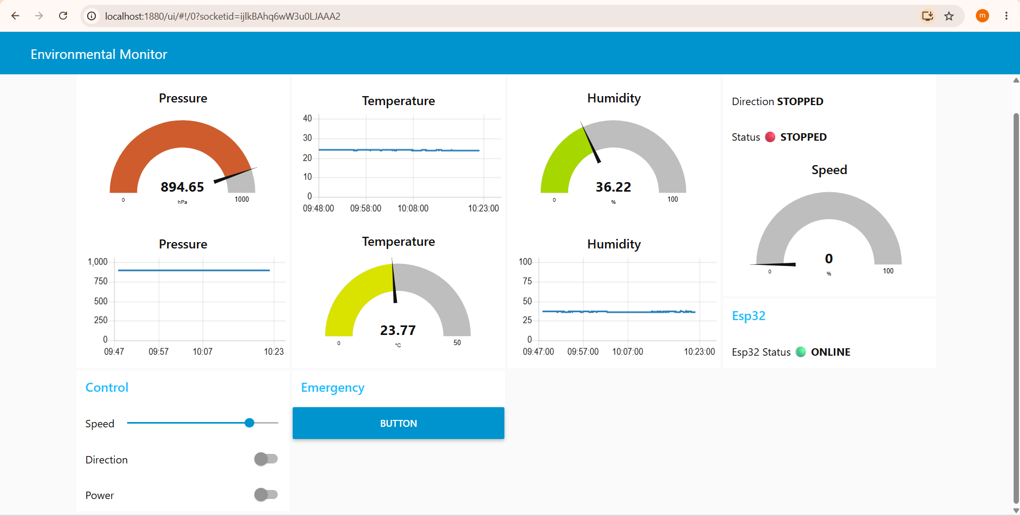
Figure 6. Dashboard at http://localhost:1880/ui with the motor powered off. Direction reads STOPPED, the state indicator is red STOPPED and the speed gauge reads 0, while the environmental gauges and charts keep updating and the presence indicator shows a green ONLINE from the retained esp32/status payload.
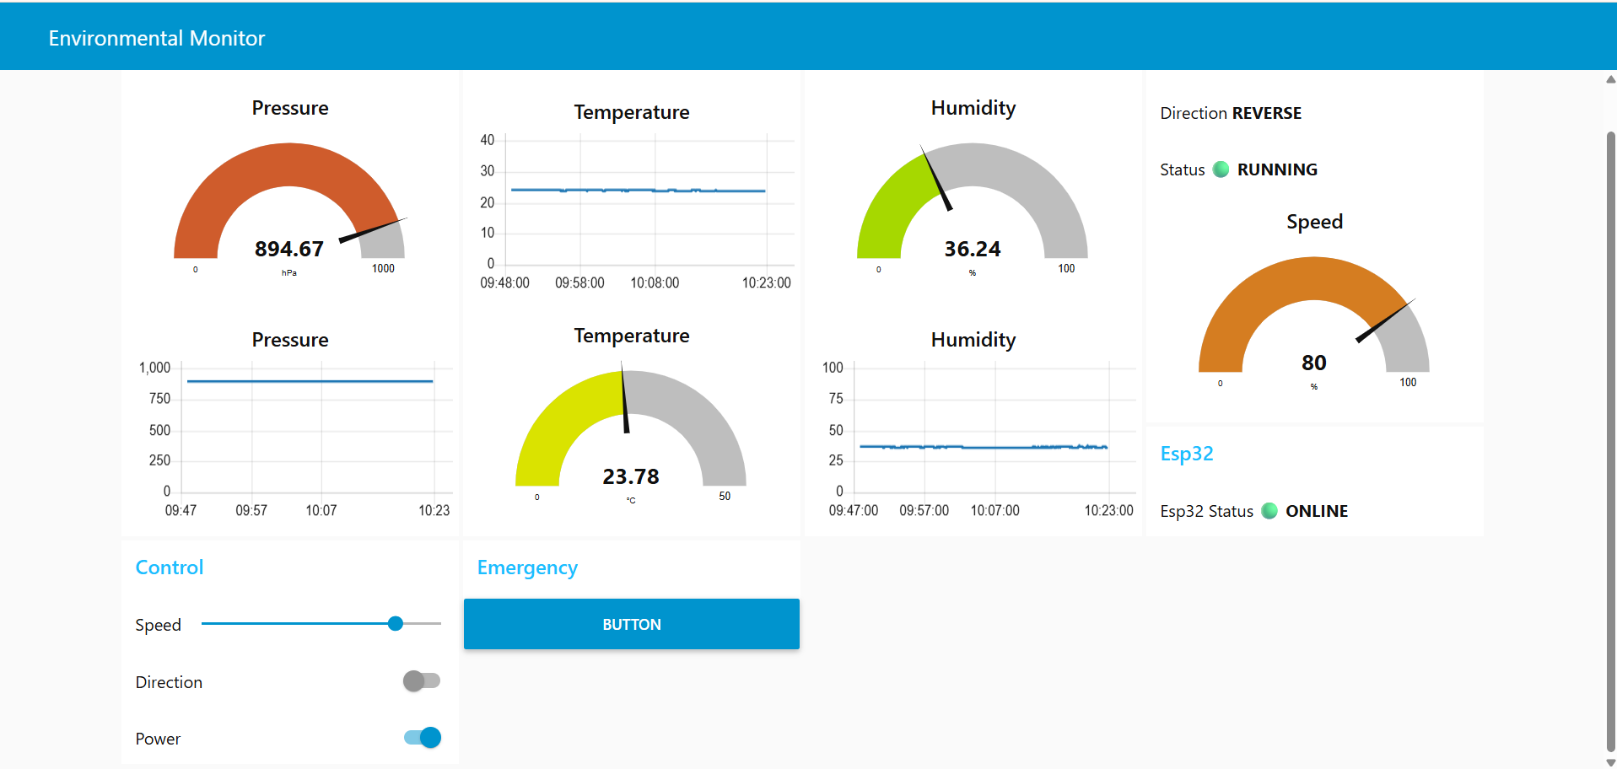
Figure 7. The same dashboard with the motor running in reverse. Direction reads REVERSE, the state indicator is green RUNNING and the speed gauge shows the percentage reported back by the ESP32 after the PWM round trip, not the raw slider position.
Observed behaviour during testing matched the design intent. Publishing an off command, cutting Wi-Fi or stopping the broker caused the motor to stop and the state topic to report stopped on the very next status publish, so the dashboard never stayed on a stale running value. Restoring Wi-Fi or restarting the broker produced an automatic reconnection, a re-subscription and a fresh status publish without an ESP32 reset, and the retained esp32/status payload brought the presence indicator back to ONLINE on its own.
Two checks are still worth running with the same rigour before submission: pulling the ESP32's power and timing how long the indicator takes to flip to OFFLINE, as discussed in Section 7.6, and refreshing the browser mid-session to confirm the charts redraw their history rather than starting from an empty axis.

11. Definition of Done
Criterion | Status
Node-RED running from terminal, connected to the local Mosquitto broker | Met, single shared broker config node at localhost:1883
Dashboard shows live temperature, humidity and pressure as both gauges and graphs | Met, see Figures 6 and 7
Motor state, direction and speed shown live and reflecting real hardware behaviour | Met, driven by publishMotorStatus() telemetry
ON/OFF, direction and speed controls actually control the motor | Met, published to the esp32/motor/cmd branch, see Figure 5
Emergency stop works independently and instantly | Outstanding, button wired to the same power command topic as the switch
Disconnecting the ESP32 shows a clear offline status within a few seconds | Implemented via LWT, timing to be measured, see Section 7.6
Flow exported as flows.json and included in the repository | Pending
README updated with screenshots, the topic list and a note on LWT implementation | Pending, topic list available in Section 5 of this report

12. Remaining Work and Next Steps
- Rework the emergency stop so it is more than a second OFF: give the button its own label and payload, force the speed setpoint to 0 alongside the power off, and reset the dashboard switch and slider positions.
- Insert the clamping function node from Section 8.4 into the wire between the speed slider and the MQTT OUT node, since the deployed flow currently publishes the slider value directly.
- Shorten the MQTT keep-alive on the ESP32 with client.setKeepAlive() so the offline indicator appears within a few seconds, then measure the real detection time by pulling power.
- Test the clamping path directly with inject nodes carrying 150, -20 and a non-numeric payload, and confirm in MQTT Explorer that only values between 0 and 100 reach the broker.
- Verify chart persistence across a browser refresh, and set the chart removal window explicitly so the retained history is a documented figure rather than a default.
- Open the dashboard on a phone over the LAN IP and confirm the groups reflow cleanly and the emergency control stays reachable without scrolling.
- Narrow the pressure gauge range from 0 to 1000 down to something like 850 to 950, so the needle carries usable resolution at Amman's ambient pressure.
- Confirm which dashboard package is actually installed and state its name and version in the README, since the palette dialog shows node-red-dashboard installed while the working notes mention the FlowFuse package.
- Disable or delete the four debug nodes, then export flows.json, capture the final screenshots and update the README with the topic table from Section 5 and the LWT explanation from Section 7.

13. References
Node.js downloads, used to install the runtime and npm on Windows. https://nodejs.org/en/download
Node-RED, Running Node-RED locally, including the global npm install and the default port 1880. https://nodered.org/docs/getting-started/local
Microsoft, about_Execution_Policies, PowerShell execution policy scopes and the RemoteSigned policy. https://learn.microsoft.com/en-us/powershell/module/microsoft.powershell.core/about/about_execution_policies
node-red-dashboard, Node-RED flow library. Deprecation announcement dated 27 June 2024. https://flows.nodered.org/node/node-red-dashboard
FlowFuse Dashboard, Node-RED Dashboard 2.0 documentation. https://dashboard.flowfuse.com
@flowfuse/node-red-dashboard, npm package page. https://www.npmjs.com/package/@flowfuse/node-red-dashboard
PubSubClient, Arduino Client for MQTT, API documentation, keep-alive default of 15 seconds and setKeepAlive(). https://pubsubclient.knolleary.net/api
PubSubClient repository and README, MQTT 3.1.1 by default, QoS 0 publishing only. https://github.com/knolleary/pubsubclient
HiveMQ, MQTT Essentials Part 9, Last Will and Testament. https://www.hivemq.com/blog/mqtt-essentials-part-9-last-will-and-testament/
EMQX, MQTT Will Message explained. https://www.emqx.com/en/blog/use-of-mqtt-will-message
Eclipse Mosquitto documentation, mosquitto.conf reference, listener and allow_anonymous directives. https://mosquitto.org/man/mosquitto-conf-5.html
MQTT Explorer. https://mqtt-explorer.com

