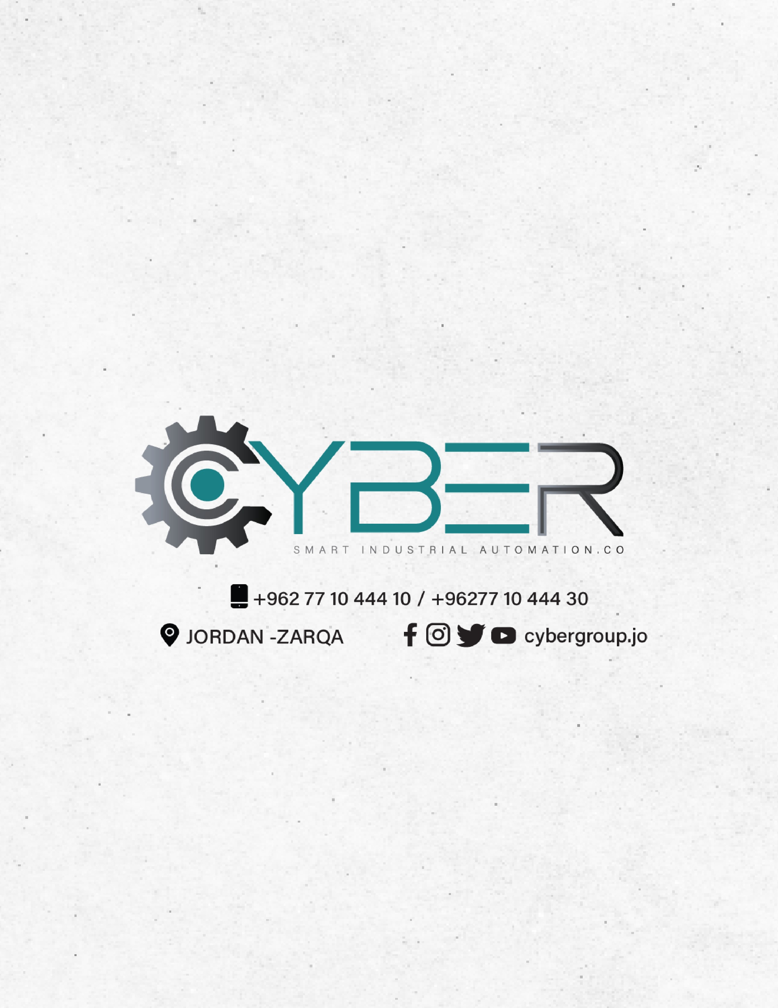

Daily Report

DATE: 21/7 /2026

Department: IoT & Embedded Systems Department

Name: Malak Alsharqawi

Tasks | Time | Status  (In progress, Done) | Expected end time | Comments
Start studying the fundamentals of embedded systems to fill the gap | 10:00 AM | DONE | 12:00 AM | There are several concepts that I wasn’t familiar with, so I had to take my time to fill this gap and understand everything very well by establishing a solid foundation
Writing the first part of the report that covers all the fundamentals | 12:00 PM | DONE | 1:00 PM | Since we were instructed to write this report so that it can be easily understood by beginners, we need to ensure all the core fundamentals are thoroughly covered.
Study and write the first section | 1:00 PM | DONE | 1:45 PM
Study and write the second section | 1:45 PM | DONE | 2:30 PM | Because I covered these topics during my university embedded systems coursework, the underlying theory is already familiar to me
Study and write the third section | 2:30 PM | DONE | 3:45 PM | The task took longer than anticipated as I had to thoroughly review power electronics.

