IoT / EMBEDDED SYSTEMS
Daily Technical Report
Project Title | IoT Training Program
Report / Day No. | Day 4
Date | 22/7/2026
Prepared By | Malak Alsharqawi
Organization | Cyber Robot
Confidential — Internal Training Documentation

Table of Contents
1. Daily Overview
1.1 Summary
1.2 Tasks Completed Today
2. Task 1: HW-872A (ACS712-05B) Current Sensor
2.1 Objective
2.2 What Is the HW-872A / ACS712 Sensor
2.3 How the Sensor Works (Hall Effect)
2.4 Hardware Setup & 3.3V Test Results
2.5 Code / Configuration
2.6 Code Breakdown
3. Task 2: SRD-05VDC Relay Module
3.1 Terminal Definitions
3.2 Trigger Logic: Active-LOW vs Active-HIGH
3.3 Safety Behavior on Disconnect & Fail-Safe Design
3.4 System Behavior Matrix
3.5 Identifying Relay Type (Jumper Test)
3.6 Standalone Relay Test Code
4. Task 3: Push Button & LED Diagnostic Test
4.1 Test Configuration
4.2 4-Pin Tactile Switch Wiring
4.3 Internal Pull-Up Logic
4.4 Diagnostic Code & Code Breakdown
4.5 Verification Results
5. Task 4: Complete System Integration
5.1 System Hardware Breakdown
5.2 Pinout & Wiring
5.3 Circuit Flow Diagram
5.4 Control & Safety Logic
5.5 Final Integrated Firmware
5.6 Code Breakdown
5.7 Verification & Telemetry Results
6. Key Technical Concepts
7. Schematics & Photos
8. Issues & Troubleshooting
9. Results & Outcome
10. Project Documentation & Notes

1. Daily Overview

1.1 Summary
Day 4 focused on building out the motor-protection sensing and switching stack for the ESP32-S3 platform. Work began with the HW-872A (ACS712-05B) Hall-effect current sensor, which was powered and tested directly on the 3.3V rail rather than its nominal 5.0V, requiring an empirically measured zero-current baseline instead of the datasheet value. The SRD-05VDC relay module was then characterized in detail — its Active-LOW / Active-HIGH trigger logic, its NO/NC contact behavior, and the fail-safe implications of each wiring choice during a microcontroller crash or disconnection. A 4-pin tactile push button was diagnosed next, focusing on the internal leg-pairing trap that can silently short a switch to ground if wired incorrectly. Finally, all three subsystems — current sensor, relay, and push button — were combined into a single polling-based motor protection system, which was progressively hardened into a final firmware build featuring dual-action button logic (E-Stop / Reset), a 4-LED status panel, and overcurrent auto-cutoff.

1.2 Tasks Completed Today
- HW-872A / ACS712-05B current sensor — 3.3V direct integration, baseline calibration, and live current measurement
- SRD-05VDC relay module — trigger logic, NO/NC fail-safe wiring, and standalone switching test
- 4-pin tactile push button — diagnostic wiring test with LED indicator using INPUT_PULLUP
- Integrated subsystem test — relay + current sensor + E-Stop push button on one polling loop
- Final integrated motor protection system — overcurrent trip, E-Stop/Reset dual-action button, and 4-LED status panel

2. Task 1: HW-872A (ACS712-05B) Current Sensor

2.1 Objective
Integrate the HW-872A current sensor breakout (Allegro ACS712ELCTR-05B-T) with the ESP32-S3, running it directly from the 3.3V rail, and empirically calibrate its zero-current baseline and sensitivity so that real load current can be read reliably over serial.

2.2 What Is the HW-872A / ACS712 Sensor
The HW-872A is an analog current-sensing breakout module designed to measure both DC and AC electrical currents, up to ±5A for the 05B variant. Unlike a direct shunt resistor that measures a voltage drop in series with the power line, the ACS712 uses indirect magnetic (Hall-effect) sensing, which provides galvanic isolation up to 2.1kV RMS — keeping the high-voltage power path physically separate from the low-voltage ESP32-S3.
Specification | Value
Sensor IC | Allegro ACS712ELCTR-05B-T
Current Range | ±5 Amps
Datasheet Sensitivity | 185 mV/A (0.185 V/A) at 5.0V supply
Output Type | Analog voltage (VOUT)

2.3 How the Sensor Works (Hall Effect)
- Current Conduction — current enters and exits through the heavy internal copper trace between the two screw terminals.
- Magnetic Field Generation — current flowing through that conductor generates a proportional magnetic field (Ampere's Law).
- Hall Element Detection — an integrated linear Hall IC senses the magnetic field without touching the conductor.
- Voltage Output — an internal low-noise amplifier converts the sensed field into a proportional analog voltage on the OUT pin.

2.4 Hardware Setup & 3.3V Test Results
The datasheet specifies standard 5.0V operation, which yields a 2.5V zero-current baseline. For this build, the sensor was powered directly from the ESP32-S3's 3.3V rail with no additional voltage-divider resistors.

Hardware Connections
- VCC → ESP32-S3 3.3V rail
- GND → ESP32-S3 GND pin
- OUT → ESP32-S3 GPIO 4 (ADC1_CH3)

Measured Results
Test | Observation | Conclusion
No-Load Baseline (0A) | Raw ADC averaged 1961.5 → 1.581 V | 3.3V supply lowers the theoretical 1.650V midpoint to 1.581V; used as the software zero-offset
Active Small Load (5mm LED) | Pin voltage rose to 1.586–1.588 V | Current registered between 0.027 A and 0.038 A (27–38 mA), confirming milliamp-level sensitivity

2.5 Code / Configuration
main.cpp — ACS712 3.3V current-sensing sketch:
/*
* HW-872A / ACS712 5A Current Sensor (3.3V Direct Mode)
* Hardware: ESP32-S3
* Pin: GPIO 4 (ADC1)
*/

#include <Arduino.h>

// Configuration Constants
const int SENSOR_PIN = 4; // ESP32-S3 ADC Pin
const float SENSITIVITY = 0.185; // 0.185 V/A (185 mV/A) for ACS712 5A
const float RESTING_OFFSET = 1.581; // Measured 0A baseline voltage at 3.3V power

void setup(){
Serial.begin(115200);
while (!Serial && millis() < 3000); // Wait up to 3s for native USB CDC
analogSetPinAttenuation(SENSOR_PIN, ADC_11db); // 0 - ~3.1V ADC range
Serial.println("\n--- ACS712 3.3V Current Sensor Initialized ---");
}

void loop(){
// 1. Average 50 readings to filter out analog ADC noise
long rawSum = 0;
for (int i = 0; i < 50; i++) { rawSum += analogRead(SENSOR_PIN); delay(2); }
float avgADC = rawSum / 50.0;

// 2. Convert 12-bit ADC reading (0 - 4095) to Voltage (0 - 3.3V)
float pinVoltage = (avgADC / 4095.0) * 3.3;

// 3. Calculate current: I = (V_measured - V_resting) / Sensitivity
float current = (pinVoltage - RESTING_OFFSET) / SENSITIVITY;

// 4. Output values
Serial.print("Raw ADC: "); Serial.print(avgADC, 1);
Serial.print(" | Pin Voltage: "); Serial.print(pinVoltage, 3);
Serial.print(" V | Measured Current: "); Serial.print(current, 3);
Serial.println(" A");
delay(500);
}

2.6 Code Breakdown
- analogSetPinAttenuation(SENSOR_PIN, ADC_11db) — expands the ESP32-S3's full-scale ADC range on GPIO 4 to roughly 3.1V across the 12-bit (0–4095) resolution.
- 50-sample averaging loop — Hall-effect sensors pick up electromagnetic ripple and ADC thermal noise; averaging 50 consecutive reads smooths this into a stable measurement.
- Pin Voltage = (Average ADC / 4095.0) × 3.3 — converts the raw digital integer into an actual physical voltage (0.000–3.300V).
- Current (A) = (V_measured − 1.581) / 0.185 V/A — subtracts the empirically calibrated resting offset to center zero amps, then divides by the sensitivity factor to yield net Amperes.

3. Task 2: SRD-05VDC Relay Module
A relay is an electromechanical switch that lets a low-power microcontroller signal (3.3V/5V from an ESP32) control a high-power AC or DC circuit safely.

3.1 Terminal Definitions
Pin | Role
VCC (control side) | Powers the relay's internal electromagnetic coil, typically 5V DC on modules like the SRD-05VDC
GND (control side) | Common ground reference
IN (control side) | Control signal pin, connected to a microcontroller GPIO
COM (switch side) | Common — the central power input line from the external supply / load
NO (switch side) | Normally Open — disconnected from COM when the coil is de-energized; power flows only when energized
NC (switch side) | Normally Closed — connected to COM when the coil is de-energized; power flows by default

3.2 Trigger Logic: Active-LOW vs Active-HIGH
Over 90% of low-cost hobby relay modules (such as the SRD-05VDC with a PC817 optocoupler) are Active-LOW by design.
- Internal design — the IN pin connects through an internal LED/optocoupler to VCC (+5V).
- LOW signal (0V/Ground) — the GPIO pulls IN to 0V, creating a 5V potential difference. Current sinks from VCC into the GPIO, lighting the optocoupler LED and energizing the relay coil.
- HIGH signal (3.3V or 5V) — little to no voltage difference across the optocoupler LED; current stops, de-energizing the coil.
Feature | Active-LOW Relays (Standard) | Active-HIGH Relays
Relay ON Signal | LOW (0V / Ground) | HIGH (3.3V or 5V)
Relay OFF Signal | HIGH (3.3V or 5V) | LOW (0V / Ground)
Primary Circuit Design | Current sinking (optocoupler / PNP) | Current sourcing (NPN / direct drive)
Market Share | ~90% of hobby modules | Rare; found on selectable boards

3.3 Safety Behavior on Disconnect & Fail-Safe Design
For an Active-LOW relay to stay energized, the microcontroller pin must actively pull IN down to ground. If the microcontroller crashes, loses power, or its signal wire is disconnected, the GPIO floats to a high-impedance state, current can no longer flow through the optocoupler LED, and the relay coil immediately de-energizes.
Terminal | GPIO Cmd | Coil State | Load State | On Disconnect/Crash | Safety
NO | LOW | ENERGIZED | LOAD ON | Coil de-energizes → NO springs open → load stops | Fail-Safe
NO | HIGH | DE-ENERGIZED | LOAD OFF | Coil stays de-energized → NO stays open → load stops | Fail-Safe
NC | LOW | ENERGIZED | LOAD OFF | Coil de-energizes → NC springs closed → load runs | Unsafe
NC | HIGH | DE-ENERGIZED | LOAD ON | Coil stays de-energized → NC stays closed → load runs | Unsafe
Takeaway: Always connect high-power loads (motors, heaters, actuators) to the Normally Open (NO) terminal, so that if the controller loses power or connection, the circuit defaults to an OPEN / stopped state.

3.4 Identifying Relay Type (Jumper Test)
For an unlabeled relay module, the trigger logic can be verified without code:
- Connect VCC to 5V and GND to ground on a bench supply.
- Touch a jumper wire on the IN pin to GND (0V) — if the relay clicks on and its LED lights, it is Active-LOW.
- Touch the IN pin to 5V — if the relay clicks on and its LED lights, it is Active-HIGH.

3.5 Standalone Relay Test Code
A minimal script used to verify the SRD-05VDC's switching action by toggling the relay every 2 seconds:
#include <Arduino.h>

const int RELAY_PIN = 5; // GPIO 5 connected to Relay IN

// Active-LOW configuration:
#define RELAY_ON LOW
#define RELAY_OFF HIGH

void setup(){
Serial.begin(115200);
while (!Serial && millis() < 3000);
pinMode(RELAY_PIN, OUTPUT);
digitalWrite(RELAY_PIN, RELAY_OFF); // Ensure motor starts OFF
Serial.println("\n--- Testing SRD-05VDC Relay Control ---");
}

void loop(){
Serial.println("Relay ON -> Motor Running...");
digitalWrite(RELAY_PIN, RELAY_ON);
delay(2000);

Serial.println("Relay OFF -> Motor Stopped.");
digitalWrite(RELAY_PIN, RELAY_OFF);
delay(2000);
}

Verification
- Relay switching — a clean mechanical "click" was heard every 4 seconds.
- Motor operation — the motor spun during RELAY_ON and halted completely during RELAY_OFF.

4. Task 3: Push Button & LED Diagnostic Test
Diagnostic procedure for validating a 4-pin tactile push button and its logic-state transitions on the ESP32-S3, verified with an LED indicator and INPUT_PULLUP mode, ahead of integrating the button as an E-Stop input.

4.1 Test Configuration
Component | Pin / Configuration | Electrical Role
Push Button Input | GPIO 6 | INPUT_PULLUP (pushed = LOW / ground)
Diagnostic LED | GPIO 7 | Digital OUTPUT (lit when button pressed)
Common Ground | GND | Shared reference ground for button & LED

4.2 4-Pin Tactile Switch Wiring
Standard 4-pin tactile push buttons contain two pairs of legs permanently connected internally in parallel: Leg A/Leg B are shorted on one side, and Leg C/Leg D are shorted on the other. When pressed, an internal metallic dome bridges the two sides.
Wiring Trap: Connecting GPIO 6 to Leg A and GND to Leg B (i.e. the same internal side) creates a permanent short circuit — GPIO 6 stays LOW regardless of whether the button is pressed. The foolproof rule is to always wire across opposite diagonal pins (e.g. GPIO 6 to Leg A, GND to Leg D), guaranteeing a Normally Open connection.

4.3 Internal Pull-Up Logic (INPUT_PULLUP)
Configuring pinMode(BUTTON_PIN, INPUT_PULLUP) enables the ESP32-S3's internal ~45kΩ pull-up resistor to the 3.3V rail, so the pin idles HIGH and reads LOW only when the button completes the circuit to ground.
Physical State | Switch Path | Voltage on GPIO 6 | Digital Read | LED (GPIO 7)
Idle (not pressed) | Open circuit | 3.3V (pulled HIGH) | HIGH (1) | LOW (OFF)
Pressed | Closed to GND | 0V (pulled to ground) | LOW (0) | HIGH (ON)

4.4 Diagnostic Code & Code Breakdown
#include <Arduino.h>

const int BUTTON_PIN = 6; // GPIO 6 -> Push Button
const int LED_PIN = 7; // GPIO 7 -> Indicator LED

void setup(){
Serial.begin(115200);
while (!Serial && millis() < 3000);
pinMode(BUTTON_PIN, INPUT_PULLUP); // Keeps pin at 3.3V (HIGH) when open
pinMode(LED_PIN, OUTPUT);
digitalWrite(LED_PIN, LOW); // Ensure LED starts OFF
Serial.println("\n--- Push Button & LED Diagnostic Test ---");
}

void loop(){
int buttonState = digitalRead(BUTTON_PIN);

if (buttonState == LOW) {
digitalWrite(LED_PIN, HIGH);
Serial.println("Button PRESSED -> State: LOW (0) | LED ON");
} else {
digitalWrite(LED_PIN, LOW);
Serial.println("Button IDLE -> State: HIGH (1) | LED OFF");
}
delay(200);
}
- pinMode(BUTTON_PIN, INPUT_PULLUP) — activates the internal pull-up so the pin has a stable 3.3V reference when open, eliminating floating-pin noise.
- digitalRead(BUTTON_PIN) — samples the digital voltage each loop (3.3V → 1, 0V → 0).
- if (buttonState == LOW) — evaluates whether the switch is actively closing the circuit to GND, driving the LED and the serial log accordingly.

4.5 Verification Results
- Idle state — serial console prints "Button IDLE -> State: HIGH (1) | LED OFF" when untouched.
- Active state — pressing the switch immediately turns on the LED and logs "Button PRESSED -> State: LOW (0) | LED ON".
- Hardware confirmed — the diagonal wiring layout was validated and is ready to be integrated into the E-Stop loop.

5. Task 4: Complete System Integration — ESP32-S3 + Current Sensor + Relay + Push Button + Motor
With each subsystem validated individually, the current sensor, relay, and push button were combined into a single motor-protection loop, then progressively hardened into a final firmware build with dual-action button logic and a 4-LED status panel.

5.1 System Hardware Breakdown
Component | Model / Spec | Purpose in Circuit
Microcontroller | ESP32-S3-N16R8 | Central control unit (reads current, drives relay & LEDs)
Switching Element | SRD-05VDC-SL-C Relay Module | Controls high-power line to the DC motor
Current Sensor | HW-872A (ACS712ELCTR-05B-T) | Measures real-time load current in series
Input | 4-pin tactile push button | Dual-action E-Stop / Reset control
Load | DC Motor | Primary device being powered & monitored
Power Source 1 | USB / ESP32 5V rail | Logic power for ESP32, relay coil, sensor VCC
Power Source 2 | External power supply | Main driving voltage for the DC motor

5.2 Pinout & Wiring

Low-Voltage Logic Domain (ESP32-S3 side)
Component | Component Pin | ESP32-S3 Pin | Role
HW-872A Current Sensor | OUT | GPIO 4 | Analog input (ADC1_CH3, ADC_11db attenuation)
HW-872A Current Sensor | VCC / GND | 3.3V / GND | Direct 3.3V logic power supply
SRD-05VDC Relay | IN | GPIO 5 | Digital output (Active-LOW control logic)
SRD-05VDC Relay | VCC / GND | 5V / GND | 5V coil power supply
Push Button | Leg A (diagonal) | GPIO 6 | Digital input with INPUT_PULLUP
Push Button | Leg D (diagonal) | GND | Direct ground reference

High-Current Power Domain (Motor Circuit)
Power flows in series from the external supply, through the relay switch, through the ACS712 sensor, and into the DC motor:
[ Power Supply (+) ] ---> Relay [ COM ]
Relay [ NO ] ---> HW-872A Terminal 1
HW-872A Terminal 2 ---> Motor (+)

[ Power Supply (-) ] -------------------------> Motor (-) ---> Common GND
Critical: The power-supply ground, motor load ground, and ESP32-S3 GND must all be tied to a shared common ground. This common reference is required for accurate analog current measurement on GPIO 4.

5.3 Circuit Flow Diagram
LOW-POWER LOGIC
GPIO 4 (ADC)
+----------+ <--------------------- +------------------+
| ESP32-S3 | GPIO 5 (Out) | HW-872A Sensor |
| | -----------+ | (ACS712-05B) |
+----+-----+ | +--------+---------+
| 5V & GND v |
v +---------+ |
+----------+ | IN | |
| SRD-05VDC|<-----+---------+ |
| Relay | |
+----+-----+ |
| |
=======|===============HIGH-POWER LOOP=========|=========
v v
+--------------+ (+) +-----------+ +------------------+
| External DC |----->| Relay COM | | Terminal Block 1 |
| Power Supply | | Relay NO |-->| Terminal Block 2 |
| | (-) +-----------+ +--------+---------+
+------+-------+ |
| v
| +-------------------+
+----------------------------->| DC Motor (-) / (+)|
| +-------------------+
v
[ ESP32 Common GND ]

5.4 Control & Safety Logic
- Normally Open (NO) vs Normally Closed (NC) — the motor power wire is connected to the NO terminal on the relay. If the ESP32 loses power, reboots, or disconnects, the relay coil de-energizes and NO springs open, immediately cutting power to the motor.
- Active-LOW triggering — sending LOW (0V) on the relay's IN pin energizes the coil (motor ON); sending HIGH (3.3V) or disconnecting the wire de-energizes the coil (motor OFF).
- E-Stop lockout — pressing the push button while running immediately sets an eStopTriggered flag, de-energizes the relay, and latches the system in a safe lockout state until reset.
- Overcurrent auto-cutoff — the loop continuously averages 50 ADC samples from the HW-872A. If the calculated current equals or exceeds the configured limit, an overcurrentFault flag is set and the relay is tripped OFF instantly.

5.5 Final Integrated Firmware — Motor Protection System
The finished build adds a 4-LED status panel and turns the single push button into a dual-action control: it acts as an E-Stop while the motor is running, and as a Reset/Restart while the system is stopped or faulted.
Component / Subsystem | Pin Label | ESP32-S3 Pin | Role
HW-872A Current Sensor | OUT | GPIO 4 | Analog input (ADC1_CH3, ADC_11db)
SRD-05VDC Relay | IN | GPIO 5 | Digital output (Active-LOW control)
Multi-Function Button | Signal | GPIO 6 | Digital input (INPUT_PULLUP, diagonal legs)
Green LED | Running | GPIO 15 | Lit when motor is powered
Red LED | Stopped | GPIO 7 | Lit when motor is stopped / faulted
Blue / Low LED | Normal Load | GPIO 17 | Lit during normal current draw
Yellow LED | Fault / High | GPIO 16 | Lit when an overcurrent trip occurs

Calibration & Theoretical Calculations
Because the sensor is powered from the 3.3V rail, both its zero-current baseline voltage and sensitivity scale proportionally relative to the nominal 5V datasheet specification:
- Empirically measured 0A baseline: 1.572 V
- Scaled sensitivity: S(3.3V) = S(5V) × (VCC / 5.0V) = 0.185 × (3.3/5.0) ≈ 0.1221 V/A (122.1 mV/A)
- Overcurrent safety threshold (trip limit): 0.300 A (300 mA)

LED Indicator Matrix & System States
System State | Relay (GPIO 5) | Green (15) | Red (7) | Low LED (17) | Yellow (16)
Initial Boot | HIGH (OFF) | OFF | ON | OFF | OFF
Normal Running (I < 0.300A) | LOW (ON) | ON | OFF | ON | OFF
Overcurrent Trip (I ≥ 0.300A) | HIGH (OFF) | OFF | ON | OFF | ON
Emergency Stop | HIGH (OFF) | OFF | ON | OFF | OFF

Push Button Logic & State Transitions
The system uses falling-edge transition detection (btnState == LOW && lastBtnState == HIGH) combined with a 50ms software debounce delay to provide dual functionality: while running, a press triggers an immediate E-Stop; while stopped or faulted, a press clears all fault flags and restarts the motor.
System Idle / Boot
| Press Button (Reset)
v
NORMAL RUNNING STATE
- Relay ACTIVE (LOW) - Green (15) & Low-Current (17) LEDs ON
| |
| Press Button (E-Stop) | Current >= 0.300A
v v
EMERGENCY STOP OVERCURRENT TRIP
- Relay OFF (HIGH) - Relay OFF (HIGH)
- Red (7) LED ON - Red (7) + Yellow (16) LEDs ON
| |
+--------------- Press Button (Reset) +
v
[ System Reset / Motor Restart ]

Complete C++ Firmware Code
/*
* Integrated Motor Protection System
* Microcontroller: ESP32-S3
* Features: current threshold protection (0.300A), Yellow LED fault indicator,
* dual-function push button (E-Stop when running, Reset when stopped),
* zero-lag state changes and LED indications
*/

#include <Arduino.h>

// --- Pin Definitions ---
const int SENSOR_PIN = 4; // ACS712 Signal Output (ADC1_CH3)
const int RELAY_PIN = 5; // Relay Control Input (Active-LOW)
const int ESTOP_PIN = 6; // Multi-function Push Button (E-Stop / Reset)
const int LED_RUNNING = 15; // Green LED: Motor Running
const int LED_STOPPED = 7; // Red LED: Motor Stopped / Fault
const int LED_LOW_CURR = 17; // Normal Current Draw LED
const int LED_HIGH_CURR = 16; // Yellow LED: High Current Fault

// --- Sensor Calibration Parameters ---
const float SENSITIVITY = 0.1221; // Scaled for 3.3V power (122.1 mV/A)
const float RESTING_OFFSET = 1.572; // Measured 0A baseline voltage
const float OVERCURRENT_LIMIT = 0.300; // Trip threshold (300 mA)

#define RELAY_ON LOW
#define RELAY_OFF HIGH

bool eStopTriggered = false;
bool overcurrentFault = false;
int lastBtnState = HIGH;
float trippedCurrent = 0.0;

void updateLEDs(bool running, bool stopped, bool lowCurr, bool highCurr){
digitalWrite(LED_RUNNING, running ? HIGH : LOW);
digitalWrite(LED_STOPPED, stopped ? HIGH : LOW);
digitalWrite(LED_LOW_CURR, lowCurr ? HIGH : LOW);
digitalWrite(LED_HIGH_CURR,highCurr? HIGH : LOW);
}

void setup(){
Serial.begin(115200);
while (!Serial && millis() < 3000);
pinMode(RELAY_PIN, OUTPUT); digitalWrite(RELAY_PIN, RELAY_OFF);
pinMode(LED_RUNNING, OUTPUT); pinMode(LED_STOPPED, OUTPUT);
pinMode(LED_LOW_CURR, OUTPUT); pinMode(LED_HIGH_CURR, OUTPUT);
updateLEDs(false, true, false, false); // Boot state: Stopped (Red)
pinMode(ESTOP_PIN, INPUT_PULLUP);
analogSetPinAttenuation(SENSOR_PIN, ADC_11db);
Serial.println("\n=== MOTOR PROTECTION SYSTEM READY ===");
}

void loop(){
// 1. Dual-action push button (edge-detected, debounced)
int btnState = digitalRead(ESTOP_PIN);
if (btnState == LOW && lastBtnState == HIGH) {
delay(50); // debounce
if (eStopTriggered || overcurrentFault) {
eStopTriggered = false; overcurrentFault = false; trippedCurrent = 0.0;
digitalWrite(RELAY_PIN, RELAY_ON);
updateLEDs(true, false, true, false);
Serial.println("Reset! Restarting Motor...");
} else {
eStopTriggered = true;
digitalWrite(RELAY_PIN, RELAY_OFF);
updateLEDs(false, true, false, false);
Serial.println("Emergency Stop Activated!");
}
}
lastBtnState = btnState;

// 2. Fault lockout guards
if (eStopTriggered) {
digitalWrite(RELAY_PIN, RELAY_OFF); updateLEDs(false, true, false, false);
delay(500); return;
}
if (overcurrentFault) {
digitalWrite(RELAY_PIN, RELAY_OFF); updateLEDs(false, true, false, true);
delay(500); return;
}

// 3. Normal operation & current sensing
digitalWrite(RELAY_PIN, RELAY_ON);
long sum = 0;
for (int i = 0; i < 50; i++) {
sum += analogRead(SENSOR_PIN); delay(2);
if (digitalRead(ESTOP_PIN) == LOW && lastBtnState == HIGH) {
eStopTriggered = true; digitalWrite(RELAY_PIN, RELAY_OFF);
updateLEDs(false, true, false, false); lastBtnState = LOW; return;
}
}
float avgADC = sum / 50.0;
float voltage = (avgADC / 4095.0) * 3.3;
float current = abs((voltage - RESTING_OFFSET) / SENSITIVITY);

// 4. Evaluate overcurrent threshold
if (current >= OVERCURRENT_LIMIT) {
overcurrentFault = true; trippedCurrent = current;
digitalWrite(RELAY_PIN, RELAY_OFF);
updateLEDs(false, true, false, true);
Serial.print("OVERCURRENT TRIP at "); Serial.println(trippedCurrent, 3);
} else {
updateLEDs(true, false, true, false);
Serial.print("Volts: "); Serial.print(voltage, 3);
Serial.print(" | Current: "); Serial.print(current, 3); Serial.println(" A [OK]");
}
delay(200);
}

5.6 Code Breakdown
- Global parameters — SENSITIVITY (0.1221 V/A) and RESTING_OFFSET (1.572V) are the 3.3V-scaled, empirically calibrated constants; OVERCURRENT_LIMIT (0.300A) is the safety cutoff.
- updateLEDs() — a single centralized helper drives all four status LEDs together, preventing inconsistent LED combinations across state transitions.
- Falling-edge button detection — btnState == LOW && lastBtnState == HIGH registers a press exactly once, with a 50ms debounce to filter mechanical contact chatter.
- Dual action logic — the same button acts as Reset when the system is stopped/faulted, and as E-Stop when the system is normally running.
- Fault lockout guards — once eStopTriggered or overcurrentFault is set, the loop short-circuits to keep the relay OFF and the correct LEDs lit until a button reset occurs.
- Mid-loop button poll — checking the button inside the 50-sample ADC averaging loop lets the system react to an E-Stop press within the ~100ms sampling window instead of waiting for it to finish.
- current = abs((voltage - RESTING_OFFSET) / SENSITIVITY) — the abs() call ensures valid positive current magnitudes regardless of the current sensor's terminal-screw wiring direction.

5.7 Verification & Telemetry Results

Normal Operation Log
Btn State: HIGH (1) [IDLE] | Volts: 1.572 V | Current: 0.000 A
Btn State: HIGH (1) [IDLE] | Volts: 1.625 V | Current: 0.286 A

E-Stop Triggered Log
CRITICAL FAULT: E-Stop Activated! | Button State: LOW (0) | Relay LOCKED OFF
CRITICAL FAULT: E-Stop Activated! | Button State: LOW (0) | Relay LOCKED OFF
- Sensor telemetry — successfully measures load current relative to the calibrated 1.572V zero baseline.
- Relay switching — properly drives the Active-LOW coil using GPIO 5.
- Push button monitoring — directly logs live digital button states (HIGH when idle, LOW when pressed) without spurious tripping.
- Safety lockout — tripping either overcurrent or E-Stop latches the relay OFF until a software reset via the button.

6. Key Technical Concepts

6.1 Hall-Effect Current Sensing & Galvanic Isolation
The ACS712 measures current indirectly by sensing the magnetic field produced by current flowing through an internal conductor, rather than measuring a voltage drop directly on the power line (as a shunt resistor would). This provides galvanic isolation up to 2.1kV RMS between the high-voltage power path and the microcontroller's low-voltage logic.

6.2 Active-LOW vs Active-HIGH Relay Logic
Most low-cost relay modules use current-sinking optocoupler drive circuits that are Active-LOW: pulling the IN pin to ground energizes the coil, while leaving it HIGH (or floating) de-energizes it. This distinction is critical for fail-safe design, since a disconnected or crashed microcontroller will always default to the de-energized (HIGH) state.

6.3 Fail-Safe NO vs NC Wiring
Wiring a load to the relay's Normally Open (NO) contact guarantees the load loses power the instant the coil de-energizes — whether by design (turning the relay off) or by failure (power loss, crash, disconnection). Wiring to Normally Closed (NC) inverts this and is unsafe for any load that must stop on failure, such as a motor.

6.4 Software Debounce & Edge Detection
Mechanical push buttons produce brief electrical "chatter" as their contacts settle. Falling-edge detection (checking for a HIGH-to-LOW transition rather than just a LOW level) combined with a short delay-based debounce ensures a single physical press registers as exactly one logical event instead of several.

7. Schematics & Photos
Reference pinout diagrams, component photos, and breadboard wiring captured during Day 4, alongside the component datasheets and vendor pages used to build the circuits above.

7.0 Schematic diagram for the final circuit
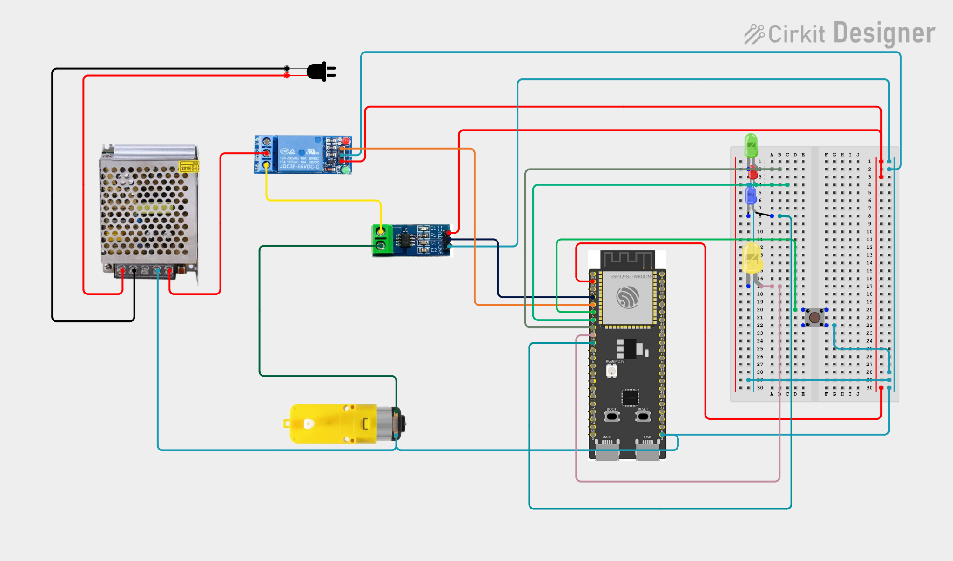

7.1 ESP32-S3-DevKitC-1 Pinout Reference
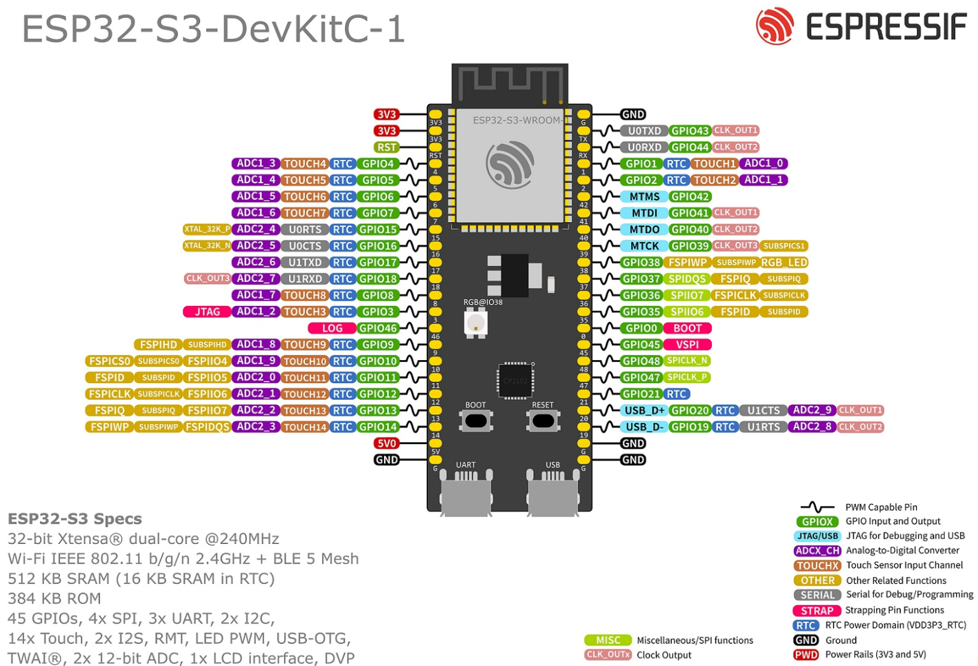
ESP32-S3-DevKitC-1 pinout diagram, used to select GPIO 4 (ADC1_CH3), GPIO 5, GPIO 6, and the LED pins.

7.2 HW-872A / ACS712 Current Sensor
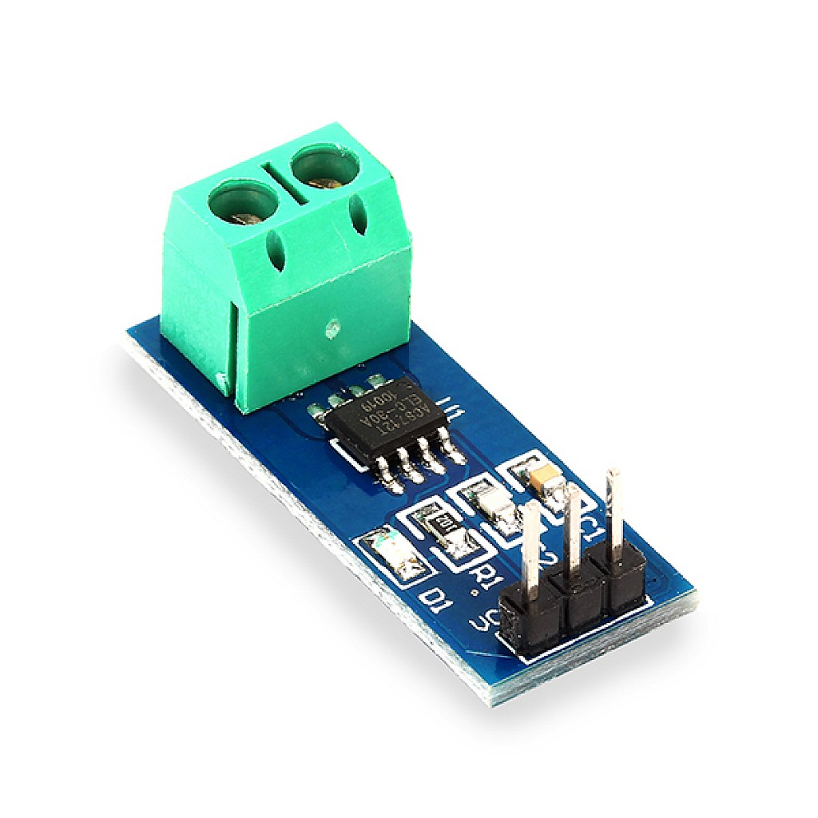
HW-872A breakout board (Allegro ACS712ELCTR-05B-T).
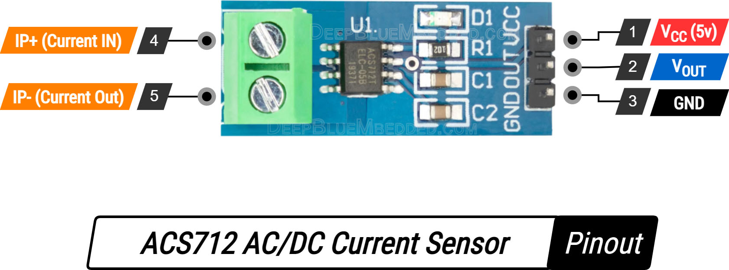
ACS712 AC/DC current sensor pinout: IP+/IP- current terminals and VCC/OUT/GND signal pins. Source: deepbluembedded.com

7.3 SRD-05VDC Relay Module
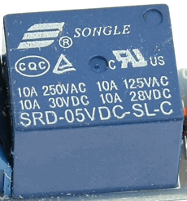
SRD-05VDC-SL-C relay module, rated 10A at 250VAC / 125VAC / 30VDC / 28VDC.

7.4 Push Button Breadboard Wiring
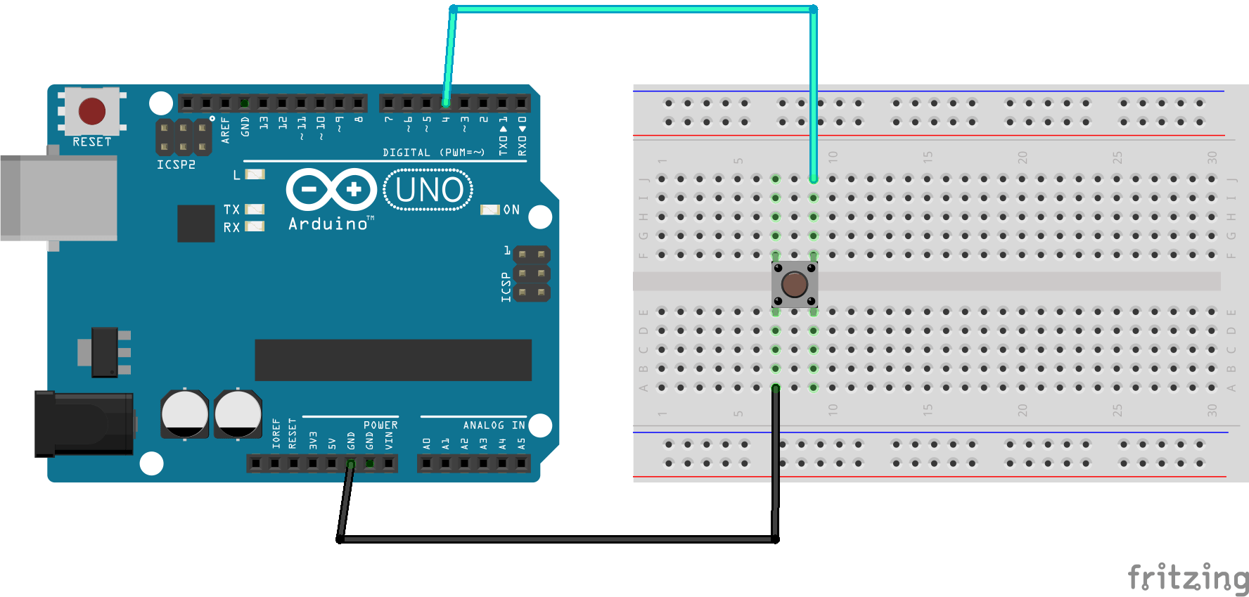
Fritzing wiring reference for the tactile push button diagnostic test (diagonal-leg wiring to avoid an internal short).

7.5 Photos for the final circuit
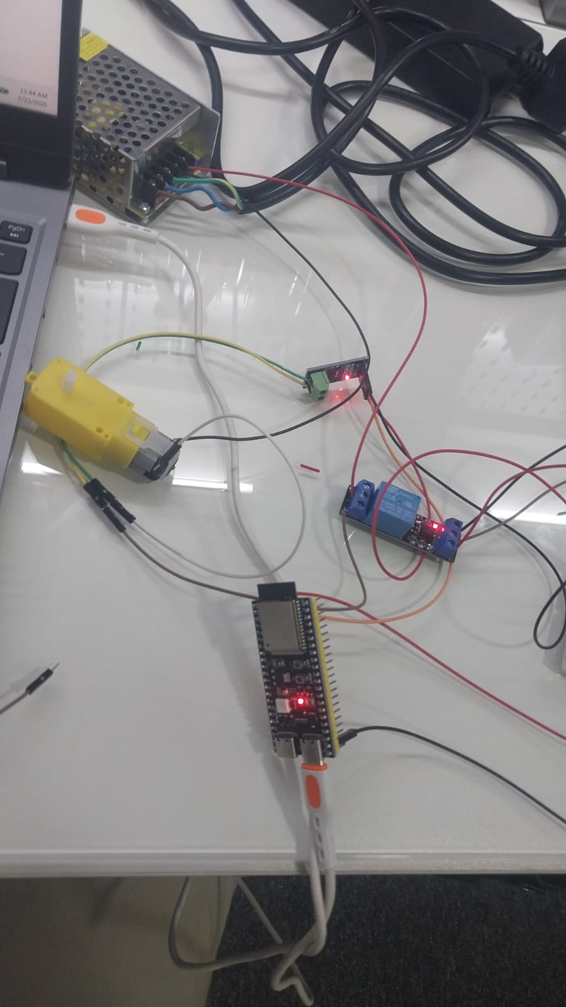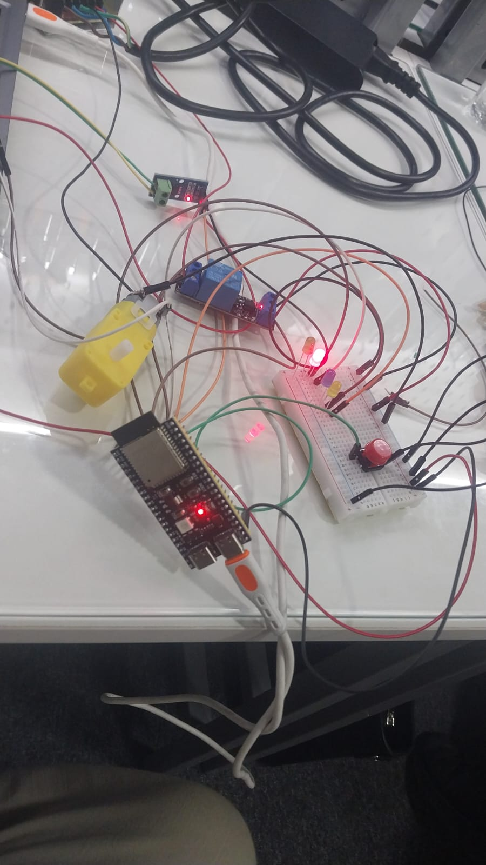

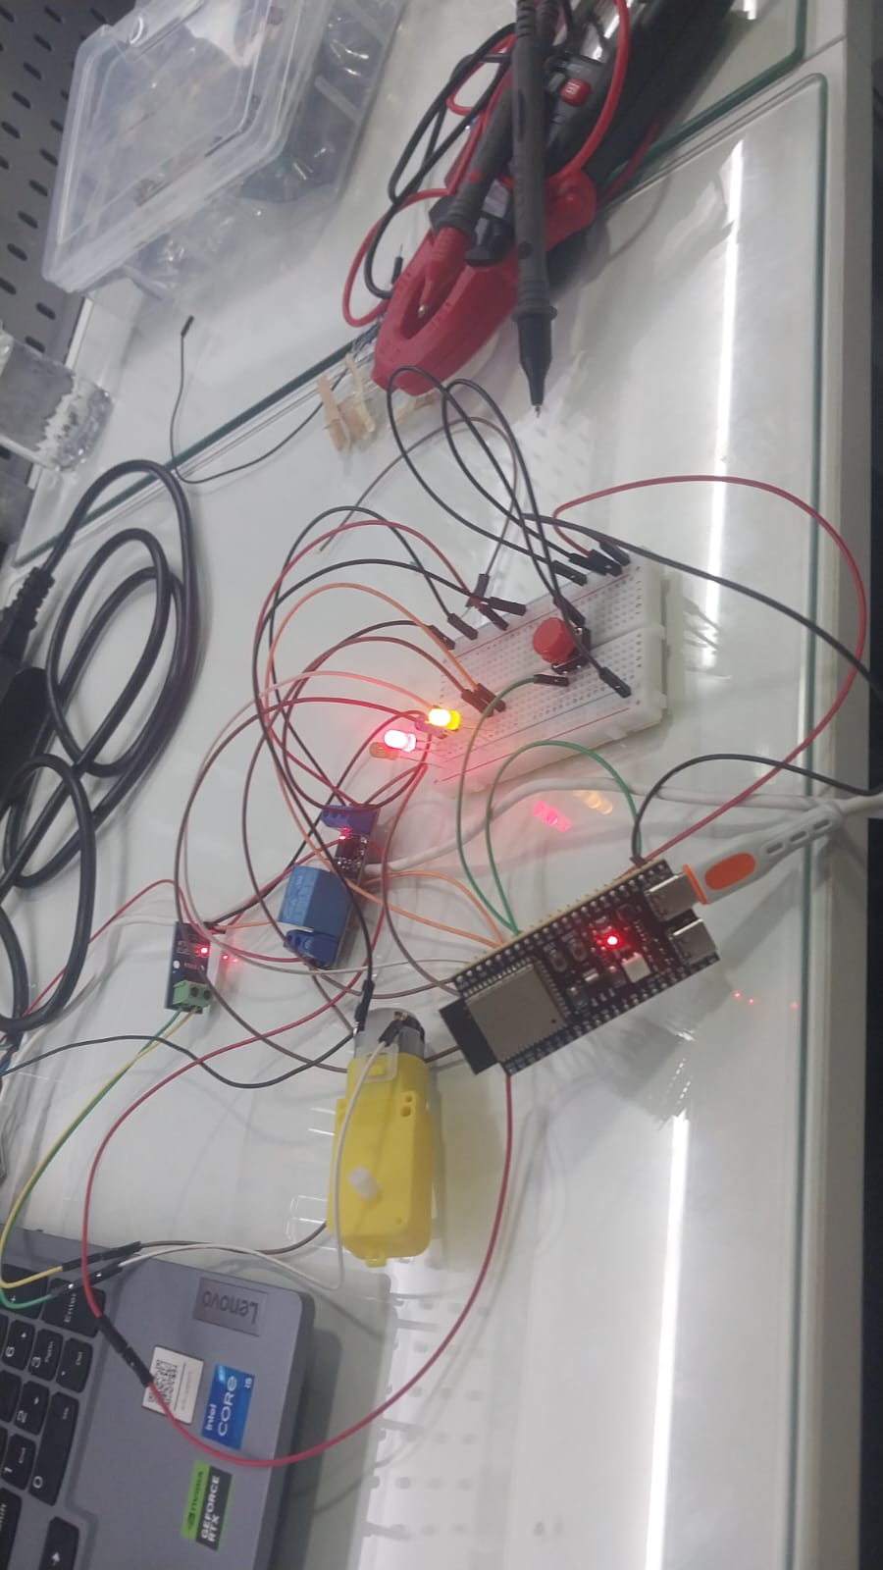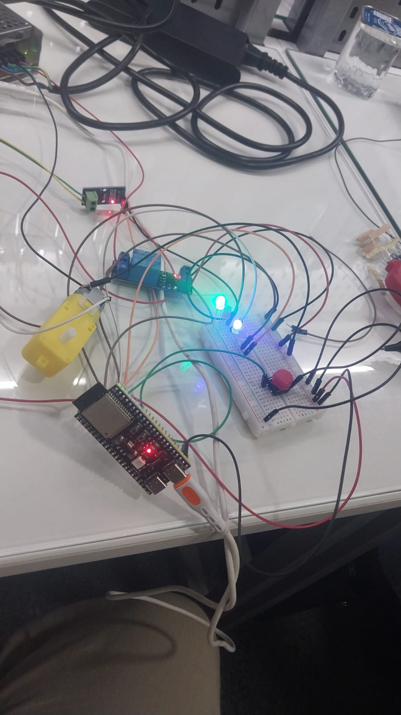

8. Issues & Troubleshooting

Symptom: Relay clicking but load not switching
Early bench testing confirmed the relay coil audibly clicked on every RELAY_ON command, but this alone does not confirm the load circuit is correct — it only verifies the low-voltage control side. The high-power NO/COM wiring was independently re-checked against the fail-safe matrix in Section 3.3 to confirm the motor was wired to NO, not NC.

Symptom: Current readings drifting slightly around 0A at rest
Small positive readings (a few mA) were observed at rest due to ADC noise and the ACS712's own internal noise floor. This was mitigated by averaging 50 ADC samples per reading and, in the final firmware, by taking the absolute value of the voltage delta so wiring polarity on the current sensor's screw terminals could not produce a spurious negative-current fault.

Symptom: Push button appeared permanently pressed
When first prototyping the 4-pin tactile switch, wiring both leads to the same internally-shorted side of the button (e.g. GPIO 6 and GND both to Leg A/Leg B) created a hard short to ground, so the pin read LOW continuously regardless of the physical button state. This was resolved by always wiring across diagonal legs, as documented in Section 4.2.

9. Results & Outcome
All four subsystems were validated individually and then successfully combined into a single integrated firmware build. The current sensor accurately tracked load current relative to its calibrated 1.572V zero baseline; the relay reliably switched the motor circuit under Active-LOW control with NO-side fail-safe wiring; the push button diagnostic confirmed clean, debounced state transitions; and the final motor protection system correctly implemented a dual-action E-Stop/Reset button, a 4-LED status panel, and an automatic overcurrent trip at 0.300A — with the relay latching OFF and remaining OFF until a deliberate button reset.

10. Project Documentation & Notes
Development Notes & Key Learnings: Day 4 Notion Notebook (shared notebook)
- Current sensor product reference (HW-872A / ACS712): HW-872 - 深圳市宏维微电子有限公司
- ACS712 AC/DC current sensor measurement guide: Arduino ACS712 AC/DC Current Sensor + Measurement Examples
- Relay module wiring guide:Relay Module with Arduino – Step by Step Guide - CircuitMagic
- SRD-05VDC-SL-C relay datasheet: SRD-05VDC-SL-C Datasheet - 5V, RELAY, Pinout - SONGLE
End of Report

