Day 8 + Day 9
IoT / EMBEDDED SYSTEMS
Daily Technical Report
Field | Details
Project Title | IoT Training Program
Report / Day No. | Day 8 & Day 9
Date | 26/7/2026 – 27/7/2026
Prepared By | Malak Alsharqawi
Organization | Cyber Robot

Confidential — Internal Training Documentation

Table of Contents
Table of Contents 2
1. Daily Overview 4
1.1 Summary 4
1.2 Tasks Completed Today 4
Task 1: BME280 Environmental Monitor & Data Logger over ESP32 Access Point (AP) 4
1. Objective 4
2. Procedure 5
Step 1 — Wire the BME280 over I2C 5
Step 2 — Determine the correct I2C address 5
Step 3 — Mount flash storage for the CSV log 6
Step 4 — Configure the ESP32 as an Access Point (AP), not a Station (STA) 6
Step 5 — Serve the dashboard, JSON feed, and CSV export 6
Step 6 — Combine everything on a non-blocking schedule 6
3. Schematic 7
4. Photos 7
5. Network Architecture 8
6. Issues & Troubleshooting 8
7. Results & Outcome 9
2. Key Technical Concepts 9
2.1 BME280 Environmental Sensor & I2C Addressing 9
Technical specifications 9
Pin configuration 10
Measured parameters 10
Communication protocols 10
Required Arduino / PlatformIO libraries 10
Basic read loop 11
Understanding the SDO pin and I2C addressing 11
Why doesn't my module have an SDO pin? 12
Three ways to find the I2C address 12
Advantages, limitations, and key takeaways 12
2.2 Non-Blocking Sampling with millis() 12
The problem with delay() 12
The solution: millis() 13
Why subtraction, not addition 13
Program flow 13
Real-world scheduling in this project 13
2.3 Persistent Storage on ESP32: Flash, NVS, EEPROM Emulation, and SPIFFS/LittleFS 13
Flash vs. NVS: not the same thing 14
Why Preferences (NVS) replaces EEPROM 14
SPIFFS and LittleFS: real files, not variables 15
Performance characteristics 15
Wear leveling 15
Decision guidance 16
Full comparison 16
2.4 ESP32 Wi-Fi Modes — STA, AP, and AP+STA 16
1. Station mode (STA) 16
2. Access Point mode (AP) — used in this project 16
3. AP + STA mode 16
Important Wi-Fi terms 16
2.5 Configuring and Using Access Point (AP) Mode 17
Configuration steps 17
Built-in DHCP server 17
AP mode vs. STA mode 17
Advantages and limitations 17
Applied workflow for this project 17
2.6 HTTP Request Routing with server.on() 18
Route 1 — serving the dashboard ("/") 18
Route 2 — live JSON data ("/data") 18
Route 3 — CSV download ("/download") 18
Execution flow summary 19
3. Refrences 19

1. Daily Overview

1.1 Summary
Day 8 and Day 9 focused on turning the ESP32 into a self-contained environmental monitoring station. A BME280 sensor was interfaced over I2C to sample temperature, relative humidity, and barometric pressure, and the on-board storage options (NVS/Preferences versus SPIFFS/LittleFS) were compared to decide how sensor history should be logged. The ESP32 was then configured as its own wireless network — an Access Point (AP), not a Station (STA) joining an existing router — so that the device works as a standalone unit that any laptop or phone can connect to directly, without depending on local Wi-Fi credentials. Finally, a lightweight HTTP server was built with server.on() route handlers to serve a live dashboard, a JSON data feed, and a downloadable CSV log, all sampled on a non-blocking millis() schedule instead of delay().
Beyond the working build, the two days also covered the underlying platform concepts that explain *why* each design choice was made rather than just *how* to wire it up: how the BME280's SDO address-selection pin works (and why four-pin breakout modules hide it); why delay() is incompatible with a device that must also serve HTTP requests; how Flash memory, NVS, EEPROM emulation, and SPIFFS/LittleFS relate to one another as software layers over the same physical chip; and how the ESP32's Wi-Fi driver differs between Station, Access Point, and combined AP+STA modes. These concepts are documented in full in Section 2, drawing on the reference notes recorded in the shared Notion notebook for this session.

1.2 Tasks Completed Today
- BME280 wiring and I2C address verification (0x76/0x77) using an I2C bus scanner, after confirming the four-pin breakout used in this project hides the SDO address-selection pin internally
- Non-blocking sensor polling and CSV logging design using millis() instead of delay(), including the overflow-safe subtraction pattern (currentTime - lastReadTime >= interval)
- Comparison of NVS/Preferences vs SPIFFS/LittleFS vs EEPROM emulation for persistent storage, covering how each sits on top of the same Flash chip, wear leveling, and which is appropriate for small settings versus appendable files
- Configured the ESP32 as a Wi-Fi Access Point (AP mode) using WiFi.mode(WIFI_AP) and WiFi.softAP() — deliberately not Station (STA) mode — including SSID/password rules and the built-in DHCP server behavior
- Built server.on() routes ("/", "/data", "/download") to serve the dashboard, live JSON readings, and the CSV export, streaming files directly from flash instead of loading them into RAM

Task 1: BME280 Environmental Monitor & Data Logger over ESP32 Access Point (AP)

1. Objective
Interface a BME280 sensor to an ESP32 over I2C, sample temperature, humidity, and pressure on a non-blocking schedule, persist the readings to a CSV log in flash storage, and serve a live dashboard plus a CSV download — with the ESP32 broadcasting its own Wi-Fi network in Access Point (AP) mode rather than joining an existing router in Station (STA) mode, so the monitor works as a standalone device anywhere.

2. Procedure

Step 1 — Wire the BME280 over I2C
- Used the 4-pin I2C breakout (VIN, GND, SDA, SCL) — the version used in this project; the SDO address-selection pin is not exposed on this module.
- Connected VIN to 3.3V, GND to GND, SDA to GPIO 21, and SCL to GPIO 22 — the ESP32's default I2C pins.
BME280 Pin | ESP32 Pin | Purpose
VIN | 3.3V | Sensor power supply
GND | GND | Common ground
SDA | GPIO 21 | I2C data line (default)
SCL | GPIO 22 | I2C clock line (default)

Step 2 — Determine the correct I2C address
- This module's SDO pin is tied internally by the manufacturer, so the address could not be read off the board by inspection.
- Ran an I2C bus scanner (Wire.begin(21, 22) plus a 1–127 address sweep) to confirm the sensor answers at 0x76.
- As a fallback, the firmware still tries bme.begin(0x76) then bme.begin(0x77) in case the module is swapped.
#include <Wire.h>

void setup() {
Serial.begin(115200);
Wire.begin(21, 22); // ESP32 default I2C pins
Serial.println("Scanning I2C bus...");
}

void loop() {
byte error, address;
int devicesFound = 0;

for (address = 1; address < 127; address++) {
Wire.beginTransmission(address);
error = Wire.endTransmission();
if (error == 0) {
Serial.print("I2C device found at address 0x");
if (address < 16) Serial.print("0");
Serial.println(address, HEX);
devicesFound++;
}
}
if (devicesFound == 0) Serial.println("No I2C devices found.");
Serial.println("----------------------------");
delay(3000);
}

Scanner output confirming the address used in this project:
Scanning I2C bus...
I2C device found at address 0x76
----------------------------

Step 3 — Mount flash storage for the CSV log
- Compared NVS/Preferences (key-value, wear-levelled, best for small settings) against SPIFFS/LittleFS (real files, best for appendable logs like CSV) and EEPROM emulation (legacy blob-based, not recommended for new work). Full reasoning is in Section 2.3.
- Chose LittleFS-style flash storage for the CSV file since the log needs to grow one row at a time and be downloaded as a normal file.
- Called storage.begin(true) so the partition is auto-formatted only the first time it fails to mount, and the CSV header row is written once on first boot.

Step 4 — Configure the ESP32 as an Access Point (AP), not a Station (STA)
- Declared a fixed SSID and password (AP_SSID / AP_PASSWORD, minimum 8 characters) and switched the radio with WiFi.mode(WIFI_AP).
- Started broadcasting with WiFi.softAP(AP_SSID, AP_PASSWORD) so the ESP32 creates its own network instead of depending on a router.
- Retrieved the gateway address with WiFi.softAPIP() — the default 192.168.4.1 — since the ESP32 itself now runs the DHCP server for any client that joins.
#include <WiFi.h>

const char* AP_SSID = "ESP32_Monitor";
const char* AP_PASSWORD = "12345678";

void setup() {
Serial.begin(115200);
WiFi.mode(WIFI_AP);
if (WiFi.softAP(AP_SSID, AP_PASSWORD)) {
Serial.println("Access Point Started");
Serial.print("SSID: "); Serial.println(AP_SSID);
Serial.print("IP Address: "); Serial.println(WiFi.softAPIP());
} else {
Serial.println("Failed to Start Access Point");
}
}

Step 5 — Serve the dashboard, JSON feed, and CSV export
- Registered server.on("/", ...) to stream the dashboard page from flash storage using server.streamFile(), which sends the file chunk-by-chunk rather than loading it into RAM.
- Registered server.on("/data", ...) to return the latest temperature, humidity, and pressure as a small JSON payload for the browser to poll via fetch('/data').
- Registered server.on("/download", ...) to stream the logged CSV file back to the browser as a file attachment, using a Content-Disposition header so the browser downloads rather than renders it.
Full route implementations and a line-by-line breakdown of each handler are given in Section 2.6.

Step 6 — Combine everything on a non-blocking schedule
- Replaced delay()-based timing with millis() so the BME280 is polled and a new CSV row is appended roughly every 10 seconds while server.handleClient() keeps answering browser requests in the same loop() without ever blocking.
unsigned long lastReadTime = 0;
const unsigned long interval = 10000; // 10 seconds

void loop() {
unsigned long currentTime = millis();
if (currentTime - lastReadTime >= interval) {
lastReadTime = currentTime;
// read BME280, append CSV row
}
server.handleClient(); // never blocked by the code above
}

3. Schematic
The diagram below shows the BME280 wired to the ESP32 over I2C, and the ESP32 broadcasting its own Access Point so a laptop or phone can connect directly to it.
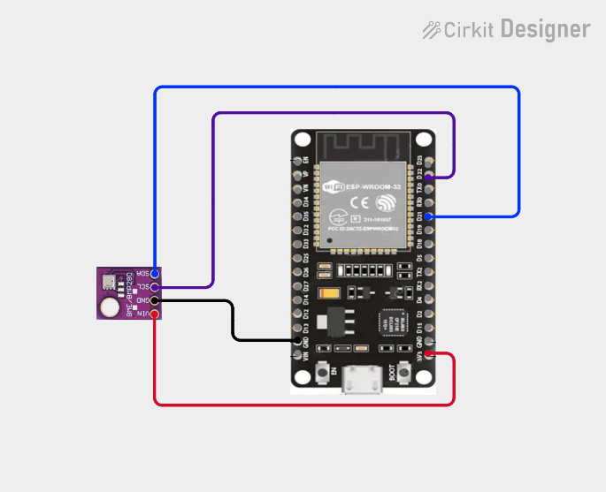

VIN and GND supply the sensor from the ESP32's 3.3V rail; SDA/SCL on GPIO 21/22 carry the I2C bus. Once powered, the ESP32 broadcasts the ESP32_Monitor network at 192.168.4.1 instead of joining a router.

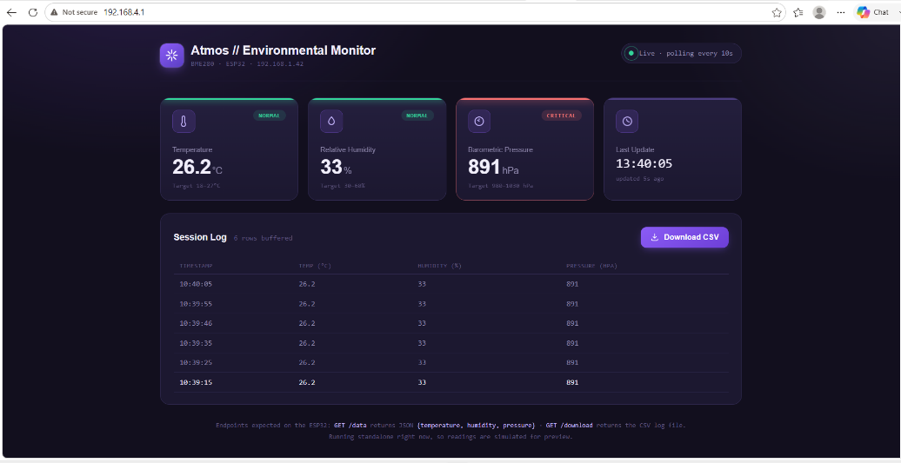
4. Photos
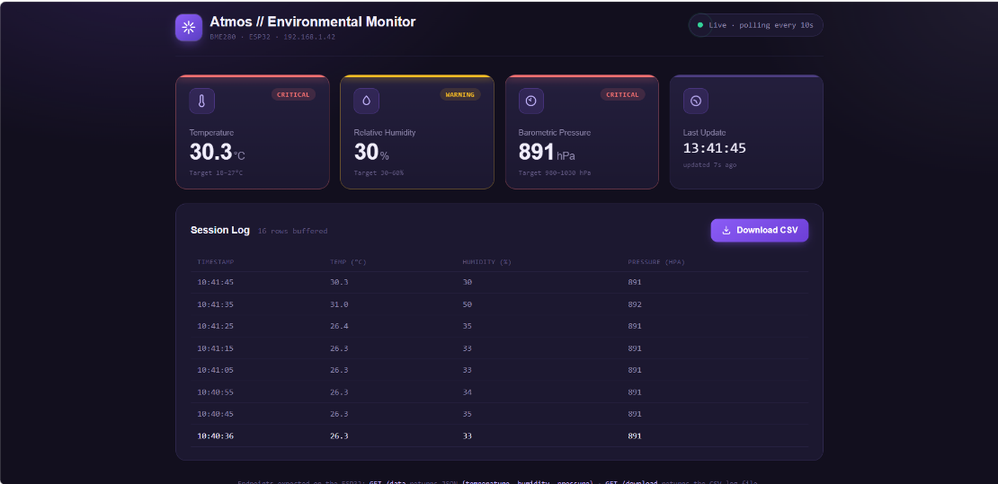

5. Network Architecture
Access Point (AP) mode — used in this project:
ESP32 (Access Point)
SSID: ESP32_Monitor | IP: 192.168.4.1
/ \
Laptop Phone
192.168.4.2 192.168.4.3

Instead of joining a router, client devices connect directly to the ESP32's own network. The ESP32 assigns each client an address itself (192.168.4.2, 192.168.4.3, ...) through its built-in DHCP server, and the dashboard is always reachable at the fixed address 192.168.4.1 — no router, internet connection, or existing Wi-Fi credentials are required. This was chosen over Station (STA) mode specifically so the monitor works as a portable, self-contained device in any location.
Typical connection sequence, from power-on to a client viewing the dashboard:
ESP32 boots -> WiFi.mode(WIFI_AP) -> WiFi.softAP() -> Broadcast SSID
-> Laptop finds network -> User connects -> ESP32 assigns IP
-> Client opens http://192.168.4.1

6. Issues & Troubleshooting
Symptom: Could not confirm the BME280's I2C address from the board silkscreen alone.
Root cause — the breakout used in this project only exposes four pins (VIN, GND, SDA, SCL); the SDO address-selection pin is tied internally by the manufacturer, so the resulting I2C address (0x76 or 0x77) cannot be read off the board by inspection.
Resolution: ran a standard I2C bus scanner (a 1–127 address sweep over Wire.beginTransmission() / Wire.endTransmission()) to confirm the module answers at 0x76, then hardcoded that address with a 0x77 fallback in bme.begin() so the sketch still recovers automatically if the module is ever replaced.
Decision point: STA mode vs AP mode for this project.
Station (STA) mode would have required the ESP32 to join an existing router and would tie the dashboard's address to whatever the local network's DHCP server assigns, meaning the device only works on networks whose credentials are already known. Since the goal for this task was a portable, standalone monitor that any laptop or phone can reach immediately — without configuring router credentials — the ESP32 was deliberately configured in Access Point (AP) mode with WiFi.mode(WIFI_AP) and WiFi.softAP(), giving a fixed, predictable address (192.168.4.1) that works the same way anywhere.
Decision point: which flash storage mechanism for the CSV log.
Preferences/NVS is optimized for small key-value settings (a Wi-Fi password, a calibration offset) and does not model an appendable file well. EEPROM emulation on the ESP32 is a single binary blob layered on top of NVS — rewriting the whole blob for every new sensor reading would be wasteful and is only recommended for porting legacy Arduino code. SPIFFS/LittleFS, by contrast, exposes true files that support opening in append mode and streaming, which matches a growing data.csv far more naturally. LittleFS was chosen over SPIFFS specifically because it is the actively maintained successor with better power-loss recovery.

7. Results & Outcome
The BME280 was confirmed on the I2C bus at address 0x76 and returned stable temperature, humidity, and pressure readings. Sampling and CSV logging ran on a 10-second millis() cycle without ever blocking the HTTP server, and the ESP32 broadcast its own Access Point (SSID: ESP32_Monitor) reachable at 192.168.4.1 without needing a router. The /, /data, and /download routes correctly served the live dashboard page, a fresh JSON reading on each poll, and the accumulated CSV log as a downloadable file that opened cleanly with a timestamp, temperature, humidity, and pressure column per row.

2. Key Technical Concepts
This section expands on the reference material recorded in the Day 8 + Day 9 Notion notebook, covering the theory behind every design decision made in Task 1.

2.1 BME280 Environmental Sensor & I2C Addressing
The BME280 is a digital environmental sensor developed by Bosch Sensortec. It measures three environmental parameters — temperature, relative humidity, and atmospheric (barometric) pressure — from a single compact module. Unlike the BMP280, which measures only temperature and pressure, the BME280 also includes a humidity sensor, making it well suited to environmental monitoring and IoT applications such as this one.

Technical specifications
Parameter | Value
Operating Voltage | 1.8V – 3.6V (many breakout boards support 3.3V and 5V via onboard regulators)
Communication | I2C or SPI
Temperature Range | -40°C to +85°C
Humidity Range | 0% – 100% RH
Pressure Range | 300 – 1100 hPa
I2C Addresses | 0x76 or 0x77
Power Consumption | Very low — suitable for battery-powered / low-power IoT applications

Pin configuration
The BME280 is commonly available as a 4-pin (I2C only) or 6-pin (I2C and SPI) breakout module. This project uses the 4-pin variant.
Pin | Description
VIN | Power supply (3.3V or 5V depending on the breakout board)
GND | Ground
SDA | I2C data line
SCL | I2C clock line

The 6-pin variant adds CS (Chip Select, SPI) and SDO (SPI MISO / I2C address selection).

Measured parameters
Temperature = 25.4 °C
Humidity = 52.8 %
Pressure = 1009.8 hPa
The sensor library returns pressure in Pa, so the firmware divides by 100 to display hPa (1 hPa = 100 Pa):
float pressure = bme.readPressure() / 100.0F;

Communication protocols
The BME280 supports two communication methods. This project uses I2C.
Protocol | Wires | Notes
I2C | SDA, SCL | Two-wire bus, easier wiring, allows multiple devices on the same bus — most common choice with ESP32/Arduino, and the method used in this project
SPI | MOSI, MISO, SCK, CS | Faster than I2C but requires more wires — typically used when higher communication speed is required

Required Arduino / PlatformIO libraries
#include <Wire.h>
#include <Adafruit_Sensor.h>
#include <Adafruit_BME280.h>
lib_deps =
adafruit/Adafruit Unified Sensor
adafruit/Adafruit BME280 Library

Basic read loop
Adafruit_BME280 bme; // I2C
#define BME280_I2C_ADDRESS 0x76

void setup() {
Serial.begin(115200);
if (!bme.begin(BME280_I2C_ADDRESS)) {
Serial.println("Could not find a valid BME280 sensor, check wiring!");
while (1);
}
Serial.println("BME280 sensor initialized successfully!");
}

void loop() {
Serial.print("Temperature: "); Serial.print(bme.readTemperature()); Serial.println(" \xC2\xB0C");
Serial.print("Humidity: "); Serial.print(bme.readHumidity()); Serial.println(" %");
Serial.print("Pressure: "); Serial.print(bme.readPressure() / 100.0F); Serial.println(" hPa");
Serial.println();
delay(2000);
}

Understanding the SDO pin and I2C addressing
SDO (Serial Data Out) is a pin on the BME280 whose function depends on the communication protocol: in SPI mode it acts as the MISO line; in I2C mode it is not used for data at all — instead it selects which of the two possible I2C addresses the sensor answers to.
SDO Connection | I2C Address
Connected to GND | 0x76
Connected to 3.3V (VCC) | 0x77

If the wrong address is used, bme.begin() fails and the sensor will not initialize. Not every I2C device uses an address-selection pin — some have a fixed address, some offer several pins for multiple addresses, and some are configured purely in software:
Method | Description | Example
Fixed address | Address cannot be changed | DS3231 RTC
Address selection pin | A dedicated pin selects one of two addresses | BME280 (SDO), MPU6050 (AD0), BH1750 (ADDR)
Multiple address pins | Several pins provide multiple possible addresses | PCF8574 I/O Expander
Software configurable | Address changed through software registers | Some advanced I2C peripherals

Different manufacturers name the same kind of pin differently — SDO (BME280), AD0 (MPU6050), ADDR (BH1750), SA0 (SSD1306 OLED), or A0/A1/A2 (PCF8574) — but they all serve the purpose of selecting the device's I2C address.

Why doesn't my module have an SDO pin?
Many inexpensive BME280 breakout boards expose only four pins (VIN, GND, SDA, SCL) — the version used in this project. On these modules the SDO pin is wired internally by the manufacturer, which means the address is fixed, cannot be changed without modifying the hardware, and cannot be determined simply by looking at the board.

Three ways to find the I2C address

if (!bme.begin(0x76)) {
if (!bme.begin(0x77)) {
Serial.println("BME280 not found!");
while (1);
}
}

Advantages, limitations, and key takeaways
- Advantages: three environmental measurements in one sensor, high accuracy, factory calibrated, very low power consumption, supports both I2C and SPI, compact, and well supported by Arduino/PlatformIO libraries.
- Limitations: measures relative (not absolute) humidity; altitude estimates from pressure are approximate unless a reference sea-level pressure is supplied; requires the correct I2C address (0x76 or 0x77) when using I2C.
- Every I2C device must have a unique bus address; SDO is simply the BME280's name for its address-selection pin, and the most reliable way to confirm it on a four-pin module is to run an I2C scanner — the method used for this project.

2.2 Non-Blocking Sampling with millis()
In embedded systems, a microcontroller often needs to perform several tasks at once — reading sensor data, serving a web page, logging data to memory, responding to button presses, driving LEDs or motors. If the program stops and waits during one task, the others cannot run; this is called blocking.

The problem with delay()
delay() pauses the entire program for a fixed duration. While it waits, the ESP32 cannot handle HTTP requests, read buttons, blink LEDs, or perform any other task — which makes it unsuitable for a device that must also run a web server.
void loop() {
Serial.println("Reading Sensor...");
delay(10000); // CPU does nothing for 10 seconds
}

The solution: millis()
Rather than stopping the program, millis() returns the number of milliseconds since the ESP32 started running, and the sketch compares elapsed time against a target interval to decide when to do recurring work — while everything else, including server.handleClient(), keeps running every pass of loop().
unsigned long lastReadTime = 0;
const unsigned long interval = 10000; // 10 seconds

unsigned long currentTime = millis();
if (currentTime - lastReadTime >= interval) {
lastReadTime = currentTime;
// read the sensor
}

Why subtraction, not addition
The comparison is always written as currentTime - lastReadTime >= interval, never as currentTime >= lastReadTime + interval. Subtraction correctly handles the rollover of millis(), which wraps back to zero approximately every 49 days of continuous ESP32 uptime — the addition form would misbehave at that rollover, while the subtraction form remains correct due to how unsigned integer arithmetic wraps.

Program flow
loop() -> get current time -> has interval passed?
No -> continue looping
Yes -> read BME280 -> print values -> update lastReadTime -> continue looping

Real-world scheduling in this project
Task | Interval
Read BME280 sensor | Every 10 seconds
Append data to CSV | Every 10 seconds
Respond to HTTP requests | Continuously
Serve dashboard updates | Whenever requested by the browser

Using millis() lets all of these tasks coexist without pausing the program — the ESP32 stays responsive, multiple tasks run concurrently, and the pattern easily scales to more periodic tasks, which is why it is the preferred timing method for embedded and IoT applications.

2.3 Persistent Storage on ESP32: Flash, NVS, EEPROM Emulation, and SPIFFS/LittleFS
The ESP32 has exactly one physical non-volatile memory chip — Flash — which keeps its contents after power is removed. Everything that needs to survive a reboot (the program itself, configuration data, files, Wi-Fi credentials) ultimately lives inside that single chip; NVS, Preferences, EEPROM emulation, SPIFFS, and LittleFS are all software layers that manage different regions of it, not separate hardware.

Flash Memory
|-- Bootloader
|-- Partition Table
|-- Application (your program)
|-- OTA Partition
|-- NVS
|-- SPIFFS / LittleFS
`-- Other Partitions

Flash vs. NVS: not the same thing
Flash is the physical storage hardware; NVS (Non-Volatile Storage) is Espressif's built-in key-value database that manages a portion of that hardware. The relationship mirrors an SSD versus a file system: the SSD is hardware, the file system is software that organizes it, and your files are the data on top.
Preferences prefs;
prefs.begin("settings", false);
prefs.putInt("speed", 100);
prefs.putBool("enabled", true);
prefs.end();

// Internally stored as:
// Namespace: settings
// speed -> 100
// enabled -> true

Why Preferences (NVS) replaces EEPROM
Espressif's official guidance is that EEPROM is deprecated on ESP32 and new applications should use Preferences instead — deprecated does not mean broken, it means the library still works for compatibility but is no longer recommended, because Preferences uses NVS directly and is faster, simpler, more flexible, and better optimized for Flash.
The ESP32 has no dedicated EEPROM hardware at all (unlike boards such as the Arduino Uno, which has Flash, RAM, and a separate EEPROM chip). The EEPROM library on ESP32 is purely an emulation layer: it creates one large binary block — a blob, short for Binary Large Object — inside NVS, and treats it as one big array of bytes.
EEPROM.write(5, 100); // modifies byte 5 inside the in-RAM copy of the blob
EEPROM.commit(); // writes the whole updated blob back into NVS
Because the whole blob is rewritten as a unit even if only one byte changed, EEPROM emulation is less efficient than Preferences, which stores each value independently — updating one key (e.g. count) never requires touching the others (e.g. speed, offset).
 | EEPROM (emulation) | Preferences (NVS)
Storage model | Single binary blob, addressed by byte offset | Key-value pairs, addressed by name
Example call | EEPROM.write(0, 100); EEPROM.commit(); | prefs.putInt("speed", 100);
Adding a new value | May require redesigning the whole memory layout | Just add a new key — nothing else changes

SPIFFS and LittleFS: real files, not variables
SPIFFS (SPI Flash File System) is a lightweight file system stored inside Flash that, unlike Preferences, stores files rather than individual variables — for example /config.json, /log.txt, /index.html, or /data.csv. LittleFS is the modern replacement for SPIFFS, offering better reliability, better long-term maintenance, improved power-loss recovery, and support for directories; unless SPIFFS is specifically required for compatibility, LittleFS is the recommended choice for new projects.
Preferences and SPIFFS/LittleFS typically report very different capacities (Preferences ≈ 20 KB, SPIFFS ≈ 1.5 MB on a common 4 MB Flash layout) not because they use different hardware, but because the partition table simply reserves different amounts of the same Flash chip for each region:
Region (4 MB Flash example) | Typical size
Application | 1.5 MB
OTA | 1 MB
NVS | 20 KB
SPIFFS | 1.5 MB

Storing a growing sensor log as individual Preferences keys (temperature1, temperature2, temperature3, ...) quickly becomes unmanageable; storing it as a file (log.txt, with one line appended per reading) is far easier to manage — which is the core reason this project logs to a CSV file on SPIFFS/LittleFS rather than to Preferences.

Performance characteristics
- Preferences — optimized for small variables, configuration values, counters, and calibration data; very fast for key-value operations.
- SPIFFS/LittleFS — optimized for reading, writing, and managing files and larger data; the better fit for file-based storage such as this project's CSV log.
- EEPROM (emulation) — designed to mimic traditional Arduino EEPROM behavior; works for porting older projects but is less flexible than Preferences for new work.

Wear leveling
Flash memory tolerates only a limited number of erase/write cycles per sector before it wears out. A good storage system spreads writes across multiple sectors — rotating between them — instead of repeatedly hitting the same one, extending the usable lifetime of the chip. Both NVS (and therefore Preferences) and LittleFS/SPIFFS implement wear-leveling internally, and because the ESP32's EEPROM emulation is itself built on NVS, it inherits the same protection.

Decision guidance

Full comparison
Feature | EEPROM (ESP32) | Preferences (NVS) | SPIFFS / LittleFS
Hardware | Flash | Flash | Flash
Storage type | Single binary blob | Key-value database | File system
Stores variables | Yes | Yes | No
Stores files | No | No | Yes
Uses addresses | Yes | No (uses keys) | No (uses paths)
Recommended for new projects | No (legacy) | Yes (settings) | Yes (files/logs)

2.4 ESP32 Wi-Fi Modes — STA, AP, and AP+STA
The ESP32's built-in Wi-Fi radio supports three operating modes, selected with WiFi.mode().

1. Station mode (STA)
The ESP32 behaves like a normal Wi-Fi client — similar to a laptop or phone — joining an existing router using a known SSID and password.
WiFi.mode(WIFI_STA);
WiFi.begin(ssid, password);

2. Access Point mode (AP) — used in this project
The ESP32 creates its own wireless network; other devices connect directly to it instead of to a router. This is the mode configured for the environmental monitor so it can be reached anywhere without existing Wi-Fi credentials.
WiFi.mode(WIFI_AP);

3. AP + STA mode
The ESP32 operates as both a Station connected to a router and an Access Point serving nearby devices simultaneously — useful for gateway-style projects, though not required for this task.
WiFi.mode(WIFI_AP_STA);

Important Wi-Fi terms

STA-mode connections can be established with a simple blocking wait for WiFi.status() == WL_CONNECTED, or more robustly with WiFi.onEvent() callbacks that fire automatically on connection, disconnection, or IP assignment — an event-driven approach that keeps the CPU free for other work such as sensor reads. This project uses AP mode, where the ESP32 does not need to wait for a connection at all since it is itself the network.

2.5 Configuring and Using Access Point (AP) Mode
An Access Point is a device that creates a Wi-Fi network so other devices can join it. When the ESP32 operates as an Access Point it does not connect to an existing router — it becomes the network itself, which is useful for standalone embedded systems, initial device configuration portals, and demonstrations that must not depend on local Wi-Fi being available.

Configuration steps
#include <WiFi.h>

const char* AP_SSID = "ESP32_Monitor";
const char* AP_PASSWORD = "12345678";

Built-in DHCP server
When operating as an Access Point, the ESP32 automatically runs a DHCP (Dynamic Host Configuration Protocol) server that assigns IP addresses to connecting clients — for example a laptop at 192.168.4.2 and a phone at 192.168.4.3 — entirely automatically, with no additional programming required.

AP mode vs. STA mode
Feature | AP Mode | STA Mode
Connects to a router | No | Yes
Creates its own Wi-Fi network | Yes | No
Requires an existing network | No | Yes
Provides IP addresses to clients | Yes (DHCP server) | No
Typical IP address | 192.168.4.1 | Assigned by the router (e.g. 192.168.1.105)

Advantages and limitations
- Advantages: no router required, works anywhere, easy to demonstrate and test, simple setup, well suited to configuration portals and local dashboards like this project's.
- Limitations: connecting devices must disconnect from their normal Wi-Fi network to join the ESP32; internet access is generally unavailable unless additional routing is implemented; range depends on the ESP32's radio and the environment.

Applied workflow for this project
Power on -> Initialize BME280 -> Initialize SPIFFS -> Start Access Point
-> Laptop connects to ESP32 Wi-Fi -> Open browser -> http://192.168.4.1
-> View live sensor dashboard -> Download CSV log
The result is a portable environmental monitoring system that can be accessed directly from any Wi-Fi-enabled device without requiring an external router or internet connection.

2.6 HTTP Request Routing with server.on()
server.on() binds a URL path to a callback function; when a client's HTTP request matches a registered path, the ESP32 runs that handler. This project registers three routes.

Route 1 — serving the dashboard ("/")
server.on("/", []() {
if (SPIFFS.exists("/index.html")) {
File file = SPIFFS.open("/index.html", "r");
server.streamFile(file, "text/html");
file.close();
} else {
server.send(404, "text/plain", "index.html not found in SPIFFS!");
}
});

Route 2 — live JSON data ("/data")
server.on("/data", []() {
float temperature = bme.readTemperature();
float humidity = bme.readHumidity();
float pressure = bme.readPressure() / 100.0F;

String json = "{";
json += "\"temperature\":" + String(temperature, 2) + ",";
json += "\"humidity\":" + String(humidity, 2) + ",";
json += "\"pressure\":" + String(pressure, 2);
json += "}";

server.send(200, "application/json", json);
});

{ "temperature": 24.50, "humidity": 48.20, "pressure": 1013.25 }

Route 3 — CSV download ("/download")
server.on("/download", []() {
if (SPIFFS.exists("/data.csv")) {
File file = SPIFFS.open("/data.csv", "r");
server.sendHeader("Content-Type", "text/csv");
server.sendHeader("Content-Disposition", "attachment; filename=sensor_data.csv");
server.streamFile(file, "text/csv");
file.close();
} else {
server.send(404, "text/plain", "File not found");
}
});

Execution flow summary
setup(): SPIFFS.begin() -> server.on() registers /, /data, /download -> server.begin()
loop(): server.handleClient() runs repeatedly, invoking the matching
server.on() handler for each incoming request

3. Refrences
- BME280 Sensor with Arduino (Pressure, Temperature, Humidity) — Random Nerd Tutorials
- Cirkit Designer — BME/BMP280 Component Reference
- ESP32 SPIFFS Storage Overview — TutorialsPoint
- SPIFFS on the ESP32 — Programming Electronics Academy
- ESP32 Essential Guide — Network Section (AvantMaker)
- Arduino-ESP32 Network API — Espressif Documentation
- Connect ESP32 to a Wi-Fi Network — DeepBlueMbedded
- ESP32 Access Point (AP) for Web Server — Random Nerd Tutorials
- ESP32 SPIFFS Tutorial: Storing Files & Building a Web Server — TeachMeMicro

End of Report

