Name:malak wessam

Id: 22010268

Steps:

1. Notepad(dockerfile)
2. Powershell

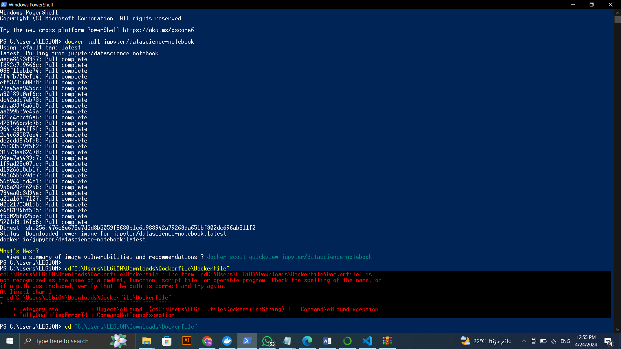.pull the Jupyter image

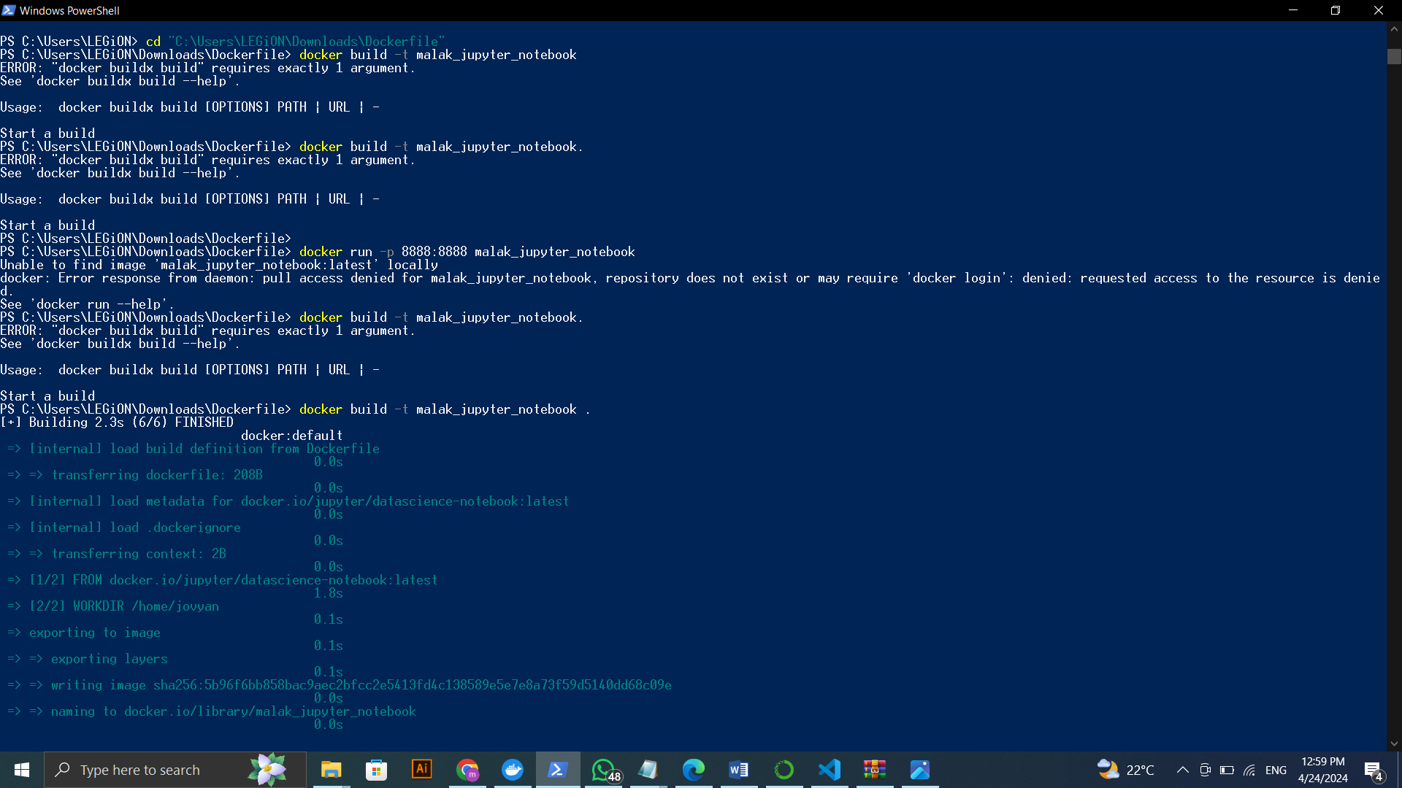.build Jupyter notebook

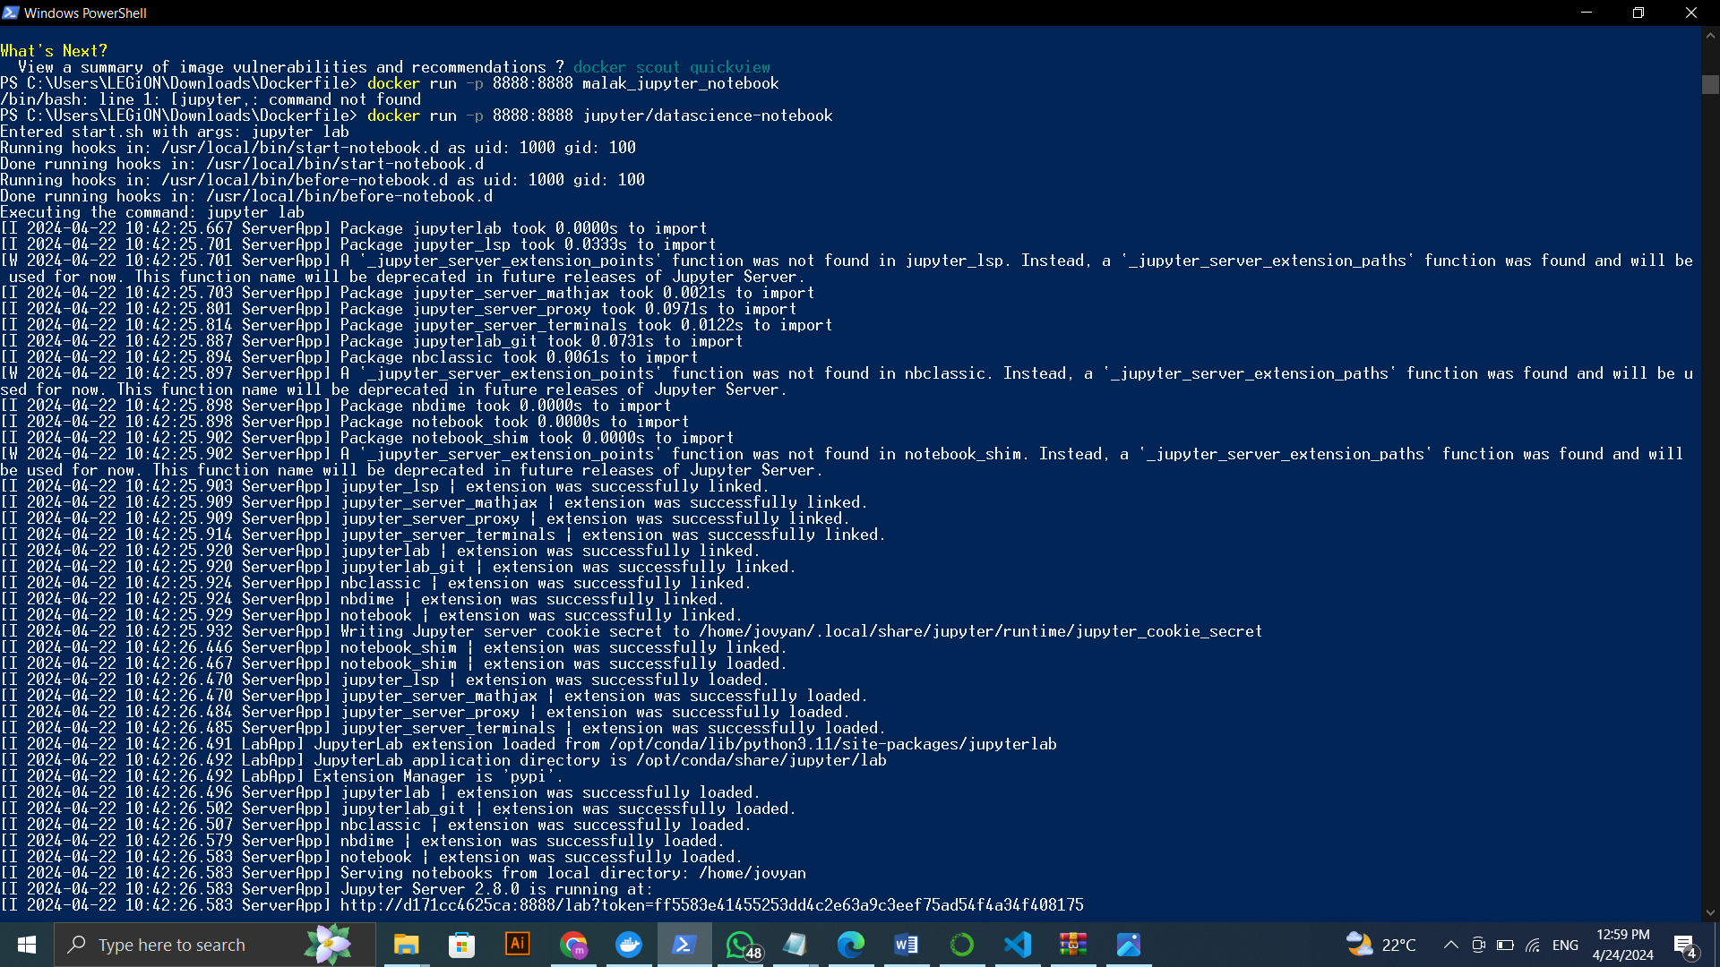.run docker image

3) cleaning and preprossecing (in Jupyter notebook)

4)the result of the analysis

