**PROJECT-NAME: AMAZON**

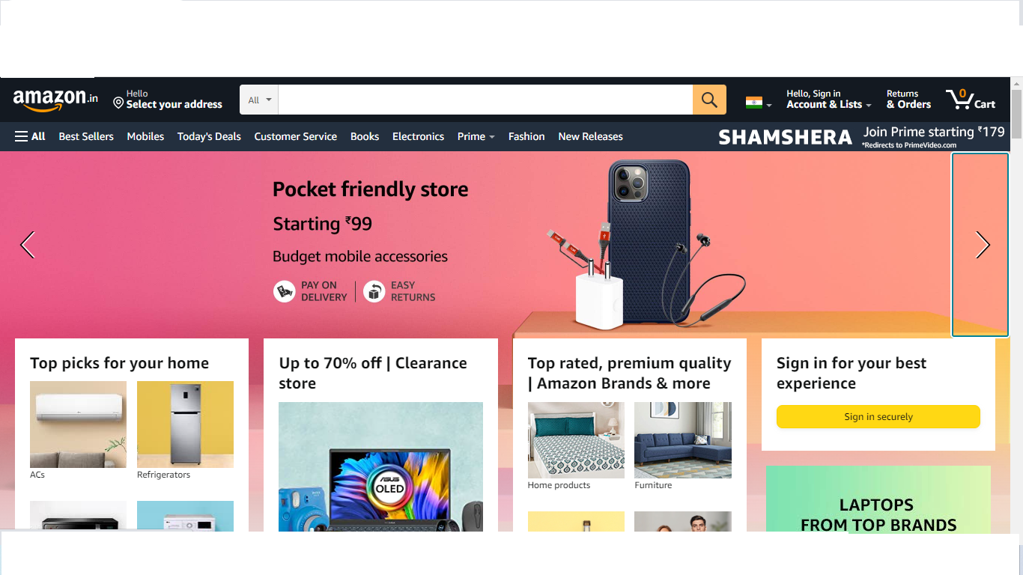

**OVERVIEW:**

Amazon is an **online retailer and web service provider**. The company provides products such as apparel, auto and industrial items, beauty and health products, electronics, grocery, books, games, jewelry, kids and baby products, movies, music, sports goods, toys, tools and other related products.

**GOALS:**

1. **HOME PAGE:**

# Logo

# Icons - (wishlist, add to cart)

# Search bar

# Sliders with arrows - (Images)

# Deals - (Images)

# Featured - (Images)

# Trending - (Images)

# Footer– ( Contact US , Helplines , Brief Description

About the company , Social-media

icons, link to mobile APP )

1. **REGISTRATION FORM:**

#user name

# e-mail address

# D.O.B

# Shopping Preference

**3. MAIN PAGE:**

# Filters - ( Brands , Color , Discount Range , Price

Country of Origin , Material , Features ,

Fit , Occsion, Pattern , Rating , Size ,

Type , Sort By: )

# Images of the chosen product with details like -

( Brand , Product Name , Price , Discount% ( If

Any) )

# On clicking the image - (Multiple images of the

product will appear from the different angles ,

zoom in , zoom out

# Product Description - Brand , Product Name ,

Price , Discount% (If Any) , Size Chart ,

Delivery Options , Product

Details , Size & Fit , Material & Care ,

Specifications , Ratings , Customer Reviews

With Images (If Any )

# Lower half of the page - related products

**4.PAYMENT PAGE:**

# Address Selection

# Payment Method - (Phonepe , Google Pay , Bhim Upi ,

Cod , Credit/Debit Card , Net

- Banking , Emi , Paytm)

**TECHNOLOGIES USED IN AMAZON:**

**Front-End:**

1.Html

2.Css

3.Bootsrap

4.React

**Dynamic:**

1.Javascript

2.Ci/cd with AWS

**Database** :

1.Mongodb

2.json Data

**Code Compliers:**

1.Visual studio code

2.Git bash

3.Git hub

4.Node js

Prepared by:

Malanabi Kammar