AgroVessel: A Spoilage-Aware, Net-Profit Decision Support System for Choosing Wholesale Markets for Perishable Produce in India
Malapati Sahasra¹, Pradeeba V²
Abstract: Smallholder farmers in India usually sell perishable produce at the nearest regulated wholesale market (mandi) or at whichever market quotes the highest price, although the money they finally receive also depends on transport cost, travel time, market closing hours and the produce lost to heat and handling on the way. This paper presents AgroVessel, an open-source web decision support system that ranks every mandi within a farmer's driving range by expected net profit. The system combines all-India daily modal prices from the Government of India's Agmarknet feed, road distances and travel times from the Open Source Routing Machine (OSRM), hourly temperature forecasts from Open-Meteo, state-wise diesel prices and an offline gazetteer of 3,435 Indian towns that places mandis with no published coordinates. In-transit loss is estimated with a Q10 temperature-coefficient shelf-life model, and each candidate departure time is checked against traffic and closing hours. AgroVessel is deployed as a FastAPI service with a bilingual (English/Hindi) interface. It was evaluated with real road distances and ERA5-based temperature profiles for two producing regions, Kolar (tomato) and Nashik (onion). Night departures reduced predicted tomato loss on a 256 km route from 12.9% to 4.0% in May. A 2-tonne lot needs a 9–44% price premium to justify travelling 50–300 km. In 20,000 simulated market days per setting, the system lowered the mean shortfall from the best achievable outcome by 11–42% compared with choosing the highest listed price, and raised mean net income by ₹3,710–21,929 per trip compared with selling at the nearest mandi.
Keywords: Agmarknet, Agricultural marketing, Post-harvest loss, Q10 temperature coefficient, Route planning, Transport cost

^{1, 2}Department of AI and Emerging Technologies, Chinmaya Vishwavidyapeeth Deemed-to-be University, Ernakulam, Kerala, India – 686667
Corresponding author: Pradeeba V, Department of AI and Emerging Technologies, Chinmaya Vishwavidyapeeth Deemed-to-be University, Ernakulam, Kerala, India – 686667. E-mail: pradeeba.v@cvv.ac.in
Author e-mails: Malapati Sahasra: malapati.cvv241195@cvv.ac.in; Pradeeba V: pradeeba.v@cvv.ac.in
ORCID iDs: Malapati Sahasra: [0000-0000-0000-0000]; Pradeeba V: [0000-0000-0000-0000]

1. Introduction
Fruits and vegetables lose a large part of their value between the farm gate and the consumer. Globally, about 14% of food by value is lost after harvest and before retail [1], and fresh produce is among the most affected commodity groups because it continues to respire, lose water and soften after harvest [2]. India's most recent national assessment, carried out by NABARD Consultancy Services for the Ministry of Food Processing Industries, placed post-harvest loss of tomato at about 11.6%, the second highest among fruits and vegetables after guava [3], [4]. An earlier ICAR assessment reported losses of a similar order for perishable horticultural crops [5]. A substantial share of this loss occurs during handling and transport in open, non-refrigerated vehicles, where produce is exposed to ambient heat for several hours [6], [7].
For an individual farmer the loss is not only physical. A truckload of tomatoes taken to a distant city market may fetch a higher modal price than the local mandi, but part of the load arrives bruised or overripe, buyers mark down the remaining produce, and the diesel, toll and driver costs of the round trip are paid regardless of the outcome. Conversely, a farmer who always sells at the nearest market avoids transport risk but may leave a large price difference unclaimed. The decision therefore requires weighing price, distance, time, temperature and lot size together, which is difficult to do mentally on the morning of harvest.
Public market information has improved considerably. The Agmarknet system publishes daily arrival and price data from more than two thousand regulated markets, and the Open Government Data platform exposes the current day's modal prices through an application programming interface (API) [8], [9]. Studies of market information in India and elsewhere have shown that better access to price information reduces price dispersion and improves farmer outcomes [10]–[13]. However, a raw price list does not by itself tell a farmer where to go: the best market is the one with the highest net return after transport and spoilage, and that depends on the farmer's own location, vehicle, crop and timing [14], [15].
1.1. Related work
Research on agricultural market access has long recognised that transaction costs, including transport, shape whether and where farmers sell. Key et al. [15] showed that proportional and fixed transaction costs create a price band within which households neither buy nor sell, and Fafchamps and Hill [14] found that the decision to travel to a market rather than sell at the farm gate depends on quantity, distance and the price gap. Information interventions have been studied extensively: Jensen [10] documented how mobile phones reduced price dispersion in Kerala fish markets, Aker [11] reported similar effects for grain markets in Niger, and Goyal [12] showed that internet kiosks raised soybean prices received by farmers in Madhya Pradesh. Mittal et al. [13] surveyed mobile phone use among Indian farmers and identified timely, locally relevant market information as a key need. More recent Indian work has examined the electronic National Agriculture Market (e-NAM), which links mandis on a common trading platform and has been associated with changes in arrivals and prices [16].
A parallel stream of work addresses price forecasting. Machine learning models such as random forests, gradient boosting and neural networks have been applied to Indian vegetable prices with useful accuracy [17]. Forecasts are complementary to the present work: they predict what a market will pay, whereas AgroVessel converts current prices into a location- and time-specific selling decision.
In logistics, perishable food distribution has been treated as a vehicle routing problem with time windows and quality decay. Osvald and Stirn [18] incorporated the perishability of fresh vegetables into routing, and Amorim et al. [19] developed a rich routing model for perishable food in which freshness affects the objective. The general vehicle routing literature is summarised by Toth and Vigo [20]. These models target distributors that serve many customers from a depot, rather than a single farmer choosing one destination for one lot. Cold-chain research has shown that temperature history, rather than elapsed time alone, governs remaining shelf life, which motivates time-temperature management and intelligent logistics [21]–[24]. Respiration and quality decay of fresh produce typically follow an Arrhenius or Q10 temperature dependence [25], [26]. Supply chain studies of the Indian fruit and vegetable sector point to fragmented, multi-intermediary chains with little cold storage, where most farm-to-market movement happens in open trucks [7], [27].
To the authors' knowledge, few publicly available tools combine live all-India mandi prices, real road routing, hourly weather and a temperature-dependent spoilage model into a single per-trip recommendation for the farmer. Existing government portals present prices, and routing tools present distances, but the farmer is left to combine them. The present work addresses this gap.
1.2. Contributions
The main contributions of this paper are:
- A net-profit formulation of the mandi selection problem that jointly accounts for live modal price, round-trip transport cost at state diesel prices, temperature-dependent in-transit loss, buyer quality markdown, traffic and market closing time, evaluated over several candidate departure times.
- A nationwide design that discovers every mandi reporting a crop on a given day from the Agmarknet feed and places it on the map with an offline gazetteer and fuzzy name matching, so that the system works in all 28 states and 8 union territories without a hand-built market list.
- An open-source, deployed implementation (FastAPI back end, bilingual web front end) with batched routing and weather calls and an automated test suite.
- A quantitative evaluation using real road distances and reanalysis temperature profiles, including a departure-time study, a break-even distance analysis and a Monte Carlo comparison against common selling heuristics.
The rest of the paper is organised as follows. Section 2 describes the data sources, models and implementation, and the experimental design. Section 3 presents and discusses the results. Section 4 concludes the paper and outlines future work.
2. Materials and Methods
2.1. System overview
AgroVessel follows a client–server architecture (Fig. 1). The farmer enters the crop, quantity, location (typed or obtained from the browser's geolocation), state, vehicle mileage, toll rate, driver fee, maximum travel distance, market closing hour and a set of candidate departure times. The FastAPI service retrieves prices for that crop across India, locates each reporting mandi, discards those outside the distance limit, and keeps the most promising candidates according to a rough net estimate. It then obtains road distances and travel times for all candidates in a single routing request and hourly temperature forecasts for all points in a single weather request. Each (market, departure time) pair is evaluated with the spoilage, cost and closing-time models, the best departure is kept for each market, and the markets are returned sorted by expected net profit.

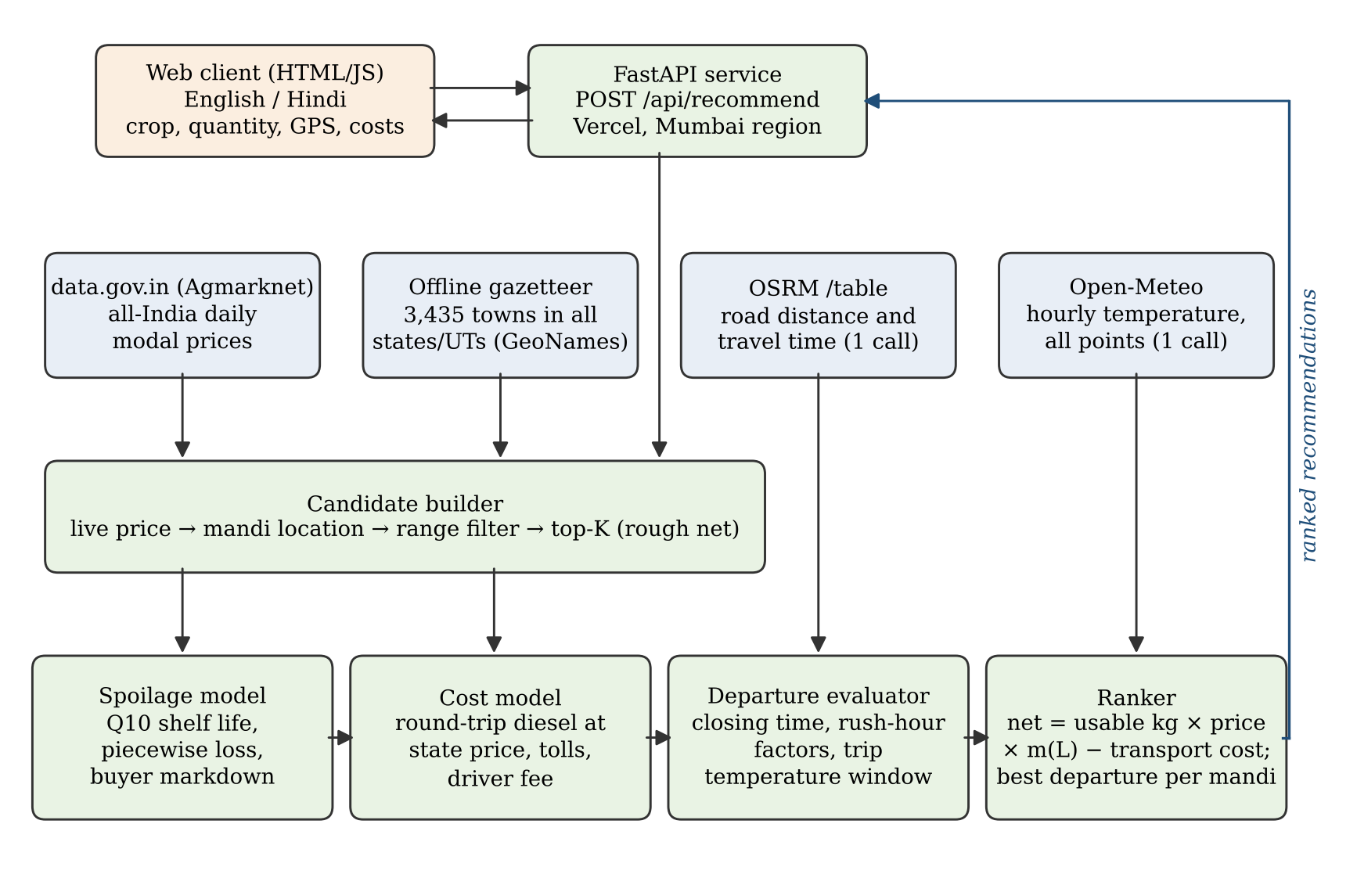
Fig. 1. Architecture of AgroVessel. External data sources (blue) feed the candidate builder and the evaluation pipeline (green); the ranked list is returned to the web client.

2.2. Data sources
Table 1 lists the data sources. Mandi prices come from the Open Government Data platform resource "Current daily price of various commodities from various markets (Mandi)", which republishes Agmarknet reports [8], [9]. Each record contains state, district, market, commodity, variety, arrival date and minimum, maximum and modal prices in rupees per quintal; the modal price is converted to rupees per kilogram. Because the API filters only on exact field values and Agmarknet commodity names differ from everyday names (for example, okra is listed as "Bhindi(Ladies Finger)" and coriander as "Coriander(Leaves)"), each crop is mapped to one or more Agmarknet commodity names, which are all queried. The query is not restricted by state, so markets across state borders are considered. Results are paged in blocks of 1,000 records and only the latest record for each market is retained.
Table 1. Data sources used by AgroVessel
Source | Content | Access | Licence
data.gov.in / Agmarknet [8], [9] | Daily modal, min. and max. price per market and commodity (₹/quintal) | REST API, key | OGDL – India
OSRM [28] | Road distance and driving time, one-to-many table | Public server | ODbL (OSM data)
Open-Meteo [29], [30] | Hourly 2 m temperature forecast and archive (ERA5) | REST API, no key | CC BY 4.0
State diesel prices [31] | ₹/litre for 36 states/UTs | Bundled table | Public data
GeoNames [32] | 3,435 Indian towns with state and district | Bundled file | CC BY 4.0

Road distance and free-flow driving time are obtained from OSRM [28] through its /table service, which returns a one-to-many distance matrix in one call. Hourly 2 m air temperature forecasts for the origin and every candidate market are obtained from Open-Meteo [29], which accepts a list of coordinates in one request. For the experiments in Section 3, historical hourly temperatures were taken from the Open-Meteo archive, which is based on the ERA5 reanalysis [30]. Diesel prices are stored per state; the values used were those published for 17–18 October 2026 [31], and the farmer may override them with the day's pump price.
2.3. Locating mandis across India
Agmarknet records do not include coordinates. AgroVessel therefore bundles a gazetteer of 3,435 Indian towns with population above 1,000 from GeoNames [32], with state and district fields. State names are first normalised, because the feed uses variant spellings such as "Chattisgarh", "Uttrakhand" and "NCT of Delhi". A mandi is then located by trying, within its state: (i) the full market name; (ii) the name with generic words such as "APMC", "market", "yard" and "F&V" removed; (iii) each part of a compound name, for example "Bangalore" in "Binny Mill (F&V), Bangalore"; (iv) the district name; (v) a fuzzy match on town names using a similarity ratio of at least 0.84, which resolves transliteration variants such as "Dehradoon" and "Madanapalli"; and (vi) the centroid of all gazetteer towns in a fuzzily matched district, with a small alias table for renamed districts (for example Hooghly/Hugli). Markets that cannot be located are skipped rather than guessed. The same gazetteer gives the nearest state for a GPS point, which pre-fills the state field. A curated list of 29 major markets with surveyed coordinates is also kept; when one of them matches a live record, its coordinates are preferred.
2.4. Temperature-dependent spoilage model
Quality loss of fresh produce accelerates with temperature, and the Q10 coefficient, the factor by which the rate increases for a 10 °C rise, is a standard way to express this dependence [25], [26]. Each crop is given a reference shelf life t_ref at T_ref = 20 °C and a Q10 value (Table 2), set to approximate values that follow the relative perishability of these crops reported in the postharvest literature [2], [6], [33]; they are configuration parameters of the system rather than measured constants. The effective shelf life at the mean transit temperature T is
t_eff = t_ref / Q10^((T − T_ref)/10) (1)
and the fraction of shelf life consumed by a trip of duration τ hours is
φ = τ / t_eff (2)
The predicted percentage loss L(φ) is a piecewise-linear function: a handling floor of 2% for φ < 0.05, rising linearly to 8% at φ = 0.10, 15% at φ = 0.20, 28% at φ = 0.35 and 50% at φ = 0.60, and capped at 50%. The mean transit temperature T is the average of the hourly forecasts at the origin and destination over the hours between departure and arrival. When no forecast is available, a conservative 32 °C is assumed. The usable quantity delivered is
U = Q × (1 − L/100) (3)
where Q is the quantity loaded. Produce that survives is not undamaged, so buyers pay a fraction m(L) of the modal price: 1.00 for L < 5%, 0.93 for 5–10%, 0.85 for 10–20%, 0.72 for 20–30% and 0.60 for 30% and above. These loss breakpoints and markdown factors are heuristics intended to be calibrated with field data, and they are stated explicitly so that users and reviewers can change them.
Table 2. Crop parameters and predicted loss (%) after a 6-hour trip
Crop | t_ref at 20 °C (h) | Q10 | 20 °C | 28 °C | 36 °C
Tomato | 72 | 2.2 | 6.0 | 12.0 | 23.2
Okra | 48 | 2.3 | 9.8 | 18.8 | 38.9
Banana | 96 | 2.2 | 3.5 | 9.2 | 16.8
Onion | 480 | 1.5 | 2.0 | 2.0 | 2.0
Coriander leaves | 18 | 2.6 | 26.6 | 50.0 | 50.0

2.5. Transport cost and traffic
For a one-way road distance d (km), vehicle mileage η (km/l), diesel price P_d (₹/l), toll rate c_t (₹/km) and flat driver fee F, the round-trip transport cost is
C = (2d / (η·μ_h)) × P_d + 2d × c_t + F (4)
where μ_h is a mileage multiplier for the departure hour h. Because the public OSRM server has no live traffic data, a simple time-of-day overlay is applied: departures between 08:00–11:00 and 17:00–21:00 have travel time multiplied by 1.25 and mileage by 0.88, departures between 00:00 and 05:00 have travel time multiplied by 0.92 and mileage by 1.05, and other hours are unchanged. These multipliers are indicative and can be replaced by a traffic-aware routing service.
2.6. Departure evaluation and ranking
For each candidate market i and departure time h, the arrival time is computed from the traffic-adjusted travel time. If the market would already be closed on arrival, the option is marked infeasible with an explanation. Otherwise the mean transit temperature, loss L, usable quantity U and markdown m(L) are computed, and the expected net profit is
N(i, h) = U × p_i × m(L) − C(i, h) (5)
where p_i is the modal price at market i. For each market, the departure with the highest N is kept. Markets with no feasible departure are excluded from the ranking and listed in a note, so that an unreachable market can never be recommended. Markets are sorted by N, and an optional baseline for selling at the farmer's own village price with no transport is included for comparison. To limit external calls, candidates are pre-ranked by a rough net computed from the straight-line distance multiplied by 1.3, and only the top max(15, 2K) are routed, where K is the number of recommendations requested.
If the live price feed is unavailable, the system falls back to placeholder sample prices for the curated markets only, and the interface states prominently that these are not real market data. A diagnostic endpoint reports whether a valid API key is configured and whether live prices are being received.
2.7. Implementation and deployment
The back end is written in Python 3 with FastAPI [34], Pydantic for request validation and HTTPX for asynchronous HTTP calls. The front end is a single HTML page with plain JavaScript, with English and Hindi labels, a "use my location" button and result cards that show the mandi price, gross revenue, transport cost, net profit, usable and lost quantity, recommended departure, expected transit temperature and price date (Fig. 2). The service is deployed as a serverless function on Vercel in the Mumbai region, which is close to the Indian data sources. The source code, data files and tests are publicly available in the project repository (github.com/MalapatiSahasra/agrovessel), and the live system is available at agrovessel.vercel.app. An automated test suite of 25 unit and end-to-end tests, using mocked external services, covers the spoilage and cost models, price matching, mandi location, state normalisation and the full recommendation pipeline.

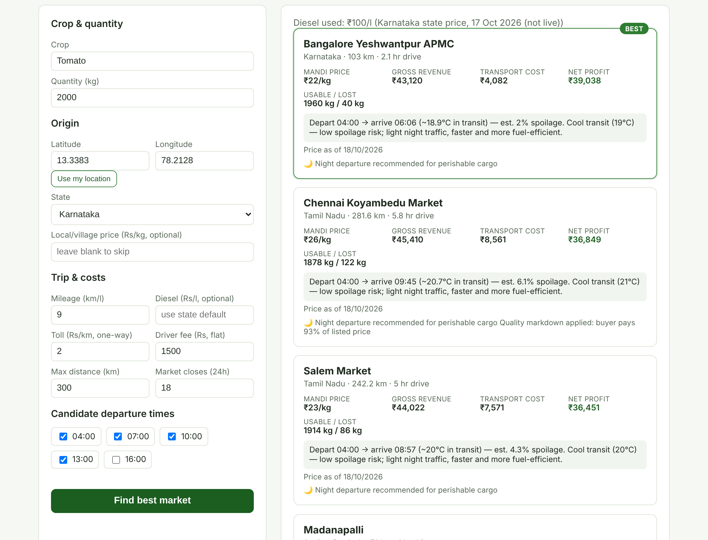
Fig. 2. AgroVessel web interface showing ranked recommendations for a 2-tonne tomato lot near Kolar. The screenshot was taken in a test environment with simulated price records; prices shown are illustrative.

2.8. Experimental design
Because live price data could not be collected over a full season within the study period and no field trial data were available, the evaluation combines real infrastructure data with clearly stated scenario assumptions. All experiments call the same engine functions that run in the deployed service.
Two producing regions were chosen. The first is a tomato farm near Srinivaspur in Kolar district, Karnataka (13.338° N, 78.213° E), an important tomato-growing area, with eight candidate markets in Karnataka, Andhra Pradesh and Tamil Nadu. The second is an onion farm near Pimpalgaon Baswant, Nashik district, Maharashtra (20.167° N, 73.983° E), with four candidate markets in Maharashtra and Gujarat. Road distances and free-flow travel times from each farm to each market were obtained from the public OSRM server on 19 October 2026. Hourly temperatures for every point were taken from the Open-Meteo archive for May 2026 (a hot month) and December 2025 (a cool month) and averaged by hour of day to form a typical diurnal profile for each month.
Unless otherwise stated, the vehicle is a light commercial truck with a mileage of 9 km/l, a toll rate of ₹2/km, a driver fee of ₹1,500, a market closing hour of 18:00, candidate departures at 04:00, 07:00, 10:00 and 13:00, and diesel at ₹99.56/l (Karnataka) or ₹97.83/l (Maharashtra). Five experiments were run: (E1) loss curves for five crops at 20, 28 and 36 °C; (E2) predicted loss and net profit for every departure hour on the Kolar–Chennai route; (E3) the price premium a distant market must offer to match a ₹20/kg local price, as a function of distance and lot size; (E4) a case study ranking the Kolar markets under an illustrative set of modal prices; and (E5) a Monte Carlo comparison of selling strategies. Finally, (E6) the computational cost of a recommendation and the response times of the deployed service were measured.
In E5, each simulated day draws a listed modal price for every market as p_i = p_0·exp(ε_i), with ε_i ~ N(0, σ²), p_0 = ₹20/kg for tomato and ₹15/kg for onion, and σ ∈ {0.10, 0.20, 0.30} representing low to high price dispersion between markets. Decisions are made on these listed prices and the model's predicted loss. The outcome is then evaluated with an arrival-day price that drifts from the listed price by a factor exp(δ), δ ~ N(0, 0.08²), and with an actual loss equal to the predicted loss multiplied by exp(ω), ω ~ N(0, 0.30²), to represent spoilage model error. Three strategies are compared: selling at the nearest mandi, selling at the mandi with the highest listed price, and following the AgroVessel recommendation. All strategies use the departure time that the model selects, which favours the two heuristics. Regret is defined as the shortfall from the best realised outcome among all markets on that day (the oracle). Each setting was simulated for 20,000 days, split equally between the May and December temperature profiles. The lot size was 2,000 kg for tomato and 5,000 kg for onion.
3. Results and Discussion
3.1. Behaviour of the spoilage model
Fig. 3 shows predicted loss against transit time for five crops at three ambient temperatures, and Table 2 gives the values after six hours. Loss rises with both time and temperature, and the temperature effect is strong: for tomato a six-hour trip is predicted to lose 6.0% at 20 °C, 12.0% at 28 °C and 23.2% at 36 °C. Okra, with a short reference shelf life and high Q10, reaches 38.9% at 36 °C, while coriander leaves reach the 50% cap within a few hours at warm temperatures. Onion, a storable bulb crop, stays at the 2% handling floor over the whole range. These differences mean that the same route can be a good choice for one crop and a poor one for another, which a price list alone cannot reveal.

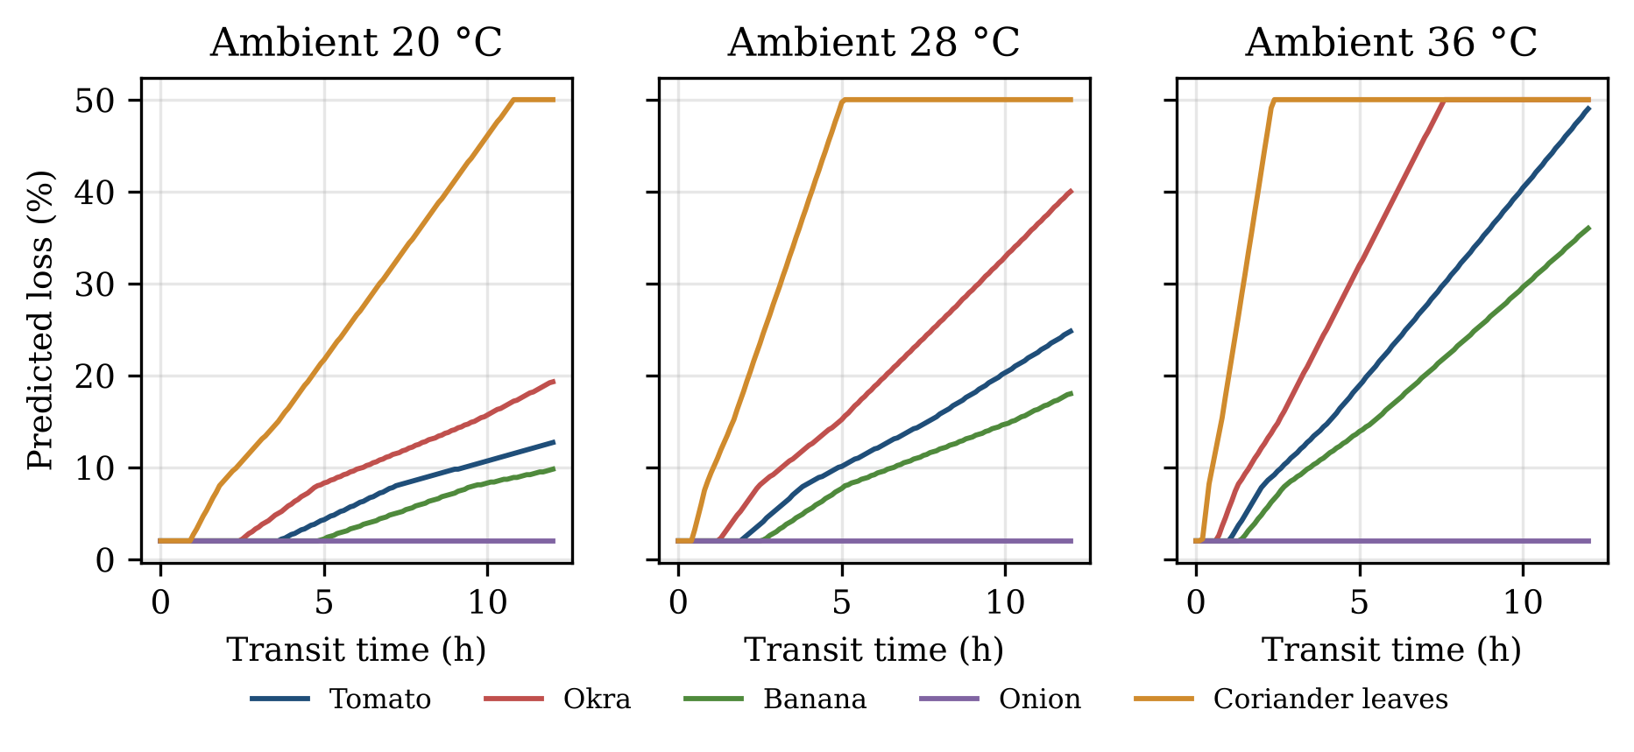
Fig. 3. Predicted in-transit loss versus transit time for five crops at ambient temperatures of 20, 28 and 36 °C (Q10 model with piecewise loss mapping).

3.2. Effect of departure time
Fig. 4 shows predicted tomato loss on the 256 km Kolar–Chennai route for every departure hour, using the real temperature profiles. In May, loss is lowest for departures between 00:00 and 03:00 (4.0–4.2%), when the whole trip falls in the coolest hours, and highest for a 10:00 departure (12.9%), which combines midday heat with the morning traffic multiplier. For a 2-tonne lot at ₹26/kg, this difference changes the expected net profit from ₹41,994 to ₹29,529, a gap of ₹12,465, or about 30% of the best outcome, for the same market and the same truck. In December the night advantage is smaller (2.0% versus 7.4%) but still worth ₹7,222. The dip after 11:00 occurs because the traffic multiplier no longer applies. In both seasons the model therefore recommends early-morning or late-night departures for perishable crops, consistent with common practice among growers and with cold-chain guidance on avoiding heat exposure [6], [22].
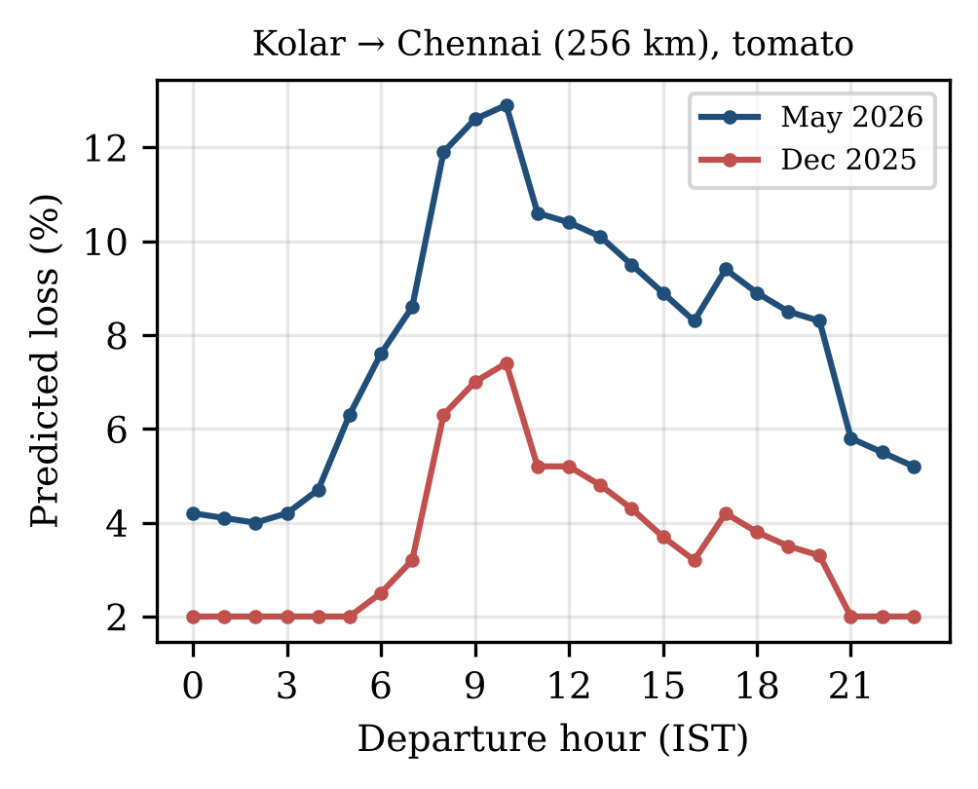
Fig. 4. Predicted tomato loss on the Kolar–Chennai route (256 km) by departure hour, using mean hourly temperature profiles for May 2026 and December 2025.
3.3. Break-even distance
Fig. 5 shows the price premium over a ₹20/kg local price that a distant market must offer for the trip to break even, for a tomato lot leaving at 04:00 in May. Lot size has a large effect because the driver fee and much of the vehicle cost are fixed per trip. For a 2-tonne lot the required premium is 9.1% at 50 km, 12.3% at 100 km, 20.6% at 200 km and 44.2% at 300 km. A 1-tonne lot needs 16.1%, 22.5%, 37.5% and 70.7% respectively, while a 5-tonne lot needs only 4.9%, 6.1%, 10.5% and 28.3%. The steps in the curves occur where longer travel time pushes predicted loss past a markdown threshold, so the buyer pays a smaller fraction of the listed price. This result supports the observation of Fafchamps and Hill [14] that larger sellers are more likely to travel to distant markets, and it suggests that pooling the produce of several small farmers into one vehicle could make higher-priced distant markets accessible to them.
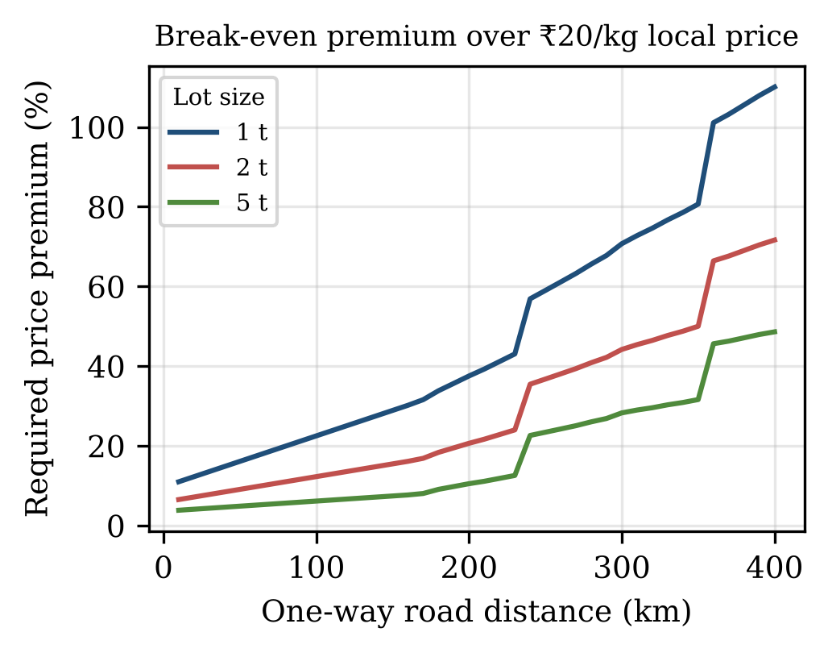
Fig. 5. Price premium over a ₹20/kg local price needed for a distant market to give the same net profit, by one-way road distance and lot size (tomato, May, 04:00 departure).
3.4. Case study: tomato near Kolar
Table 3 shows the ranking produced for a 2-tonne tomato lot from the Kolar farm in May under an illustrative set of modal prices (₹18–26/kg). Coimbatore (381.6 km by road) is excluded because it exceeds the 300 km limit. All markets are best reached with a 04:00 departure. Chennai Koyambedu ranks first with an expected net profit of ₹41,630 despite the highest transport cost (₹7,926) and 4.7% predicted loss, because its price advantage outweighs these costs. Bengaluru ranks second (₹39,221), and the nearest market, Kolar APMC, ranks last (₹33,143), so following the recommendation instead of selling locally adds ₹8,487 for this lot. In December the ranking is unchanged, but the Chennai loss falls to the 2% floor and its net profit rises to ₹43,034. Salem, with a higher price than Bengaluru but more than twice the distance, ranks below it, which illustrates why the highest-price and best-net markets often differ.

Table 3. Ranking for a 2-tonne tomato lot near Kolar, May (illustrative prices)
Market | Road km | Price (₹/kg) | Temp (°C) | Loss (%) | Transport (₹) | Net profit (₹)
Chennai (Koyambedu) | 256.3 | 26.0 | 26.7 | 4.7 | 7,926 | 41,630
Bengaluru (Yeshwantpur) | 95.7 | 22.0 | 22.5 | 2.0 | 3,899 | 39,221
Salem | 232.5 | 23.0 | 25.6 | 4.0 | 7,329 | 36,831
Madanapalle | 48.3 | 19.5 | 23.3 | 2.0 | 2,711 | 35,509
Anantapur | 194.0 | 21.0 | 25.5 | 2.2 | 6,364 | 34,712
Chikkaballapur | 56.6 | 19.0 | 22.1 | 2.0 | 2,919 | 34,321
Kolar APMC | 25.4 | 18.0 | 22.4 | 2.0 | 2,137 | 33,143
All markets: best departure 04:00. Coimbatore (381.6 km) excluded by the 300 km limit.

3.5. Decision value under uncertainty
Table 4 and Fig. 6 summarise the Monte Carlo comparison. Selling at the nearest mandi has by far the largest mean regret, from ₹5,174 per trip at low price dispersion to ₹17,017 at high dispersion for Kolar tomato, and from ₹6,929 to ₹22,851 for Nashik onion. Choosing the highest listed price performs much better, because in these settings price differences between markets are often larger than the transport cost differences. AgroVessel further reduces the mean regret relative to the highest-price rule in every setting: by 42% (₹2,518 to ₹1,464) at σ = 0.10, 38% at σ = 0.20 and 32% at σ = 0.30 for tomato, and by 15%, 12% and 11% for onion. Its recommendation differs from the highest-price choice on 36.3%, 20.4% and 13.1% of tomato days and on 19.3%, 8.9% and 5.7% of onion days. The mean gain over the highest-price rule ranges from ₹118 to ₹1,053 per trip, while the gain over the nearest market ranges from ₹3,710 to ₹21,929 per trip.
Two patterns stand out. First, the benefit of a spoilage- and cost-aware recommendation is largest when prices across markets are similar, because then transport and loss decide which market is best; when prices differ widely, the highest price usually wins anyway. Second, the benefit is larger for tomato than for onion, because onion's low perishability removes the spoilage term and leaves mainly transport cost. AgroVessel does not reach the oracle, because it decides on the previous day's prices and predicted loss, and both differ from the realised values in the simulation. The remaining regret of ₹760–2,161 per trip is a measure of the value of better price forecasts and better-calibrated loss models.

Table 4. Mean regret (₹ per trip) by strategy and price dispersion σ
Case | σ | Nearest | Highest price | AgroVessel | Regret reduction vs highest
Kolar tomato | 0.10 | 5,174 | 2,518 | 1,464 | 42%
Kolar tomato | 0.20 | 10,432 | 1,529 | 955 | 38%
Kolar tomato | 0.30 | 17,017 | 1,114 | 760 | 32%
Nashik onion | 0.10 | 6,929 | 2,544 | 2,161 | 15%
Nashik onion | 0.20 | 14,286 | 1,487 | 1,304 | 12%
Nashik onion | 0.30 | 22,851 | 1,040 | 922 | 11%
20,000 simulated days per row; 2 t tomato, 5 t onion. Regret = shortfall from the best realised market.

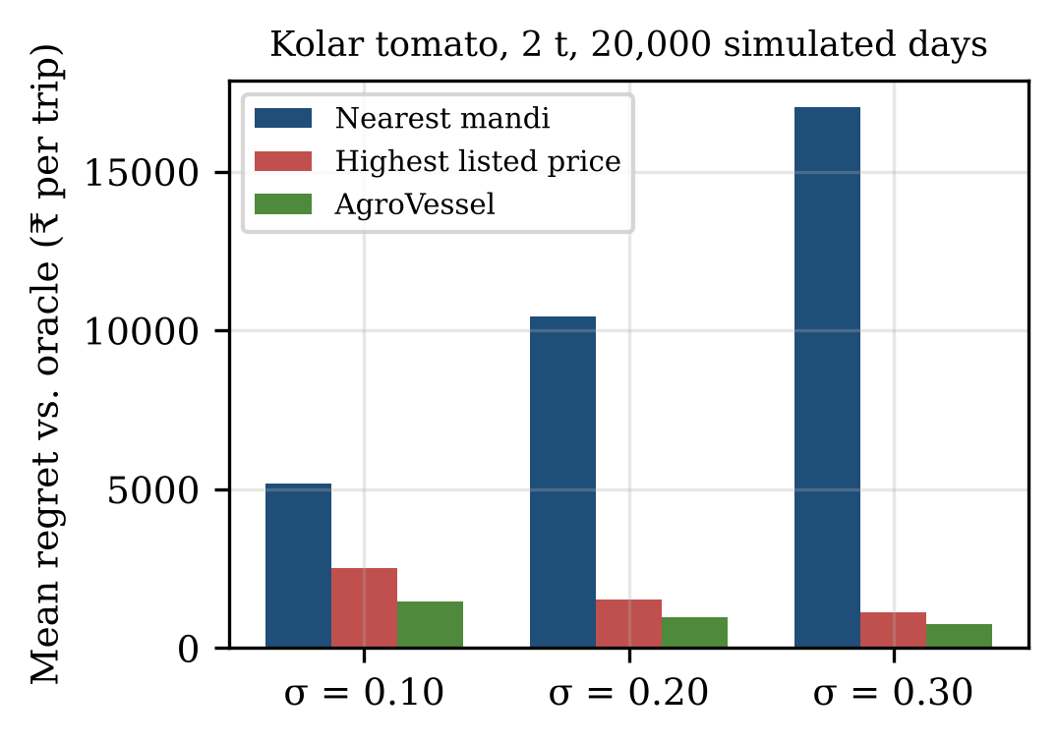
Fig. 6. Mean regret relative to the best realised market (oracle) for three selling strategies, Kolar tomato, 2-tonne lot, 20,000 simulated days per setting.
3.6. System performance and testing
Table 5 reports performance measurements. With external services mocked, generating a recommendation from 400 price records, including mandi location, distance filtering, routing and weather parsing, spoilage evaluation for four departures and ranking, took a median of 14.5 ms (95th percentile 25.0 ms) on a cloud container, so the decision logic itself is negligible in the end-to-end time. On the deployed service, measured from a browser in India on 19 October 2026, lightweight endpoints such as the health check and the state lookup responded in about 60–70 ms, and the page loaded in about 1.5 s. A full recommendation took 12.8–13.2 s. Almost all of this time was spent waiting for the price API, which was being called with an unauthorised public demonstration key and timed out. Batching routing and weather into one call each keeps the number of external calls per recommendation constant (one price query per commodity name, one routing call and one weather call) regardless of how many markets are evaluated. All 25 automated tests pass in under one second.
Table 5. Performance measurements
Measurement | Result
Engine time, 400 price records (mocked APIs) | median 14.5 ms, p95 25.0 ms
Health check / state lookup (deployed) | 60–70 ms
Page load (deployed) | ≈1.5 s, 6.8 kB HTML
Full recommendation (deployed, price API timing out) | 12.8–13.2 s
External calls per recommendation | 1 price query per commodity name + 1 routing + 1 weather
Automated tests | 25 passed in 0.95 s

3.7. Discussion and limitations
The results indicate that a recommendation combining price, distance, temperature and timing can change both where and when a farmer sells, with the largest effect on timing for perishable crops in hot months and on market choice for small lots and similar prices. These are model-based results, and several limitations must be acknowledged.
First, the spoilage and markdown parameters are drawn from general postharvest guidance and have not been calibrated against measured losses in Indian open trucks. The Monte Carlo study partly addresses this by adding a 30% log-normal error to the loss, but calibration with field data remains the most important next step. Second, the model uses ambient air temperature, while the temperature inside a loaded, covered truck can be higher because of solar gain and respiration heat [21], [23]. Third, OSRM travel times are for free-flowing cars and underestimate truck travel times, and the traffic multipliers are heuristic. Fourth, modal prices describe a market's typical transaction, not the price a particular lot will fetch, and arrivals from many farmers responding to the same information could reduce the price at the recommended market. Fifth, the case-study prices are illustrative, not observed, because live price collection was not available during the study period; a deployment with a valid data.gov.in key will allow evaluation on observed prices. Finally, the system relies on third-party public services whose availability and rate limits are outside the authors' control.
Despite these limitations, the approach is transparent: every recommendation shows the price date, transport cost, predicted loss, transit temperature and reason for the chosen departure, so that a farmer can judge whether to trust it. The design also generalises easily, because new crops require only a reference shelf life, a Q10 value and a commodity name mapping.
4. Conclusion
This paper presented AgroVessel, a web decision support system that recommends where and when an Indian farmer should sell a perishable lot by maximising expected net profit. It combines all-India Agmarknet prices, OSRM road routing, Open-Meteo temperature forecasts, state diesel prices and an offline gazetteer with a Q10 spoilage model, a buyer markdown, traffic factors and market closing times. The system is deployed, bilingual and open-source, and works for every state and union territory.
Using real road distances and reanalysis temperatures for Kolar and Nashik, the evaluation showed that departure time alone can change predicted tomato loss on a 256 km route from 4.0% to 12.9% in May, worth about ₹12,500 on a 2-tonne lot; that the price premium needed to justify a distant market falls sharply with lot size; and that, in simulation, the recommendation reduced mean regret by 11–42% compared with choosing the highest listed price and increased mean net income by ₹3,710–21,929 per trip compared with selling at the nearest mandi.
Future work will calibrate the loss model with measurements from farmer trips, add truck-specific travel times and in-vehicle temperature estimates, incorporate short-term price forecasts [17], support produce pooling among farmers, and extend the interface to additional Indian languages and voice input for low-literacy users.
Acknowledgements
This research received no specific grant from any funding agency in the public, commercial or not-for-profit sectors. The authors thank the Government of India Open Government Data platform and Agmarknet for public market data, and the OpenStreetMap, OSRM, Open-Meteo and GeoNames communities for openly licensed data and services.
References
[1] Food and Agriculture Organization of the United Nations, The State of Food and Agriculture 2019: Moving Forward on Food Loss and Waste Reduction, Rome: FAO, 2019. https://www.fao.org/3/ca6030en/ca6030en.pdf
[2] A. A. Kader, "Increasing food availability by reducing postharvest losses of fresh produce", Acta Horticulturae, No. 682, pp. 2169–2176, 2005. https://doi.org/10.17660/ActaHortic.2005.682.296
[3] NABARD Consultancy Services (NABCONS), Study to Determine Post-Harvest Losses of Agri Produces in India, New Delhi: Ministry of Food Processing Industries, Government of India, 2022.
[4] S. Lamba, R. Singh and S. Anand, "Tomato trail: Tracking food loss and food waste in Madhya Pradesh", WRI India Working Paper, New Delhi: World Resources Institute India, 2024. https://wri-india.org/research/tomato-trail-tracking-food-loss-and-food-waste-madhya-pradesh
[5] S. N. Jha, R. K. Vishwakarma, T. Ahmad, A. Rai and A. K. Dixit, Assessment of Quantitative Harvest and Post-Harvest Losses of Major Crops and Commodities in India, Ludhiana: ICAR-All India Coordinated Research Project on Post-Harvest Technology, ICAR-CIPHET, 2015.
[6] I. K. Arah, H. Amaglo, E. K. Kumah and H. Ofori, "Preharvest and postharvest factors affecting the quality and shelf life of harvested tomatoes: A mini review", International Journal of Agronomy, Vol. 2015, art. no. 478041, pp. 1–6, 2015. https://doi.org/10.1155/2015/478041
[7] S. Negi and N. Anand, "Supply chain efficiency: An insight from fruits and vegetables sector in India", Journal of Operations and Supply Chain Management, Vol. 7, No. 2, 2014. https://periodicos.fgv.br/joscm/article/view/43769
[8] Government of India, Open Government Data Platform, "Current daily price of various commodities from various markets (Mandi)", data.gov.in, accessed Oct. 2026. https://www.data.gov.in/resource/current-daily-price-various-commodities-various-markets-mandi
[9] Directorate of Marketing and Inspection, Ministry of Agriculture and Farmers Welfare, Agmarknet: Agricultural Marketing Information Network, accessed Oct. 2026. https://agmarknet.gov.in
[10] R. Jensen, "The digital provide: Information (technology), market performance, and welfare in the South Indian fisheries sector", The Quarterly Journal of Economics, Vol. 122, No. 3, pp. 879–924, 2007. https://doi.org/10.1162/qjec.122.3.879
[11] J. C. Aker, "Information from markets near and far: Mobile phones and agricultural markets in Niger", American Economic Journal: Applied Economics, Vol. 2, No. 3, pp. 46–59, 2010. https://doi.org/10.1257/app.2.3.46
[12] A. Goyal, "Information, direct access to farmers, and rural market performance in Central India", American Economic Journal: Applied Economics, Vol. 2, No. 3, pp. 22–45, 2010. https://doi.org/10.1257/app.2.3.22
[13] S. Mittal, S. Gandhi and G. Tripathi, "Socio-economic impact of mobile phones on Indian agriculture", ICRIER Working Paper No. 246, New Delhi: Indian Council for Research on International Economic Relations, 2010. https://ideas.repec.org/p/ind/icrier/246.html
[14] M. Fafchamps and R. V. Hill, "Selling at the farmgate or traveling to market", American Journal of Agricultural Economics, Vol. 87, No. 3, pp. 717–734, 2005. https://doi.org/10.1111/j.1467-8276.2005.00758.x
[15] N. Key, E. Sadoulet and A. de Janvry, "Transactions costs and agricultural household supply response", American Journal of Agricultural Economics, Vol. 82, No. 2, pp. 245–259, 2000. https://doi.org/10.1111/0002-9092.00022
[16] A. Singh, Kiran and S. Sihag, "Changing pattern of prices and arrivals of agricultural commodities through e-NAM: A case study of Sirsa APMC in Haryana", Economic and Regional Studies, Vol. 16, No. 4, pp. 694–707, 2023. https://doi.org/10.2478/ers-2023-0042
[17] R. K. Paul, M. Yeasin, P. Kumar, P. Kumar, M. Balasubramanian, H. S. Roy, A. K. Paul and A. Gupta, "Machine learning techniques for forecasting agricultural prices: A case of brinjal in Odisha, India", PLOS ONE, Vol. 17, No. 7, art. no. e0270553, 2022. https://doi.org/10.1371/journal.pone.0270553
[18] A. Osvald and L. Z. Stirn, "A vehicle routing algorithm for the distribution of fresh vegetables and similar perishable food", Journal of Food Engineering, Vol. 85, No. 2, pp. 285–295, 2008. https://doi.org/10.1016/j.jfoodeng.2007.07.008
[19] P. Amorim, S. N. Parragh, F. Sperandio and B. Almada-Lobo, "A rich vehicle routing problem dealing with perishable food: A case study", TOP, Vol. 22, No. 2, pp. 489–508, 2014. https://doi.org/10.1007/s11750-012-0266-4
[20] P. Toth and D. Vigo (Eds.), Vehicle Routing: Problems, Methods, and Applications, 2nd ed., Philadelphia: SIAM, 2014. https://doi.org/10.1137/1.9781611973594
[21] R. Jedermann, M. Nicometo, I. Uysal and W. Lang, "Reducing food losses by intelligent food logistics", Philosophical Transactions of the Royal Society A, Vol. 372, No. 2017, art. no. 20130302, 2014. https://doi.org/10.1098/rsta.2013.0302
[22] S. Mercier, S. Villeneuve, M. Mondor and I. Uysal, "Time–temperature management along the food cold chain: A review of recent developments", Comprehensive Reviews in Food Science and Food Safety, Vol. 16, No. 4, pp. 647–667, 2017. https://doi.org/10.1111/1541-4337.12269
[23] N. Ndraha, H. I. Hsiao, J. Vlajic, M. F. Yang and H. T. V. Lin, "Time-temperature abuse in the food cold chain: Review of issues, challenges, and recommendations", Food Control, Vol. 89, pp. 12–21, 2018. https://doi.org/10.1016/j.foodcont.2018.01.027
[24] M. M. Aung and Y. S. Chang, "Temperature management for the quality assurance of a perishable food supply chain", Food Control, Vol. 40, pp. 198–207, 2014. https://doi.org/10.1016/j.foodcont.2013.11.016
[25] S. C. Fonseca, F. A. R. Oliveira and J. K. Brecht, "Modelling respiration rate of fresh fruits and vegetables for modified atmosphere packages: A review", Journal of Food Engineering, Vol. 52, No. 2, pp. 99–119, 2002. https://doi.org/10.1016/S0260-8774(01)00106-6
[26] K. Tano, M. K. Oulé, G. Doyon, R. W. Lencki and J. Arul, "Comparative evaluation of the effect of storage temperature fluctuation on modified atmosphere packages of selected fruit and vegetables", Postharvest Biology and Technology, Vol. 46, No. 3, pp. 212–221, 2007. https://doi.org/10.1016/j.postharvbio.2007.05.008
[27] J. Gustavsson, C. Cederberg, U. Sonesson, R. van Otterdijk and A. Meybeck, Global Food Losses and Food Waste: Extent, Causes and Prevention, Rome: FAO, 2011. https://www.fao.org/3/i2697e/i2697e.pdf
[28] D. Luxen and C. Vetter, "Real-time routing with OpenStreetMap data", Proceedings of the 19th ACM SIGSPATIAL International Conference on Advances in Geographic Information Systems, pp. 513–516, 2011. https://doi.org/10.1145/2093973.2094062
[29] P. Zippenfenig, "Open-Meteo.com Weather API" (Version 0.2.69), Zenodo, 2023. https://doi.org/10.5281/zenodo.8112599
[30] H. Hersbach, B. Bell, P. Berrisford, S. Hirahara, A. Horányi, J. Muñoz-Sabater et al., "The ERA5 global reanalysis", Quarterly Journal of the Royal Meteorological Society, Vol. 146, No. 730, pp. 1999–2049, 2020. https://doi.org/10.1002/qj.3803
[31] Goodreturns, "Diesel price today: State-wise diesel rates in India", goodreturns.in, accessed 17 Oct. 2026. https://www.goodreturns.in/diesel-price.html
[32] GeoNames, GeoNames Geographical Database (cities1000), CC BY 4.0, accessed Oct. 2026. https://www.geonames.org
[33] A. A. Kader (Ed.), Postharvest Technology of Horticultural Crops, 3rd ed., Oakland: University of California, Agriculture and Natural Resources, Publication 3311, 2002.
[34] S. Ramírez, FastAPI, software, accessed Oct. 2026. https://fastapi.tiangolo.com

