1. For parents, identify homozygous calls, which are biallelic
   1. Subset of SNPs that are homozygous and biallelic in a vector of row numbers from vcf file
2. VCF file
   1. For each of the progeny and each row in the vector of row numbers for homozygous, biallelic SNPs we want to know if the SNP call is a heterozygous save in a matrix with columns as progeny and rows
   2. Compare counts of heterozygous SNPs for each progeny and identify outliers

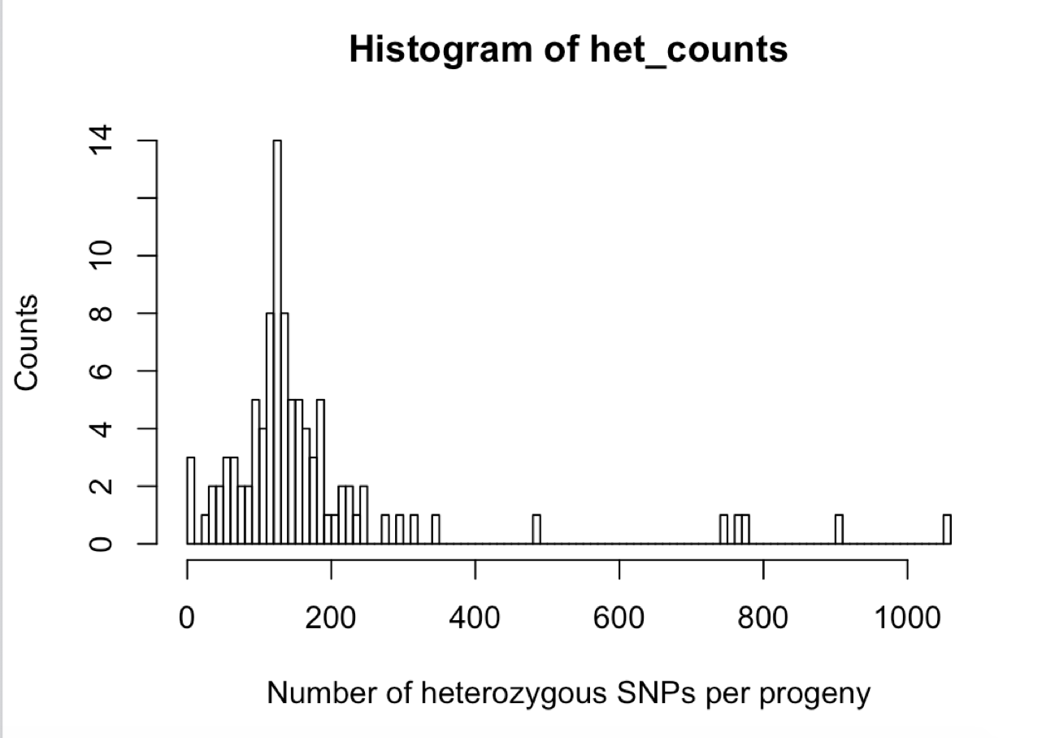

1. Sliding window analysis
   1. Define window size (by number of SNPs) and count heterozygous SNP calls in a window, identify regions with high number of heterozygous SNPs

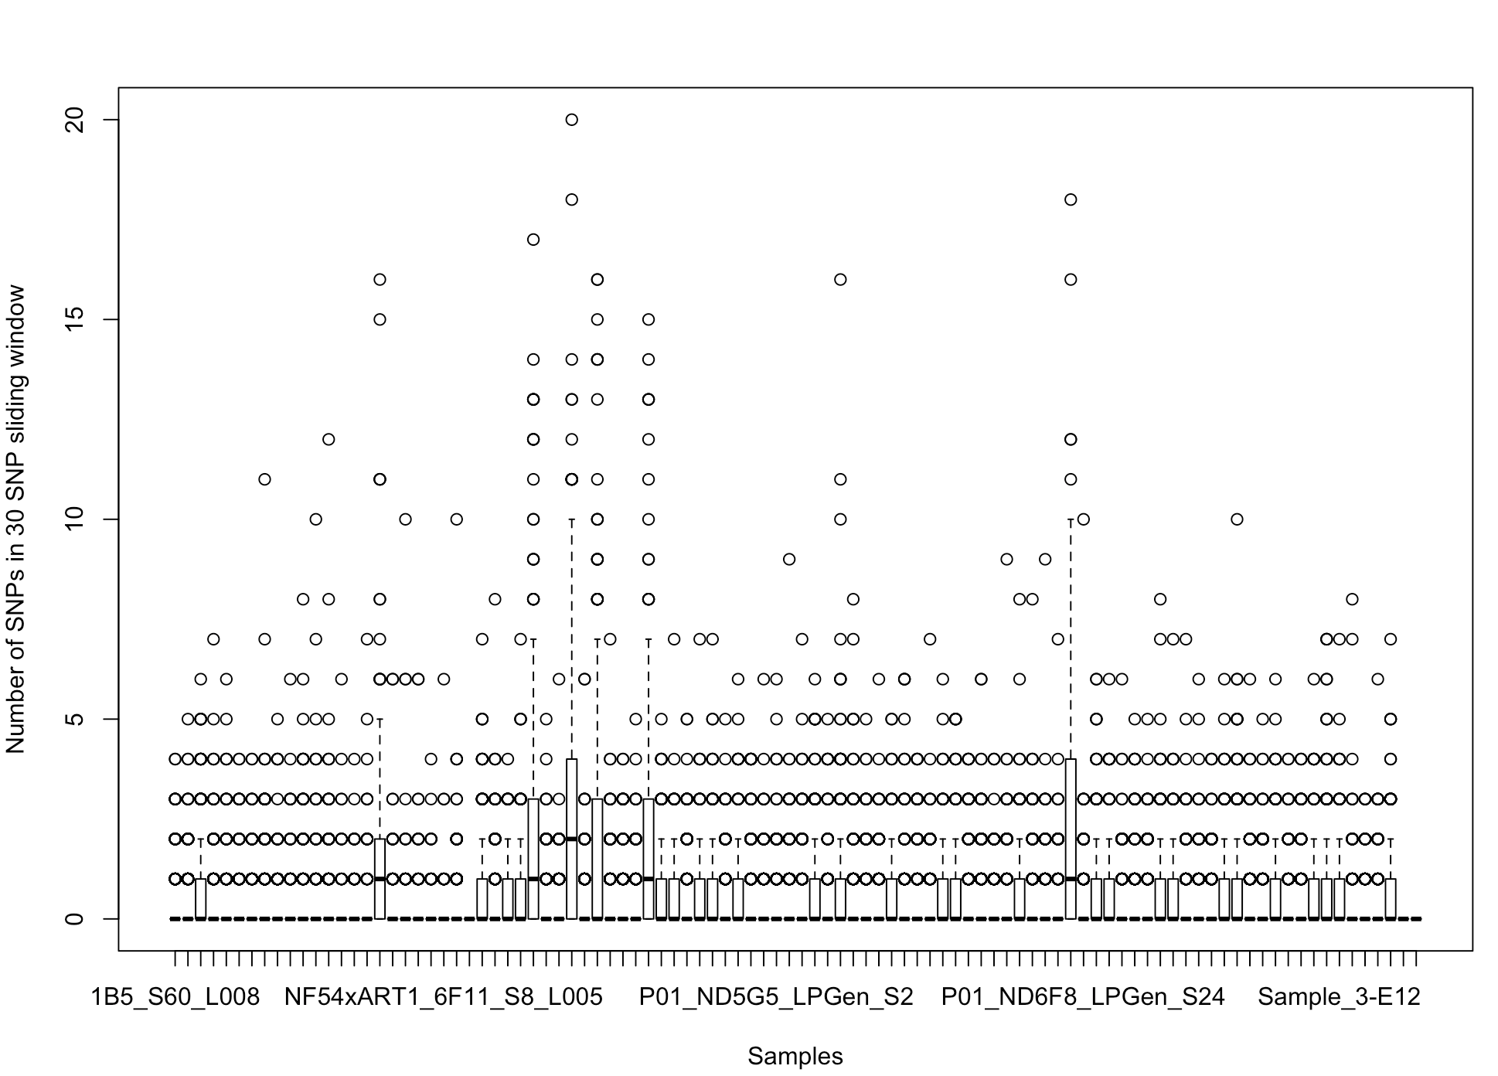

* 1. Define window based on actual location of SNPs and average cross-over length from previous crosses