MICHAEL S.MALATE

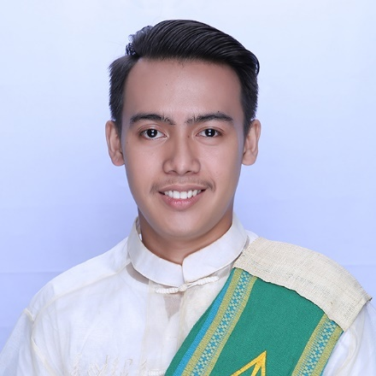

Cantiguib, Alburquerque, Bohol

09104194324

malatemichael22@gmail.com

# PERSONAL INFORMATION

Age: 23

Date of Birth: April 26, 1999

Gender: Male

Civil Status: Single

Nationality: Filipino

Religion: Roman Catholic

Languages: Cebuano, Filipino, English

# EDUCATION

Primary**:** Dangay Elementary School

Dangay,Alburquerque, Bohol

March (2011)

Secondary**:** Immaculata High Shool

Poblacion, Baclayon, Bohol

March (2015)

Tertiary**:** Holy Name University

Janssen Heights, Dampas District, Tagbilaran City

April (2019)

# Skills

* Hardware troubleshooting
* Software Installation
* Network troubleshooting
* Web Development (PHP, HTML5, CSS, Bootstrap)
* Programming (Java, C)
* Microsoft Office (MS Word, Excel, PowerPoint, etc.)
* Graphics designing (Adobe Photoshop)

# Certificates

* Organized by Philippine Society of Information Technology Educators in Cooperation with College of Engineering and Computer Studies – HNU, March 2, 2018
* 10th Bohol IT Student Congress
* Organized by RivanIT Systems Cooperation, March 18, 2017
* VoIP and Wireless Communictations

# Work experiences

**Alturas Group of Companies (IT – Systems Development)**

Position: System Programmer

Specialization: IT/Computer –Hardware and Software

Duration: August 2022 to Present

**IBEX Bohol**

Position: Customer Service Representative

Specialization: Customer Service ( Financial account)

Duration: April 2021 to Present

**Qualfon Philippines**

Position: Customer Service Representative ( Tier 3 )

Specialization: Customer Service ( Telco account)

Duration: January 2020 to March 2021

**Alturas Group of Companies (Home & Fashion Distribution Center)**

Position: Technical Support Staff

Specialization: IT/Computer –Hardware and Software

Duration: May 2019 to October 2019

**Provincial Government of Bohol**

Position: OJT (Trainee) – IT Support

Specialization: IT/Computer - Creative Design

Duration: November 2018 to February 2019

**Holy Name University**

Position: Working Student – IT Support

Specialization: IT/Computer –Hardware and Software

Duration: October2015 toOctober2018

# references

* Dr Maria Celia Z. Ligason

Chair, College of Computer Studies

Holy Name University

Email : [electra362@yahoo.com](mailto:electra362@yahoo.com)

* Prof. Maria Isabel Abucejo

Faculty, College of Engineering and Computer Studies

Holy Name University

Email: [isah.hnu@gmail.com](mailto:isah.hnu@gmail.com)