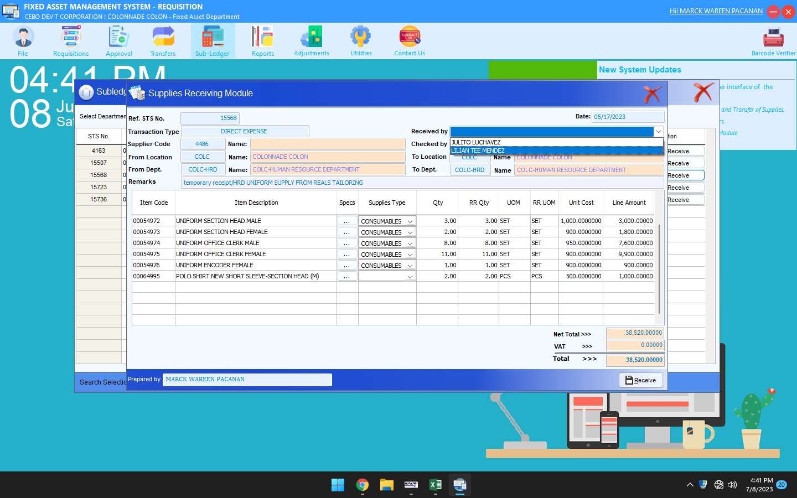

ADD RECEIVING INCHARGE NAME : MARC WAREEN V. PACANAN

THIS ACCOUNT ARE INACTIVE LILLIAN AND JULITO

THANKS