• Please put location OCN under the account of rhenrad miller banate

• Only DEPARTMENT = OCN-laundry remain deprt.

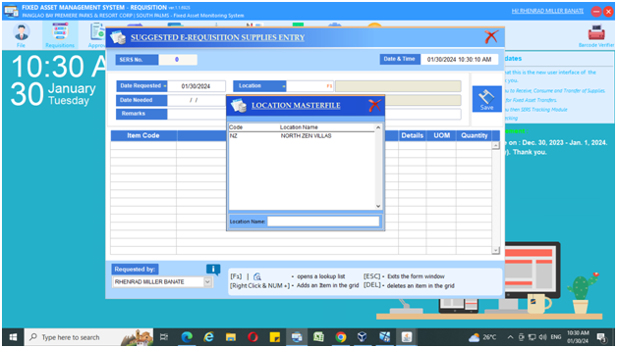

**rhenrad miller banate 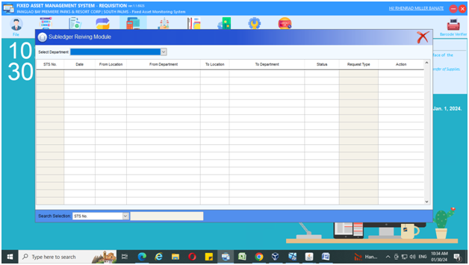 FAD ACCOUNT**

SUB LEDGER RECEIVING MODULE