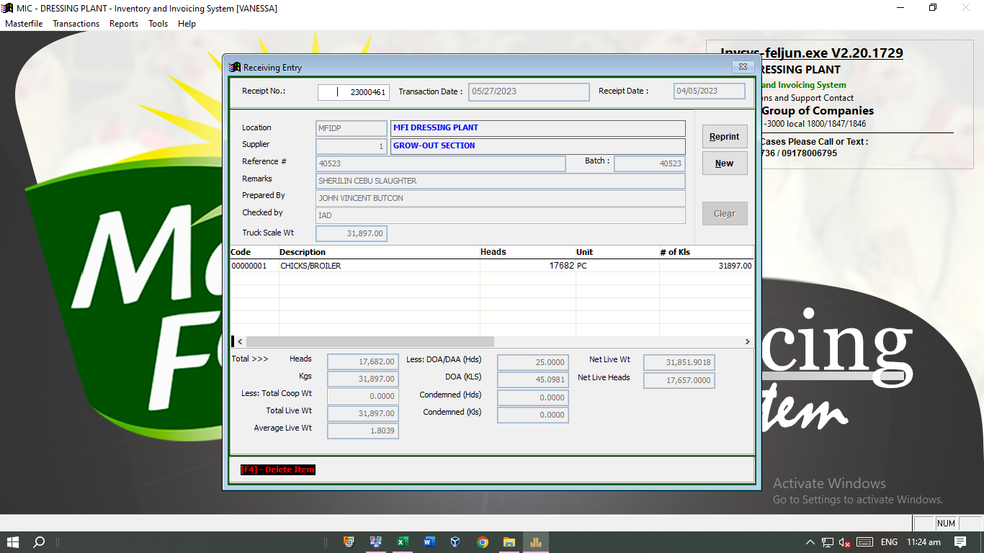

Computation must be:

TOTAL KILOS-DOA KLS-COND.KLS-WASTE DED. = NET WT.

Waste deduction