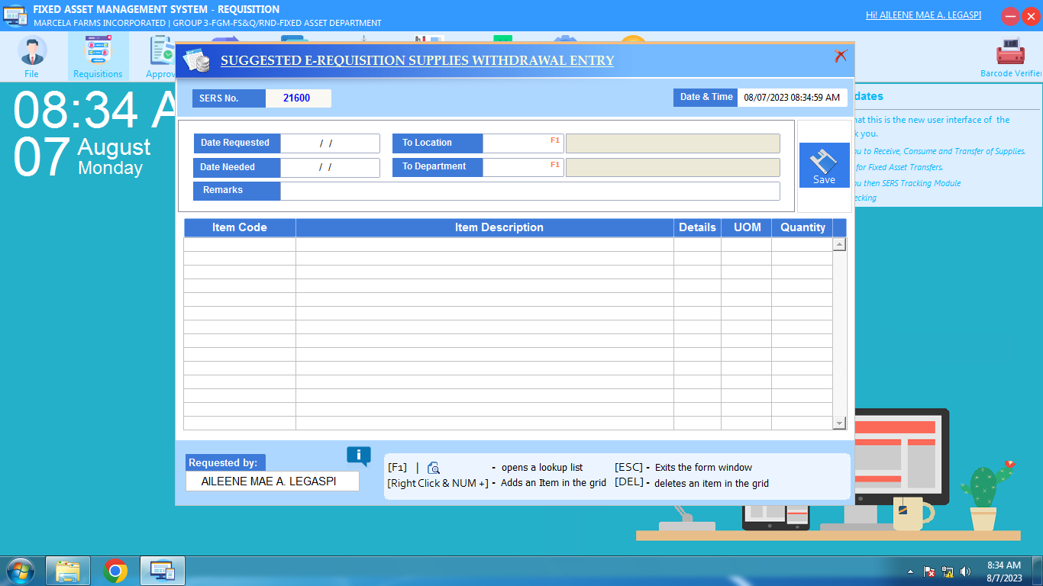

Pa set-up ko diri sa SWS location mam/sir thank you.