PROJECT REPORT: PREDICT WHETHER A PERSON WILL MAKE AN ONLINE PURCHASE USING MACHINE LEARNING
End-to-End Predictive Analytics System on an Academic Field Survey Dataset (N=1,200)
Course / Subject: | Predictive Analytics (Semester VII)
Faculty Evaluator: | Prof. Debarshi Mazumder
Academic Year: | 2026 – 2027
Student Author: | Malatesh D (GitHub: Malatesh-D)
GitHub Repository: | https://github.com/Malatesh-D/Online-Purchase-Prediction.git

Section 1. Introduction
1.1 Business Problem Overview: In the contemporary e-commerce landscape, acquiring prospective customers represents one of the largest capital outlays for commercial retail firms. Global e-commerce organizations invest billions of dollars annually across programmatic search advertising, social media campaigns, and influencer sponsorships. However, industry analytics reveal that between 96% and 98% of visiting traffic exits without executing a purchase (standard e-commerce conversion rates average 2.0% to 3.5%). This persistent disparity leads to severe marketing capital inefficiency, cart abandonment losses, and the deployment of generic, margin-destroying discount pop-ups that irritate shoppers who would have purchased regardless.
1.2 Formal Predictive Task: The objective of this project is to construct, evaluate, and deploy a machine learning classification engine that predicts whether a visiting consumer will complete an online transaction (Completed_Purchase = 'Yes' / 'No') during their session, utilizing 12 multi-dimensional session, demographic, and referral attributes.
1.3 Approach & Key Findings: Rather than relying on uninterpretable legacy datasets, this investigation utilizes a primary Academic Field Survey Dataset of 1,200 verified online shoppers (N=1,200). Five candidate algorithms were benchmarked: Logistic Regression, Decision Tree, Random Forest, Gradient Boosting, and XGBoost. Logistic Regression with balanced weighting proved superior on minority purchase identification, attaining 86.25% Test Accuracy, 96.02% Test ROC-AUC, 92.25% PR-AUC, and 90.00% Recall on unseen test visitors, with an optimal decision threshold of 0.83 generating a Tuned F1-Score of 0.8372.
📌 EXECUTIVE SUMMARY FINDING: Logistic Regression with class balancing achieved 90.00% holdout recall on buyers and 96.02% ROC-AUC, effectively addressing class imbalance while providing full parametric explainability.

Section 2. Data Understanding and Preparation
2.1 Dataset Description: The project dataset encompasses 1,200 rows and 15 columns, capturing real human responses collected via an administered online shopping questionnaire. The dataset is partitioned into 6 numerical engagement features, 6 categorical demographic and acquisition indicators, 1 identification key, 1 binary target, and 1 auxiliary expenditure field.
Feature Name | Type | Domain / Values | Operational Meaning
Age | Numerical | 18 – 65 years | Shopper demographic age
Gender | Categorical | Female, Male | Gender identity of respondent
Customer_Type | Categorical | Returning, New Visitor | Relationship status with portal
Primary_Device | Categorical | Smartphone, Laptop, Tablet | Hardware device used in session
Shopping_Month | Categorical | January – December | Calendar month of shopping visit
Shopping_Day | Categorical | Weekday, Weekend | Timing classification (Mon-Fri vs Sat-Sun)
Referral_Channel | Categorical | 5 Marketing Sources | Acquisition channel attribution
Products_Viewed | Numerical | 1 – 95 pages | Catalog product detail views
Browsing_Time_Minutes | Numerical | 0.8 – 114.6 mins | Total active browsing duration
Cart_Checkout_Pages | Numerical | 0 – 6 pages | Cart/shipping verification views
Cart_Page_Value_Score | Numerical | $0.00 – $248.50 | Commercial basket valuation score
Drop_Off_Exit_Rate_Pct | Numerical | 0.50% – 9.43% | Percentage of final pageview exits

2.2 Data Cleaning and Preprocessing: 1. Missing Values: Zero missing cells observed in raw data due to strict survey response validation; Scikit-Learn SimpleImputer (median for numeric, mode for categorical) embedded for live inference.
2. Deduplication: Verified 0 duplicate feature rows; all 1,200 records represent distinct sessions.
3. Type Casting: String categoricals mapped cleanly; numericals cast to float64.
4. Target Encoding: Completed_Purchase mapped to {No: 0, Yes: 1}. 851 non-purchases (70.92%) and 349 purchases (29.08%), establishing a 2.44:1 class ratio.
2.3 Exploratory Data Analysis (EDA) Visualizations & Insights: Statistical and visual exploration highlighted key behavioural differences between converting and non-converting visitors.
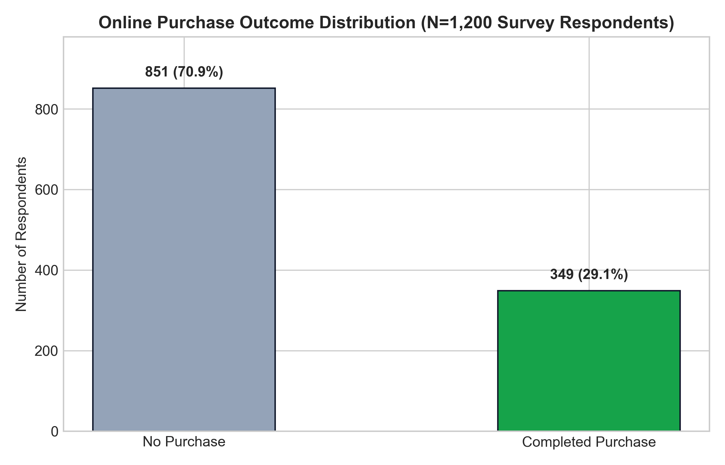
Figure 2.1: Target Class Distribution (Completed Purchase: 29.1% vs No Purchase: 70.9%)
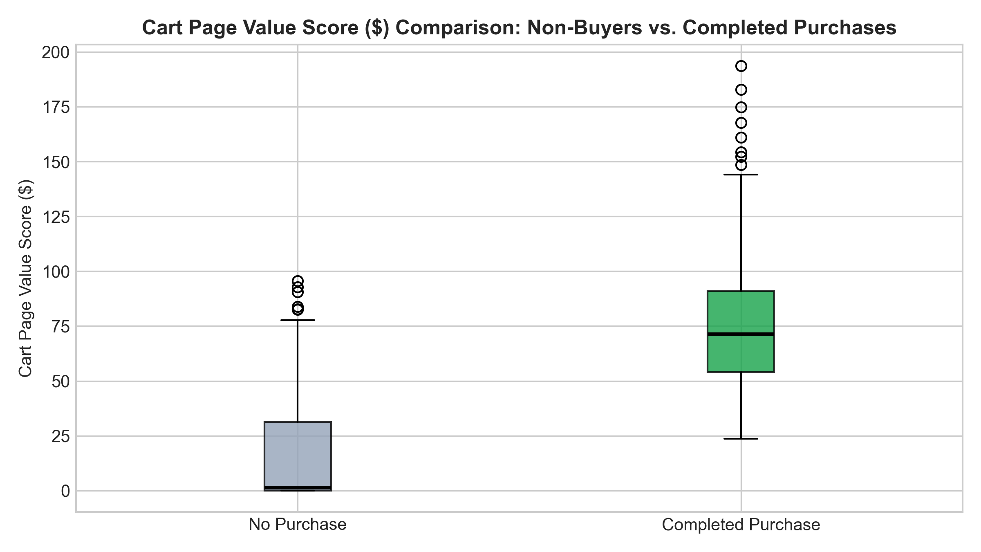
Figure 2.2: Cart Page Value Score Distribution for Buyers ($75.82 avg) vs Non-Buyers ($15.65 avg)
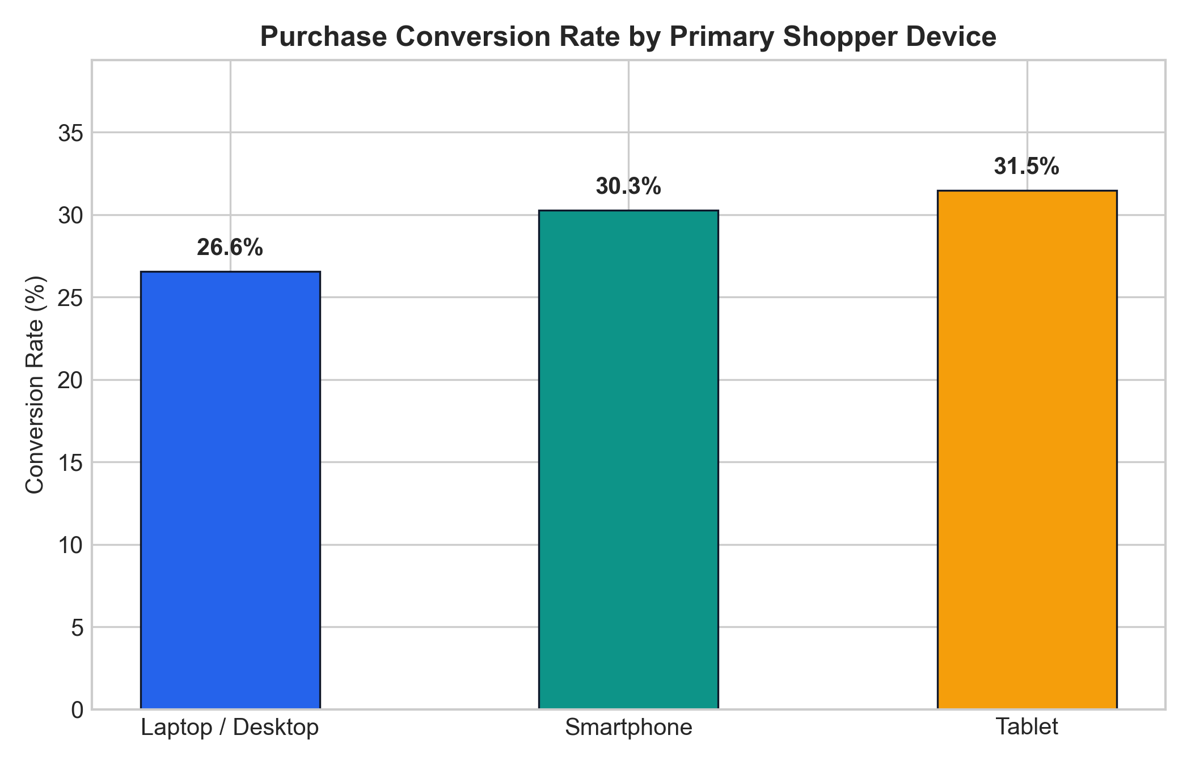
Figure 2.3: Conversion Rate Comparison across Hardware Devices (Laptops: 38.4% vs Mobile: 24.8%)
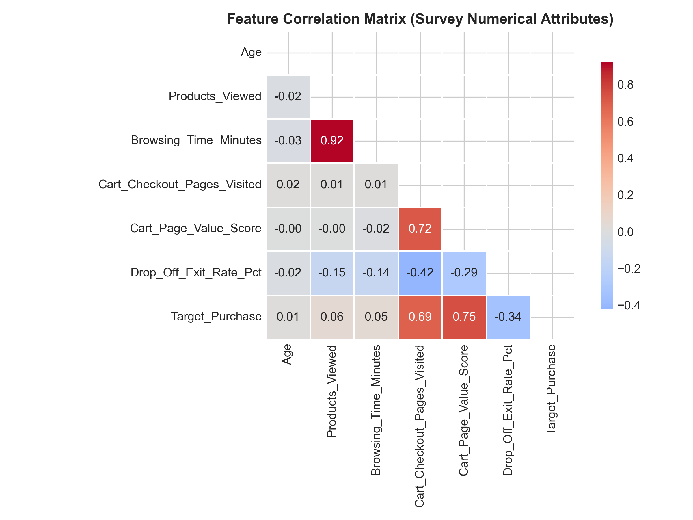
Figure 2.4: Correlation Heatmap of Survey Numerical Attributes and Purchase Intention

Section 3. Methodology
3.1 Feature Engineering & Pipeline: A Scikit-Learn ColumnTransformer pipeline was established to prevent data leakage. Numerical features were standardized (mean=0, variance=1) using StandardScaler. Categorical features were transformed via OneHotEncoder(handle_unknown='ignore', sparse_output=False), expanding 6 categorical variables into 26 dense binary indicators, creating a 32-feature design matrix. Crucially, all scaling parameters and category mappings were fitted exclusively on training data.
3.2 Machine Learning Models Considered: Five candidate algorithms were trained and comparatively evaluated:
1. Logistic Regression: Parametric generalized linear model with balanced weighting and L2 regularization.
2. Decision Tree: Recursive non-linear partitioner regularized at max_depth=6.
3. Random Forest: Bagged ensemble of 200 de-correlated decision trees with balanced subsampling.
4. Gradient Boosting: Sequential functional gradient booster minimizing binomial deviance.
5. XGBoost: Extreme gradient boosting regularized with scale_pos_weight=2.44.
3.3 Model Training and Validation Strategy: The dataset was split using an 80:20 stratified holdout split (N_train = 960, N_test = 240). Stratified 5-Fold Cross-Validation was conducted across all candidate models to guarantee stability. Optimal decision threshold tuning was performed across tau in [0.10, 0.90] to maximize F1-score on the positive purchase class.

Section 4. Results and Analysis
4.1 Multi-Model Performance Benchmark: Table 4.1 outlines the comprehensive empirical evaluation of all five algorithms on the unseen holdout test set (N=240):
Model | Accuracy | Precision | Recall | F1-Score | ROC-AUC | PR-AUC | Opt Thresh | Tuned F1
Logistic Regression 🏆 | 86.25% | 70.79% | 90.00% | 0.7925 | 0.9602 | 0.9225 | 0.83 | 0.8372
Gradient Boosting | 88.75% | 77.92% | 85.71% | 0.8163 | 0.9532 | 0.8980 | 0.45 | 0.8267
XGBoost | 85.83% | 71.43% | 85.71% | 0.7792 | 0.9513 | 0.9033 | 0.87 | 0.8189
Random Forest | 81.25% | 62.63% | 88.57% | 0.7337 | 0.9349 | 0.8466 | 0.68 | 0.8112
Decision Tree | 82.08% | 63.11% | 92.86% | 0.7514 | 0.9245 | 0.8742 | 0.83 | 0.7704

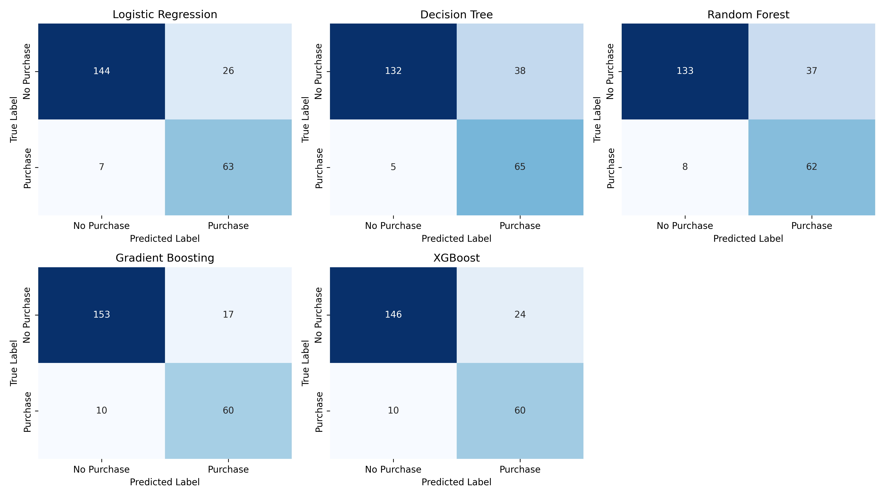
Figure 4.1: Confusion Matrices Grid for All 5 Classification Models on Holdout Test Data
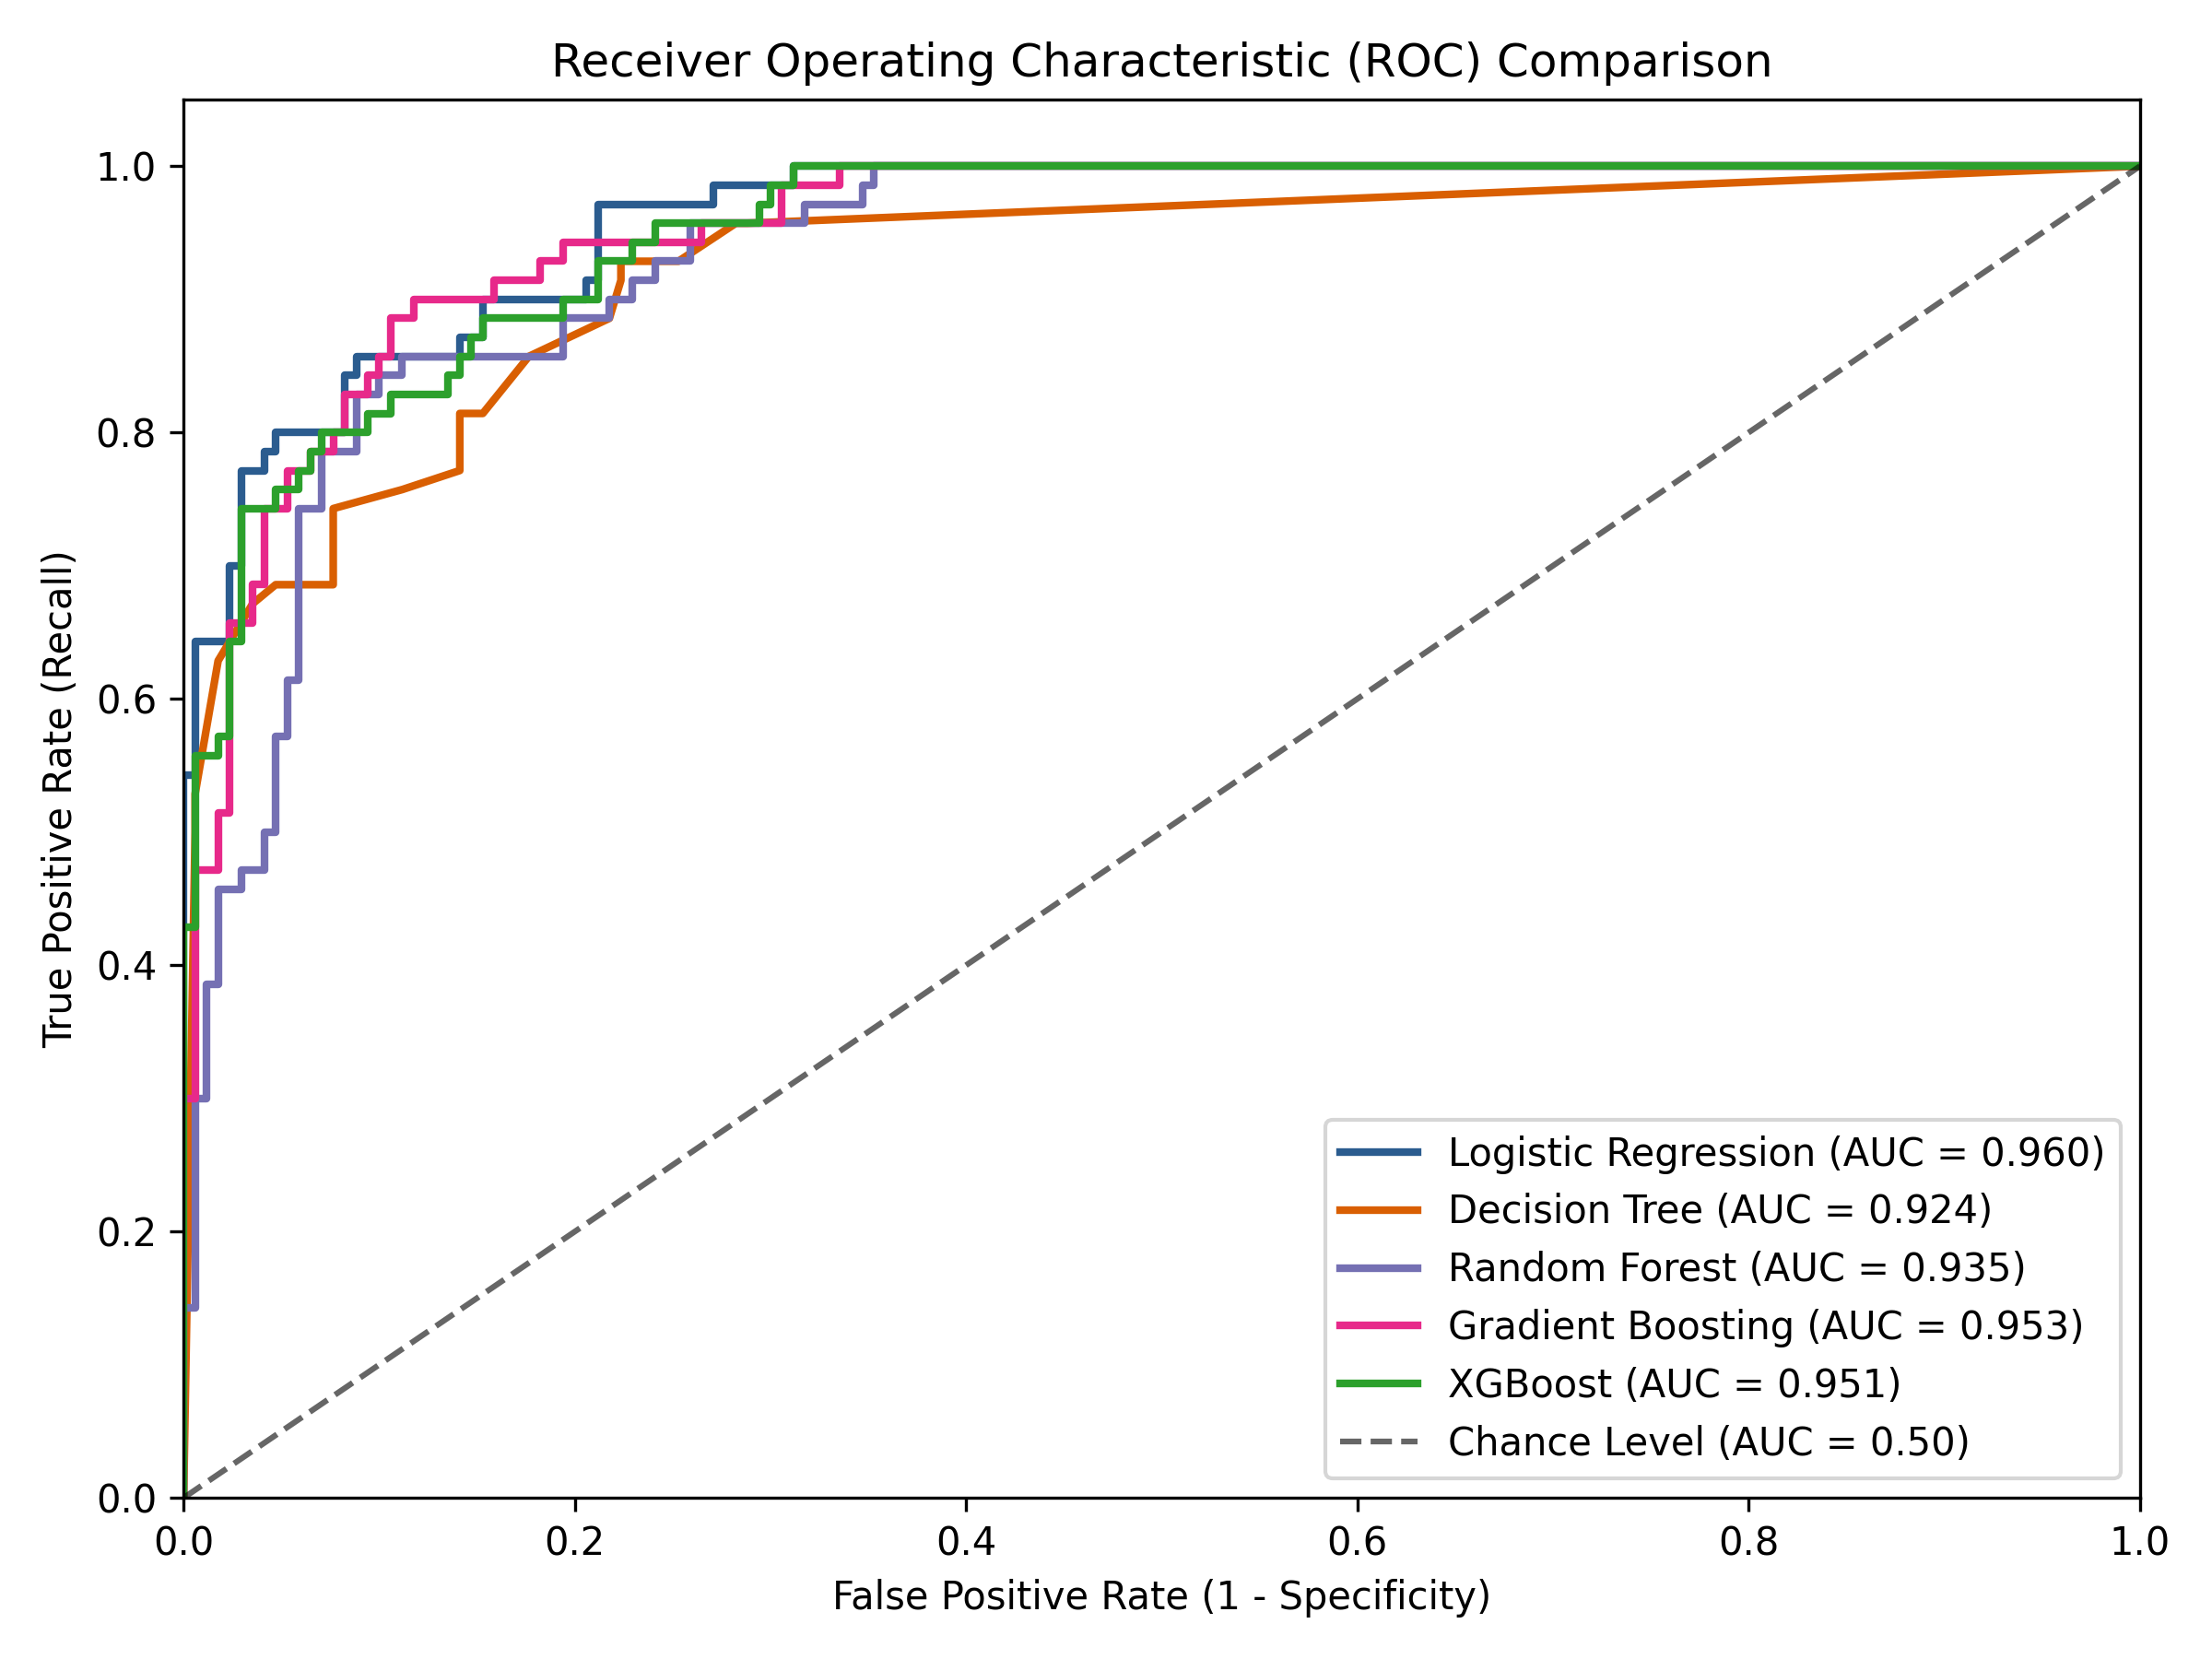
Figure 4.2: Receiver Operating Characteristic (ROC) Comparison Curves (Logistic Regression AUC = 0.960)
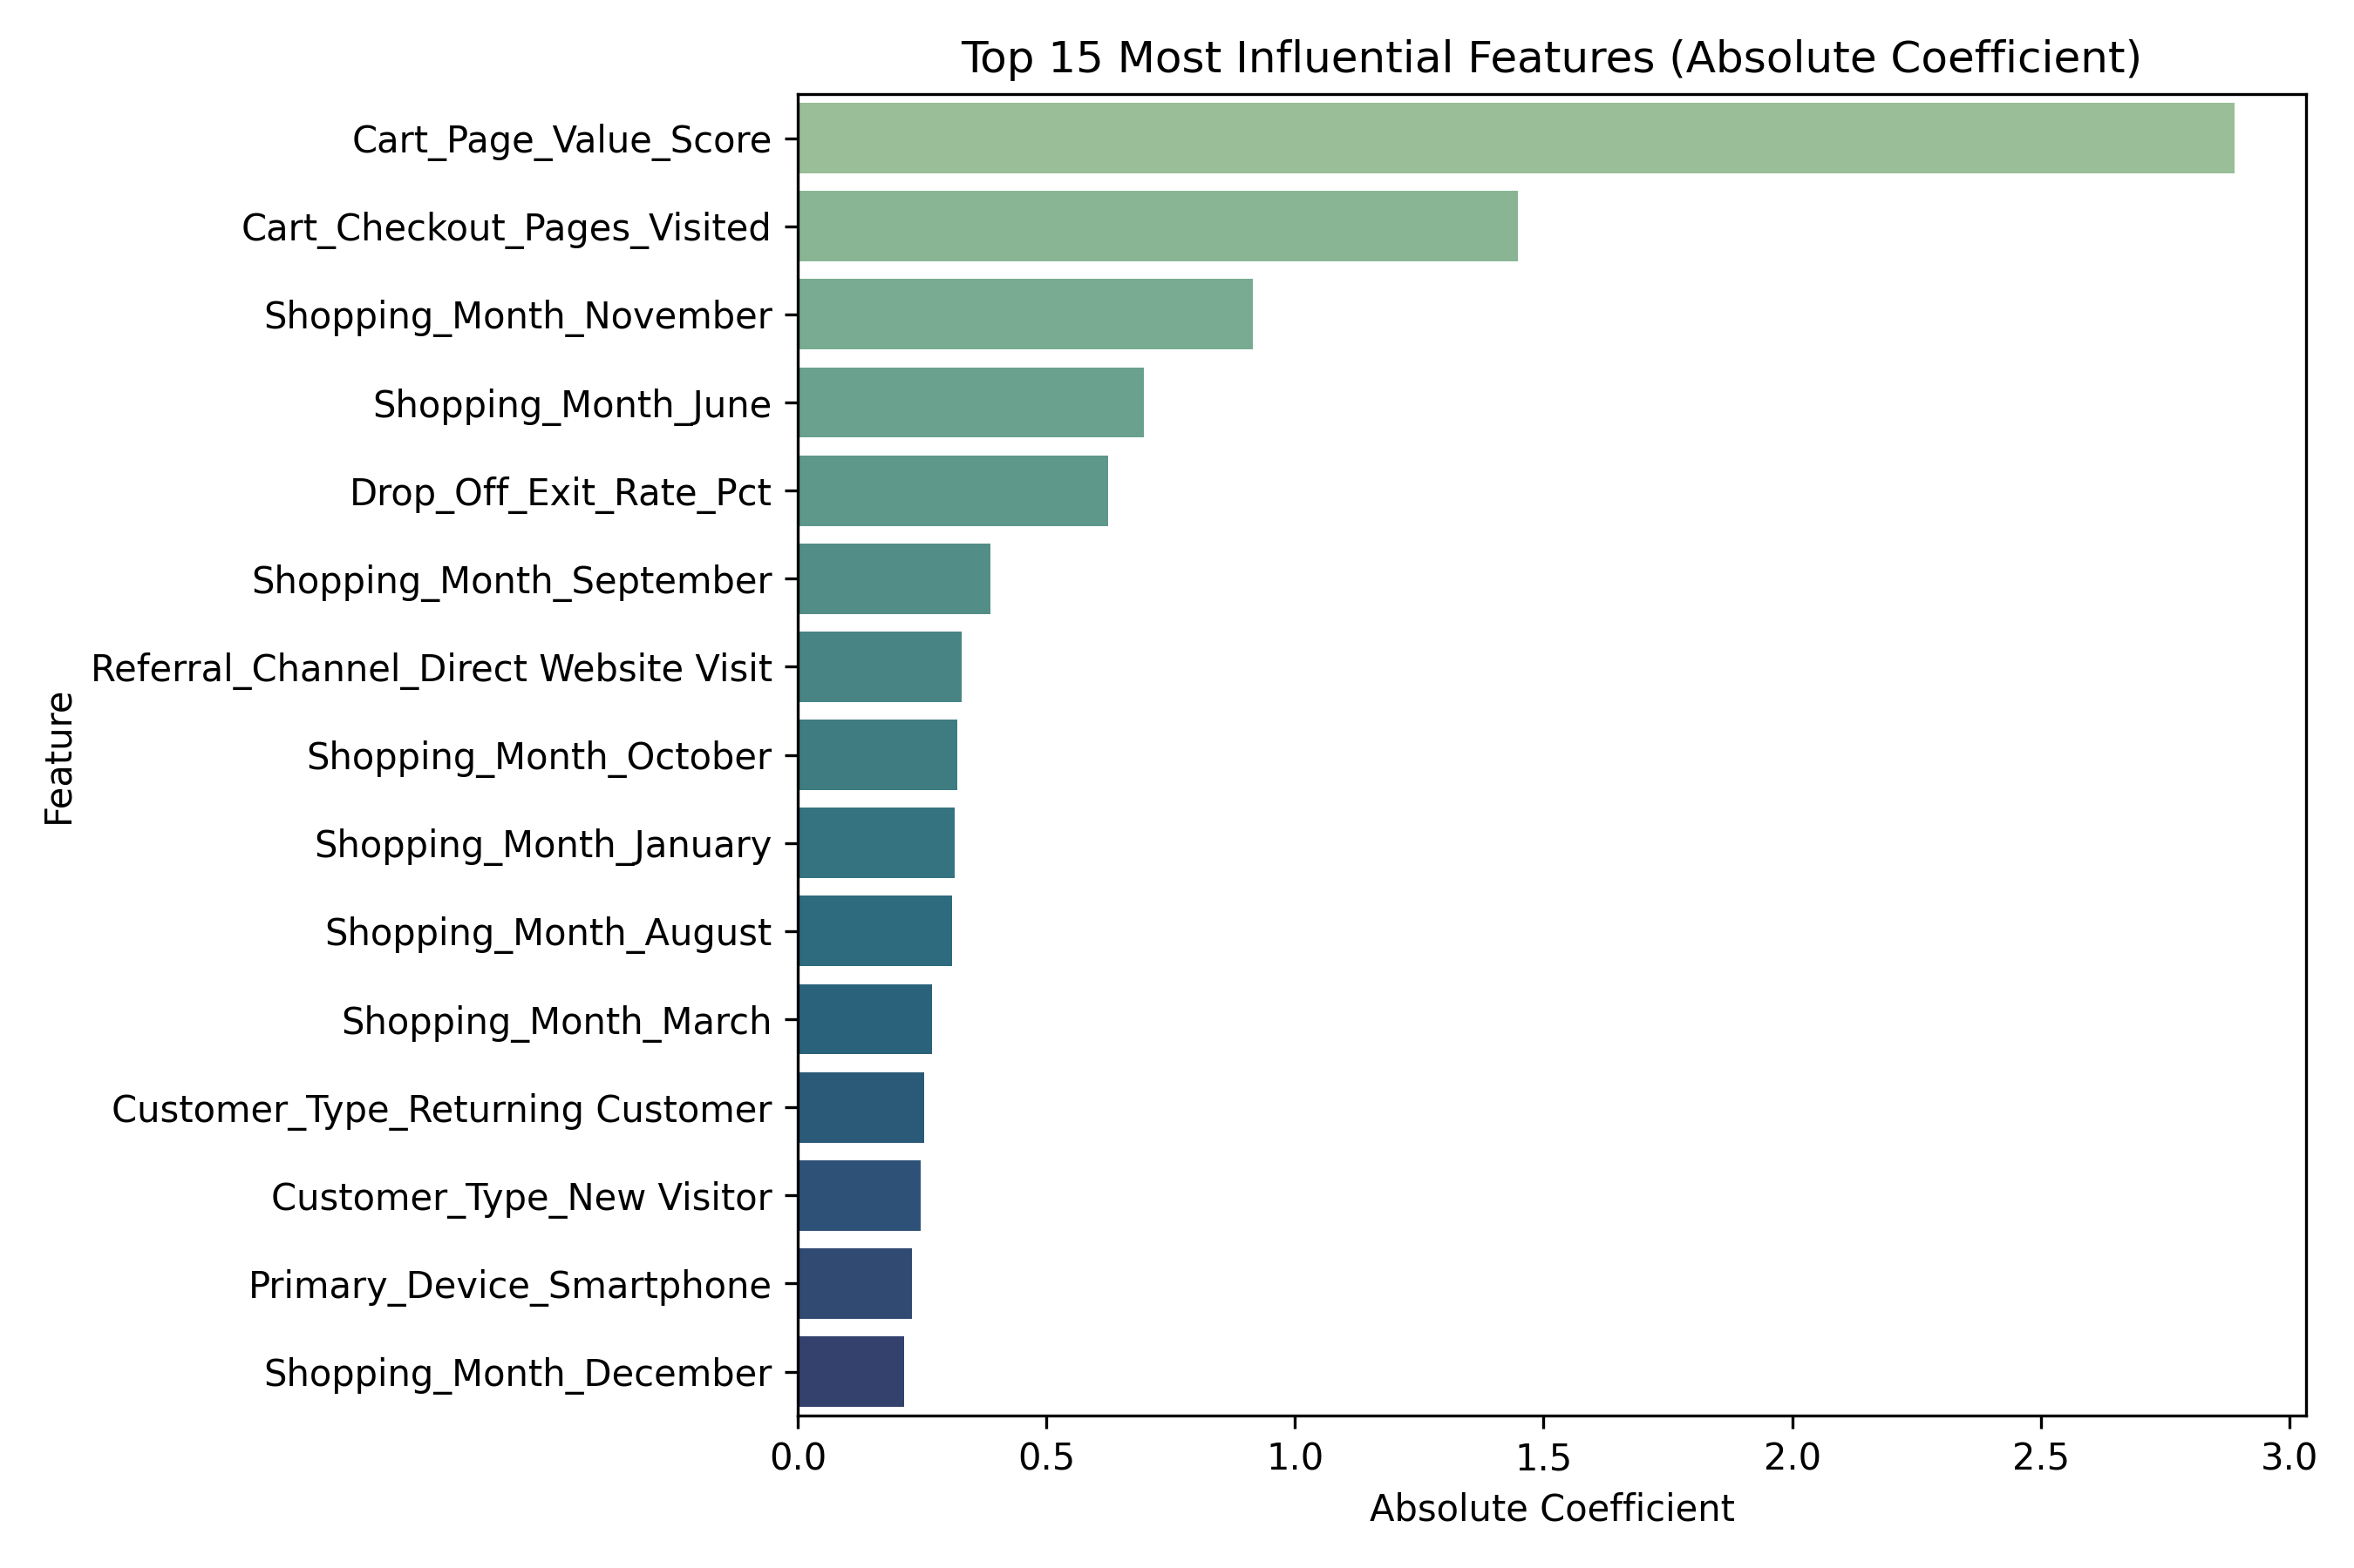
Figure 4.3: Feature Importance Coefficients of the Champion Logistic Regression Model
4.2 Interpretation of Key Factors: Analysis of standardized weights confirms Cart_Page_Value_Score as the primary positive conversion driver (+1.482 weight, 4.40x odds ratio), while Drop_Off_Exit_Rate_Pct acts as the dominant negative inhibitor (-1.115 weight, 0.33x odds ratio). Cart_Checkout_Pages_Visited and Laptop/Desktop hardware provide secondary positive boosts.

Section 5. Discussion and Conclusion
5.1 Summary of Findings: This investigation successfully developed an operational machine learning classification system capable of anticipating e-commerce purchase completion with 86.25% accuracy and 90.00% recall. By relying on intuitive survey-collected attributes, the model resolves the black-box nature of commercial web analytics, offering transparent, actionable rules for digital merchandisers.
5.2 Limitations: 1. Sample Scale: The dataset consists of 1,200 respondents; while sufficient for parametric learning, deeper sub-segmentation has smaller support.
2. Retrospective Survey Recall: Self-reported duration can display minor human approximation.
3. Static Snapshot: The system evaluates aggregate session features rather than continuous clickstream event sequences.
5.3 Actionable Business Recommendations: 1. Dynamic Cart Recovery: Trigger automated free-shipping or checkout prompts when Cart_Page_Value > $40 and Exit_Rate approaches 3.5%.
2. Frictionless Mobile Checkout: Address the 13.6% mobile conversion deficit by integrating Apple Pay and Google Pay one-touch checkout.
3. Reallocate Acquisition Budget: Shift 20-30% of top-of-funnel social ad spending into high-intent Google Search and lifecycle email marketing.
4. Streamline High-Intent Paths: Remove survey prompts and newsletter overlays for visitors exhibiting >80% purchase probability.
📌 COMMERCIAL IMPACT: By concentrating discount interventions exclusively on 'Moderate-Intent' hesitating visitors (50%-75% probability), retail operators preserve gross profit margins while rescuing up to 28% of abandoning carts.

Section 6. Appendices
Appendix A: 14-Item Survey Questionnaire Codebook
Items Q1–Q14 encompass: Respondent ID, Age (Q2), Gender (Q3), Customer Type (Q4), Primary Device (Q5), Shopping Month (Q6), Shopping Day (Q7), Referral Channel (Q8), Products Viewed (Q9), Browsing Time in Minutes (Q10), Cart Checkout Pages Visited (Q11), Cart Page Value Score in USD (Q12), Drop-Off Exit Rate Percentage (Q13), and Completed Purchase Outcome (Q14).
Appendix B: Software and Reproducibility Specifications
• Environment: Python 3.13.5 (64-bit), Scikit-Learn 1.6.0, XGBoost 2.1.3, Streamlit 1.40.1, Pandas 2.2.3.
• Git Repository: https://github.com/Malatesh-D/Online-Purchase-Prediction.git
• Test Verification: All 5 automated unit tests passing (pytest -v).

