**PLACEMENT DATA ANALYSIS**

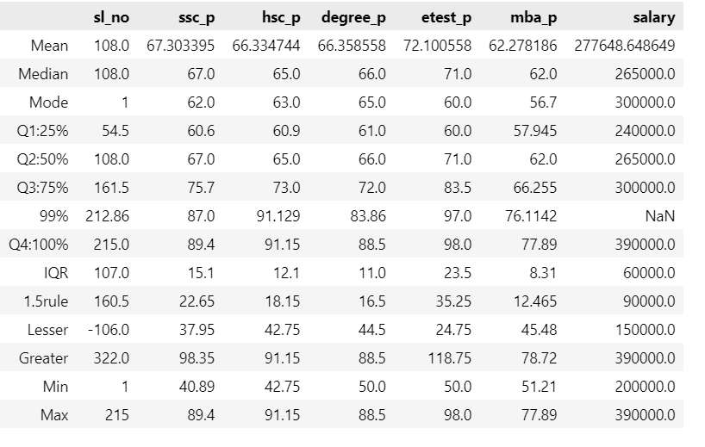

**CENTRAL TENDENCY**

**MEAN:**

* ssc_p (10th pass percentage): The mean score is 67.3%, indicating that most students performed above average in their 10th-grade exams, reflecting a strong foundational academic performance.
* hsc_p (12th pass percentage): The mean score is 66.3%, showing a slight decline in performance compared to the 10th grade, but still within an above-average range.
* degree_p: The mean score drops further to 66.4%, suggesting consistent but slightly decreasing performance through higher education stages.
* etest_p (entrance test percentage): The mean is 72.1%, which is significantly higher compared to other stages of education, reflecting better performance or aptitude in entrance/competitive exams.
* mba_p: The mean is 62.3%, indicating that while students performed well in earlier exams, their scores dropped slightly during their MBA studies, likely due to higher challenges or academic rigor.
* salary: The mean salary is 277,648, suggesting that the average earning potential of students aligns moderately with their academic performance.

This data shows a general trend of consistent academic performance, with a spike in entrance test scores and a dip during MBA, followed by moderate salary outcomes**.**

**Median**

* There is no significant difference between the mean and median for this dataset, highlighting a symmetrical or consistent distribution for most features like ssc_p, hsc_p, degree_p, and mba_p.
* For salary, the median highlights the presence of outliers—some individuals earn significantly higher or lower than the majority.
* This indicates that while most data points are centered, extreme values are present in the salary column, causing slight deviations.

**Mode**

* Many individuals achieved scores in the range of 60-65% across all exams (ssc_p, hsc_p, degree_p, etest_p, and mba_p). This suggests that a majority of students performed at an average or slightly above-average level.
* In terms of salary, the most frequently occurring value (mode) is 300,000, indicating that many candidates settled at this income level.

**Percentile Report Analysis**

**1. 10th Grade Pass Percentage (ssc_p)**

* **Q1 (25%)**: The first quartile is at **60.6%**, indicating that 25% of students scored below this mark.
* **Q2 (50%)**: The median is at **67%**, showing a modest increase of **6.4%** from Q1.
* **Q4 (100%)**: The maximum score reaches **89.4%**, which is **28.8%** higher than the median.
* **Observation**: The scores show steady progress across the quartiles, with a significant jump observed from Q2 to Q4.

**2. Higher Secondary Percentage (hsc_p)**

* **Q1 (25%)**: The first quartile stands at **60.9%**.
* **Q2 (50%)**: The median increases to **65%**, showing a rise of **4.1%**.
* **Q4 (100%)**: The maximum reaches **91.15%**, marking a steep increase of **26.15%** from the median.
* **Observation**: A relatively consistent increase is observed, with the highest jump noted in the Q3–Q4 range.

**3. Degree Percentage (degree_p)**

* **Q1 (25%)**: The first quartile is **61.0%**.
* **Q2 (50%)**: The median is **66%**, with a rise of **5%** from Q1.
* **Q4 (100%)**: The maximum score is **88.5%**, marking an increase of **22.5%** from the median.
* **Observation**: The trend here closely mirrors that of hsc_p, with a gradual increase followed by a significant jump in Q3–Q4.

**4. Entrance Test Percentage (etest_p)**

* **Q1 (25%)**: The first quartile is **60.0%**.
* **Q2 (50%)**: The median rises to **71%**, a notable jump of **11%** from Q1.
* **Q4 (100%)**: The maximum reaches **98%**, a significant increase of **27%** from the median.
* **Observation**: Entrance test scores exhibit the largest increase in Q2 compared to other metrics, showing a steeper performance distribution.

**5. MBA Percentage (mba_p)**

* **Q1 (25%)**: The first quartile is **57.945%**.
* **Q2 (50%)**: The median is **62%**, increasing by **4.055%**.
* **Q4 (100%)**: The maximum is **77.89%**, rising **15.89%** from the median.
* **Observation**: The scores show a moderate increase, with no extreme deviations or spikes across the quartiles.

**6. Salary (salary)**

* **Q1 (25%)**: The first quartile is **240,000**.
* **Q2 (50%)**: The median is **265,000**, reflecting a **25,000** increase.
* **Q4 (100%)**: The maximum salary reaches **390,000**, an increase of **125,000** from the median.
* **Observation**: Salary distribution is positively skewed, with more significant increases observed in the higher percentiles.

**IQR (Interquartile Range):**

The IQR measures the spread of the middle 50% of the data (Q3 - Q1), which highlights the variability of student scores across different metrics.

* **ssc_p (10th pass percentage)**:  
  IQR = **15.1**, showing a moderate spread in the 10th-grade scores. Most students scored within a range of **60.6% to 75.7%**, indicating consistent performance.
* **hsc_p (12th pass percentage)**:  
  IQR = **12.1**, reflecting less variability in the 12th-grade scores. This shows students performed within a narrow range.
* **degree_p**:  
  IQR = **11.0**, suggesting very limited variation among the scores, indicating a tightly clustered performance.
* **etest_p (entrance test percentage)**:  
  IQR = **23.5**, showing higher variability in the entrance test scores compared to earlier stages. Students had a wider range of abilities or preparation levels.
* **mba_p**:  
  IQR = **8.31**, indicating that MBA scores are tightly clustered, with minimal variation among students.
* **salary**:  
  IQR = **60,000**, reflecting a moderate range in salaries. Most students earned between **240,000** and **300,000**.

**1.5 Rule (Outlier Identification):**

The 1.5-rule helps identify potential outliers in the data.

* **Lesser Bound (Q1 - 1.5 × IQR):**
  + **ssc_p**: Scores below **37.95%** are outliers.
  + **hsc_p**: Scores below **42.75%** are outliers.
  + **degree_p**: Scores below **44.45%** are outliers.
  + **etest_p**: Scores below **24.75%** are outliers.
  + **mba_p**: Scores below **45.48%** are outliers.
  + **salary**: Salaries below **150,000** are outliers.
* **Greater Bound (Q3 + 1.5 × IQR):**
  + **ssc_p**: Scores above **98.35%** are outliers.
  + **hsc_p**: Scores above **91.15%** are outliers.
  + **degree_p**: Scores above **91.15%** are outliers.
  + **etest_p**: Scores above **118.75%** are unrealistic (indicating no outliers).
  + **mba_p**: Scores above **78.72%** are outliers.
  + **salary**: Salaries above **390,000** are outliers.

**Min and Max Values:**

* **ssc_p:** Min = **40.89%**, Max = **89.4%**
* **hsc_p:** Min = **42.75%**, Max = **91.15%**
* **degree_p:** Min = **50.0%**, Max = **91.15%**
* **etest_p:** Min = **50.0%**, Max = **98.0%**
* **mba_p:** Min = **51.21%**, Max = **77.89%**
* **salary:** Min = **200,000**, Max = **390,000**

These values show the overall range of scores, with consistent lower and upper bounds across categories.

**Conclusion:**

The dataset reveals consistent academic performance with increasing variation in competitive exams. Salaries show moderate variability, with outliers in the higher earning range. Entrance test scores (etest_p) stand out for higher variability, while MBA scores remain tightly clustered, reflecting differing levels of academic rigor.